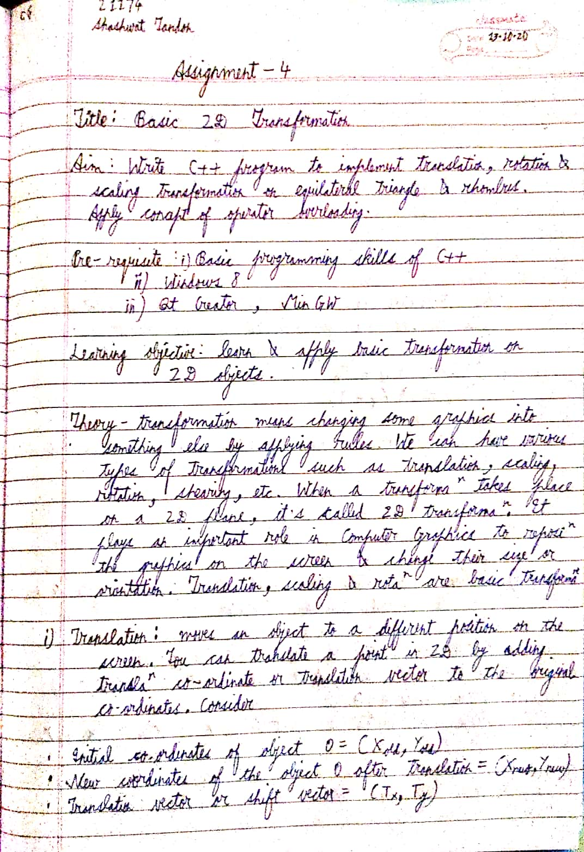

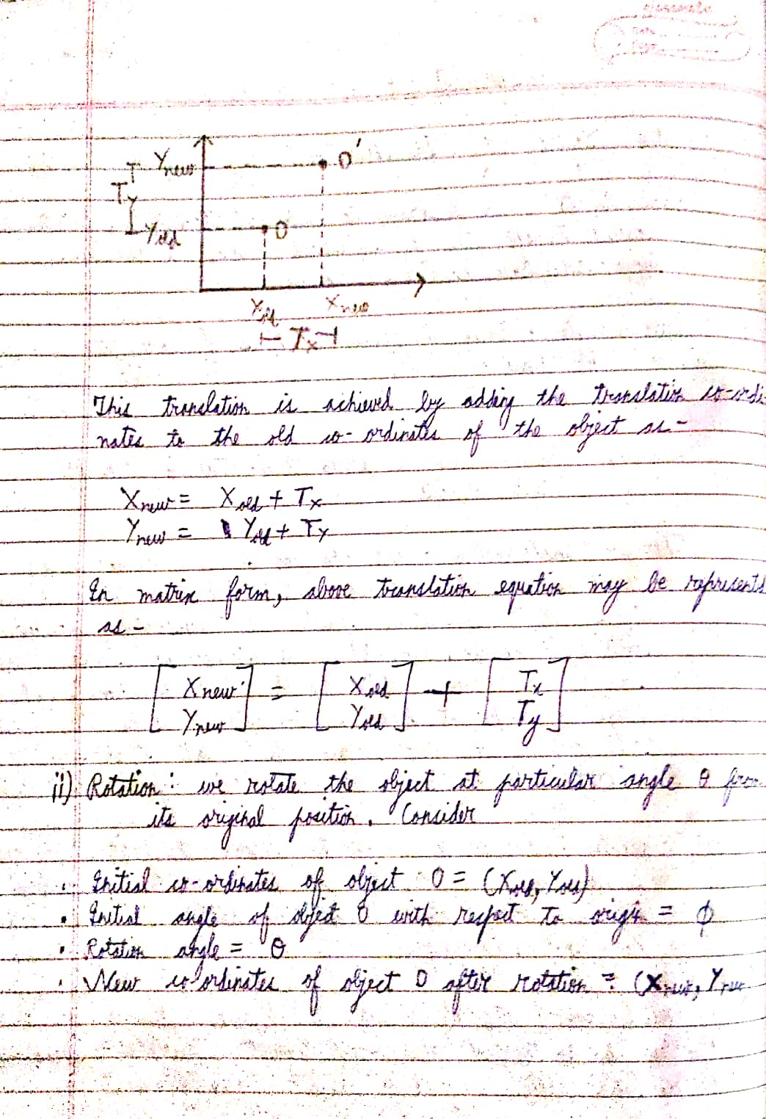

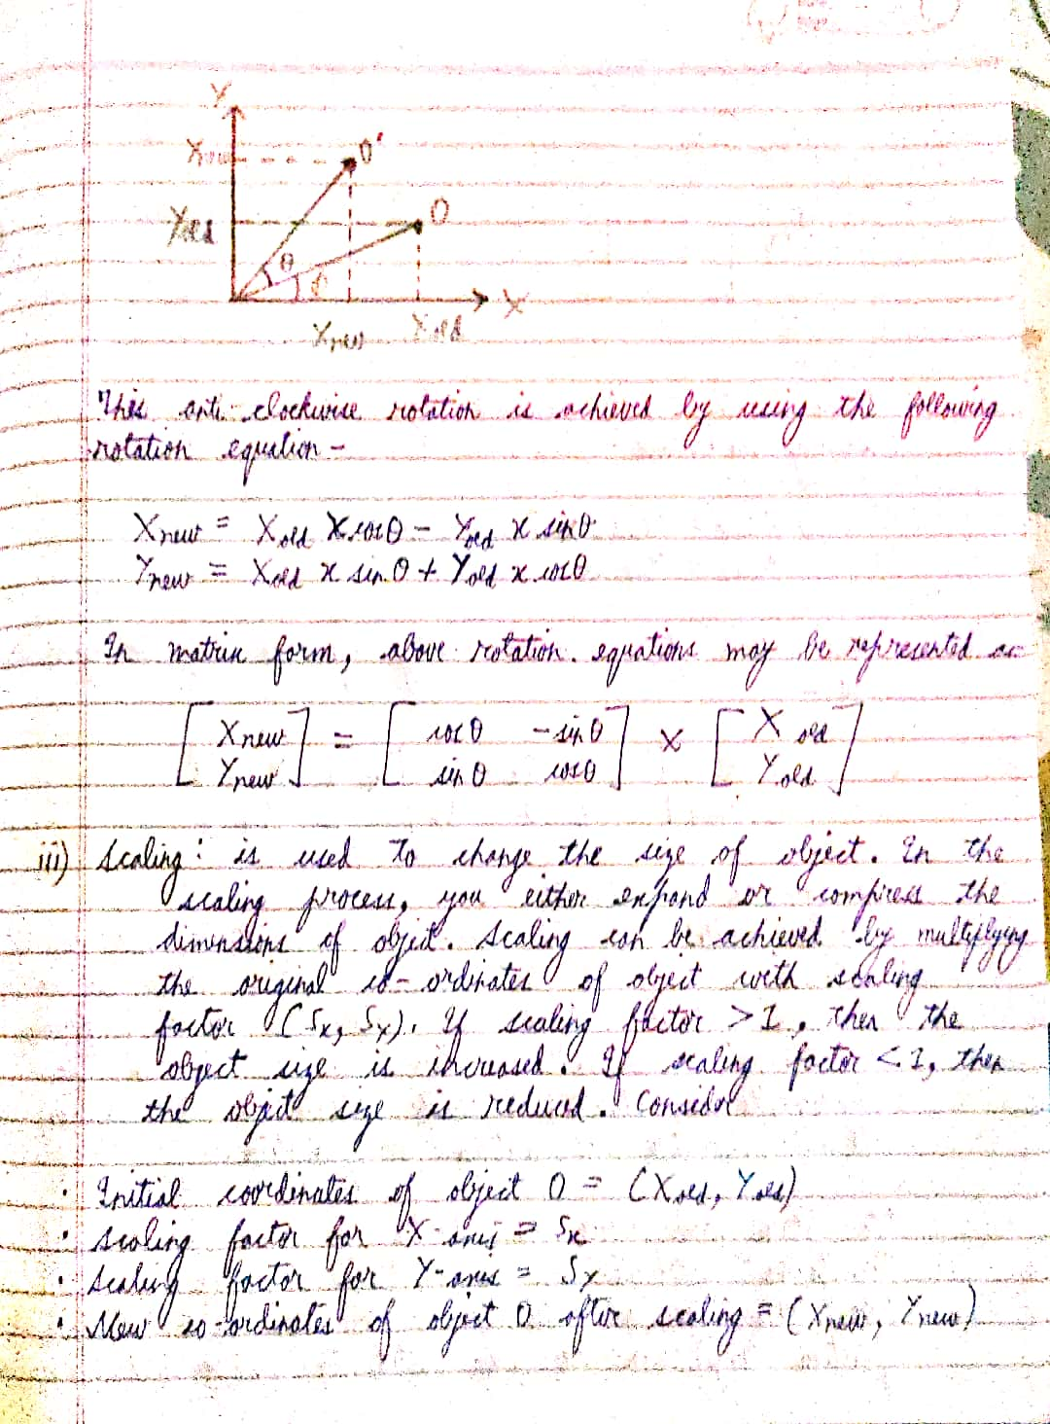

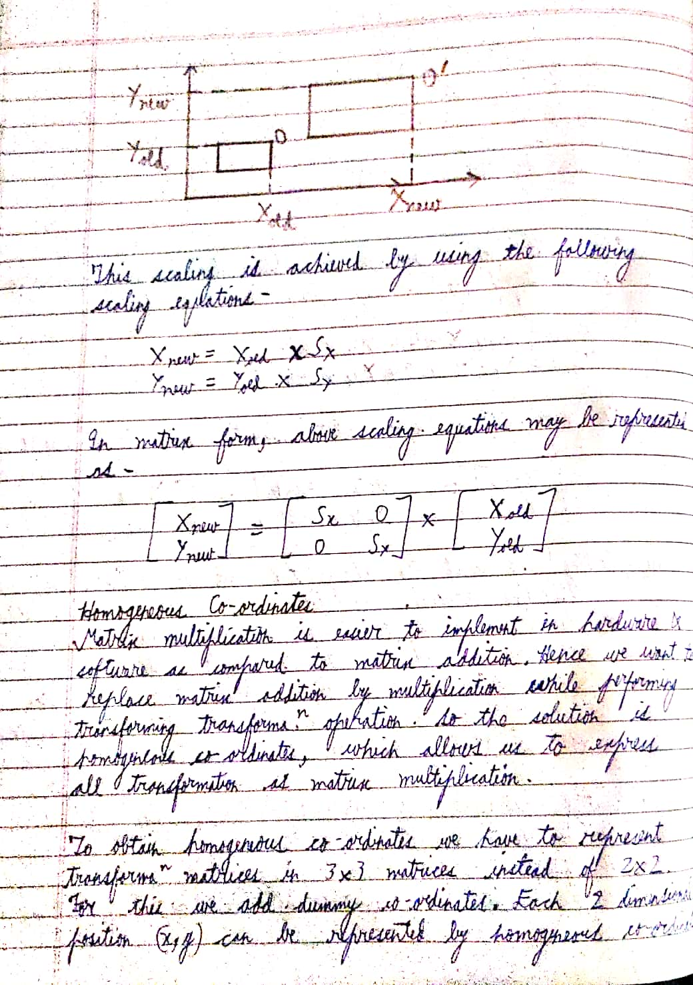

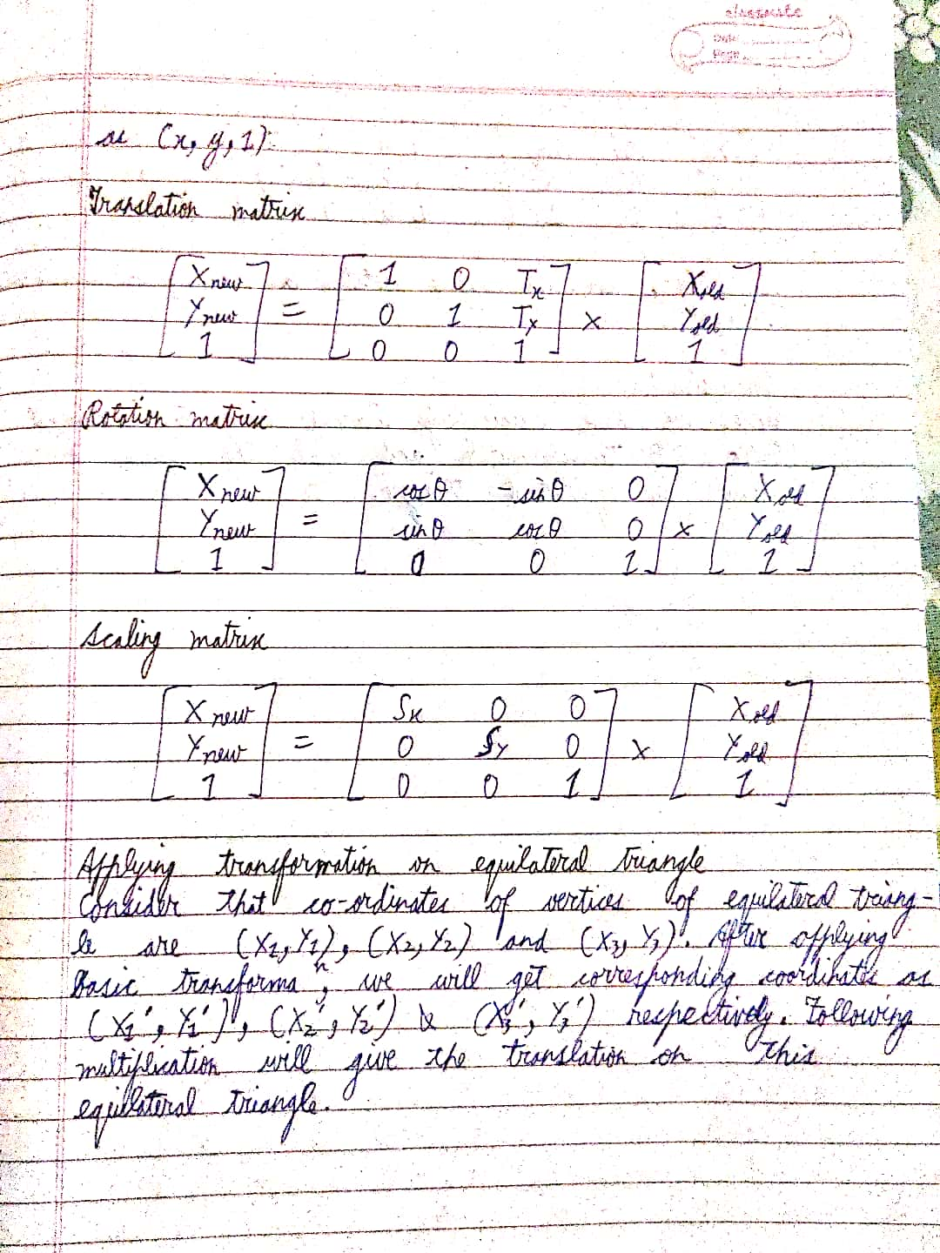

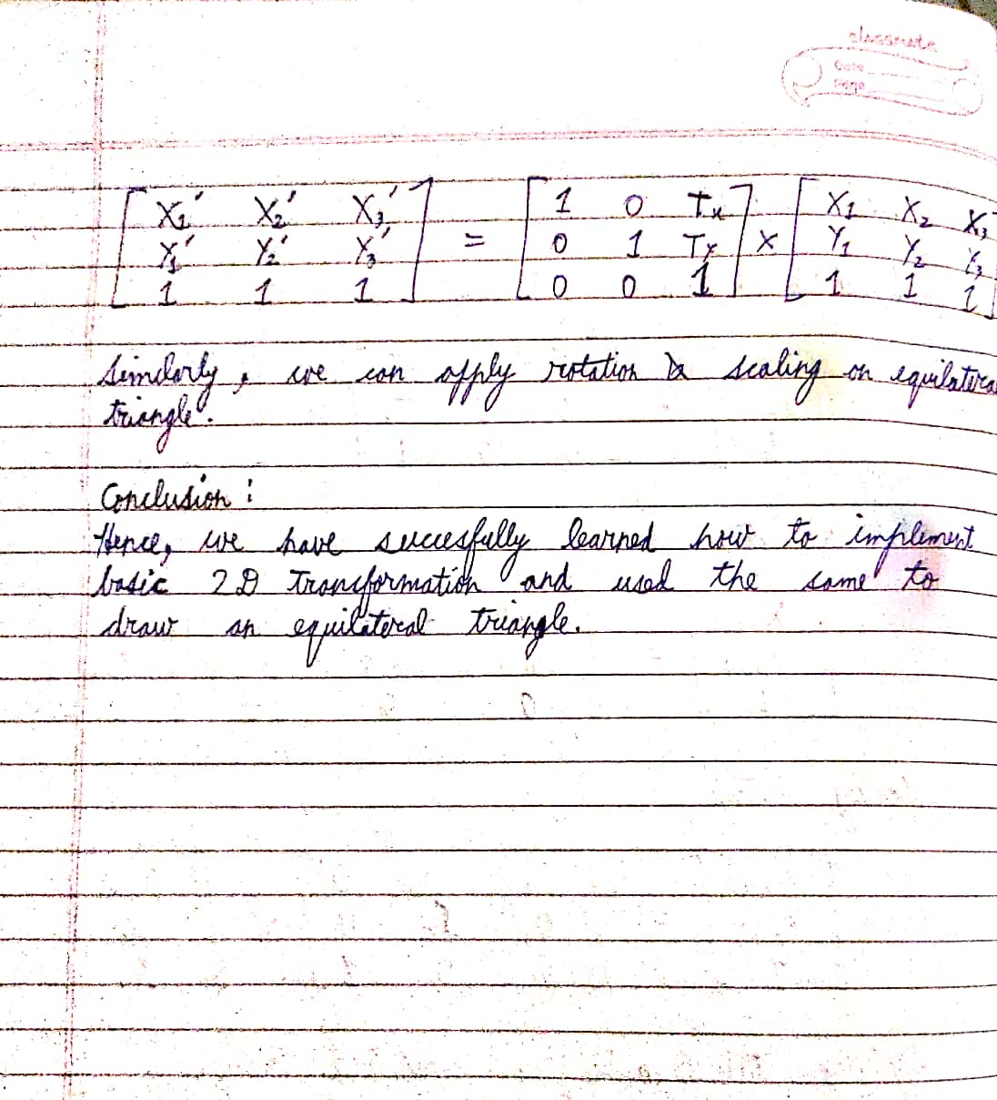

Code

mainwindow.cpp

#include "mainwindow.h"

#include "ui_mainwindow.h"

#include<iostream>

#include<math.h>

#include "QColorDialog"

using namespace std;

static QImage img(500,500,QImage::*Format_RGB888*);

QColor rang;

MainWindow::**MainWindow**(QWidget *parent)

: QMainWindow(parent)

, ui(new Ui::MainWindow)

{

ui->setupUi(this);

choice = 0;

DDA(250,0,250,500);

DDA(0,250,500,250);

for(int i=0;i<3;i++)

{

for(int j=0;j<3;j++)

{

if(i == j)

{

translateDiff[i][j] = 1;

scaleDiff[i][j] = 1;

rotateDiff[i][j] = 1;

}

else

{

translateDiff[i][j] = 0;

scaleDiff[i][j] = 0;

rotateDiff[i][j]= 0;

}

}

}

for(int i=0;i<2;i++)

{

for(int j=0;j<3;j++)

{

originalMat[i][j] = 1;

resultMat[i][j] = 0;

}

}

}

MainWindow::~***MainWindow***()

{

delete ui;

}

void MainWindow::**DDA**(int x1, int y1, int x2, int y2)

{

float dx, dy, step;

dx = x2 - x1;

dy = y2 - y1;

step = abs(dx) > abs(dy) ? abs(dx) : abs(dy);

float x =x1,y = y1;

float xincr = dx / step, yincr = dy / step;

for(int i = 0;i<step;++i)

{

if(choice == 0)

img.setPixel(x,y,qRgb(0,255,0));

else

img.setPixel(x,y,rang.rgb());

x += xincr;

y += yincr;

}

ui->label->setPixmap(QPixmap::fromImage(img));

}

void MainWindow::**Multiply**(float arr1[2][3],float arr2[3][3])

{

for(int i = 0;i < 2;i++)

for(int j = 0;j < 3;j++)

for (int k = 0;k < 3;k++)

{

resultMat[i][j] += arr1[i][k] * arr2[k][j];

}

DDA(250+resultMat[0][0],250-resultMat[0][1],250+resultMat[1][0],250-resultMat[1][1]);

for(int i=0;i<2;i++)

{

for(int j=0;j<3;j++)

{

resultMat[i][j] = 0;

}

}

}

void MainWindow::**on_pushButton_clicked**()

{

choice = 1;

int x1, y1, x2, y2;

x1 = ui->textEdit->toPlainText().toInt();

y1 = ui->textEdit_2->toPlainText().toInt();

x2 = ui->textEdit_3->toPlainText().toInt();

y2 = ui->textEdit_4->toPlainText().toInt();

originalMat[0][0] = x1;

originalMat[0][1] = y1;

originalMat[1][0] = x2;

originalMat[1][1] = y2;

DDA(250+x1,250-y1,250+x2,250-y2);

}

void MainWindow::**on_pushButton_2_clicked**()

{

choice = 1;

int tx, ty;

tx = ui->textEdit_5->toPlainText().toInt();

ty = ui->textEdit_6->toPlainText().toInt();

translateDiff[2][0] = tx;

translateDiff[2][1] = ty;

Multiply(originalMat,translateDiff);

}

void MainWindow::**on_pushButton_3_clicked**()

{

choice = 1;

int sx, sy;

sx = ui->textEdit_5->toPlainText().toInt();

sy = ui->textEdit_6->toPlainText().toInt();

scaleDiff[1][1] = sy;

scaleDiff[0][0] = sx;

Multiply(originalMat,scaleDiff);

}

void MainWindow::**on_pushButton_4_clicked**()

{

choice = 1;

int Angle;

Angle = ui->textEdit_7->toPlainText().toInt();

rotateDiff[0][0] = cos(Angle*3.14/180);

rotateDiff[0][1] = sin(Angle*3.14/180);

rotateDiff[1][0] = -sin(Angle*3.14/180);

rotateDiff[1][1] = cos(Angle*3.14/180);

Multiply(originalMat,rotateDiff);

}

void MainWindow::**on_pushButton_5_clicked**()

{

rang = QColorDialog::getColor();

}

main.cpp

#include "mainwindow.h"

#include <QApplication>

int main(int argc, char *argv[])

{

QApplication a(*argc*, argv);

MainWindow w;

w.show();

return a.exec();

}

mainwindow.h

#ifndef MAINWINDOW_H

#define MAINWINDOW_H

#include <QMainWindow>

QT_BEGIN_NAMESPACE

namespace **Ui** { class **MainWindow**; }

QT_END_NAMESPACE

class **MainWindow** : public QMainWindow

{

Q_OBJECT

public:

// class MainWindow::Matrix;

**MainWindow**(QWidget *parent = nullptr);

~***MainWindow***();

void **DDA**(int,int,int,int);

void **Multiply**(float arr1[2][3],float arr2[3][3]);

private slots:

void **on_pushButton_clicked**();

void **on_pushButton_4_clicked**();

void **on_pushButton_2_clicked**();

void **on_pushButton_3_clicked**();

void **on_pushButton_5_clicked**();

private:

Ui::MainWindow *ui;

float tx,ty,choice,translateDiff[3][3],scaleDiff[3][3],rotateDiff[3][3];

float originalMat[2][3],resultMat[3][3];

};

#endif // MAINWINDOW_H

