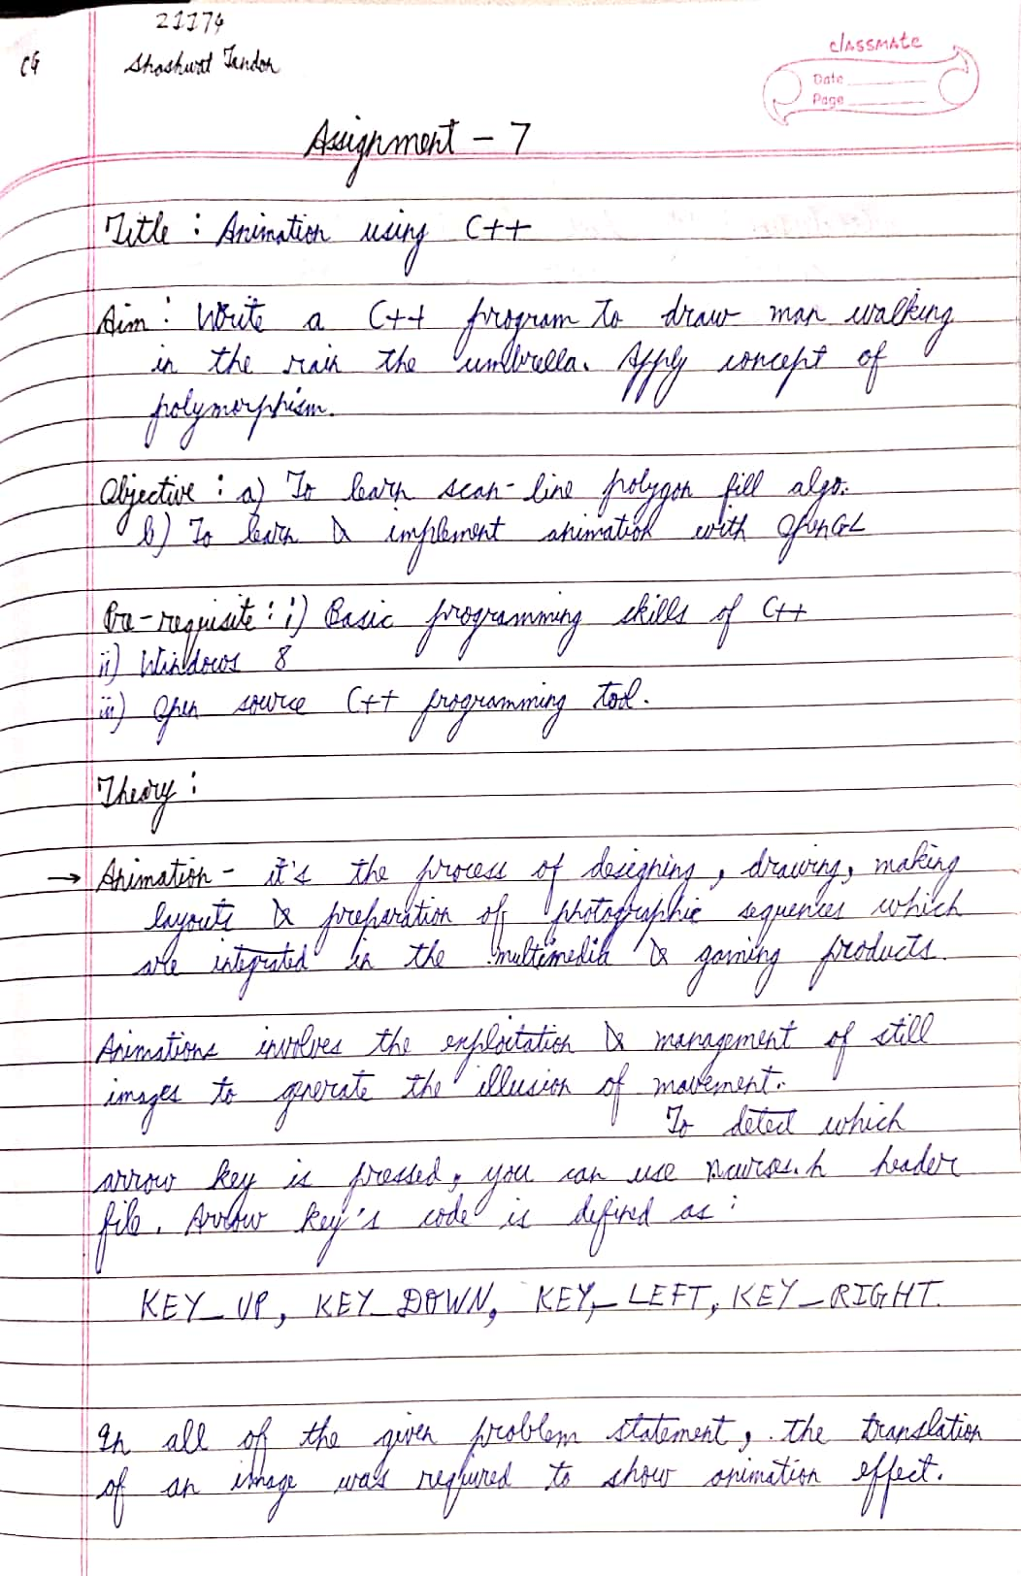

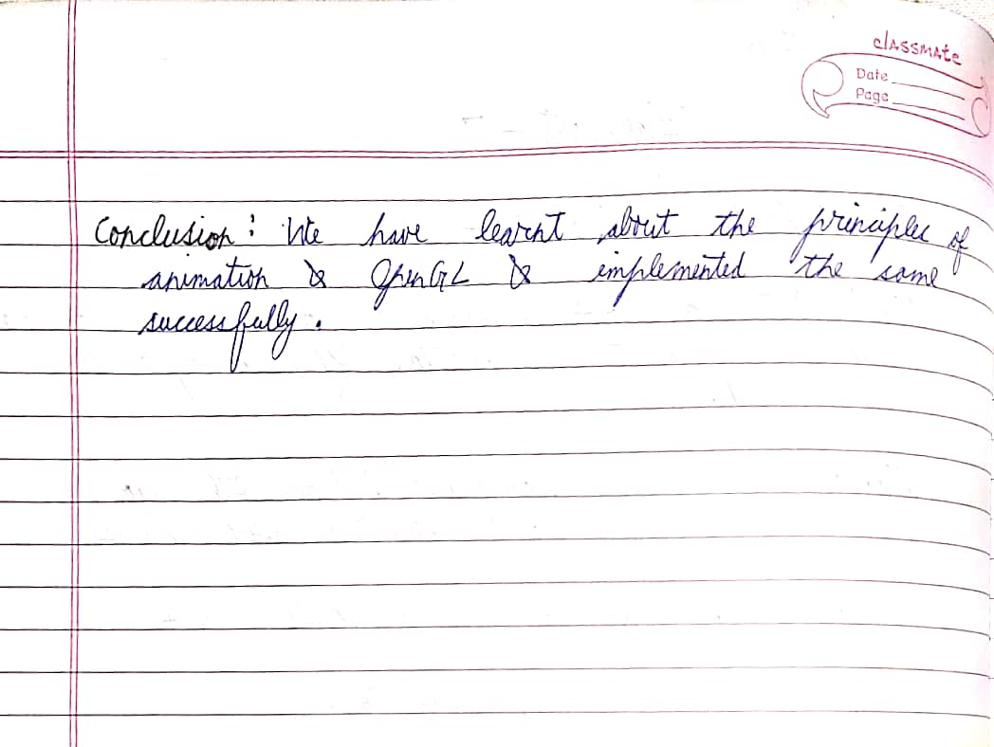

CODE

//Sassy_Don30

#include<GL/glut.h>

#include<iostream>

#include<stdlib.h>

using namespace std;

float x = 92;

float y = 400;

int flag = 0;

void Init(void) {

glClearColor(0, 0, 0, 1); // black color diya

}

void Reshape(int w, int h) {

// viewport ready aur matrix mode tayaar kiya

glViewport(0, 0, w, h);

glMatrixMode(GL_PROJECTION);

glLoadIdentity();

// ek alag matrix aur use kiya yaha pe

gluOrtho2D(0, 1000, 500, 0);

glMatrixMode(GL_MODELVIEW);

}

void DrawMan() {

glClear(GL_COLOR_BUFFER_BIT);

glLoadIdentity();

float angle; // umbrella ke liye variable

glBegin(GL_POLYGON); // umbrella draw karne ke liye

for (int i = 180; i < 360; i++){

angle = i * 3.142 / 180; // angle ko radian me kiya

glColor3f(1, 1, 0); // white color

glVertex2f((x - 2) + 29 * cos(angle), (y - 27) + 29 * sin(angle)); // unbrella draw karne ke liye hai ye

}

glEnd();

float angle2; // khopdi draw karne ke liye

glBegin(GL_POLYGON);

for (int i = 0; i < 360; i++){

angle2 = i * 3.142 / 180; // angle to radian

glColor3f(0, 1, 1);

glVertex2f(x + 11 * cos(angle2), (y - 11) + 11 * sin(angle2)); // khopdi ke liye

}

glEnd();

//stick

glBegin(GL_LINES);

glColor3f(1, 1, 1);

glVertex2f(x - 10, y - 26);

glVertex2f(x - 10, y - 10);

glEnd();

//hand right

glBegin(GL_LINES);

glColor3f(1, 1, 1);

glVertex2f(x + 1, y + 9);

glVertex2f(x + 15, y + 18);

glEnd();

//leg left

glBegin(GL_LINES);

glColor3f(1, 1, 1);

glVertex2f(x - 1, y + 33);

glVertex2f(x - 13, y + 43);

glEnd();

//leg right

glBegin(GL_LINES);

glColor3f(1, 1, 1);

glVertex2f(x + 1, y + 33);

glVertex2f(x + 15, y + 43);

glEnd();

/*

//hand left

glBegin(GL_LINES);

glColor3f(1, 1, 1);

glVertex2f(x - 5, y - 10);

glVertex2f(x - 23, y + 5);

glEnd();

//hand left ka palm jisse umbrella pakdi hai

glBegin(GL_LINES);

glColor3f(1, 1, 1);

glVertex2f(x - 23, y + 5);

glVertex2f(x - 1, y + 9);

glEnd();

*/

// left hand

glBegin(GL_LINES);

glColor3f(1, 0, 0);

glVertex2f(x, y + 9);

glVertex2f(x - 10, y - 10);

glEnd();

//body

glBegin(GL_LINES);

glColor3f(1, 1, 1);

glVertex2f(x, y);

glVertex2f(x, y + 33);

glEnd();

//land

glBegin(GL_POLYGON);

glColor3f(.4, .26, .13);

glVertex2f(0, 443);

glVertex2f(999, 443);

glVertex2f(999, 499);

glVertex2f(0, 499);

glEnd();

// baarish ke liye hai ye

glBegin(GL_LINES);

for (int t = 0; t < 10; t++) {

int x1 = rand() % 999;

int y1 = rand() % 499;

glColor3f(1, 1, 1);

glVertex2f(x1, y1);

glVertex2f(x1, y1 + 10);

}

glEnd();

glutSwapBuffers();

}

void OnIdle() {

glutPostRedisplay();

if (x < 950) // haar second aage chalta rahega

x += 0.009;

}

int main(int argc, char** argv){

glutInit(&argc, argv);

glutInitDisplayMode(GLUT_SINGLE | GLUT_RGB);

glutInitWindowPosition(0, 0);// window size aur position hai yaha pe

glutInitWindowSize(1000, 500);

glutCreateWindow("Rain Man");

Init();

glutDisplayFunc(DrawMan); // inbuilt chhezo me pass kiya hamare likhe functions aur run

glutReshapeFunc(Reshape);

glutIdleFunc(OnIdle);

glutMainLoop();

return 0;

}

OUTPUT

