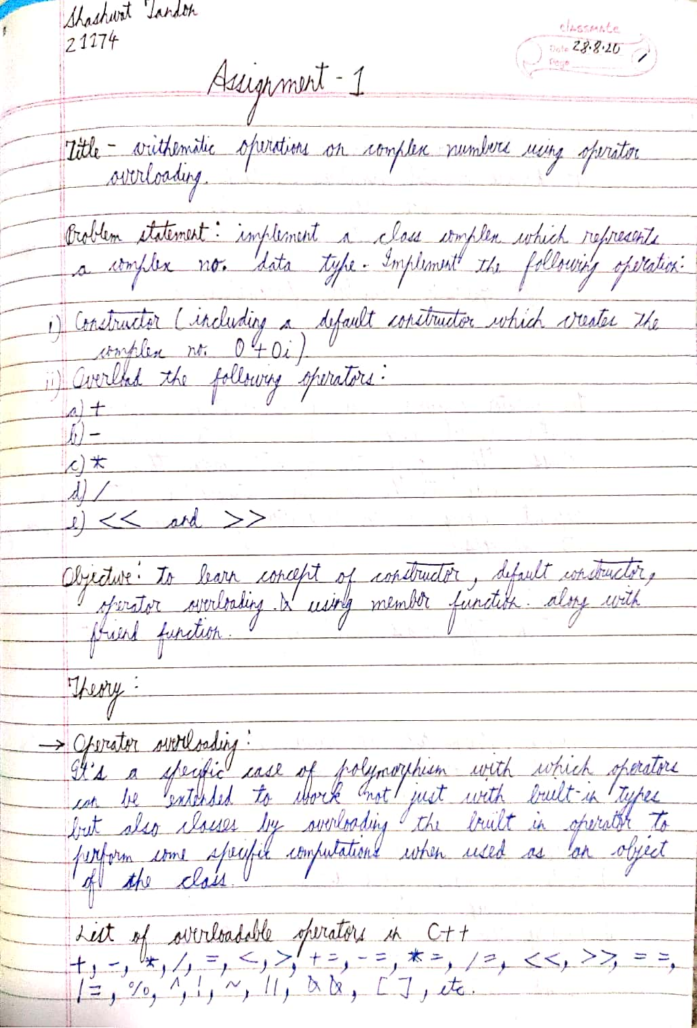

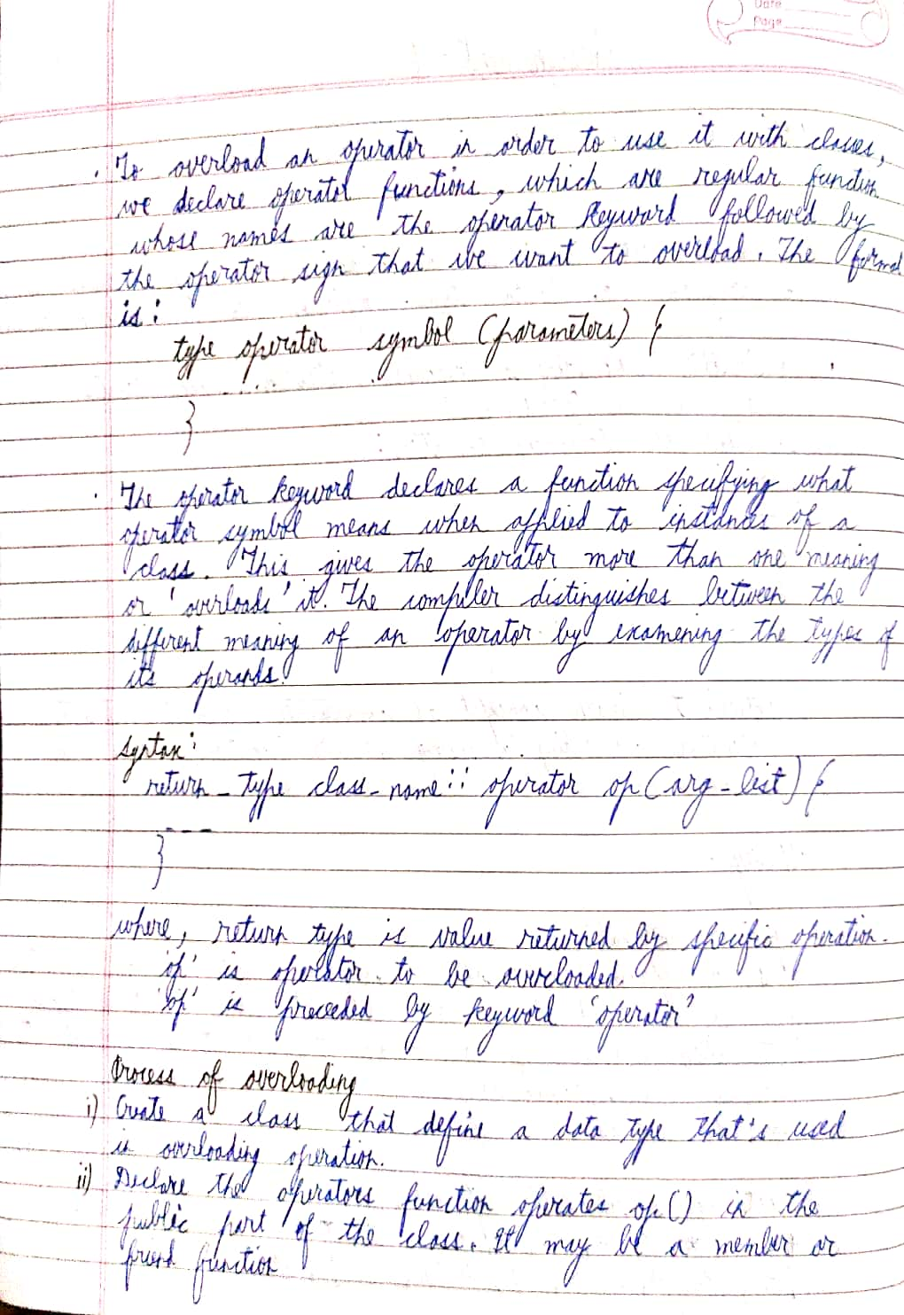

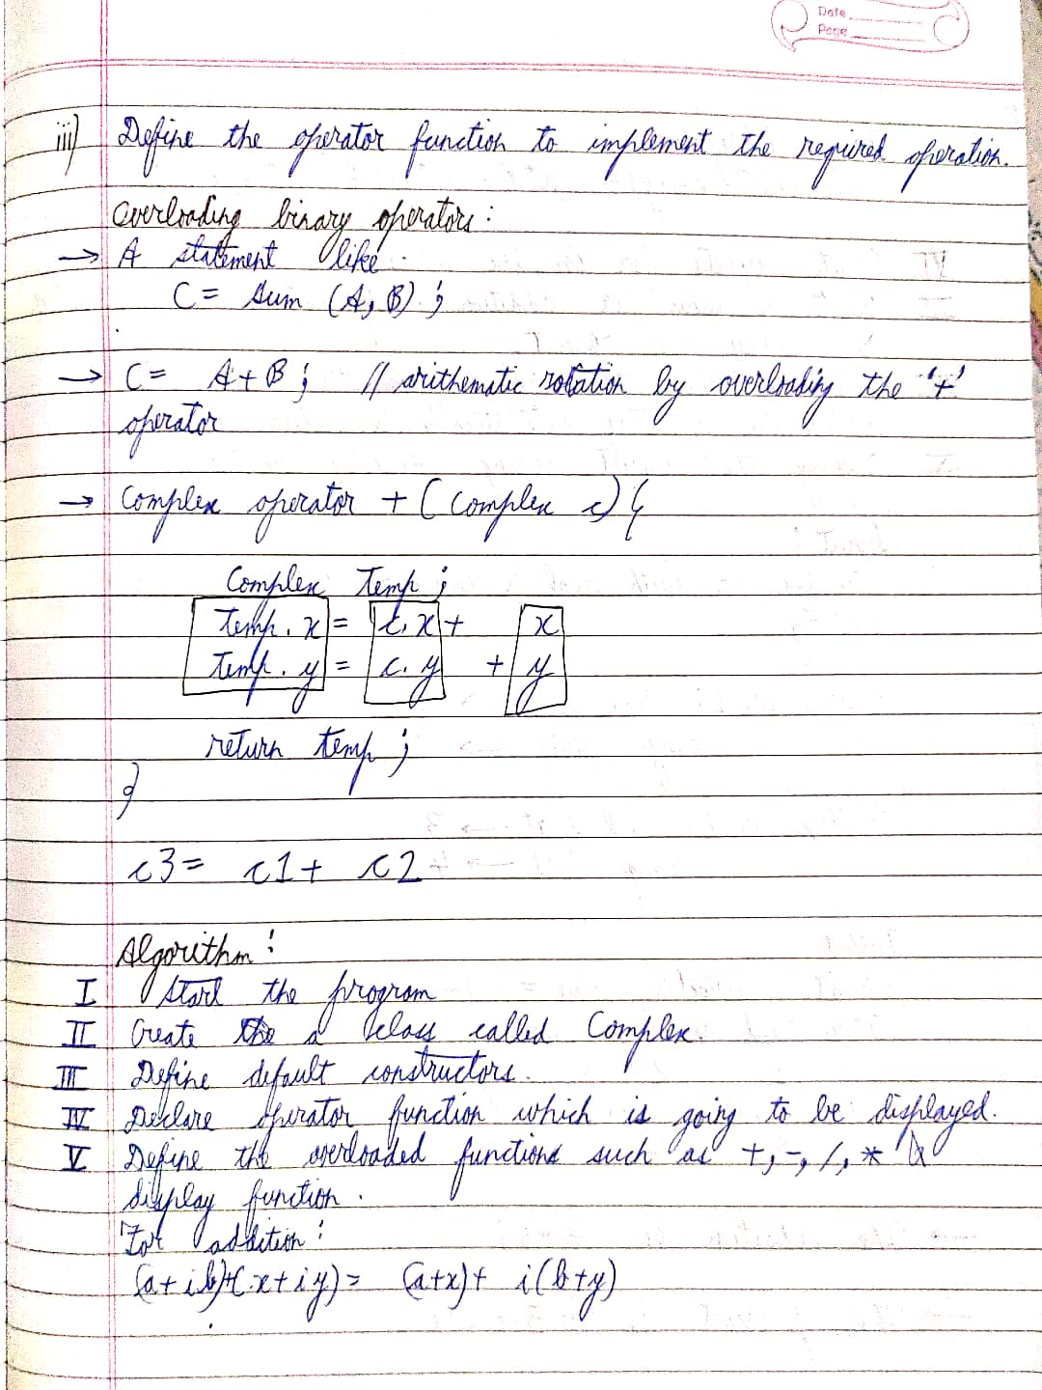

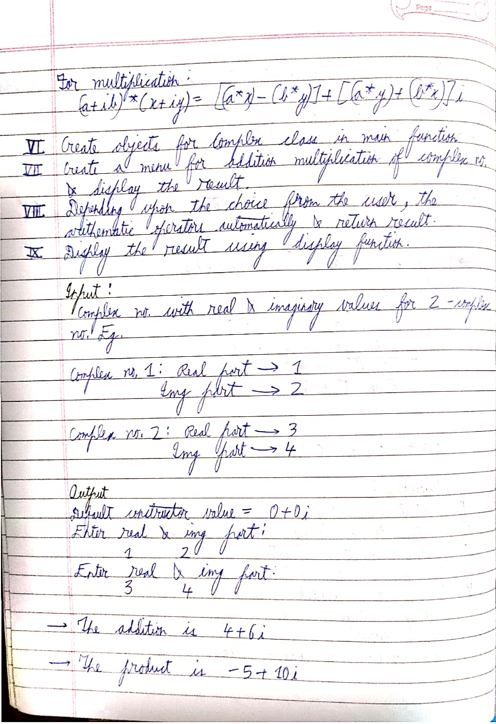

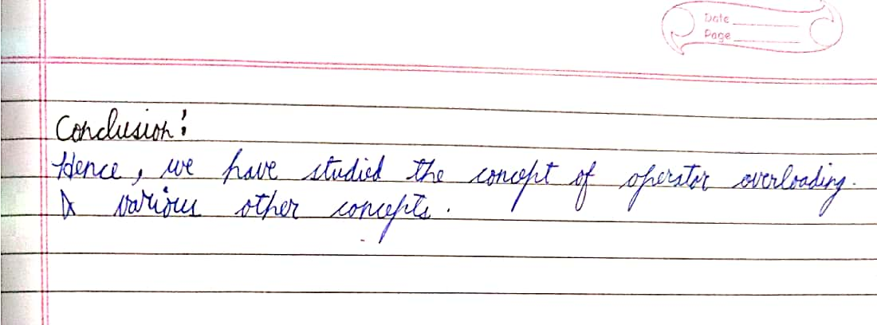

Code

**#include** <iostream>

**using** **namespace** std;

**class** **Complex**{

**private**:

**float** real,img; //abstraction ke liye

**public**:

**Complex**(){ //constructor by default 0

real=0;

img=0;

}

**Complex**(**float** a,**float** b){ //argument wala contructor

real=a;img =b;

}

**Complex** **operator +**(**Complex** **const** &c){ //+ ke liye overload kar rahe aur temp return kar rahe, same for others

**Complex** temp;

temp.real = real + c.real;

temp.img = img + c.img;

**return** temp;

}

**Complex** **operator -**(**Complex** **const** &c){

**Complex** temp;

temp.real = real - c.real;

temp.img = img - c.img;

**return** temp;

}

**Complex** **operator \***(**Complex** **const** &c){

**Complex** temp;

temp.real = (real*c.real)-(img*c.img);

temp.img = (real*c.img)+(img*c.real);

**return** temp;

}

**Complex** **operator /**(**Complex** **const** &c){

**Complex** temp;

temp.real = (real* c.real + img*c.img)/(c.real*c.real + c.img*c.img);

temp.img = (img*c.real + real*c.img)/(c.real*c.real + c.img*c.img);

**return** temp;

}

**friend** **ostream** &**operator<<**(**ostream** &o,**Complex** &c){ //output stream ko friend le rahe and << ko overload

**if**(c.img<0){

o<<c.real<<c.img<<"i"<<**endl**; // agar nahi karenge to 1-2i galat dikhega,1+-2i dikhega fir

}

**else**{

o<<c.real<<"+"<<c.img<<"i"<<**endl**; //normal display hoga

}

**return** o;

}

**friend** **istream** &**operator>>**(**istream**&i,**Complex** &c){ //input stream ko dost banaya >> overlaod karke

cout<<"Enter value of real part:"<<**endl**;

i>>c.real;

cout<<"Enter value of imaginary part"<<**endl**;

i>>c.img;

**return** i;

}

};

**int** **main**()

{

**int** operation; //jo operation karenge aur hamare declared variables

**bool** cont = **true**;

**Complex** a,b,add,subtract,multiply,div;

**while**(cont){

cout<<"Enter value of a"<<**endl**;

cin>>a;

cout<<a;

cout<<"Enter value of b"<<**endl**;

cin>>b;

cout<<b;

cout<<"Choose desired operation: \n1.Add \n2.Subtract \n3.Multiply \n4.Divide \n5.Exit"<<**endl**; //menuu

cin>>operation;

**switch**(operation){ //switch case to handle output

**case** 1:

add = a+b;

cout<<add;

**break**;

**case** 2:

subtract = a-b;

cout<<subtract;

**break**;

**case** 3:

multiply = a*b;

cout<<multiply;

**break**;

**case** 4:

div = a/b;

cout<<div;

**break**;

**case** 5:

cout<<"Byeeee"<<**endl**;

cont = **false**;

**break**;

**default**:

cout<<"Enter appropriate choice"<<**endl**;

}

}

**return** 0;

}

Output

Enter value of a

Enter value of real part:

1

Enter value of imaginary part

2

1+2i

Enter value of b

Enter value of real part:

3

Enter value of imaginary part

4

3+4i

Choose desired operation:

1.Add

2.Subtract

3.Multiply

4.Divide

5.Exit

1

4+6i

Enter value of a

Enter value of real part:

1

Enter value of imaginary part

2

1+2i

Enter value of b

Enter value of real part:

3

Enter value of imaginary part

4

3+4i

Choose desired operation:

1.Add

2.Subtract

3.Multiply

4.Divide

5.Exit

3

-5+10i