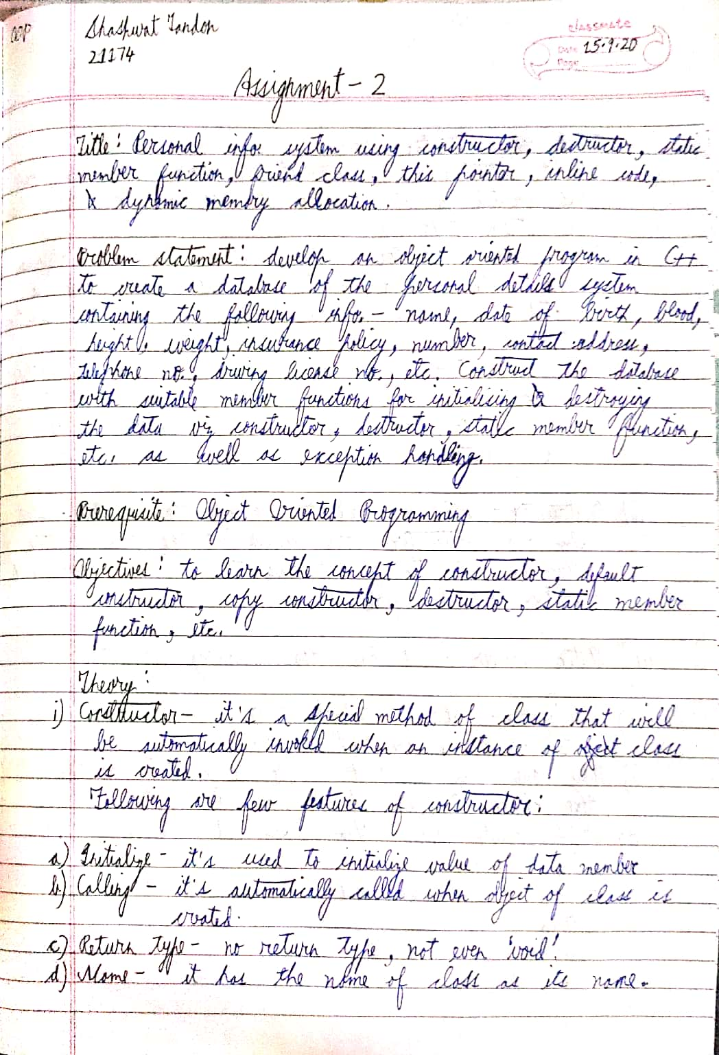

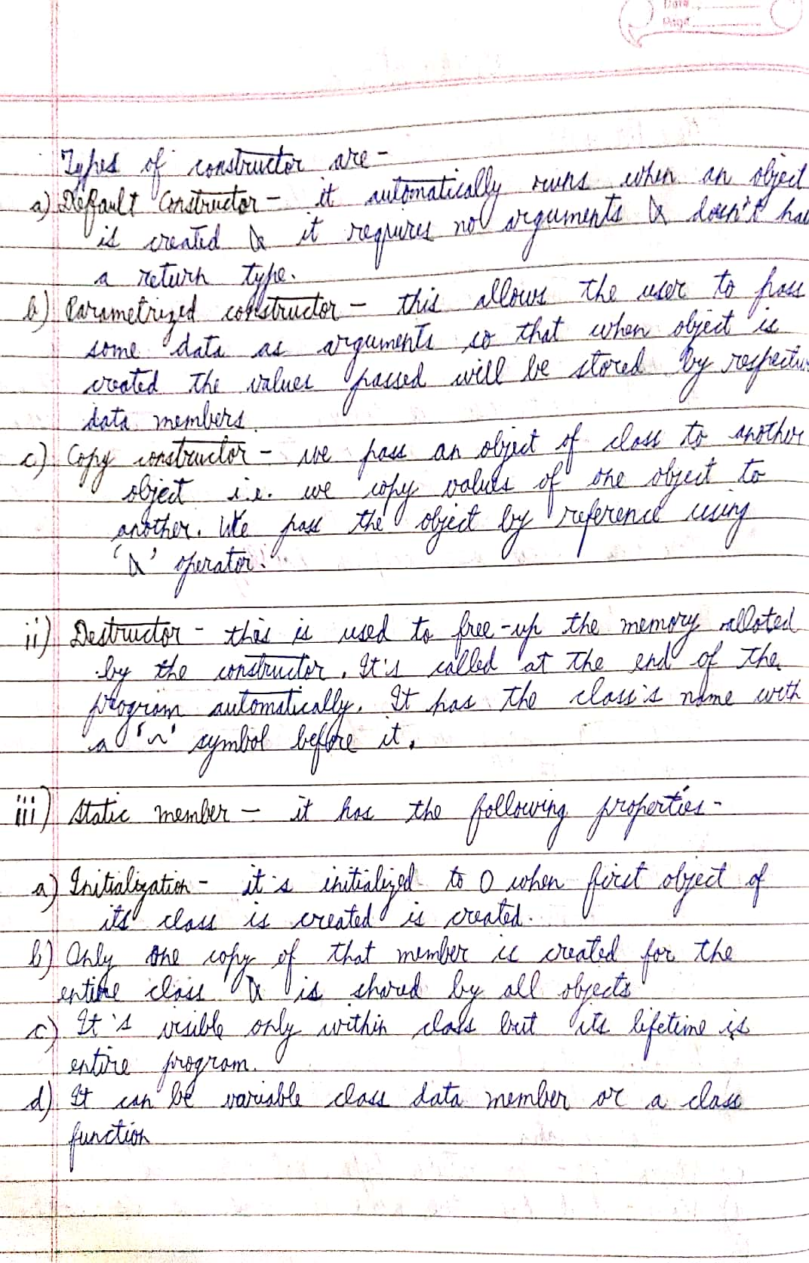

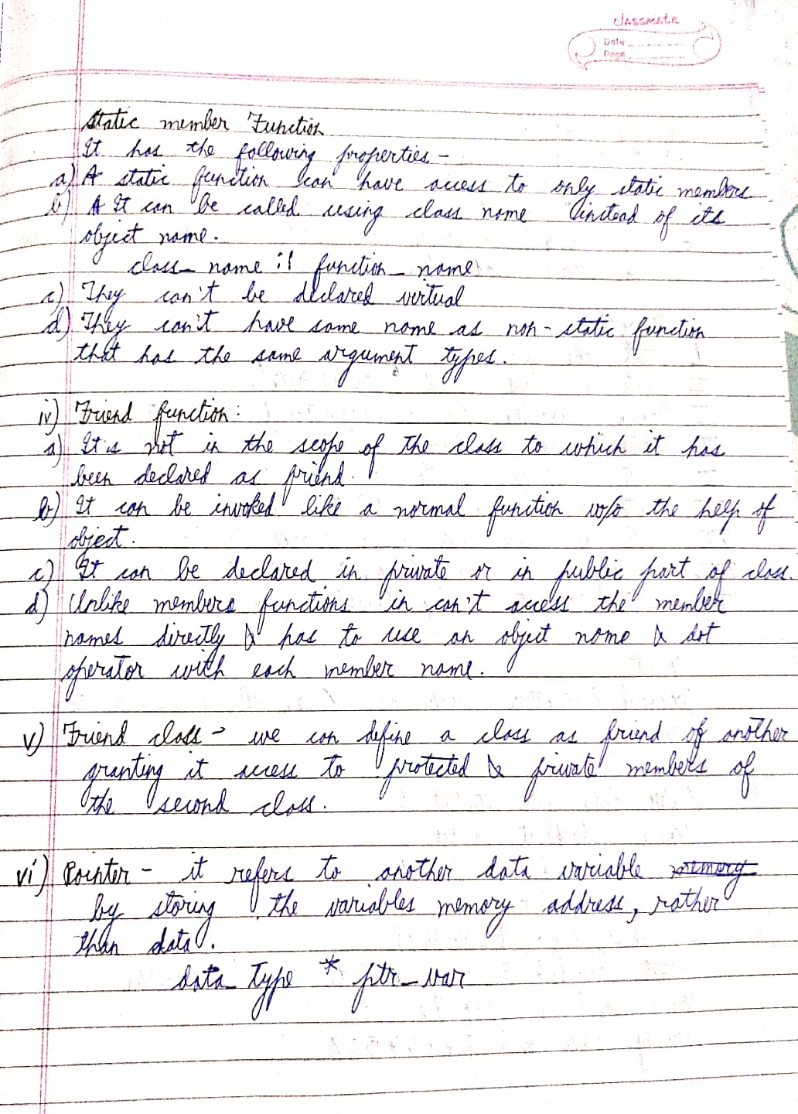

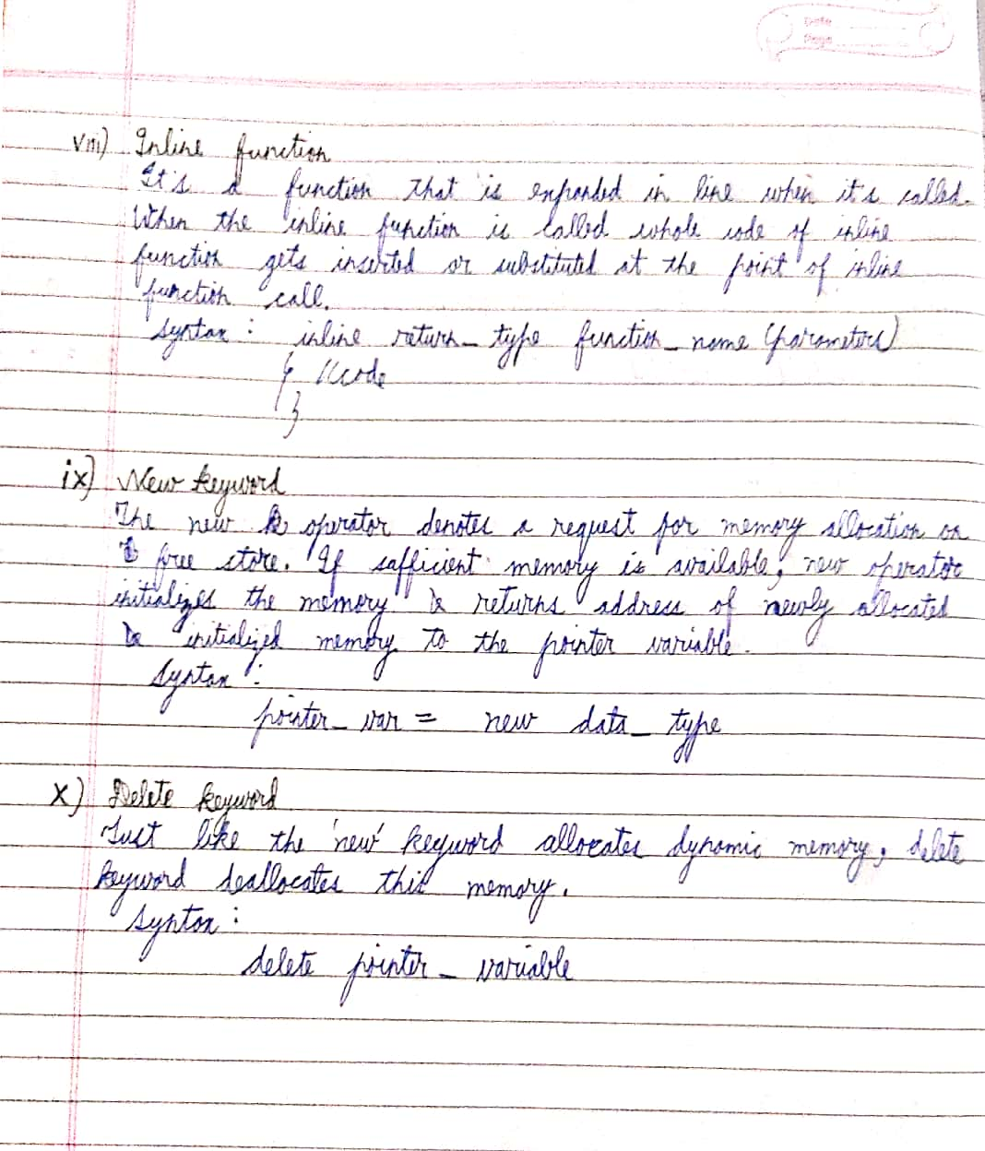

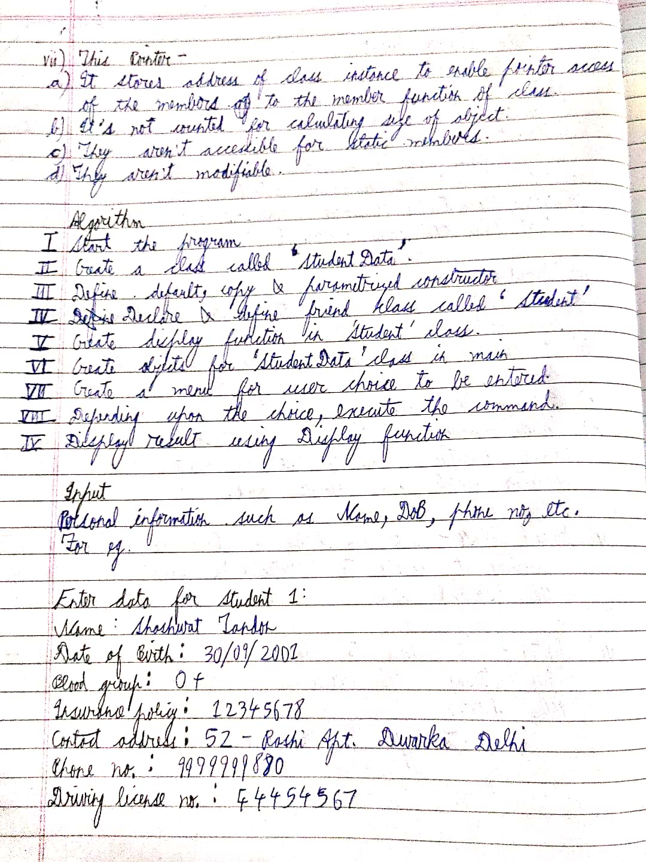

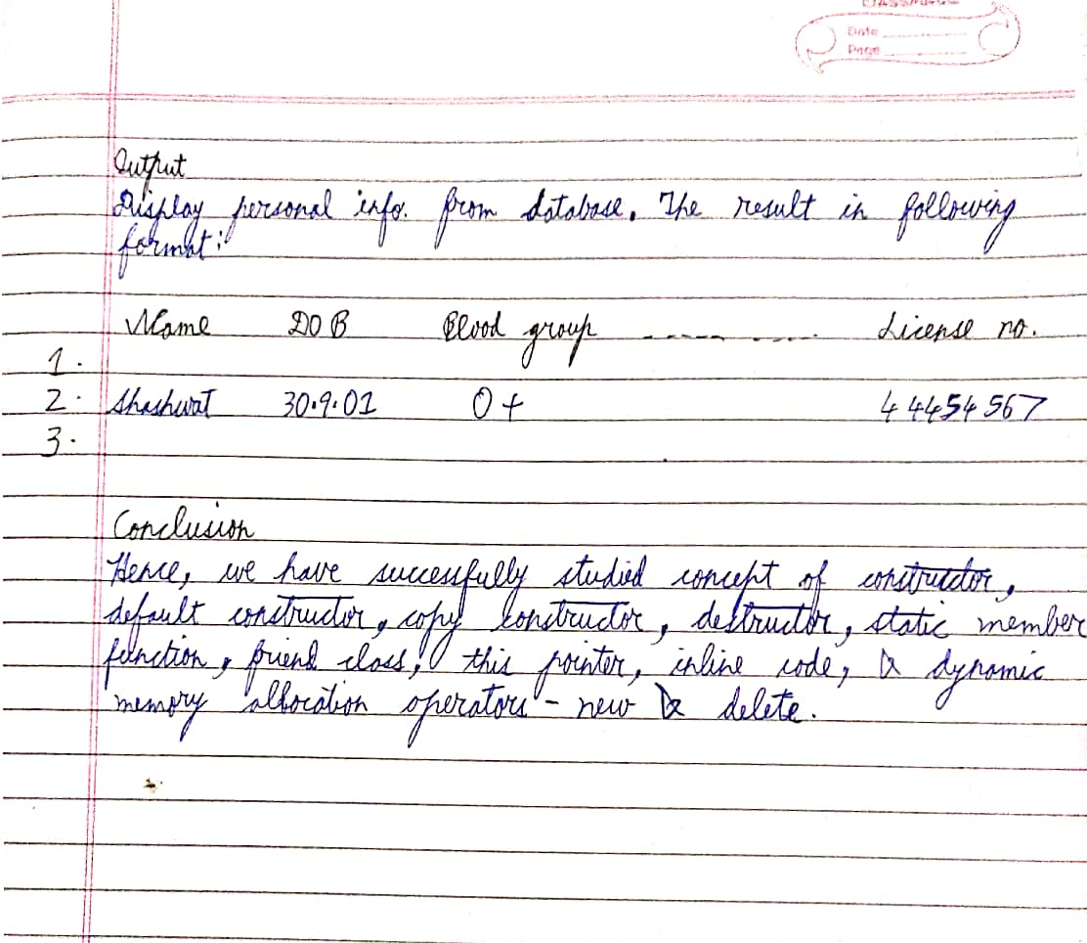

Code

#include <iostream>

using namespace std;

class StudentData{

private:

string name,cls,blood_group,address;

int roll_no,div,dob,tele_no,license_no;

static int count;

public:

StudentData(){

cout<<"Default constructor used...."<<endl;

name = "XYZ";

roll_no = -4;

cls = "Second Year";

div = 1;

dob=000;

blood_group = " ";

address = " ";

tele_no = 0000;

license_no = 0;

count++;

}

StudentData(string name , int roll_no,string cls,int div,int dob,string blood_grp,string address,int tele_no,int dr_no){

cout<<"Parameterized constructor called...."<<endl;

this->name = name;

this->roll_no = roll_no;

this->cls = cls;

this->div = div;

this->dob=dob;

this->blood_group =blood_group;

this->address = address;

this->tele_no = tele_no;

this->license_no = license_no;

count++;

}

StudentData(StudentData &stud){

name = stud.name;

roll_no = stud.roll_no;

cls = stud.cls;

div = stud.div;

dob = stud.dob;

blood_group = stud.blood_group;

address = stud.address;

tele_no = stud.tele_no;

license_no = stud.license_no;

count++;

}

~StudentData(){

cout<<"Destroyer has been called"<<endl;

count--;

}

inline void InputData(){

cout<<"Enter student name:";

getline(cin,name);

cout<<"Enter roll no:";

cin>>roll_no;

cout<<"Enter class:";

cin>>cls;

cout<<"Enter division:";

cin>>div;

cout<<"Enter date of birth:";

cin>>dob;

cout<<"Enter blood group:";

cin>>blood_group;

cin.ignore();

cout<<"Enter address:";

getline(cin,address);

cout<<"Enter telephone number:";

cin>>tele_no;

cout<<"Enter driving license number:";

cin>>license_no;

}

static int Student_Count(){

return count;

}

friend class Student;

};

class Student{

public:

void PrintData(StudentData &s){

cout<<"Student's name: "<<s.name<<endl;

cout<<"Student's roll no: "<<s.roll_no<<endl;

cout<<"Student's class: "<<s.cls<<endl;

cout<<"Student's division: "<<s.div<<endl;

cout<<"Student's date of birth: "<<s.dob<<endl;

cout<<"Student's blood group: "<<s.blood_group<<endl;

cout<<"Student's address: "<<s.address<<endl;

cout<<"Student's telephone no: "<<s.tele_no<<endl;

cout<<"Student's driving license no: "<<s.license_no<<endl;

}

};

int StudentData::count = 0;

int main()

{

StudentData *stu1 = new StudentData;

StudentData *stu2 = new StudentData;

StudentData *stu3 = new StudentData("Shashwat",21174,"SE",1,300901,"O+","Vayusena Nagar ,Nagpur",98989898,4444444);

StudentData *stu4 = new StudentData;

Student stu;

stu1->InputData();

stu2 = stu1;

stu4->InputData();

stu.PrintData(*stu1);

stu.PrintData(*stu2);

stu.PrintData(*stu3);

stu.PrintData(*stu3);

cout<<"No. of Students:"<<stu1->Student_Count()<<endl;

delete stu1,stu2,stu3,stu4;

return 0;

}

Output

Constructor called

Constructor called

Parameterized constructor called

enter name Sassy

enter roll no 74

enter class SE

enter div 1

enter date of birth 300901

enter address 100/4 HQ MC Nagpur

enter telephone number 123456789

Copy constructor called

Student's name: Sassy

Student's roll no: 74

Student's class: SE

Student's division: 1

Student's date of birth: 300901

Student's address: 100/4 HQ MC Nagpur

Student's telephone no: 123456789

Destructor called

Copy constructor called

Student's name: XYZ

Student's roll no: 01

Student's class: SE

Student's division: 1

Student's date of birth: 280401

Student's address: Dharampeth Nagpur

Student's telephone no: 123456789

Destructor called

Copy constructor called

Student's name: XYZ

Student's roll no: 01

Student's class: SE

Student's division: 1

Student's date of birth: 280401

Student's address: Dharampeth, Nagpur

Student's telephone no: 123456789

Destructor called

No of student: 3

Destructor called

Destructor called

Destructor called