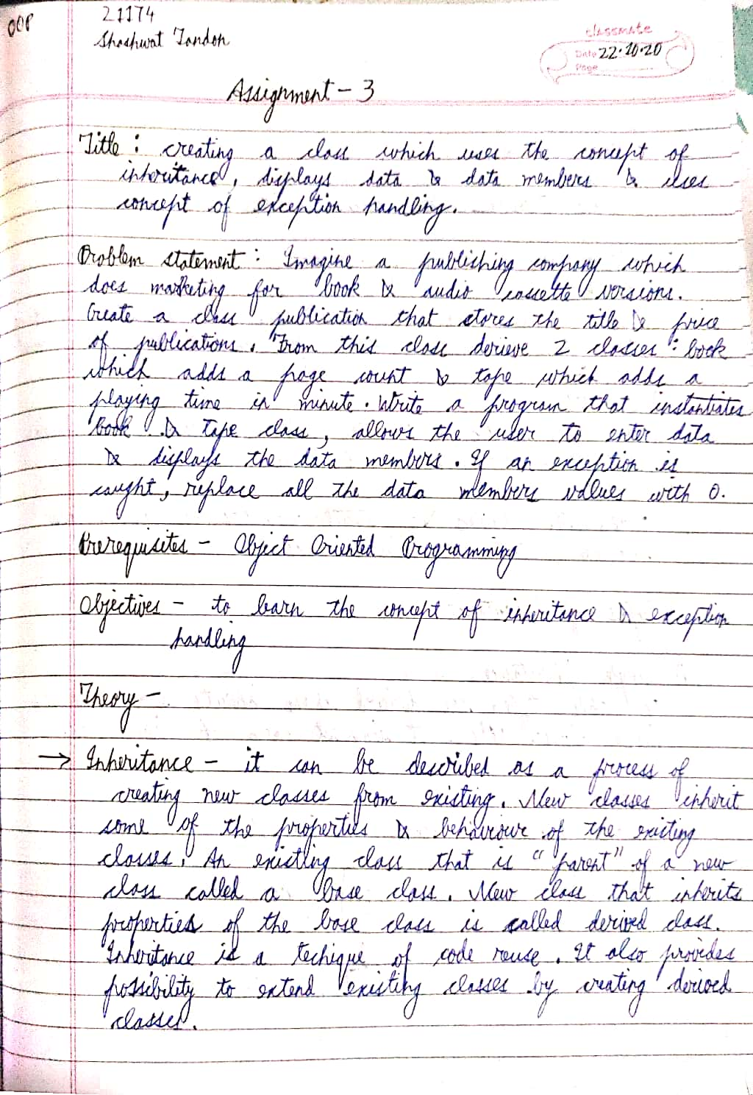

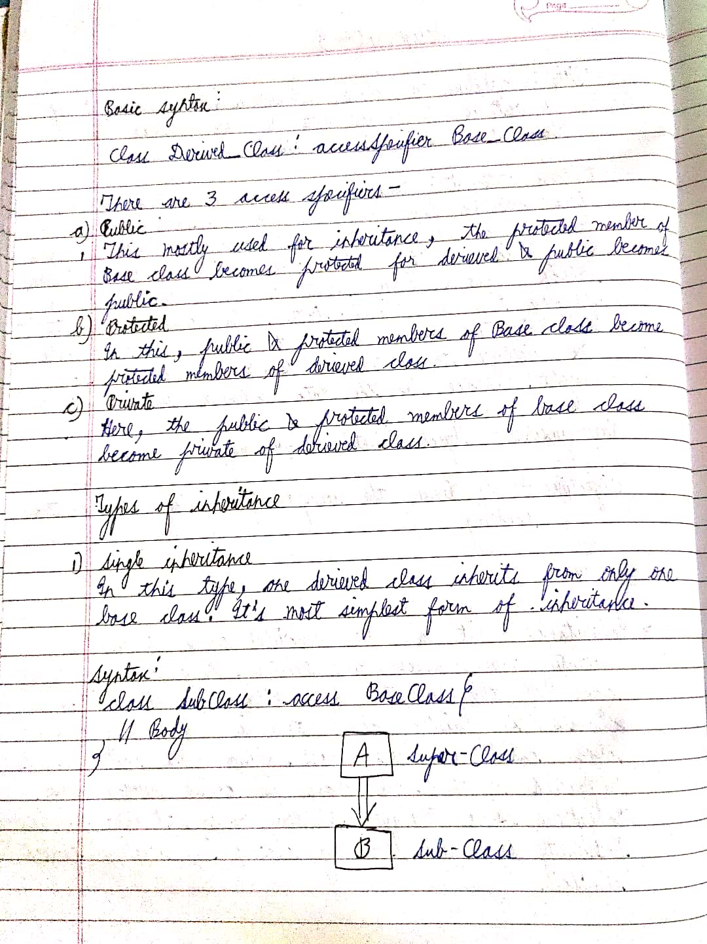

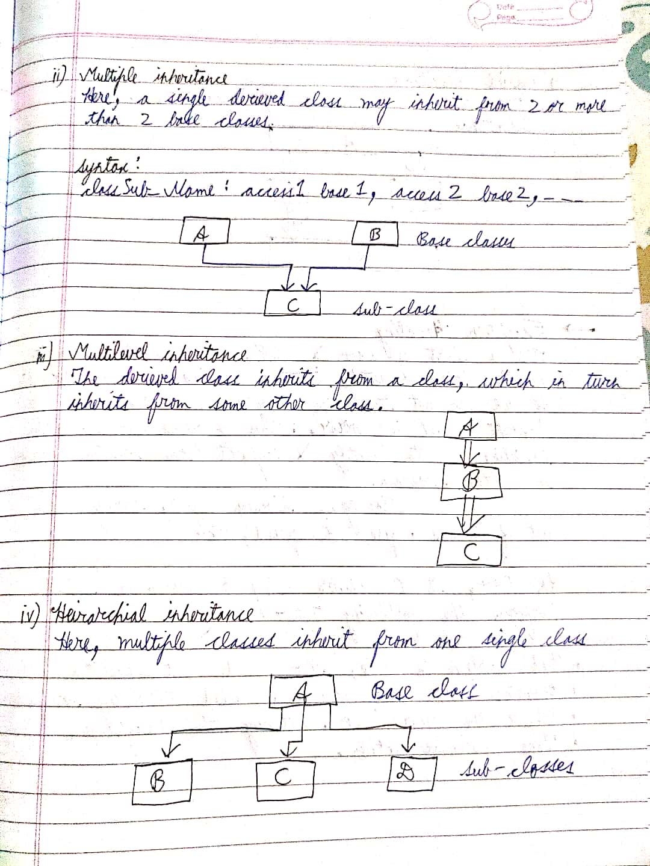

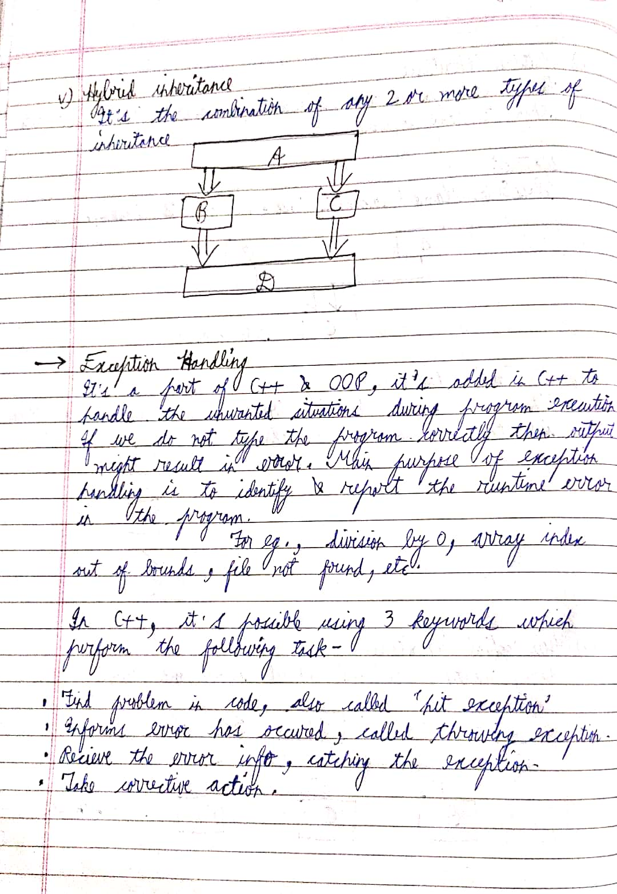

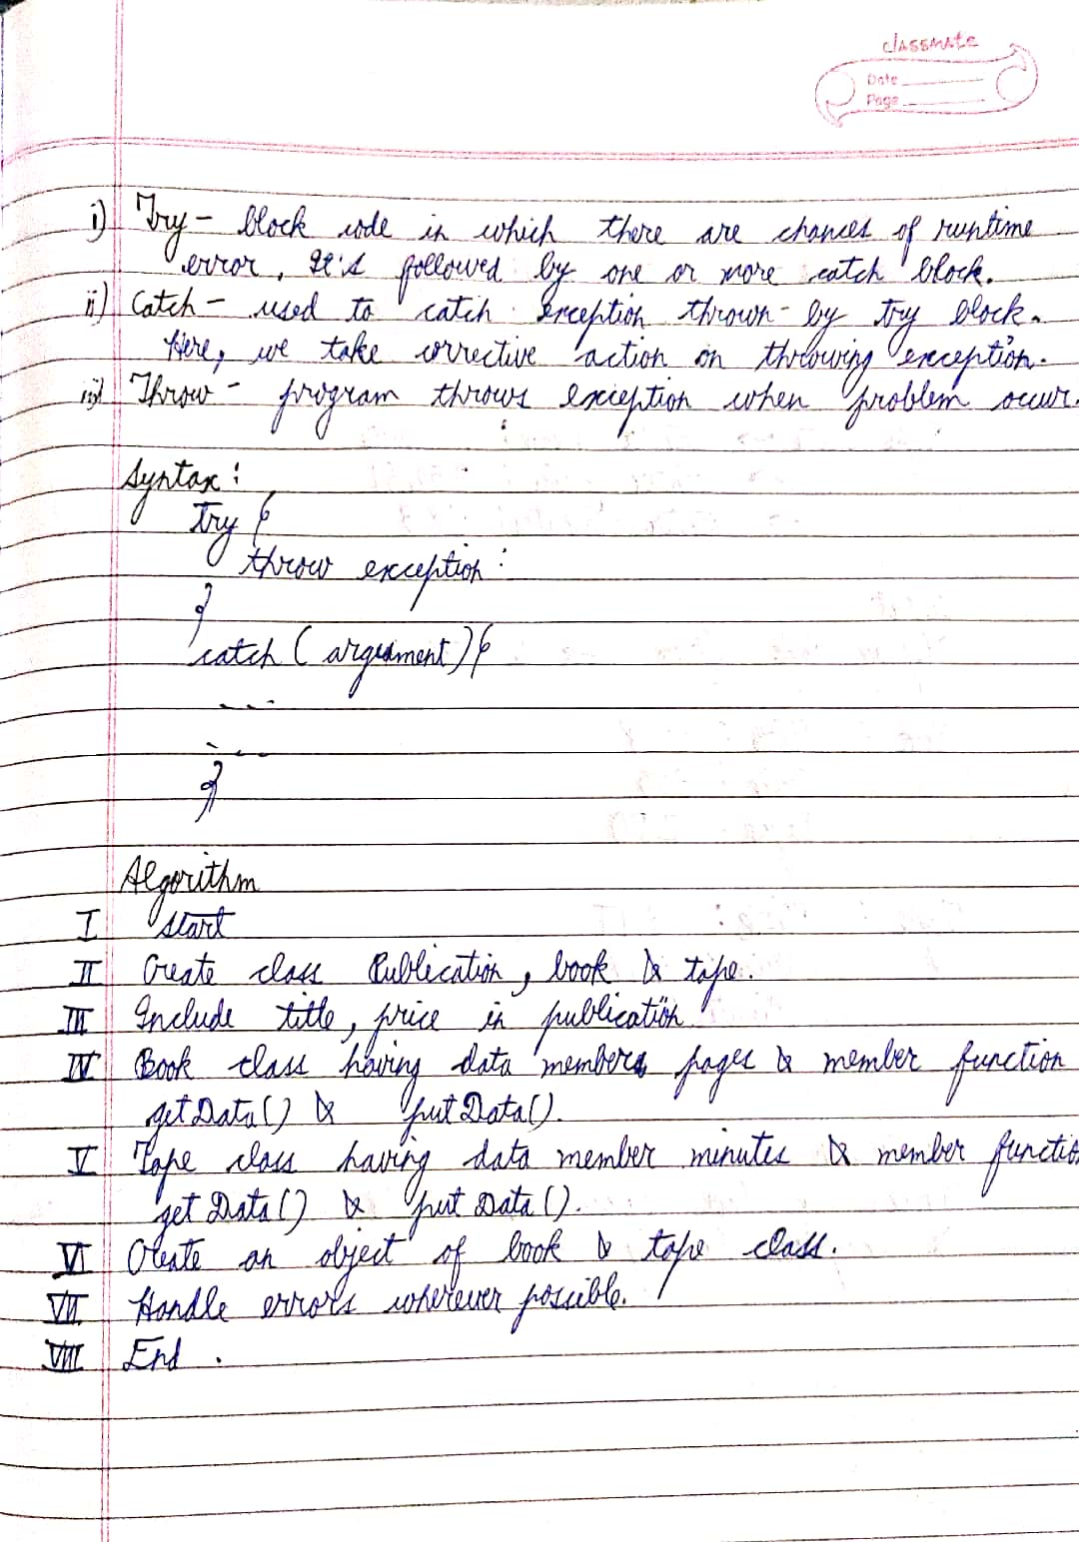

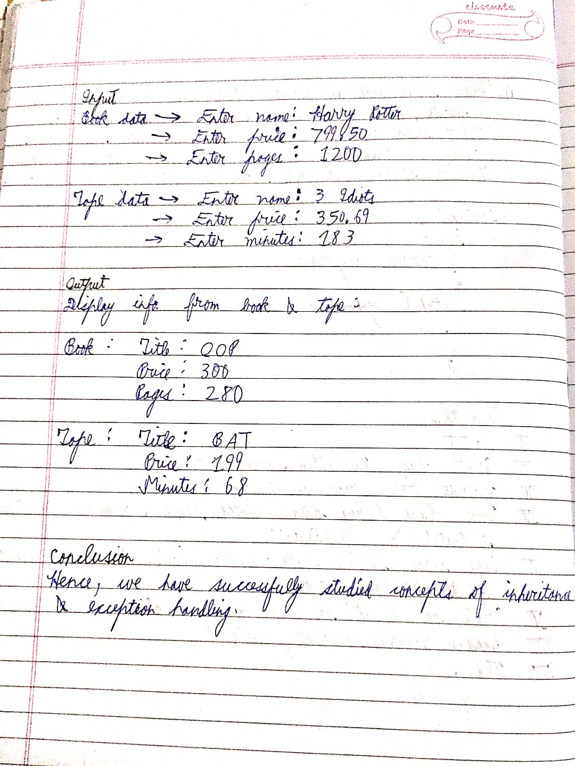

CODE

#include <iostream>

#include <string>

using namespace std;

class Publication{

protected:

string title;

float price;

public:

Publication(){

title = "";

price = 0.0;

}

virtual void GetName(){

cout<<"Enter title: (can't be less than 3) ";

cin.ignore();

cin>>title;

if(title.size() < 3) throw title;

cout<<"Enter price: (can't be less than 10)";

cin>>price;

if(price <= 10.0) throw price;

}

virtual void ShowName(){

cout<<"\*\*\*\*\*\*\*\*\*\*\*\*\*\*\*\*\*\*\*\*\*\*\*"<<endl;

cout<<"Title: "<<title<<endl;

cout<<"Price: "<<price<<endl;

}

~Publication(){

cout<<"Destroy publication"<<endl;

}

};

class BookPublish: public Publication{

private:

int pageCount;

public:

BookPublish(){

pageCount = 0;

}

void GetName(){

Publication::GetName();

cout<<"Enter pages: (can't be less than 20) ";cin>>pageCount;

if(pageCount <= 20) throw pageCount;

}

void ShowName(){

Publication::ShowName();

cout<<"Pages: "<<pageCount<<endl;

//cout<<"\*\*\*\*\*\*\*\*\*\*\*\*\*\*\*\*\*\*\*\*\*\*\*"<<endl;

}

~BookPublish(){

cout<<"Destroy book"<<endl;

}

};

class TapePublish: public Publication{

private:

float playTime;

public:

TapePublish(){

playTime = 0.0;

}

void GetName(){

Publication::GetName();

cout<<"Enter time: (can't be less than 10)";

cin>>playTime;

if(playTime <= 10) throw playTime;

}

void ShowName(){

Publication::ShowName();

cout<<"Time: "<<playTime<<endl;

//cout<<"\*\*\*\*\*\*\*\*\*\*\*\*\*\*\*\*\*\*\*\*\*\*\*"<<endl;

}

~TapePublish(){

cout<<"Destroy tape"<<endl;

}

};

int main()

{

/\*

Publication \*ptrHub[100];

int n=0;

char choice;

do{

cout<<"Book or Tape?(b/t): ";cin>>choice;

if(choice=='b'){

ptrHub[n] = new BookPublish;

ptrHub[n]-> GetName();

}

else {

ptrHub[n] = new TapePublish;

ptrHub[n]->GetName();

}

n++;

cout<<"Enter another item?(y/n): ";cin>>choice;

} while(choice=='y');

for(int i=0;i<n;i++){

ptrHub[i]->ShowName();

cout<<endl;

}\*/

Publication\* ptrArr[10];

int quantity=0;

char choice,repeatChoice= 'y';

while(repeatChoice=='y'){

try{

cout<<"Enter book or tape? (b/t):";

cin>>choice;

if(choice=='b'){

ptrArr[quantity] = new BookPublish;

ptrArr[quantity]->GetName();

}

else{

ptrArr[quantity] = new TapePublish;

ptrArr[quantity]->GetName();

}

quantity++;

cout<<"Enter another item (y/n):";

cin>>repeatChoice;

}

catch(string &title){

cout<<"Title galat hai"<<endl;

}

catch(float &price){

cout<<"Price galat hai"<<endl;

}

catch(int &pages){

cout<<"Pages kam hai re"<<endl;

}

catch(float &timeTape){

cout<<"Time galat hai re"<<endl;

}

catch(...){

cout<<"Kuch toh gadbad hai"<<endl;

}

}

for(int i=0;i<quantity;i++) {

ptrArr[i]->ShowName();

//ptrArr[i] ->~Publication();

delete ptrArr[i];

}

cout<<"\n Byeeeeeee"<<endl;

return 0;

}

Output

Enter book or tape? (b/t):b

Enter title: (can't be less than 3) oop

Enter price: (can't be less than 10)300

Enter pages: (can't be less than 20) 550

Enter another item (y/n):y

Enter book or tape? (b/t):t

Enter title: (can't be less than 3) conda

Enter price: (can't be less than 10)420

Enter time: (can't be less than 10)68

Enter another item (y/n):n

\*\*\*\*\*\*\*\*\*\*\*\*\*\*\*\*\*\*\*\*\*\*\*

Title: oop

Price: 300

Pages: 550

Destroy publication

\*\*\*\*\*\*\*\*\*\*\*\*\*\*\*\*\*\*\*\*\*\*\*

Title: conda

Price: 420

Time: 68

Destroy publication

Byeeeeeee

Process returned 0 (0x0) execution time : 43.076 s

Press any key to continue.