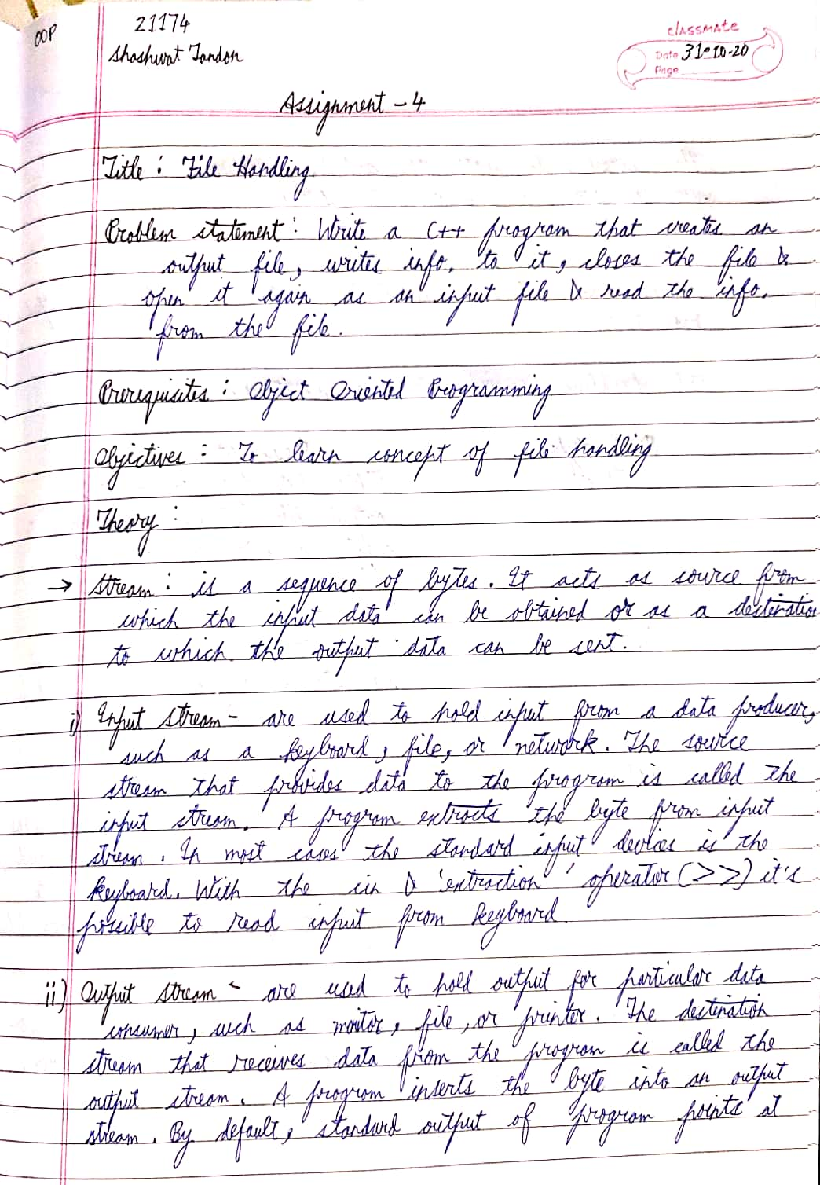

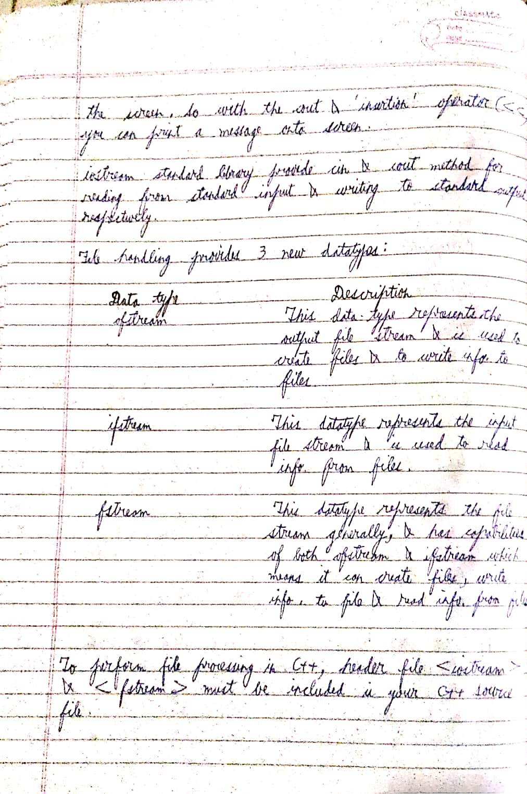

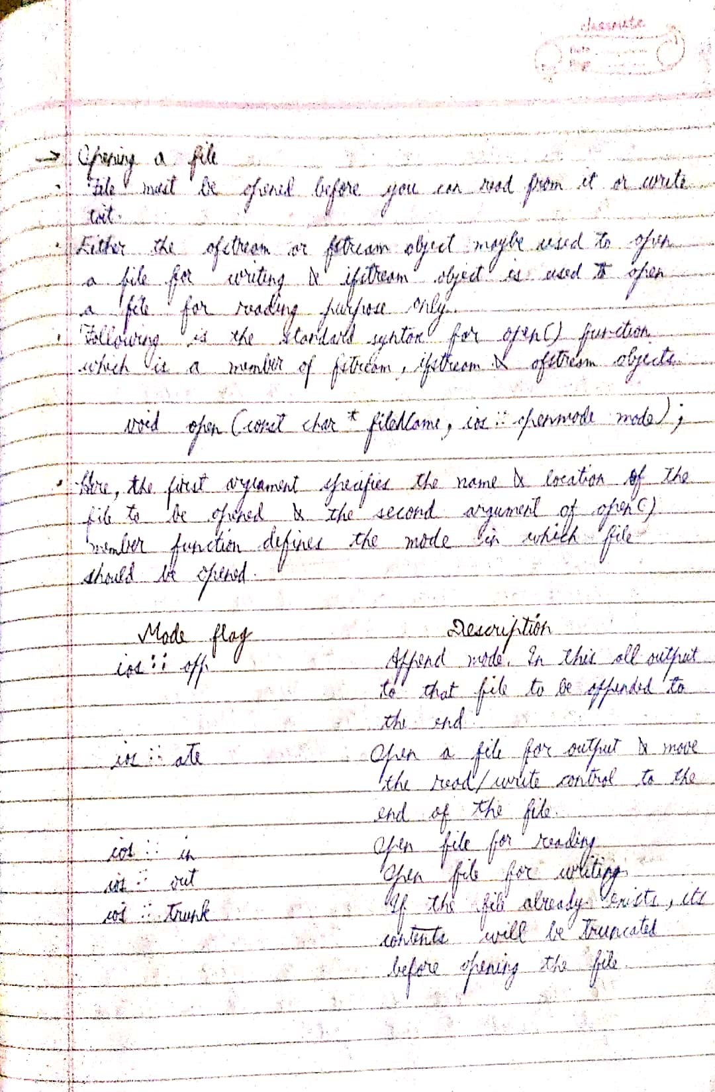

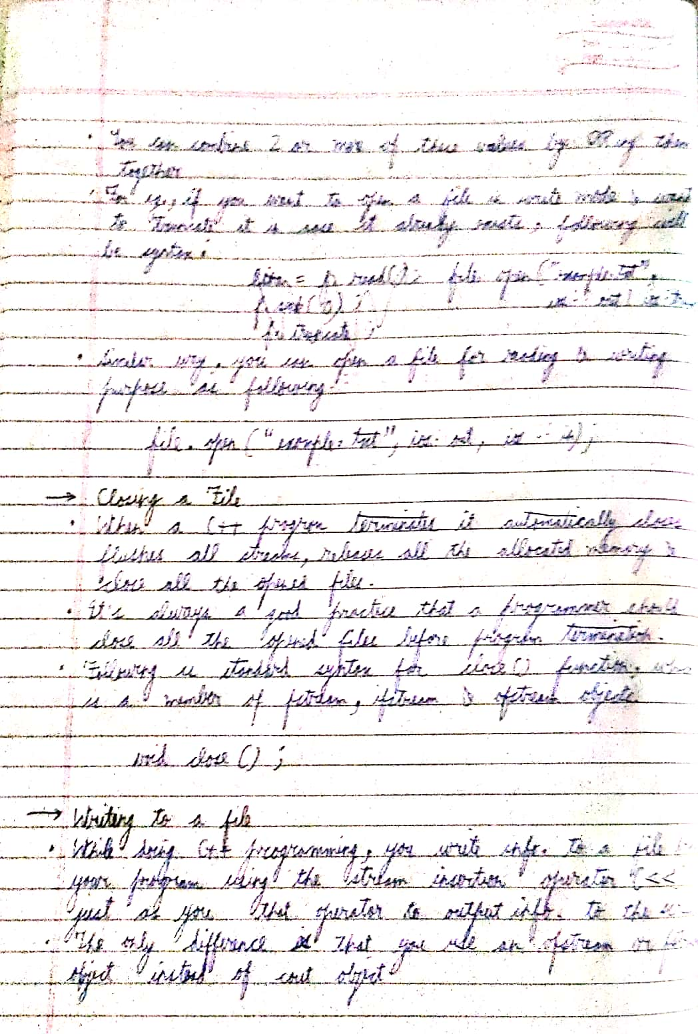

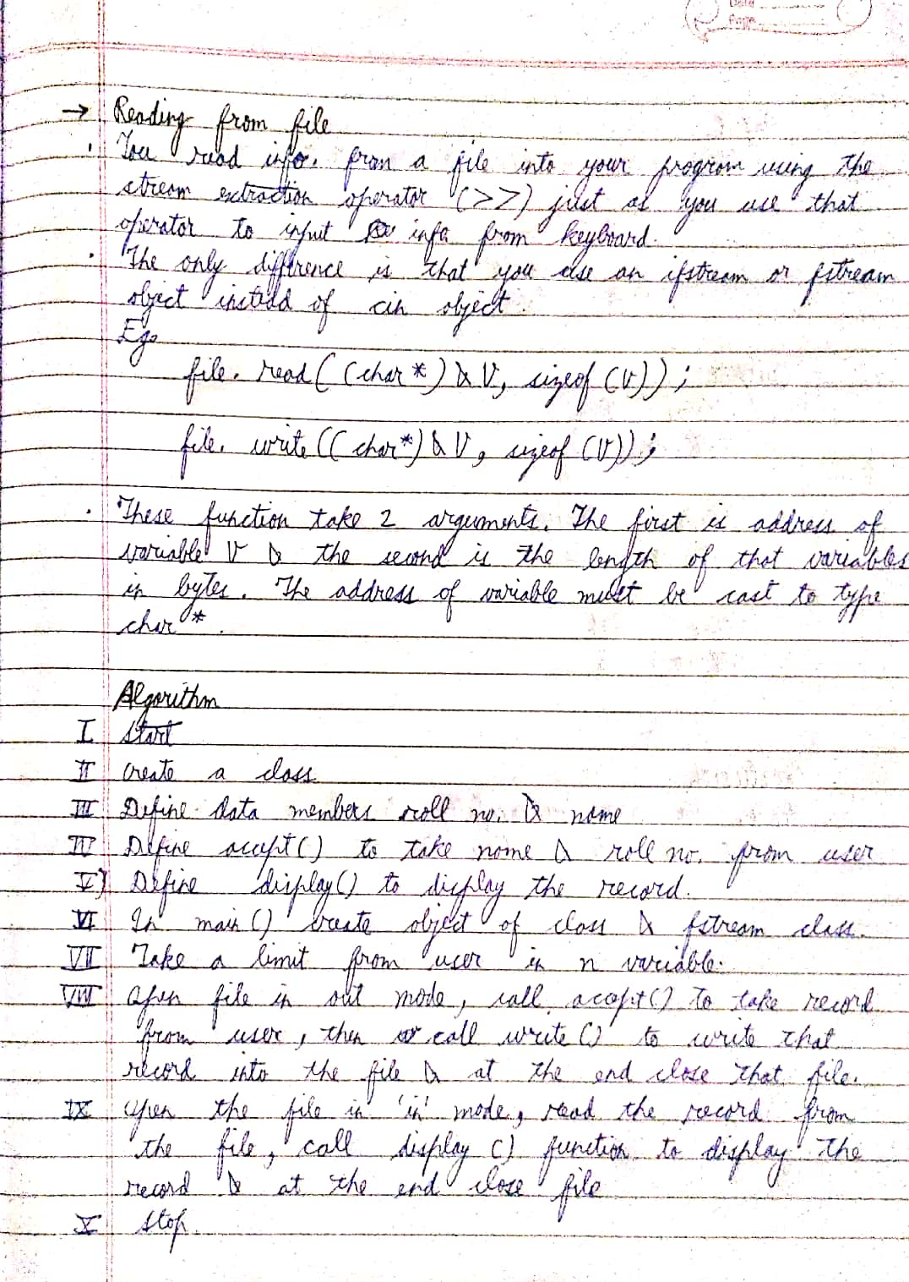

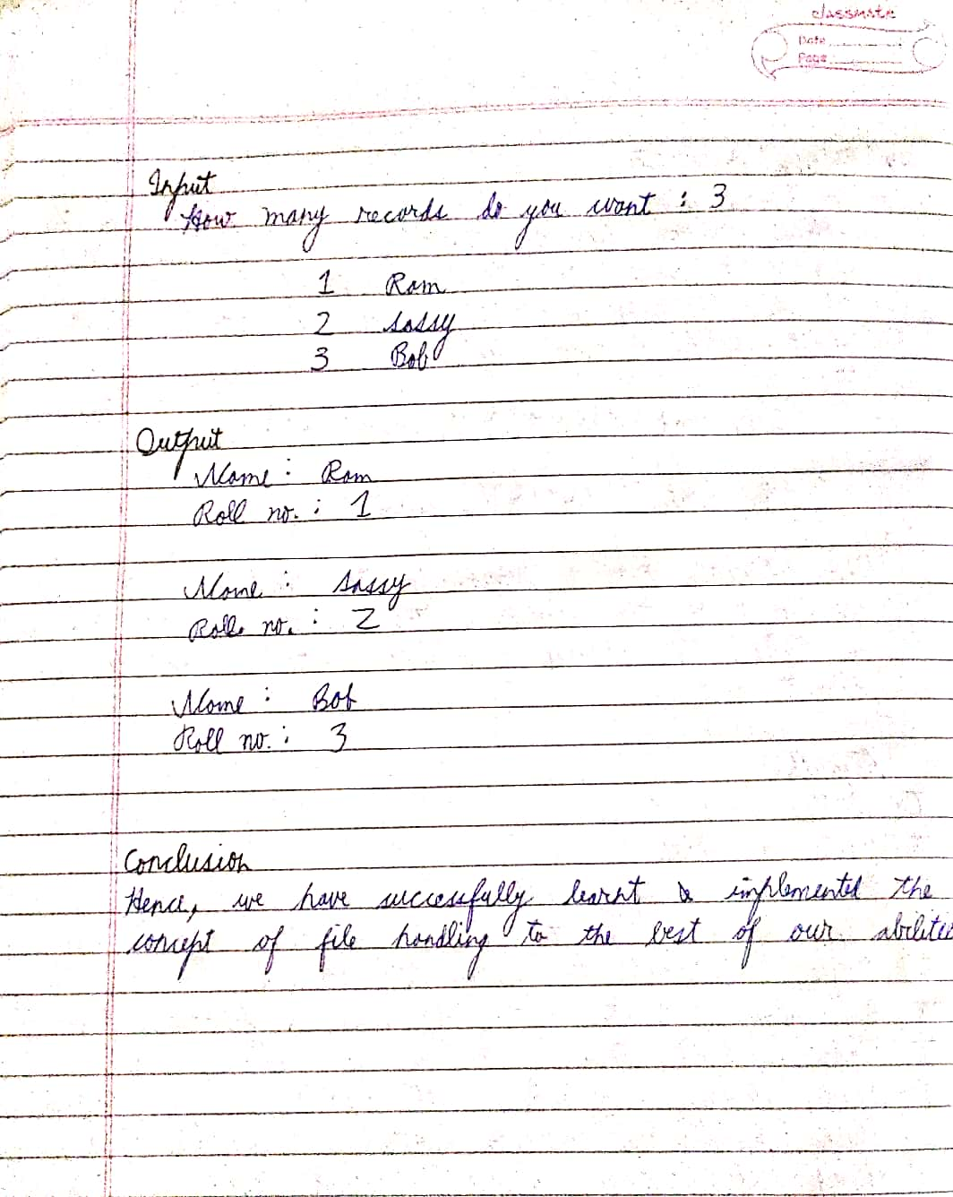

CODE

#include <iostream>

#include <fstream>

using namespace std;

int main()

{

fstream fileHandle;

string pehliLine;

fileHandle.open("example.txt",ios::out); //iske alawa ofstream use karke kar sakte the but koi na

cout<<"File created"<<endl;

cout<<"Write to file"<<endl;

cout<<"Enter data:"<<endl;

fileHandle<<"My name is Shashwat Tandon"<<endl;

fileHandle<<"I study in PICT CS branch"<<endl;

cin>>pehliLine;

fileHandle<<pehliLine<<endl;

fileHandle.close(); //file band kaam khatam

fileHandle.open("example.txt",ios::in);

string str;

cout<<"Read from file"<<endl;

cout<<"File content"<<endl;

while(!fileHandle.eof()){

cin.ignore();

getline(fileHandle,str);

cout<<str;

cout<<""<<endl;

}

fileHandle.close();

return 0;

}

OUTPUT

File created

Write to file

Enter data:

I am 19 years old

Read from file

File content

My name is Shashwat Tandon

I study in PICT CS branch

I am 19 years old

Process returned 0 (0x0) execution time : 10.751 s

Press any key to continue.