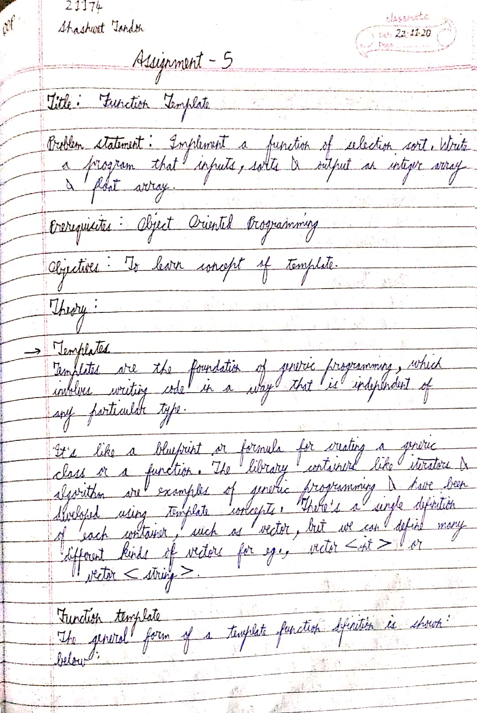

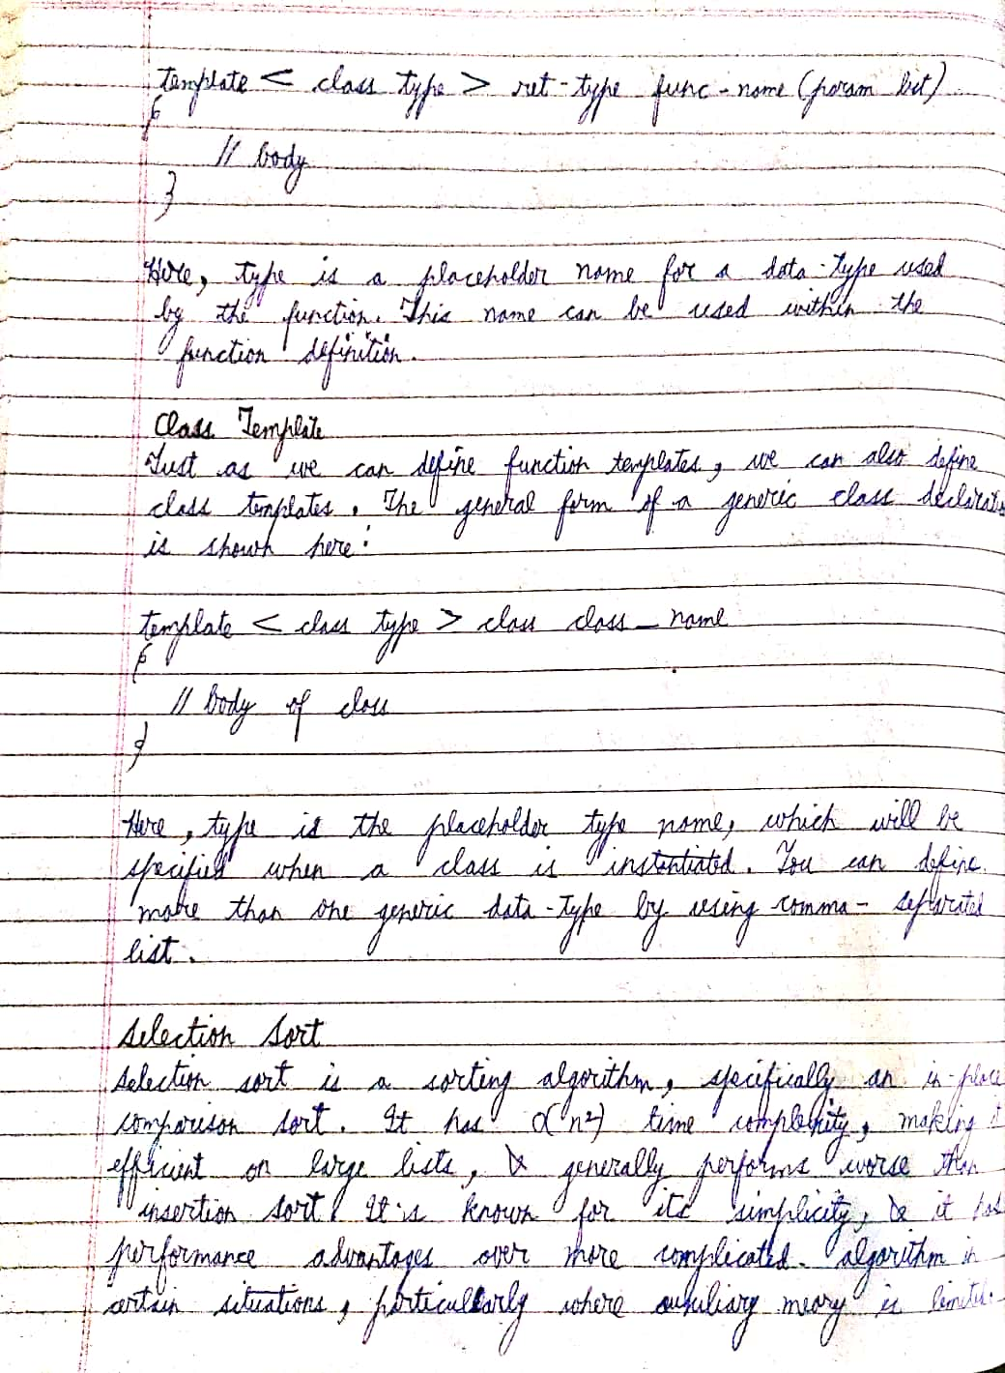

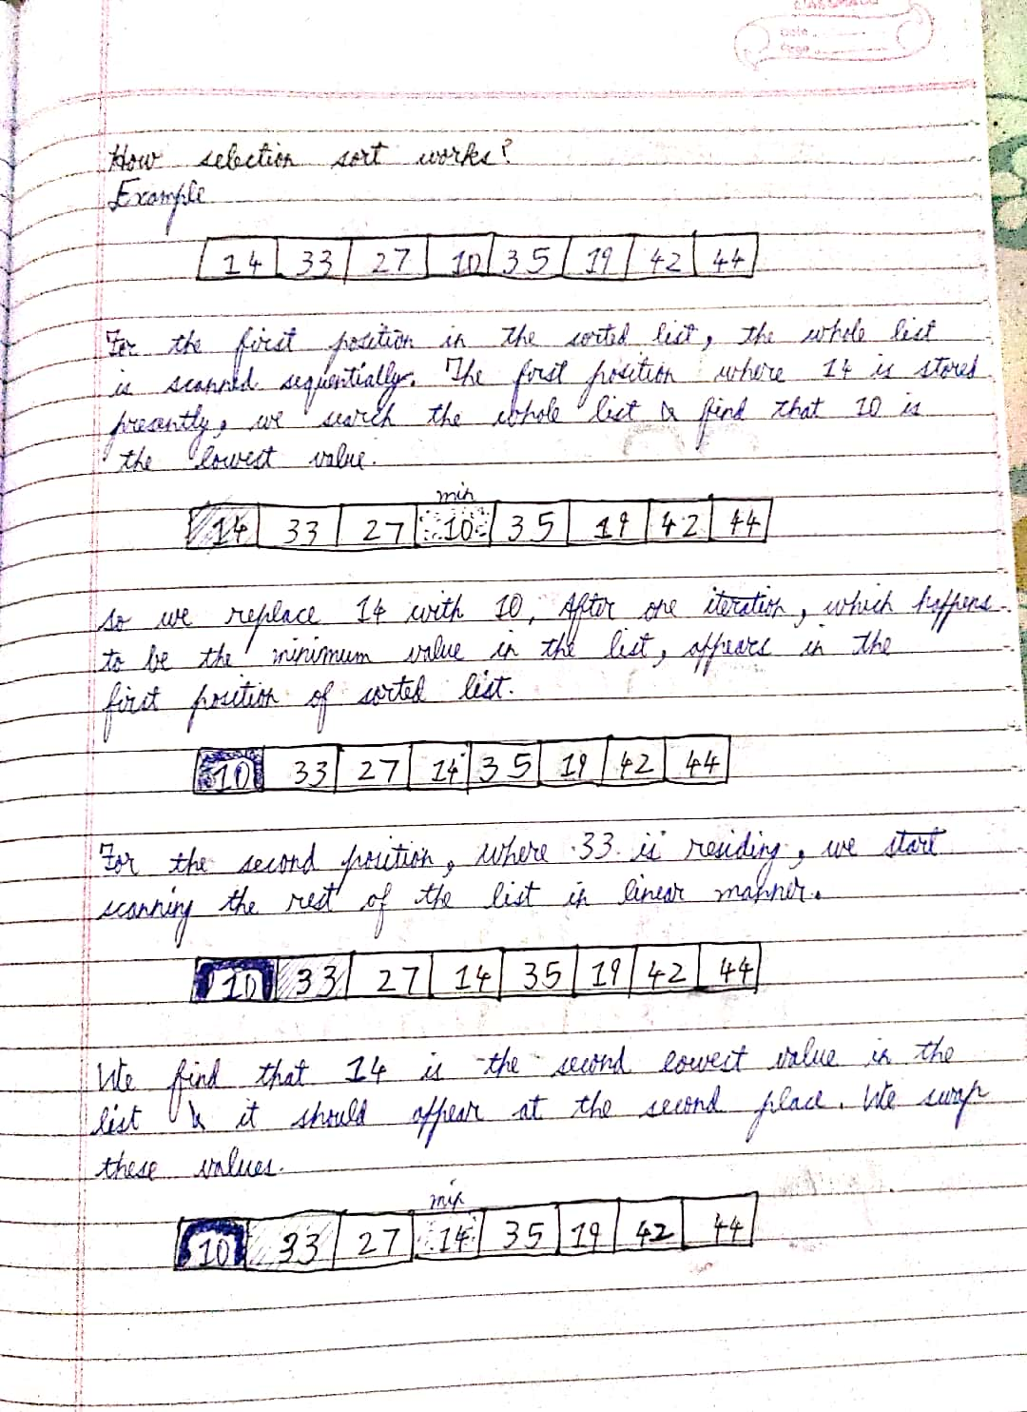

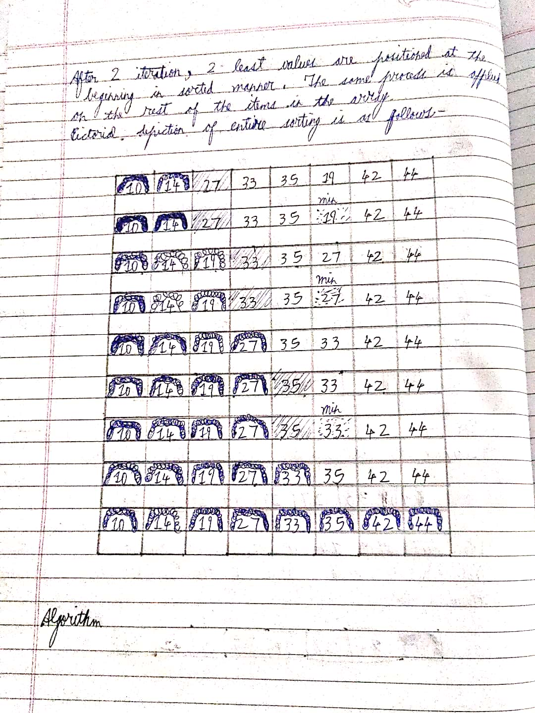

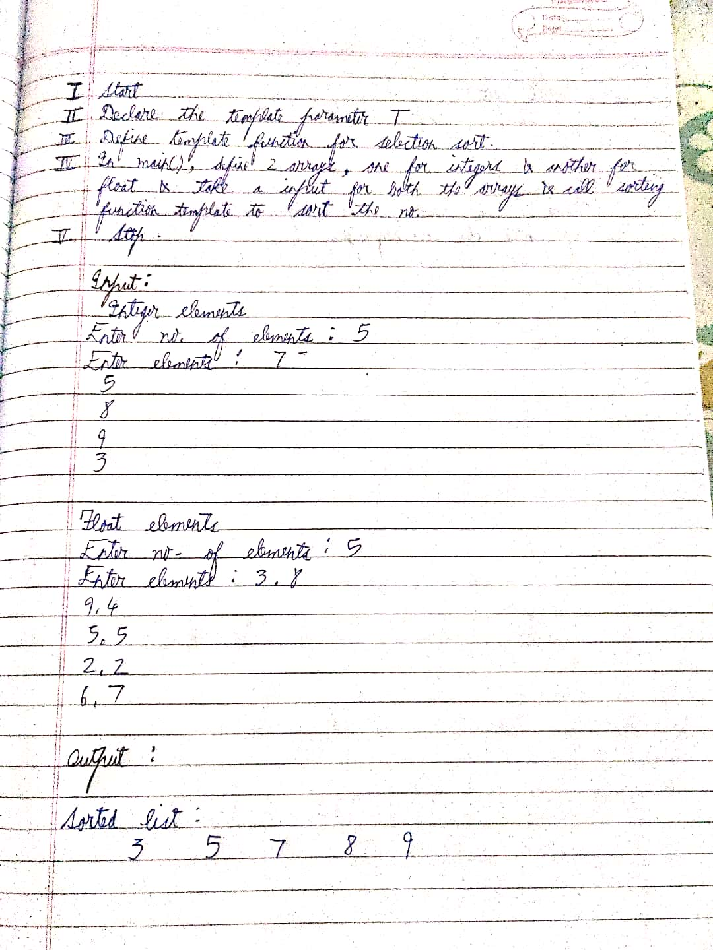

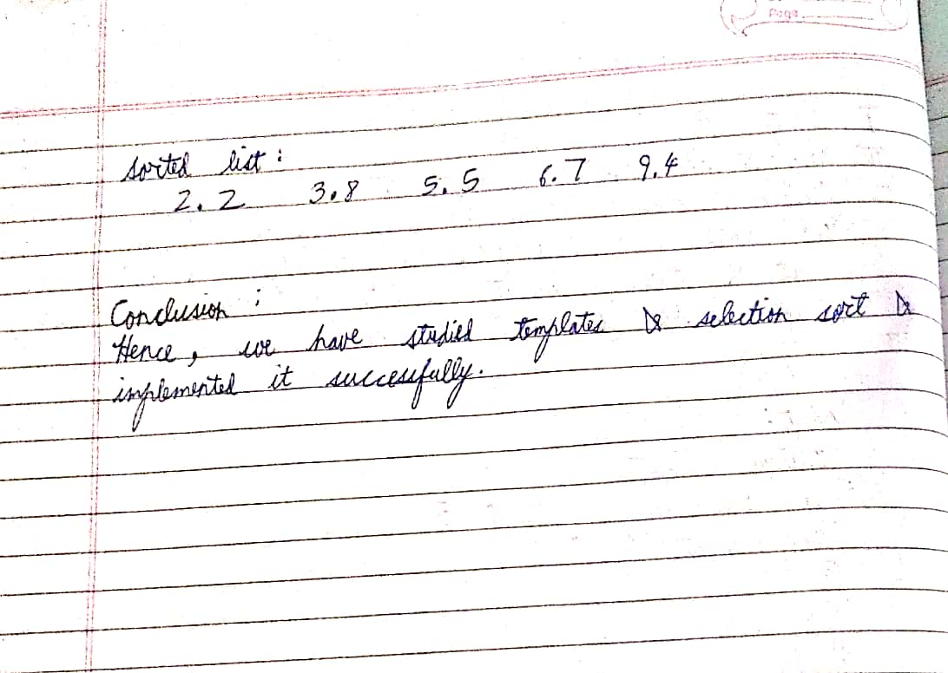

CODE

#include <bits/stdc++.h>

using namespace std;

template<class T>

void Swap(T &a, T &b){

T temp = a;

a = b;

b = temp;

}

template<class T>

void SelectionSort(){

int length;

cout<<"Enter size of array:";

cin>>length;

T arr[length];

for(int i=0;i<length;i++){

cout<<"arr["<<i+1<<"] = ";

cin>>arr[i];

}

int minIndex;

for(int i=0;i<length-1;i++){

minIndex = i;

for(int j=i+1;j<length;j++)

if(arr[j]<arr[minIndex])

minIndex = j;

Swap(arr[i], arr[minIndex]);

}

for(int i=0;i<length;i++)

cout<<arr[i]<<" ";

}

int main()

{

cout<<"Integer sort"<<endl;

SelectionSort<int>();

cout<<"\nFloat sort"<<endl;

SelectionSort<float>();

cout<<"\nChar sort"<<endl;

SelectionSort<char>();

return 0;

}

OUTPUT

Integer sort

Enter size of array:5

arr[1] = 6

arr[2] = 3

arr[3] = 4

arr[4] = 9

arr[5] = 2

2 3 4 6 9

Float sort

Enter size of array:5

arr[1] = 2.6

arr[2] = 8.4

arr[3] = 5.3

arr[4] = 7.1

arr[5] = 9.2

2.6 5.3 7.1 8.4 9.2

Char sort

Enter size of array:3

arr[1] = b

arr[2] = z

arr[3] = a

a b z