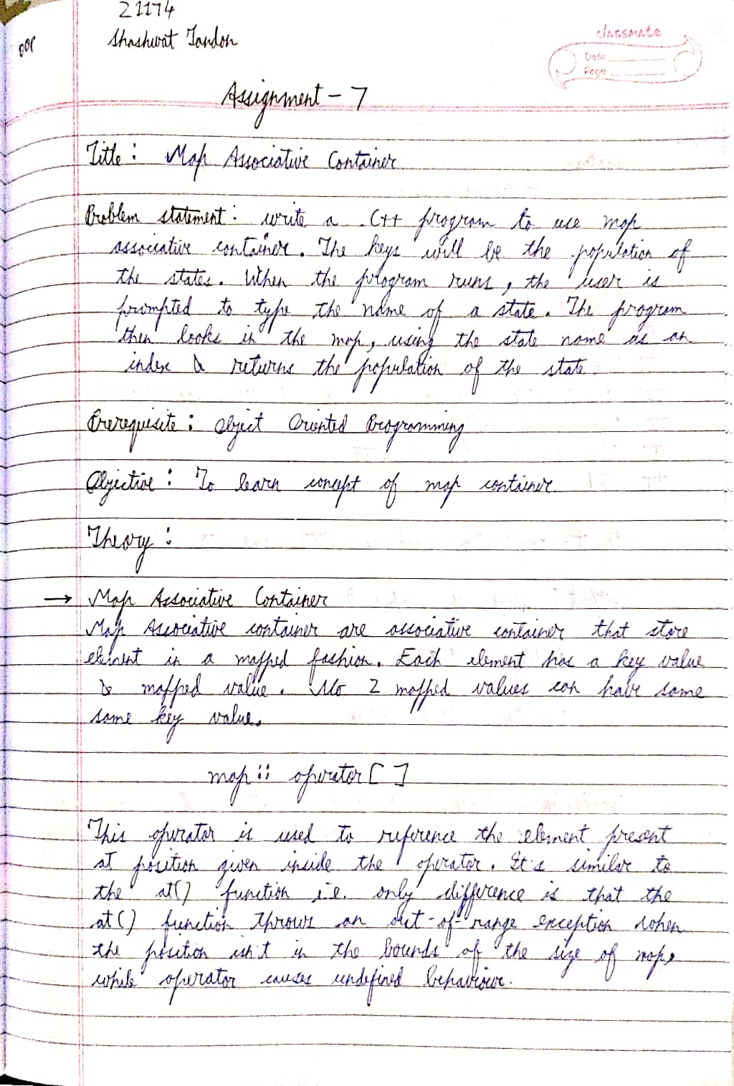

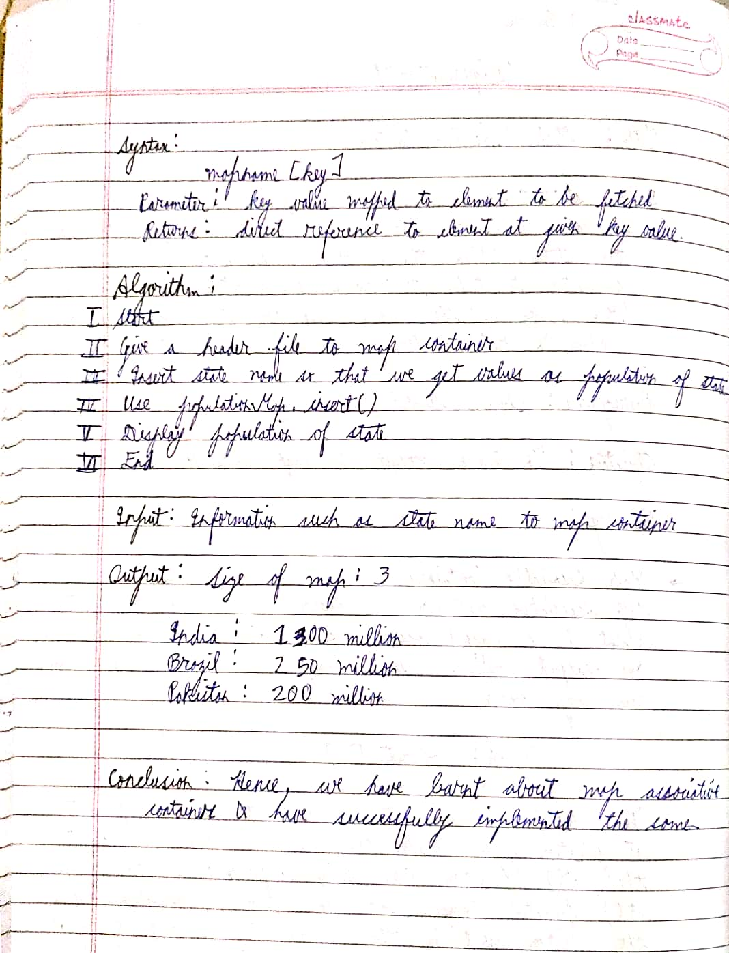

CODE

// Sassy_Don30

#include<bits/stdc++.h>

#define pb push_back

using namespace std;

class Mapper{ // is class me population aur state ke 2 variables honge

int population;

string state;

public:

void GetData(){ // is function me user se input lenge dono datas

cout<<"\nEnter name of state: ";

cin>>state;

cout<<"\nEnter population of state: ";

cin>>population;

}

void DisplayData(vector<Mapper> vec, int len){

map<string, int, less<string>> mapState; // less string usko alphabet ke according sort kar dega apne aap

for(int i=0;i<len;i++) // haar state ko map me dala aur fir usko population di

mapState[vec[i].state] = vec[i].population;

cout<<"\n----------------------------------------";

cout<<"\nState\t\tPopulation";

for(auto const& pair: mapState){

cout<<"\n"<<pair.first<<"\t\t"<<pair.second;

}

cout<<"\n----------------------------------------";

}

void Search(vector<Mapper> vec, int len){

map<string, int, less<string>> mapState; // less string usko alphabet ke according sort kar dega apne aap

for(int i=0;i<len;i++) // haar state ko map me dala aur fir usko population di

mapState[vec[i].state] = vec[i].population;

string findState; // yaha pe state jise dhoondhna hai voh lenge input aur print karenge

cout<<"\nEnter state: ";

cin>>findState;

if(mapState[findState] == 0){ // dictionary in python jaisa hi hai

cout<<"\nState doesn't exist in database!!";

}

else{

cout<<"\nPopulation is: "<<mapState[findState];

}

}

};

int main(){

vector<Mapper> vec;

Mapper obj;

int siz, choice;

do{

cout<<"\nMenu: \n1.Create \n2.Display \n3.Search \n0.Exit";

cout<<"\nEnter choice: ";

cin>>choice;

switch(choice){

case 1:

cout<<"\nEnter number of states: ";

cin>>siz;

for(int i=0;i<siz;i++){ // objects leke vector me dale

obj.GetData();

vec.pb(obj);

}

break;

case 2:

obj.DisplayData(vec, siz);

break;

case 3:

obj.Search(vec, siz);

break;

default:

cout<<"\nEnter appropriate value!!!";

break;

}

} while(choice != 0);

return 0;

}

OUTPUT

Menu:

1.Create

2.Display

3.Search

0.Exit

Enter choice: 1

Enter number of states: 3

Enter name of state: Kerala

Enter population of state: 770000

Enter name of state: Manipur

Enter population of state: 590000

Enter name of state: Assam

Enter population of state: 420000

Menu:

1.Create

2.Display

3.Search

0.Exit

Enter choice: 2

----------------------------------------

State Population

Assam 420000

Kerala 770000

Manipur 590000

----------------------------------------

Menu:

1.Create

2.Display

3.Search

0.Exit

Enter choice: 3

Enter state: Delhi

State doesn't exist in database!!

Menu:

1.Create

2.Display

3.Search

0.Exit

Enter choice: 3

Enter state: Assam

Population is: 420000

Menu:

1.Create

2.Display

3.Search

0.Exit

Enter choice: 0

Enter appropriate value!!!