B - Design Word Count: 80

UI Mockups

Version 1:
Home Page
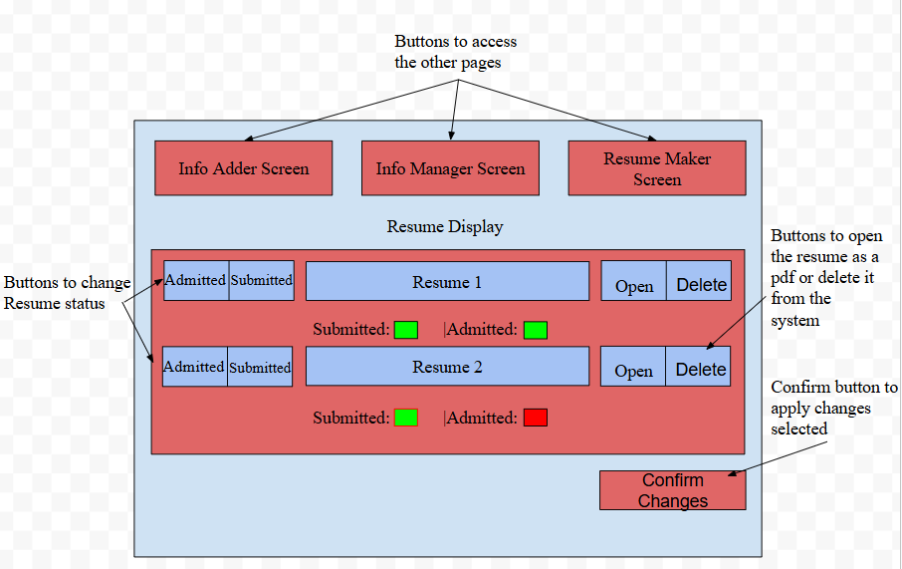

Information Adding Page
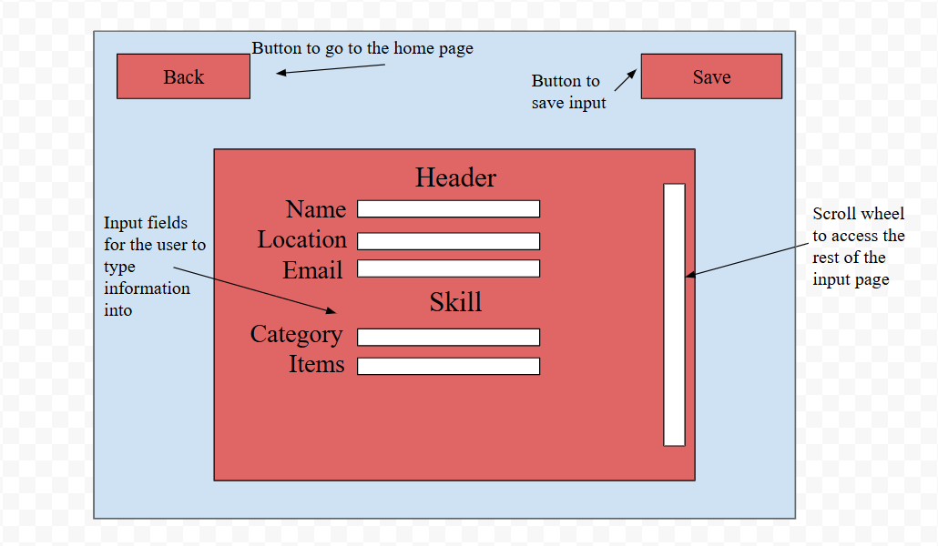

Information Manager Page
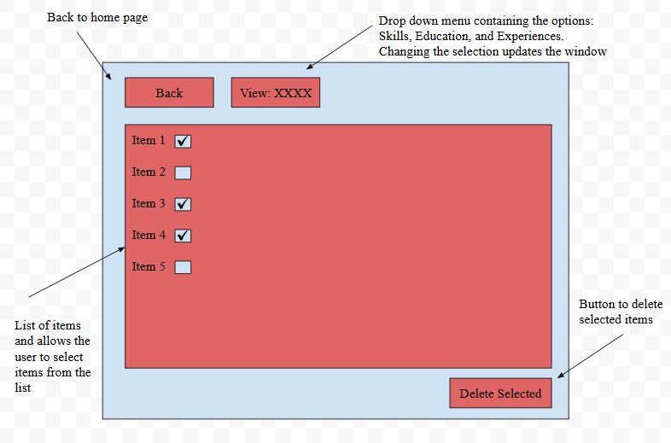
Resume Creation Page: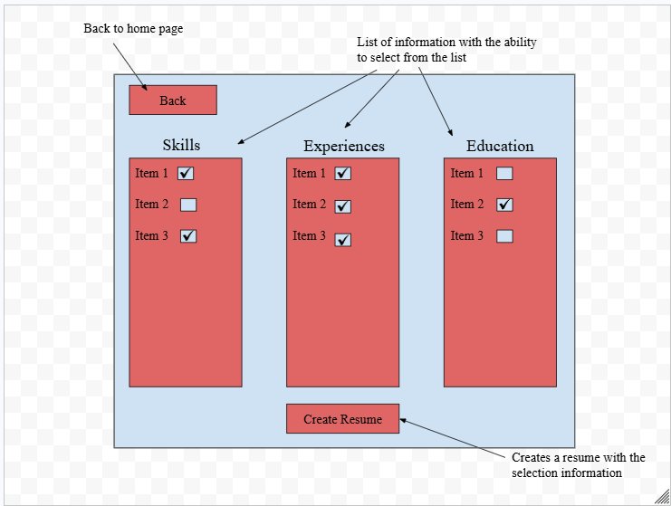

Version 2 (After client feedback):
Pages not displayed again were approved by the client. Pages that were not approved were redesigned using client feedback (see Appendix A) and are displayed below.
Home Page
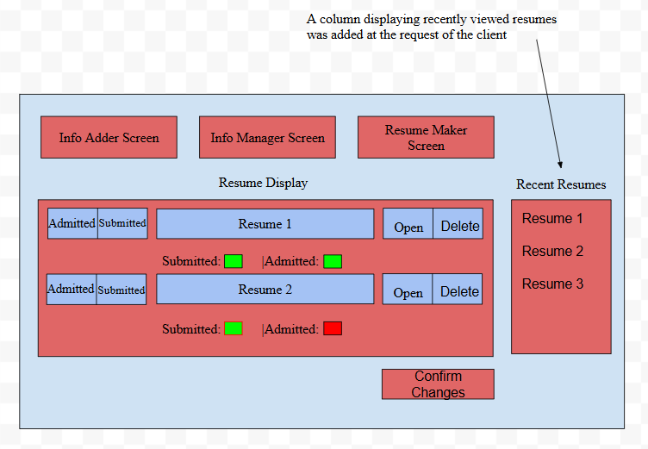

.Information Adding Page
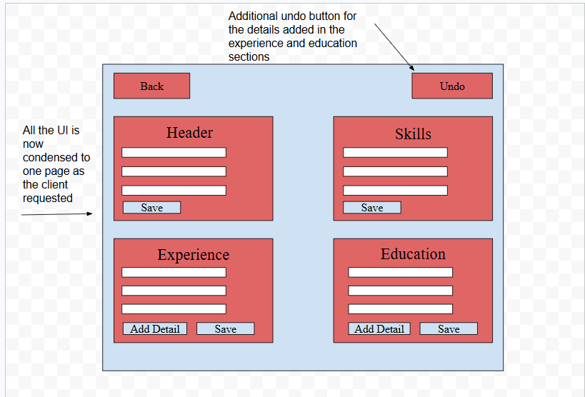

UML Diagram of Non UI classes

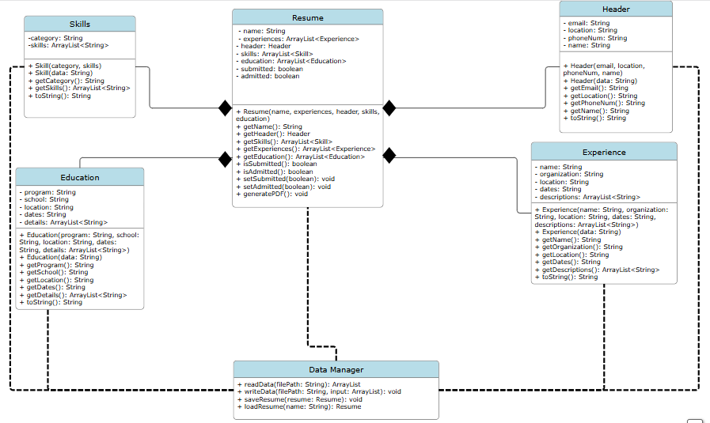
UI Flowchart
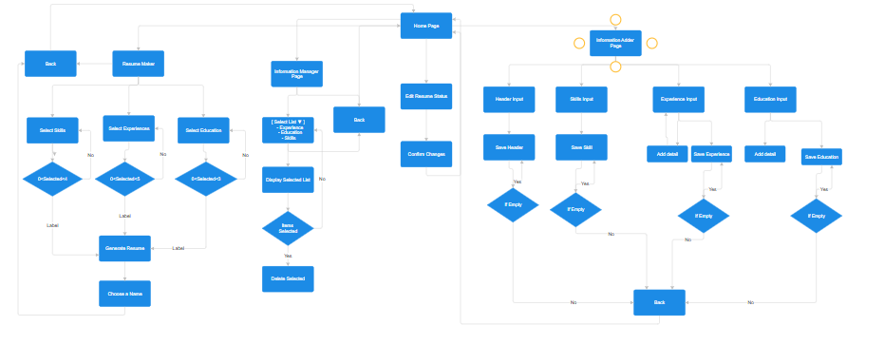
Zooming in on each page
Home Page Functionality
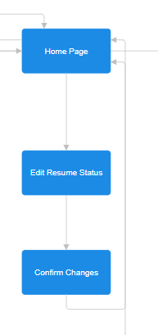
Information Adder
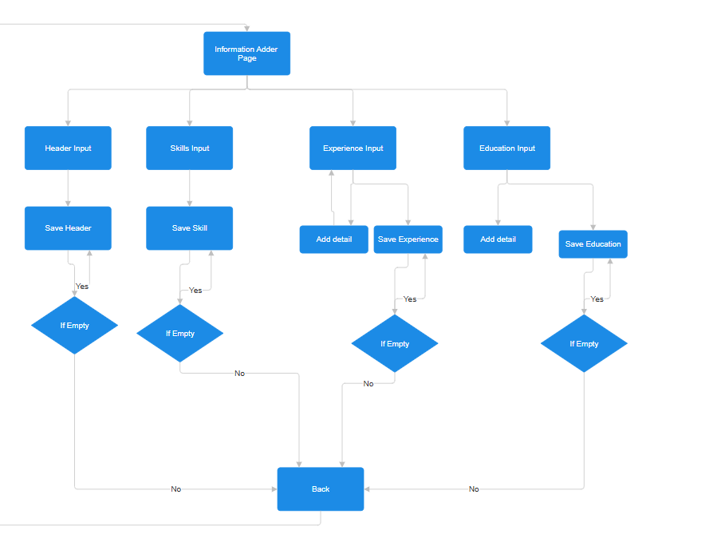
Information Manager
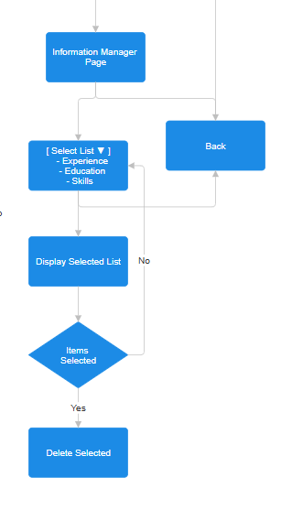
Resume Maker
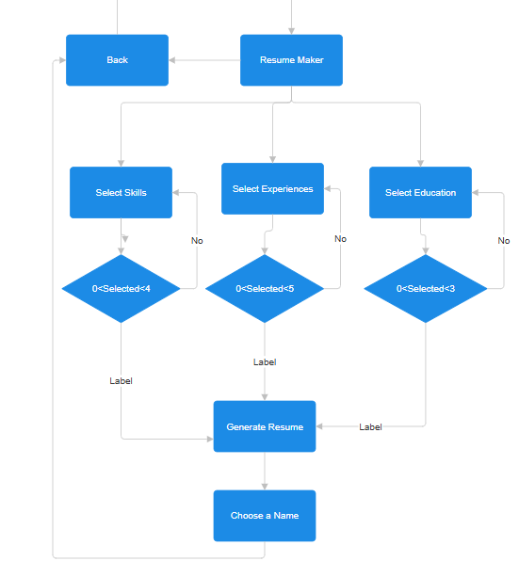
Undo Detail Algorithm
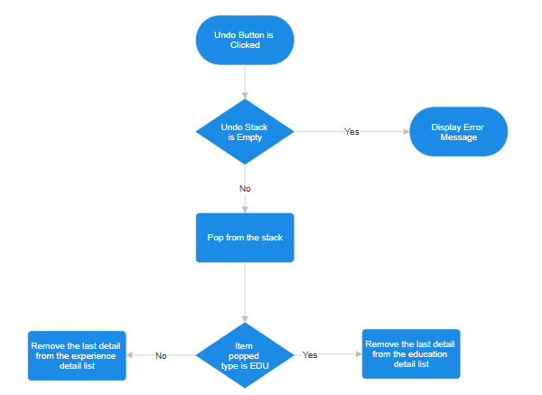
Resume Status Update Algorithm
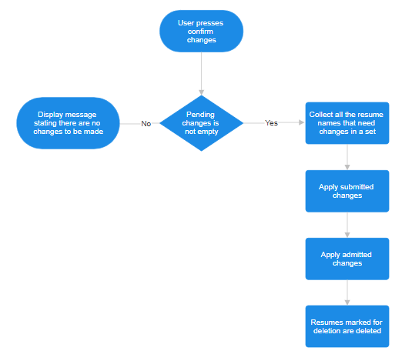

Testing Plan

Success Criterion | Action to be Tested | Testing Method | Expected Result
1 | Saving a new header, skill, experience, and education value. | Go to the info adder page, fill in every field, and press save. Go to the information viewer to view the entry. | Entries are saved and persist after a restart.
1 | Attempting to save each object with an empty field | Go to the info adder page and press the save button without adding anything. | Entries are not saved unless the entry is a skill.
1 | Deleting existing entries of data. | Go to the Info Manager page and attempt to delete the entries that exist. | Entries are deleted and are no longer visible and will not reappear.
1 | Adding experiences and education entries with multiple details | Go to the information adder page and attempt to put multiple details into one entry. Then, view the entry in the information manager page to see if all details were saved. | Entries will be saved with multiple details stored in a list.
2 | Creating a resume with one of each item. | Go to the resume maker page and select one item from each category, then click create resume. | The resume will be properly generated and displayed on the home page.
2 | Creating a resume with no items. | Go to the resume maker and click create resume without selecting any items. | The resume will not be generated, and an error message will appear.
2 | Trying to include too many items in a resume. | Go to the resume maker and try to select more than the maximum amount of items in a category. | Further selections will not be added, and an error message will appear.
3 | Verify that the created resumes show up on the dashboard | After creating a resume in the resume maker page, return to the home screen and verify that it is on the dashboard. | The resume should appear on the homepage, with both submitted and admitted showing up as false for it.
3 | Attempting to delete a resume through the dashboard | Attempt to delete a created resume by selecting it on the home page and confirming its deletion | The resume should be no longer visible and its data no longer stored.
4 | Toggling the submitted and admitted status on a resume | Attempt to change the status of a resume by selecting a status change and confirming it. | The status of the resume should change from either green to red or red to green depending on the starting value.
4 | Confirming multiple actions at once. | Attempt to both change the status and delete a resume at the same time across multiple resumes. | All actions should occur without issue, and deletions should make status changes invalid, but no error message should appear.
5 | Opening an existing resume from the dashboard | Attempt to open a resume from the dashboard as a PDF using the provided button. | The resume should open in the user's main browser as a PDF.
5 | Attempting to open a resume that does not have a PDF saved | Manually delete the PDF from the file system, reopen the app, and attempt to open the resume. | An error message should appear stating that the PDF cannot be opened.
6 | Opening multiple resumes and having them appear under recently viewed. | Open more than one resume on the homepage without closing the application in between, and then verify the recently viewed updates. | Resumes opened should appear in the recently viewed section in chronological order.
6 | Opening more than 5 resumes consecutively. | Open more than 5 unique resumes without closing the application. | Only the 5 most recent resumes should appear in the recently viewed section.
6 | Open the same resume 5 times. | Open the same resume 5 times without closing the application from the homepage. | Only one resume should show in the recently viewed section.
6 | Deleting a resume in the recently viewed section. | Open a resume, then return to the app and delete it. | The resume should be removed from the recently viewed display as well as the homepage.
7 | Attempting to undo a detail added to an education or experience entry. | Go to the information adding page, make a detail entry to both an education and experience entry, undo them, save, and view them in the information viewer page. | The detail added should not appear in the final entry.
7 | Attempting to undo when no actions were done. | Open the information adder page, press the undo button without adding any details. | An error message should appear stating that there is nothing to undo.

