Weather Aggregator API

Project Overview
The Weather Aggregator API is a Flask-based backend service that collects current weather data for multiple cities in Armenia using the Open-Meteo API. The application stores the retrieved data in a PostgreSQL database and automatically removes records older than 30 days.
This project demonstrates how to build a production‑style backend service using Flask, PostgreSQL, SQLAlchemy, and REST APIs.

Technology Stack
- Python
- Flask
- PostgreSQL
- SQLAlchemy
- Open‑Meteo API
- python-dotenv

Project Features
- REST API built with Flask
- Weather aggregation for multiple Armenian cities
- PostgreSQL database integration
- SQLAlchemy ORM
- Automatic database table creation
- Automatic deletion of records older than 30 days
- Health check endpoint
- Environment variable configuration

Project Structure
weather-aggregator/
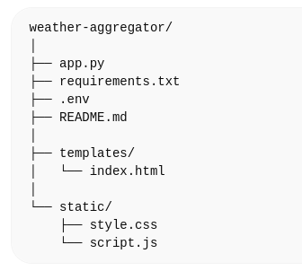

Environment Variables
Create a .env file in the root directory.
Example:
APP_ENV=development
APP_VERSION=1.0

POSTGRES_USER=postgres
POSTGRES_PASSWORD=password
POSTGRES_DB=weather_database
POSTGRES_HOST=localhost
POSTGRES_PORT=5432

Database Setup
Create the PostgreSQL database.
CREATE DATABASE weather_database;

The application automatically creates the required table on startup.

Database Table
weather

id SERIAL PRIMARY KEY
city VARCHAR(50)
temperature FLOAT
wind_speed FLOAT
condition VARCHAR(50)
timestamp TIMESTAMP

requirements.txt
Example dependencies:
Flask
Flask-SQLAlchemy
psycopg2-binary
requests
python-dotenv

Running the Application
Start the Flask server:
flask run
Application will run at:
http://127.0.0.1:5000

API Endpoints

Home
/
Returns the frontend page.

Health Check
/health

Example response:
{
"status": "healthy",
"version": "1.0"
}

Get Weather For All Cities
/api/v1/all-weather

Fetches weather for all configured cities and stores the results in the database.

curl example
curl http://127.0.0.1:5000/api/v1/all-weather

Get Weather For One City
/api/v1/weather/<city>

Example:
/api/v1/weather/yerevan

curl example
curl http://127.0.0.1:5000/api/v1/weather/yerevan

Example API Response
[
{
"city": "Yerevan",
"temperature": 18.4,
"wind_speed": 12.1,
"condition": "Mild"
}
]

Automatic Data Cleanup
Weather records older than 30 days are automatically deleted.
Cleanup runs:
- On application startup
- After new weather data is fetched

Supported Cities
The system aggregates weather data for several Armenian cities including:
- Yerevan
- Gyumri
- Vanadzor
- Dilijan
- Hrazdan
- Abovyan
- Kapan
- Goris
- Sevan
- Ijevan
- Armavir
- Artashat
- Sisian

Database Schema Diagram
+-------------------+
| weather |
+-------------------+
| id (PK) |
| city |
| temperature |
| wind_speed |
| condition |
| timestamp |
+-------------------+

Screenshots
You can add screenshots of:
- PostgreSQL table data
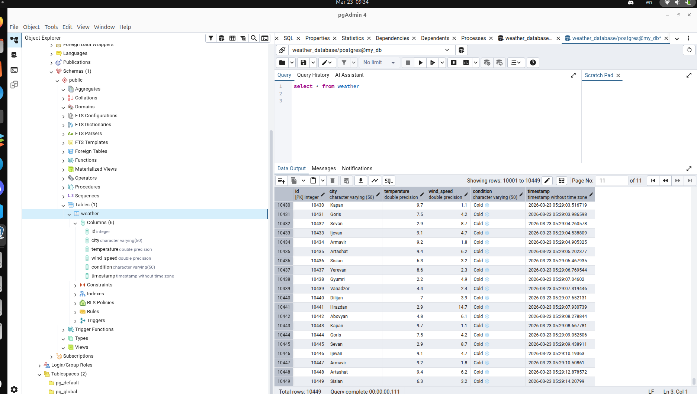
- Frontend page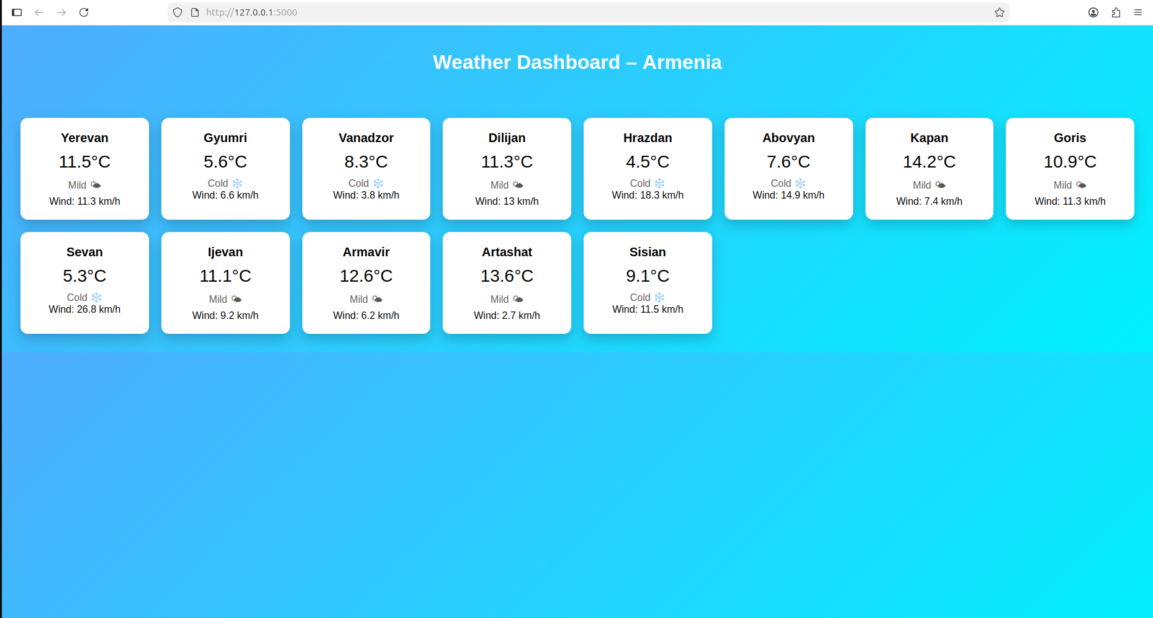

Future Improvements
Possible enhancements:
- Weather history endpoint
- Scheduled background weather updates
- Frontend dashboard with charts
- API rate limiting
- Authentication
- Production deployment with Gunicorn

