Basics of Multimedia System ELE888

W2020

**Ling Guan**

3

Multilayer Neural Networks

Mar. 27th, 2020

Mar. 27th, 2020

3

Kim Sasung 500642700 3

Paul

## Dominic



500636052 3

# XOR Problem

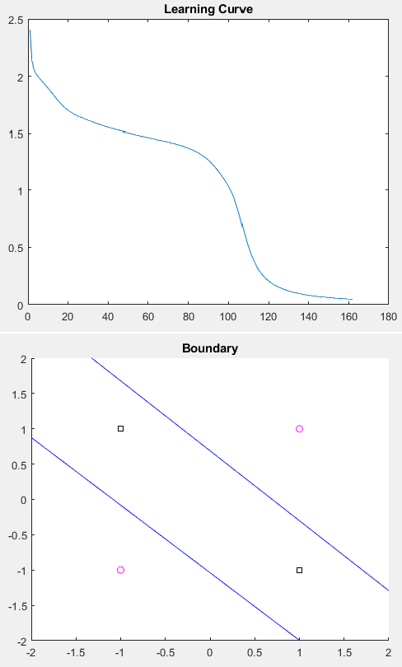

For paul: verify that the computed final weight vectors satisfy the XOR problem.

# ‘Wine’ Data Set

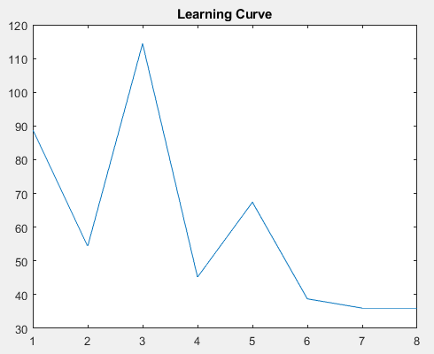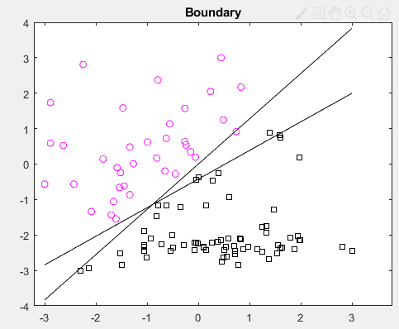

### Observation & Discussion

blablabla

### Conclusion

blablabla