BCSE302P – Database Systems Lab
D2 Slot – L11+L12

BlueLedger
Community Mangrove Reforestation & Carbon-Credit Ledger

Project Proposal & Database Design Document

Course | BCSE302P – Database Systems Lab
Submission | 1 - Project Proposal & Database Design Document
Submission Date | 29 September 2026
Project | BlueLedger — mobile application for mangrove reforestation tracking
Student Names | Saswat Balyan 24BCE0591  Rudra Pratap 24BCE0415  Aryan Singh 24BCE0418

1. Project Title
BlueLedger: A Relational Database System for Verified Mangrove Reforestation Tracking and Carbon-Credit Accounting

BlueLedger is an offline-first mobile application that lets field users record mangrove-planting plots and automatically computes carbon credits for them. This document proposes adapting its ad-hoc local storage into a proper relational database so the same real-world workflow gains referential integrity, auditable transactions, and queryable history.

2. Introduction and Background
Mangrove forests are among the most effective natural carbon sinks, and community-driven reforestation programs increasingly rely on digital tools to record planting activity and convert verified effort into tradable carbon credits. BlueLedger is a mobile application built for exactly this purpose: field users log in, record a planting plot (GPS location, species, area in hectares, photo evidence), and the app computes a carbon-credit amount using a species-specific per-hectare rate with area-based bonus multipliers.
The application already implements a working mobile interface (splash, onboarding, login/signup, a four-tab home screen – Dashboard, Upload, Wallet, Profile), device GPS capture, an image picker for plot evidence, and a deterministic carbon-credit formula. However, it has no real database: all data is serialized into unstructured text and held in the device's local application storage. This document treats that gap as the starting point for the required database design work.

3. Problem Statement
Community reforestation programs need a trustworthy, auditable record of who planted what, where, and how many carbon credits that effort is worth. In the current BlueLedger implementation this record is fragile by construction:
- No relational structure. The application currently keeps the entire list of planting projects as one block of unstructured text, and the current user's details as another single block. There is no per-record identity the storage understands, no foreign keys, and no way to query a subset of records without loading everything into memory first.
- Unsafe concurrent writes. Adding a new plot means reading the whole project list, appending one entry in memory, and writing the whole list back. Two near-simultaneous submissions can race and silently overwrite each other — there is no transactional guarantee.
- Business rules hidden in code, not data. The species-to-carbon-rate mapping (Rhizophora = 14, Avicennia = 12, Bruguiera = 10 credits/hectare) is hardcoded into the app's logic rather than stored as data. Adding a species or correcting a rate requires a new app release, and there is no historical record of which rate was in effect when a given credit was minted.
- No audit trail for credits. The minted-credit amount is baked directly into each project record at upload time. There is no separate ledger of mint/redeem events, so a future credit-redemption feature cannot be implemented safely.
- Single-user, unauthenticated storage. Login/signup currently accepts any non-empty credentials and stores exactly one user record per device — there is no user table, no password verification, and no way for a plot to be attributed to a specific verified contributor.
A structured database directly addresses each of these problems: it gives every plot, user, species rate, and credit event a durable, constrained, queryable identity, and lets the minting rule live as data rather than as compiled logic.

4. Objectives
- Replace the current unstructured, single-block storage of user and project data with a normalized relational schema (five tables) accessed through a proper embedded database, without changing the app's existing screens, navigation, or carbon-credit formula.
- Enforce referential integrity with primary/foreign-key constraints so no Project can reference a non-existent User or Species, and no CreditTransaction can reference a non-existent Project.
- Externalize the species-to-credit-rate mapping (currently hardcoded into the app's logic) into a queryable Species reference table.
- Introduce an append-only CreditTransaction ledger so minted and (future) redeemed credits form an auditable history, independent of the current wallet balance shown on screen.
- Support indexed, filterable queries (by user, species, status, date range) so the Dashboard and Wallet screens no longer need to load the entire upload history into memory on every screen open.
- Document the schema to at least Third Normal Form (3NF) with a concrete example drawn from this project's own data (the species-rate transitive dependency).

5. Scope of the Project
Category | Items
Already implemented  (existing application, unchanged) | Mobile UI: splash, onboarding, login/signup, Dashboard/Upload/Wallet/Profile screens · in-app navigation · GPS capture for plot location · image picker for plot photos · the carbon-credit calculation formula (species rate × hectares × area bonus) · saved “remember me” and language preference
Included in this proposal  (database-design scope) | Relational schema for User, Community, Species, Project and CreditTransaction · a proper database layer replacing the current unstructured local storage · CRUD operations backed by SQL · aggregate queries for Dashboard/Wallet totals · project verification status field
Existing features that the new schema must not break | The species-selection dropdown on the Upload screen, the bonus-multiplier rule (≥10 ha → 1.2×, ≥5 ha → 1.1×), and the wallet-summary figures shown on the Wallet screen
Excluded from current scope | Cloud/server backend and network sync · blockchain-based credit minting · real payment or credit-redemption processing · a dedicated admin/verifier screen (the schema reserves a status field for this, but building the review screen is future work) · multi-device data synchronization

6. Requirement Analysis

6.1 Functional Requirements

User roles
- Registered Contributor (implemented today as a mock login): creates an account, submits planting projects, views their own dashboard and wallet.
- Verifier / Admin (proposed, enabled by a status field on each project but out of scope to build a screen for in this phase): would approve or reject submitted projects before credits are minted.

Data to be stored
- User accounts (email, username, phone, credentials, optional community membership)
- Communities/cooperatives enrolled in the program
- Reference data for mangrove species and their carbon-credit rate per hectare
- Planting projects (plot id, species, hectares, GPS coordinates, photo evidence, verification status)
- An append-only ledger of credit-minting and credit-redemption events

CRUD operations required
Entity | Create | Read | Update | Delete
User | Sign up | Login / profile view | Edit profile | Not exposed (retain audit trail)
Community | Program admin enrolls a community | Dashboard “total communities” stat | Update region/name | Rare / admin-only
Species | Seed reference rows | Populate species dropdown | Adjust credit rate | Not exposed (rates are historical)
Project | Upload screen → new plot | Dashboard / Wallet history | Edit before verification | Delete a draft/pending project
CreditTransaction | System-generated on mint / redeem | Wallet ledger view | Immutable (append-only) | Never deleted (audit requirement)

Data retrieval, filtering, relationships and reporting
- Filter a user's projects by species, verification status, or date range.
- Sort a user's credit-transaction history chronologically (Wallet screen).
- Look up a project's species rate at the time it was planted via the Species reference table, rather than recomputing it from constants buried in application logic.
- Insert a Project and its initial MINT CreditTransaction as a single atomic transaction so credits can never exist without a backing project.
- Aggregate totals: SUM(credit_amount) per user (wallet balance), SUM(hectares) per user or per species, COUNT(projects) per community, for the Dashboard's headline metrics.

6.2 Non-Functional Requirements
Quality | Requirement, tied to an observed gap in the current system
Performance | Indexed foreign keys give fast, targeted lookups for wallet/dashboard queries, replacing the current approach of loading the entire upload history into memory on every screen open.
Data integrity | NOT NULL, CHECK and foreign-key constraints replace today's unchecked fields — e.g. nothing currently stops a negative hectares value or an arbitrary species name from being stored.
Security | A password-hash column and real credential verification replace the current mock login, which accepts any non-empty password.
Scalability | A relational table scales to thousands of rows per user without the read-entire-list-then-rewrite-entire-list pattern the app currently uses for every single upload.
Reliability | Database transactions remove the race condition in the current upload flow (read-then-write is not atomic today), where two concurrent uploads could overwrite each other.

7. Database Selection and Justification
Selected technology: SQLite, accessed through the Android Room Persistence Library — an embedded relational database.

Why Room/SQLite fits this specific project (not chosen by default, but because the project's own characteristics point to it):
- Already the intended direction for this app. The project's build configuration already lists the Room persistence library as a dependency, and the codebase documents it as “prepared for future use.” Adopting it is the change with the least unnecessary restructuring, matching the assessment's instruction to prioritise modifications with the most DBMS relevance for the least disruption.
- The app is offline-first by design. BlueLedger is explicitly built around local, offline data persistence with no backend server. A cloud document store (Firestore, MongoDB Realm) would introduce a network dependency the product does not currently have; an embedded relational engine keeps that design intact.
- The data is inherently relational, not document-shaped. A User has many Projects; a Project references exactly one Species; a Project generates many CreditTransactions. These are clean one-to-many foreign-key relationships with a fixed, shallow shape — not deeply nested or schema-varying documents that would benefit from a document model.
- Aggregation is a core requirement. The Dashboard/Wallet screens need SUM and GROUP BY-style aggregates (total hectares, total credits, per-species totals). SQL expresses these directly; a key-value or document store would require pulling every record into the application to aggregate them, which is exactly the current (broken) approach.
- Transactional guarantees protect the credit ledger. Minting a credit must never happen without a backing project. A relational database's built-in transaction support gives that guarantee for free; the app's current local-storage mechanism has no transaction concept.
- Drop-in fit with the existing reactive architecture. The screens already update reactively from the data layer, so a database that can stream live query results back to the UI requires no change to how screens observe and display data — only the storage layer underneath changes.

7.1 Comparison with alternatives
Option | Type | Verdict for BlueLedger
SQLite / Room (selected) | Embedded relational | Fits offline-first design, relational data shape, existing reactive architecture, and an already-declared dependency. Chosen.
Firebase Firestore / MongoDB | Cloud document | Would suit a future multi-device sync feature, but adds a network dependency and cost the current offline-first product does not need; harder to enforce a single source of truth for species rates. Reasonable Phase-2 addition (see Future Enhancements), not a replacement now.
Local unstructured storage (current) | Key-value | Already tried in this application and shown to be insufficient: no querying, no relations, one overwritable record per type, no concurrency safety.
Server-side PostgreSQL/MySQL | Client-server relational | Appropriate once a backend for project verification and a credit marketplace exists (already identified as a known gap). Out of scope until that backend is built.
Graph database (e.g. Neo4j) | Graph | No multi-hop relationship-traversal use case exists in this domain (no social graph, no path-finding); not justified.

7.2 Advantages and limitations
- Advantages: zero network dependency, transactional writes, compile-time-checked queries, native support for reactive data streams, mature tooling, no additional cost.
- Limitations (acknowledged honestly): SQLite is a single-writer, file-based engine local to one device — it has no built-in multi-device replication. If BlueLedger later needs data shared across a contributor's devices or a server-side verification workflow, a sync layer or a migration to a client-server database (PostgreSQL) would be required; this is listed under Future Enhancements rather than solved here, to avoid unnecessary restructuring in this phase.

7.3 Integration with the existing stack
The proposed database slots directly underneath the app's existing data layer, which already separates the screens from how data is stored. The behavior the screens currently rely on — logging in, submitting a plot, and reading back totals — stays the same; only the storage mechanism behind it changes, from unstructured local text to a structured, constrained database. As a result, no visible screen or navigation flow needs to change for this migration.

8. Data Model / Database Design
This is the core design section (4 of 10 assessment marks). It presents the ER diagram, per-entity attribute definitions, the relational schema as SQL DDL, key/constraint reasoning, and the normalization argument, all derived from the entities identified above.

8.A Entity-Relationship Diagram
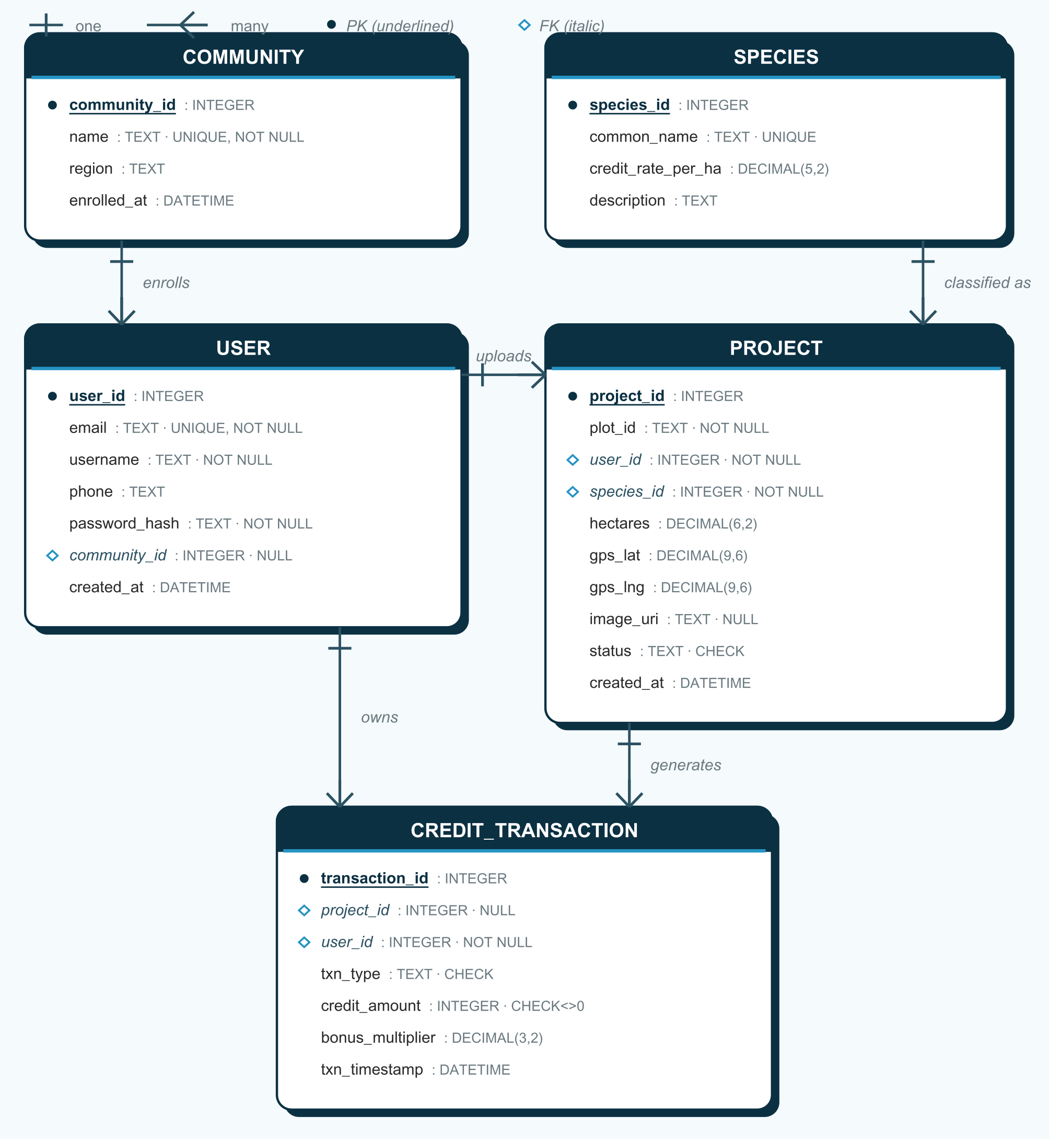
Figure 1. ER diagram for the proposed BlueLedger schema — 5 entities, all one-to-many relationships, surrogate integer primary keys.

8.B Entity Descriptions

COMMUNITY
Represents a village or cooperative enrolled in the program. Newly proposed: the current Dashboard screen already displays a “total communities enrolled” figure with no underlying record to back it.
Attribute | Data Type | Constraint
community_id | INTEGER | PRIMARY KEY, AUTOINCREMENT
name | TEXT | NOT NULL, UNIQUE
region | TEXT | NULLable
enrolled_at | DATETIME | NOT NULL, DEFAULT CURRENT_TIMESTAMP

USER
Evolves the current, minimal user record (email, phone, username only) into a real account record with credential storage and optional community membership.
Attribute | Data Type | Constraint
user_id | INTEGER | PRIMARY KEY, AUTOINCREMENT
email | TEXT | NOT NULL, UNIQUE
username | TEXT | NOT NULL
phone | TEXT | NULLable
password_hash | TEXT | NOT NULL
community_id | INTEGER | FOREIGN KEY → COMMUNITY(community_id), NULLable
created_at | DATETIME | NOT NULL, DEFAULT CURRENT_TIMESTAMP

SPECIES
Reference/lookup table. Replaces the hardcoded species-to-rate mapping currently built into the app's credit-calculation logic with queryable, editable data. Seed rows: Rhizophora (14), Avicennia (12), Bruguiera (10) — the rates already used by the app today.
Attribute | Data Type | Constraint
species_id | INTEGER | PRIMARY KEY, AUTOINCREMENT
common_name | TEXT | NOT NULL, UNIQUE
credit_rate_per_ha | DECIMAL(5,2) | NOT NULL, CHECK (credit_rate_per_ha > 0)
description | TEXT | NULLable

PROJECT
Direct evolution of the existing project record. The free-text species field becomes a validated foreign key, and a new status column formalizes a verification workflow that today does not exist (credits are minted instantly and unconditionally).
Attribute | Data Type | Constraint
project_id | INTEGER | PRIMARY KEY, AUTOINCREMENT
plot_id | TEXT | NOT NULL
user_id | INTEGER | FOREIGN KEY → USER(user_id), NOT NULL
species_id | INTEGER | FOREIGN KEY → SPECIES(species_id), NOT NULL
hectares | DECIMAL(6,2) | NOT NULL, CHECK (hectares > 0)
gps_lat | DECIMAL(9,6) | NOT NULL
gps_lng | DECIMAL(9,6) | NOT NULL
image_uri | TEXT | NULLable
status | TEXT | NOT NULL, CHECK IN ('PENDING','VERIFIED','REJECTED'), DEFAULT 'PENDING'
created_at | DATETIME | NOT NULL, DEFAULT CURRENT_TIMESTAMP

CREDIT_TRANSACTION
An append-only ledger. The minted-credit amount is no longer stored solely on the Project record; instead every mint (and, later, every redemption) is its own row. project_id is nullable because a REDEEM transaction draws from a user's pooled balance rather than a single project. Wallet balance = SUM(credit_amount) grouped by user.
Attribute | Data Type | Constraint
transaction_id | INTEGER | PRIMARY KEY, AUTOINCREMENT
project_id | INTEGER | FOREIGN KEY → PROJECT(project_id), NULLable
user_id | INTEGER | FOREIGN KEY → USER(user_id), NOT NULL
txn_type | TEXT | NOT NULL, CHECK IN ('MINT','REDEEM')
credit_amount | INTEGER | NOT NULL, CHECK (credit_amount <> 0)
bonus_multiplier | DECIMAL(3,2) | NOT NULL, DEFAULT 1.00
txn_timestamp | DATETIME | NOT NULL, DEFAULT CURRENT_TIMESTAMP

8.C Relational Schema (SQL DDL)
The Room persistence library generates SQL equivalent to this from the entity definitions; it is shown directly here for clarity and portability.
CREATE TABLE community (
community_id INTEGER PRIMARY KEY AUTOINCREMENT,
name TEXT NOT NULL UNIQUE,
region TEXT,
enrolled_at DATETIME NOT NULL DEFAULT CURRENT_TIMESTAMP
);
CREATE TABLE user (
user_id INTEGER PRIMARY KEY AUTOINCREMENT,
email TEXT NOT NULL UNIQUE,
username TEXT NOT NULL,
phone TEXT,
password_hash TEXT NOT NULL,
community_id INTEGER,
created_at DATETIME NOT NULL DEFAULT CURRENT_TIMESTAMP,
FOREIGN KEY (community_id) REFERENCES community(community_id)
);
CREATE TABLE species (
species_id INTEGER PRIMARY KEY AUTOINCREMENT,
common_name TEXT NOT NULL UNIQUE,
credit_rate_per_ha DECIMAL(5,2) NOT NULL CHECK (credit_rate_per_ha > 0),
description TEXT
);
CREATE TABLE project (
project_id INTEGER PRIMARY KEY AUTOINCREMENT,
plot_id TEXT NOT NULL,
user_id INTEGER NOT NULL,
species_id INTEGER NOT NULL,
hectares DECIMAL(6,2) NOT NULL CHECK (hectares > 0),
gps_lat DECIMAL(9,6) NOT NULL,
gps_lng DECIMAL(9,6) NOT NULL,
image_uri TEXT,
status TEXT NOT NULL DEFAULT 'PENDING'
CHECK (status IN ('PENDING','VERIFIED','REJECTED')),
created_at DATETIME NOT NULL DEFAULT CURRENT_TIMESTAMP,
FOREIGN KEY (user_id) REFERENCES user(user_id),
FOREIGN KEY (species_id) REFERENCES species(species_id)
);
CREATE TABLE credit_transaction (
transaction_id INTEGER PRIMARY KEY AUTOINCREMENT,
project_id INTEGER,
user_id INTEGER NOT NULL,
txn_type TEXT NOT NULL CHECK (txn_type IN ('MINT','REDEEM')),
credit_amount INTEGER NOT NULL CHECK (credit_amount <> 0),
bonus_multiplier DECIMAL(3,2) NOT NULL DEFAULT 1.00,
txn_timestamp DATETIME NOT NULL DEFAULT CURRENT_TIMESTAMP,
FOREIGN KEY (project_id) REFERENCES project(project_id),
FOREIGN KEY (user_id) REFERENCES user(user_id),
CHECK ((txn_type = 'MINT' AND project_id IS NOT NULL) OR txn_type = 'REDEEM')
);
CREATE INDEX idx_project_user ON project(user_id);
CREATE INDEX idx_project_species ON project(species_id);
CREATE INDEX idx_txn_user ON credit_transaction(user_id);
CREATE INDEX idx_txn_project ON credit_transaction(project_id);

Representative queries
-- Wallet balance and total hectares for the signed-in user (Wallet / Dashboard screens)
SELECT COALESCE(SUM(ct.credit_amount), 0) AS wallet_balance
FROM credit_transaction ct
WHERE ct.user_id = :userId;
SELECT COALESCE(SUM(p.hectares), 0) AS total_hectares
FROM project p
WHERE p.user_id = :userId;
-- Per-species totals for an analytics/report view
SELECT s.common_name, COUNT(p.project_id) AS plots, SUM(p.hectares) AS hectares
FROM project p JOIN species s ON s.species_id = p.species_id
GROUP BY s.common_name;
-- Community leaderboard by total credits minted
SELECT c.name, SUM(ct.credit_amount) AS total_credits
FROM credit_transaction ct
JOIN user u ON u.user_id = ct.user_id
JOIN community c ON c.community_id = u.community_id
WHERE ct.txn_type = 'MINT'
GROUP BY c.name
ORDER BY total_credits DESC;

8.D Keys and Constraints
Constraint type | Where applied | Purpose
PRIMARY KEY | *_id on every table | Uniquely identifies each row; SQLite auto-generates a monotonic surrogate key.
FOREIGN KEY | user.community_id, project.user_id, project.species_id, credit_transaction.project_id/user_id | Guarantees every reference points to a row that actually exists — an integrity check the current unstructured storage cannot make.
UNIQUE | user.email, community.name, species.common_name | Prevents duplicate accounts, duplicate community records, and duplicate species reference rows.
NOT NULL | email, username, password_hash, hectares, gps_lat/lng, txn_type, credit_amount, etc. | Blocks incomplete records — today nothing stops an empty species name from being saved.
CHECK | hectares > 0, credit_rate_per_ha > 0, credit_amount <> 0, status/txn_type enumerations, MINT→project_id required | Encodes domain rules directly in the schema instead of relying on UI-side validation alone.

8.E Normalization

1NF — fixing the current violation
The existing storage is not even in First Normal Form: the entire list of projects is held as one serialized block of text under a single stored value — a repeating group packed into a single atomic field. The proposed schema gives every project its own row with atomic columns, satisfying 1NF.

2NF — trivially satisfied
Every table in the design uses a single-column surrogate primary key (*_id), so there are no composite keys and therefore no possibility of a partial-key dependency. 2NF holds by construction.

3NF — the species-rate example
This is the concrete anomaly the redesign removes. If a credit-rate column were added directly onto the project table instead of extracting species into its own table, it would depend on the project's species rather than on the project's own primary key — a transitive dependency (project → species → credit rate) that violates 3NF. The practical symptom is exactly the situation already present in the app today: the rate is duplicated in application logic rather than being looked up once. Extracting SPECIES as its own table with a foreign key from PROJECT removes the transitive dependency and the update anomaly it would otherwise cause (correcting Rhizophora's rate would no longer require touching every historical project row).

9. System Architecture / Workflow Diagram
The diagram below follows the required Users → Application/System → Database → Output flow, mapped onto BlueLedger's actual application layering.
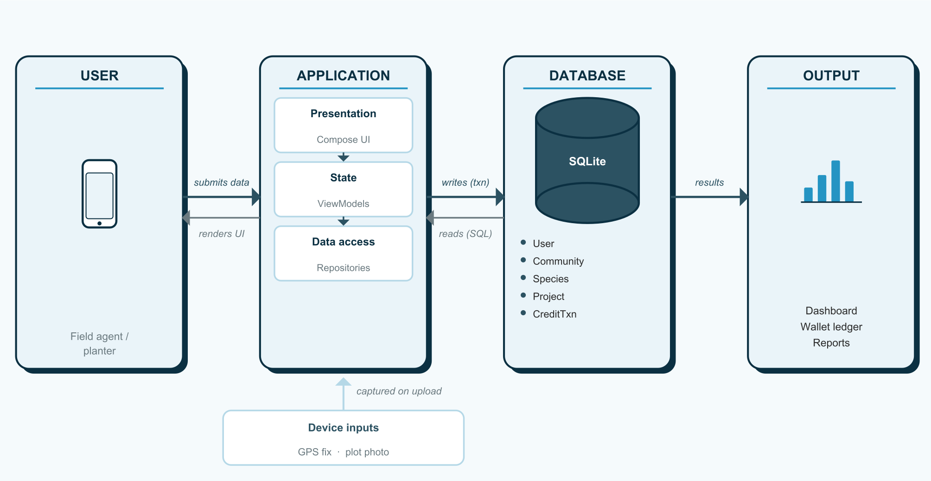
Figure 2. BlueLedger system architecture with the proposed SQLite persistence layer. Solid arrows are write/request calls; the lighter return arrows are the live data updates that refresh the screens.

A. Existing vs Proposed System
Aspect | Existing (today) | Proposed
Storage | Two unstructured text blocks in local device storage | 5-table relational schema in an embedded SQLite database
User model | Single overwritable user record, mock authentication | USER table, unique email, password hash, multi-account capable
Species rates | Hardcoded in application logic | SPECIES reference table, editable without a rebuild
Credit history | Baked into each project's single credit-amount field | Append-only CREDIT_TRANSACTION ledger, supports future redemption
Integrity | None — any value accepted | Primary-key, foreign-key, NOT NULL and CHECK constraints enforced by the database engine
Queries | Full-list loading into memory, then in-app filtering | Indexed SQL queries and aggregates (SUM, GROUP BY)
Concurrency | Read-then-write race during upload | Atomic database transactions on insert

B. Proposed Implementation Plan
Phase | Work | Outcome
1. Database setup | Introduce the embedded database and its configuration into the application. | A working, empty database ready to hold data
2. Schema / model implementation | Define the five entities (User, Community, Species, Project, CreditTransaction) with the constraints in §8.D; seed the Species reference rows. | The full schema created and seeded
3. Data-access integration | Implement the queries needed to create, read, update, and delete records, equivalent to today's data-access methods. | All required database operations available
4. Application integration | Connect the existing data layer to the new database instead of the current unstructured local storage, keeping the same behavior visible to the screens. | Screens read/write through the new database transparently
5. Reference-data wiring | Point the species-selection dropdown at the live Species table instead of a fixed list. | Species list becomes data-driven
6. Testing and validation | Test all CRUD operations against a test database; verify constraint violations are rejected; verify wallet totals match manually computed values. | Verified, constraint-correct database behavior

