1.Go to App.js,Delete all in between the <div></div>.And also remove className.

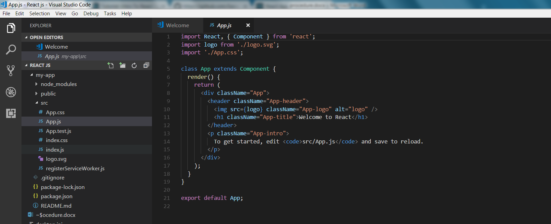

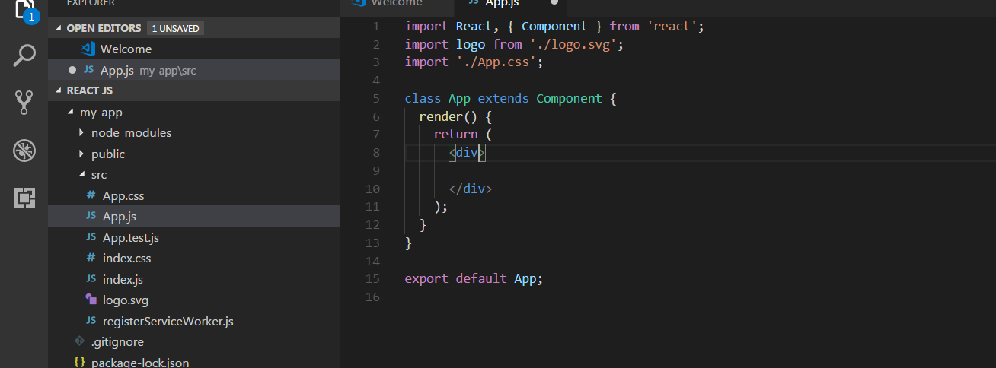

2.Delete app.css and logo.svg.And remove from import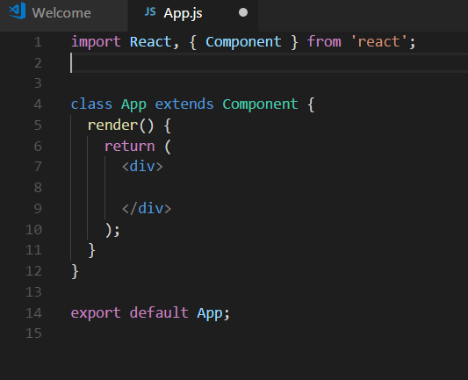

3.install react bootstrap.

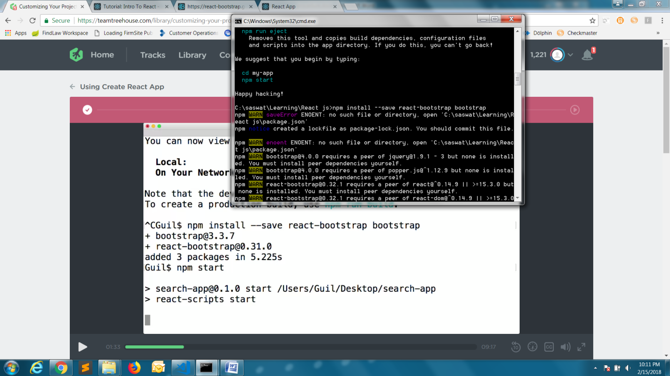

4.npm start

5.use of grid and jumbotron of bootstrap

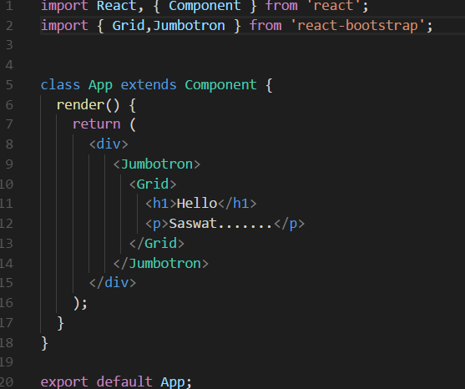

6.create a new folder components in scrc.

7.Add searchForm.js in components

8.in searchForm.js

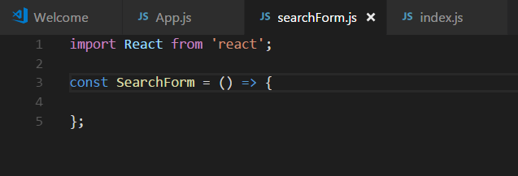

9. export default SearchForm;

10.copy code from react bootstrap

<Form inline>

<FormGroup controlId="formInlineEmail">

<FormControl type="search" placeholder="enter something..." />

</FormGroup>

<Button type="submit">

Search

</Button>

</Form>

11. import { Form, FormControl,FormGroup,Button } from 'react-bootstrap';

12. export default SearchForm;

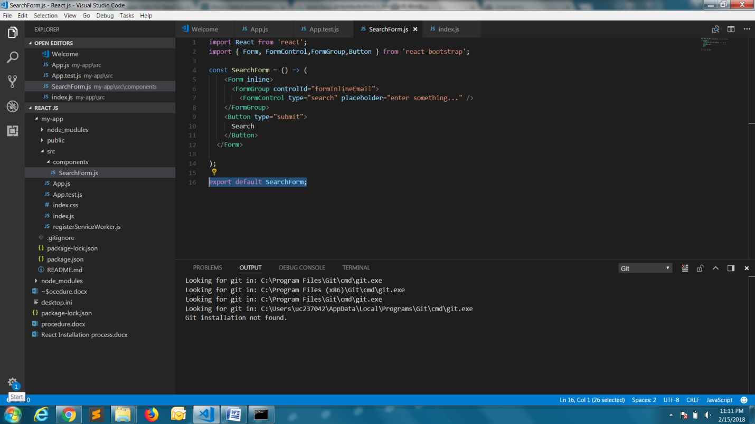

13.Import

import SearchForm from './components/SearchForm';

14. 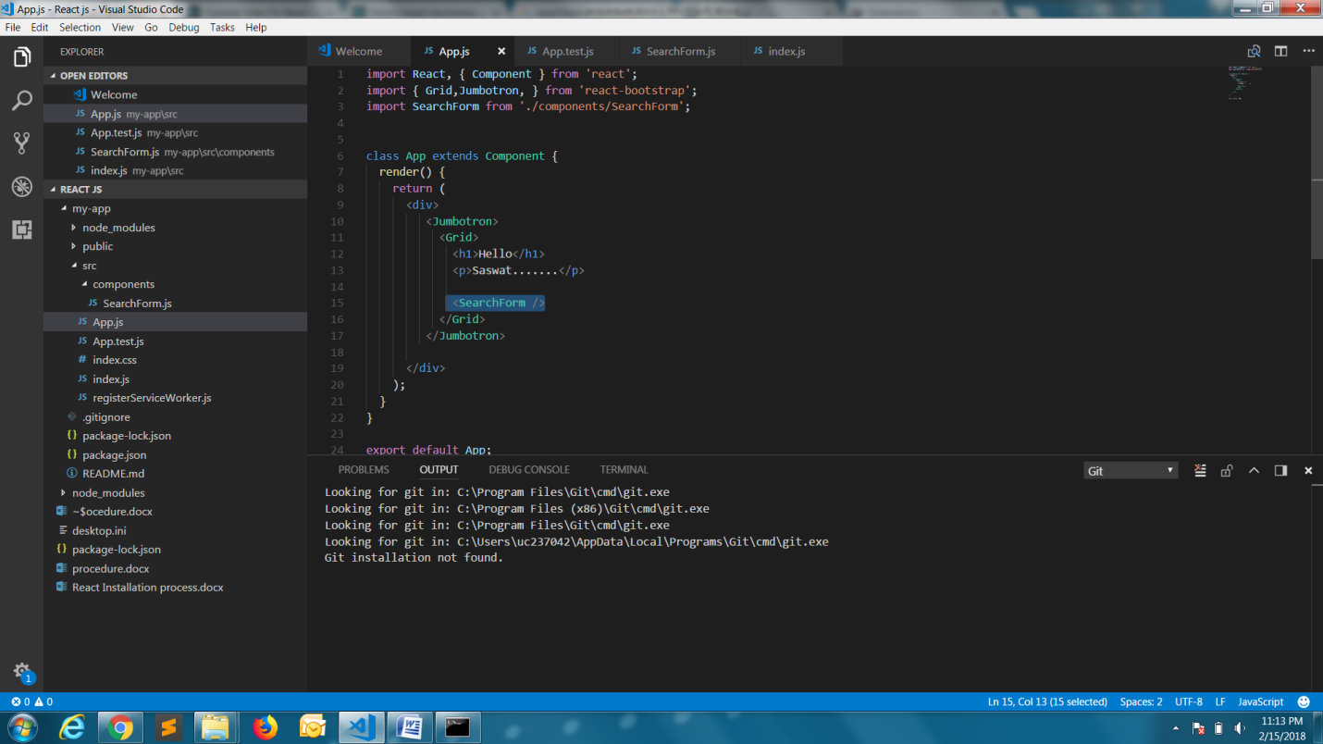

15.npm test to test our app through jest