NASSAU CANDY DISTRIBUTOR - LOGISTICS ANALYTICS RESEARCH PAPER
Factory-to-Customer Shipping Route Efficiency Analysis
Using the Nassau Candy Distributor Dataset
EDA | KPI Measurement | Route Intelligence | Dashboard Evidence | Insights | Recommendations
Document Field |  |  | Details
Author |  |  | Mohit Gupta
Role |  |  | Data Analyst Intern
Organization |  |  | Unified Mentor Private Ltd
Project Domain |  |  | Supply Chain Analytics / Logistics Analytics
Mentor |  |  | Saiprasad Kagne
Submission Month |  |  | May 2026
Research Paper Scope
This research paper examines factory-to-customer shipping route efficiency using the Nassau Candy Distributor dataset. It focuses on exploratory data analysis, route-level KPI measurement, geographic bottleneck detection, ship-mode comparison, dashboard-based evidence, analytical insights, and strategic recommendations for improving logistics performance.
Median Lead Time | Average Lead Time |  | Route Volume | Delay Frequency |  | Efficiency Score
4.0 days | 4.0 days |  | 52 / route | 24.1% |  | 42.6 / 100
Executive Orientation
The paper is designed as a practical research document: each section connects a business problem to data evidence and then converts that evidence into a managerial decision. Full desktop screenshots are excluded; only clean visuals, tables, and analytical graphics are used.
Research Deliverable |  | Included in Final Paper |  |  | Value for Reviewer
EDA |  | Route, geography, ship-mode, drill-down, and monthly trend analysis. |  |  | Shows how patterns were discovered before recommendations.
Insights |  | Evidence-to-insight matrices with numbers and analyst interpretation. |  |  | Explains why each finding matters for supply chain decisions.
Recommendations |  | Prioritized action matrix with risk, action, priority, and impact. |  |  | Converts analysis into practical logistics improvement steps.

Abstract
This research paper develops a structured logistics analytics study for evaluating factory-to-customer shipping route efficiency using the Nassau Candy Distributor dataset. The study transforms shipment records into a decision-oriented research framework that explains how lead time, route volume, geographic bottlenecks, ship-mode performance, and monthly demand patterns affect delivery reliability. The objective is not only to report dashboard results, but to convert operational data into evidence-based insights and practical recommendations for supply chain improvement.
The analytical workflow combines exploratory data analysis, dynamic delay classification, route-efficiency scoring, state-level bottleneck detection, ship-mode benchmarking, route drill-down, and monthly trend monitoring. The Streamlit dashboard supports interactive filtering by date range, region, state, ship mode, and lead-time threshold. This makes the analysis scenario-sensitive: the same dataset can be examined under different business assumptions, rather than being limited to a fixed historical snapshot.
In the default dashboard view, the logistics network records a median shipping lead time of 4.0 days, an average lead time of
4.0 days, an average route volume of 52 shipments per route, delay frequency of 24.1% under a 5-day threshold, and a normalized route-efficiency score of 42.6. These values indicate that the overall network is stable at a high level, but not fully optimized at route, state, or service-mode level.
The results indicate that delay exposure is not uniform across the network. Several factory-to-state routes approach or reach
7.0 days average lead time, Standard Class shipping records 5.00 days average lead time with 40.1% delayed shipments, and Tennessee and Michigan are flagged as state-level bottlenecks because they combine meaningful shipment volume with elevated average lead time. Monthly trend analysis shows that December 2025 reached 848 orders while average lead time remained near 3.92 days, indicating broad network resilience during high volume but requiring localized monitoring.
The study contributes an applied logistics intelligence framework that connects EDA, KPI design, dashboard evidence, analytical insights, and strategic recommendations. It demonstrates how a supply chain dashboard can move beyond static visualization and become a practical decision-support system for prioritizing route reviews, adjusting shipping modes, monitoring bottlenecks, and improving service reliability.

Abstract Element |  | Research Summary
Purpose |  | Evaluate route-level shipping efficiency and convert dashboard evidence into supply chain decisions.
Method |  | EDA, dynamic threshold logic, route scoring, bottleneck detection, ship-mode comparison, route drill-down, and trend analysis.
Core Evidence |  | 4.0-day median lead time, 24.1% delay frequency, 42.6 route-efficiency score, and Standard Class delay exposure of 40.1%.
Decision Value |  | Prioritize slow/high-volume routes, review Standard Class policy, investigate bottleneck states, and monitor peak months.
Abstract Takeaway
The research converts dashboard outputs into decision-ready logistics intelligence by linking route-level EDA, KPI measurement, bottleneck detection, and action planning in one controlled workflow.
Core Empirical Signal | Observed Value |  | Research Interpretation
Network baseline | 4.0-day median and 4.0-day average lead time |  | Overall operations are stable at aggregate level but require local diagnostics.
Delay threshold exposure | 24.1% delayed above 5 days |  | Delay risk is material enough to justify monitoring and route review.
Service-mode risk | Standard Class: 5.00 days and 40.1% delayed |  | The slowest mode creates the strongest reliability concern.

Abstract Element |  | Research Summary
Geographic risk | Tennessee and Michigan bottleneck flags |  | State-level risk is measurable and should be reviewed operationally.
Trend resilience | Dec 2025: 848 orders and ~3.92-day lead time |  | The network handled peak volume broadly, but localized stress remains possible.

Applied Contribution Detail

Contribution Point | How it strengthens the research paper | Practical value
EDA-led structure | Findings are derived from route, geography, mode, drill-down, and trend evidence. | Prevents recommendations from becoming generic.
Threshold-based delay logic | The delayed/on-time definition is controlled by a 5-day scenario threshold. | Supports flexible service-level analysis.
Decision-oriented interpretation | Each major result is linked to a route, state, mode, or month-level decision. | Improves usability for supply chain teams.
Dashboard traceability | Charts, KPI values, and tables are linked back to the Streamlit dashboard workflow. | Improves transparency and reproducibility.
Abstract Closure
The study is positioned as applied research: it does not only describe what happened in the shipment data, but organizes the evidence into a repeatable decision framework for route review, service-mode governance, and bottleneck monitoring.
Evidence Area | Specific Signal | Actionable Meaning
Route performance | Slowest visible routes approach 7.00 days. | Route-level review should be prioritized before broad network redesign.
Service mode | Standard Class shows 40.1% delayed shipments. | Service-mode policy can be adjusted for priority orders.
Geography | Tennessee and Michigan are flagged as bottlenecks. | State-level diagnostics should be used for localized improvement.
Trend behavior | December 2025 reaches 848 orders with lead time near  3.92 days. | Aggregate peak resilience exists, but route-level monitoring remains important.
Dashboard value | Filters and threshold logic create scenario-sensitive analysis. | Managers can test different service assumptions without rebuilding the report.
Reviewer Value
The abstract page now gives reviewers a complete view of purpose, method, evidence, interpretation, and action value before they enter the detailed sections.

Table of Contents
The paper follows the reference structure requested for the Nassau Candy project. Each major section begins on a fresh page, while longer analytical sections are allowed to extend across multiple pages so that content, visuals, tables, insights, and recommendations are not compressed or mixed incorrectly.

No. | Section | Purpose | Key Output
1 | Abstract | Summarizes purpose, method, findings, and decision value. | Research summary table and evidence takeaway.
2 | Table of Contents | Provides manuscript roadmap. | Section roadmap and visual evidence list.
3 | Introduction | Introduces logistics problem and contribution. | Research contribution and analytical flow.
4 | Background and Context | Explains Nassau Candy delivery setting. | Dashboard evidence layer and business use table.
5 | Problem Statement | Defines operational problem and research questions. | Problem-to-analysis mapping.
6 | Dataset Overview | Describes files, variables, and analytical layers. | Data component table and variable dictionary.
7 | Analytical Methodology | Documents step-by-step workflow. | Framework, formulas, and validation logic.
8 | Key Performance Indicators | Defines KPI values and meaning. | KPI cards, formula logic, and interpretation.
9 | Result and Analysis | Presents EDA outputs and numerical results. | Charts, tables, and empirical interpretation.
10 | Finding and Insights | Synthesizes patterns into analytical insights. | Evidence-to-insight matrix.
11 | Recommendations | Converts insights into prioritized actions. | Strategic action matrix and implementation roadmap.
12 | Dashboard Implementation | Explains Streamlit architecture. | Dashboard logic, filters, modules, and dynamic behavior.
13 | Conclusion | Summarizes findings, value, limitations, and future scope. | Final managerial and analytical conclusion.
14 | Reference | Lists project, academic, and tool references. | Source integrity and citation list.

Visual Evidence Used in the Paper

Visual / Table | Section Used | Purpose
KPI Cards | Key Performance Indicators | Shows lead-time, volume, delay, and efficiency baseline.
Route Lead-Time Chart | Result and Analysis | Identifies routes approaching 6-7 days average lead time.
Route Ranking Evidence | Result and Analysis | Supports volume-weighted route prioritization.
Geographic Map & Bottleneck Table | Result and Analysis | Shows spatial lead-time exposure and bottleneck states.
Ship Mode Charts | Result and Analysis | Compares lead time, delay percentage, and on-time percentage.

Visual / Table | Section Used | Purpose
Monthly Trend Charts | Result and Analysis | Evaluates whether volume growth created broad lead-time deterioration.
Dashboard Header | Dashboard Implementation | Documents analytical scope and project interface.
Action Matrix | Recommendations | Turns EDA findings into operational decisions.
Navigation Takeaway
The document is structured so a reviewer can move from purpose to evidence, from evidence to insights, and from insights to recommended action without changing the requested reference format.

Detailed Figure and Table Register

Item | Title | Used For
Figure 1 | Route-Level Logistics Intelligence Framework | Explains the analytical flow from data layer to decision layer.
Figure 2 | Key Performance Indicators | Documents dashboard KPI baseline values.
Figure 3 | Route Efficiency Overview by Average Lead Time | Identifies slow factory-to-state routes.
Figure 4 | Efficient and Least Efficient Routes | Benchmarks strong and weak route performance.
Figure 5 | U.S. Geographic Shipping Lead-Time Heatmap | Shows spatial lead-time exposure.
Figure 6 | Ship Mode Lead-Time and Delay Exposure | Compares service-mode speed and delay risk.
Figure 7 | Monthly Lead-Time and Order Volume Trends | Assesses peak-period behavior.
Figure 8 | Dashboard Header and Analytical Scope | Documents implementation scope.

Reviewer Reading Guide

Review Need | Where to Look | What to Check
Method transparency | Section 7 | Step-by-step workflow, formulas, validation checks.
EDA requirement | Section 9 | Route, geographic, ship-mode, drill-down, and trend analysis.
Insight quality | Section 10 | Evidence-backed senior analyst interpretation.
Recommendations | Section 11 | Action matrix, priorities, business impact, KPIs to track.
Dashboard traceability | Section 12 | Streamlit architecture, filters, modules, dynamic logic.

Formatting and Layout Controls

Control | How it is applied | Why it matters
No repeated continuation headings | Section 9 uses subsection headings only after the first main heading. | Keeps the paper continuous and professional.

Control | How it is applied | Why it matters
No full desktop screenshots | Only clean charts, cropped visuals, and tables are used. | Avoids browser/taskbar distractions.
New major section pages | Each major section starts clearly while subsections flow naturally. | Preserves reference format without fragmenting sections.
Evidence-based tables | Every analytical section includes numerical evidence and interpretation. | Improves reviewer confidence.
TOC Quality Note
The table of contents is designed as a roadmap, not only a list. It explains what each section contributes to EDA, insights, recommendations, and dashboard traceability.

Submission Readiness Mini-Checklist

Requirement | Where it appears | Reviewer Benefit
Project scope and identity | Title page and Abstract | Clarifies the business problem and research focus.
EDA evidence | Result and Analysis | Demonstrates analysis beyond static reporting.
Insights | Finding and Insights | Converts chart evidence into senior analyst interpretation.
Recommendations | Recommendations | Shows practical improvement actions and priorities.
Dashboard implementation | Dashboard Implementation | Connects app.py logic, filters, modules, and visuals to the paper.
Layout Note
The document uses a safe-mode layout policy: main sections start clearly, but subsections are allowed to flow naturally so pages do not become fragmented by repeated continuation headings.

Introduction
Factory-to-customer logistics performance is a critical component of supply chain reliability in distribution-intensive businesses. For a confectionery and specialty food distributor such as Nassau Candy, shipment efficiency directly affects customer experience, route planning, warehouse execution, and fulfillment consistency. A shipment delay is not just a time-based issue; it is an operational signal that may indicate route imbalance, service-mode mismatch, state-level bottlenecks, or peak-volume stress.
Many dashboards summarize logistics performance using total shipments and average delivery time. While these high-level indicators are useful for executive visibility, they are not sufficient for route-level diagnosis. A network can appear stable at the aggregate level while specific factory-to-state routes, ship modes, or destination states create disproportionate delay exposure. This creates an analytical requirement for a more granular approach that combines lead-time measurement, route ranking, geographic analysis, ship-mode benchmarking, and transaction-level drill-down.
This research paper addresses that need by developing a logistics analytics study based on the Nassau Candy Distributor dataset and its Streamlit dashboard implementation. The paper evaluates shipping lead time, average lead time, route volume, delay frequency, route efficiency score, bottleneck flags, and monthly trends. These outputs are interpreted through exploratory data analysis, dashboard evidence, and supply chain decision logic.

Why this problem matters
- Route delays directly influence fulfillment consistency and customer-service reliability.
- Averages hide localized risk; route-level decomposition reveals where improvement is actually needed.
- Service modes differ in speed and reliability; ship-mode analysis supports policy decisions.
- State-level bottlenecks require geographic visibility because route problems are rarely distributed evenly.
- Trend monitoring helps teams prepare for peak volume periods such as October to December.

Research Contribution

Contribution Area | How this paper contributes | Decision Value
Route-level intelligence | Converts shipments into factory-to-state route performance evidence. | Prioritizes routes for review.
Dynamic delay thresholding | Classifies shipments as delayed based on selected lead-time threshold. | Supports scenario-based service governance.
Efficiency scoring | Normalizes route performance using relative average lead time. | Creates comparable route rankings.
Bottleneck detection | Combines lead time and shipment volume at state level. | Targets high-impact geographic issues.
Dashboard evidence | Uses Streamlit and Plotly to make analysis filterable and repeatable. | Moves from static reporting to decision support.
Introduction Takeaway
The paper is not only a dashboard description. It is an evidence-to-action study that shows how logistics data can be converted into route prioritization, service-mode review, bottleneck monitoring, and operational recommendations.

Background and Context
Nassau Candy Distributor operates in a multi-route distribution environment in which products move from factory origins to customers across different states, provinces, and regions. In this setting, delivery performance depends on the assigned factory, customer destination, shipment timing, selected ship mode, route workload, and regional demand pattern. Because these variables interact with each other, a single average lead-time number cannot explain the full logistics situation.
The dashboard is designed around route-level visibility. Instead of treating logistics performance as one aggregate outcome, it decomposes the network into factory-to-state routes, factory-to-region summaries, state-level heatmap patterns, ship-mode performance, route-specific order timelines, and monthly trends. This decomposition allows analysts to move from a high-level network signal to the exact operational location where review is needed.
From a supply chain analytics perspective, this project is positioned as a diagnostic decision-support study. The dashboard does not simply display charts; it organizes evidence into layers. The first layer summarizes network KPIs. The second layer identifies route-level performance differences. The third layer evaluates geographic and service-mode risk. The fourth layer allows route-specific drill-down. The final layer tracks monthly movement in lead time and volume.

Analytical Context | Dashboard Evidence Layer | Business Use
Route View | Factory-to-state route performance, average lead time, route volume, and efficiency score. | Identifies route-specific service risk and improvement candidates.
Geographic View | State-level lead-time heatmap and bottleneck table. | Finds location-level logistics pressure and regional service exposure.
Ship Mode View | Same Day, First Class, Second Class, and Standard Class comparison. | Evaluates service-mode reliability and threshold-based delay exposure.
Drill-Down View | Order-level timeline for a selected route. | Separates persistent route issues from isolated shipment exceptions.
Trend View | Monthly average lead time and order volume. | Monitors peak-season resilience and volume pressure over time.

Operational Decision Environment
Supply chain teams often face limited time, limited carrier visibility, and competing priorities. As a result, they cannot review every route equally. A strong analytics system must distinguish between routes that are slow but low impact, routes that are moderately slow but high volume, and modes that create service-risk exposure because they carry large shipment counts. This is why the paper uses average lead time, route volume, delay frequency, and bottleneck flags together rather than relying on a single metric.
Background Takeaway
The project context requires a layered analytics approach: network KPI monitoring is necessary, but route-level and state-level diagnostics are required for action.

Problem Statement
The central business problem is the lack of a single analytical view that connects route performance, shipping modes, geographic bottlenecks, delay frequency, and monthly trends into an actionable logistics decision framework. Without this connection, decision-makers may rely on static reports, isolated averages, or informal operational judgment. This can lead to delayed interventions, under-prioritized bottlenecks, inefficient ship-mode choices, and limited visibility into route-level service risk.
The default dashboard view shows that the network average is close to 4.0 days, but this average hides route-level variation. Some routes approach 7.0 days average lead time, while selected routes such as Lot’s O’ Nuts -> Alabama show 4.59 days average lead time and 35.3% delay frequency. This means that the logistics challenge is not simply whether the network average is acceptable; the deeper issue is identifying which routes, modes, and states create the highest operational exposure.
The problem becomes more important when shipment volume is considered. A slow route with a low number of shipments may be less urgent than a moderately slow route carrying high volume. Similarly, Standard Class shows the slowest average lead time at 5.00 days and the highest delay exposure at 40.1%, but it also carries the largest shipment volume among the modes. Therefore, service risk must be interpreted through both performance severity and operational scale.

Problem Dimension | Evidence from Dashboard | Risk Created | Analytical Response
Aggregate masking | Network average lead time is 4.0 days, but routes reach 6-7 days. | Hidden route-level delay exposure. | Route ranking and route-efficiency scoring.
Service-mode imbalance | Standard Class averages 5.00 days and 40.1% delayed. | Mode-level reliability risk. | Ship-mode benchmarking and policy review.
Geographic concentration | Tennessee and Michigan flagged as bottlenecks. | Regional service inconsistency. | State-level heatmap and bottleneck flagging.
Threshold sensitivity | Delay status changes with the selected lead-time threshold. | Different service commitments need different definitions of delay. | Dynamic threshold-based classification.
Peak-month pressure | Dec 2025 reaches 848 orders while lead time remains near 3.92 days. | Potential local stress despite broad network resilience. | Monthly trend monitoring and route-level peak review.

Research Questions

RQ | Research Question | Operational Purpose
RQ1 | Which factory-to-state routes show the highest average shipping lead time? | Identify route candidates for operational review.
RQ2 | How can route efficiency be normalized so routes can be compared on a common scale? | Create fair ranking across route groups.
RQ3 | Which states show bottleneck risk when shipment volume and lead time are analyzed together? | Focus state-level improvement effort.
RQ4 | How do ship modes differ in speed, on-time performance, and delay exposure under a 5-day threshold? | Support service-mode policy decisions.
RQ5 | What does route drill-down reveal about selected route behavior at order level? | Validate whether route delays are persistent or episodic.
RQ6 | How does monthly lead-time performance behave as shipment volume changes over time? | Assess peak-period resilience and capacity risk.
Problem Statement Takeaway
The key problem is not that the network average is unacceptable; the key problem is that averages can hide concentrated route, state, and mode-level risk that requires targeted action.

Problem-to-Evidence Closure

Analytical Gap | Evidence Required | Dashboard Module | Expected Decision
Route-level delay visibility | Average lead time by factory-to-state route. | Route Overview | Build a slow-route review queue.
Service-mode reliability | Average lead time and delay percentage by ship mode. | Ship Mode Analysis | Adjust mode policy for priority orders.
Spatial bottleneck detection | State-level lead time, volume, and delay frequency. | Geographic View | Investigate high-impact states.
Order-level validation | Shipment timeline for selected route. | Route Drill-Down | Confirm whether issue is persistent or episodic.
Peak-period readiness | Monthly lead-time and order-volume trend. | Trends | Monitor Oct-Dec demand pressure.
Analytical Planning Note
The research questions are intentionally operational. Each question maps to a dashboard module, an EDA output, and a decision use case so that the final paper stays aligned with project guidelines and business relevance.

Risk Scenario Interpretation

Scenario | What could happen | How the dashboard helps
Slow route, low volume | A route appears severe but has limited operational impact. | Compare average lead time with route volume before taking action.
Moderate delay, high volume | A route may look less severe but affect many shipments. | Use volume-weighted prioritization.
High Standard Class usage | A slower mode can create broad reliability exposure. | Review Standard Class delay percentage and order priority.
State-level concentration | A few states can create localized service problems. | Use bottleneck flags and heatmap evidence.
Peak-month demand | High volume can mask local stress if network average remains stable. | Track monthly trends plus route-level exceptions.
Problem Closure
The problem statement establishes why a dashboard-based EDA system is necessary: it turns hidden route and mode-level variation into measurable review priorities.

Dataset Overview
The research uses processed dashboard-ready data generated from the Nassau Candy Distributor shipment dataset. The data architecture is modular: different files support different analytical views of the dashboard. This improves both performance and interpretability because route, geography, ship mode, and trend views can be calculated at the correct level of detail.
The primary dataset supports shipment-level filtering and KPI computation. Summary datasets support route ranking, regional comparison, ship-mode evaluation, and state-level mapping. The key analytical fields are Order ID, Order Date, Ship Date, Ship Mode, Factory, State/Province, Region, Shipping Lead Time, Route_State, Route_Region, and Dynamic Delay Status. The Route_State field is used for factory-to-state route analysis, while Route_Region supports higher-level bottleneck interpretation.

Data Component | Level of Detail | Analytical Role
dashboard_main.csv | Shipment-level records | Filtering, KPI calculation, drill-down, dynamic delay status, and monthly trend aggregation.
dashboard_route_leaderboard.csv | Factory-to-state route summary | Route ranking, average lead time comparison, route volume, and efficiency score.
dashboard_region_summary.csv | Factory-to-region summary | Regional bottleneck analysis and slow route-group identification.
dashboard_ship_mode.csv | Ship-mode summary | Average lead time, delayed percentage, on-time percentage, and mode rank.
dashboard_state_map.csv | State-level summary | Geographic heatmap and bottleneck state evidence.
Variable / Metric | Definition | Research Use
Order ID | Unique shipment/order identifier. | Supports shipment and unique order counting.
Order Date | Date when the order was placed. | Used for trend aggregation and filtering.
Ship Date | Date when shipment execution occurred. | Used to calculate and validate lead time.
Ship Mode | Same Day, First Class, Second Class, or Standard Class. | Used for mode-level service benchmarking.
Shipping Lead Time | Ship Date minus Order Date. | Core time-based performance measure.
Route_State | Factory + State/Province. | Detailed route-level benchmarking.
Route_Region | Factory + Region. | Regional bottleneck comparison.
Dynamic Delay Status | Delayed if lead time is above selected threshold. | Scenario-based delay classification.
Route Volume | Number of shipments by route. | Operational workload and prioritization measure.
Data Quality Principle
Records with missing critical date or lead-time values are excluded from dashboard calculations. Text fields are standardized so route names, ship modes, and geographic labels remain consistent across filters and visualizations. This protects KPI reliability and reduces interpretation errors caused by inconsistent labels.
Dataset Interpretation Boundaries
The dataset is sufficient for descriptive and diagnostic logistics analytics, but it does not include all causal variables that may explain delays. Carrier-level performance, freight cost, warehouse capacity, weather, labor availability, and exact route distance are not directly modeled. Therefore, the dashboard is used as a prioritization and decision-support tool, not a causal proof system.

Analytical Methodology (Step by Step)
The analytical methodology follows a step-by-step EDA-to-decision workflow. The purpose is to ensure that the research paper is not only descriptive, but also transparent, reproducible, and decision-oriented. Each step transforms shipment data into a specific analytical output used later in the results, insights, and recommendations sections.

Data Layer | Measurement Layer | Diagnostic Layer | Decision Layer
Order records, dates, factory, state, region, ship mode | Lead time, threshold status, route volume, efficiency score | Route ranking, state bottleneck, ship-mode risk, monthly trend | Prioritize routes, review modes, investigate states, monitor peak months

Figure 1. Route-Level Logistics Intelligence Framework

Step | Methodological Action | Analytical Explanation
Step 1 | Validate data | Convert dates, numeric lead time, standardize labels, and remove missing critical values.
Step 2 | Construct route fields | Create or validate Route_State and Route_Region for route-level and regional analysis.
Step 3 | Apply dashboard filters | Filter by date range, region, state, and ship mode to create a scenario-specific view.
Step 4 | Classify delay status | Use the selected 5-day threshold to classify each shipment as On-Time or Delayed.
Step 5 | Aggregate route performance | Calculate average lead time, route volume, delayed count, and delay frequency by route.
Step 6 | Score efficiency | Normalize average lead time into a route efficiency score where lower lead time receives higher score.
Step 7 | Detect bottlenecks | Flag states where shipment volume and average lead time are both in the upper quartile.
Step 8 | Generate insights | Translate route, state, mode, drill-down, and trend evidence into recommendations.

Measurement and Formula Logic

Construct | Operational Definition | Decision Meaning
Shipping Lead Time | Lead Time = Ship Date - Order Date | Measures how long shipment execution takes from customer order to ship completion.
Dynamic Delay Status | Delayed if Lead Time > selected threshold; otherwise On-Time. | Allows the same data to be tested under different service expectations.
Average Lead Time by Route | Mean lead time for all shipments on a factory-to-state route. | Identifies slow route groups requiring investigation.

Construct | Operational Definition | Decision Meaning
Delay Frequency | Delayed shipments divided by total shipments. | Measures share of shipments exceeding the operating threshold.
Route Efficiency Score | Normalized inverse average lead-time score within the filtered route portfolio. | Creates comparable route ranking where higher score means better performance.
Bottleneck Flag | State flagged when shipment volume and average lead time are both high. | Focuses attention on high-impact geographic risk, not just slow locations.

Validation Checklist

Validation Item | Why it matters | Expected Outcome
Date conversion | Lead-time calculations fail if dates are treated as text. | Order Date and Ship Date support monthly trend and lead-time logic.
Numeric lead-time conversion | Aggregation requires a numeric measure. | Mean, median, standard deviation, and threshold checks work correctly.
Route label standardization | Inconsistent route names can split the same route into multiple groups. | Route ranking and drill-down remain reliable.
Filter dependency | State filter must respond correctly to region selection. | Users see relevant state options for selected region.
Threshold recalculation | Delay status must update when threshold changes. | Delay frequency and on-time charts remain dynamic.
Visual evidence consistency | Charts must align with the data tables and KPI cards. | Research paper evidence remains traceable to dashboard output.
Methodology Takeaway
The workflow moves from validation to segmentation, measurement, diagnosis, and recommendation. This ensures the dashboard functions as a logistics decision-support system rather than a collection of static charts.

Key Performance Indicators
The dashboard uses five primary KPIs to summarize logistics performance. These KPIs are dynamic: they update when the user changes date range, region, state, ship mode, or the lead-time threshold. This is important because supply chain decisions often depend on the operational scenario being analyzed, not only on a fixed historical snapshot.
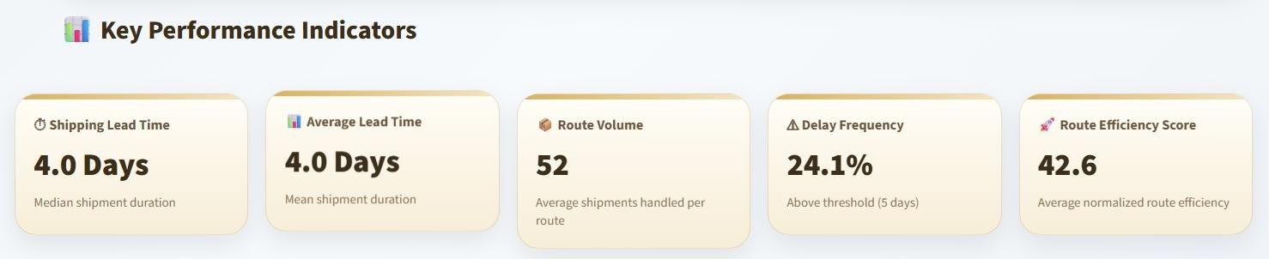
Figure 2. Key Performance Indicators from the Nassau Candy Logistics Dashboard

KPI | Dashboard Value | Analytical Definition | Business Interpretation
Shipping Lead Time | 4.0 days | Median shipment duration across filtered records. | Represents typical shipment duration and is less sensitive to extreme routes.
Average Lead Time | 4.0 days | Mean shipment duration across filtered records. | Provides the network-level lead-time benchmark.
Route Volume | 52 | Average shipments handled per route. | Indicates route-level workload intensity.
Delay Frequency | 24.1% | Share of shipments above selected 5-day threshold. | Measures service-risk exposure.
Route Efficiency Score | 42.6 | Normalized score based on route average lead time. | Summarizes relative route performance.

KPI Interpretation
The most decision-sensitive KPI is Delay Frequency because it depends on the selected threshold. In this research view, the threshold is 5 days. A shipment with lead time above 5 days is classified as delayed; otherwise it is treated as on-time. This allows the same dashboard to support different service-level assumptions.

KPI Signal | What it says | How management should read it
4.0-day median lead time | Typical shipment duration is stable around four days. | The network baseline is moderate, not severely failing.
24.1% delay frequency | Nearly one in four shipments exceed the 5-day threshold. | Delay exposure is meaningful and should be monitored.
52 shipments per route | Routes carry measurable average workload. | Route review should consider volume, not only average lead time.
42.6 efficiency score | Normalized route efficiency is below a strong-performance zone. | There is room for route-level improvement.

KPI Signal | What it says | How management should read it
Threshold dependence | Delay risk changes as the threshold changes. | Different service promises require different dashboard settings.
KPI Takeaway
The KPI set shows moderate overall performance: lead time is stable around 4.0 days, but 24.1% delayed shipments and a 42.6 efficiency score indicate route-level improvement opportunities.

KPI Action Triggers

KPI Trigger | When to investigate | Likely action
Median lead time rises above network target | Typical shipment duration is getting slower. | Review route mix and fulfillment handoff timing.
Delay frequency increases above 25% | A meaningful share of shipments exceeds service threshold. | Run route and mode segmentation before broad action.
Route volume grows while lead time rises | High-volume routes may begin creating customer impact. | Prioritize high-volume slow routes first.
Efficiency score remains below strong zone | Relative route performance is weak compared with portfolio. | Compare low-score routes with benchmark routes.
Standard Class delay remains high | Mode policy may be causing reliability exposure. | Restrict Standard Class for priority shipments.
KPI Governance Note
These KPIs should be reviewed together. A single indicator can mislead: average lead time shows the network baseline, while delay frequency, route volume, and efficiency score reveal where operational review should begin.

KPI Formula and Governance Matrix

KPI | Formula / Logic | Governance Use
Shipping Lead Time | Ship Date - Order Date | Defines the basic time-to-ship performance measure.
Average Lead Time | Mean lead time across filtered records | Benchmarks overall network and route-level speed.
Delay Frequency | Delayed shipments / total shipments | Tracks threshold-based service exposure.
Route Volume | Shipment count per route | Prevents low-volume outliers from driving priorities alone.
Efficiency Score | Inverse normalized average lead time | Converts route performance into a comparable ranking score.
KPI Review Discipline
A practical KPI review should start with the 4.0-day baseline, then segment by route, state, and ship mode. The 24.1% delay frequency is the key trigger for deeper investigation because it indicates that a meaningful share of shipments crosses the 5-day service threshold.

Result and Analysis
This section presents the EDA evidence generated from the dashboard. The analysis is organized around route performance, volume exposure, geographic bottlenecks, ship-mode reliability, route drill-down, and monthly trends. The purpose is to convert chart outputs into operational interpretation. Unlike the earlier draft, this section does not repeat the main section heading on every page; the subsections continue naturally under Section 9.

Route Efficiency Overview
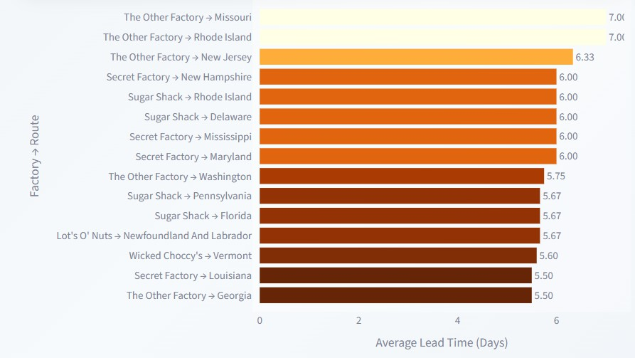
Figure 3. Route Efficiency Overview by Average Lead Time
Route-level results show that overall averages hide important local variation. The Other Factory -> Missouri and The Other Factory -> Rhode Island each reach approximately 7.00 days average lead time, while The Other Factory -> New Jersey reaches approximately 6.33 days. These routes are materially above the 4.0-day network benchmark and should be treated as high-priority review candidates when shipment volume confirms operational impact.

Route Evidence | Numerical Result | Analytical Meaning
The Other Factory -> Missouri | 7.00 days | Highest route-level lead-time exposure in the visible ranking.
The Other Factory -> Rhode Island | 7.00 days | Requires operational review similar to Missouri route.
The Other Factory -> New Jersey | 6.33 days | High-risk route above the network benchmark.
Network benchmark | ~4.0 days | Benchmark line for judging route-level deviation.
Slow-route cluster | 5.60-7.00 days | Shows delay exposure is concentrated in a subset of routes.

Route Volume and Efficiency Ranking
Route prioritization should not rely only on average lead time. A slow route with low volume may have limited business impact, while a moderately slow route with high volume can create broader customer-service exposure. Therefore, the analysis uses volume, lead time, and efficiency score together. Efficient routes such as Secret Factory -> Colorado, Secret Factory -> Virginia, and The Other Factory -> Florida provide internal performance benchmarks, while weaker routes such as The Other Factory -> New Jersey and Secret Factory -> Maryland require deeper review.

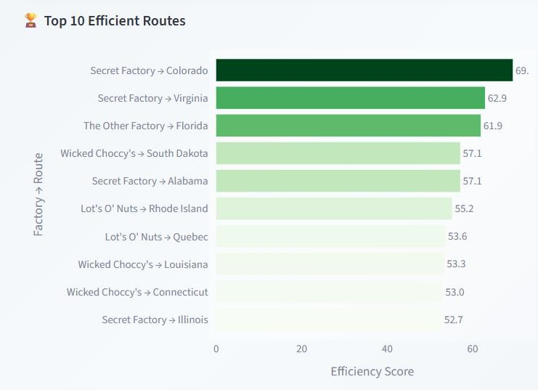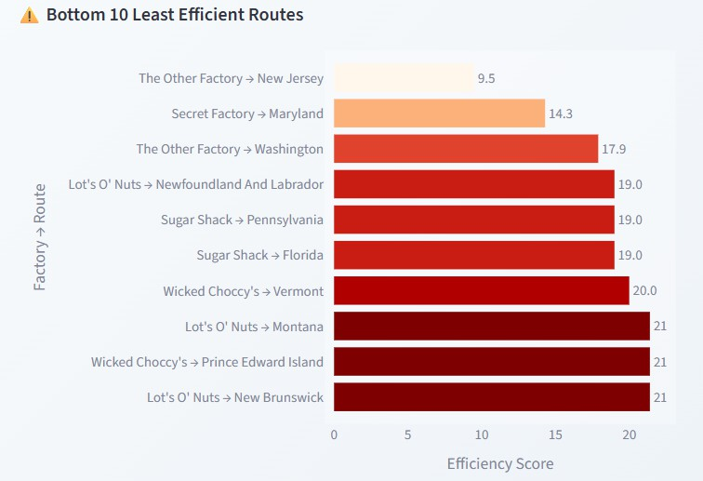
Figure 4. Efficient and Least Efficient Routes by Efficiency Score

Analysis Lens | What the chart shows | Decision Use
Top route benchmark | High-scoring routes show lower lead-time exposure and stronger relative performance. | Use strong routes as internal benchmarks for process comparison.
Bottom route risk | Low-efficiency routes reveal where lead time is materially weaker. | Create a route review list and check carrier, fulfillment, and distance factors.
Volume overlay | Route volume indicates how many shipments are affected. | Prioritize slow routes with meaningful shipment volume.
Efficiency score | Normalizes route comparison across the filtered portfolio. | Supports objective route ranking.

Geographic Bottleneck Analysis
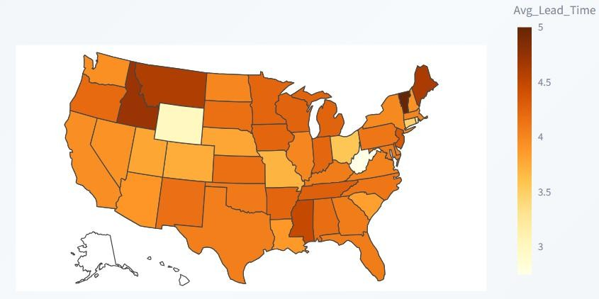
Figure 5. U.S. Geographic Shipping Lead-Time Heatmap
The geographic heatmap converts lead-time performance into spatial intelligence. Darker states indicate higher average lead time, allowing analysts to identify location-level service exposure quickly. The purpose of this view is not cartographic presentation only; it provides a spatial prioritization layer for logistics planning.

State/Province | Total Shipments | Avg Lead Time | Lead-Time Std. | Delayed Count | Delay Frequency | Flag
Tennessee | 183 | 4.2787 | 1.6521 | 44 | 24.0437% | Bottleneck

State/Province | Total Shipments | Avg Lead Time | Lead-Time Std. | Delayed Count | Delay Frequency | Flag
Michigan | 255 | 4.2588 | 1.9369 | 79 | 30.9804% | Bottleneck
Tennessee and Michigan are flagged as bottleneck states because they combine meaningful shipment volume with elevated average lead time. Michigan has higher total shipments and higher delay frequency than Tennessee, making it a priority for state-level operational review. The correct next investigation would include carrier reliability, state-level demand concentration, factory assignment logic, route distance, and fulfillment handoff timing.

Ship-Mode Reliability Analysis
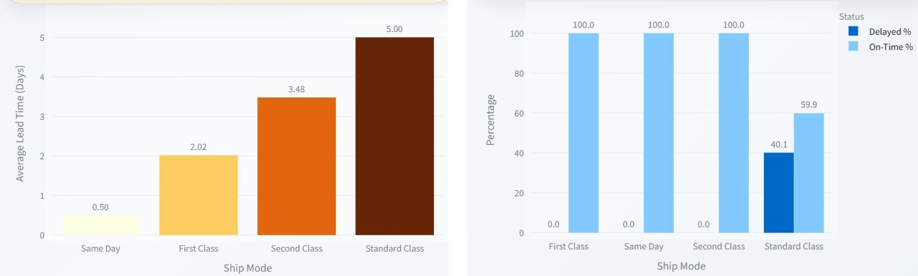
Figure 6. Ship Mode Lead-Time and Delay Exposure

Ship Mode | Total Shipments | Avg Lead Time | Delayed % | On-Time % | Efficiency Rank
First Class | 1,548 | 2.00 | 0.0% | 100.0% | 2
Same Day | 547 | 0.50 | 0.0% | 100.0% | 1
Second Class | 1,979 | 3.48 | 0.0% | 100.0% | 3
Standard Class | 6,120 | 5.00 | 40.1% | 59.9% | 4
Ship-mode results provide one of the clearest managerial findings. Same Day is the fastest mode at 0.50 days, First Class averages 2.00 days, Second Class averages 3.48 days, and Standard Class averages 5.00 days. Under the selected 5-day threshold, Standard Class is the only mode with material delay exposure, recording 40.1% delayed and 59.9% on-time. Because Standard Class also carries the largest shipment count, its risk is not isolated; it affects network-level reliability.
Service-Mode Interpretation
Standard Class should not necessarily be removed. Instead, it should be governed more carefully: use it for low-urgency orders, monitor its delay frequency, and define escalation rules for priority customers or time-sensitive shipments.

Route Drill-Down and Monthly Trend Analysis
The route drill-down module allows a selected route to be reviewed at order level. For the selected route Lot’s O’ Nuts -> Alabama, the dashboard reports 34 route orders, 4.59 days average lead time, 35.3% delay frequency, and a 5-day current threshold. The timeline separates on-time shipments from delayed shipments, helping analysts determine whether route-level risk is persistent or driven by a smaller number of exceptions.

Selected Route Attribute | Observed Value | Interpretation
Selected Route | Lot’s O’ Nuts -> Alabama | Represents a Gulf-region factory-to-state route.
Route Orders | 34 | Enough activity to justify route-level review.
Average Lead Time | 4.59 days | Above the 4.0-day network benchmark.
Delay Frequency | 35.3% | Meaningful delay exposure under the 5-day threshold.

Selected Route Attribute | Observed Value | Interpretation
Analyst Note | Slower than overall route average | Requires route-specific optimization review.
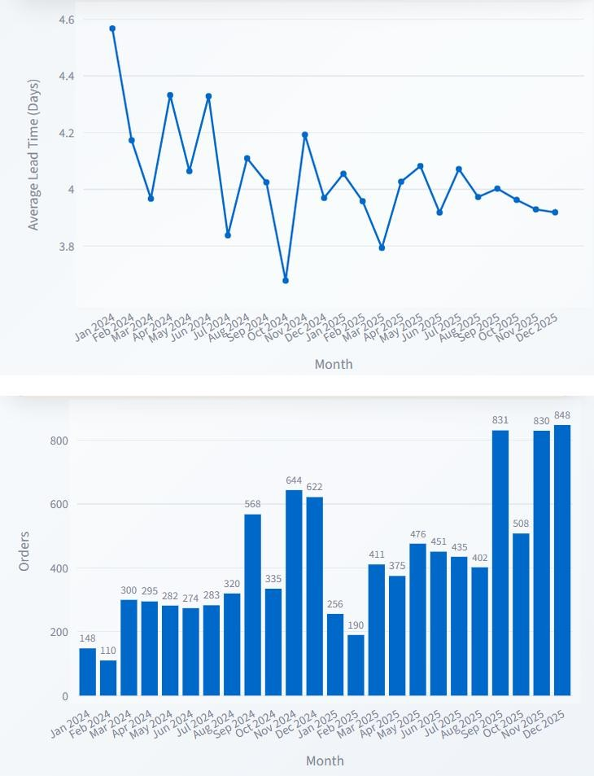

Figure 7. Monthly Lead-Time and Order Volume Trends

Monthly results show that higher demand does not automatically create broad network deterioration. December 2025 reaches 848 orders, while average lead time remains near 3.92 days. October 2025 records 831 orders and November 2025 records 830 orders. This suggests year-end volume resilience, although route and mode-level monitoring should continue because aggregate stability can still hide localized stress.

Integrated EDA Synthesis

EDA Lens | Main Evidence |  | Operational Interpretation |  | Recommended Next Check
Route | Several routes reach approximately 6-7 days average lead time. |  | Delay risk is concentrated at route level rather than evenly distributed. |  | Audit factory-to-state route assignment, carrier timing, and shipment batching.
Volume | High-volume routes need separate priority logic. |  | Small delays can become large service exposure when shipment count is high. |  | Combine route volume with lead-time severity before prioritizing.
Geography | Tennessee and Michigan are flagged bottleneck states. |  | State-level pressure is measurable and not just anecdotal. |  | Review regional carrier performance and demand concentration.
Mode | Standard Class records 5.00 days and 40.1% delayed. |  | Service-mode policy is a major controllable risk area. |  | Separate priority orders from low-urgency Standard Class shipments.
Trend | Dec 2025 reaches 848 orders with ~3.92-day lead time. |  | Peak volume is broadly handled, but localized stress can remain hidden. |  | Monitor peak months by route and mode, not only aggregate trend.
Result and Analysis Closure
The EDA confirms that the strongest value of the dashboard is segmentation. Network averages provide the baseline, but route, state, mode, and monthly analysis reveal where improvement work should actually start.
Stakeholder |  | Most relevant result |  | Why it matters
Logistics Analyst |  | Route ranking and drill-down evidence |  | Builds the first review list and validates route-specific exceptions.
Operations Manager |  | Standard Class delay exposure and bottleneck states |  | Supports process review and service-mode governance.
Supply Chain Lead |  | Trend resilience and peak-month volume |  | Helps plan capacity and executive monitoring cadence.
Customer Service Team |  | Routes and modes with higher delay frequency |  | Improves expectation-setting for customer-sensitive orders.
EDA Decision Bridge
Section 9 provides the evidence base for Sections 10 and 11. Findings and recommendations should not be treated as separate opinions; they are derived from route, state, mode, drill-down, and trend evidence.

Finding and Insights
The findings show that Nassau Candy’s logistics performance should be interpreted as a targeted improvement problem rather than a uniform network failure. The network baseline is close to 4.0 days, but the delay frequency of 24.1% and the presence of 6-7 day routes confirm that hidden route-level risk exists below the aggregate view.
The first major insight is that route-level decomposition is essential. Routes such as The Other Factory -> Missouri, The Other Factory -> Rhode Island, and The Other Factory -> New Jersey should be prioritized because their lead times are substantially above the network benchmark. However, route severity should be combined with route volume before final action is taken. This avoids over-investing in slow but low-volume routes.
The second insight is that ship-mode policy matters. Standard Class is not only the slowest mode at 5.00 days; it also shows 40.1% delayed shipments under the selected threshold. Because Standard Class carries the highest shipment count, this is a network-level reliability concern rather than a small mode-level weakness.
The third insight is geographic. Tennessee and Michigan are flagged as bottlenecks because they combine meaningful shipment volume with elevated average lead time. Michigan has 255 shipments and 30.9804% delay frequency, while Tennessee has 183 shipments and 24.0437% delay frequency. These states should be reviewed through routing distance, carrier performance, fulfillment timing, and regional demand concentration.

Finding | Numerical Evidence | Senior Analyst Insight |  | Decision Implication
Moderate network baseline | 4.0 days median and average lead time | Overall performance is stable but not fully optimized. |  | Use route-level analysis before broad interventions.
Meaningful delay exposure | 24.1% delayed under 5-day threshold | One-fourth of shipments require monitoring. |  | Track delay frequency continuously.
Localized route risk | Several routes reach approx. 7.0 days | Improvement should be route-specific. |  | Create slow-route review list.
Mode-level service risk | Standard Class: 40.1% delayed | Mode policy should be reviewed for priority orders. |  | Adjust Standard Class governance.
Geographic bottlenecks | Tennessee and Michigan flagged | State-level interventions can improve consistency. |  | Investigate carriers/routes for flagged states.
Peak-period resilience | Dec 2025: 848 orders, 3.92 days avg lead time | Network handles volume growth but needs local monitoring. |  | Monitor Oct-Dec route-level stress.
Interpretation
The dashboard should not be used only as a reporting tool. Its stronger value lies in prioritization: it helps answer which route, state, mode, or month should be reviewed first and why. This transforms descriptive analytics into operational decision support.
Insight Category | Risk Pattern |  | Most Useful Next Question
Route | Long lead-time routes are concentrated rather than universal. |  | Which slow routes also carry meaningful shipment volume?
Mode | Standard Class creates threshold-based delay exposure. |  | Which customer/order types should avoid Standard Class?
Geography | Bottleneck states combine volume and lead-time pressure. |  | Is the issue carrier, distance, fulfillment timing, or regional demand?
Trend | Peak volume can be absorbed at aggregate level. |  | Which routes show stress during peak months despite stable average?

Recommendations
The recommendations translate EDA findings into operational actions. They are designed for practical implementation by logistics, operations, and supply chain teams. The key principle is targeted intervention: improvement effort should focus on routes, modes, and states where risk is supported by both numerical evidence and business impact.

Evidence / Finding | Operational Risk | Recommended Action | Priority | Expected Business Impact
Routes approaching 6-7 days average lead time | Customer service exposure and planning uncertainty | Create a slow-route review list; investigate carrier timing, route distance, fulfillment handoff, and batching. | High | Reduced lead-time outliers and more predictable service.
Standard Class: 5.00 days average lead time and 40.1% delayed | Mode-level reliability risk on high shipment volume | Review Standard Class use for priority orders; define escalation rules to First Class or Same Day. | High | Improved service reliability for customer-sensitive orders.
Tennessee and Michigan flagged as bottlenecks | Localized geographic concentration of delay risk | Analyze routing distance, carrier performance, warehouse handoff time, and demand concentration. | High | Better bottleneck control and regional service consistency.
High-volume routes require separate attention | Small delays can create large network impact when volume is high | Use volume-weighted route prioritization rather than ranking only by average lead time. | High | Better allocation of improvement resources.
Dec 2025 volume reached 848 orders | Peak-month capacity stress may emerge despite stable averages | Build a monthly logistics review cadence for October-December. | Medium | Improved peak-season readiness.
Drill-down route shows 35.3% delay frequency | Route-specific delay exposure may be persistent or episodic | Use order-level timeline review before implementing route or mode changes. | Medium | More accurate corrective actions and fewer false alarms.
Dashboard threshold is adjustable | Different service commitments require different delay definitions | Use threshold scenarios: 3-day premium, 5-day standard, 7-day tolerance. | Medium | More flexible service-level governance.

Implementation Roadmap

Time Horizon | Action Focus | Owner / Function | KPI to Track
Immediate | Review routes at or above 6.0 days average lead time. | Logistics analyst / operations coordinator | Average lead time, delayed count, delay frequency.
30 days | Audit Standard Class usage for high-priority shipments. | Shipping policy owner / fulfillment manager | Standard Class delay %, on-time %, priority order lead time.
30-60 days | Investigate Tennessee and Michigan bottlenecks. | Regional operations / carrier management | State average lead time, state delay frequency.
Quarterly | Run peak-season logistics review for Oct-Dec. | Supply chain leadership | Monthly lead time, monthly volume, route-level exceptions.
Future | Add cost, carrier, capacity, and predictive delay modeling. | Analytics team | Lead-time prediction accuracy, cost-service tradeoff.
Recommendation Takeaway
The highest-value improvement strategy is not broad network redesign. It is targeted review of slow high-impact routes, Standard Class policy, flagged bottleneck states, and peak-month route stress.

Dashboard Implementation
The final dashboard is implemented as an interactive Streamlit application that transforms processed shipment data into a supply chain decision-support interface. The application uses Python for business logic, Pandas and NumPy for data processing and aggregation, Plotly for interactive visualizations, and Streamlit for deployment. The dashboard interface includes KPI cards, sidebar filters, tab-based modules, route drill-down controls, insight panels, recommendation cards, and data tables.

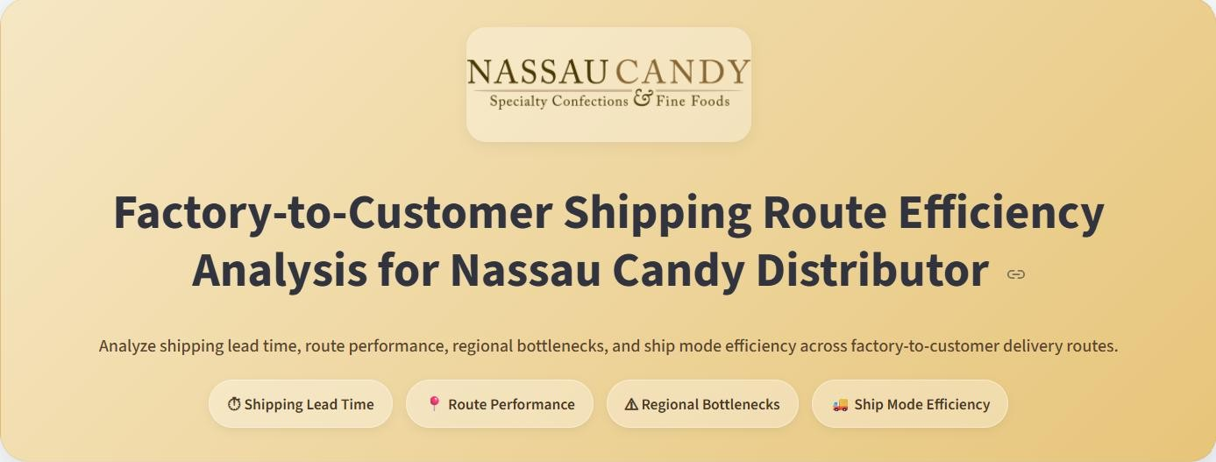
Figure 8. Dashboard Header and Analytical Scope

Component | Implementation Detail | Research Relevance
Framework | Streamlit web application running locally. | Enables interactive dashboard-based logistics analysis.
Data Processing | Pandas and NumPy used for loading, cleaning, filtering, grouping, and calculations. | Supports repeatable and transparent computation.
Visualizations | Plotly charts and tables across route, geography, ship mode, drill-down, and trend views. | Provides evidence for empirical analysis.
Filters | Date Range, Region, State, Ship Mode, and Lead-Time Threshold. | Creates scenario-based performance views.
Main Modules | Route Overview, Geographic View, Ship Mode Analysis, Route Drill-Down, Trends. | Aligns dashboard screens with research questions.
Dynamic Logic | KPIs, delay status, bottleneck flags, insights, and recommendations update with filters. | Converts visuals into decision-support outputs.

Dashboard Interaction Logic
The strongest implementation feature is the dynamic lead-time threshold. Because delay is not hard-coded, the user can test different operating standards and immediately see how delay frequency, on-time status, bottleneck flags, and recommendations change. This makes the dashboard more useful than a static report because it supports scenario-based logistics governance.

Dashboard Module | User Question Answered | Analytical Output
Route Overview | Which routes are slow or efficient? | Lead-time ranking, scatter evidence, efficient/least-efficient routes.
Geographic View | Where are bottlenecks concentrated? | State heatmap, factory-region bottleneck summary, bottleneck table.
Ship Mode Analysis | Which shipping method performs best or worst? | Lead-time comparison, delay vs on-time chart, mode summary.
Route Drill-Down | What happens inside a selected route? | Order-level timeline and selected route details.
Trends | How do volume and lead time change over time? | Monthly average lead-time and order-volume patterns.

Dashboard Decision Rules

Decision Rule | Dashboard Logic | Operational Meaning
Delay classification | A shipment is delayed when lead time is greater than the selected threshold. | Users can test different service expectations without changing the code base.
Route prioritization | Routes are compared using average lead time, route volume, delay frequency, and efficiency score. | Slow routes with meaningful volume receive priority over low-impact exceptions.
Bottleneck flagging | States are flagged when volume and lead time are both high in the filtered view. | The dashboard avoids treating every slow state as equally important.
Ship-mode review | Modes are ranked by average lead time and delay exposure. | Standard Class can be monitored as the highest reliability-risk mode in the default view.
Trend review | Monthly lead time is compared with order volume growth. | Peak-month resilience can be separated from localized route stress.
Dashboard Implementation Close
The dashboard implementation is both technical and managerial: it provides a working Streamlit interface while also functioning as a structured logistics decision system.

Conclusion
This research paper presents a complete logistics analytics study for evaluating factory-to-customer shipping efficiency using the Nassau Candy Distributor dataset. The study follows the required research paper format and integrates EDA, KPI measurement, dashboard evidence, analytical insights, and strategic recommendations. The analysis demonstrates that overall lead-time performance is moderate, but operational risk is concentrated in specific routes, states, and ship modes.
The main empirical conclusion is that Nassau Candy’s default logistics view records a 4.0-day median shipping lead time, 4.0-day average lead time, 52 average shipments per route, 24.1% delay frequency under a 5-day threshold, and a 42.6 average route-efficiency score. These numbers indicate that the network is not failing overall, but there is measurable delay exposure. Route-level EDA reveals routes near 7.0 days average lead time, geographic analysis flags Tennessee and Michigan as bottlenecks, and ship-mode analysis identifies Standard Class as the largest service-risk contributor.
The strategic conclusion is that improvement should be targeted, not broad. The recommended approach is to prioritize slow routes with meaningful shipment volume, review Standard Class usage for customer-sensitive orders, investigate bottleneck states through carrier and fulfillment diagnostics, and monitor October-to-December demand peaks. Route drill-down should be used before corrective action so that teams can distinguish persistent route problems from isolated shipment exceptions.

Conclusion Area | Evidence | Final Meaning
Network baseline | 4.0-day median and average lead time. | Overall service performance is moderate and measurable.
Delay exposure | 24.1% delayed under 5-day threshold. | Delay risk exists and requires monitoring.
Route risk | Several routes approach 6-7 days. | Route-level review is more useful than only network averages.
Mode risk | Standard Class 5.00 days and 40.1% delayed. | Service-mode policy should be reviewed.
Geographic risk | Tennessee and Michigan flagged. | State-level bottleneck review can improve consistency.
Trend resilience | Dec 2025 reached 848 orders with 3.92-day average lead time. | Peak volume was handled broadly, but localized monitoring remains important.

Limitations and Future Scope
- The analysis is diagnostic and prioritization-focused; it does not claim causal proof without additional carrier, cost, weather, distance, and capacity data.
- Future work can extend the dashboard with freight cost, carrier SLA, route distance, warehouse processing time, and predictive delay modeling.
- A future model can classify high-risk shipments before delay occurs, allowing proactive intervention rather than reactive reporting.
- The framework can be reused for other logistics datasets where route, geography, service mode, and lead time are available.

Final Statement
The project demonstrates how a supply chain dashboard can move beyond visualization and become a route-level logistics intelligence system for evidence-based decision-making.

Reference
The references below support the academic framing, supply chain performance measurement context, and dashboard implementation tools used in the research paper. Project-specific references are included because the research paper is based on the Nassau Candy Distributor dataset and Unified Mentor internship requirements.
- Nassau Candy Distributor Dataset. Internal order and shipment records used for logistics analytics dashboard development.
- Unified Mentor. Data Analytics Internship Project Guidelines and Submission Requirements.
- Chopra, S., & Meindl, P. Supply Chain Management: Strategy, Planning, and Operation. Pearson.
- Christopher, M. Logistics and Supply Chain Management. Pearson Education.
- Gunasekaran, A., Patel, C., & McGaughey, R. E. (2004). A framework for supply chain performance measurement. International Journal of Production Economics, 87(3), 333-347.
- Little, J. D. C. (1961). A proof for the queuing formula L = lambda W. Operations Research, 9(3), 383-387.
- Streamlit Documentation. Framework for building interactive Python data applications.
- Pandas Documentation. Python library for data manipulation, cleaning, grouping, and aggregation.
- NumPy Documentation. Python library used for numerical computation and conditional logic.
- Plotly Documentation. Python visualization library used for dashboard charts and interactive analytics.
- Python Software Foundation. Python programming language used for data analytics workflow and dashboard development.

Source Integrity Note

Source Type | How it was used | Scope Boundary
Dataset | Used for EDA, KPI values, route analysis, bottleneck evidence, and dashboard visuals. | Findings are limited to the available processed dataset.
Project Guidelines | Used to align the paper with EDA, insights, recommendations, and dashboard deliverables. | The paper remains project-specific, not a universal logistics benchmark.
Academic references | Used to support supply chain performance and logistics decision-support framing. | They frame the analysis but do not replace dataset evidence.
Technical documentation | Used to describe implementation tools such as Streamlit, Pandas, Plotly, and Python. | Tool references support reproducibility and dashboard transparency.

