TenderScreen Project Report
  - Mini Project 06 | UE24AM342AA5
30 October 2026
Team SRNs
PES1UG24AM256
PES1UG24AM266
PES1UG24AM269
PES1UG24AM292

1 Problem scope and authority
Tender conditions can interact with startup and MSE policy relaxations. TenderScreen screens a fictional declared bid summary against a closed official IIT Palakkad tender, returns cited condition findings and preserves human committee authority. It does not award contracts, authenticate certificates, consolidate current law or perform a complete technical evaluation.

2 Architecture and request workflow
Web client → FastAPI validation and quarantine → Redis research queue → LangGraph research worker → persisted Redis handoff → separate verifier worker → persisted cited result → API polling → human committee. Redis stores states, leased jobs, events and feedback. Provider/model serving, corpus indexing and monitoring have separate containers.
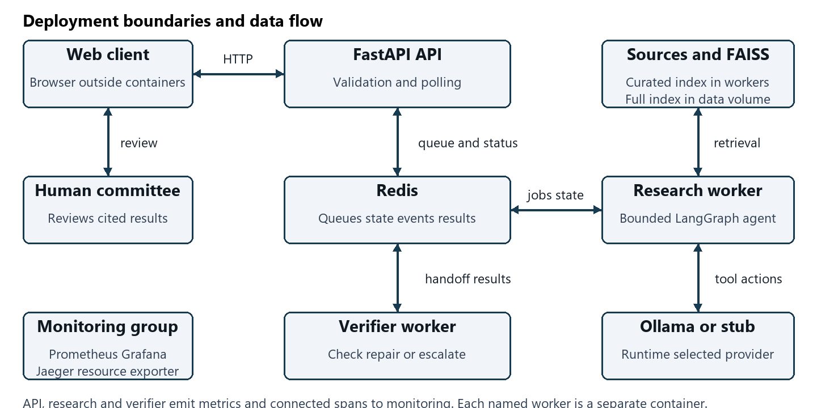
The research agent chooses request_fields, corpus_search, clause_lookup and handoff actions. The verifier checks exact citations and deterministic finite findings, performs one alternate exact-ID retrieval if appropriate, then verifies again or escalates. Bounds: 12 steps, 10 tools, 45 seconds including queueing. Calls have timeouts, up to three attempts, 0.1/0.2-second backoff and a shared breaker opening after two exhausted calls for 15 seconds.

3 Data contracts corpus and retrieval
Pydantic rejects unsupported tender identifiers, incorrect types, negative amounts, missing five-year arrays and unknown fields before agents start. Recursive regex guardrails quarantine obvious injection/toxicity. Responses include run ID, status, findings, citations, verification and human escalation. The four official PDFs have URLs, page mappings and SHA256 fingerprints. Full ingestion produced 128 page-preserving chunks using 1100-character windows and 150-character overlap. Hash embeddings are 512-dimensional; actual nomic semantic embeddings are 768-dimensional. Live screening queries curated exact clauses tested against their source pages. Targeted refresh updated one vector and retained 127 without rebuilding all embeddings.

4 Evaluation method and controlled comparison
Twenty-four fixed cases have expected routes and citation sets. The deliberate v2 change adds policy retrieval, exact follow-up and verifier repair. Metrics are finite-reference proxies, not independent legal judgements. Context precision uses all retrieved contexts. No-finding hallucination is zero by definition and must be read alongside verified coverage.
Metric | Stub v1 | Stub v2
groundedness | 75.00% | 100.00%
context relevance | 100.00% | 91.25%
faithfulness | 75.00% | 100.00%
hallucination rate | 0.00% | 0.00%
The actual CPU Llama batch is preserved separately: v1 verified 12/24, v2 verified 2/24, with groundedness and faithfulness 50% and 8.33%. Timeouts and shared breaker cooldown confound a prompt-only comparison. Ordinary and startup HTTP smoke runs did verify successfully at 18.53 and 40.75 seconds. The startup sample missed the 30-second SLO while remaining within the 45-second hard deadline. These limitations are part of the measured result.

5 Predeclared SLO capacity and scaling
The declared target is complete-run p95 ≤30 seconds. Locust measures submission through a terminal verified result, including queueing and polling. The actual matrix uses a 0.5-second HTTP stub, 10-second warmup, 45-second active runs and graceful draining. These single-host, single-repeat measurements do not establish production capacity.
Workers | Users | Success RPS | p50 s | p95 s | Failed | SLO
1 | 1 | 0.481 | 1.9 | 2.0 | 0 | met
1 | 10 | 0.437 | 16.0 | 16.0 | 0 | met
1 | 20 | 0.319 | 33.0 | 33.0 | 0 | miss
1 | 30 | 0.077 | 45.0 | 45.0 | 15 | miss
3 | 10 | 1.569 | 4.9 | 6.5 | 0 | met
3 | 30 | 1.236 | 17.0 | 17.0 | 0 | met
3 | 60 | 0.892 | 34.0 | 34.0 | 0 | miss
Research performs sequential delayed planning calls; replication increases available research slots. Compare the same concurrency for scaling, and inspect agent histograms and resource metrics. The verification stage remains separate. First tested SLO misses are shown in the full guide. Cache-disabled versus enabled runs are included below; a small difference may reflect noise rather than a useful speedup.
Cache | Success RPS | p50 s | p95 s
disabled | 0.476 | 1.9 | 1.9
enabled | 0.455 | 1.9 | 2.1

6 Costs observability and operational verification
Actual successful-response usage: 61,116 prompt tokens and 5,811 completion tokens over 171 model responses. The largest token-volume action was clause_lookup. Local provider fees were USD 0 per 100 runs, excluding hardware and electricity; failed-call token work may be unknown. Retrieval caching does not eliminate model calls. About 20% of run UUIDs are sampled for reference metrics when labels match; otherwise only a citation proxy is available. Feedback is persisted per run.
Prometheus recorded all eight configured targets healthy; Grafana provisions 17 panels for API, agents and resources. The internal exporter reads Docker and Redis statistics. OpenTelemetry carriers connect API, research and verification; both smoke traces contain all three services. Twenty-three automated tests passed on Windows and Linux. Public GitHub Actions passed. The separate clean-source clone artifact records build and request-path rehearsal using available cached dependencies.

7 Design decisions failures and recovery
Polling was chosen for a local asynchronous demonstration without callback infrastructure. Deterministic finite verification was chosen over a free-form legal judge. The delayed stub isolates repeatable controls and capacity from model variability. The live profile establishes actual inference and semantic retrieval. An automatic policy override, unconditional single-pass answer and result caching without corpus/version keys were rejected.
Genuine incidents include unavailable/scanned source copies, Windows FAISS native setup, WSL bridge DNS build failures, WSL idle shutdown and real CPU inference timeouts. Official text-layer sources, correct native runtime, host build networking and foreground WSL operation recovered the environment. Provider failures produce explicit incomplete escalation; storage and named volumes are preserved during restarts. The runbook covers provider outage and stalled workers. Remaining work for production includes current legal review, certificate authenticity, independent labels, stronger identity/access controls and faster model serving.

8 Reproduction and evidence
Public repository: https://github.com/SasyakSubudhi/TenderScreen-Bid-Compliance. README.md contains base and live startup commands. Generate private configuration, then run the matching Compose command with --build. Do not commit or share generated environment files. docs/DEMO.md maps all ten demonstrations. Evidence includes evaluation.json, live_evaluation.json, live_costs.json, load_matrix.json, incremental_semantic.json, observability.json, docker_live_smoke.json, docker_stub_smoke.json and the final container test log. The comprehensive companion guide explains components, functions, formulas, worked cases, glossary and 70 viva questions.

