DBMS MINI PROJECT

RESORT MANAGEENT SYSTEM : -

Submitted By :

SATISH G HUDDAR

PES1UG20CS590

V Semester J-Section

# Project Description :

Traditionally, all the information of the customers who have booked a particular resort is stored in books/ledgers. This is very inefﬁcient and labour intensive. This problem can be solved using SQL database, which is stored digitally and information is safe.

The database consists of several entities like customer, resort, offers, food_item, reservation, bill,. Etc which contain all the necessary information.

# Scope :

To create a website system for managing resort reservations and make it easier for the user to book the resort and buy ticket

# Entity Relationship (ER) Diagram :

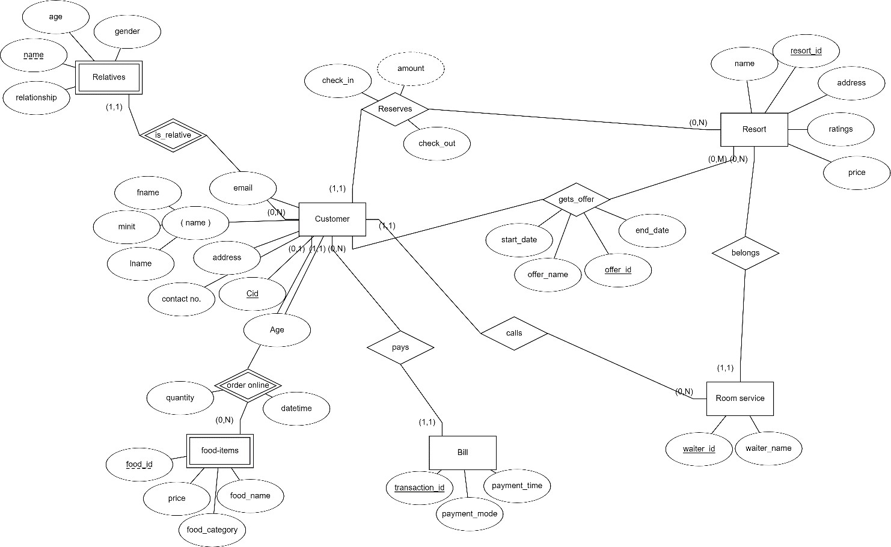

**Relational Schema :**

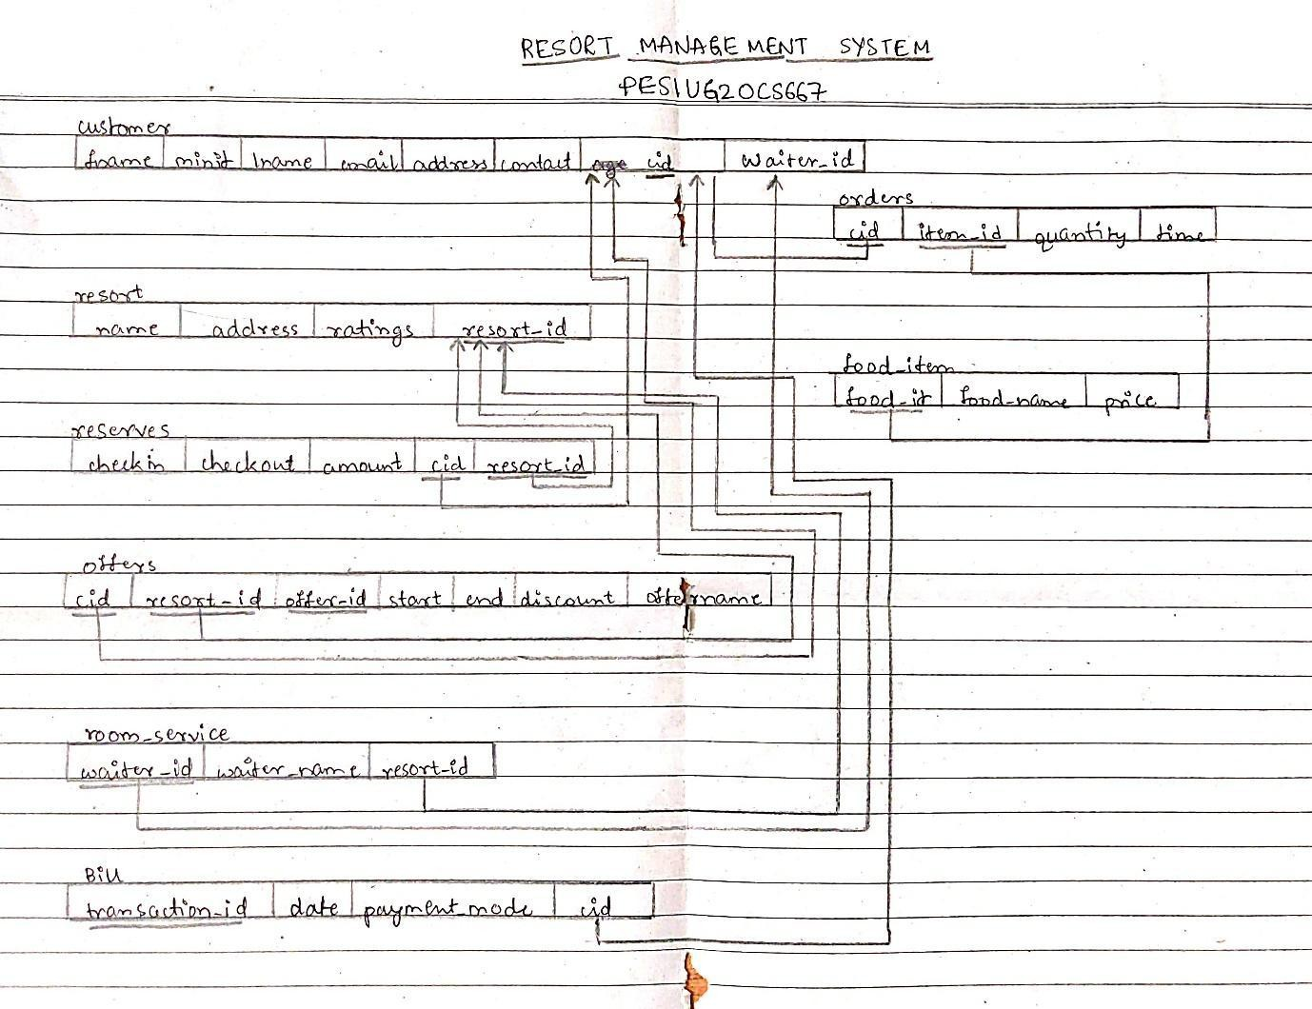

DDL Statements-Building the Database

CREATE TABLE resort (

resort_id DECIMAL(4, 0) PRIMARY KEY CHECK (resort_id > 0), resort_name varchar(50) NOT NULL,

address varchar(40) NOT NULL, rating DECIMAL(3,2), price_per_day float

);

CREATE TABLE room_service (

waiter_id DECIMAL(3, 0) PRIMARY KEY,

waiter_name varchar(20), resort_id DECIMAL(4, 0),

FOREIGN KEY (resort_id) REFERENCES resort(resort_id) ON DELETE CASCADE

);

CREATE TABLE customer (

cid Decimal(4, 0) PRIMARY KEY CHECK (cid > 0), fname VARCHAR(20),

minit CHAR(1), lname VARCHAR(20),

address varchar(30), email varchar(30), contactNo DECIMAL(10, 0),

waiter_id DECIMAL(3, 0),

FOREIGN KEY (waiter_id) REFERENCES room_service(waiter_id) ON DELETE CASCADE

);

CREATE TABLE offers ( offer_id DECIMAL(2, 0), offer_name varchar(20),

cid DECIMAL(4, 0) CHECK (cid > 0),

resort_id DECIMAL(4, 0) CHECK (resort_id > 0), discount int,

startdate DATE, enddate DATE,

FOREIGN KEY (resort_id) REFERENCES resort(resort_id) ON DELETE CASCADE, FOREIGN KEY (cid) REFERENCES customer(cid) ON DELETE CASCADE,

PRIMARY KEY(resort_id, cid, offer_id)

);

CREATE TABLE reservation(

cid DECIMAL(4, 0) CHECK (cid > 0),

resort_id DECIMAL(4, 0) CHECK (resort_id > 0), checkin DATE NOT NULL,

checkout DATE NOT NULL, amount float,

CHECK (checkout > checkin),

FOREIGN KEY (cid) REFERENCES customer(cid) ON DELETE CASCADE,

FOREIGN KEY (resort_id) REFERENCES resort(resort_id) ON DELETE CASCADE, PRIMARY KEY(resort_id, cid)

);

CREATE TABLE relatives( cid DECIMAL(4, 0),

relative_name VARCHAR(20), gender char(1), relationship VARCHAR(20),

FOREIGN KEY (cid) REFERENCES customer(cid) ON DELETE CASCADE ON UPDATE CASCADE,

PRIMARY KEY (cid, relative_name)

);

CREATE TABLE food_item ( food_id decimal(2, 0), food_name varchar(20), price numeric CHECK (

price BETWEEN 0.00 AND 500.00

),

PRIMARY KEY(food_id)

);

= customer orders food via some food delivery app CREATE TABLE orders (

cid DECIMAL(4, 0),

item_id DECIMAL(3, 0), quantity INT,

time DATETIME,

FOREIGN KEY(cid) REFERENCES customer(cid) ON DELETE RESTRICT,

FOREIGN KEY(item_id) REFERENCES food_item(food_id) ON DELETE RESTRICT, PRIMARY KEY (cid, item_id)

);

= number of digits in transaction Id varies, 12 is most common CREATE TABLE bill (

transaction_id DECIMAL(12, 0) PRIMARY KEY, date DATE,

cid DECIMAL(4, 0),

paymentmode varchar(10),

FOREIGN KEY(cid) REFERENCES customer(cid) ON DELETE RESTRICT

);

DML Statements-Populating the Database

insert into food_item Values('01','thaali','400');

insert into food_item Values('02','pizza','250');

insert into food_item Values('03','ghee rice','120');

insert into food_item Values('04','schezwan fried rice','120');

insert into food_item Values('05','chicken biryani','180');

insert into food_item Values('06','mutton thaali','320');

insert into food_item Values('07','surma fish','240');

insert into offers Values('01','winter vaction', '1001','1006','20','2022-12-20','2022-12-30');

insert into offers Values('02','diwali offer', '1005','1001','15','2022-10-01','2022-12-31');

insert into offers Values('03','special offer', '1007','1007','25','2022-11-01','2022-12-31');

insert into resort Values ('1001',"The Dukes Retreat",'Lonavala',5,1999);

insert into resort Values ('1002',"Ferreira Resort",'Lonavala',4,1799);

insert into resort Values ('1003',"Villa San Lorentz",'Lonavala',5,1699);

insert into resort Values ('1004',"Misty Meadows",'Lonavala',4,1499);

insert into resort Values ('1005',"Sunshine Resort",'Lonavala',5,1699);

insert into resort Values ('1006',"Dandeli Jungle Resort",'Dandeli',5,1499);

insert into resort Values ('1007',"Wild Planet Jungle Resort",'Dandeli',5,1299);

insert into resort Values ('1008',"Swast-Mast Resort",'Lonavala',4,1399);

insert into resort Values ('1009',"Alurkar Resort",'Belgaum',5,1499);

insert into resort Values ('1010',"Gavkari",'Belgaum',5,999);

insert into room_service Values('101','chotu','1001');

insert into room_service Values('102','bhola','1002');

insert into room_service Values('103','brijesh','1003');

insert into room_service Values('104','ajay','1004');

insert into room_service Values('105','shukh','1005');

insert into room_service Values('106','vikalp','1006');

insert into room_service Values('107','alam','1007');

insert into room_service Values('108','suresh','1008');

insert into room_service Values('109','keshav','1006');

insert into room_service Values('110','sharad','1009');

insert into room_service Values('111','munna','1010');

insert into customer Values('1001','narendra','','modi','gujarat' ,'modi@gmail.com' ,'1234567890','106');

insert into customer Values('1002','amit','','shah','gujarat' ,'shah@gmail.com' ,'1234567890','102');

insert into customer Values('1003','atal','b','vajpayee','bihar' ,'vajpayee@gmail.com' ,'1234567890','103');

insert into customer Values('1004','abdul','','kalam','patna' ,'aniket@gmail.com' ,'1234567890','104');

insert into customer Values('1005','yogi','','adityanath','uttar pradesh' ,'yogi@gmail.com' ,'1234567890','102');

insert into customer Values('1006','balasaheb','','thakre','mumbai' ,'thakre@gmail.com' ,'1234567890','101');

insert into customer Values('1007','basavraj','','bommai','karnataka' ,'bommai@gmail.com' ,'1234567890','102');

insert into bill Values('250707244234','2022-11-21','1001','upi');

insert into bill Values('202622637838','2022-11-22','1002','debit card');

insert into bill Values('644161913172','2022-11-15','1003','credit card');

insert into bill Values('988602103725','2022-11-21','1004','upi');

insert into bill Values('859741505883','2022-11-21','1005','cash');

insert into bill Values('346488919858','2022-11-26','1006','credit card');

insert into orders Values('1001','1','3','2022-11-21  10:55:05');

insert into orders Values('1002','4','4','2022-11-21  13:56:55');

insert into orders Values('1003','5','2','2022-11-10  12:35:05');

insert into orders Values('1004','7','8','2022-11-20  21:55:05');

insert into orders Values('1002','3','1','2022-11-18  07:24:05');

insert into orders Values('1006','4','4','2022-11-25  09:18:05');

insert into relatives Values('1002','bhaskar bhat','m','friend');

insert into relatives Values('1003','vijay verma','m','friend');

insert into relatives Values('1003','sujay patil','m','friend');

insert into relatives Values('1004','sharad shukla','m','friend');

insert into relatives Values('1004','anil desai','m','son');

insert into relatives Values('1005','manish gupta','m','colleague');

insert into relatives Values('1005','kartik singh','m','colleague');

insert into relatives Values('1005','shilpa trivedi','f','colleague');

insert into relatives Values('1006','manthan patil','m','friend');

insert into reservation values('1001','1001','2022-11-11','2022-11-21',15592);

insert into reservation values('1002','1002','2022-11-15','2022-11-22',12593);

insert into reservation values('1003','1003','2022-11-15','2022-11-227',11893);

insert into reservation values('1004','1004','2022-11-16','2022-11-21',7495);

insert into reservation values('1005','1005','2022-11-18','2022-11-21',4077.6);

insert into reservation values('1006','1006','2022-11-20','2022-11-26',8994);

## Tools Used

* UI for database operations – streamlit
* Database connection – mysql-connector-python
* Xampp

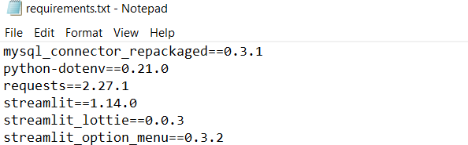

## QUERIES

JOIN QUERIES

1. **Display ﬁrst name of customer and name waiter assigned to him**

select fname, waiter_name from customer as c join room_service as w on c.waiter_id = w.waiter_id;

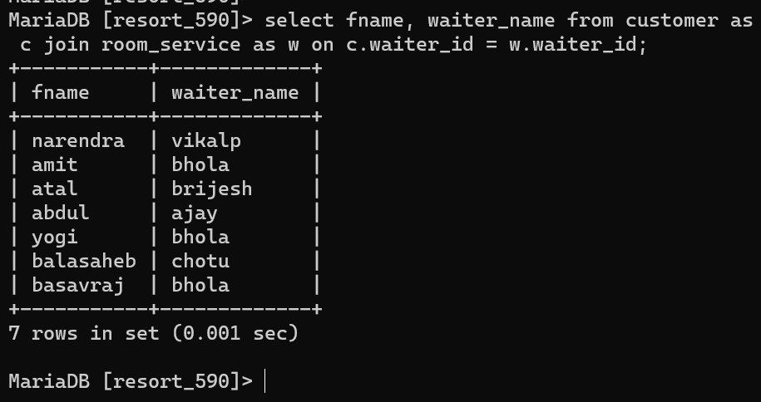

1. **Display food_name, price and quantity of all food orders made by customer with cid=1001**

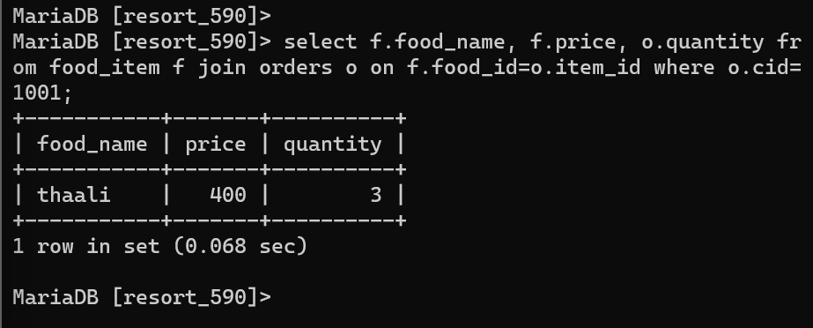

1. **Display resort_id, resort name and address of all those resorts where the number of bookings is greater than 1.**

select r.resort_id, r.resort_name,r.address from resort r where r.resort_id in (

select re.resort_id from reservation re group by re.resort_id having count(*) > 1

);

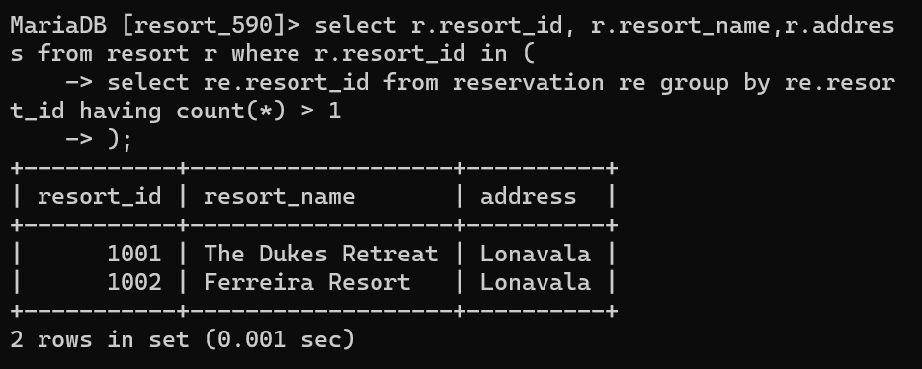

1. **Display information of resort which are available for booking**

select r.resort_id, r.resort_name, r.address from resort r where not exists (select * from reservation re where re.resort_id=r.resort_id);

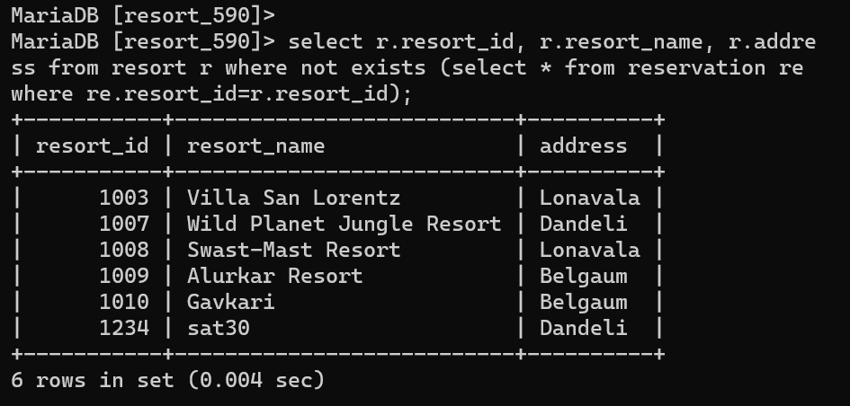

## AGGREGATE FUNCTIONS

1. **Display total bookings for each resort**

select r.resort_id, r.resort_name, count(*) as total_bookings from resort r join reservation rs on r.resort_id=rs.resort_id group by resort_id;

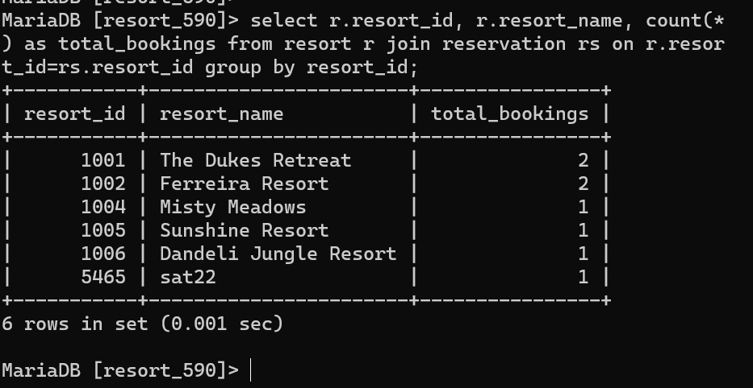

1. **List all resorts city wise**

select r.address as location, count(*) total_resorts from resort r group by r.address;

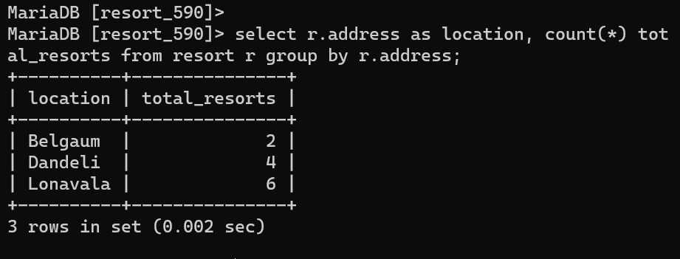

1. **To find number of payments done through different modes**

select paymentmode,count(*) from bill GROUP BY paymentmode;

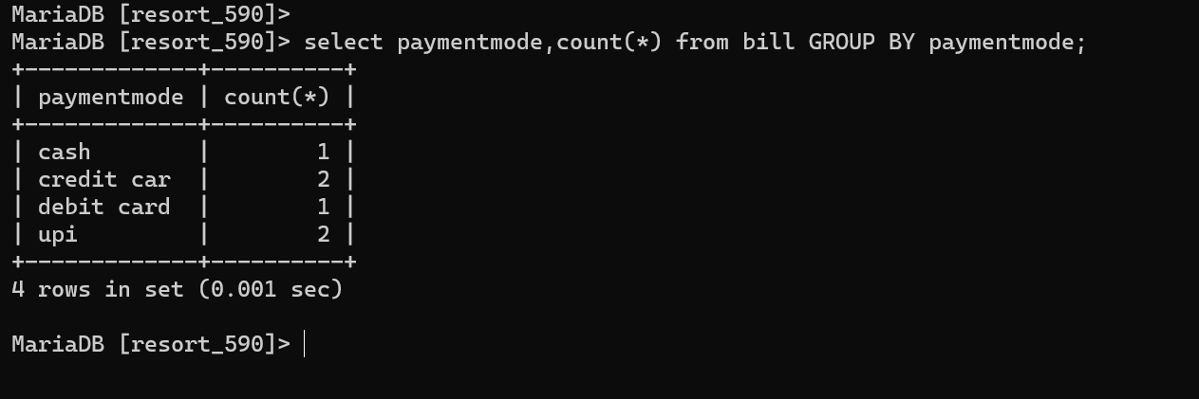

1. **Number of resorts Rating wise**

select rating,count(*) from resort GROUP BY rating;

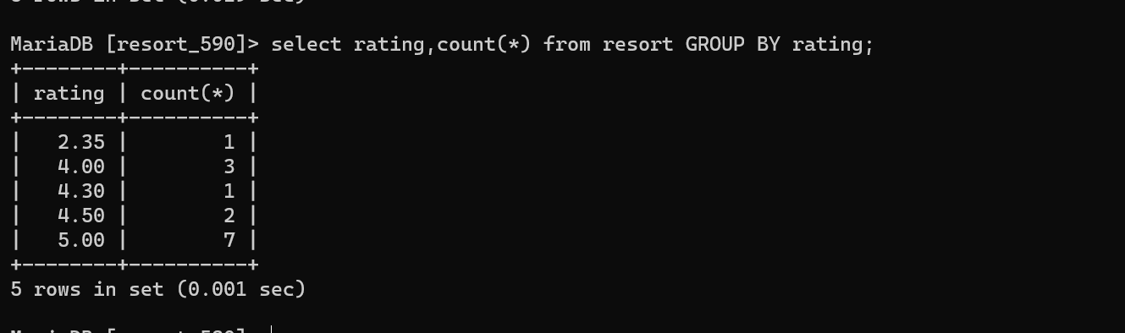

## SET OPERATIONS

1. **List all customers who have booked a resort with “Diwali offer” in Lonavala.**

(select re.cid from reservation re natural join resort r where address="lonavala")

Union

(select c.cid from customer c natural join offers o where offer_name="diwali offer");

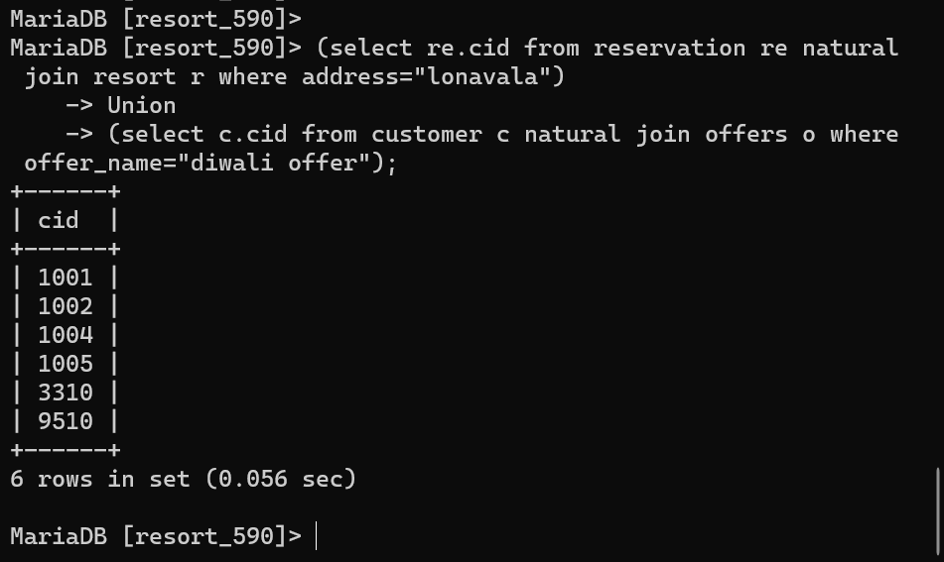

1. **List all customers who have NOT paid the bill but have ordered food item**

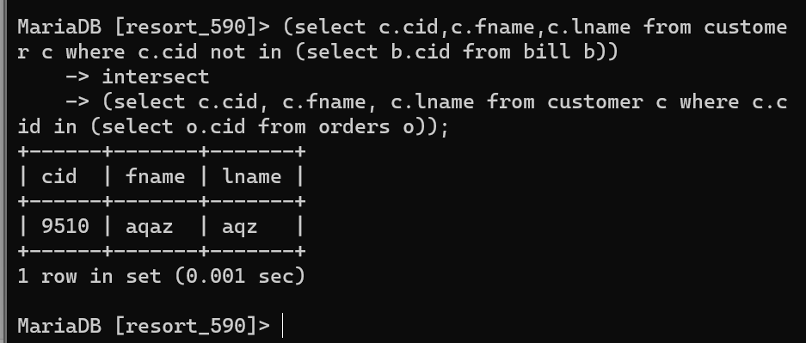

1. **List Customer who not got any offer**

Select cid,fname from customer except select cid from offers;

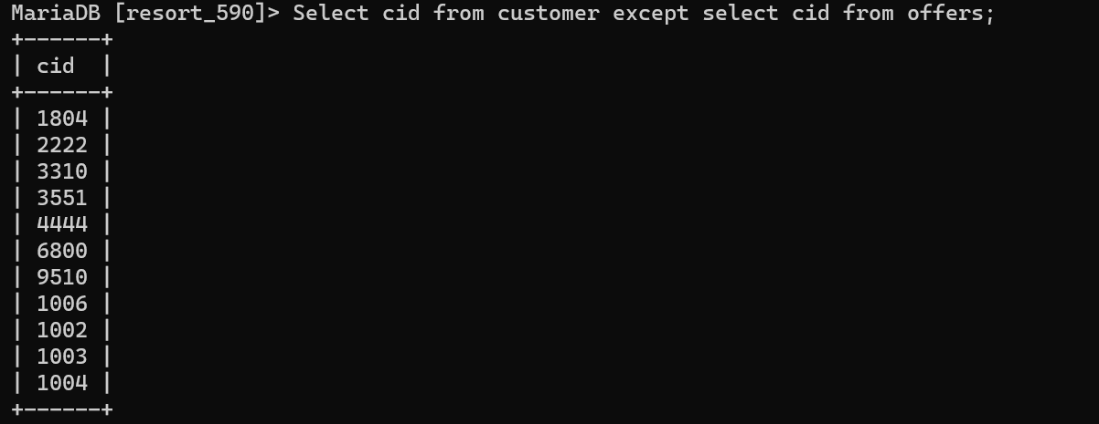

1. **To find resort which not have reserved**

Select resort_id from resort EXCEPT Select resort_id from reservation;

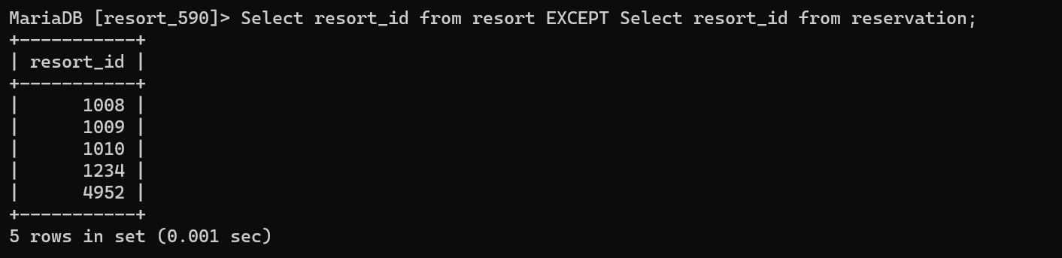

## FUNCTIONS

1. To convert rating to feedback
2. DELIMITER $$
3. CREATE FUNCTION ratef(rate decimal(1))
4. RETURNS VARCHAR(50)
5. DETERMINISTIC
6. BEGIN
7. IF rate < 3 THEN
8. RETURN "Average";
9. ELSE
10. RETURN "Very Good";
11. END IF;
12. END$$
13. DELIMITER ;

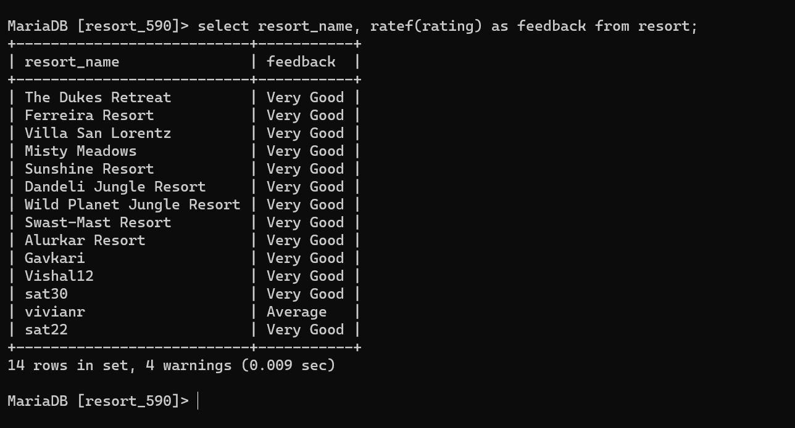

## STORED PROCEDURE

1. display information of all resorts in a given city

DELIMITER $$

CREATE OR REPLACE PROCEDURE get__resort_count(IN city varchar(15), OUT r_count integer)

BEGIN

SELECT COUNT(*) into r_count FROM resort where address=city; END $$

DELIMITER ;

SET @r_count=0;

CALL get__resort_count(“Nanadi”, @r_count); SELECT @r_count;

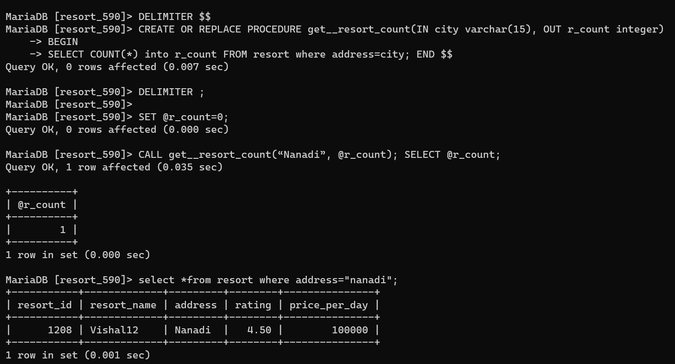

## TRIGGERS

1. display error message when a new entry is added to a resort which is already booked.

DELIMITER $$

CREATE OR REPLACE TRIGGER valid_reservation_on_insert BEFORE INSERT

ON reservation FOR EACH ROW BEGIN

DECLARE error_msg VARCHAR(255);

SET error_msg = ("Resort is already booked!");

*-- if checkin for new entry is before checkout for that resort IF NEW.checkin < (select checkout from reservation where*

resort_id=NEW.resort_id) THEN SIGNAL SQLSTATE='45000'

SET MESSAGE_TEXT = error_msg; END IF;

END $$

CREATE OR REPLACE TRIGGER valid_reservation_on_update BEFORE UPDATE

ON reservation FOR EACH ROW BEGIN

DECLARE error_msg VARCHAR(255);

SET error_msg = ("Resort is already booked!");

*-- if checkin for new entry is before checkout for that resort IF NEW.checkin < (select checkout from reservation where*

resort_id=NEW.resort_id) THEN SIGNAL SQLSTATE '45000'

SET MESSAGE_TEXT = error_msg; END IF;

END $$ DELIMITER ;

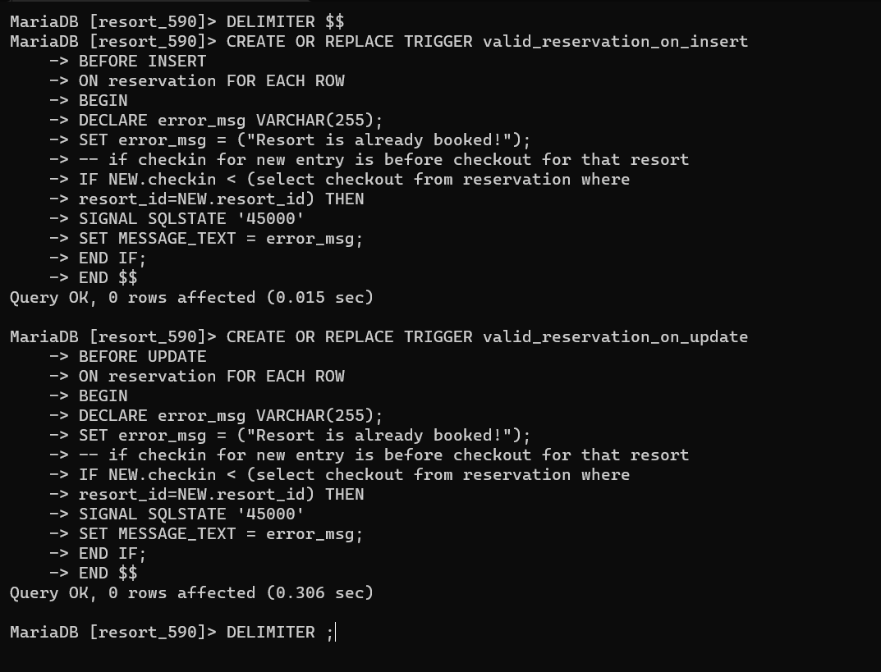

Example

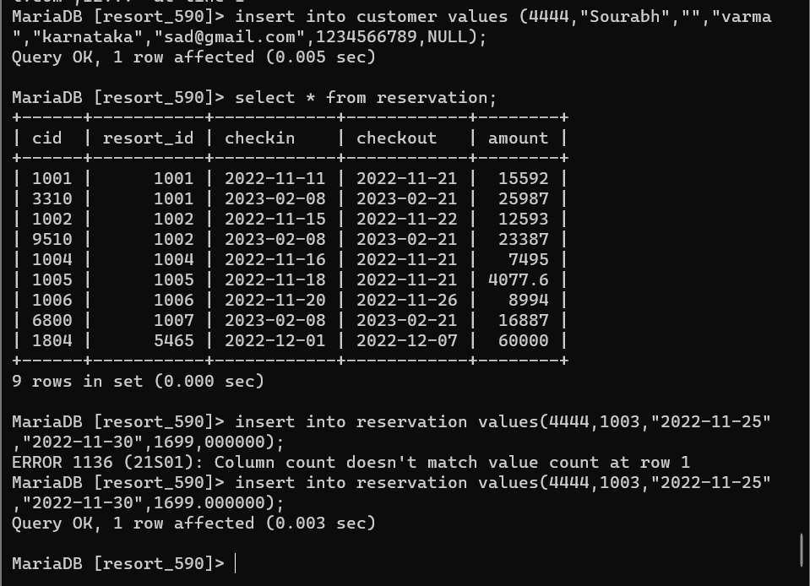Successful insertion

Case when error is triggered

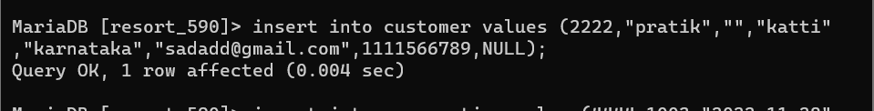

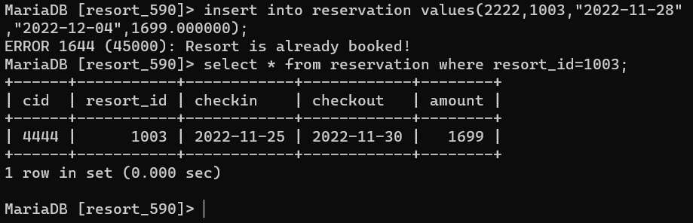

## CURSORS

Cursor :

To Create backup table for food item

CREATE TABLE `Curbackup_foodItem` (

  `food_id` int(11) DEFAULT NULL,

  `food_name` varchar(30) DEFAULT NULL,

  `price` int(11) DEFAULT NULL

);

DELIMITER $$

CREATE PROCEDURE curs()

BEGIN

DECLARE done INT DEFAULT 0;

DECLARE foodid , price int(10);

DECLARE foodname VARCHAR(20);

DECLARE cur CURSOR FOR SELECT * FROM food_item;

DECLARE CONTINUE HANDLER FOR NOT FOUND SET done = 1;

OPEN cur;

label: LOOP

FETCH cur INTO foodid ,  foodname , price;

INSERT INTO Curbackup_foodItem VALUES(foodid ,  foodname , price);

IF done = 1 THEN LEAVE label;

END IF;

END LOOP;

CLOSE cur;

END;$$

DELIMITER ;

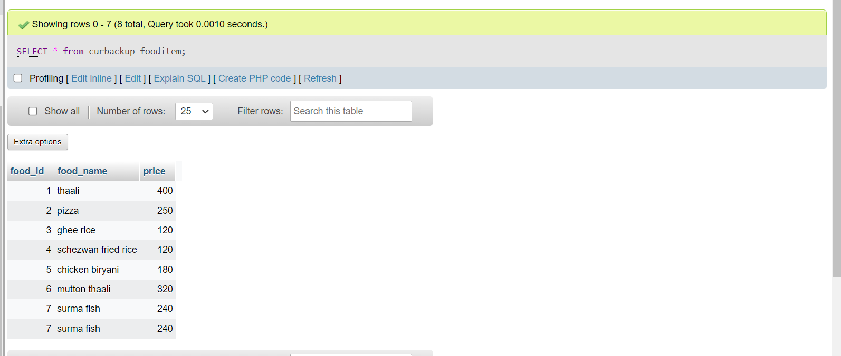

## Developing a Frontend

## The frontend should support

## 1. Addition, Modiﬁcation and Deletion of records from any chosen table – Done✅

## 2. There should be a window to accept and run any SQL statement and display the result – Done✅

## Frontend made using Streamlit

### Frontend Visuals

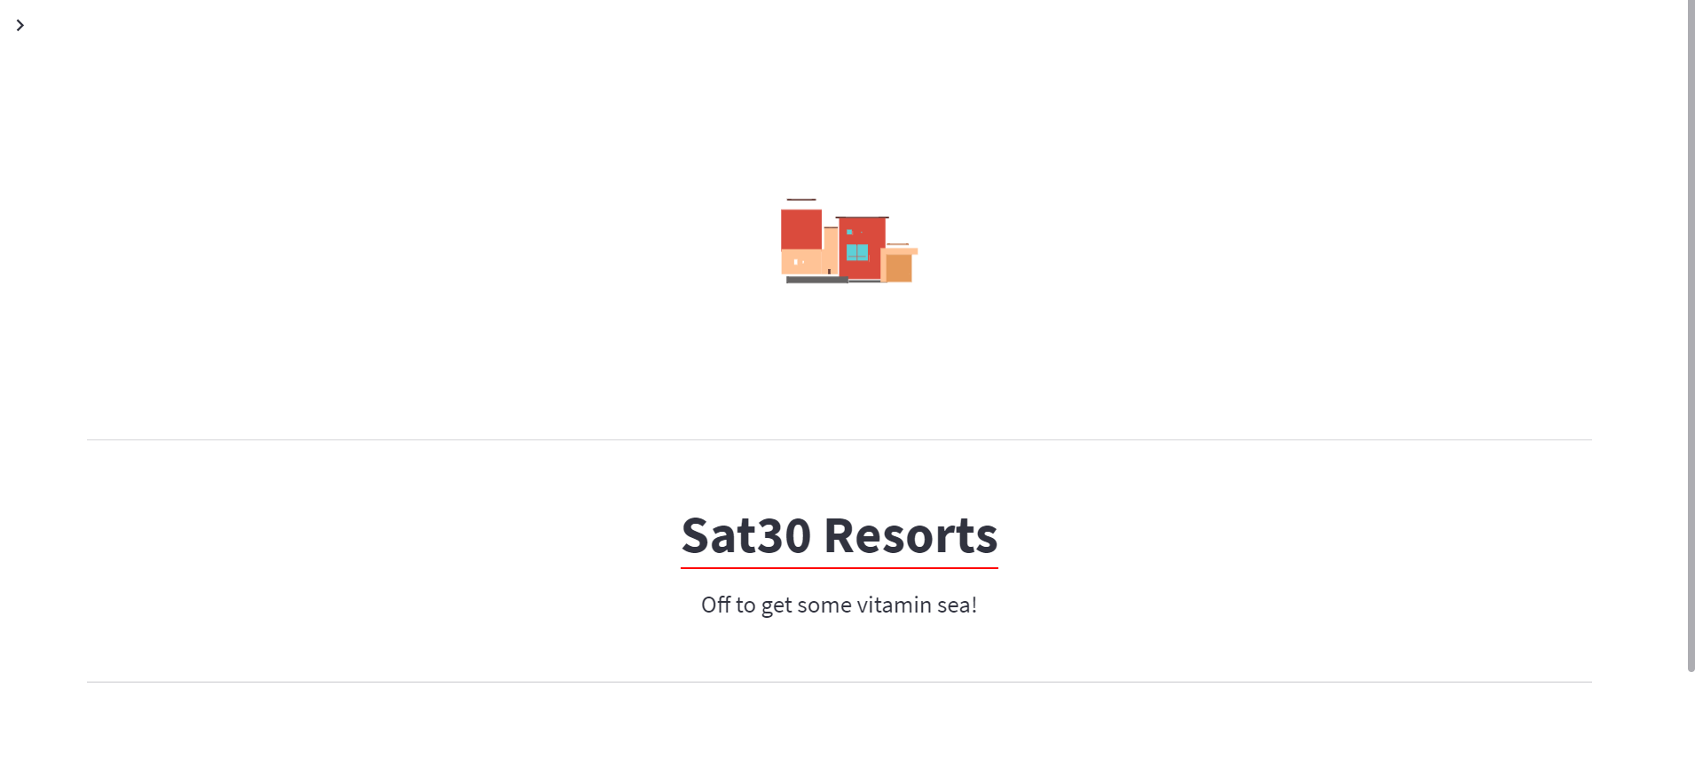

INSERT - OPERATION

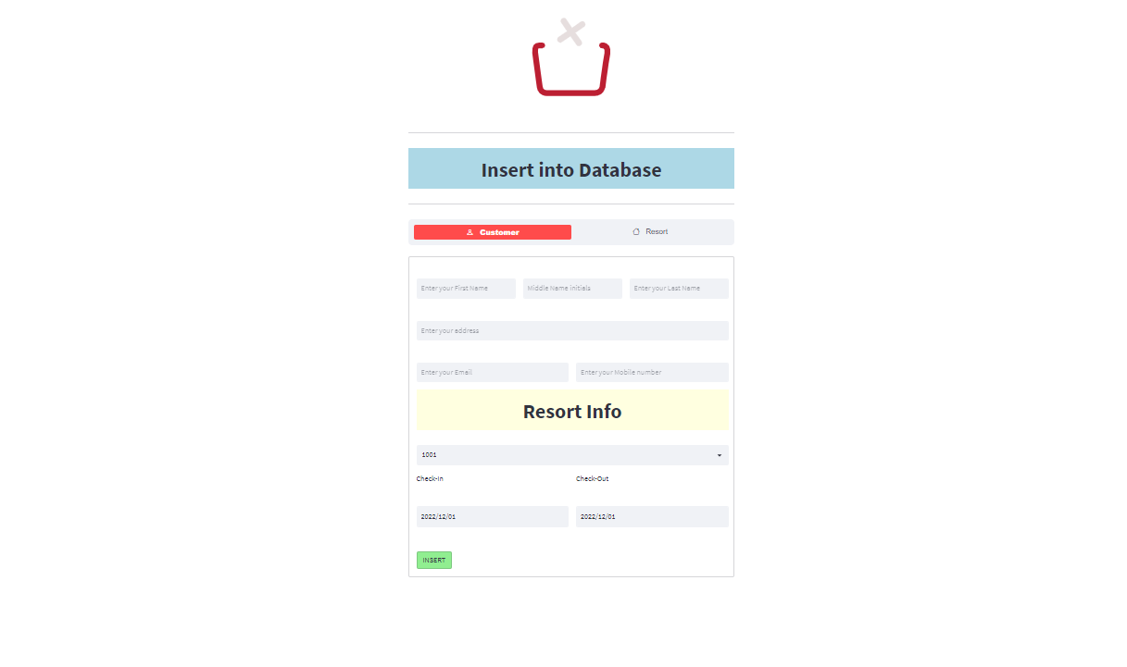

### READ-OPERATION

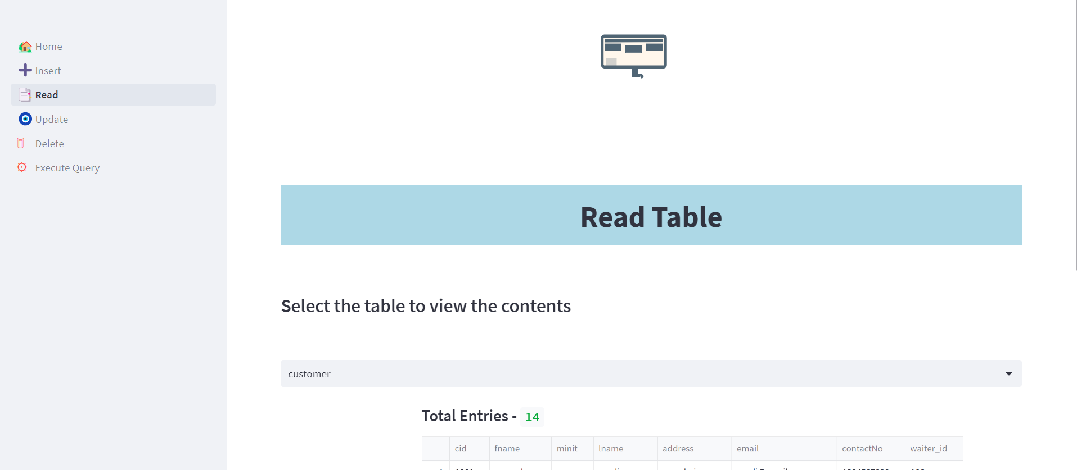

UPDATE-OPERATION

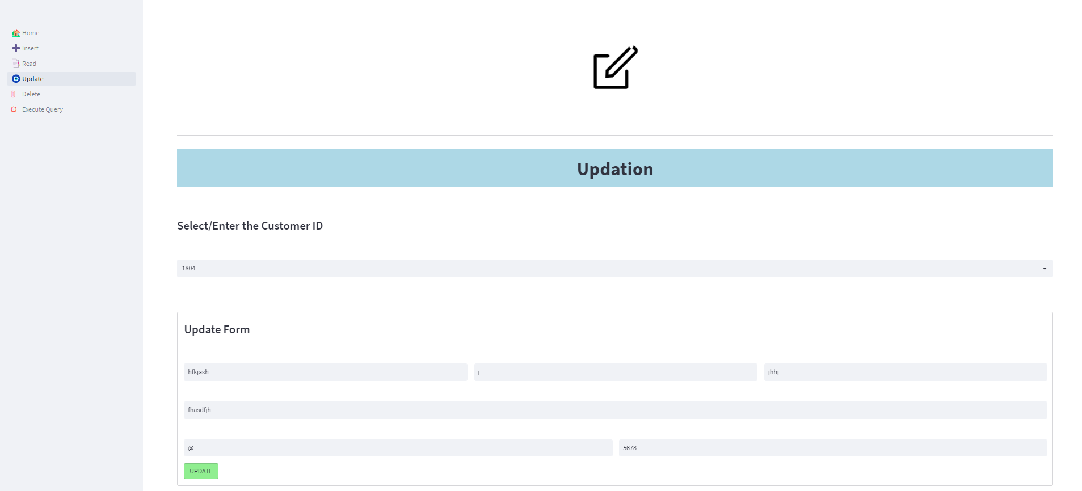

### DELETE-OPERATION

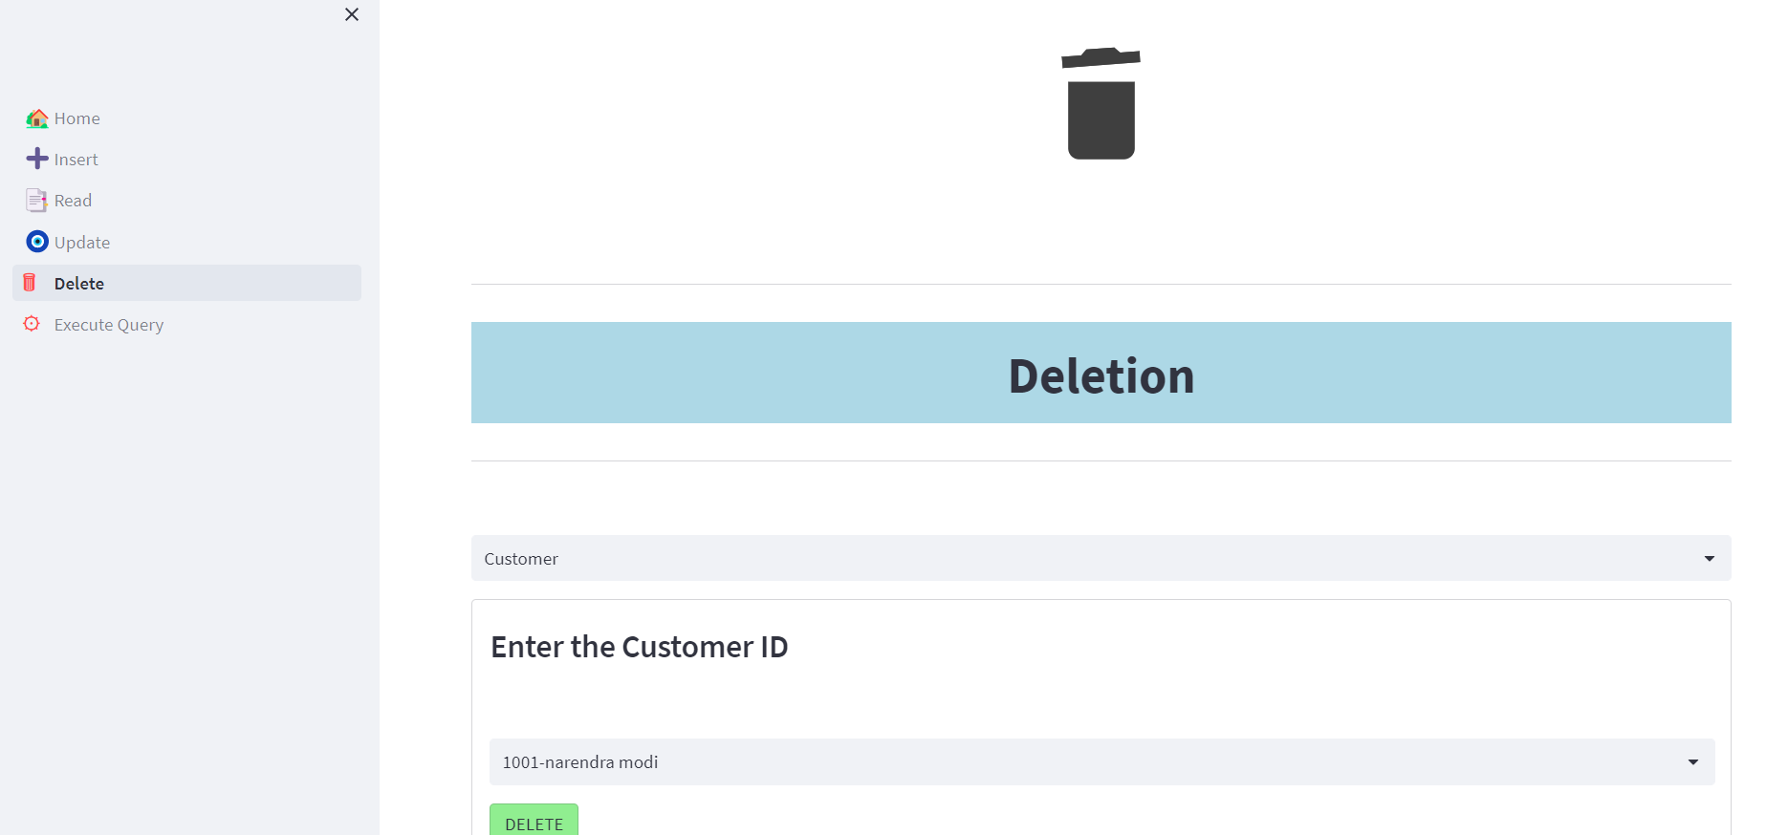

QUERY-EXECUTION

