 | CORE FLIGHT SYSTEM  Health and Safety  BUILD 2.2.0.0  FLIGHT SOFTWARE BUILD VERIFICATON  TEST REPORT  Flight Software Branch – Code 582  Version 1.0

Signatures
Submitted by:

_______________________________________ _______________
Walt Moleski/582 Date
CFS Flight Software Tester

Approved by:

_______________________________________ _______________
Charlie Wildermann/582 Date
Flight Software Branch/Head

_______________________________________ _______________
Barbie Medina/582 Date
CFS Flight Software Product Development Lead

Plan Update History
Version | Date | Description | Affected Pages
Draft 0.1 | 10/24/2011 | Draft for review | All
1.0 | 10/26/2011 | Initial Release | All

Table of Contents
1 Introduction 1
1.1 Document Purpose 1
1.2 Applicable Documents 1
1.3 Document Organization 1
1.4 Definitions 2
2 OVERVIEW 3
2.1 Flight Data System Context 3
2.2 Test History 4
2.3 Testing Overview 4
2.4 Version Information 8
3 Build Verification Test Preparation 9
3.1 Scenerio Development 9
3.2 Procedure Development and Execution 9
3.3 Test Products 9
4 Build Verification Test Execution 10
4.1 Testbed Overview 10
4.2 Requirements Verification Matrix 11
4.3 Requirements Partially Tested 11
4.4 Requirements/Functionality Deferred 11
4.5 Requirements/Functionality Deferred for Mission Testing 11
5 Build Verficiaton Test Results 12
5.1 Overall Assessment 12
5.2 Procedure Description 12
5.3 Analysis Requirements Verification 13
5.4 DCRs 15
5.4.1 DCRs Verified 15
5.4.2 Outstanding DCRs 16
5.5 Notes 16
Appendix A - RTTM 17
Appendix B - Command, Telemetry, and Events Verification Matrix 18

Introduction

Document Purpose

This Test Report describes the test results from the Core Flight System (CFS) Health and Safety (HS) Flight Software (FSW) Test Team build 2.2.0.0 verification testing. It is used to verify that the HS FSW has been tested in a manner that validates that it satisfies the functional and performance requirements defined within the CFS HS Requirements Document. This Test Report summarizes the FSW test history, the build verification process, the build test configuration, and the test execution and results.

Applicable Documents
Unless otherwise stated, these documents refer to the latest version.

Parent Documents (Mission and FSW)

- 582-2008-037 CFS Health and Safety Requirements Document, Version 1.3
- 582-2008-012 CFS Deployment Guide

Reference Documents

All of the references below can be found on the Code 582 internal website at http://fsw.gsfc.nasa.gov/

- 582-2003-001 FSB FSW Test Plan Template
- 582-2004-001 FSB FSW Test Description Template
- 582-2004-002 FSB FSW Test Scenario Template
- 582-2004-003 FSB FSW Test Procedure Template
- 582-2004-004 FSB FSW Test Execution Summary Template
- 582-2004-005 FSB Test Product Peer Review Form
- 582-2000-002 FSB FSW Unit Test Standard

Document Organization
Section 1 of this document presents some introductory material.
Section 2 provides a flight software overview and context along with the test history and testing overview.
Section 3 describes the build verification process including procedure development and execution and test products produced.
Section 4 describes the build test configuration which includes an overview of the testbed and the requirements verification matrix.
Section 5 describes the test execution and results by subsystem.
Appendix A - provides the Requirements Traceability Matrix
Appendix B - provides the Command, Telemetry, and Events Verification Matrix

Definitions
There were 3 verification methods used during build verification testing. They were:
- Demonstration: Show compliance with system requirement by exhibiting the required capability (e.g. by demonstrating interactive capability, display capability, print capability, etc.
- Inspection: Show compliance with a system requirement by visual verification of the software (e.g. verifying preparation for delivery, proper interfacing)
- Analysis: Perform detailed analysis of code, generated data (both intermediate data and final output data), etc., to determine compliance with system requirements.

The fields in the Requirements Verification Matrix in Section 4.3 are defined as follows:
- Requirements Tested Passed: Requirement was fully tested in a build test procedure and passed all tests.
- Requirements Tested Failed: Requirement was fully tested in a build test procedure and failed one or more aspect of the testing.
- Requirements Tested Partially: Requirement was tested partially in a build test procedure. To be fully tested, the partially tested requirement is either tested additionally in one or more other test procedures within the same build and/or other aspects of the requirement must be tested in a later build, due to capabilities not present in the current build
- Total Tested: Total number of requirements fully tested in a build test procedure. Includes total passed and total failed, but does not include requirements tested partially, unless (included as a separate entry) testing in multiple procedures within the same build constitutes total testing of a particular requirement. Total Requirements Tested is computed this way in order to avoid multiple counting of individual requirements that are tested partially in more than one procedure.
- Deferred: Number of requirements that were planned to be tested in current build, but were not tested due to some FSW capability or necessary system component not being present.
- Total: Total Requirements Tested + Number of Requirements Deferred

In each software test section in Section 5 there is a table of DCR’s. The state definitions are as follows:
- Opened: The DCR is currently being addressed
- Assigned: The DCR was accepted and the modification is being addressed
- InTest: The DCR was corrected and is currently in test
- Validated: The DCR was corrected and tested and has been validated, needs to have a CCB to close the DCR
- Closed: The DCR is closed and have been resolved and tested to satisfaction
- Closed with Defect: The DCR is closed and the defect is most likely assigned a differed DCR number associated with another subsystem.

OVERVIEW

Flight Data System Context
Figure 2-1 illustrates the CFS system context. The cFE interfaces to five external systems: an Operating System (OS), a Hardware Platform (HP), an Operational Interface (OI), Applications (APP), and other cFE-based systems.

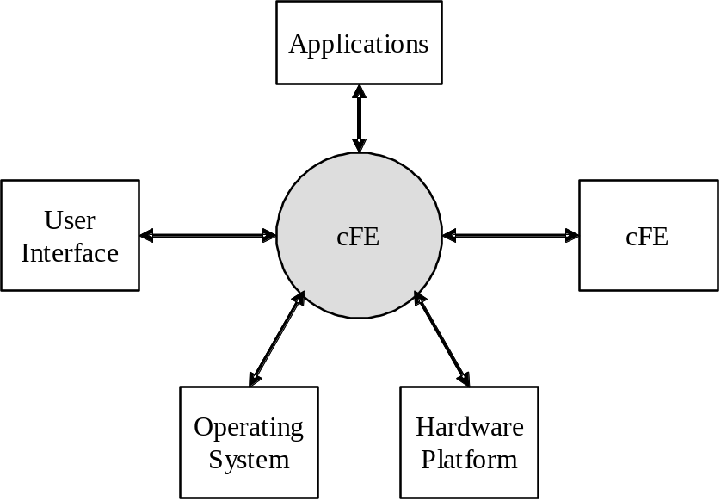

Figure 2-1 CFS System Context
The figure below shows major interfaces between the Health and Safety application and other core Flight Executive (cFE) tasks and CFS applications. Although it isn’t shown explicitly, all task-to-task communications are accomplished via the cFE Software Bus (SB) application.
Inputs to the HS application include: 1) Wake-up calls from the Scheduler (SCH) application which trigger processing, 2) Housekeeping requests from the SCH application which trigger housekeeping data collection, 3) configuration commands from the Command Ingest (CI) task, 4) updates to the Health and Safety Tables managed by the Table Services (TBL) application, 5) Event Messages from the Event Services (EVS) application, and 6) Application information from the Executive Services (ES) application.
Outputs from the HS application include: 1) HS housekeeping messages sent to the Housekeeping (HK) application, 2) Processor Reset calls sent to the ES application, 3) Software Bus messages sent to system applications, 4) Event Messages, 5) Watchdog management commands to the Operating System/Board Support Package (OS/BSP), and 6) CPU Aliveness characters to the UART.

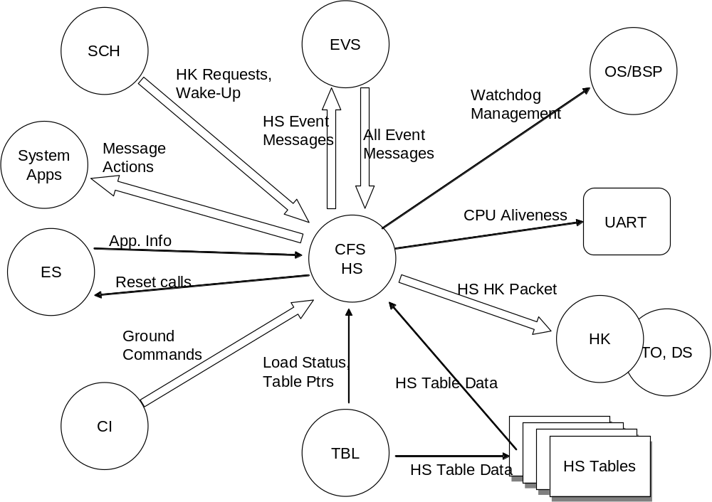
Figure 2-2 CFS HS Context

Test History
HS 1.0.0.0 – Build Verification Testing completed 7/14/2009 by Walt Moleski
HS 2.0.0.0 – Build Verification Testing completed 9/11/2009 by Walt Moleski
HS 2.1.0.0 – Build Verification Testing completed 1/19/2011 by Walt Moleski
HS 2.2.0.0 – Build Verification Testing completed 10/20/2011 by Walt Moleski

Testing Overview
The CFS Test procedures assume that the CFS application and its corresponding test application are not executing before the start of the test. If this is the case, the test procedures will need to be modified to handle this situation.

The HS application was tested during Build Verification testing using the following:
- 1 test application: tst_hs
- 8 main test procedures: hs_appmon.prc, hs_cpuhog.prc, hs_eventmon.prc, hs_exectr.prc, hs_gencmds.prc, hs_reset.prc, hs_stress.prc, hs_watchdog.prc
- 13 procedures that setup the Critical Application Definition Table: hs_amt1.prc to hs_amt13.prc
- 9 procedures that setup the Critical Event Definition Table: hs_emt1.prc to hs_emt9.prc
- 4 procedures that setup the Execution Counter Definition Table: hs_xct1.prc to hs_xct4.prc
- 2 procedures that setup the Message Action Definition Table: hs_mat1.prc and hs_mat2.prc
- 1 procedures called by the main procedures to startup the HS and TST_HS applications: hs_start_apps.prc
- All tests require the Advanced Spacecraft Integration and System Test (ASIST) Ground Station

The TST_HS test application is used to send schedule requests for the output of HS’s housekeeping data to the HS application. This was useful when performing build verification testing since it provided great control over the sequence of steps. In addition, having the test application eliminated the need to modify the SCH_LAB application and rebuild. When deployed for a mission, the Scheduler (SCH) Application would provide this request. In addition, the test application has 8 ground commands defined to help with the HS testing. These commands are described below:
- TST_HS_NOOP
  - This command that issues an event and increments the command processed counter.
- TST_HS_ResetCtrs
  - This command resets the command processed and command error counters to zero (0).
- TST_HS_SetCounters
  - This command sets several Health and Safety (HS) counters so that the HS_ResetCtrs command can be tested and verified.
- TST_HS_SetResetsPerformed
  - This command sets the Processor Resets performed by HS counter to the supplied value such that requirements relating to when the Reset Counter is equal to the MAX Resets allowed can be tested.
- TST_HS_EnableWatchdog
  - This command sets the HS Watchdog Update flag to TRUE allowing the HS application to service the WatchDog Timer.
- TST_HS_DisableWatchdog
  - This command sets the HS Watchdog Update flag to FALSE allowing the HS Application to be stopped without causing a Watchdog Reset.
- TST_HS_SetStartupDelay
  - This command sets a flag that will delay the startup of the TST_HS application to more than the HS_STARTUP_SYNC_TIMEOUT configuration parameter in order to test whether HS begins processing after waiting but never receiving the startup-synch.
- TST_HS_RemoveStartupDelay
  - This command clears a flag set by the SetStartupDelay command.
- TST_HS_HogCPU
  - This command attempts to hog the CPU by looping for the command-specified number of iterations.

The main HS test procedures do the following:

Procedure | Description
hs_appmon | The purpose of this test is to verify the Health and Safety (HS) Application Monitoring commands function properly. Invalid commands as well as anomalies will be tested to see if the HS application handles these appropriately.
hs_cpuhog | The purpose of this test is to verify the Health and Safety (HS) application performs CPU Utilization as stated by the requirements.
hs_eventmon | The purpose of this test is to verify the Health and Safety (HS) Event Monitoring commands function properly. Invalid commands as well as anomalies will be tested to see if the HS application handles these appropriately.
hs_exectr | The purpose of this test is to verify the Health and Safety (HS) handles the Execution Counter Management requirements properly.  NOTE: If the Mission decides not to use Execution Counters, this test can be skipped.
hs_gencmds | The purpose of this test is to verify the Health and Safety (HS) general commands, CPU aliveness and miscellaneous commands function properly. These commands will be tested as well as invalid commands to see if the HS application handles these appropriately.
hs_reset | The purpose of this test is to verify the Health and Safety (HS) Application initializes the appropriate data items based upon the type of initialization that occurs (Application Reset, Processor Reset, or Power-On Reset). This test also verifies that the proper notifications occur if any anomalies exist with the data items stated in the requirements.
hs_stress | The purpose of this test is to verify the Health and Safety (HS) Application handles the maximum <PLATFORM_DEFINED> entries in the Critical Application, Critical Event and Execution Counter Tables.
hs_watchdog | The purpose of this test is to verify the Health and Safety (HS) Application handles the Watchdog Management requirements properly.

The test procedures described in the table below are called by at least one of the test procedures above.

Procedure | Description
hs_amt1 | This procedure generates the default Critical Application Table image.
hs_amt2 | This procedure generates a Critical Application Table image that contains a cFE Core Application that triggers a cFE Processor Reset when it fails to check-in.
hs_amt3 | This procedure generates a Critical Application Table image that contains a cFE Core Application that triggers an Event Message to be sent when it fails to check-in.
hs_amt4 | This procedure generates a Critical Application Table image that contains a cFE Core Application that triggers a Software Bus message to be sent when it fails to check-in.
hs_amt5 | This procedure generates a Critical Application Table image that contains a cFE Non-Core Application that triggers an Application Restart when it fails to check-in.
hs_amt6 | This procedure generates a Critical Application Table image that contains a cFE Non-Core Application that triggers a cFE Processor Reset when it fails to check-in.
hs_amt7 | This procedure generates a Critical Application Table image that contains a cFE Non-Core Application that triggers an Event Message to be sent when it fails to check-in.
hs_amt8 | This procedure generates a Critical Application Table image that contains a cFE Non-Core Application that triggers a Software Bus message to be sent when it fails to check-in.
hs_amt9 | This procedure generates a Critical Application Table image that contains the maximum <PLATFORM_DEFINED) entries.
hs_amt10 | This procedure generates a Critical Application Table image that contains two cFE Non-Core Applications that will never execute.
hs_amt11 | This procedure generates a Critical Application Table image that contains invalid data in order to test how HS handles table validation failures.
hs_amt12 | This procedure generates a Critical Application Table image that contains the maximum <PLATFORM_DEFINED> entries with different actions in order to perform some stress testing.
hs_amt13 | This procedure generates a Critical Application Table image that contains multiple entries for the HS application. Each entry specifies a different action.
hs_emt1 | This procedure generates the default Critical Event Table image.
hs_emt2 | This procedure generates a Critical Event Table image that contains an entry for the TST_HS_NOOP event that triggers the TST_HS application to restart.
hs_emt3 | This procedure generates a Critical Event Table image that contains an entry for the HS_NOOP event that triggers a cFE Processor Reset.
hs_emt4 | This procedure generates a Critical Event Table image that contains an entry for the TST_HS_NOOP event that triggers the TST_HS application to be deleted or stopped.
hs_emt5 | This procedure generates a Critical Event Table image that contains an entry for the HS_NOOP event that triggers a Software Bus message to be sent.
hs_emt6 | This procedure generates a Critical Event Table image that contains the maximum <PLATFORM_DEFINED> entries.
hs_emt7 | This procedure generates a Critical Event Table image that contains two entries for applications that never execute.
hs_emt8 | This procedure generates a Critical Event Table image that contains invalid data in order to test how HS handles table validation failures.
hs_emt9 | This procedure generated a Critical Event Table image that contains multiple entries for the TST_HS_NOOP event with different actions for each entry.
hs_mat1 | This procedure generates the default Message Actions Table image.
hs_mat2 | This procedure generates a Message Actions Table image that contains invalid data in order to test how HS handles table validation failures.
hs_xct1 | This procedure generates the default Execution Counter Table image.
hs_xct2 | This procedure generates an Execution Counter Table image that contains two applications that will never execute.
hs_xct3 | This procedure generates an Execution Counter Table image that contains the maximum <PLATFORM_DEFINED> entries.
hs_xct4 | This procedure generates an Execution Counter Table image that contains invalid data in order to test how HS handles table validation failures.

The CFS Deployment Guide contains the instruction for how to set up both the CFS Flight and Ground test environment. The testers use a CFS Test Account for each build test. This account runs ASIST and is setup to contain all the files needed to test the application. These files are extracted from MKS, the source repository tool. Included in these files are test utilities. These utilities can be located in 2 places depending upon whether they are “local” or “global” utilities. The local utilities are extracted into the working prc directory ($WORK/prc). The global utilities are pointed to by ASIST in the global area defined on the test system. Additional tools utilized by the test procedures are located in the $TOOLS directory. It is assumed that test procedures and the ASIST telemetry database used for testing is built using procedure and database templates.

The following utilities were used during testing:

Name | Description
CFE_startup | Directive combines the "start_data_center", "open_tlm", and "open cmd <cpu>" ASIST startup commands.
close_data_center | Directive that closes the command and telemetry connection to the CPU being used.
create_tbl_file_from_cvt | Procedure that creates a load file from the specified arguments and cvt
load_start_app | Procedure to load and start a user application from the /s/opr/accounts/cfstest/apps/cpux directory.
load_table | Procedure that takes the specified file and transfers the file to the specified processor and then issues a TBL_LOAD command using the file.
tst_hs (version 2.2.0.0) | Test application required to test the HS application.
ut_pfindicate | Directive to print the pass fail status of a particular requirement number.
ut_runproc | Directive to formally run the procedure and capture the log file.
ut_sendcmd | Directive to send EVS commands. Verifies command processed and command error counters.
ut_sendrawcmd | Send raw commands to the spacecraft. Verifies command processed and command error counters.
ut_setrequirements | A directive to set the status of the cFE requirements array.
ut_setupevents | Directive to look for multiple events and increment a value for each event to indicate receipt.
ut_tlmupdate | Procedure to wait for a specified telemetry point to update.
ut_tlmwait | Directive that waits for the specified telemetry condition to be met

Version Information

Item | Version
HS Requirements | 1.4
HS Application | 2.2.0.0
TST_HS Application | 2.2.0.0
CFE | 6.2.2.0
ASIST | 9.7k
VxWorks | 6.4

Build Verification Test Preparation

Scenerio Development
No new scenarios were developed for HS 2.2.0.0 Build Verification Test. All scenarios are stored on the MKS server, in CFS-Repository HS test-and-ground directory within the Scenarios subdirectory. It should be noted that as HS requirements evolve these scenarios are not updated to reflect any changes made.

Procedure Development and Execution
This build test was completed by running 8 test procedures. All test procedures were written using the STOL scripting language. The naming convention for files created by the test procedures was: scx_cpu<#>_<procedure name>_GMT.<ext>.

Test Products
Four log files were generated for every procedure that was run. They are defined as follows:
- Logs with the .loge extension list all events sent by the flight software
- Logs with the .logr extension list all requirements that passed validation by demonstration
- Logs with the .logp extension lists all prints that are generated by the test procedure
- Logs with the .logf extension lists everything from the other logs along with the steps in the test procedure
- Logs with the .logs extension lists the SFDU information (if applicable) contained in the full log.

A test summary report is developed in MKS for each procedure by the tester after build testing is completed. All test products are maintained on MKS in the CFS-Repository HS test-and-ground directory.

Build Verification Test Execution

Testbed Overview
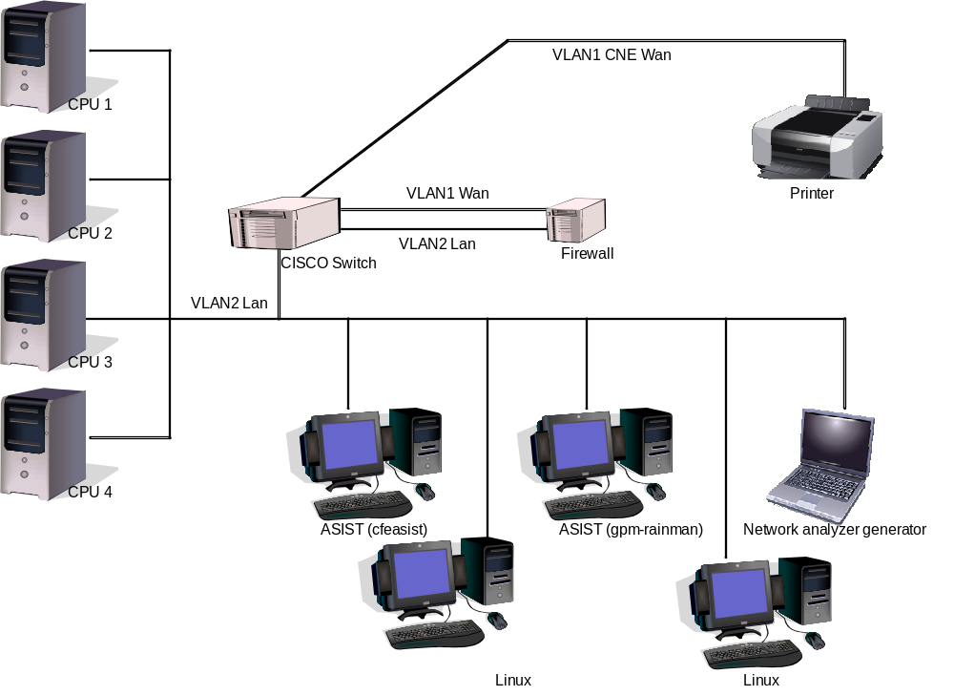
HS FSW testing took place in the CFS FSW Development and Test Facility. A high level view of the CFS FSW Test Bed is shown in Figure 4-1. This facility is located in GSFC Building 23, Room N410. This facility consists of two ASIST workstations running ASIST version 9.7k and three MPC750 CPU boards running VxWorks 6.4. CPU1 is primarily used for development testing while CPU2 and CPU3 are used for build verification testing.

Figure 4-1 CFS FSW Development and Testing Facility

Equipment | Description | Purpose
CPU1 | MPC750 board | Development testing
CPU2 | MPC750 board | Build verification testing
CPU3 | MPC750 board | Build verification testing
Workstation | cfeasist (Dell Dimension 360 running RedHat Linux) | Running ASIST 9.7k for build testing
Workstation | gpm-rainman (Dell Dimension 360 running RedHat Linux) | Running ASIST 9.7k for build testing
Linux Workstation | cfelnx (Dell Precision 470 running RedHat Linux) | FSW Development
Linux Workstation | gpm-raindrop (Dell Precision 420 running RedHat Linux) | Serial port communications to flight CPUs from cfeasist & gpm-rainman
Network analyzer generator | PC running Wireshark | Communications diagnostics
Cisco Switch | 2900 series with 2 VLAN’s | Managed switch, allows port sniffing and VLANs
Firewall | Mini PC running Monowall | Lab firewall
Printer
4 port RS 232 Serial | Keyspan 49WLC 4-port USB Serial Adapter | Serial port communications to flight CPUs
VLAN2 Lan
VLAN1 CNE Wan

Requirements Verification Matrix

Health and Safety
(HS)
Requirements Tested Passed | 58
Requirements Tested Failed | 0
Requirements Tested Partially | 0
Total Tested | 58
Deferred | 0
Total | 58

Requirements Partially Tested
There were no requirements that were partially tested.

Requirements/Functionality Deferred
No requirements were deferred to later build testing.

Requirements/Functionality Deferred for Mission Testing
No requirements/functionality was deferred to mission testing.

Build Verficiaton Test Results

Overall Assessment
During this build test of the HS Application, the software behaved as expected.

Below is a summary of the results:
- 49 requirements passed via demonstration
- 9 requirements passed via analysis
- No DCRs were generated
- 8 DCRs were verified

Procedure Description

Procedure | Description | Requirements tested
hs_appmon | The purpose of this test is to verify the Health and Safety (HS) Application Monitoring commands function properly. Invalid commands as well as anomalies will be tested to see if the HS application handles these appropriately. | HS1002; HS1003; HS1004; HS2000; HS2000.1; HS2000.1.1; HS2000.1.2; HS2000.2; HS2000.2.1; HS2000.2.2; HS2000.2.3; HS2000.3; HS2001; HS2002; HS2003; HS2004; HS2004.1; HS7001; HS7100; HS8000
hs_cpuhog | The purpose of this test is to verify the Health and Safety (HS) application performs CPU Utilization as stated by the requirements. | HS6008; HS6009; HS6010; HS7100; HS8000
hs_eventmon | The purpose of this test is to verify the Health and Safety (HS) Event Monitoring commands function properly. Invalid commands as well as anomalies will be tested to see if the HS application handles these appropriately. | HS1000; HS1002; HS1003; HS1004; HS5000; HS5000.1; HS5000.1.1; HS5000.1.2; HS5000.2; HS5001; HS5002; HS5003; HS5004; HS5004.1; HS7001; HS7100; HS8000
hs_exectr | The purpose of this test is to verify the Health and Safety (HS) handles the Execution Counter Management requirements properly.  NOTE: If the Mission decides not to use Execution Counters, this test can be skipped. | HS3000; HS3000.1; HS3001; HS3001.1; HS7100; HS8000
hs_gencmds | The purpose of this test is to verify the Health and Safety (HS) general commands, CPU aliveness and miscellaneous commands function properly. These commands will be tested as well as invalid commands to see if the HS application handles these appropriately. | HS1000; HS1001; HS1002; HS1003; HS1004; HS6005; HS6006; HS6007; HS6011; HS6012; HS7000; HS7001; HS7100; HS8000
hs_reset | The purpose of this test is to verify the Health and Safety (HS) Application initializes the appropriate data items based upon the type of initialization that occurs (Application Reset, Processor Reset, or Power-On Reset). This test also verifies that the proper notifications occur if any anomalies exist with the data items stated in the requirements. | HS1003; HS7001; HS7100; HS8000; HS8001; HS8002; HS8003; HS8003.1; HS8004; HS8004.1; HS8005; HS8005.1; HS8006; HS8006.1
hs_stress | The purpose of this test is to verify the Health and Safety (HS) Application handles the maximum <PLATFORM_DEFINED> entries in the Critical Application, Critical Event and Execution Counter Tables. | HS2000.2.3; HS2003; HS3000; HS5003; HS7100; HS8000
hs_watchdog | The purpose of this test is to verify the Health and Safety (HS) Application handles the Watchdog Management requirements properly. | HS4000; HS4000.1; HS4000.2; HS7100; HS8000

Analysis Requirements Verification
There were 9 requirements verified using analysis and are described below:

Requirement | Requirement Text | Analysis
HS2000.1a | If the entry indicates that the application is a cFE Core Application and it has not executed for the corresponding table-defined number of HS execution cycles, HS shall perform one of the table-defined actions  - cFE Processor Reset  - Send an Event message  - Send a Software Bus message | The cFE Processor Reset action was verified by looking at the UART log file for the appmon test procedure. The UART shows Event ID 42 for CFE_TBL was generated prior to the first reset. The other actions were verified by demonstration.
HS2000.2b | If the entry indicates that the application is a cFE Core Application and it has not executed for the corresponding table-defined number of HS execution cycles, HS shall perform one of the table-defined actions  - Restart the Application (that failed to check-in)  - cFE Processor Reset  - Send an Event message  - Send a Software Bus message | The cFE Processor Reset action was verified by looking at the UART log file for the appmon test procedure. The UART shows Event ID 42 for LC was generated prior to the second reset. The other actions were verified by demonstration.
HS4000 | During each HS execution cycle, HS shall check the status of the Update Watchdog Timer flag. | This requirement was verified because its sub-requirements were verified. Since requirements 4000.1 and 4000.2 passed, it can be assumed that the WatchDog Timer Flag's status is checked each cycle.
HS4000.1 | If it is set to TRUE, HS shall service the Watchdog timer. | This requirement was verified by stopping the HS application after startup and waiting for the WatchDog timer to expire which resulted in a WatchDog Reset of the processor used for this test. The UART log of the HS_WatchDog test verifies this by indicating the WatchDog Reset as the type when the processor restarts.
HS4000.2 | If it is set to FALSE, HS shall not service the Watchdog Timer. | This requirement was verified by utilizing the TST_HS application to set the HS WatchDog Timer Flag to false and stopping the HS application after startup. The expected result was that the processor used for this test continues running after the WatchDog timer expires. A TST_HS NOOP command was issued and executed to verify that the processor did not reset. The UART log of the HS_WatchDog test verifies this.
HS5000.1b | If the event is defined in the Critical Event Table, HS shall execute one of the following table-defined actions:  - Restart Application that generated the Event  - Perform cFE Processor Reset  - Delete the Application that generated the event  - Send a Software Bus message | The cFE Processor Reset action was verified by looking at the UART log file for the eventmon test procedure. The UART shows Event ID 45 for HS EID: (23) was generated prior to the first reset. The other actions were verified by demonstration.
HS6005 | During each HS execution cycle, HS shall send a <PLATFORM_DEFINED> character(s) to the UART port every <PLATFORM_DEFINED> second(s). | The UART log of the GenCmds test contained the expected characters which indicate that the system is running.
HS8006 | Upon any initialization, HS shall wait until the cFE startup synch has been received indicating all Applications have started. | This requirement was verified by adding the HS application to the cFE startup script and verifying that the CPU Aliveness character printed out after all the applications in the startup script were executing. The UART log of the HS_Reset test verifies this.
HS8006.1 | If the startup-synch is not received in <PLATFORM_DEFINED> seconds, HS shall begin processing. | This requirement was verified by adding the HS and TST_HS applications to the cFE startup script and having the TST_HS application delay for more than the startup-synch timeout value used by HS. If the HS CPU Aliveness indication character appears in the UART before the TST_HS application Housekeeping request events, then HS started processing before receiving the startup-synch. The UART log of the HS_Reset test verifies this.

DCRs
No new DCRs were generated during HS 2.2.0.0 testing.

DCRs Verified
The following DCRs were verified during testing:

DCR | Description | Test Method | Test Approach
13600 | HS: Default table source files do not specify the correct app name according to the CFS Standards | Analysis | The table image files resulting from the table make process were loaded successfully from the ASIST command browser.
13609 | HS: The wrong event ID is sent when CPU Hogging occurs | Test Procedure | The correct event is now generated when the HS application detects CPU Hogging.
13838 | HS CPU Utilization reports incorrectly after a Processor Reset | Not appropriate for Build Test | DCR #14490 removed the hs_idletask.c file to which this fix was applied. The HS CPU Utilization was re-designed using that DCR as well.
14488 | HS Update As-Built Design Slides | Inspection | The submitted design slides reflected the As-Built state of HS.
14489 | HS should not be subscribed to Events MID when not processing events | Analysis | This DCR was verified using the ASIST command browser. The HS application was started with Event Monitoring enabled. Three HS-NOOP commands were issued. The Events Monitored count incremented by 3. The Disable Event Monitoring command was issued followed by another 3 HS_NOOP commands. The Events Monitored count remained the same.
14490 | HS should simplify CPU utilization calibration | Test Procedure | The hs_gencmds and hs_CPUHog test procedures verify this DCR. The new commands were added to the hs_gencmds test procedure and they executed successfully. The SetUtilMask command was also issued in the hs_cpuhog test procedure to verify that CPU Hogging occurs when exceeding the defined threshold.
14685 | The User’s Guide should address the case where an infinite reset loop could occur | Inspection | The User’s Guide contained the desired updates documented in the DCR.
15116 | Update CFS applications to all use the same data type for commands executed and commands rejected counters | Test Procedure | The HS housekeeping packet was changed with this DCR. The ASIST database and display page associated with the HS Housekeeping packet also needed to be changed in order to receive this packet without error. The noted changes were made and the HK packet was received properly during each test procedure’s execution.

Outstanding DCRs
DCR | Description
15469 | HS Idle Task default priority same as Utility Task Priority

Notes
Prior to testing, the HS_IDLE_TASK_PRIORITY should be checked to make sure there are no tasks or applications that run at a lower priority that what is specified in this configuration parameter.

Also, other configuration parameters needed to be modified to make the CPU Utilization work in the CFS Lab. The HS_UTIL_PER_INTERVAL_HOGGING was modified from 9900 (99%) to 1000 (10%) in order to generate the event message. Also, in order to see some utilization numbers in the Average and Peak housekeeping items, HS_UTIL_CONV_MULT1 was changed from 2500 to 1 and HS_UTIL_CONV_DIV was changed from 50505 to 1000. These parameters will need to be adjusted for each environment that HS executes.

It should be noted that integration testing is the ultimate verification of the HS application’s performance in a system-like scenario.

- RTTM
The HS Build 2.2.0.0 RTTM can be found on the MKS server, in CFS-Repository HS test-and-ground directory results folder.

- Command, Telemetry, and Events Verification Matrix

Command | Test Procedure(s) | Notes/Comments
HS_NOOP | EventMon, GenCmds
HS_ResetCtrs | GenCmds
HS_EnableAppMon | AppMon
HS_DisableAppMon | AppMon
HS_EnableEvtMon | EventMon
HS_DisableEvtMon | EventMon
HS_EnableCPUAlive | GenCmds
HS_DisableCPUAlive | GenCmds
HS_ResetPRCtr | GenCmds
HS_SetMaxResetCnt | AppMon, EvnetMon, GenCmds, Reset
HS_EnableCPUHog | CPUHog, GenCmds
HS_DisableCPUHog | GenCmds

Telemetry | Test Procedure(s) | Notes/Comments
HS_CMDPC | AppMon, EventMon, ExeCtr, GenCmds, Reset, Stress, Watchdog
HS_CMDEC | AppMon, EventMon, ExeCtr, GenCmds, Reset, Stress, Watchdog
HS_AppMonState | AppMon, EventMon, ExeCtr, GenCmds, Reset, Stress, Watchdog
HS_EvtMonState | AppMon, EventMon, ExeCtr, GenCmds, Reset, Stress, Watchdog
HS_CPUAliveState | AppMon, EventMon, ExeCtr, GenCmds, Reset, Stress, Watchdog
HS_CPUHogState | CPUHog
HS_StatusFlags
HS_PRResetCtr | AppMon, EventMon, ExeCtr, GenCmds, Reset, Stress, Watchdog
HS_MaxResetCnt | AppMon, EventMon, ExeCtr, GenCmds, Reset, Stress, Watchdog
HS_EVTMonCnt | AppMon, EventMon, ExeCtr, GenCmds, Reset, Stress, Watchdog
HS_InvalidEVTAppCnt | AppMon, EventMon, ExeCtr, GenCmds, Reset, Stress, Watchdog
HS_AppStatus[] | AppMon, Stress
HS_MsgActCnt | AppMon, EventMon
HS_CPUUtilAve | CPUHog
HS_CPUUtilPeak | CPUHog
HS_ExecutionCtr[] | ExeCtr
Table Telemetry
HS_AMT[].AppName | AppMon, Reset, Stress, amtx
HS_AMT[].NullTerm | amtx
HS_AMT[].CycleCnt | amtx
HS_AMT[].ActionType | amtx
HS_EMT[].AppName | EventMon, Reset, Stress, emtx
HS_EMT[].NullTerm | emtx
HS_EMT[].EventID | emtx
HS_EMT[].ActionType | emtx
HS_XCT[].ResourceName | ExeCtr, Reset, Stress, xctx
HS_XCT[].NullTerm | xctx
HS_XCT[].ResourceType | xctx
HS_MAT[].EnableState | mat1, mat2
HS_MAT[].Cooldown | mat1, mat2
HS_MAT[].MessageData[] | mat1, mat2

Id | Event Message | Test Procedure(s) | Notes/Comments
1 | HS_INIT_EID | AppMon, CPUHog, EventMon, ExeCtr, GenCmds, Reset, Stress, Watchdog
2 | HS_APP_EXIT_EID
3 | HS_CDS_RESTORE_ERR_EID
4 | HS_CR_CMD_PIPE_ERR_EID
5 | HS_CR_EVENT_PIPE_ERR_EID
6 | HS_CR_WAKEUP_PIPE_ERR_EID
7 | HS_SUB_EVS_ERR_EID
8 | HS_SUB_REQ_ERR_EID
9 | HS_SUB_CMD_ERR_EID
10 | HS_AMT_REG_ERR_EID
11 | HS_EMT_REG_ERR_EID
12 | HS_XCT_REG_ERR_EID
13 | HS_MAT_REG_ERR_EID
14 | HS_AMT_LD_ERR_EID | AppMon, EventMon, ExeCtr, Reset
15 | HS_EMT_LD_ERR_EID | AppMon, EventMon, ExeCtr, Reset
16 | HS_XCT_LD_ERR_EID | AppMon, EventMon, ExeCtr, Reset
17 | HS_MAT_LD_ERR_EID | AppMon, EventMon, ExeCtr, Reset
18 | HS_CDS_CORRUPT_ERR_EID
19 | HS_CC_ERR_EID | GenCmds
20 | HS_MID_ERR_EID
21 | HS_HKREQ_LEN_ERR_EID
22 | HS_LEN_ERR_EID | AppMon, EventMon, GenCmds
23 | HS_NOOP_INF_EID | AppMon, EventMon, GenCmds
24 | HS_RESET_DBG_EID | GenCmds
25 | HS_ENABLE_APPMON_DBG_EID | AppMon
26 | HS_DISABLE_APPMON_DBG_EID | AppMon
27 | HS_ENABLE_EVENTMON_DBG_EID | EventMon
28 | HS_DISABLE_EVENTMON_DBG_EID | EventMon
29 | HS_ENABLE_ALIVENESS_DBG_EID | GenCmds
30 | HS_DISABLE_ALIVENESS_DBG_EID | GenCmds
31 | HS_RESET_RESETS_DBG_EID | GenCmds
32 | HS_SET_MAX_RESETS_DBG_EID | AppMon, EventMon, GenCmds, Reset
33 | HS_APPMON_GETADDR_ERR_EID
34 | HS_EVENTMON_GETADDR_ERR_EID
35 | HS_EXECOUNT_GETADDR_ERR_EID
36 | HS_MSGACTS_GETADDR_ERR_EID
37 | HS_RESET_LIMIT_ERR_EID | AppMon, EventMon
38 | HS_APPMON_APPNAME_ERR_EID | AppMon, Stress
39 | HS_APPMON_RESTART_ERR_EID | AppMon, Stress
40 | HS_APPMON_NOT_RESTARTED_ERR_EID
41 | HS_APPMON_FAIL_ERR_EID | AppMon, Stress
42 | HS_APPMON_PROC_ERR_EID | AppMon
43 | HS_APPMON_MSGACTS_ERR_EID | AppMon
44 | HS_EVENTMON_MSGACTS_ERR_EID | EventMon
45 | HS_EVENTMON_PROC_ERR_EID | EventMon
46 | HS_EVENTMON_RESTART_ERR_EID | EventMon
47 | HS_EVENTMON_NOT_RESTARTED_ERR_EID
48 | HS_EVENTMON_DELETE_ERR_EID | EventMon
49 | HS_EVENTMON_NOT_DELETED_ERR_EID
50 | HS_AMTVAL_INF_EID | AppMon, CPUHog, EventMon, ExeCtr, GenCmds, Reset, Stress, Watchdog
51 | HS_AMTVAL_ERR_EID | AppMon, Reset
52 | HS_EMTVAL_INF_EID | AppMon, CPUHog, EventMon, ExeCtr, GenCmds, Reset, Stress, Watchdog
53 | HS_EMTVAL_ERR_EID | EventMon, Reset
54 | HS_XCTVAL_INF_EID | AppMon, CPUHog, EventMon, ExeCtr, GenCmds, Reset, Stress, Watchdog
55 | HS_XCTVAL_ERR_EID | ExeCtr, Reset
56 | HS_MATVAL_INF_EID | AppMon, CPUHog, EventMon, ExeCtr, GenCmds, Reset, Stress, Watchdog
57 | HS_MATVAL_ERR_EID | Reset
58 | HS_DISABLE_APPMON_ERR_EID | AppMon, EventMon, ExeCtr, Reset
59 | HS_DISABLE_EVENTMON_ERR_EID | AppMon, EventMon, ExeCtr, Reset
60 | HS_SUB_WAKEUP_ERR_EID
61 | HS_CPUMON_HOGGING_ERR_EID | CPUHog
64 | HS_ENABLE_CPUHOG_DBG_EID | CPUHog, GenCmds
65 | HS_DISABLE_CPUHOG_DBG_EID | GenCmds
66 | HS_EVENTMON_SUB_EID
67 | HS_EVENTMON_UNSUB_EID
68 | HS_BADEMT_UNSUB_EID
103 | Not defined in hs_events.h | GenCmds
104 | Not defined in hs_events.h | GenCmds
106 | Not defined in hs_events.h | CPUHog, GenCmds

