**CAR RENTAL SYSTEM**

[Queries for MySql command line]

*First create a database named car_rental_system:*

***Query:***

create database car_rental_system;

*Select that database:*

***Query:***

use car_rental_system;

*Then create all the necessary tables:*

**STEP 1:**

create table all_id(

ID varchar(50));

**OUTPUT:**

***Query:***

describe all_id;

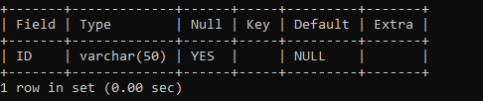

**STEP 2:**

create table booking_details(

REG_NO varchar(50),

UID varchar(50),

BOOKING_DATE date,

START_DATE date,

PASSENGERS_NO int,

STATUS varchar(25),

B_ID varchar(50) PRIMARY KEY);

**OUTPUT:**

***Query:***

Describe booking_details;

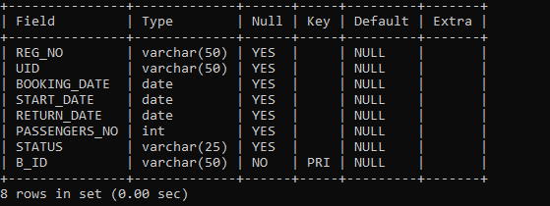

**STEP 3:**

create table cancel_details(

CANCEL_B_ID varchar(50) PRIMARY KEY,

UID varchar(50),

BOOKING_DATE date,

CANCEL_DATE date,

REG_NO varchar(50),

STATUS varchar(25));

**OUTPUT:**

***Query:***

Describe cancel_details;

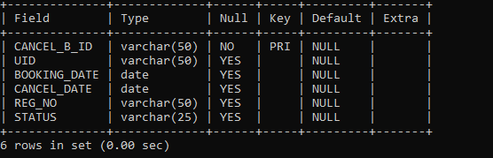

**STEP 4:**

create table car_details(

REG_NO varchar(50) PRIMARY KEY,

MODEL varchar(50),

COMAPNY varchar(50),

SEATS int,

FAIR int,

STATUS varchar(15));

**OUTPUT:**

***Query:***

Describe car_details;

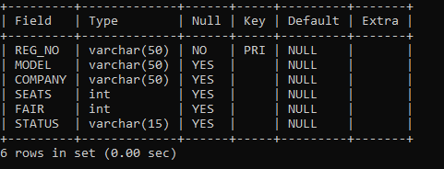

**STEP 5:**

create table payment_details(

PID varchar(50) PRIMARY KEY,

UID varchar(50),

BID varchar(50),

FAIR_TYPE varchar(50),

PAYMENT_AMOUNT int,

PAYMENT_DATE date);

**OUTPUT:**

***Query:***

Desribe payment_details;

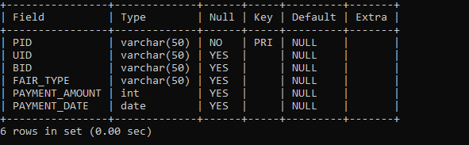

**STEP 6:**

create table user_base(

ID varchar(50) PRIMARY KEY,

Name varchar(50),

Contact bigint,

Address varchar(70),

PIN int,

Email varchar(50));

**OUTPUT:**

***Query:***

Decribe user_base;

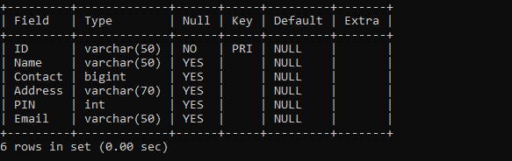

**Step 7:**

Create table user_pwd(

Email varchar(50) PRIMARY KEY,

Pwd varchar(25));

**OUTPUT:**

***Query:***

Describe user_pwd;

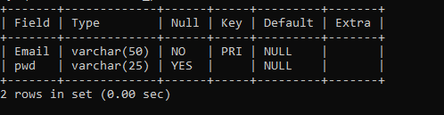

----------------------------------------------------------------------------------------------------

**Step 8:**

Insert car into car_details table;

***Query:***

