**Case Study Mary**

**Students Name:**

**University Name: Slotts’s College**

**Authors Note:**

Table of Contents

Part 1 2

Legal Issues 2

Types of drugs 2

Mandatory reporting 3

Assessment 3

Referral 4

Part 2- Research 4

Part3 - Critical reflection 6

Reviews and reflections on decisions taken with inputs received from supervisor 6

Miniport on my professional responsibility and accountability 7

Reference 9

## Part 1

## Legal Issues

Legal issues in this case study are mainly two kinds. One is drugs and alcohol abuse, and the second is child endangerment. According to the Australia Department of Health, use of marijuana is deemed illegal unless the user has sufficient justification. Legal possession of marijuana is allowed only in case of medicinal need, and possession of a license and permit schemes under Narcotics Drug Act 1967(Drug laws in Australia, 2022). The therapeutic use of marijuana is available under TGA Special Access scheme (Office of Drug Control, 2022). It is evident from the case study that Mary is neither in need of medical marijuana nor does she hold a license for the same. Penalties for illegal drug possession range from driving license disqualification, fines and even imprisonment. The use of alcohol is permitted under legal drugs. The second point of discussion is the effect of parent’s drug addiction on child wellbeing. As evident from the case, small amount of marijuana was found in Toby’s room, Mary's 15-year-old son. Toby is still a minor, this poses a serious question about her ability to raise her son in a clean and nurturing environment. Furthermore, this can be a case of willful child endangerment (Mandatory reporting of child abuse and neglect, 2022). This opens the door to many more legal entanglements depending on Mary's region.

## Types of drugs

It is essential to understand what type of drugs Mary used. Based on drug type, proper steps can be taken towards building an effective rehabilitation programme, as different medications have different degrees of effect on the body and mind.

The types of drugs discussed below briefly are based on the way they affect the body:

Depressants: This acts as anti-stimulation and reduces arousal. Examples are Kava, GHB, benzodiazepines and alcohol (Alcohol and Drug Foundation, 2022).

Stimulants: Stimulants are depressants. They increase neurological activity, which makes a person more alert and awake. Examples are caffeine, cocaine, beetle nut, and nicotine (Alcohol and Drug Foundation, 2022).

Hallucinogens: These are psychedelics, affect cognitive function, mood and perception. Consumption induces a distorted perception of reality. Examples include DMT, LSD, and Ayahuasca (Psychedelics - Alcohol and Drug Foundation, 2022).

Alcohol and marijuana are drugs and belongs to Depressant. It affects functioning of central nervous system. They result in poor levels of concentration, subdued voluntary responses, poor hand-eye coordination, and inability to stand and walk. This can be supported by the evidence in the case when Mary states that her addiction has shaken her confidence to find a full-time job.

## Mandatory reporting

Mandated reporting requirements identify cases where child neglect and abuse happened and provide assistance. This kind of reporting help child welfare agencies focus on children in danger (Sarkar, Ozanne-Smith & Bassed, 2019). They appoint groups of people who conduct thorough investigation and provide the government authorities with report. The first law passed for mandated reporting was enacted through the Family Law Act in 1975, which all Australian jurisdiction**s** have adopted **(**Mandatory reporting of child abuse and neglect, 2022). Although there are different practices from region to region such as representatives chosen for the report, types of neglect and abuse, judging the level of action considered as escalated abuse and neglect. On the whole, the spirit remains the same: to uphold child protection and welfare.

In the present case, as it is already pointed out, Mary's drug addiction is affecting her ability to lead a healthy and everyday life and affecting her son, Toby's wellbeing. He is dependent on Mary, this is a hindrance as there are no other immediate family members for support and guidance. Mary's mental condition is semi-stable, which is compounded by her alcoholism.

## Assessment

Assessment and referral are two critical tools that need to be followed for next set of procedures that is appropriate for AOD programmes (Alcohol and Other Drugs Partnerships and Pathways, 2022).

The assessment procedure should include routine questions that focus on drug use, present health and mental condition, social influence, financial stability, and legal status.

Various procedures help in the process of Assessment. These assessment tools are region to region-dependent and differ from one another. Here two types of Assessment tools are discussed 1st is WA Assessment Tool, and 2nd is Victoria Assessment Tool.

WA Assessment Tool

The WA Assessment tool is a form of audit mechanism that involves asking a series of questions. Based on the answer, a frequency table is created. This frequency table helps create a risk profile (Screening tools for alcohol and other drug use, 2016).

Victoria Assessment Tool

The Victorian Assessment Tool is more detailed and covers various topics such as psychological profile, medical history check, mental health, alcohol and other drugs, suicidal tendencies, history of family violence (AOD Comprehensive Assessment, 2022).

## Referral

The next step is a referral. Some critical indicators of proper referral are the intensity of drug dependency, drug-induced health issues, prevailing clinical depression and positive experience with the previous rehabilitation program. Other indicators are negative experiences from previous drug rehabilitation programs and requirement of detoxification. As these steps are vital for effective rehabilitation, some of the areas that need special mention are matching the need of the person with the agency, intention of referral must be clear and follow agency guidelines (Alcohol and Other Drugs Partnerships and Pathways, 2022).

# Part 2- Research

Appropriate AOD Program

There are three modes of AOD rehabilitation programs such as (i) reducing harm, (ii) screening, assessment and coordination, and (iii) intense intervention. (Alcohol and Other Drugs Partnerships and Pathways, 2022).

1. Reducing harm

This type of treatment is provided to reduce immediate and short term harm, provide support, and refer people for treatment. In addition, there are many types of intervention systems in place, such as shelters for sobering up and supplying information to family members (Alcohol and Other Drugs Partnerships and Pathways, 2022).

2. Screening, assessment and coordination

This involves performing through a check, referring, and matching the need of a person with the intervention offered. Intervention can either occur through a series of sessions or single seating.

3. Intense mode of intervention

This is focused on bringing repetitive behaviour alterations, improving mental and physical condition, and uplifting emotional and social status. These are therapeutic and based on evidence. Four broad types of intervention are pharmacotherapy, detoxification process, social and psychological counselling, and rehabilitation.

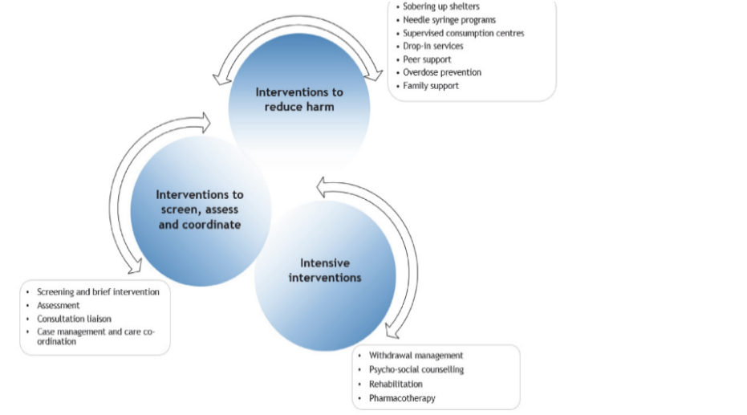

Fig 1. Different types of the intervention system

Source: (Alcohol and Other Drugs Partnerships and Pathways, 2022)

In the present case, choosing between full-time rehab program and part-time rehab is challenging. As Mary's addition seems to be intensive, selecting a part-time rehab program is not effective. On the other hand, full-time rehab program if chosen, someone has to take care of Toby in her absence. She is a single mother and has no other adult family members, thus question of Toby’s care in her absence is unanswered. Toby is young, so not expected to take care of himself and the house. Therefore, the solution remains in choosing a child service programme. This case involves all the tell-tale signs of child endangerment; thus, the Family Act of 1975 can be invoked to arrange for a foster or child care home temporarily. The duration of foster care can be argued on the basis of Mary's rehab success. Once the issue of child care is taken care of, plans can be made to initiate a rehab program for Mary.

Mary can be initiated into the 2nd type of AOD treatment program that involves assessing, referral, and matching Mary's needs with the programme. The arguments forwarded for choosing this mode of AOD treatment over others are based on many reasons. First, this kind of rehab program provides screening and brief interventions. These can be performed in primary care settings. Second, as Mary is a habitual addict, she is in need of immediate detoxification. The detoxification process can be carried out in primary care setting effectively. Third, as this kind of AOD programme focuses on a person's needs, goals and treatment, a continuous assessment can help keep track of goals set and the extent to which the plan is achieved. She is unemployed, this program can also help her get access and navigate to services and support for employment across another system. Apart from employment other accessible services are welfare, legal services, child protection service and housing. There is facilities through which Mary can contact other social and health welfare services.

All the 3 types of AOD programs have particular treatment settings as shown below in the diagram. Correlation between severity of addiction and the choice of treatment exists. Thus patients with low severity conditions can be treated in a primary health care setting. Here, based on Mary's addiction level, a stand-alone specialist AOD setting seems appropriate.

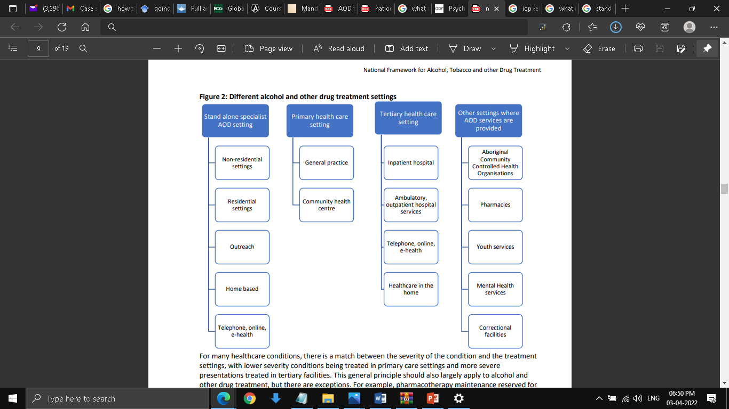

Fig 2: Treatment setting

Source: Alcohol and Other Drugs Partnerships and Pathways, 2022

# Part3 - Critical reflection

Reviews and reflections on decisions taken with inputs received from supervisor.

The decisions for choice of AOD program for Mary are based on the severity of her addiction, social and economic condition. My supervisor pointed out that a part time rehab program is also a suitable option. Part-time rehab program will help Mary take care of her child and look for employment opportunity. My decision to consider an AOD rehab program that involves through assessment, referral and matching of needs with programs deemed more suitable for Mary as I can conduct a thorough evaluation. My supervisor pointed out here, even if the questionnaire prepared for assessment can be specific but at same time it can be wrong. This can happen if the respondent decides to provide inaccurate answers. Incorrect review can lead to faulty referral, so on and so forth. Being more involved with the case, my assumption that Mary will voluntarily provide correct answer may be misplaced. My supervisor who is more experienced advised me to avoid such oversight. Besides this my supervisor also thought a more intense AOD program is suitable in this case.

## Miniport on my professional responsibility and accountability

I uphold my professional responsibility and accountability through the below mentioned points

1. Offered treatment practices only that are available within the capability of the organisation
2. I ensured that my methods are ethical and followed the statutory guidelines of my position
3. I made sure that personal boundaries are not crossed with the client and respected different cultural practices during all times, including religion, race, creed, sexuality
4. I endeavoured to make the goals of the service such as strategies, treatment, number of times intervention and its frequency required clear
5. I devised developed, maintained and evaluated The Treatment plan diligently.
6. I maintained client confidentiality within the given guidelines while sharing information.
7. I maintained my relationship with my client strictly on professional basis.
8. I declared if there are any conflict of interest that may arise if my client happens to be someone close.
9. My practices are devoid of any prejudices.
10. Correct statement of finance required.

# Reference

Drug laws in Australia. Australia Department of Health. (2022). Retrieved 3 April 2022, from https://www.health.gov.au/health-topics/drugs/about-drugs/drug-laws-in-australia.

Medicinal cannabis cultivation and production licences and permits | Office of Drug Control. Odc.gov.au. (2022). Retrieved 3 April 2022, from https://www.odc.gov.au/medicinal-cannabis-cultivation-and-production-licences-and-permits.

Mandatory reporting of child abuse and neglect. (2022). Retrieved 3 April 2022, from https://aifs.gov.au/cfca/publications/mandatory-reporting-child-abuse-and-neglect

Psychedelics - Alcohol and Drug Foundation. (2022). Retrieved 3 April 2022, from https://adf.org.au/drug-facts/psychedelics/

Sarkar, R., Ozanne-Smith, J., & Bassed, R. (2020). Mandatory reporting of child physical abuse and dental neglect by Australian dentists. Forensic Science, Medicine and Pathology, 16(1), 134-142, from https://pubmed.ncbi.nlm.nih.gov/31637584/

Alcohol and Other Drugs Partnerships and PathwaysAlcohol and Other Drugs Partnerships and Pathways. (2022). Retrieved 3 April 2022, from https://ww2.health.wa.gov.au/-/media/Files/Corporate/Policy-Frameworks/Mental-Health/Policy/Alcohol-and-Other-Drug-Withdrawal-Management-Policy/Supporting/Partnerships-and-Pathways.pdf

Case Management in Non-Government Alchohol and other Drug Services: A Practical Toolkit. (2022). Retrieved 3 April 2022, from https://www.aadant.org.au/sites/default/files/uploads/files/aadant-case-managing-in-non-government-aod-services-a-practical-toolkit.pdf

AOD COMPREHENSIVE ASSESSMENT. (2022). Retrieved 3 April 2022, from https://content.health.vic.gov.au/sites/default/files/migrated/files/collections/forms-and-templates/v/victorian-aod-comprehensive-assessment-form.pdf

Screening tools for alcohol and other drug use. (2016). Queensland Health. Retrieved April 3, 2022, from https://www.health.qld.gov.au/public-health/topics/atod/screening