**Socio-Economic Impacts of COVID-19**

**Students Name:**

**University Name:**

**Authors Note:**

Table of Contents

Introduction 3

Purpose and importance 3

Definition 3

Body 3

Effect on Primary sector 3

Impact on Secondary sectors 4

Effect on tertiary sector 4

Government Actions to stimulate growth 8

Conclusion 8

Reference 9

# Introduction

## Purpose and importance

Covid19 affected every aspect of human life in all parts of the world. According to data published by WHO, it has claimed 6.1 million lives now (WHO Coronavirus Dashboard, 2022). Along with lives, the Covid pandemic has shaken the world economy. This essay throws light on how Covid19 caused the global socio-economy crisis. Some of the key terms used here are defined.

## Definition

Global Socio-Economy- This is a broad term that encapsulates how the social and economic settings of different countries interact with each other (Buheji et al., 2020).

Sector Definition- The economy of a country can be primarily divided into three sectors which are (i) primary segment, (ii) secondary segment and (iii) tertiary segment. The primary sector includes natural resources such as agriculture and mining. Secondary includes manufacturing, and tertiary includes services, education, and real estate (Insee, 2022).

The discussion is divided into three different segments of the economy. First, countries' fiscal and monetary policies in this backdrop are also discussed.

# Body

## Effect on the Primary sector

**Agriculture**

Two important categories of the primary sector, namely agriculture and old petroleum, are considered. Agriculture continues to be the backbone of many developed and developing countries. A significant portion of agriculture is dependent on tourism and other allied services. Hotels, restaurants, lodges, and other tourism destinations were put out of business for an extended period. Thus with less demand from a commercial segment of food, there was a 2% dip in the price of agricultural commodities (Nicola et al., 2020). The immediate days of Covid lockdown worldwide saw nothing to very less trading taking place in commodities exchange. The livestock, which depends upon a steady supply of by-products of agriculture, is also affected.

**Oil and petroleum**

The sudden decrease in global oil demand caused a massive crash in oil prices. This is because the use of cars and other machinery dependent on petroleum products to run decreased significantly, and this sudden decrease in oil demand could not be offset by a decrease in oil production. Oil production is based on a complex set of operations that takes time to control its flow. The steepest price drop in Brent crude in 30 years, from $35 to $25.70, happened due to this pandemic (Nicola et al., 2020).

## Effect on Secondary sectors

**Manufacturing industry**

Millions of workers were put out of a job overnight. The manufacturing sector, one of the core industries that help increase spending by the government to boost the economy, was affected significantly. A survey in the UK showed that 80% of the respondents indicated the possibility of negative turnover, while 98% feared going out of business in future (Nicola et al., 2020). Perhaps the importance of the manufacturing industry needs more highlighted. This is because it is one of the tools that help the government tackle inflation to a certain degree. A government can provide jobs, increase industry output, increase domestic consumption, increase the propensity of spending for people and develop products for export through the manufacturing industry.

## Effect on the tertiary sector

**Services sector**

The services sector also forms part of the secondary industry. As offices and major service providers were shut down, a large part of the workforce was affected. This particularly affected country that is more dependent on the services sector than manufacturing. The diagram below helps understand how the service sector became the major driving factor in the GDP growth rate in high-income and middle-income countries. Although the availability of essential services in hospitals, telecommunication and food supply remained unaffected, the services such as hospitality, transportation of goods and packages, real estate and public administration were seriously affected. Businesses that depended upon exports and imports were winded up due to the non-availability of means of goods transportation; real estate saw a slump in prices as people scrambled to gather essential items and decreased or no means of income. The shock from Covid19 is forecasted to render 39% of jobs or 55 million people unemployed over 12 months across the world (Ludvigson, Ma and Ng, 2022).

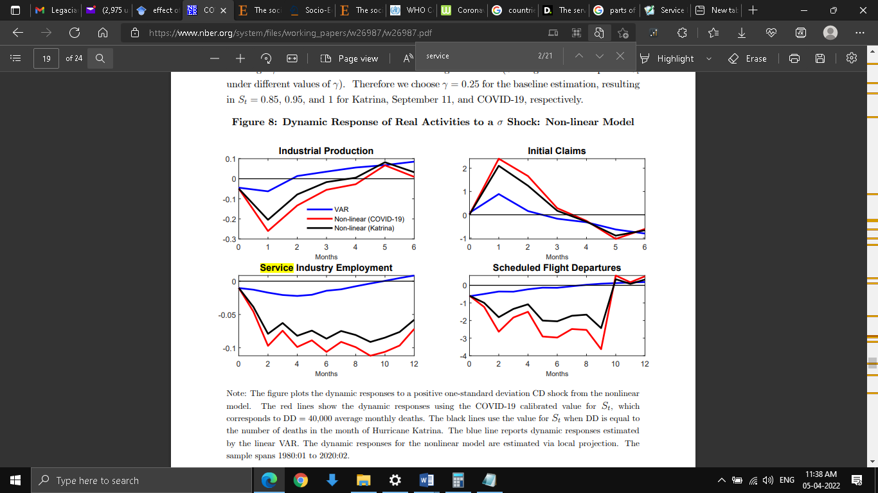

Fig: Service industry employment trend

Source: (Ludvigson, Ma and Ng, 2022)

**Airlines industry**

The airline industry, which is also part of the service sector, suffered a catastrophic loss. The running cost of airport and airlines maintenance need to be borne out of the pocket. In many cases, employees are forced to take pay cuts for months. As a result, Malaysia airlines saw a 30% decline in passenger traffic (Nicola et al., 2020).

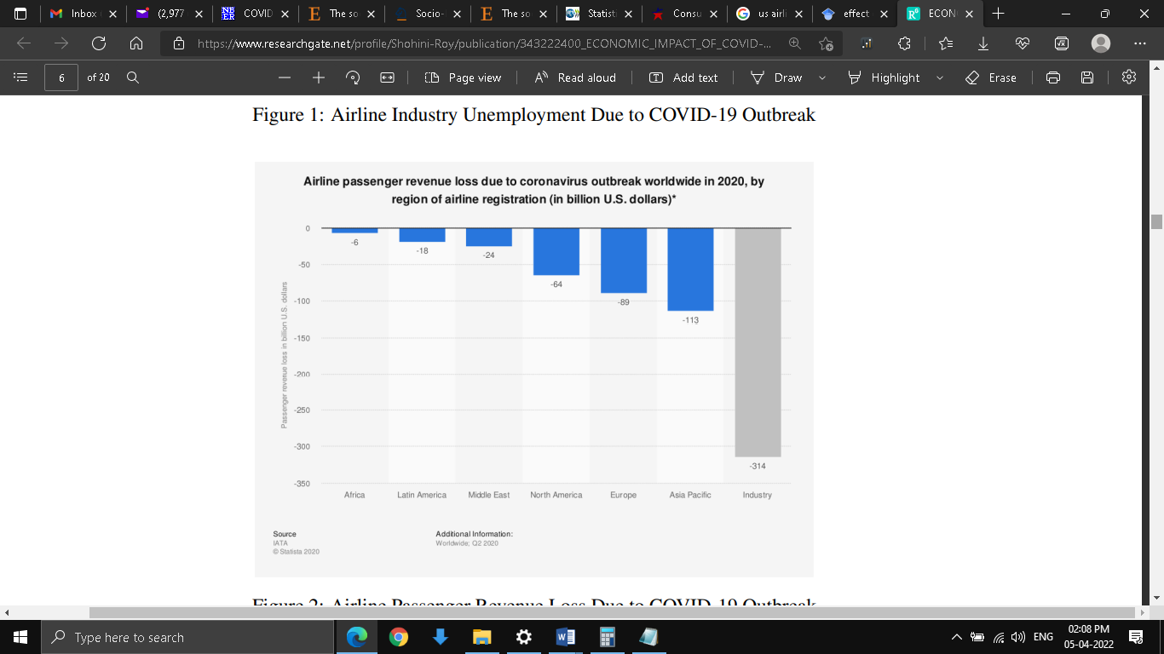

Fig: Airlines passenger revenue loss in 2020 due to Covid

Source: (Roy, 2022)

**Education**

As governments scrambled to gather essential commodities such as food and primary care for their population, the education system was completely overlooked. Schools and colleges shut down, and millions of students lurked in the dark about their future. According to UNESCO, close to 900 million learners are affected either directly or indirectly due to the closure of educational institutes.

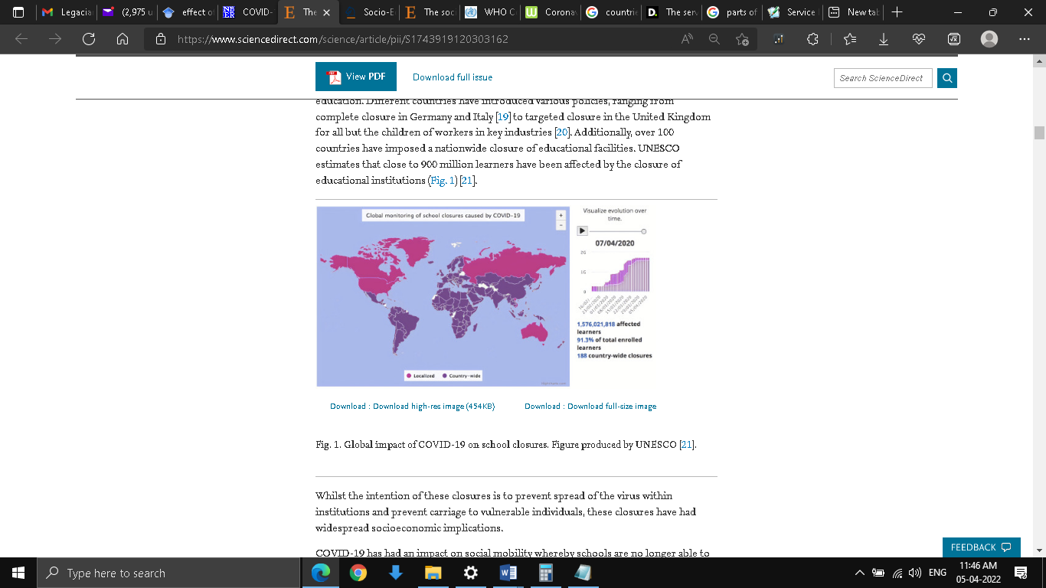

Fig 2: School closures across the word

Source: (Nicola et al., 2020)

Being away from school has prompted a sharp decrease in the learning curve among children. Schools and colleges provide a space where kids can learn to socialize and interact and have fun. Long term close of school has a psychological impact on children as they cannot interact in open and free spaces. Although schools were closed, rent and other overhead costs needed to be paid to keep the school running. This created a problem as parents were forced to pay the same despite having diminished income and children staying home. Students pursuing technical education were also affected as specialized teachers and labs were unavailable.

**Finance sector**

The initial response of governments across the world was haphazard and not in tune with the need. The sudden closure of the manufacturing and services industry initiated huge CPI (consumer price inflation). The below diagram shows the CPI indication of 28 OECD countries and the change in expenditure shares.

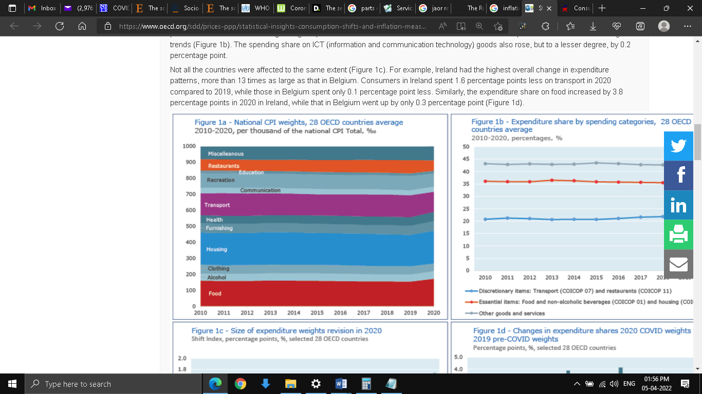

Fig: National CPI of 28 OECD countries average across sectors

Source: (Oecd.org., 2022)

## Government Actions to stimulate growth

Europe, along with a contribution from member countries, infused €1.7 trillion. ECB(European Central Bank) and European Commission injected 750 Billion and 25 Billion, respectively, into the asset purchase program and investment fund. The UK announced a total package of 239Billion. This fund was used for job retention, deferred VAT and Tax payments, and funding for small businesses. In addition, the Federal Reserve Bank decreased interest rate and declared $125 billion in bonds, child support funding, and other measures (Nicola et al., 2020). This was done so that increased spending by the government would stimulate public spending. Thus through structured fiscal policy by the government and monetary policy, Central Reserve banks help to support the financial system, dampen the impact on economically vulnerable groups and provide a lifeline for businesses to survive.

# Conclusion

Covid19 seriously affected the Global socio-economic settings. Some sectors of the economy are affected more than others. The tourism and Airlines industry saw the highest dip in growth rate. High inflation drew the price of commodities through the sky. The most vulnerable section of the society, who does not have easy and affordable access to essential commodities, suffered a lot. Loss of income in many households made it more difficult and rising prices. The government introduced various fiscal and monetary stimuli to stabilize the economy and reduce inflation, but the loss of business and employment remained unchecked. From the social point of view, COVID induced lockdown measures witnessed an increased crime rate, particularly against women and children. Being away for a long time from school and away from books affected children and slowed down their learning abilities.

# 

# Reference

Buheji, M., da Costa Cunha, K., Beka, G., Mavric, B., De Souza, Y.L., da Costa Silva, S.S., Hanafi, M. and Yein, T.C., 2020. The extent of covid-19 pandemic socio-economic impact on global poverty. a global integrative multidisciplinary review. American Journal of Economics, 10(4), pp.213-224. Available at: <https://www.researchgate.net/profile/Mohamed-Buheji/publication/341044016_The_Extent_of_COVID-19_Pandemic_Socio-Economic_Impact_on_Global_Poverty_A_Global_Integrative_Multidisciplinary_Review/links/5eaab2f045851592d6ac3165/The-Extent-of-COVID-19-Pandemic-Socio-Economic-Impact-on-Global-Poverty-A-Global-Integrative-Multidisciplinary-Review.pdf> [Accessed 6 April 2022].

Deloitte Insights. 2022. The services powerhouse: Increasingly vital to world economic growth. [online] Available at: <https://www2.deloitte.com/us/en/insights/economy/issues-by-the-numbers/trade-in-services-economy-growth.html> [Accessed 6 April 2022].

Insee.fr. 2022. Definition - Tertiary sector | Insee. [online] Available at: <https://www.insee.fr/en/metadonnees/definition/c1584> [Accessed 6 April 2022]

Ludvigson, S.C., Ma, S. and Ng, S., 2020. COVID-19 and the macroeconomic effects of costly disasters (No. w26987). National Bureau of Economic Research.. Available at: <https://www.nber.org/system/files/working_papers/w26987/w26987.pdf> [Accessed 6 April 2022].

Nicola, M., Alsafi, Z., Sohrabi, C., Kerwan, A., Al-Jabir, A., Iosifidis, C., Agha, M. and Agha, R., 2020. The socio-economic implications of the coronavirus pandemic (COVID-19): A review. International journal of surgery, 78, pp.185-193. Available at: <https://doi.org/https://doi.org/10.1016/j.ijsu.2020.04.018>[Accessed 6 April 2022]

Oecd.org. 2022. Statistical Insights: Consumption shifts and inflation measurement during COVID-19 - OECD. [online] Available at: <https://www.oecd.org/sdd/prices-ppp/statistical-insights-consumption-shifts-and-inflation-measurement-during-covid-19.htm> [Accessed 6 April 2022].

Referenceforbusiness.com. 2022. Definition of service industry. [online] Available at: <https://www.referenceforbusiness.com/management/Sc-Str/Service-Industry.html> [Accessed 6 April 2022].

Roy, S., 2022. Economic Impact of Covid 19 Pandemic. [online] Research Gate. Available at: <https://www.researchgate.net/profile/Shohini-Roy/publication/343222400_ECONOMIC_IMPACT_OF_COVID-19_PANDEMIC/links/5fa1e11e92851c14bc036d68/ECONOMIC-IMPACT-OF-COVID-19-PANDEMIC.pdf> [Accessed 6 April 2022].

Weber, M., Roth, G., abd Wittich, C., 2019. Economy and society (1st ed.). Univ. of California Press. . [online] Available at: <https://www.ucpress.edu/book/9780520280021/economy-and-society> [Accessed 6 April 2022].

WHO Coronavirus (COVID-19) Dashboard. Covid19.who.int., 2022. . [online] Available at: <https://covid19.who.int/.> [Accessed 6 April 2022].