**Strategic Marketing of Pepsi Max**

**Students Name:**

**University Name:**

**Authors Note:**

**Executive Summary**

This report is an effort to create a strategic marketing plan for the new product launch of Pepsi called Pepsi Max in Australia. The report elucidates the marketing objectives with short-term and long-term goals and presents the strategic marketing approach and marketing mix strategies in the context of the present market condition and competitor presence. To help the reader understand why certain marketing strategies are adopted in the current scenario, an overview of industry and business organizations needed to be understood and thus presented here.

Table of Contents

1. Introduction 3

2. Background 3

(i) Industry overview 3

(ii) Pepsi Business Organisation 4

3. Current Business 4

(i) Overview of the current business 4

(ii) SWOT analysis 5

(iii) VRIO Analysis 6

4. Marketing Objectives 7

(i) Short term objectives 7

(ii) Long term objectives 7

5. Market and Competitor analysis 8

6. Strategic Marketing Approach 9

7. Marketing Mix 10

Application of 7Ps 10

8. Recommendation 12

(i) Proximity Analysis 12

(ii)Proposed VRIO 12

(iii) Blue Ocean Strategy 12

(iv) Plc Strategies 13

Reference 14

# 1. Introduction

This paper reflects on the strategic marketing adopted by Pepsi to introduce Pepsi Max to a new set of customers in a new geographical location. To elucidate the strategies of the marketing, the current business overview is explained accompanied by SWOT(strength, weakness, opportunity, and threat) analysis as well as a current VRIO(value, rarity, imitability, and organizational) framework evaluation. Based on the insights from SWOT and VRIO analysis, marketing objectives, market, and competitor analysis, strategic marketing approach, and marketing mix is proposed for Pepsi Max. The best possible recommendations and conclusion are presented at the end of this paper.

# 2. Background

## (i) Industry overview

The total sales of non-alcoholic drinks amounted to US$1,340,481 million in 2022 and the market is expected to grow by 5.57% at a compounded annual growth rate of 2022-2026 (Statista Market Forecast, 2022). Soft drinks occupy the lion’s share in terms of total market volume at US$899,978m in 2022. Soft drinks generated a person revenue of US$176.71. It is estimated that by 4 years in 2026, a majority portion of the soft drinks revenue will be driven by out-of-home consumption habits. Some of the major players in the sectors of soft drinks by revenue world-wise are Pepsi Co, Coca-Cola, and Red Bull (Statista, 2022).

Fig 1: Projected Non-beverage worldwide sales value from 2020 to 2028(Value in billions)

(Source**:** Leading beverage companies worldwide in 2020)

## (ii) Pepsi Business Organisation

# Pepsi is a large conglomeration and is present in many geographical regions such as North America, Latin America, Europe, the Middle East, South Asia, Africa, China, Asia Pacific, New Zealand, and Australia. Some of the well-known brands Pepsi include Frito Lay, Quaker Foods, and Pepsi Co Beverages among others. Pepsi beverages are available in regions such as the United States, Canada, Latin America, Europe, and other regions (Pepsico Annual Report, 2022). The distribution strategy of Pepsi. The distribution strategy is Pepsi includes direct-store delivery, direct customer warehouse shipment, up-selling through e-commerce portals, and a wide array of networks. The customers of Pepsi include wholesale type distributors, customers of food service, grocery stores, independent bottlers, eCommerce retailers, membership stores, mass merchandisers, convenience and discount stores, hard discounters, as well as drug stores (Pepsico Annual Report, 2022).

# 3. Current Business

## (i) Overview of the current business

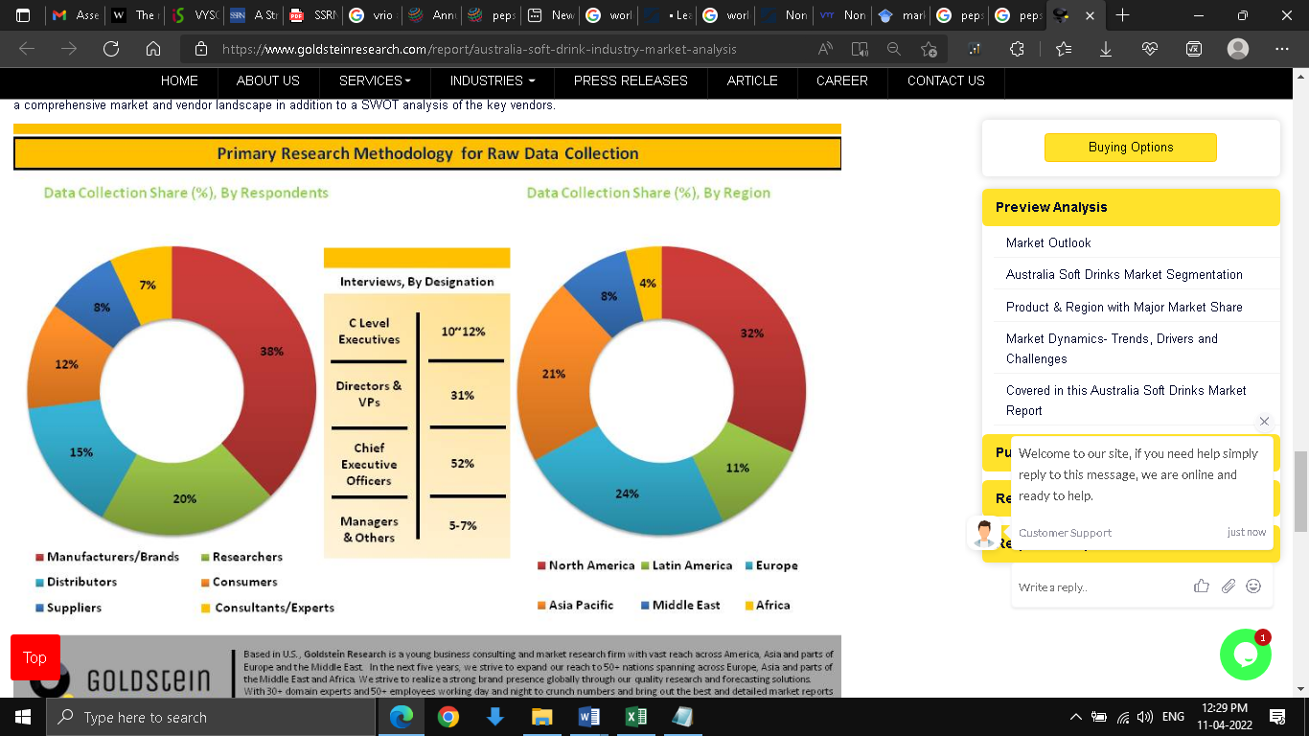

Fig 2: Pie Chart of Distributors and Region-wise presence

(Source Market Research. (2022)

The total sales of non-alcoholic drinks amounted to US$1,340,481 million in 2022 and the market is expected to grow by 5.57% at a compounded annual growth rate of 2022-2026 (Statista Market Forecast, 2022). Soft drinks occupy the lion’s share in terms of total market volume at US$899,978m in 2022. Soft drinks generated per person revenue of US$176.71. It is estimated that by 4 years in 2026, a majority portion of the soft drinks revenue will be driven by out-of-home consumption habits. Some of the major players in the sectors of the soft drinks by revenue world-wise are Pepsi Co, Coca Cola, and Red Bull (Statista, 2022).present more in-depth business overview a detailed SWOT and VRIO analysis is chosen.

## (ii) SWOT analysis

**Strength**:

As Pepsi entered the Australian market earlier than its competitors, for this it has a greater advantage in market operations (Dai, 2021). Thus it has more market penetration capability. The strong product development and innovation strategy enabled Pepsi to diversify its product portfolio from soft drinks to food products. Apart from this the leaders and figures chosen for brand propositions also add to further its influence on the market share.

**Weakness**:

Increased focus of people to choose healthy alternatives such as organic products is one area of concern. Besides this, Pepsi has to also factor in the demographic change in the population such as a change in population age and, a change in the ethnic, minority, and majority populations (Belayneh, Abara & Reddy, 2019). Apart from this, the constant need for optimization results in higher management cost that drains the company’s profit margin. Other weaknesses are e impact of Covid 19, reduced future demand, and increased product recall due to compromised safety and quality (Quan, 2020).

**Opportunity**:

As Pepsi is already present in different regions of the world. It can leverage its position financially and politically to influence its market share presence in Australia. Its deep-rooted networks and b2b customers provide a significant strategic advantage to reach even in those regions of the country, where there is very less or no competition at all (Belayneh, et al., 2019).

**Threats**

The main threats to Pepsi are from 2 of the largest players in Australia, one is Coca-Cola Amatil and the second one is Asashi Holdings, which jointly comfort of more than 55% of the revenue with 40% and 15% holdings respectively (Beverage industry in Australia, 2022).

## **(iii) VRIO Anal**ysis

Value: Pepsi has a diverse set of networks and suppliers. These can be used to push volume, to generate more sales per unit. As a benefit of buying more products from Pepsi, the retailers and b2b customers can enjoy higher credit facilities (VRIO, 2022).

**Rarity**

Soft drinks and beverages are highly dependent on water availability. Australia is already prone to water scarcity in various regions and thus water is viewed as a precious natural resource (Gupta et al., 2019).

**Imitability**

There are multiple substitutes and alternatives in the soft drinks section of Australia. Thus it is fairly easy for any competitor to enter the Australian market with the new product line. Although some of the core areas of strength for Pepsi is its strong corporate governance culture, which may not be imitated easily and readily by any new entrants (Pepsico Annual Report, 2022).

**Organization**

Given the long historical background which is enriched by knowledge gained from years of corporate governance structuring, cost reduction techniques, increasing value for shareholders, improvising the raw materials supply chain, lean management of logistical operations. It is fair to state that the core organizational values in these areas are strong and able to withstand major competition in Australia (Handayani & Ardini, 2018).

# 4. Marketing Objectives

The current marketing objective is to introduce Pepsi Max in parts of Australia. Introducing of Pepsi Max can be regarded as part of its product extension. To foray into specific regions of Australia that have not witnessed any sales of Pepsi Max, the marketing strategy is developed in two-phase. One is concerned with setting the short-term goal and the second is setting the long-term goal.

## (i) Short term objectives

The existing customer database of Australia will be the initial target for the product push. This can be done either by contacting large b2b suppliers and retailers or through the web of networks connected to various small business outlets. If the big b2b customers are chosen, it can lead to the creation of a higher credit margin (Stoltze et al., 2018). This can happen as this is a new product and the suppliers can be worried if it will be taken positively by the consumers. Thus high stock pillage of new products such as Pepsi Max if not preferred by consumers can lead to stock pillage and a lower rate of return from increasing stock. Thus big customers can request increased credit lines to supplement this risk. Whereas this risk is not present for smaller business outlets as the warehousing capabilities are also significantly less.

## (ii) Long term objectives

The long-term objectives are primarily focused on increased sponsorships, increased investment in automating the marketing process and CRM systems, increased brand awareness programs, developing content marketing and digital marketing initiatives, and appointing well-known personalities for brand promotion. It can be argued that some of the outlined long-term strategies can also be included in short-term goals. The answer is yes, they can be. But it must be noted that Pepsi is always cautious when it comes to brand image building (Wood et al., 2021). So it usually follows a well-worked and well-laid strategy applied in other countries. The intimate details are different but the general overview is the same, i.e. push through existing suppliers to reach existing customers and then gradually scaling up with increased brand awareness campaigns, all the while checking if its projected sales value and volume lag its actual sales figures.

# 5. Market and Competitor analysis

Some of the popular companies and brands named in the beverages and soft drink segment, operating out of Australia are given below.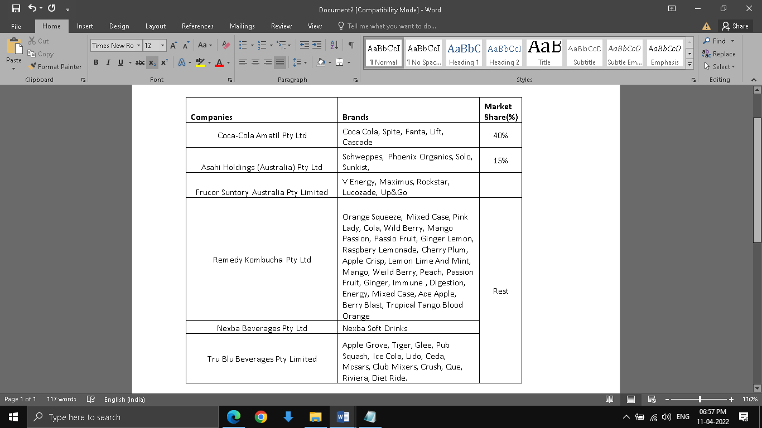

Table 1: Competitors’ brand and market share

Sources: (Beverage industry in Australia, 2022), (Pepsico Annual Report, 2022), (Asahi Soft Drinks Brands, 2022), (Frucor Suntory Brands, 2022), (Nexba Soft Drink Range, 2022)

The above table shows the probable market share of the competitors as well as their brand in the soft drinks segment. It may be noted that the 2 of the major players that is Coca-cola and Asahi do-not have lave long product mix line. While niche players such as Remedy, Nexba, and Tru Blu have very high product differentiation in the same category. A high product mix provides a customer with ample choices and variety to select from (Pinna et al., 2018).

# 6. Strategic Marketing Approach

The strategic marketing approach of Pepsi on basis of market segmentation, targeting, and position is explained here.

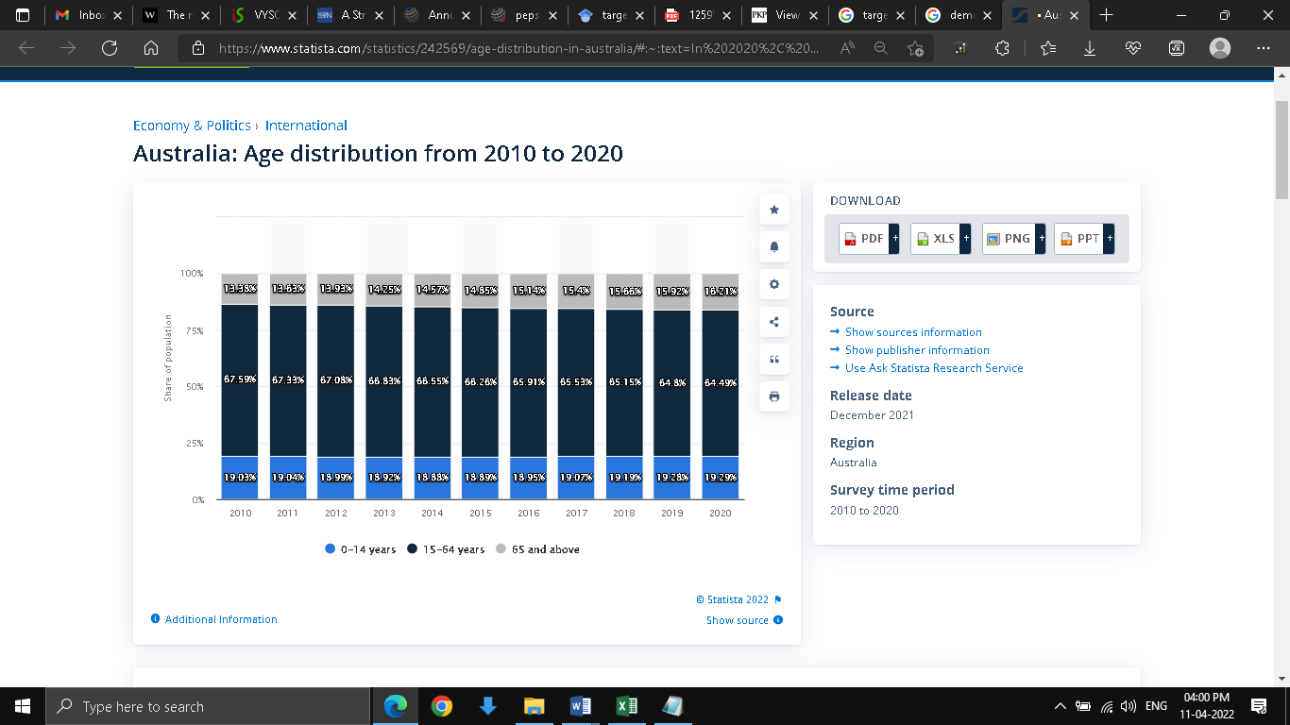

Fig 3:Demographic profile of Australia

Source: (Statista, 2022)

**(i) Segmentation**

The main target customers are between the age of 14 to 60 years. The demographic profile data of Australia shows the majority of the population are between 0 to 64 years. It is also evident from the fig that the Generation Z population and Millenials that are born between 1996 and 2012 and 1980 to 1996, are showing an increasing trend. This is an important first criterion, as this kind of age segmentation will help to develop product promotion and campaign as well as the means to reach the targeted segment (Demartini et al., 2018). For example, the population between the age of 20 to 30 years are spent thrifty and less product conscious, as they look for more affordable products. These unique insights help Pepsi to keep the price of Pepsi Max affordable for young school and university students. The age group between 30 to 50 years slowly develops a brand conscious, as with increased income and more maturity in spending habits, people look for brand association that matches their social outlook.

**(ii) Targeting**

The target audience for Pepsi Max comes from both Millennials and Generation Z age groups. Among these the target consumers are mainly those who have a sense of a unique or rather unusual lifestyle, also those who have special personalities or traits and preferences. This goes with the very brand image Pepsi wants to convey through its new product Pepsi max as something new, exciting, and adventurous (Panwar et al., 2019). The people within this age group grew up in a more liberal environment which promoted risk-taking attitudes more. And this has penetrated every aspect of life including food and drink habits. Canteens in school, cafeterias in the workplace, lounges in movie theatres, party floors in nightclubs, open street-side shops, corporate briefings and meetings, relatives and friends visiting, shopping aisles in retailers, and online e-commerce portals are some of the most frequented places of these age groups.

**(iii) Positioning**

As the target customers are between 20 to 64 years of age, and the majority is highly skewed towards the millennials age group, Pepsi Max will be promoted as both an affordable and quality healthy product. Long gone are those days when the brand image was not just built on cheap availability. The age group gives considerable importance to the importance of healthy drinking and eating. This makes it necessary to project this new brand Pepsi Max as not just another product, but a healthy mixed with affordability

# 7. Marketing Mix

The marketing mix strategy of Pepsi Max is explained with the help of 7Ps in light of an ethical and sustainable approach.

## Application of 7Ps

**Product (explained with the help of the NPD process)**

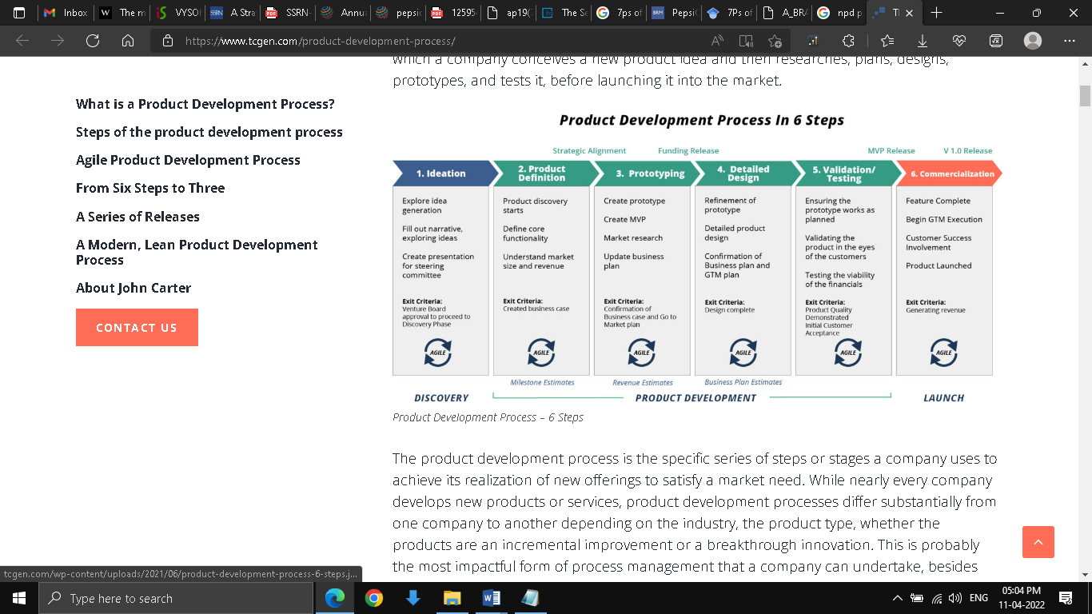

Fig4: NPD (New Product Development Process) Flow Diagram

Source:( New Product Development Process, 2022)

**NPD process**

Pepsi max can be introduced to the board of directors and major shareholders through presentation in annual general meetings, through ideation. This presentation will include the reasons it needs to introduce a new product in Australia through the projected market size and the revenue it will bring additional and this entails product definition. The next stage is prototyping, where once the conceptualization is finalized, the product designing team can develop the shape size of the Pepsi Max container (Vassallo et al., 2018). This prototype product can be launched in chosen locations on a pilot basis as MVP (Minimal viable product) to check the initial reaction from the public. Based on feedback received, additional changes can be incorporated in taste, color, proportion, and size to make it GTM(go to market) ready in the detailed design phase. The next step is ensuring that GTM design works as planned is called validation. Once confirmed the GTM design of Pepsi Max is validated by customers, the viability of the financials will be tested. After this customer acceptance stage, the last stage is commercialization, where final features are incorporated in Pepsi Max, GTM is executed and the product is finally launched.

**Price**

The price will be kept in line with the competitors. An over-priced product will drive away potential customers, while a seriously under-priced one will undermine the brand equity of Pepsi. Pricing forms part of ethics, as undue competition in cost-cutting strategies will hurt other major market players and can even wipe out small and marginal players.

**Promotion**

The main engine driving the bulk of the promotional efforts will be online, which includes both paid and free promotion platforms. Facebook, popular food bloggers on YouTube, and new product launches on YouTube will be the prime focus. Mass email marketing, an eCommerce platform for new launches, and freebies in mass youth functions are also some of the initial stages of promotion (Dai, 2021). As momentum gains, big retailers and b2b customers, restaurants, and pubs will be roped in. An ethical approach toward promotion is not trying to glorify the good aspects of a product to hide its ill effects and shortcomings.

**Place**

Based on the initial feedback received through online and offline modes of promotion, the first place to hit shelves in select supermarkets. As a beverage product like Pepsi Max has a certain shelf life, supermarkets provide the best opportunity for gaining attraction for the potential buyer before it nears its shelf life.

**People**

The aspect of the people is kept on the back burner as there is no direct dealing between Pepsi and the final consumer, but the communication line will be kept open and active for easy and reliable customer queries and feedback about Pepsi Max (Belayneh et al., 2019). This will also be implemented in the development of the product as it goes through the different stages of product evolution.

**Process**

The existing logistics framework will be used for gathering the required materials and delivering the finished product to respective warehouses and retailers as and when demands arise. This is one of the core areas of Pepsi where it has mastered the concept of lean management in almost every process. This will ensure that system is used at its optimal potency without incurring additional costs.

**Physical Evidence**

As the initial target audience of Pepsi Max will be a known customer base, so the physical evidence with regards to product container, packaging, labeling, banner, image, and color all play a major role. It is because when they will buy a new product from Pepsi, the initial judgment will come through visual observation (Handayani & Ardini, 2018). Thus a product designed in line with previously launched successful products paves way for the easier win of customer confidence.

# 8. Recommendation

## (i) Proximity Analysis

Proximity analysis can help target those customers and consumers who happen to be in the vicinity of supermarkets or hypermarkets or other retail establishments that has food and beverage sections available. Promotional messaging services such as SMS, and quick alerts can intimate customers on a real-time basis about new discounts or new product availability.

## (ii)Proposed VRIO

**Value**

Adopting practices that are ecologically friendly and sustainable will project a brand image of Pepsi as not just a profit-hungering business but also an environmentally conscious one. This in turn can result in more customer preference who have a choice of organic foods.

**Rarity**

Pepsi must ensure that its’ groundwater consumption is within permissible limits of the government. Using recycled water is not part of the recommendations but recycled water can always be used for various other industrial operations without affecting product quality. This will bring down its cooling costs done by convenient ways.

**Imitability**

Pepsi can focus on creating a diverse range of soft drinks other than the ones already present. As already presented before-some its competitors have a wide range of soft drinks as products. This will lead to less chance of product imitability but more diversification.

**Organizational**

Adopting a diverse and inclusive workforce as the core organizational value will promote its brand image as a company unbiased in terms of employment and opportunity.

## (iii) Blue Ocean Strategy

Australia presents a mixed bag of developed and underdeveloped regions with huge polarity. Thus regions of very low development also present an opportunity for new business launches. As there are no to very few competitions in underdeveloped regions, it presents an uncontested market space. Pepsi co can virtually create and capture all demand. This will lead to higher value addition for the brand without incurring a huge cost.

## (iv) Plc Strategies

**Introduction**

New product Pepsi max introduction, build selective distribution channels, develop product awareness and use extensive sales promotion.

**Growth**

In this stage, Pepsi Max’s costs will be reduced to penetrate the market, and focus on intensive distribution and brand awareness. Sales promotion was reduced due to huge product demand.

**Maturity**

Introduce 3 new flavors of Pepsi Max, match price with best competitors, more intensive distribution. Focus on brand differentiation with competitors and encourage consumers to brands switching.

**Decline**

As sales start declining, prices will be slashed, and unprofitable outlets took out of distribution. Product supply is reduced to cater only to hardcore loyal customers and stop sales promotion.

**9. Conclusion**

Floating a new product in Australia is challenging as there are predominant players as well as niche players. Although market penetration is quite easy as Pepsi can keep its business sustained through very competitive pricing. There are some drawbacks to product diversification. Unlike other small players, Pepsi has only a few products to offer. So it needs to work on its product diversification. Increased product diversification can result in more customer switching from other brands. As Pepsi has a long-standing good brand image so winning customer confidence for new product try-outs will not need added efforts. Online marketing promotion should be an area of prime focus and the initial roll-out should be slow and steady. Until strong customer demand are reported from retail outlets, production outputs will be kept low and then gradually scaled up to meet demand. Creating a sustainable and ethical marketing mix is important as this will not only impact a long-term growth of Pepsi Max but also create a balance between business needs and environmental needs. Unscrupulous use of groundwater will lead to water deficiency in the region and lead to ecological imbalance.

# Reference

5 Marketing Strategies We Can Learn from Pepsi — AM Collective. (2022). Retrieved 11 April 2022, from https://amcollective.sg/reads/5-marketing-strategies-we-can-learn-from-pepsi#:~:text=As%20a%20brand%2C%20Pepsi%20has,a%20busy%20and%20modern%20lifestyle

Belayneh, B., Abara, G., & Reddy, P. A. K. (2019). Assessment of Marketing Mix Strategies of the Hawassa Millennium Pepsi-Cola Plant. Assessment, 52. Retrieved 11 April 2022, from https://core.ac.uk/download/pdf/234694511.pdf

Dai, Y. (2021). Comparison of Emphasis Point Towards Marketing Strategies Between Pepsi & Coca-Cola. In 6th International Conference on Financial Innovation and Economic Development (ICFIED 2021) (pp. 79-83). Atlantis Press. Retrieved 11 April 2022, from https://www.atlantis-press.com/article/125954272.pdf

Demartini, M., Pinna, C., Aliakbarian, B., Tonelli, F., & Terzi, S. (2018). Soft drink supply chain sustainability: A case based approach to identify and explain best practices and key performance indicators. Sustainability, 10(10), 3540.Retrieved 11 April 2022, from https://www.mdpi.com/2071-1050/10/10/3540/pdf

Gupta, A., Jain, D., Datta, D., & Mehrotra, S. (2019). Negative marketing-Strategy analysis. Retrieved 11 April 2022, from https://d1wqtxts1xzle7.cloudfront.net/59124341/V5I1-129820190503-12748-1h8d00o-with-cover-page-v2.pdf?Expires=1649692474&Signature=Gc~eYeeN9bvLjrdaaxlt51Dtpj2rpme-jNVKV~36yiOakhBtsY5a9cBo-nOBUfte7ceOcV4-tpP6MujF6jG1NVHoUTofW-1lfrlTeiJR-vZGCUvQKicCSXvPtKUU875U~LAdifcJEtqo1SYN~Ya8Xfk0uTVya37zkuGU4JyCzXpG39NqqxSyVW~ARRNdYotz30KBFRMx2~iXljm5uHoUygnPATD0gteDsHNuFrq0GJ6IY2n1qjVtbiWBMkNKnYWgVD~EV9s0I5wcaO~r-Z5MgHPqa6ur9BSqhLZlHzLX3ZA2ADvZe~0p35~RsSna5E8wvkXYPhJEY1gf-sABx-B2Qg__&Key-Pair-Id=APKAJLOHF5GGSLRBV4ZA

Handayani, N., & Ardini, L. (2018). Local Product Marketing Strategy (Home Industry) in ASEAN Economic Community (AEC) Era. International Journal of Business Administration, 9(1), 75-80.Retrieved 11 April 2022, from https://www.sciedu.ca/journal/index.php/ijba/article/view/12851/7956

Panwar, D., Anand, S., Ali, F., & Singal, K. (2019). Consumer decision making process models and their applications to market strategy. International Management Review, 15(1), 36-44.Retrieved 11 April 2022, from http://www.imrjournal.org/uploads/1/4/2/8/14286482/imr-v15n1art3.pdf

Pinna, C., Demartini, M., Tonelli, F., & Terzi, S. (2018). How soft drink supply chains drive sustainability: Key performance indicators (KPIs) identification. Procedia CIRP, 72, 862-867.Retrieved 11 April 2022, from https://www.sciencedirect.com/science/article/pii/S2212827118305237/pdf?md5=1e7539ff50d8bbbe1f012e732cb7f339&pid=1-s2.0-S2212827118305237-main.pdf

Stoltze, F. M., Barker, J. O., Kanter, R., Corvalán, C., Reyes, M., Taillie, L. S., & Carpentier, F. R. D. (2018). Prevalence of child-directed and general audience marketing strategies on the front of beverage packaging: the case of Chile. Public health nutrition, 21(3), 454-464.Retrieved 11 April 2022, from https://idl-bnc-idrc.dspacedirect.org/bitstream/handle/10625/57342/IDL-57342.pdf?sequence=2

Vassallo, A. J., Kelly, B., Zhang, L., Wang, Z., Young, S., & Freeman, B. (2018). Junk food marketing on Instagram: content analysis. JMIR public health and surveillance, 4(2), e9594.Retrieved 11 April 2022, from https://publichealth.jmir.org/2018/2/e54/

Wood, B., Williams, O., Nagarajan, V., & Sacks, G. (2021). Market strategies used by processed food manufacturers to increase and consolidate their power: a systematic review and document analysis. Globalization and health, 17(1), 1-23.Retrieved 11 April 2022, from <https://globalizationandhealth.biomedcentral.com/articles/10.1186/s12992-021-00667-7>

Quan, J. (2020). The Trend of PepsiCo by Comparing PepsiCo’s Financial Reports in 2018 to 2019 Based on Harvard Analytical Framework. In 2020 5th International Conference on Modern Management and Education Technology (MMET 2020) (pp. 162-166). Atlantis Press. Retrieved 11 April 2022 <https://www.atlantis-press.com/article/125945868.pdf>.

References

Statista. (2022). Retrieved 11 April 2022, from https://www.statista.com/statistics/242569/age-distribution-in-australia/#:~:text=In%202020%2C%20around%2019.29%20percent,65%20years%20old%20and%20over

Market Research. (2022). Retrieved 11 April 2022, from https://www.goldsteinresearch.com/report/australia-soft-drink-industry-market-analysis

Beverage industry in Australia. (2022). Retrieved 11 April 2022, from https://www.obesityevidencehub.org.au/collections/environmental/corporate-political-activity-of-the-beverage-industry-in-australia#:~:text=on%20physical%20inactivity-,The%20soft%20drink%20manufacturing%20industry%20in%20Australia%20is%20moderately%20concentrated,half%20(55%25)%20of%20revenue

IBISWorld (2022). Retrieved 11 April 2022, from https://www.ibisworld.com/au/industry/functional-beverage-production/5502/

Leading beverage companies worldwide in 2020,. Retrieved 11 April 2022, from https://www.verifiedmarketresearch.com/product/non-alcoholic-beverage-market/#:~:text=According%20to%20Verified%20Market%20Research,7.81%25%20from%202021%20to%202028

Pepsico Annual Report. (2022). Retrieved 11 April 2022, from https://www.pepsico.com/docs/album/annual-reports/pepsico-inc-2021-annual-report.pdf?sfvrsn=fc90bdd6_3

Pepsico. (2022). Retrieved 11 April 2022, from https://www.pepsico.com.au/about/about-the-company

Statista Market Forecast. (2022). Retrieved 11 April 2022, from https://www.statista.com/outlook/cmo/non-alcoholic-drinks/worldwide

Statista. (2022). Retrieved 11 April 2022, from https://www.statista.com/statistics/307963/leading-beverage-companies-worldwide-based-on-net-sales/

New Product Development Process. (2022). Retrieved 11 April 2022, from https://www.tcgen.com/product-development-process/

VRIO. (2022). Retrieved 11 April 2022, from https://uir.unisa.ac.za/bitstream/handle/10500/27648/Transcription+Lesson+7+VRIO-1.pdf?sequence=3

Asahi Soft Drinks Brands. (2022). Retrieved 11 April 2022, from https://www.asahi.com.au/brands/soft-drinks

Frucor Suntory Brands. (2022). Retrieved 11 April 2022, from https://www.frucorsuntory.com/our-brands/?_sft_country=australia

Nexba Soft Drink Range. (2022). Retrieved 11 April 2022, from https://www.nexba.com/our-range/soft-drink/