**Global Interconnections of Modern Financial Institutions**

**Students Name:**

**University Name:**

**Authors Note:**

Table of Contents

1. Introduction 2

2. Main Body 2

3. Conclusion 9

4. Reference 10

# 1. Introduction

This essay is prepared to reflect on the global interconnectivity of financial institutions across the world. Global interconnectivity in the present century bears more effect on individual countries and even more on its citizens than what it used to be a century back mainly propelled by advancements in telecommunication technology. This makes it important to study the nuances of global financial institution interconnectivity even more so now. The global financial crisis has happed throughout history buts its frequency and severity have magnified in the last few decades only. To give a brief understanding of the interconnectivity, its implications and subsequent solutions, 3 distinct procedures are applied. The first is giving a broad overview of how global financial institutions from the smallest to the largest and the sovereign. The second procedure involves what are the implications of measured risks or vulnerabilities that arise due to such interconnection. To elucidate on the second procedure the global financial crisis of 2008, the Eurozone crisis of 2010 and the Brexit deal of 2014 are shown as examples. The 3rd and the last procedure gives a brief understanding of ways financial institutions mitigate such crises or vulnerabilities. The concluding section includes finding and recommendations.

# 2. Main Body

**Interconnectivity and dependency**

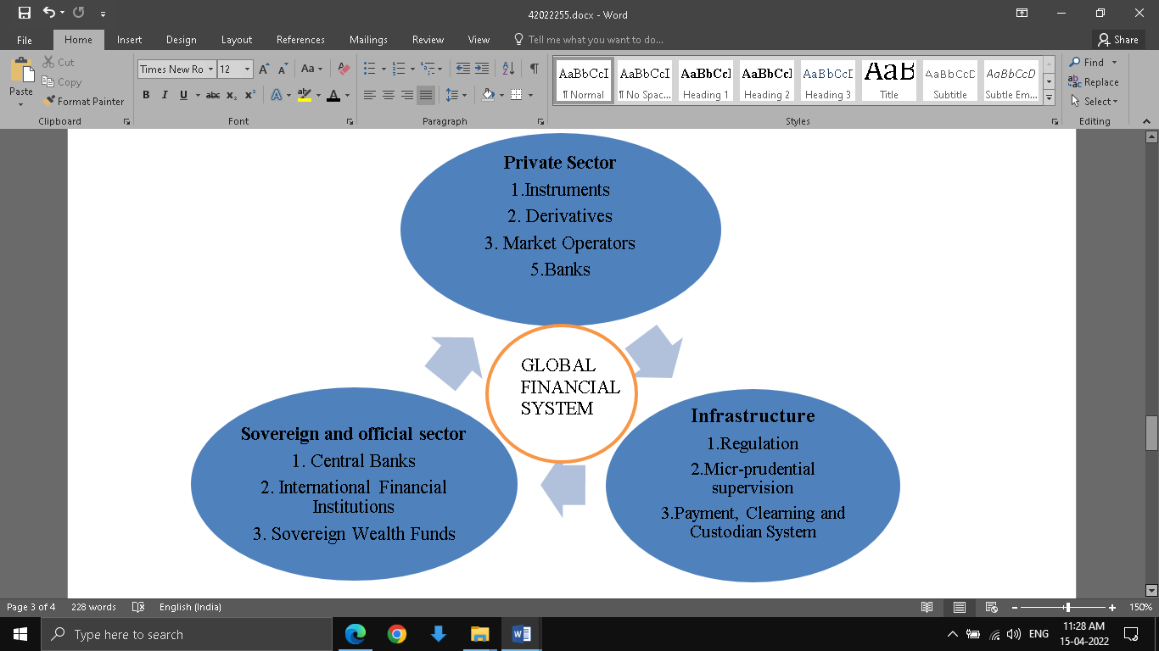

Fig 1: Financial system interconnection

(Source: Masera,2018)

The above diagram gives a brief overview of how financial markets are linked between public and private parties through the infrastructure. The sovereign and official sectors control financial institutions under its governing bodies such as countries, regions and states. Their main tools of action are policy guidelines defined by the central bank of the respective countries. These guidelines prepared by Central Banks and Reserve Banks are abided by the private sector both domestic and international (Xu and Corbett, 2019). The private sector which includes privately owned banks and market operators has its own set of instruments and derivatives for controlling its financial relationships with other private or public sector bodies. The infrastructure is the main backbone of the financial system be it domestic or global. The infrastructure provides a way of conducting financial transactions in a safe and secure environment (Conesa, 2020). The main components of the infrastructure are regulatory bodies, payment, clearing and custodian system. The infrastructure provides common meeting grounds for private to private and private to public bodies both domestic and international.

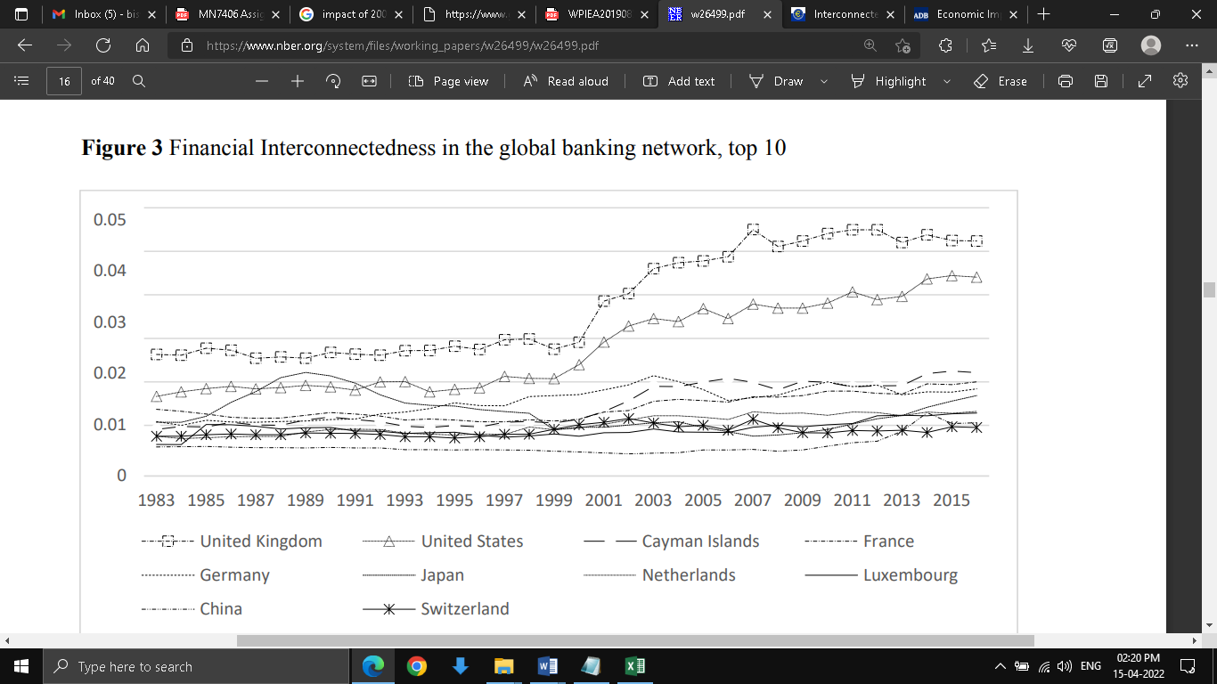

Fig 2: Financial interconnectedness in the global financial network

(Source: Xu and Corbett, 2019)

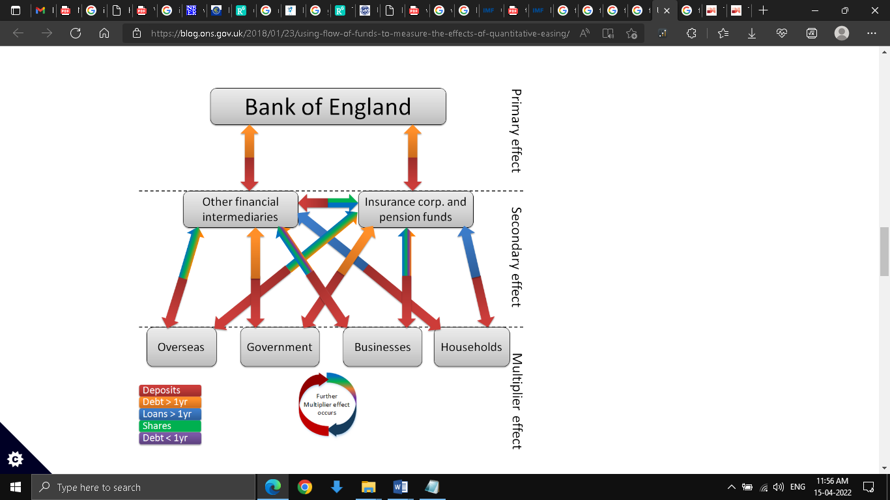

Fig 3: Domestic and Foreign financial institution interconnectivity

(Source: Patel, 2022)

The above diagram shows the path of flow of various financial instruments such as deposits, debts, loans and shares flow between the various domestic financial institution, sovereign financial institutions and overseas financial institutions. This diagram also shows the multiplier effect of transactions where the economic activity starts a chain reaction through which every economic input generates a further increase in economic output.

**Vulnerabilities of interconnection**

The interconnectedness of international financial institutions is shown in the below diagram.

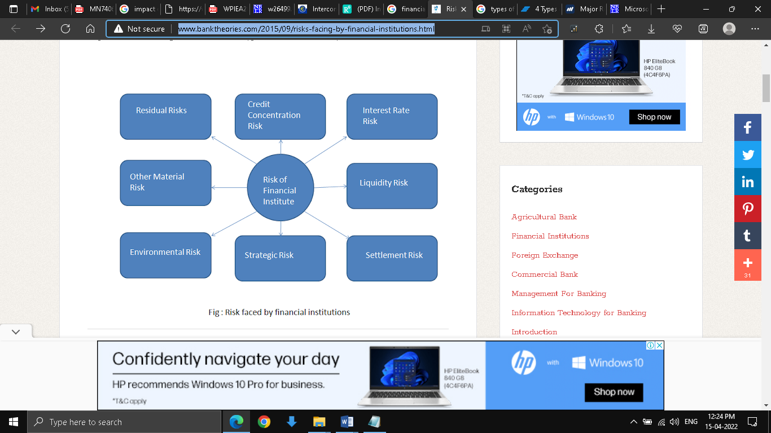

Fig 4: Vulnerabilities of financial institutes

(Source: H, 2022)

There are mainly 6 types of risk faced by international financial institutions which are residual risks, environmental risk, strategic risk, settlement risk, liquidity risk, interest rate risk and credit concentration risk. The types of risk can be explained with the help of an example. When Lloyd Banking Group lends money to SME businesses, they devise a strategy that will alleviate the systematic or the inherent market risk in the lending process. Even after the systematic risk are alleviated to some extent, some risks known as residual risks that cannot be removed always remain. Lloyd Group might decide to lend capital to new SME business initiatives that are heavily dependent on foreign investors, as part of its strategy. This is a strategic decision with a degree of risk (Mieszala, R., 2019). If the SMEs that are highly dependent upon foreign investors face an investment crisis due to environmental risks such as Pandemics and political crises in foreign markets, then Lloyds Groups is also affected. This leads to interest rate risk, as the interest rate at which it lent initially cannot offset the loss in banks’ capital as SMEs keep faltering on interest payments (Barroso, 2018). If Lloyd Group has short term obligations of settling dues, then increasing NPAs can threaten its short term liquidity. This is called a liquidity crisis. Settlement risks arise when financial institutions forward payment with the condition that the borrower will return the payment at the prescribed date and time. In case the borrower fails to settle the payment with a counter payment then there arises settlement risk for the financial institution.

**Risk mitigation technique**

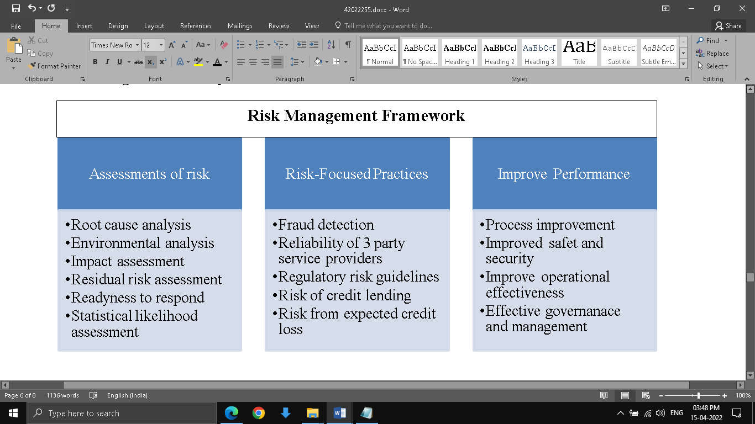

Fig 5: Risk management framework in financial institutions

(Source: Mossadams.com, 2022)

The above diagram is an example of a strategic risk management framework in financial institutions. The 3 basic processes are the assessment of risk, the identification of events and areas where risks are present or will likely arise. Lastly is the risk reduction process. These processes are not independent of one another and work in a continuous cyclical direction (Chance, 2020). After the last stage of the process, improvement is reached the whole process of assessment, identification and improvement are again started. Risk management is a continuous improvement cycle.

**Examples of shocks/crises spreading between countries/industries**

To show how the vulnerabilities of international financial interconnection affect the global economic condition across countries 2 relevant examples are discussed here, one is the subprime mortgage crisis of 2007-2008 and the other one is the Eurozone crisis of 2010.

**U.S. Subprime crisis**

The US house market activity peaked in its expansion in 2006 and thus construction began declining. The decline caused a loss in financial assets that were linked to mortgages. These losses caused severe strain on the global financial market and by the end of 2007, the recession has started in the US economy (Weinberg, 2018). The losses were particularly severe in asset-backed commercial papers. This was followed by a declaration of bankruptcy by Lehman Brothers and AIG, which is an insurance company that sought Federal Reserve support. Lehman Brothers was an international financial institution linked to various other global financial institutions (Burkhanov, 2018). The insolvency of Lehman prompted stress in foreign exchange and global interbank markets. This in turn led to a run on money market funds, where too many investors flooded the market with redemption requests. This heavily affected the non-US banks. From 2008 to 2015, about 500 banks were shut down (ADM, 2022). This in turn affected to a greater or lesser extent other foreign financial institutions connected to these banks (Gulzar et al., 2019.

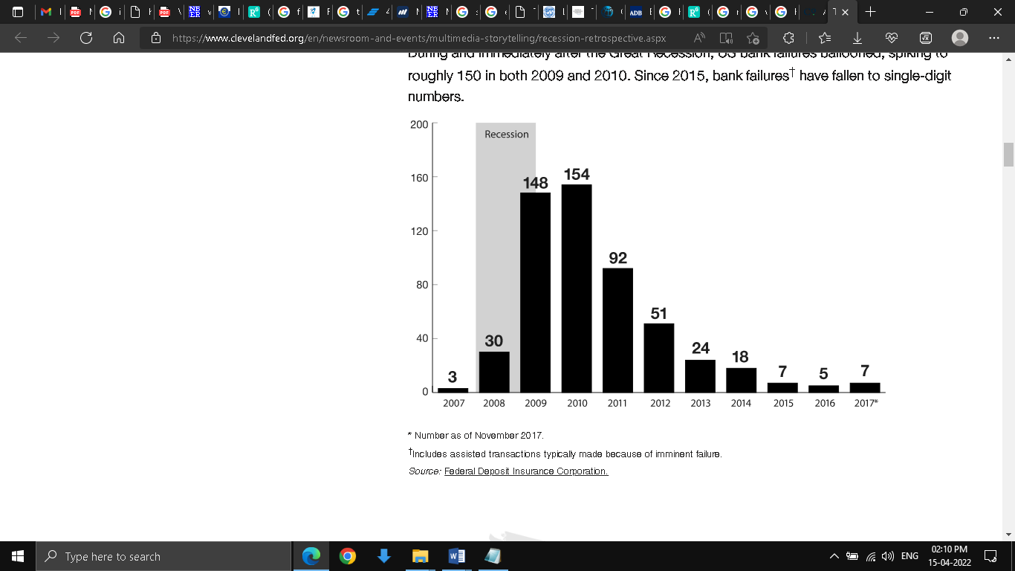

Fig 6: US bank failures from 2008 to 2017

(Source: Park Lazette, 2018)

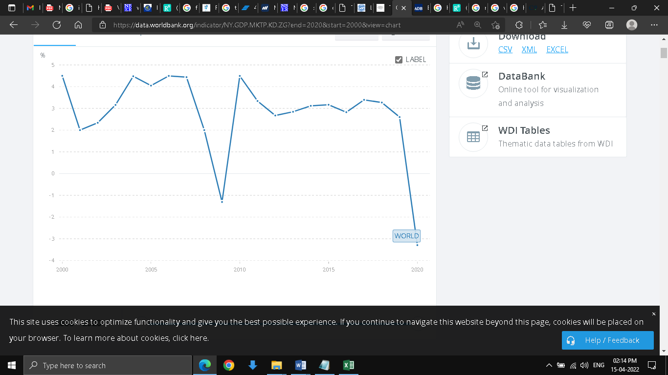

Fig 7: World GDP after the onset of the 2008 US Subprime crisis

(Source: Data.worldbank.org., 2022)

**European sovereign debt crisis**

The European sovereign debt crisis or popularly known as the Eurozone crisis is yet another example of how the interconnectedness of financial institutions creates a cyclical effect of any misfortune. The sovereign debt of Greece to the EU reached alarming heights during the period by 2008. By 2010, when Greece defaulted on its debt payment, it threatened the viability of the Eurozone which comprised 27 countries. The member countries sanctioned loans to Greece to prevent it from debt payment default under conditions that Greece will improve its austerity measures. Although this initiative did not prevent from letting the sovereign crisis of Greece affect other member countries. The collapse of Iceland’s banking system led to a domino fall and within 3 years only, this crisis led to a potential debt default by Spain, Portugal, Ireland and Italy.

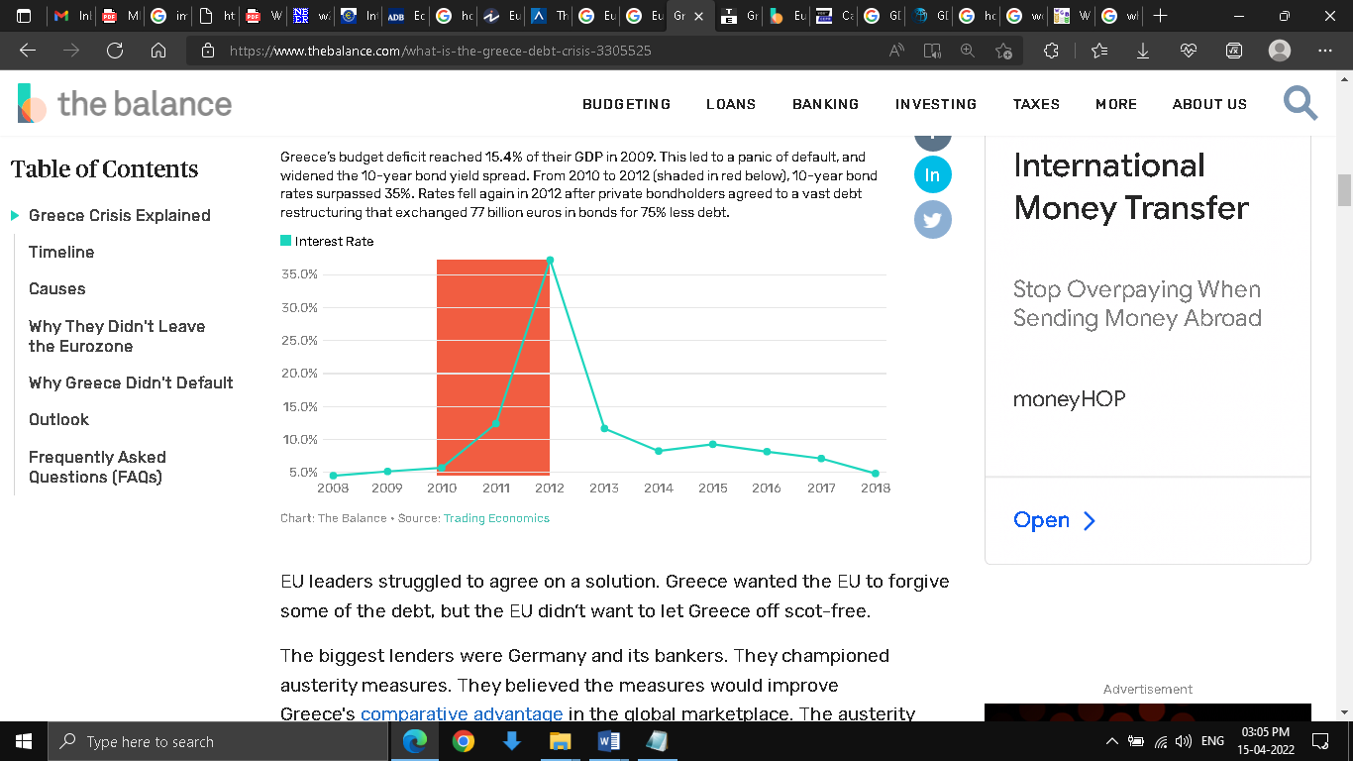

Fig 8: Greece government interest rate 2008-2018

(Source: J BOYLE, 2022)

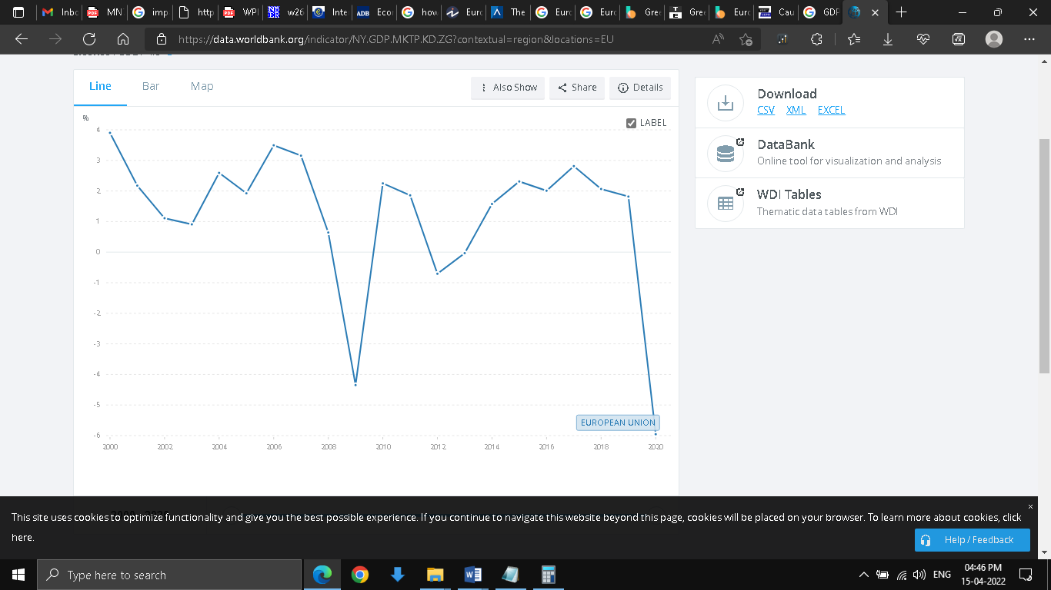

Fig 9: EU GDP growth rate 2000-2020

(Source: Data.worldbank.org., 2022)

# 3. Conclusion

The internet revolution was followed by the digital revolution. These revolutions have brought distant countries, economies, regions, banks, financial institutions, lenders and debtors closer than ever before. This has greatly enhanced economic activity through both intra and inter-party participation. Easy and fast information access has led to both successes as well as disastrous financial events. The financial meltdowns in the past few decades such as the subprime crisis, Eurozone crisis, and Brexit referendum showed the acute vulnerability that the financial institutions share. This network of intricate and complex overlap of relationships between international financial institutes has made it increasingly difficult to identify, isolate and treat. For this reason, any erratic changes in one part of the network reverberate throughout the system. The fall of Lehman Brothers initiated a domino chain reaction resulting in the systematic collapse of several financial institutions. In the case of the Eurozone crisis, the inefficient sovereign policy led to a burgeoning sovereign debt of Greece. Several EU countries came to bailout with a huge cache of financial aid. In the long run, this crisis proliferated in neighbouring countries. Consequently, Spain, Italy, Ireland and Portugal also started building up sovereign debt. This very crisis threatened the existence of the EU itself. This led to another string of stringent austerity policies and consequently global economy shrunk due to less output and spending. It is also evident that some of the systematic risks can be mitigated through a proper risk management framework. The risk management conducted through a continuous improvement process provides a dynamic solution to any kind of risk that can arise in future. It is suggested that all financial institutes should do a periodic risk assessment, identification and improvement. In this way, any ill effects originating in one financial institute can be stopped from spreading to other international financial institutes.

# 4. Reference

ADM. (2022). A Brief History of U.S. Bank Failures. [online] Available at: <https://americandeposits.com/brief-history-us-bank-failures/> [Accessed 15 April 2022].

Barroso, J.B.R.B., Silva, T.C. and de Souza, S.R.S., (2018). Identifying systemic risk drivers in financial networks. Physica a: Statistical Mechanics and its applications, 503, pp.650-674. [online] Available at: <https://www.researchgate.net/profile/Sergio-Souza-13/publication/323543785_Identifying_systemic_risk_drivers_in_financial_networks/links/5ab93cd00f7e9b68ef532ad5/Identifying-systemic-risk-drivers-in-financial-networks.pdf> [Accessed 15 April 2022].

Burkhanov, U., (2018). The Big Failure: Lehman Brothers’ Effects On Global Markets. [online] Research Gate. Available at: <https://www.researchgate.net/publication/270622761_The_Big_Failure_Lehman_Brothers%27_Effects_On_Global_Markets#:~:text=The%20Lehman%20Brothers%20failure%20stressed,replaced%20private%20with%20public%20funding> [Accessed 15 April 2022].

Chance, D.M., (2020). Financial Risk Management: An End User Perspective. [online] Available at: <https://www.worldscientific.com/doi/epdf/10.1142/9789811201844_0001> [Accessed 15 April 2022].

Conesa, M., Lotti, G. and Powell, A., (2020). Resilience and fragility in global banking: Impacts on emerging economies (No. IDB-WP-1133). IDB Working Paper Series. [online] Available at: <https://www.econstor.eu/bitstream/10419/234706/1/IDB-WP-1133.pdf> [Accessed 15 April 2022].

Data.worldbank.org. (2022). GDP growth (annual %) - European Union | Data. [online] Available at: <https://data.worldbank.org/indicator/NY.GDP.MKTP.KD.ZG?contextual=region&locations=EU> [Accessed 15 April 2022].

Data.worldbank.org. (2022). GDP growth (annual %) | Data. [online] Available at: <https://data.worldbank.org/indicator/NY.GDP.MKTP.KD.ZG?end=2020&start=2000&view=chart> [Accessed 15 April 2022].

Gulzar, S., Mujtaba Kayani, G., Xiaofen, H., Ayub, U. and Rafique, A., (2019). Financial cointegration and spillover effect of global financial crisis: A study of emerging Asian financial markets. Economic research-Ekonomska istraživanja, 32(1), pp.187-218. . [online] Banktheories.com. Available at: <https://www.tandfonline.com/doi/full/10.1080/1331677X.2018.1550001> [Accessed 15 April 2022].

H, M., (2022). Risks facing by the Financial Institutions . Part-1. [online] Banktheories.com. Available at: <http://www.banktheories.com/2015/09/risks-facing-by-financial-institutions.html> [Accessed 15 April 2022].

J BOYLE, M., (2022). Understand the Greek Debt Crisis. [online] The Balance. Available at: <https://www.thebalance.com/what-is-the-greece-debt-crisis-3305525> [Accessed 15 April 2022].

Masera, R., (2018). Reforming financial systems after the crisis: a comparison of EU and USA. [online] Research Gate. Available at: <https://www.researchgate.net/figure/The-Global-Financial-System-main-components_fig3_227486553> [Accessed 15 April 2022].

Mieszala, R., (2019). Impact of the collapse of the Lehman Brothers bank and the 2008 financial crisis on global economic security. Scientific Journal of the Military University of Land Forces, 51. [online] Available at: <https://yadda.icm.edu.pl/baztech/element/bwmeta1.element.baztech-02007a71-49a6-40ca-8eb6-64f10dfcf89d/c/11_Mieszala_Impact_149-158.pdf> [Accessed 15 April 2022].

Mossadams.com. (2022). Top Risk Areas for Financial Institutions and Three Key Risk-Management Strategies. [online] Available at: <https://www.mossadams.com/articles/2019/july/risk-management-for-financial-institutions> [Accessed 15 April 2022].

Park Lazette, M., (2018). The Great Recession in Retrospect. [online] Available at: <https://www.clevelandfed.org/en/newsroom-and-events/multimedia-storytelling/recession-retrospective.aspx> [Accessed 15 April 2022].

Patel, R., (2022). Using Flow of Funds to measure the effects of Quantitative Easing | National Statistical. [online] Blog.ons.gov.uk. Available at: <https://blog.ons.gov.uk/2018/01/23/using-flow-of-funds-to-measure-the-effects-of-quantitative-easing/> [Accessed 15 April 2022].

Weinberg, J., (2018). The Great Recession and Its Aftermath | Federal Reserve History. [online] Federalreservehistory.org. Available at: <https://www.federalreservehistory.org/essays/great-recession-and-its-aftermath> [Accessed 15 April 2022].

Xu, Y. and Corbett, J., (2019). USING NETWORK METHOD TO MEASURE FINANCIAL INTERCONNECTION. [online] Nber.org. Available at: <https://www.nber.org/system/files/working_papers/w26499/w26499.pdf> [Accessed 15 April 2022].