**Chronic Disease Cancer**

**Students Name:**

**University Name:**

**Authors Note:**

Table of Contents

Introduction 2

Discussion 2

Aetiology and pathophysiology of cancer 5

Medical management of Cancer 6

Reference 8

# Introduction

Cancer is a debilitating chronic disease with virtually no long term definite treatment that affects people of all ages. It is a vast topic by itself and thus focussing on any one of the 4 main types of cancer namely carcinoma, sarcomas, leukaemia and lymphomas, would not justify leaving out the others from the discussion (Cancer Basics, 2022). This paper thus gives a perception of cancer as a disease in general, covering its prevalence in the USA population through relevant statistical data. Apart from that aetiology, pathophysiology, and evidence-based practices of disease management of cancer are also discussed.

# Discussion

Cancer prevalence in the USA is a major cause of cancer as evident from the figures and charts given below. There is an increasing trend in the number of cancers reported from 1999 to 2018. The USA, allocated $4.1 trillion for health care spending according to NHEA in 2020 registering a 9.7% growth rate over the previous year (Historical CMS, 2022).

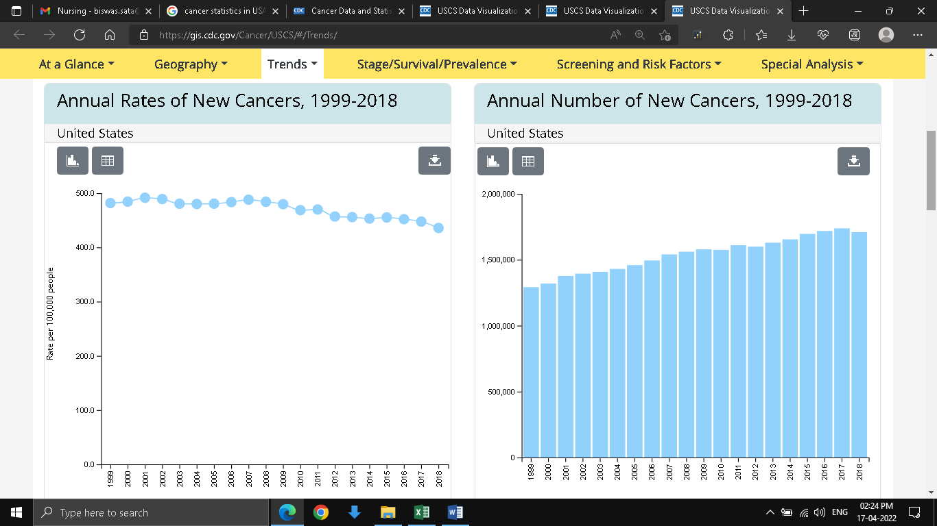

Fig 1: Total cancer counts from 1999-2018

(Source: United States Cancer Statistics, 2022)

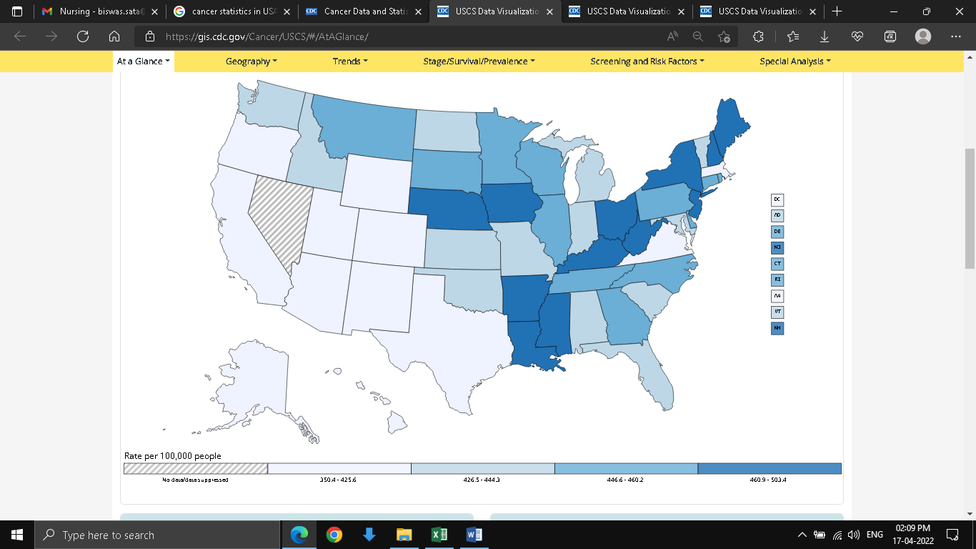

Fig2: Rate of New Cancers in the United States, 2018

(Source: Cancer Statistics CDC, 2022)

According to the latest data available with the CDC of USA as of 2018, there are 1,708,921 new cases of cancer that are reported. The number of people who died was 599,265. 436 new cancer cases were reported with 149 deaths per 100,00 people according to (CDC Cancer Statistics CDC, 2022).

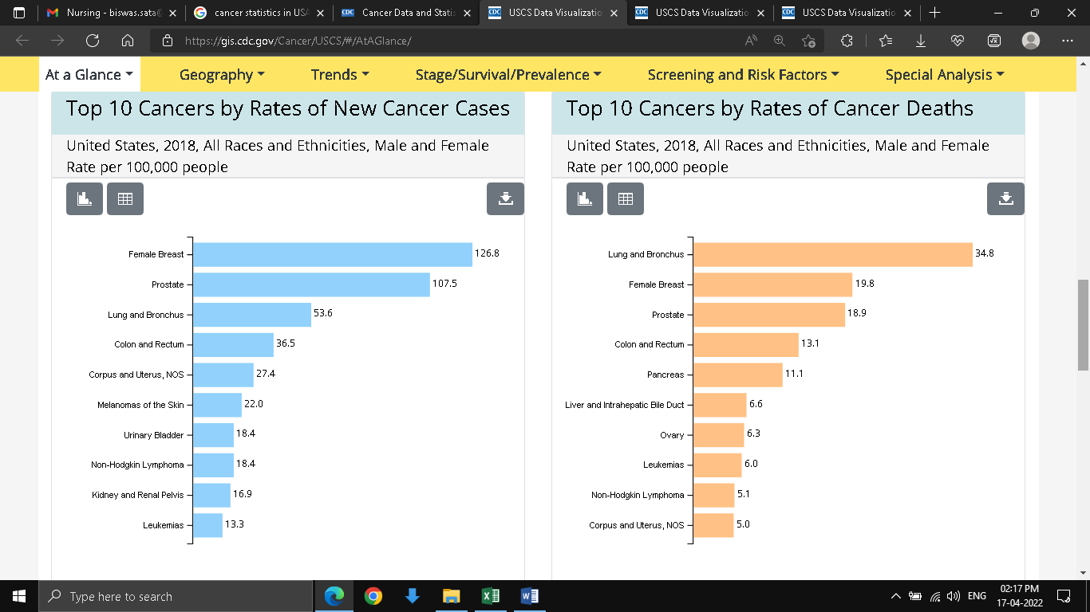

Fig 3: Top 10 New Cancer reports and Top 10 Cancers Deaths

(Source: Cancer Statistics CDC, 2022)

Female breast cancer was the highest reported type and lungs and bronchus related cancer was the highest among all races and ethnicities, both male and female (Cancer Statistics CDC, 2022).

# Aetiology and pathophysiology of cancer

**Aetiology**

The major cause of cancer is mutations of DNA within the cell. The DNA present inside the cell is a conglomeration of a large number of individual genes, which contains instructions for cellular functions. These mutations of genes cause rapid uncontrolled cellular growth. Compromised gene loses their ability to self-correct and heal themselves causing cells to become cancerous (Cancer - Symptoms and causes, 2022).

**Pathophysiology**

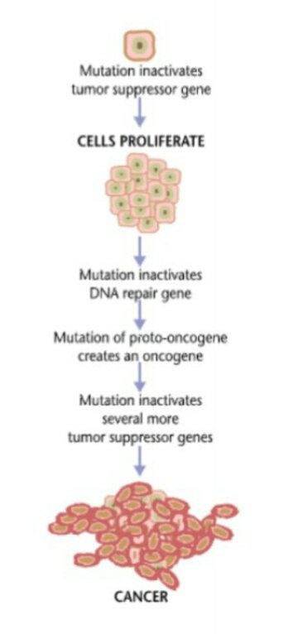

Fig 3: Cancer Pathophysiology

Source: (Singh et al., 2021)

There are 5 stages in caner pathophysiology, which are 1st is DNA damage, 2nd is a mutation in genetic somatic cells, 3rd is the activation of oncogenes, inactivation of suppressor genes, alteration of apoptosis, 4th is altered genes become more active with loss of regulatory genes and last is 5 stage, onset of malignant neoplasm.

# Medical management of Cancer

Some of the types of medical management of cancer are listed below

1. Biomarker testing- Tool for identification of specific genes, proteins for the type of cancer and choice of cancer treatment. Used for tumour testing, genetic testing, somatic testing and tumour subtyping (Pennell, et al., 2019).

2. Chemotherapy - Use of drugs to destroy cancerous cells with few side effects. It’s delivered orally, intravenous, injection, topical, intrathecal, injection (Madmoli, 2018).

3. Hormone therapy – This type of treatment either slows down or stops the growth of breast and prostate cancer. It is associated with side effects. There are two types, one that blocks certain hormones and the other is control how hormones affect the body (Visvanathan, 2019).

4. Hyperthermia- Raising the temperature of specific areas of tissue affected by cancer to 113 F damages and kill cancerous cells but causes slight harm to normal tissue (Brero, et al., 2020).. Techniques used are probes from microwave, radio waves, lasers, ultrasound, and perfusion.

5. Immunotherapy- Immunotherapy boosts the weak immune system to fight against cancer (García-Aranda & Redondo, 2019). These are t-cell transfer therapy, monoclonal antibodies, treatment vaccines, immune system modulators, and immune checkpoint inhibitors.

6. Photodynamic Therapy – Drug activated by the incidence of light kills cancer and different abnormal cells.

7. Radiation Therapy- High doses of radiation are used to kill cancer and even shrunk tumour size (Thompson et al., 2018). This treatment has side effects. Some techniques are external beam radiation and internal radiation therapy.

8. Stem Cell Transplant – Blood cells that are destroyed in people affected by cancer are replenished through stem cell treatment (Nunes et al., 2018. Cancer patients suffering from neuroblastoma and multiple myeloma are best suited for this treatment.

9. Surgery – This is a direct intervention technique, in which the tissue or organ or place affected by cancer is removed surgically if possible (O'Donnell et al., 2019). Types are open surgery and minimally invasive surgery.

10. Targeted Therapy – This kind of treatment seeks to control the growth, division and spreading of the cancer cells, and helps the immune system destroy cancer cells (Shahid et al., 2019). It also delivers sell killing substance to cancer infected cells, cause cancer cell death and starve cancer cells of hormones.

# Reference

Brero, F., Albino, M., Antoccia, A., Arosio, P., Avolio, M., Berardinelli, F., ... & Lascialfari, A. (2020). Hadron therapy, magnetic nanoparticles and hyperthermia: A promising combined tool for pancreatic cancer treatment. Nanomaterials, 10(10), 1919. Retrieved 17 April 2022, from https://www.mdpi.com/2079-4991/10/10/1919/htm

García-Aranda, M., & Redondo, M. (2019). Immunotherapy: a challenge of breast cancer treatment. Cancers, 11(12), 1822. Retrieved 17 April 2022, from https://www.mdpi.com/2072-6694/11/12/1822/htm

Madmoli, M. (2018). Evaluation of chemotherapy complications in patients with cancer: A systematic review. International Journal of Research Studies in Science, Engineering and Technology, 5(12), 59-64. Retrieved 17 April 2022, from http://www.ijrsset.org/pdfs/v5-i12/5.pdf

Nunes, T., Hamdan, D., Leboeuf, C., El Bouchtaoui, M., Gapihan, G., Nguyen, T. T., ... & Janin, A. (2018). Targeting cancer stem cells to overcome chemoresistance. International journal of molecular sciences, 19(12), 4036. Retrieved 17 April 2022, from https://www.mdpi.com/1422-0067/19/12/4036/pdf

O'Donnell, J.S., Hoefsmit, E.P., Smyth, M.J., Blank, C.U. and Teng, M.W., 2019. The promise of neoadjuvant immunotherapy and surgery for cancer treatment. Clinical Cancer Research, 25(19), pp.5743-5751. Retrieved 17 April 2022, from https://www.researchgate.net/profile/Michele-Teng/publication/332770330_The_Promise_of_Neoadjuvant_Immunotherapy_and_Surgery_for_Cancer_Treatment/links/5dc9db6a92851c818046d3b5/The-Promise-of-Neoadjuvant-Immunotherapy-and-Surgery-for-Cancer-Treatment.pdf

Pennell, N. A., Arcila, M. E., Gandara, D. R., & West, H. (2019). Biomarker testing for patients with advanced non–small cell lung cancer: real-world issues and tough choices. American Society of Clinical Oncology Educational Book, 39, 531-542. Retrieved 17 April 2022, from https://ascopubs.org/doi/pdfdirect/10.1200/EDBK_237863

Shahid, K., Khalife, M., Dabney, R., & Phan, A. T. (2019). Immunotherapy and targeted therapy—the new roadmap in cancer treatment. Annals of Translational Medicine, 7(20). Retrieved 17 April 2022, from https://www.ncbi.nlm.nih.gov/pmc/articles/PMC6861781/.

Singh, Y., Dubey, A., Prakash, O., & Tiwari, D. (2021). Drug repurposing in Oncology: Opportunities and challenges. Retrieved 17 April 2022, from https://www.researchgate.net/figure/Figure-1-Pathophysiology-of-cancer_fig1_350372510

Thompson, M. K., Poortmans, P., Chalmers, A. J., Faivre-Finn, C., Hall, E., Huddart, R. A., ... & Coles, C. E. (2018). Practice-changing radiation therapy trials for the treatment of cancer: where are we 150 years after the birth of Marie Curie?. British journal of cancer, 119(4), 389-407. Retrieved 17 April 2022, from https://www.nature.com/articles/s41416-018-0201-z

Visvanathan, K., Fabian, C. J., Bantug, E., Brewster, A. M., Davidson, N. E., DeCensi, A., ... & Somerfield, M. R. (2019). Use of endocrine therapy for breast cancer risk reduction: ASCO clinical practice guideline update. Journal of clinical oncology, 37(33), 3152-3165. Retrieved 17 April 2022, from https://edoc.unibas.ch/72124/3/jco.19.01472.pdf

Cancer - Symptoms and causes. (2022). Retrieved 17 April 2022, from https://www.mayoclinic.org/diseases-conditions/cancer/symptoms-causes/syc-20370588#:~:text=Cancer%20is%20caused%20by%20changes,how%20to%20grow%20and%20divide.

Cancer Basics. (2022). Retrieved 17 April 2022, from https://www.cancer.net/navigating-cancer-care/cancer-basics/what-c%C3%A1ncer

Cancer Statistics CDC. (2022). Retrieved 17 April 2022, from https://gis.cdc.gov/Cancer/USCS/#/AtAGlance/

Historical CMS. (2022). Retrieved 17 April 2022, from https://www.cms.gov/Research-Statistics-Data-and-Systems/Statistics-Trends-and-Reports/NationalHealthExpendData/NationalHealthAccountsHistorical

United States Cancer Statistics. (2022). Retrieved 17 April 2022, from https://gis.cdc.gov/Cancer/USCS/#/Trends/