**Big Apple Case Study**

**Students Name:**

**University Name: Liverpool John Moores University**

**Authors Note:**

Table of Contents

1a. Market type 2

1b. Apple Competitors 2

1c.Marketing Mix 2

1d. Marketing Mix of Apple 2

2a. Market Research 3

2b. Demographic profile 3

2c. Apple’s demographic profile 3

3a. SWOT Analysis 3

3b. SWOT Analysis Apple 3

3c PESTLE Analysi 4

3d. PESTLE Analysis of Apple 4

4a. Marketing Ma 5

4b. Apple Marketing Map 5

5a. Product Life Cycle 5

5b. iPhone 11product Life Cycle 6

6a.PR 6

6b. Apples PR 6

7a. Business Ethics 7

7b. Importance of business ethics 7

7c. Business ethics criticism for Apple 8

Reference 9

# **1a**. Market type

Apple belongs to the oligopoly market. These market players are few in numbers but the pricing decisions and strategies and output decisions are interlinked and interdependent upon one another (Stats.oecd.org, 2022).

# **1b**. Apple Competitors

The main competitors of Apple are, Samsung, IBM, Google, Amazon, and Microsoft (Competitors of Apple, 2022).

# 1c.Marketing Mix

A marketing mix is a strategic tool that interlinks and makes the decisions and strategies interdependent on one another across four main basic domains which are product, price, place and promotion. This entailed the most basic structure of devising a marketing strategy of either products or services. The marketing mix tool can be expanded and include more domains for better control of the outcome of the marketing plan. These variables are people, process, place and physical evidence.

# 1d. Marketing Mix of Apple

Marketing mix strategy of apple:

**Product**

Main products are Mac, Ipad, iPhone, Apple Watch, and Apple Tv. Air Tags (Apple, 2022).

**Price**:

No competitive pricing wars with other major market players. Apple offers premium-priced products. Apple never operated in the low priced category (Macworld, 2020).

**Place**

Exclusive Apple Store shops that display only brands of Apple. Apple Stores are spread throughout the world. To give unique staff members about the brand value of Apple, staff members of Apple Store are specially trained. There are also multiple third party retail shops, outlets and online e-commerce market (Digiday, 2022).

**Promotion**

Promotion strategy is similar to product pruning. In a gap or one or two years, new featured models that claim to make the previous one less attractive and disadvantageous are released. This is a hunger marketing strategy. Unique brand value is linked with the notion of social status. People indulge in compulsive buying just for social status upliftment, creating self-driven consumer action. Apple also uses paid platforms such as YouTube and Facebook through popular Tech promotion channels as word of mouth strategy (He, 2022).

# 2a. Market Research

Market research helps to create a holistic understanding of competitors and external factors affecting the market. Through competitor analysis, the market share of the competitors by volume and value can be analysed. It also helps to understand the customer segments of a particular market on basis of demographics and socioeconomic status.

# 2b. Demographic profile

It means information regarding the structure of the population. Information about age, education level, sex, location, income, and employment.

# 2c. Apple’s demographic profile

Apple’s demographic profile varies from country to country. Its main target customers are between 16 years to 24 years worldwide (WebTribunal, 2022). People with socioeconomic status between upper to upper-middle class are the main target. 83% of teens in USA uses Apple iPhone (KommandoTech, 2022).

# 3a. SWOT Analysis

SWOT analysis gives a brief overview of how balanced a strategic position of a business is through evaluation of its strength, weakness, opportunity and threat. Weakness needs to be reduced. Factors contributing to strength used as leverage to turn opportunity into strength and mitigate threats.

# 3b. SWOT Analysis Apple

|  |  |
| --- | --- |
| **Strengths:**   * Strong R&D division * Strong organisational leadership * Unique brand value * Exceptional product quality and service * Significantly high number of technology patent rights | **Weakness:**   * Premium-priced product. * No entry into the low-end smartphone market. * Reliance on cheap labour in China with minimal pay and facilities. * Reliance on supplier bases outsides USA (Apple Annual Reports, 2022). * Supply chain significantly exposed to external shocks |
| **Opportunities:**  1. Entry in vast low priced electronic segment in East and South-East Asia  2. Exclusive technology patent rights can be shared with other technology firms.  3. New product development through shared intellectual property rights. | **Threats:**  1. Low-end market players  2. After-sales service costs exceptionally high |

# **3c PESTLE Analysi**s

PESTEL is acronym for political, economic, social, technological, legal, environmental factors that affect and shape the of the strategic business decisions of a company to achieve operational efficiency.

# 3d. PESTLE Analysis of Apple

|  |  |
| --- | --- |
| Political: | * Significantly exposed to geopolitical environmental factors. * The extensive supplier base can be affected * Production facilities affected |
| Economic: | * Well-positioned in developed countries. * Increase in HNI individual provide more avenues for market share in developing countries. |
| Social: | * Brand value of Apple well established with social status. * Product design and service well mapped with changing social norms as countries transition from millennials to Generation Z. |
| Technological: | * Adaptation of new technology in Apple in pace with other parts of the world in sustainability. * Global insistence to prolong the use of electronic devices is incorporated in product development. |
| Legal: | * Highly subject to changes in legal laws both domestically and internationally. * Frequent changes in legal formalities in supplier base countries and customer target market countries affects Apple’s operational efficiency. |
| Environment: | * Highly susceptible to environmental changes. * Covid 19 like a pandemic slowed down and even halted production facilities for months. |

4a. Marketing Ma**p**

Marketing Map helps to understand competitor behaviour and identify gaps in the market by mapping products available in the market with the competitors that belong.

# 4b. Apple Marketing Map

The marketing map analysis on basis of price and quality indicates that there is a significant gap for market entry in the segment of medium quality medium price.

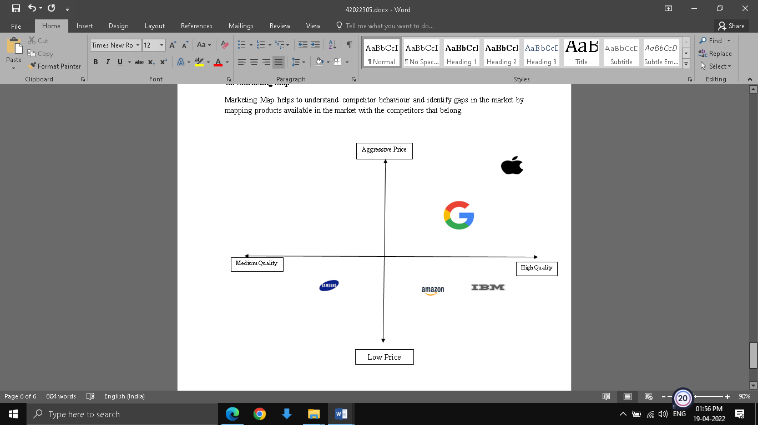

Fig1: Apple Market Map

# 5a. Product Life Cycle

It denotes the 4 stages of product goes through, starting with the introduction, growth, maturity and lastly the decline stage (Twi-global, 2022). The introduction is a slow development stage, development gains momentum in the growth stage, development stabilizes in maturity and finally stops in the decline stage.

# 5b. iPhone 11product Life Cycle

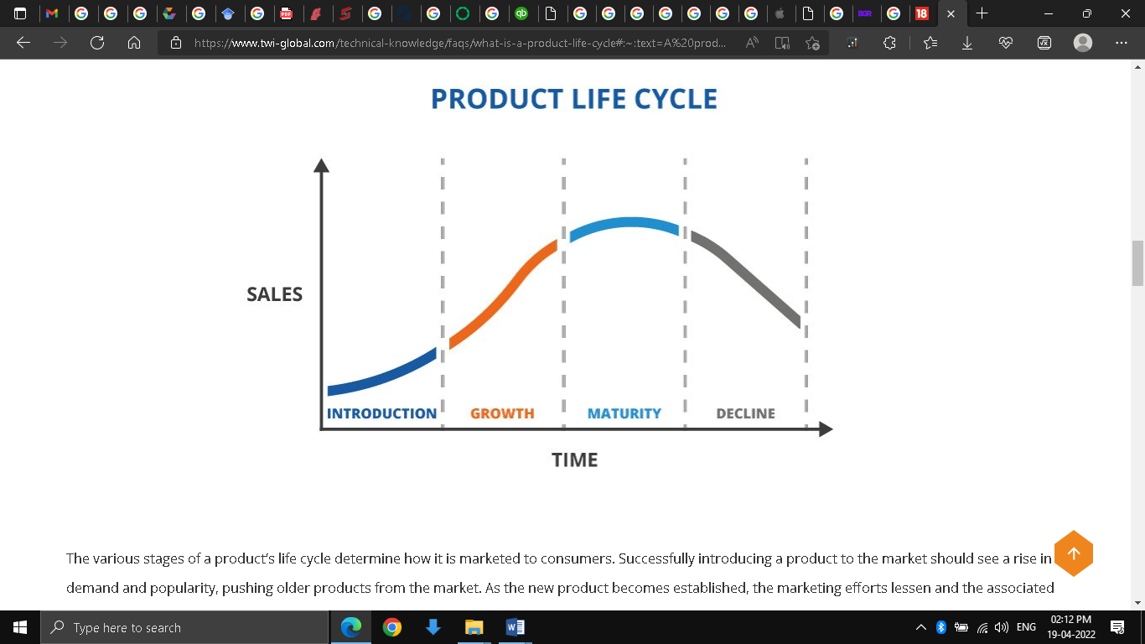

Fig2: Product Life Cycle

(Source: Twi-global, 2022)

Apple iPhone 11 was launched in September 2019, which can be called the introduction phase (MacRumors, 2022). It became the most sold and popular phone in 2020 and this phase can be called the growth phase (9to5Mac, 2022). Apple will discontinue the production of the iPhone 11 after the launch of the iPhone 14 by end of 2022 (News18, 2022). This phase can be called the transition from maturity to decline phase. Currently, iPhone is transitioning from maturity to the decline phase.

# 6a.PR

PR is an acronym for public relations. Through PR the market is made aware of the business, manages and cultivates a relationship with consumers and raises business and brand reputation through communication (Business, 2022).

# 6b. Apples PR

**Secrecy**

Apple uses secrecy, which in turn gives rise to speculation. As speculation rises, people become more inquisitive to differentiate between authentic and unauthentic news. This creates doubts. For eg., the launch of Apple iPhone 12 in 2020 was abuzz with speculation generated by media conversation. But Apple didn’t release any information and then suddenly declared the launch date and sent an invitation just one week before the actual event launch (Medium, 2022).

**Scarcity**

Another public relations strategy that Apple uses is creating scarcity in order to increase demand. E.g. Before any new product launch, public will make a long que before Apple Stores, as there are limited stocks present. Apple deliberately keeps stocks limited on launch dates so that long queues before Apple Stores will create a frenzy among and grab the attention of others (Medium, 2022).

# 7a. Business Ethics

It is the principle of following fair and just actions for the greater good of the organisation, the people and the environment. Thus it is relevant to the conduct of both the organisation and the individuals on a holistic level. Business ethics is applicable to various domains of business, from strategy building in boardrooms to organisational value, environmentally sustainable practices, stakeholder value creation. Other important domains of business where ethics matter are employee management, supplier base management, sales and finance management.

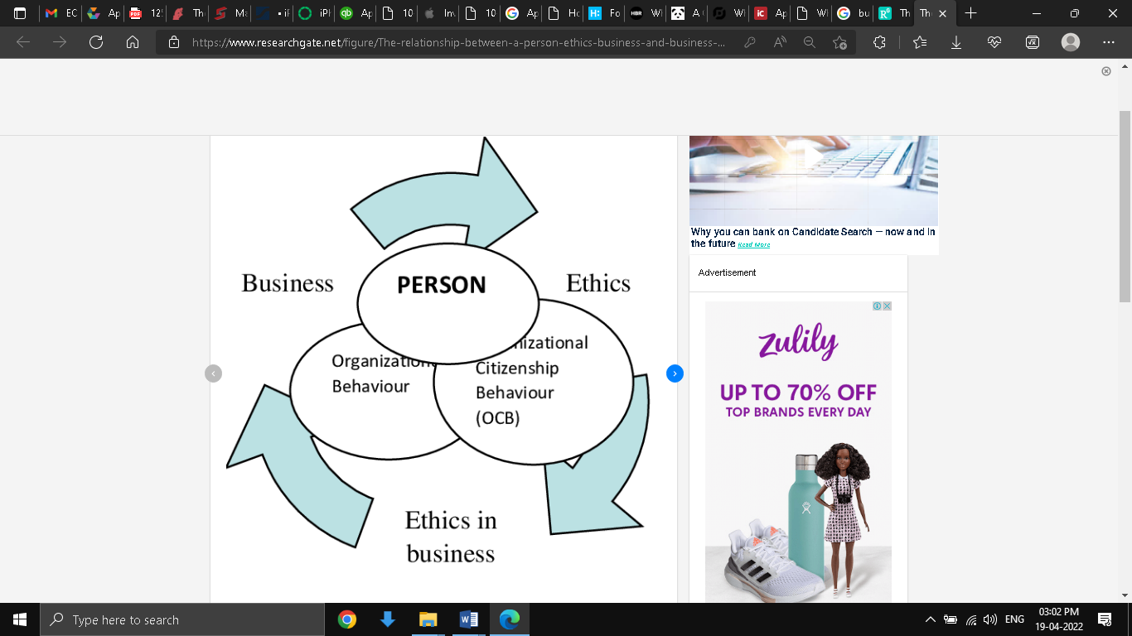

Fig 3: Business ethics and its relation

(Source: Kowal et al, 2021)

# 7b. Importance of business ethics

The functions of a business are subject to local rules and regulations. These rules are devised to discourage the adoption of unfair business practices. As such practices can hurt other business establishments but also create a bad reputation for the business environment in that particular region. That is why it is important for corporations to devise and plan their business strategies under such local laws and regulations. Unethical business practices can create an undue advantage over competitors. Thus if every other competitor follows the unethical practice in that region, then the business reputation gets undermined. In modern-day business when every corporation is looking for ways for globalization, the business ethics of the organisation, as well as the business standard where it wants to expand, has become important. Without any ethical standards, every business will only become a profit-driven organisation, putting the safety of citizens, stakeholders, investors, employees and the environment at risk.

# 7c. Business ethics criticism for Apple

Some of the business ethics of Apple that are subject to criticism are in areas of use of child labour in the Democratic Republic of Congo, in areas of sustainable business practices related to the use of PVC, BFR and Phthalates in its electronic products and tax avoidance. (Ethical Consumer, 2022)

Apple along with other tech giants such as Tesla is facing lawsuits due to gross violation of human rights and children’s protection. The use of child labour in the small scale cobalt mining artisanal industry of DRC led to death and serious injury(Ethical Consumer, 2022).

On sustainable environmental practice, Apple lacked a quantified future target date in its endeavour to reduce the use of BFR and PVC in newer products. Although it claims to have done so it also mentioned that the use of such products is still an issue in Thailand, India and South Korea. This statement is in conflict with its sustainability goas(Ethical Consumer, 2022).

Apple has subsidiaries in Singapore, Ireland and Netherlands. This raises the doubt of tax avoidance by Apple as these regions are known to support that. This doubt was supported by the fact that there is no separate country-based financial data nor any clear statements of tax paid in these countries(Ethical Consumer, 2022).

# Reference

9to5Mac. (2022). iPhone 11 now ‘the world’s most popular smartphone’ as it surpasses iPhone XR. [online] Available at: <https://9to5mac.com/2020/05/26/iphone-11-popularity-surpasses-iphone-xr/> [Accessed 19 April 2022].

Apple Annual Reports. (2022). [online] Available at: <https://www.annualreports.com/HostedData/AnnualReports/PDF/NASDAQ_AAPL_2020.pdf> [Accessed 19 April 2022].

Apple. (2022). Apple Accessories. [online] Available at: <https://www.apple.com/in/shop/accessories/all> [Accessed 19 April 2022].

Business. (2022). Public relations | Business Queensland. [online] Available at: <https://www.business.qld.gov.au/running-business/marketing-sales/marketing-promotion/pr#:~:text=PR%20involves%20communicating%20with%20your,awareness%2C%20attitudes%20and%20behaviour%20change.> [Accessed 19 April 2022].

Competitors of Apple. (2022). Apple Competitors. [online] Available at: <https://www.comparably.com/companies/apple/competitors> [Accessed 19 April 2022].

Digiday. (2022). 'Everything is well thought out': How the Apple store has become a template for retailers. [online] Available at: <https://digiday.com/retail/everything-well-thought-apple-store-become-template-retailers/> [Accessed 19 April 2022].

Ethical Consumer. (2022). How ethical is Apple Inc? | Ethical Consumer. [online] Available at: <https://www.ethicalconsumer.org/company-profile/apple-inc> [Accessed 19 April 2022].

He, M., (2022). Analysis of iPhone’s Marketing Strategy. [online] Available at: <https://www.atlantis-press.com/proceedings/icfied-21/125954341> [Accessed 19 April 2022].

KommandoTech. (2022). 27 iPhone Statistics to Make Steve Jobs Smile in Heaven. [online] Available at: <https://kommandotech.com/statistics/iphone-statistics/> [Accessed 19 April 2022].

Kowal, J., Keplinger, A. and Klebaniuk, J., (2021). ICT Management in Psycho-social and Economic Research for Human Development (ICTM) Digitalisation, Innovation and Education for Socioeconomic Development Monograph, Volume 1. [online] Research Gate. Available at: <https://www.researchgate.net/figure/The-relationship-between-a-person-ethics-business-and-business-behaviour_fig1_355192736> [Accessed 19 April 2022].

MacRumors. (2022). iPhone 11: Still a Good Buy? Everything We Know. [online] Available at: <https://www.macrumors.com/roundup/iphone-11/#:~:text=The%20iPhone%2011%20was%20introduced,and%20an%20A13%20Bionic%20chip.> [Accessed 19 April 2022].

Macworld. (2020). How Apple prices its products: 3 rules to understand. [online] Available at: <https://www.macworld.com/article/234911/3-rules-to-understand-the-price-of-apple-products.html> [Accessed 19 April 2022].

Medium. (2022). How Does Apple Use Public Relations?. [online] Available at: <https://prsuperstaruk.medium.com/how-does-apple-use-public-relations-3fa1c10e6a99> [Accessed 19 April 2022].

News18. (2022). Apple May Kill The iPhone 11 Soon After The Launch Of iPhone 14. [online] Available at: <https://www.news18.com/news/tech/apple-may-kill-the-iphone-11-soon-after-the-launch-of-iphone-14-5009977.html> [Accessed 19 April 2022].

Stats.oecd.org. (2022). OECD Glossary of Statistical Terms - Oligopoly Definition. [online] Available at: <https://stats.oecd.org/glossary/detail.asp?ID=3270#:~:text=An%20oligopoly%20is%20a%20market,each%20firm%20some%20market%20power.> [Accessed 19 April 2022].

Twi-global. (2022). What is a Product Life Cycle? (Definition, Stages and Examples). [online] Available at: <https://www.twi-global.com/technical-knowledge/faqs/what-is-a-product-life-cycle#:~:text=A%20product%27s%20life%20cycle%20is,%2C%20packaging%20redesigns%2C%20and%20more.> [Accessed 19 April 2022].

WebTribunal. (2022). 33 Apple Statistics to Chew On in 2022. [online] Available at: <https://webtribunal.net/blog/apple-statistics/#gref> [Accessed 19 April 2022].