**Policy Brief: Family Violence**

**Students Name:**

**Federation University**

**Authors Note:**

Table of Contents

Key messages 2

Introduction 2

Why family violence matters 2

Research 3

Implication of the research 6

Policy and practice 8

Reference 9

Key messages

* 2.2 million Australians encountered domestic violence. Another 3.6 million Australians suffered emotional abuse.
* Current Family Law is not adequate to address non-physical coercive actions on victims.
* A comprehensive change in service delivery is needed.
* The next policy change needs to address issues faced by specially-abled victims and Aboriginals/ Torres state islanders.

Introduction

Family violence is a social problem that permeates every corner of the world, from developed nations to developing nations. This policy brief is prepared to be a guideline for pro-actively handling family violence issues in Australia. This document sets up the building blocks based on which policy can be prepared through steps. The first is, to understand why issues like family violence matter for discussion. The second step is researching the reasons that give rise to family violence. The third step is the implications of the research findings based on the second research step. The implications provide an idea as to how the reasons underlying family violence affect a region's broader socio-economy and politics. The last and the concluding section of the policy brief outlines the new policy guidelines regarding family violence. For this social policy theoretical frameworks such as the Institutional Redistributive Model of Social Policy are applied to map the justifications in policy recommendations to factors underlying a particular theoretical model (SOCIAL POLICY- CONCEPTS AND DEFINITIONS, 2022) The changes that are advocated abide by the guidelines provided in the AASW’s Code of Practice and Code of Ethics.

# Why family violence matters

Family violence is one of the main issues plaguing Australia's national health and welfare. Sometimes people affected by such violent domestic and family violence become lifelong victims. The perpetrators of such violent acts become habitual offenders. According to the data published by the Australian Bureau of Statistics in its 2016 survey of Personal Survey, nearly 2.2 million Australians have met with some kind of direct or indirect form of violence (Australian Institute of Health and Welfare, 2022). While 3.6 million Australians experienced emotional abuse from their partner (Australian Institute of Health and Welfare, 2022).

According to the findings published by Mission Australia, it mentions that women have a higher probability to experience abuse from their partners. Homelessness, another rising social problem in Australia, is attributed to domestic and family violence. Out of the total client pool served by Mission Australia, about 29% who sought help for being homeless mentioned domestic and family violence as the main reason they sought help (Domestic and Family Violence statistics, 2022). The issue of domestic violence is not confined to certain age limits. According to Mission Australia, many respondents from its client survey indicated being subjected to physical and mental abuse even in childhood. Amongst the aboriginal communities, the evidence of family violence seems to be the worst. The local indigenous people are more prone to be hospitalized from aggravated assault arising from family violence by 32 times than their non-aboriginal counterparts (Domestic and Family Violence statistics, 2022).

# Research

The research seeks to find out the reasons for family violence in social-economic contexts, which are social, economic, gender, and its effect on mental health. Apart from this, the type of family violence prevalent is also discussed in this section.

**(i) Social inequality**

Toxic masculinity is an outcome of social inequality. Belief about masculinity deep-rooted in social misconception is one of the prime factors for the high rate of violence towards women (Family violence explained, 2022). These behaviours or practices arise from a notion of social norms and rules unwritten on ways to act in a society. Some of the common traits of perpetrators are controlling families through emotional abuse. Propagators of toxic masculinity have a misplaced notion that makes them believe they possess the right to behave in any way they want. Sometimes they will not take responsibility for their behaviours and can even blame the present situation on others. They may sometimes place the blame on their addictions to alcohol and stress. Victims can be abused because the perpetrators do not have control over the sudden outburst of emotions and thus end up being hurt physically and mentally (Usher et al., 2020). In some cases, the victims will comply with the perpetrator’s views that the violent actions in some cases were not done on purpose. The perpetrator’s insistence that their actions are sometimes involuntary can drain the victim’s will to report or speak up against such actions.

**(ii) Gender and economic inequality**

Gender inequality is one of the prime reasons that cause family violence. This is more prevalent in the case of older women (International Women’s Day – AASW, 2022). Gender inequality has affected a whole generation of women and continues to do so. This inequality affects every aspect of life starting from childhood schooling, college education level, job prospects, marriage prospects and old-age dependency. It is important to point out that the social workers working with the Australian Association of Social Workers reported that gender inequality is the prime reason that led to increased homelessness for aged women, increased sexual abuse, and being falsely accused of crimes related to poverty and family violence. Older women have less privilege than their male counterparts in terms of social and economic status, so they are used as scapegoats more often than not (Sawrikar, 2019). It is also observed that there is an ongoing tendency to support a culture that encourages violence against women and relinquishes the perpetrators from all and any kind of responsibility. This goes against the very ethos that gives rise to an equal society.

**(iii) Natural calamity and mental health**

The link between natural calamity and family is unique and needs discussion. Australia has suffered numerous bush fire incidents but its recurrence and devastation have increased exponential during the last 2-to 3 years. Such devastating bush fire incidents cause loss of land, vegetation, home, property, life and assets. This irreparable loss causes heavy emotional damage that affects those who are in its direct path and other members and individuals such as front-line workers (Bushfires: mental health, trauma and family violence – AASW, 2022). Firefighters and doctors who are pressed into action are sometimes overwhelmed by such experience. This affects their mental well-being and slowly reveals the symptoms such as frequent altercations, and disagreements. This slowly snowballs into heated arguments. Without any provision for counselling and guidance, people affected by such natural disasters fall into a psychological trap, which self sustains itself. This psychological issue manifests as violent behaviours with family members. As the family members are in dark about the reasons for such violent behaviours, they fail to provide the perpetrator with the necessary support.

**(iv) Inadequacy of current family law system**

According to the reviews and suggestions obtained from the social workers, the government is requested to put into action all the recommendations of the Australian Law Reforms Commission’s review of the Family Law System. This is because the present family laws in Australia fail to provide adequate protection to women and children from family violence. The current law does recognize physical violence in its system, but it fails to recognize other forms of action such as coercive actions (Family law system – AASW, 2022). These actions are propagated not through any physical means but psychologically, emotionally and financially. As there are no visible tell-tale signs of any forceful action over the victim, the perpetrator is not apprehended. As women and children are easier to be manipulated through coercive actions, the vast majority are only them. This loophole in the present system doesn't allow any intervention even when there is violence and abuse and thus it fails to respond to the needs of the victim. Another issue in the present family law system is regarding legal proceedings (Yates, 2020). If the system recognises the presence of violence and abuse and starts proceedings for the remediation of the situation, it demands that both parties enter as equals. According to social workers who have closely worked with family violence victims, this is a gross misconception of the system.

**(v) Abuses recognized by system**

There are mainly 4 types of family violence prevalent: physical abuse, verbal abuse, economic abuse, and social abuse (Hegarty et al., 2018).

**(a) Physical abuse**-

This type of violence is the most serious kind. It leads to injury and pain. Some of the common tactics used against victims are not allowing them to sleep, and not providing adequate warmth and nutrition. Sometimes even emergency medical care is denied. Partners can commit sexual assault. Even pets and animals living together are harmed. In extreme cases, physical violence leads to life-threatening injuries and even death.

**(b) Verbal abuse**-

Sometimes adult partners and children undergo verbal abuse either in private confinements or public places. The main intention of the abuser is to humiliate, demean, subjugate, degrade and intimidate.

**(vi) Abuse not recognised by system**

**(a) Economic abuse**-

Partners dependent upon other family members for economic support are usually victims of this kind of violence, mainly women. The common methods applied against the victim are denying access to income or assets.

**(b) Social abuse**-

This kind of family violence is more prevalent but is less harmful physically. These are usually carried out on young children such as isolation, taking control of every social activity and interaction. At times this kind of social abuse even involves incidents where the victim's liberty is seized forcefully.

**(ii) Closed proximity and violence**

There were increased reports of sporadic family violence in the aftermath of the Covid lockdown worldwide. This was also witnessed in Australia. Being confined in a closed space with no means of recreation and reduced social interaction led to psychological issues that amounted to violent outbursts and emotions (National Families Week: AASW, 2022). In some cases, such psychological stress led to domestic violence. This affected every individual irrespective of their age or social status. As the nation got busy handling the ongoing pandemic, the critical lines of communication that were earlier open and handling domestic violence complaints got shut down. This led to no other choice but to either comply with the present aggressor or resort to even more violent means (Douglas, 2019). The local caretaker, government-appointed caseworker, or social worker knew the prevailing issues of a family affected by domestic violence. As these important resources support the family well-fare system in Australia affected the pandemic lockdown, the local law enforcement officials could only intervene to deliver their part of the duty. Thus, the larger part of the issue regarding domestic violence which is counselling, guidance and rehabilitation was not followed up properly.

# Implication of the research

This section explains the implications or understanding of the research. The implications can be discussed in broad categories. A theoretical framework of socio-policy analysis is used to narrow down the discussion in the present context.

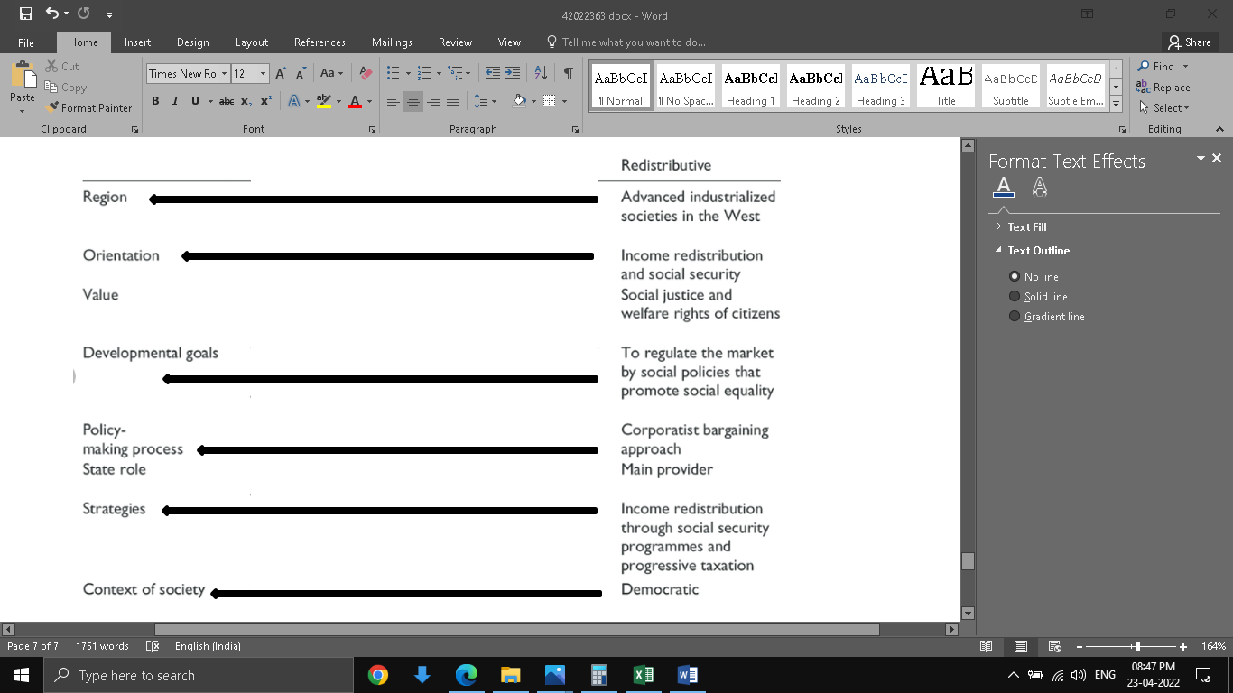

Fig 1: Institutional redistributive model of social policy

(Source: SOCIAL POLICY- CONCEPTS AND DEFINITIONS, 2022)

**Institutional redistributive model of social policy**

This policy states that social welfare is an important part of a society, which provides universalist services beyond the boundaries of the market based on need. The underlying principle is based on social equality, where the resources are redistributed in a controlled fashion by the system through time (SOCIAL POLICY- CONCEPTS AND DEFINITIONS, 2022).

The implications of the research on social welfare activities are discussed below. The main focus is better to control the present system through which resources are utilized properly.

**Domestic and family violence support services**

There is an increased need for service types such as domestic violence counselling, aboriginal and Torres state islander services, court-based services, perpetrator intervention programs and more focus on research (Domestic and Family Violence Support Services, 2022). Other service types that can be launched are telephone-based services, counselling for children and young people and the local domestic violence service system. To make these services available to every woman and child, all available modes of service need to be launched: centre-based, virtual-based, and mobile-based. Accordingly, to the information obtained the women and children can be approached to impart advice, individual advocacy, for counselling. The outcome of these endeavours is to increase the safety from domestic and family violence and improve the overall well-being. At the same time, it will help to increase the perpetrator’s responsibility (Domestic and Family Violence Support Services, 2022). That way the perpetrators will not be absolved of accusations easily like before. The public can be made more aware of issues related to domestic and family violence as well as the available support services, through which victims can seek help.

**Women’s shelter and non-accommodation support services**

Homelessness among family violence affected women is a prevalent issue in Australia is already mentioned. This service is thus meant for people who are at high risk of homelessness. Apart from those women and child who are not homeless but are in imminent physical danger should use this service (Domestic and Family Violence Support Services, 2022). Other special target groups are aboriginals and women of Torres Strait Islands as well as children. The service types offered are mobile-based support, centre-based and temporary supported accommodation. Based on the information obtained through these services, case management can be prepared. This is a service that is markedly different from that offered in Domestic and family violence support services. This is because homelessness poses more danger to the victims compared to those who have not been made homeless. Case management provides a program tailored to the needs and wants of the victim. Case management can be improved through effective risk and need management, safety planning, support planning, review and close monitoring (Domestic and Family Violence Support Services, 2022). The outcomes that should be reached are proper access to services for victims, proper delivery of services chosen, independent housing facility, maintenance of independent housing by victims, better access to jobs, increased self-reliance and connection with the community.

# Policy and practice

Based on the understanding of the research into family violence and the implications the following set of set guidelines is proper within the AASW’s Code of Practice and Code of Ethics (Code of Ethics- AASW, 2020).

* Rules and guidelines passed by parliament should be fairly equivalent across different regions of Australia.
* The current guidelines of Family Law need to be redefined to recognize all forms of violence and not just physical violence.
* Increased accommodation facilities for the homeless.
* Reduce the complexity in the legislation process for faster justice delivery to the victims of family violence.
* Victims whose source of income has vanished as a fallout of family violence, must be provided with financial aid to pursue their cause in court.
* Increased funding for the development of the Integrated Family System.
* Increased awareness to be propagated through the community based legal system. This will help victims from the clutches of domestic violence.
* The case management of any victim should be followed diligently and impartially by caseworkers.
* The perpetrator apprehension system should be reformed so that they do not find the necessary means, or it becomes harder for them to connect with their victims. This will ensure that the victims who are undergoing counselling do not bounce back into the clutches of the violence again.
* Issues faced by victims who are physically challenged in using the Integrated Family Systems must be addressed.
* For physically challenged victims the types of service and modes of access for that service must be integrated in such a way it requires minimal assistance from others.

# Reference

Australian Institute of Health and Welfare. (2022). Retrieved 23 April 2022, from https://www.aihw.gov.au/reports-data/behaviours-risk-factors/domestic-violence/overview#:~:text=According%20to%20the%20Australian%20Bureau,emotional%20abuse%20from%20a%20partner.

Bushfires: mental health, trauma and family violence - AASW. (2022). Retrieved 23 April 2022, from https://www.aasw.asn.au/news-media/2020/the-invisible-impact-of-the-bushfires-mental-health-trauma-and-family-violence

Code of Ethics- AASW. (2020). Retrieved 23 April 2022, from https://www.aasw.asn.au/practitioner-resources/code-of-ethics#:~:text=The%20Code%20of%20Ethics%20of,pursuit%20of%20the%20profession%27s%20aims.

Domestic and Family Violence statistics. (2022). Retrieved 23 April 2022, from https://www.missionaustralia.com.au/domestic-and-family-violence-statistics

Domestic and Family Violence Support Services. (2022). Retrieved 23 April 2022, from https://www.publications.qld.gov.au/ckan-publications-attachments-prod/resources/c96539aa-1351-4971-8f5b-7515fb3c121c/investment-spec-dfvss.pdf?ETag=7157f7e289154a97190c02d3058167a8

Douglas, H. (2019). Policing domestic and family violence. International Journal for Crime, Justice and Social Democracy, 8(2), 31. Retrieved 23 April 2022, from https://www.proquest.com/openview/b8068fa022ebcd2a734b4a47a4f0a411/1?pq-origsite=gscholar&cbl=4425140

Family law system - AASW. (2022). Retrieved 23 April 2022, from https://www.aasw.asn.au/news-media/2019-2/current-family-law-system-does-not-adequately-protect-women-and-children-from-violence-say-australian-social-workers

Family violence explained. (2022). Retrieved 23 April 2022, from https://www.betterhealth.vic.gov.au/health/healthyliving/family-violence-explained#resistance-to-seeking-help-for-violence

Hegarty, K., D Hindmarsh, E., & T Gilles, M. (2018). Domestic violence in Australia: definition, prevalence and nature of presentation in clinical practice. Retrieved 23 April 2022, from https://www.mja.com.au/journal/2000/173/7/domestic-violence-australia-definition-prevalence-and-nature-presentation

International Women’s Day - AASW. (2022). Retrieved 23 April 2022, from https://www.aasw.asn.au/news-media/2020/poverty-family-violence-all-a-result-of-gender-inequality-says-aasw-ahead-of-international-womens-day-on-8-march

National Families Week: AASW. (2022). Retrieved 23 April 2022, from https://www.aasw.asn.au/news-media/2020/national-families-week-aasw-calls-on-increased-focus-on-family-violence-during-covid-19-and-for-a-separate-medicare-item

Sawrikar, P. (2019). Child protection, domestic violence, and ethnic minorities: Narrative results from a mixed methods study in Australia. PLoS one, 14(12), e0226031. Retrieved 23 April 2022, from https://journals.plos.org/plosone/article?id=10.1371/journal.pone.0226031

SOCIAL POLICY- CONCEPTS AND DEFINITIONS. (2022). Retrieved 23 April 2022, from http://epgp.inflibnet.ac.in/epgpdata/uploads/epgp_content/S000032SW/P001730/M021686/ET/15016485151-Module1ConceptsandDefinitions-Text.pdf

Usher, K., Bhullar, N., Durkin, J., Gyamfi, N., & Jackson, D. (2020). Family violence and COVID‐19: Increased vulnerability and reduced options for support. International journal of mental health nursing. Retrieved 23 April 2022, from https://www.ncbi.nlm.nih.gov/pmc/articles/pmc7264607/

Yates, S. (2020). Gender, context and constraint: Framing family violence in Victoria. In Women's Studies International Forum (Vol. 78, p. 102321). Pergamon. Retrieved 23 April 2022, from https://www.scirp.org/journal/paperinformation.aspx?paperid=112820