**GLOBAL BUSINESS ENVIRONMENT: CULTURE, MANAGEMENT & THE ECONOMY**

**Students ID Number:**

**Sainsbury Global Expansion**

**3000**

**Submission date**

**Executive Summary**

This report is prepared to discuss the problems encountered by Sainsbury, due to cultural differences and shifts in global economic conditions in its expansion into Indonesia. Trompenaar’s and Hofstede's Models Of Cultural Dimensions are used to discuss the problems faced by Sainsbury due to cultural differences between UK and Indonesia and their probable effect on Sainsbury. To point out the economic impact on Sainsbury due to its expansion in Indonesia, the link between globalisation and the world’s economy is explained first and its inference is linked to Indonesia’s economy. Next, the international trade between UK and Indonesia is briefly discussed and the ways this is going to impact Sainsbury is explained with help of the Global Strategic Rivalry Theory. In the next part, the macroeconomic conditions of Indonesia are discussed using two important indicators, GDP and GDP per capita. The discussion also involves the link between Indonesia’s national income and Sainsbury’s business expansion and its implications for its expansion. This is explained using how different factors that make up the national income can change from time to time causing economic fluctuations and the impact of such fluctuation on Sainsbury. Next, the impact of the exchange rate on the competitive advantage of Sainsbury is discussed and the ways new agreements in trade, investment and economic cooperation usher in a new age of industrial revolutions which can act to Sainsbury’s advantage in its expansion into Indonesia. The last part includes the concluding section. The last part ends with a conclusion and recommendation.

Table of Contents

1. Introduction 3

1.1 Indonesia 3

1.2 Sainsbury 3

2. Analysis and Discussion 3

2.1: Culture 3

2.1.1 Globalisation and culture 3

2.1.2 Culture and communication 4

2.1.3 Cultural difference 5

2.1.4 Managing people in the international business environment 7

2.1.5 Managing cross-cultural negotiation and conflict 7

2.2 The Global economy 8

2.2.1 Globalisation and the world economy 8

2.2.2 International trade 10

2.2.3 The macroeconomic environment 11

2.2.4 Exchange Rate and competitiveness 12

2.2.5 The New economy: knowledge, technology and network effects 13

3. Conclusion and recommendations 14

Reference 15

# 1. Introduction

The report discusses the cultural difference issues and economic issues faced by Sainsbury while foraying into foreign markets of Indonesia from the UK.

## 1.1 Indonesia

Indonesia is located in the Southeast part of Asia. According to data published by the world-bank population of Indonesia is 273,523,621 (World Bank Population Indonesia, 2022). The current GDP of Indonesia stands at $1.03 trillion in 2020 (Worldbank GDP Indonesia, 2022). Indonesia’s GDP growth rate took a sharp hit during the covid pandemic when its growth declined by 2.1% in 2020, the sharpest decline in more than 2 decades (Worldbank GDP growth rate Indonesia. 2022). According to World Bank, Indonesia is currently at 73rd position business ranking wise worldwide (Worldbank Doing Business, 2022). Indonesia has a presidential system of governance structure, where the president is head of both the state and government. The main spoken languages are Javanese (32 %), Sundanese (15 %) and Malay (4 %) (Europarl, 2022).

## 1.2 Sainsbury

Sainsbury is a British company located in the UK. Sainsbury has popular brands such as Argo, Habitat, Tu, and Nectar distributed through 600 supermarkets and 800 convenience stores in Europe supported by strong 189000 employees. Sainsbury’s prime target is to position itself in the low-cost segment of the retailer market in Indonesia (About Sainsburys, 2022).

# 2. Analysis and Discussion

## 2.1: Culture

### 2.1.1 Globalisation and culture

The rapid technological development and trade liberalization has led to the intermingling of economies and culture. While the west advanced far superiorly through the trade and technology revolution, the east took time to catch up. The interaction between east and west brought forward various aspects of cultural differences previously unknown and made business organisations rethink their operational strategy in the foreign market.

Starting from the year 1960 to 1980, these two decades saw substantial trade liberalization in Indonesia which helped the nation first benefits from the worldwide flows of investment, exchange of knowledge and accelerated economic growth. Indonesia’s economy grew by almost 7.5% annually from 1975 to 1980. The next five years growth slowed down to 3.7% annually. To keep the economic growth rate stable and on an increasing trend, the country changed its trade regime to become more outward-facing than before. This led to the increased integration of Indonesia into the global economy. Trade liberalization was quickly followed by industrialization (Budi Waluyo, 2022). The integration of Indonesia into the global economy made a knee jerk effect on both Indonesians and foreign business houses trading with Indonesia, primarily driven by cultural and customary differences. Despite the initial cultural shock brought by the integration, Indonesia adapted quickly to align its business environment with the global economy.

Sainsbury has operated only in Hong Kong, China, Bangladesh and India. There are few cultural similarities between these countries but the approach to entering the market and position itself has been different in each Asian country. Thus a different business model in each country is based on the cultural, social, economic and political situation. For example, Sainsbury’s commitment to becoming Net-Zero by 2040, in its environmental impact which is at the heart of its strategy is targeted differently in each country (About Sainsburys, 2022). Advanced economies like Europe have the necessary infrastructure to complement Sainsbury’s effort of Net Zero, while less advanced economies of Asia like Indonesia has far less capability economically, and politically to address environmental issues. This shows how globalization presents both an opportunity and challenge for a foreign company like Sainsbury in Indonesia.

### 2.1.2 Culture and communication

**Trompenaars’ 7 Cultural Dimensions**

Fig 1: Trompenaars’ 7 Cultural Dimensions

(Source: Eurac, 2022)

Indonesia has primarily been a culture which believed in communitarianism, while the UK follows universalism. Indonesia is a more community-based culture, the interest of the group is more important than individual freedom and achievement. For effective brand positioning for Sainsbury, the objective is to cater for the need of the community whether its employees or customers. The extent and length to which work and personal life overlap are also different in UK and Indonesia. For example, building a strong relationship is important in Indonesia before building a strong business relationship because Indonesians adhere to diffuse relationships. Keeping emotions separate from the business relationship is another aspect, in which Indonesians aspire to build trust and rapport with each other (Eurac, 2022). Thus Sainsbury’s objective irrespective of whom it is dealing with, customers, suppliers, producers, and employees, should be based on rapport and trust-building. The social hierarchy in Indonesia is different from that UK. Wealth is the main determining factor of social status in the UK. Social hierarchy in Indonesia to some extent is based on the feudal concept of the olden days, where titles and surnames matter. UK population does not ascribe to such feudal titles and surnames except the royal families. Cultural differences like these indicate each country where Sainsbury operates demands a different strategic approach.

### 2.1.3 Cultural difference

Cultural Difference

Fig2: Hofstede's Culture Dimension Theory

(Source: Business Communication, 2022)

**Hofstede's Culture Dimension Theory**

There 6 main independent dimensions that give rise to cultural differences, such as the power to distance, uncertainty avoidance, masculinity and feminism, long term orientation, collectivism and individualism.

This theory can help Sainsbury identify and segregate certain patterns in cultural differences between UK and Indonesia, which can be leveraged to maximize productivity. Indonesia has less gap between power distributions compared to the UK. The business environment is more structured and corporate hierarchical based in the UK than in Indonesia. Less gap in power distribution in Indonesia’s business environment indicates that there is less inequality between people with and without power. For Sainsbury, this presents a different challenge to handle labour unions’ demands and rights in Indonesia. The gender gap in Indonesia is wider the han UK. Thus employee rights and responsibilities are more gender-specific in Indonesia which is less obvious in the UK. Communitarianism which is more prevalent in Indonesia than in the UK also gives rise to collectivism (Annisa Hamud, 2022). Thus community-based feeling and unity are stronger in Indonesia than in the UK. Thus any decision of Sainsbury that does not involve the benefit of the whole community may not be effective for Indonesians. As a nation, Indonesians have seen several social disturbances such as riots and protests for better civil liberties and rights, unlike the UK which is generally peaceful (Human Rights Watch, 2022). Indonesians thus don’t look for short term pragmatic solutions and neither they seem to avoid confrontation with civil injustice. Thus Sainsbury needs to tread very carefully on matters related to civil rights and responsibilities.

### **2.1.4** Managing people in the international business environment

Sometimes offices and operational units which are geographically located in a different time zone and separated by cultural differences can face difficulties in 3 main areas, which are communication, workplace etiquette and organizational hierarchy. The main hurdles to communication Sainsbury will likely face with operations management in Indonesia are not only bound by language impairment. Thus translators or managers efficient in both English and the local language can facilitate the process, but the flow of information and the intent of the message can change drastically while being communicated. Apart from limitations posed by the use of different languages, both cultures have different attitudes and reactions to the way communication is facilitated. For example, the less power distance between employer and employee in Indonesia takes the form of a less formal way of communication, while n the case of the UK it is very formal and direct (Cappelli, 2020). Apart from communication, few workplace etiquettes can come as a cultural shock for managers accustomed to UK cultural ways while working, in Indonesia. A simple example such as using the left hand for passing anything to an individual in Indonesia is culturally offensive and disrespectful, while it is not so in the UK. Without cultural sensitization, if actions like this go on unchecked and unchanged, then it can cause friction between Sainbury’s the UK and Indonesian counterparts working together in the country. The cultural differences pointed out in the previous section also calls for the establishment of different organisational hierarchy. This in turn changes the power distribution in the organisational hierarchy of two units operating out of 2 different countries. For example, Sainsbury can have 4 different middle-level managers in the same operations with the same power vested in them, while the numbers, as well as the power vested, can be more or less in Indonesia. This difference in invested power in managers for the same operational level in 2 different countries can hinder the exchange of information due to the changed status level in authority.

### 2.1.5 Managing cross-cultural negotiation and conflict

Interactions between two culturally different entities are bound to cause conflict. For this reason, the process of conflict resolution for Sainsbury through subsequent negotiation is also dependent upon the cultural practices of Indonesia. The business environment in the UK is more layered and structured compared to Indonesia. This kind of relationship between entities is bound by a legally enforceable undertaking where dispute and conflict resolution are settled through lawsuits. In the case of Indonesia, the road to conflict resolution for business houses is less recourse towards litigations and more towards mediation (Linklaters, 2022). This Sainsbury’s approach toward conflict resolution with local business enterprises or stakeholders or employees depends upon the mode of resolution chosen. On the one hand, mediation can aid Sainsbury to establish a cordial relationship with Indonesians, on the other hand avoiding litigations and lawsuits can put the company in a disadvantaged position. Another important distinction in the case of negotiations in Indonesia is influenced by the polychromic work culture of Indonesians, where multiple actions are pursued in parallel (Leadership Cross Roads, 2022). The UK on the other hand follows monochromic work culture where time is sequential. Due to the polychronic work culture, the process of negotiation is also not sequential for Indonesians but rather takes on a continuous holistic form. For Sainsbury which has relied on a negotiation process in the UK that is unidirectional, the negotiation tactics can become omnidirectional. Thus any conflict resolution with the suppliers/producers of raw materials in Indonesia can involve dealing with matters that do not conform to industry standards in the UK for Sainsbury.

## 2.2 The Global economy

### 2.2.1 Globalisation and the world economy

Macroeconomic indicators of such as GDP, GDP per capita, and GNP are used to draw inferences about the impact of globalisation on the world economy in the past 2 decades.

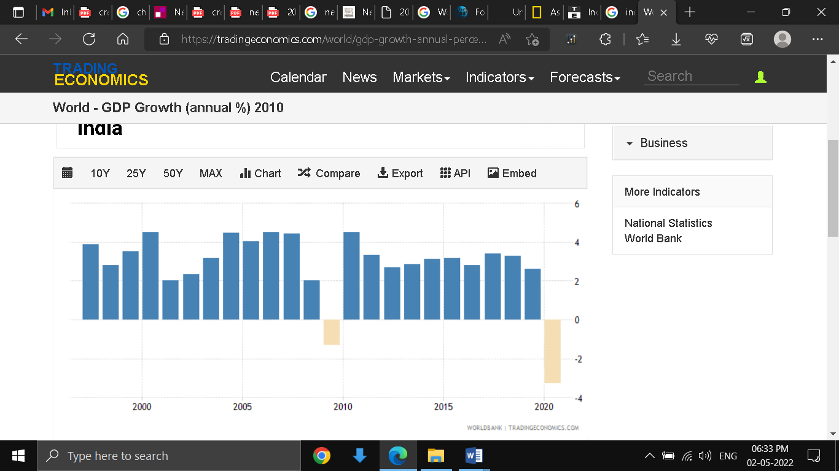

**Fig 4: World GDP growth from 2000 to 2020**

**(**Source: World GDP Growth Trading Economics, 2022)

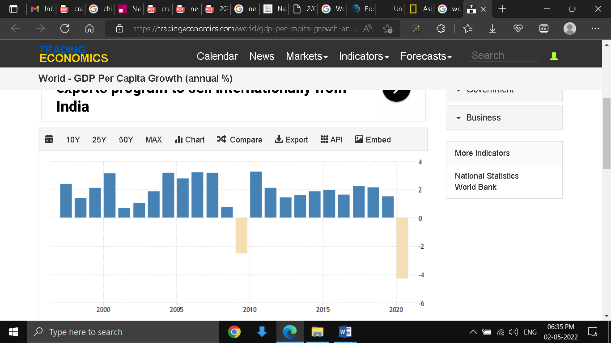

**Fig 5: World GDP per capita growth from 2000 to 2020**

(Source: World GDP Per Cap Growth Trading Economics, 2022)

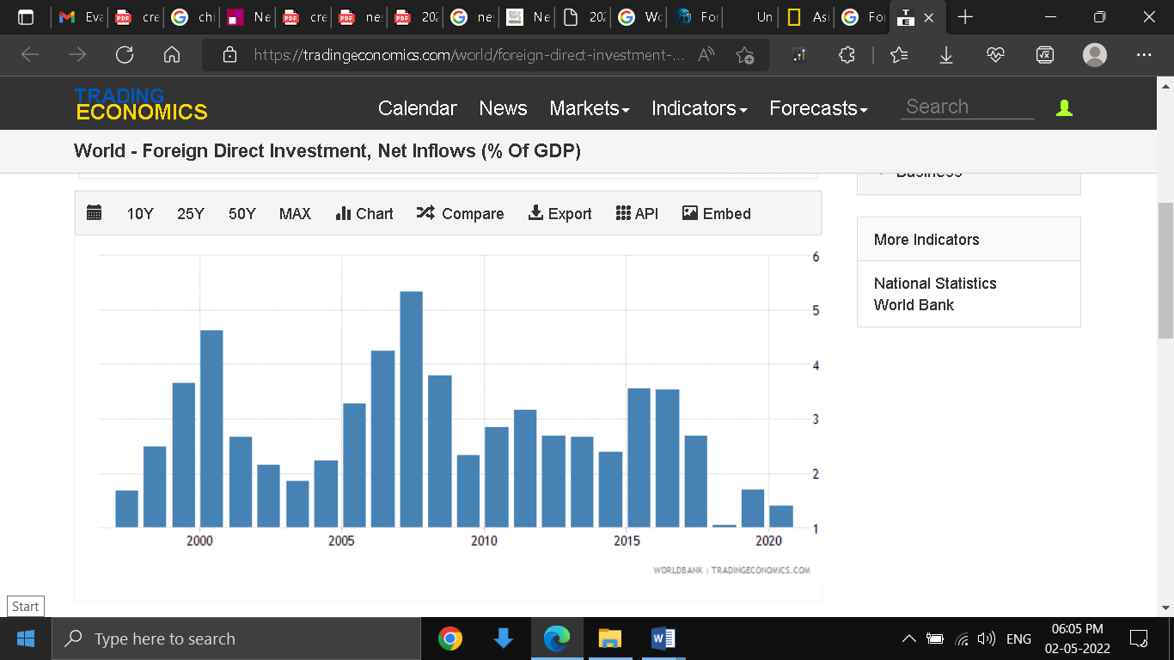

**Fig 6: Foreign direct investment, net inflows (% of GDP) 2000 to 2020**

(Source: World FDI Tradingeconomics.com. 2022)

Globalisation has made a significant impact on the world economy in the last two decades. As different countries opened their borders for increased export and import, it lead to increased domestic and international competition. Some competitions were healthy while others were not. Globalisation has enabled smaller and medium scaled enterprises to make their products available on the doorstep of foreign countries (Glushkova et al., 2019). Traditional industries that were heavily dependent upon domestic consumers faced intense completion from foreign companies. In some emerging economies, the traditional industries were wiped away as there was no necessary infrastructure present to safeguard such industries. This trend is more noticeable in emerging or developing Asian economies where traditions were negatively impacted due to globalisation. The effect of globalisation is not without its demerits. As the world economy became more integrated and connected, any major turbulence in one part creates an aftereffect on other connected parts also. For example, a close inspection of the macro indicators like World GDP, World GDP per capita, and World FDI, for the years 2000 to 2020 indicates an almost similar trend in rising and fall. This close synchronous action across major indicators like these points to the fact that the world economy has become a complex network of connections, through the process of globalisation.

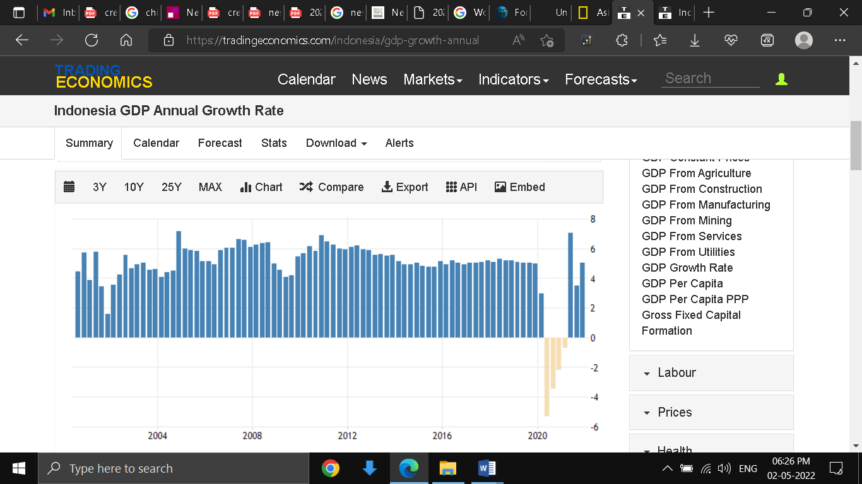 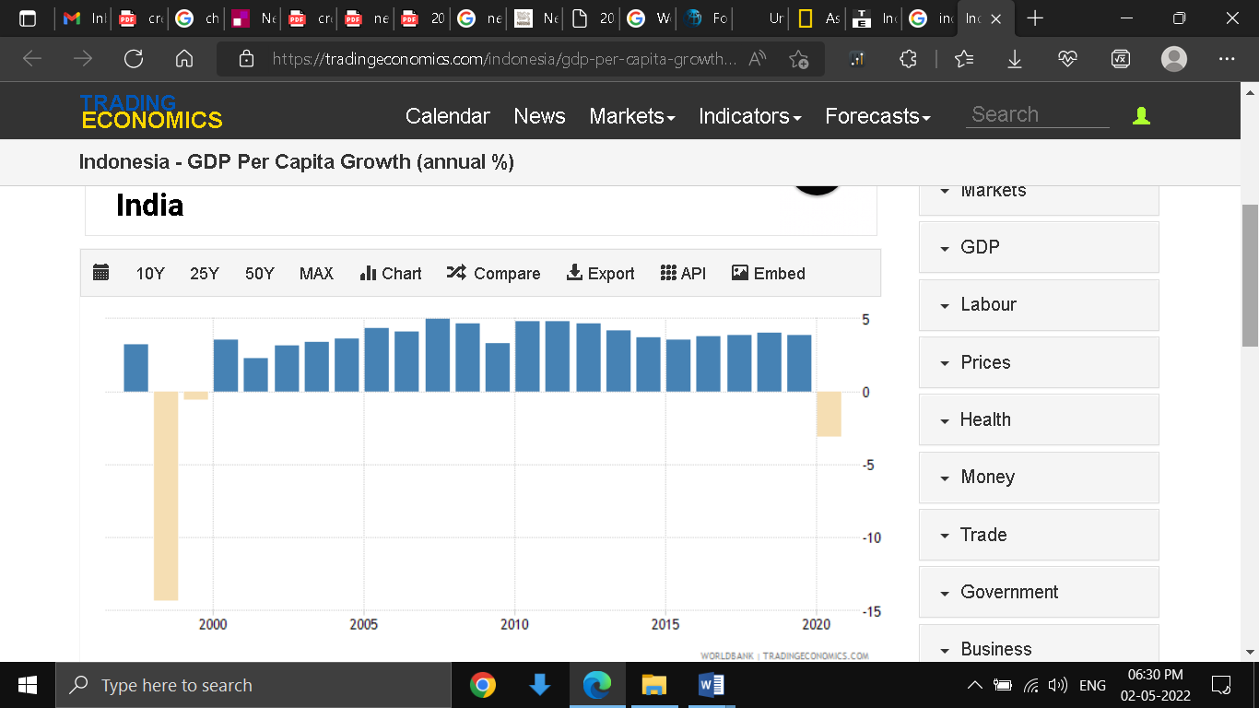

Fig 7: Indonesia GDP growth 2000-20 Fig 7: Indonesia GDP per capita growth 2000-20

(Source: GDP Growth Trading Economics. 2022) (Source: GDP per cap Trading Economics. 2022)

A comparison of the world economic macro indicators and the country-specific macro indicators of Indonesia such as GDP growth rate and GDP per capita growth rate resembled a near similar pattern of rising and fall. For example, the sudden fall across all the four indicators for both World and Indonesia occurred almost around the same time of 2008-2009 and during 2020. The dip in the growth rate during 2008 is attributed to the global financial crisis during the housing crisis in the US and the Covid crisis of 2021.

### 2.2.2 International trade

**Global Strategic Rivalry Theory**

This theory indicates ways MNCs direct efforts to have a competitive advantage over other global firms in their industry (Github. 2022). Sainsbury does not face a high barrier to entry in Indonesia to compete successfully with other global firms. Sainsbury can use two competitive advantage over other domestic players in Indonesia, which is economies of scale and low cost of raw material sourcing from neighbouring countries. Sainsbury can scale its production facility in Indonesia through capital infusion diverted from other subsidiary units in different countries in the form of FDI. In case the decision to scale up the production facility is not undertaken, it can still offer products at competitive pricing through the low cost of source of finished products from neighbouring places such as China, Hong Kong, and Bangladesh and finish the product packaging for the final consumers in Indonesia.

International trade relations between the UK and Indonesia are slowly picking up and although currently, Indonesia’s exports to and from the UK constitute less than 1% of the total trade volume in 2021 the export volume is supposed to increase in the future (The Jakarta Post, 2022). The top 5 products that were imported from the UK to Indonesia are paper products, metal ores, industrial machinery, and cars. While the top categories exported to the UK from Indonesia are footwear, wood and cork manufacturers, clothing, and furniture. A closer look at the export list from Indonesia to the UK reveals products that are already in the product category list of Sainsbury. UK is thus one of the preferred destinations for Indonesian exporters (Assets Publishing Service Gov UK, 2022). As the trade relations between the two countries are still in the development stage, Sainsbury can increase its trade export volume from Indonesia to the UK and use this opportunity to expand its business in Indonesia.

### 2.2.3 The macroeconomic environment

Indonesia’s macro-economic environment is evaluated with indicators like GDP, GDP per capita, percentage of unemployment, inflation rate, personal remittances received and sovereign debt.

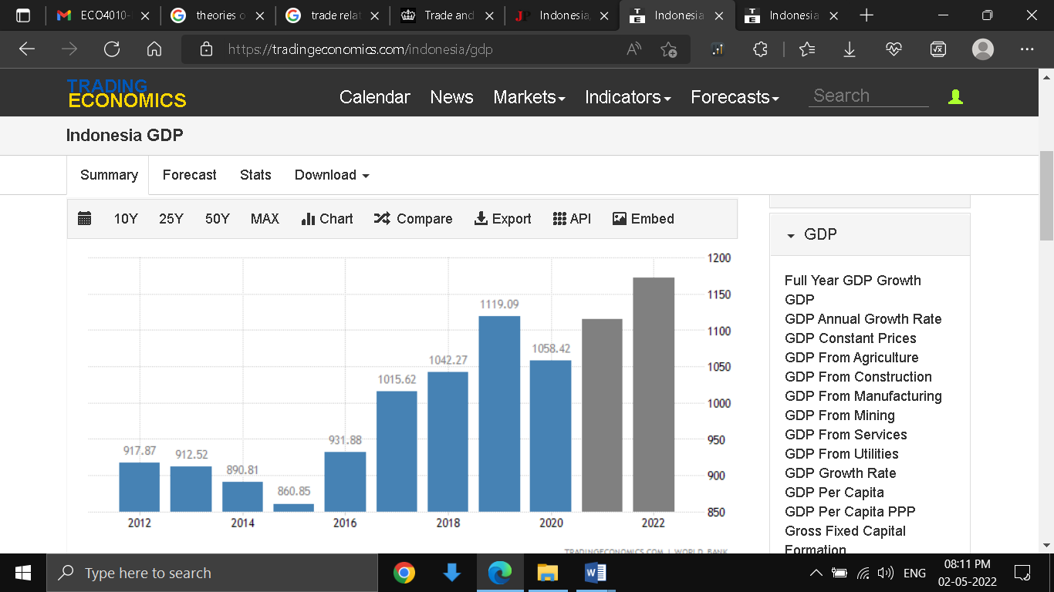 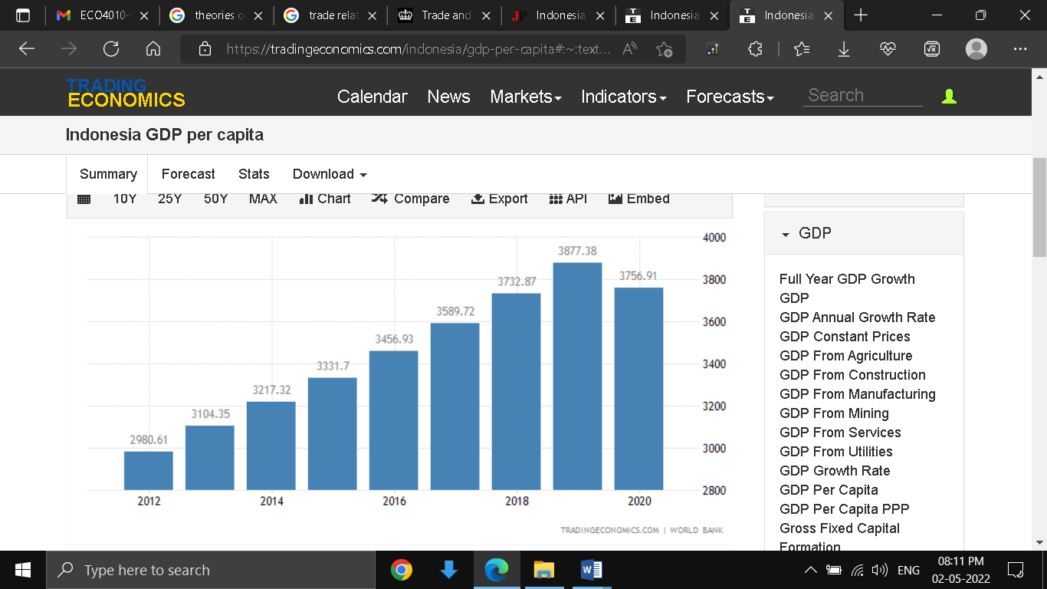

Fig 8: GDP Current Value Indonesia 2012-20 Fig 9: GDP Per capita Indonesia 2012-20

(Source: GDP Trading Economics. 2022) (Source: Indonesia GDP per cap Trading Economics. 2022)

According to the data published by Trading, Economics Indonesia is witnessing strong economic development as evident from the two graphs above. The forecast provided by Trading Economics with regards to Indonesia’s GDP in 2020 indicates a positive trend. Due to the Covid outbreak in 2020, the GDP and per capita GDP of Indonesia both took a hit as indicated in the negative trend of the graphs.

**National Income theory**

To explain the relationship between national output and Sainsbury’s business expansion in Indonesia, two concepts were reintroduced, which are (i) national income and the other being economic fluctuation. National income denoted the total output of the economy which is the culmination of factors such as consumer spending, investment, government spending, exports and imports (Barata, 2019).

**Economic fluctuation theory**

The national income of any country goes through cycles of increase and decrease. Sometimes the rise and fall of national incomes are seasonal, which comes and goes and in some cases, the long term (Isaic, 2019). In times when consumer spending. Government spending is expanding with increased investment and a low rate of inflation, and the national income experiences an uprising trend. When the economy is facing a high rate of inflation and unemployment, consumer spending goes down and the national income registers decreasing trend.

Sainsbury’s business operations viability is dependent upon 3 important macro-economic factors in Indonesia, one is consumer spending, second is government spending and third is an investment. Low consumer spending will impact the profit margin of all business organisations including Sainsbury’s. As profit margin decreases, business organisations slow down investment. With low investment, the economic activity slows down even further. Foreign economies increase their risk perception for Indonesia and this affects the flow of FDI in Indonesia. As Sainsbury will not be able to depend upon FDI inflow, its business expansion will also slow down. In this way, a bad turn of events in the domestic economic decisions by Indonesia can jeopardise the expansion and viability of Sainsbury in the country.

### 2.2.4 Exchange Rate and competitiveness

**Effect on Competitiveness**

Exchange rate fluctuation poses a serious threat for any organisation whose significant portion of its revenue is dependent upon exports. This is because exchange rate fluctuations can cause either appreciation or depreciation of the home currency. For Sainsbury, the exchange rate is a double-edged sword. If Sainsbury decides to export its products to developed economies then any sudden change in the exchange rate will also hamper its profitability. For example, products exported to the UK are usually paid in Euro or Pound in return. This is then converted to the market exchange rate. Let’s assume the exchange value of 1 pound is equal to 18,170.58 (which is the current exchange rate). So the price of products is kept, keeping in the mind the current exchange rate of pound sterling to Indonesian rupiah. Now after the product is purchased in the UK and paid back in the pounds, the current market exchange rate will be applied for conversion. If for some reason the currency value of the Indonesian Rupiah appreciates in comparison to Pound, then the 1 pound sterling will not give Rupiah 18,170.58 in return, but less than that. Thus the initial cost price which was based upon the initial market exchange rate has now failed to cover the actual cost of the product. This causes a dip in profitability margin (Nguyen and Do, 2020). Thus although Sainsbury is using its economy of scale to bring down product prices sufficiently, exchange rate fluctuations can wipe out such scale advantages. Thus if the retailer landscape of Indonesia is dominated by domestic players who have a strong domestic customer base and will have low exposure to export risk, can outpace Sainsbury competitively in the short-run period. While Sainsbury has to again build up its competitive advantage using its economies of scale to offset such losses due to exchange rate fluctuations. Too many of such short term exchange rate fluctuations decrease any competitive advantage gained in the long run.

### 2.2.5 The New economy: knowledge, technology and network effects

There is increased collaboration between UK and Indonesia to promote the exchange of information between different institutions, that will support sustainable production as well as non-discriminatory, two-way sustainable trade built on mutual respect and understanding of national legislation and standard and certification. The collaboration is supposed to improve the delivery of sustainable infrastructure projects and provide support for upstream and downstream industries, low carbon emission industry, electric vehicles, as well as green technology. UK plans to offer integrated support in the completion of sustainable infrastructure projects in Indonesia through UK Export Finance and investments made from British International Investment (GOV UK, 2022). UK will increase its cooperation to develop the ICT infrastructure and digital transformation in the use of high technology, digital economy and the current 4.0 industrial revolution of Indonesia. The new trade pacts between the two countries increase the B2B discussions for the development of a new ecosystem of electric-assisted mobility, as well as battery production facilities such as processing mineral resources like nickel. Sainsbury’s expansion strategy in Indonesia is timed well with the new agreements in trade, investment and economic cooperation between the 2 nations. Thus Sainsbury does not have to reinvent its operational procedures in Indonesia to suit its business strategy according to the present infrastructure capability of Indonesia. This gives Sainsbury a head start over other new players that may try and enter the market. Because the technology and knowledge transfer between the two countries along with infrastructural development will help Sainsbury replicate its operational strategies in Indonesia as built over years of experience in other countries.

# 3. Conclusion and recommendations

The discussion on the cultural aspect of the 2 nations of the UK and Indonesia reveals vast dissimilarities. Communitarianism, emotional attachment, ascription to titles, a sense of synchronous time and insistence on particularism are some of the core ethe of Indonesia’s culture. If these cultural aspects are not taken into account while formulating its market entry and operational strategy then it can create friction points between Sainsbury’s organisational value and Indonesia’s cultural norms. The friction points can create roadblocks for Sainsbury in its expansion in Indonesia. From an economic point of view, Indonesia is one of the fastest emerging economies in Asia and its future outlook looks promising. Although there are certain areas of concern such as exchange rate fluctuations. If Sainsbury decides to increase its export to developed countries then exchange rate fluctuations can undermine its competitive advantage of Sainsbury. The macro-economic indicators of Indonesia are poised to grow as indicated by the forecast. FDI constitutes one of the main avenues of investment in the country. Political and civil unrest can decrease FDI inflow in the country and slow the pace of investment and economic growth. New bilateral agreements on trade, investment and economic cooperation between UK and Indonesia will give a strong boost to the current Industrial revolution that is in going on in Indonesia. This will improve the access to the required infrastructure for retailers like Sainsbury to expand their business in Indonesia. To avoid conflicts due to cultural differences, employees or managers from the US who will be going to work with their Indonesian counterparts should go through cultural sensitization courses. This will make them aware of the cultural norms and etiquette. Apart from undergoing cultural sensitization programs the senior management has to devise new organizational value for business units and offices operating out of Indonesia. Because organisational value depends upon societal norms and customs.

# Reference

About Sainsburys. 2022. Sainsbury Annual Report. [online] Available at: <https://about.sainsburys.co.uk/~/media/Files/S/Sainsburys/documents/reports-and-presentations/annual-reports/sainsburys-ar2021.pdf> [Accessed 2 May 2022].

Annisa Hamud, N., 2022. Justice for Community: Political Perspective of Michael Sandel’s Communitarianism. [online] Kemendagri. Available at: <https://www.google.com/url?sa=t&rct=j&q=&esrc=s&source=web&cd=&ved=2ahUKEwi6v66MqcD3AhWe8XMBHVYOC98QFnoECAIQAQ&url=https%3A%2F%2Fjurnal.kemendagri.go.id%2Findex.php%2Fjbp%2Farticle%2Fdownload%2F678%2F416&usg=AOvVaw3m-TNjgFSpujJO8MacE-AI> [Accessed 2 May 2022].

Assets Publishing Service Gov UK. 2022. UK-Indonesia Partnership Roadmap 2022 to 2024. [online] Available at: <https://assets.publishing.service.gov.uk/government/uploads/system/uploads/attachment_data/file/1070146/indonesia-trade-and-investment-factsheet-2022-04-25.pdf> [Accessed 2 May 2022].

Barata, A., 2019. Strengthening national economic growth and equitable income through sharia digital economy in Indonesia. Journal of Islamic Monetary Economics and Finance, 5(1), pp.145-168. [online] Available at: <http://www.jimf-bi.org/index.php/JIMF/article/view/1053/745 view-on-the-mainstream-theory-of-economic-cycles.pdf> [Accessed 2 May 2022].

Budi Waluyo, D., 2022. Globalisation and deglobalisation: the Indonesian perspective. [online] Bis.org. Available at: <https://www.bis.org/publ/bppdf/bispap100_k.pdf> [Accessed 2 May 2022].

Business Communication. 2022. Hofstede's Culture Dimension Theory. [online] Available at: <https://sites.google.com/site/buscomproeaflya/hofstede-s-theory-views-of-culture> [Accessed 2 May 2022].

Cappelli, P., 2020. Stop over‐engineering people management. Harvard Business Review, 98(5), pp.55-63. . [online] Available at:< https://empowerment.ee/wp-content/uploads/2020/10/Stop-Overengineering-People-Management.pdf> [Accessed 2 May 2022].

Eurac. 2022. How Hofstede & Trompenaars Models Of Cultural Dimensions Apply To Global Leadership • eurac - European Academy for Executive Education. [online] Available at: <https://eurac.com/how-the-2-models-of-cultural-dimensions-hofstede-trompenaars-apply-to-global-leadership> [Accessed 2 May 2022].

Europarl. 2022. Political institutions in Indonesia. [online] Available at: <https://www.europarl.europa.eu/RegData/etudes/BRIE/2020/646149/EPRS_BRI(2020)646149_EN.pdf> [Accessed 2 May 2022].

GDP Growth Trading Economics. 2022. Indonesia GDP Annual Growth Rate. [online] Available at: <https://tradingeconomics.com/indonesia/gdp-growth-annual> [Accessed 2 May 2022].

GDP per cap Trading Economics. 2022. Indonesia - GDP Per Capita Growth (annual %). [online] Available at: <https://tradingeconomics.com/indonesia/gdp-per-capita-growth-annual-percent-wb-data.html#:~:text=GDP%20per%20capita%20growth%20(annual%20%25)%20in%20Indonesia%20was%20reported,compiled%20from%20officially%20recognized%20sources.> [Accessed 2 May 2022].

GDP Trading Economics. 2022. Indonesia GDP. [online] Available at: <https://tradingeconomics.com/indonesia/gdp> [Accessed 2 May 2022].

Github. 2022. What Is International Trade Theory?. [online] Available at: <https://saylordotorg.github.io/text_international-business/s06-01-what-is-international-trade-th.html> [Accessed 2 May 2022].

Glushkova, S., Lomakina, O. and Sakulyeva, T., 2019. The economy of developing countries in the context of globalization: Global supply chain management. International Journal of Supply Chain Management, 8(1), pp.876-884. [online] Available at:< https://core.ac.uk/download/pdf/230748361.pdf> [Accessed 2 May 2022].

GOV UK. 2022. UK-Indonesia Partnership Roadmap 2022 to 2024. [online] Available at: <https://www.gov.uk/government/publications/uk-indonesia-partnership-roadmap-2022-to-2024/uk-indonesia-partnership-roadmap-2022-to-2024> [Accessed 2 May 2022].

Human Rights Watch. 2022. World Report 2021: Rights Trends in Indonesia. [online] Available at: <https://www.hrw.org/world-report/2021/country-chapters/indonesia> [Accessed 2 May 2022].

Indonesia GDP per cap Trading Economics. 2022. Indonesia GDP per capita. [online] Available at: <https://tradingeconomics.com/indonesia/gdp-per-capita#:~:text=GDP%20per%20capita%20in%20Indonesia%20is%20expected%20to%20reach%204450.00,according%20to%20our%20econometric%20models.> [Accessed 2 May 2022].

Isaic, R., Smirna, T. and Paun, C., 2019. A critical view on the mainstream theory of economic cycles. Management & Marketing, 14(1), pp.48-58. [online] Available at: <https://www.researchgate.net/profile/Paun-Cristian/publication/332526656_A_critical_view_on_the_mainstream_theory_of_economic_cycles/links/5ce52b46299bf14d95af6a42/A-critical-view-on-the-mainstream-theory-of-economic-cycles.pdf> [Accessed 2 May 2022].

Leadership Cross Roads. 2022. Negotiating International Business. [online] Available at: <http://www.leadershipcrossroads.com/mat/cou/Indonesia.pdf> [Accessed 2 May 2022].

Linklaters. 2022. Commercial mediation in Indonesia | Commercial mediation – a global review| Linklaters. [online] Available at: <https://www.linklaters.com/en/insights/publications/commercial-mediation-a-global-review/commercial-mediation-a-global-review/indonesia> [Accessed 2 May 2022].

Nguyen, V.C. and Do, T.T., 2020. Impact of exchange rate shocks, inward FDI and import on export performance: a cointegration analysis. The Journal of Asian Finance, Economics and Business, 7(4), pp.163-171. [online] Available at: <https://www.koreascience.or.kr/article/JAKO202014862061231.page> [Accessed 2 May 2022].

The Jakarta Post. 2022. Indonesia, UK seek stronger economic ties with first JETCO meeting. [online] Available at: <https://www.thejakartapost.com/business/2022/02/24/indonesia-uk-seek-stronger-economic-ties-with-first-jetco-meeting.html#:~:text=Currently%2C%20the%20UK%20is%20not,US%241.47%20billion%20last%20year.> [Accessed 2 May 2022].

World FDI Tradingeconomics.com. 2022. World - Foreign Direct Investment, Net Inflows (% Of GDP) - 2022 Data 2023 Forecast 1970-2020 Historical. [online] Available at: <https://tradingeconomics.com/world/foreign-direct-investment-net-inflows-percent-of-gdp-wb-data.html> [Accessed 2 May 2022].

World GDP Growth Trading Economics. 2022. World - GDP Growth (annual %). [online] Available at: <https://tradingeconomics.com/world/gdp-growth-annual-percent-2010-wb-data.html> [Accessed 2 May 2022].

World GDP Per Cap Growth Trading Economics. 2022. World - GDP Per Capita Growth (annual %). [online] Available at: <https://tradingeconomics.com/world/gdp-per-capita-growth-annual-percent-wb-data.html> [Accessed 2 May 2022].

Worldbank Doing Business. 2022. Ease of doing business rank (1=most business-friendly regulations) - Indonesia | Data. [online] Available at: <https://data.worldbank.org/indicator/IC.BUS.EASE.XQ?locations=ID> [Accessed 2 May 2022].

Worldbank GDP growth rate Indonesia. 2022. GDP growth (annual %) - Indonesia | Data. [online] Available at: <https://data.worldbank.org/indicator/NY.GDP.MKTP.KD.ZG?locations=ID> [Accessed 2 May 2022].

Worldbank GDP Indonesia. 2022. GDP (current US$) - Indonesia | Data. [online] Available at: <https://data.worldbank.org/indicator/NY.GDP.MKTP.CD?locations=ID> [Accessed 2 May 2022].

Worldbank Population Indonesia. 2022. Population, total - Indonesia | Data. [online] Available at: <https://data.worldbank.org/indicator/SP.POP.TOTL?locations=ID> [Accessed 2 May 2022].