**International Marketing Strategy of Sainsbury**

**International marketing**

**BU7411**

**Sue Ollerhead**

**Word Count - 4327**

**Student Assessment Number (J Number)**

**Table of Contents**

1. Introduction 1

2. International Market Analysis 2

(i) International market assessment 2

(ii) 2 types of market entry strategy 6

(iii) Impact on market entry strategy 6

3. Cross-cultural research and analysis 8

4. Impact of cross-cultural issues on international marketing -mix strategy 12

(i) Promotion strategy 12

(ii) Product strategy 13

(iii) Place strategy 13

(iv) Price strategy 14

5. Conclusion 15

6. Appendices 16

Reference 17

# 1. Introduction

The portfolio is prepared so that the marketing team can be prepared to tackle issues related to the cultural difference when foraying in a different foreign market. Sainsbury is one of the leading food wholesalers in the UK. Popular brands of Sainsbury are Argo, Habitat, Tu, Nectar, and Sainsbury Bank. It has over 600 supermarkets and 800 convenience stores. Sainsbury has a strong workforce of 189,000 employees (Sainsbury Annual Report, 2022). Cambodia is located in South East of Asia and witnessed a strong GDP growth of 5.3% in 2022 and is poised to grow 6.5% in 2023. Although the Covid lockdown badly ravaged it, it is one of the few economies in the world that witnessed 2 consecutive years of positive economic growth since the pandemic (Cambodia’s Economy, 2022).

# 2. International Market Analysis

## (i) International market assessment

**(a) PESTEL Analysis**

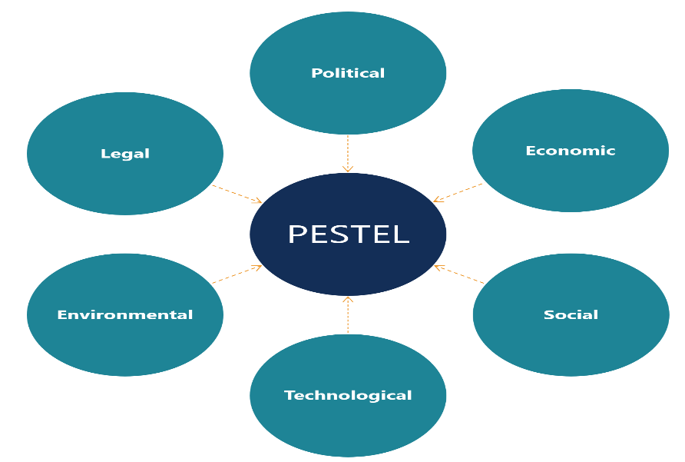

Fig 1: PESTLE Analysis

(Source: PESTEL Analysis, 2022)

|  |  |
| --- | --- |
| **Indicators** | **Description** |
|
| **Political** | 1. According to Freedom House data, Cambodia scores far below other neighbouring countries with a score of 24/100. This score is the culmination of two measures: political rights and civil liberties (Freedom in the World, 2022).  2. Ruling the Cambodian People’s Party (CCP) deals with dissents and anti-government propaganda with an iron hand.  3. The severe repression of rival political parties increases the ruling party's stronghold excessively.  4. Power concentration on one hand invokes corruption, favouritism and lobbying in the system. |
| **Economical** | 1. Impressive journey of Cambodia to push its status from lower-income to reaching lower-middle-income status in 2015 and aspiring to reach upper middle income by 2030 (World Bank in Cambodia, 2022).  2. Garment and tourism, manufacturing and construction contribute 70% of the economic output.  3. Cambodia hit in 2020 during Covid Pandemic when the economy shrank by 3.1%. The present economy is in rebound mode now with a 3% real growth rate in GDP in 2021.  4. The phenomenal growth in the last 2 decades saw an almost 2 times increase in total monthly consumption value from Riel 4985 in 2014 to Riel 8283 in 2019 in food consumption value.  5. Monthly. The number of durable goods per household also increased from 2014 to 2019 (Report of Cambodia Socio-Economic Survey, 2020). Indicating more access and easy affordability for the population. |
| **Social** | 1. Poor health is an issue that has permeated every social stratum of Cambodia.  2. Youth are exposed to the failing health condition of the country (Key Issues affecting Youth in Cambodia, 2022).  3. Cambodia made strong progress in education. 98.4% of the school-going population was enrolled in schools. Goof literacy rate of 91% for 15-24 years of age. Though high drop rate across the region is still a problem.  4. Youth between 15-30 years comprised 43% of the  The working-age population in Cambodia. Low education levels and skillsets still plague this labour force.  5. Conservative business culture, risk-averse (Doing Business in Cambodia, 2022). |
| **Environmental** | 1. Rapid pace of economic growth in the past 2 decades brought a series of environmental issues for Cambodia.  2. Cambodia's Royal Government is strongly focused on resolving these issues (Environmental Sustainability in Asia: Cambodia, 2022).  3. Cambodia's national target is to reach 100% coverage of improved water supply and sanitation by 2025. |
| **Legal** | 1. New investment law amended the old laws to increase transparency, more investment for SMEs, and selection of government-mandated competent authority for registration.  2. Cambodia’s government-focused to on instil good governance principles through better public management, financial, and decentralization reforms. This increases efficiency, transparency, and accountability in the business environment.  3. Changes in banking laws allowed investors to foray into Cambodia’s capital market (Doing Business in Cambodia, 2022).  4. Foreign investment is highly encouraged with some restrictions on land ownership. |
| **Technological** | 1. Cambodia undergoing 4th industrial revolution.  2. Lack of digital literacy among end-users.  3. Lack of infrastructure investment (3 ways Cambodia uses technology for good, 2022).  4. Increased digital business due to pandemic push.  5. Accelerated SDG (Sustainable development goals) through innovation. |

**Overall impact assessment**

|  |  |  |
| --- | --- | --- |
| **Indicators** | **Impact**  **High/Medium/Low** | **Overall**  **Impact** |
| **Political** | High | Medium |
| **Economical** | Medium |
| **Social** | High |
| **Environmental** | Medium |
| **Legal** | Medium |
| **Technological** | Medium |

The current political system is highly centralized with a high authoritarian stance. This poses a serious challenge for any business environment, particularly for a foreign entity like Sainsbury. The economic condition of Cambodia is hopeful as the economic output is increasing indicating increased consumer and government spending. The social system is plagued by unemployment, corruption, and low education level. This creates an environment of lawlessness and heightened criminal activities affecting the business operations of Sainsbury. On the environmental front, Cambodia is striving strongly to create a sustainable environment. Sainsbury can align its sustainability practices should it decide to open a subsidiary. Cambodia is still witnessing the technological transformation and has not peaked out in its potential yet. This has no serious impact on Sainsbury’s expansion. Legal entanglements are there but the government strongly advocates for better governance to attract foreign investors.

## (ii) 2 types of market entry strategy

Based on the assessment of Cambodia’s market 2 types of strategy is suggested, which are export strategy and setting up operational units on a private limited basis.

**(a) Export Strategy**

The export strategy offers Sainsbury an almost risk-free venture in Cambodia. This is primarily because this will not require setting up operational units. Low capital investment in Cambodia can limit Sainsbury’s exposure to market uncertainty to a huge extent. Export through local partners such as agents or distributors will provide Sainsbury with the necessary knowledge about the market dynamics (Lorvoralak & Wongsurawat, 2019). The issue with this strategy is total dependency on distributing partners. With no local market knowledge in hand, partnering agents become the eyes and ears of Sainsbury. This can be exploited by partnering agents against Sainsbury. Agents can ask for exclusive business deals with Sainsbury, which in the long run can result in an unprofitable venture for Sainsbury.

**(b) Private Limited Company**

Sainsbury can open up offices and operational establishments on a private limited basis. Operating as a private limited will reduce its exposure to the downfall of the market economy of Cambodia to a great extent. This is because Sainsbury will have less than a 50% stake in joint ownership of the company with a local market player. The local market player can be chosen from domestic players. Apart from covering the risk exposure through a private limited partnership, Sainsbury can also utilize the domestic player's market knowledge, supply and logistic chain, and distribution channel.

## (iii) Impact on market entry strategy

**(a) Export Strategy**

There are two options for export, either through a local distributor or through a local retailer. The impact is also different. Both local agents and retailers have market knowledge but the retailer will have more backchannels ready for pushing the product. Business houses with strong political linkage can have an upper hand in positioning themselves comfortably in the market economy. On the legal front, the legal laws are simple, fair and square for local business operators. The export will cover Sainsbury from issues related to local rules and regulations. As this is taken care of by exporting partner. The social aspects can hurt Sainsbury. Cambodia has still a long way to go from lower-income to middle income. Sainsbury so far has operated on higher to upper-middle-income economies. Thus, product promotion in a lower-income economy presents a big challenge. Using exporting partners completely leaves the product promotion operations at the partner's whims. Offline promotion techniques are best suited for Cambodia where there is still a lack of digital literacy. For distributing partners without sufficient reach in offline modes such as shops, retail outlets, supermarkets, and convenience markets, the promotion will not be effective and fall short of reaching target customers.

**(b) Private Limited Company**

Using privately limited will limit exposure to market dynamics by transferring a part of the risk to local partners. This can limit the UK-based shareholders' personal risk, but the controls rest with the majority shareholders. If majority shareholders have strong political channels, then it can benefit Sainsbury. At the same time, any fallout with the ruling party can leave Sainsbury on tenterhooks. Any economic downfall in Cambodia will directly impact the majority shareholders, which can also impact Sainsbury’s expansion operations (Derenne & Flynn, 2020). As already stated, land ownership is restricted to foreign entities, thus Sainsbury can face difficulties with land acquisition. Regarding social conditions, setting up production and packaging units needs labour infusion. Low skill levels and education levels can impact production pace. Additional training programs can supplement the skills needed. Although this will cost Sainsbury additionally.

**(iv)Most suitable method**

**Private Limited Company**

Among the 2 strategies suggested, Private Limited Partnership is best suited for Sainsbury. The partnership will enable Sainsbury to navigate the legal and political clout by piggybacking. This will also enable Sainsbury to gain knowledge of the demographic profile for better customer targeting. Suppose the local partners have a dedicated supply, logistics and distribution channel. In that case, the same can be used by Sainsbury in the initial phase, till more capital is allocated for Sainsbury’s supply chain and logistics infrastructure. As local partners have more knowledge on labour availability, this can be leveraged to source skilled employees. This can to some extent reduce the need for frequent employee training programs. Cambodia is an economy that is slowly transforming from lower to middle income (Sangwongwanich & Wongsurawat, 2021). Sainsbury can benefit from this rising trend in economic output as more people start buying consumer products. As the banking system goes through a series of changes of improved transparency and lending capabilities, this can help Sainsbury obtain working capital from banks on more lenient terms. The local investors in this Private Limited partnership can liaise with various industry leaders. This liaison can help the domestic and foreign investors in the Private limited Partnership model with knowledge regarding how other competitors follow. Thus, instead of reinventing the wheel, this know-how can help Sainsbury build on Cambodia's presently available technology and infrastructure to reach the break-even point easily and square off its losses slowly. Several well-known multinational brands have set up manufacturing units in Cambodia such as Marks and Spencer, Adidas, M&M and Uniqlo (Cambodia’s Garment Manufacturing Industry, 2022).

# 3. Cross-cultural research and analysis

Cambodia is markedly different from the UK culturally. This segment helps to understand the ways cross-cultural differences can arise. Customer-level cross-cultural theory helps understand how consumer perception is driven by products and services available in the market. The way a customer positions oneself according to self-perception can differ from what the market wants to position the customer. Trompenaars’ 7 Cultural Dimensions is discussed to frame the cultural evaluation of Cambodia. This model framework will also help to understand the differences and similarities in Sainsbury's product marketing opportunities and challenges (Doole & Lowe, 2019). Groceries are the primary target product to be launched in Cambodia. These will be launched under the brand names Argos, Habitat, Tu, and Nectar. The target customers are people who belong to the middle income and upper-middle-income group and are rich according to the mean household income as shown in Table 1 in Appendice. The reason for keeping poor and near-poor out is that convenience and supermarkets are not very often.

**7 Cultural Dimensions of Trompenaars**

Fig 3: Trompenaars’ 7 Cultural Dimension

(Source: The Seven Dimensions of Culture: Understanding and Managing Cultural Differences, 2022)

**Achievement v/s ascription:**

Product positioning should reflect Sainsbury's concern and commitment to the community. UK culture’s belief in freedom and achievement is different from Cambodia where groups and communities are more significant than individuals. The initial product positioning although targeted towards the middle, upper-middle and rich, should not be reflective of the divisive mentality of Sainsbury. The promotional campaign cannot portray any product as linked to any specific community or income group, which will portray Sainsbury as a biased foreign company (Pirlog, 2021). Pre-product launch polls can be carried out across target regions to capture customers’ price and quality aspirations. This feedback can be included during actual product launch announcements. Target consumers will feel more empowered if they are linked in this way with the product.

**Neutral v/s emotional:**

UK and Cambodia vary by a vast margin when it comes to emotional expression. Cambodia has been one of the worst affected countries in the world, that has witnessed the genocidal reigns of past rulers, which are still very much alive in memories of the present pollution (Cambodia Angkor Air - Proudly The National Flag Carrier, 2022). This is reflective of their cultural traits and customs. This is in contrast to the UK, which has not had such severe repression of any rulers in recent times. The market entry has to be done in such a fashion that portrays foreign brands of Sainsbury not as a market capturer from a foreign land. Any aggressive action by Sainsbury can be projected by domestic competitors as aggression by foreign economic power on Cambodia and use this for its benefit. The political system in Cambodia is highly authoritarian. Any fallout in understanding with the ruling government due to such negative remarks by rival companies can derail Sainsbury’s expansion plan in Cambodia.

**Internal direction v/s outer direction:**

A marked difference between the UK and Cambodia is the sense of control. While western countries or the UK have propounded that the nature of the outcome can be controlled by controlling the external environment. Easter countries or Cambodia for that matter propagated the method of looking inward. Looking inwards helps to align one’s activities with the external environment. There is no confrontation with external characteristics. Self-glorification or self-achievement through tools to control outer characteristics is portrayed in western media, advertisements and promotions (Qi & Lee, 2019). This may not work in Cambodia and the country greatly reveres the nature and environment. Thus product positioning needs to be aligned with the self-perception of the target customer. A customer who perceives oneself as an organic and natural product user, cannot be targeted with synthetically produced products. This is irrespective of the customers chosen such as middle, upper income and rich.

**Sequential time versus synchronous time:**

Synchronic time is more dominant in Asia hence, time is not viewed as separate chronological events but rather a series of events overlapping one another. This has different implications in every sphere of business and marketing and promotion. Promotional campaigns depend on effective communication with target customers. If the message conveyed is about sequential events, it may fail to draw customers' attention. A good example in Cambodia is items of gift. As cultural events sometimes overlap in themes and seasons, gifts that can be offered on all occasions can find good buyers. This methodology of adopting the same gift for all festival occasions in the UK can be viewed as odd practice. Apart from marketing communication, the synchronous or sequential time has also affected product pricing. Seasonal discounts and promotions do not have to be highly sequential time-based. This saves Sainsbury from constantly updating its seasonal and festival based promotional campaigns. Less frequent product price variation also instils confidence in customers. This is particularly applicable to middle-income customers, who look for price stability to plan their monthly budget plans (Qi & Lee, 2019).

**Universalism versus particularism:**

Cambodia has followed a particularism type of culture where relationships matter more than rules. This is also evident because Cambodia has been a land of celebration of life and nature. Sainsbury's focus on relationship building with target customers should not base on profit-driven metrics. This applies to all customer types irrespective of income group.

**Individualism versus communitarianism:**

Far East countries including Cambodia have followed communitarianism for several decades. This involves building a strategy that caters to the interest of the mass instead of individuals. Sanitation and drinking water are persistent social problems in Cambodia. Sainsbury can commit itself to provide free portable water container products to the needy and underprivileged populations in and around regions where its outlets or target customers are. CSR activity can put Sainsbury in good books as a community-conscious business organisation (Myles, 2018).

**Specific Versus diffuse relationship:**

Another cultural difference between the UK and Cambodia is how work and personal life overlap each other. The UK has very specific work schedules and follows a sequential time. Whereas, Cambodia follows a synchronic culture where the distinction between work and personal life is not clearly defined. This gives rise to an informal form of relationship and cues as boundaries between work and personal life shorten. Thus, communications with target customers should not be direct, specific, or with clear descriptive words. It can be conveyed through contextual clues. For example, youth in Cambodia aged between 15 to 30 form the major chunk of the workforce and are shaping the entrepreneurial landscape (ENTREPRENEURIAL CAMBODIA, 2018). The lack of proper funds stops such initiatives. Sainsbury can help establish retail outlets for willing individuals to take up entrepreneurship in the retail business through loan disbursement. These budding entrepreneurs can then act as local torchbearers of the community, furthering the cause of Sainsbury. Thus, as more such local youth are roped in successfully as local torchbearers, the better grip Sainsbury holds over its brand image as a community-conscious business.

# 4. Impact of cross-cultural issues on international marketing -mix strategy

Marketing mix strategies and the impact of cultural differences on that strategy are discussed here. Here 4 Ps i.e., product, price, place, and promotion are discussed.

## (i) Promotion strategy

The brand message of Sainsbury in the UK is “Helping everyone eat better”. It is to be noted that the message is meant for the masses and individual customers but they are built on the socio-economic context of the UK. For the UK it has already provided well for its citizens and now the focus is not on quantity but on quality. In the context of Cambodia, the same message can be conveyed with a slight twist. Instead of focusing on eating better, the focus can be on easy and affordable accessibility. Thus, unlike in the UK, the focus is on quantity and less on quality. As already pointed out, a significant percentage of the population still has less access to affordable food (Morgan et al., 2019). This has caused widespread poverty, particularly in rural areas. Thus, if the promotional campaign is focused on creating awareness among the population about the need for easy and affordable food, then the perception of people including target customers, about Sainsbury brands can be moulded in a way that is more fitting in the present context. Apart from basing the promotional campaign on pressing social needs like poverty, Sainsbury can also rope in education as its preferred theme. Education and poverty are almost twin sides of a coin. Sainsbury can declare to support children’s education with free educational materials supply for a certain number of products the customers buy (Baines et al., 2019). This is more fitting to the target customers as all of them are from middle, upper and rich income brackets and understand the role of education in shaping life. Thus, in short promotional strategies are meant to connect people. The social context of Cambodia provides ample opportunities to link the products and target customers on an emotional basis.

## (ii) Product strategy

Cambodia follows a communitarianism way of life where the intermingling between different members of the community is quite often. Thus, any product that focuses on fulfilling individual needs can have fewer takers than those that support more than one. This idea does not apply to every kind of product. Only products that have a high degree of penetration within the daily lives of Cambodians can be promoted in this way. The product perception of UK consumers and that of Cambodians also differ to a good extent. For example, rice which is a staple diet in Cambodia can have different perceptive value to UK consumers. For this reason, product differentiation in the rice category has a different effect on both consumers of the UK and Cambodians. UK consumers being non-rice-based culture can give more importance to product differentiation, such as different types of packaging, different taste, and different types of rice, as rice is only used on rare occasions. And rare occasions call for rarer experiences. In the case of Cambodians, product differentiation does not make much difference to customer perception, as Cambodians choose to prefer known rice brands on which they have been dependent as a staple source of diet for a long time. Taking a cue from Kotler’s 5 layers of product, the same can be applied to other types of food products under Sainsbury to upsell them. In the case of rice which already has different layers of benefits under its belt for Cambodians, products that make up for the ingredients of side dishes can be offered together. This is again linked to how Cambodians celebrate and recognize food as part of life itself unlike in the UK, where food is regarded as a necessity for life but not life itself. This strikes as a cultural difference between the two countries (Zhang & Wang, 2019).

## (iii) Place strategy

Cambodia is a culturally diverse country with various religious communities living together in harmony. Unlike in the UK, product promotion in sensitive places in Cambodia can be an issue for Sainsbury. Giving due and equal importance to religious and cultural practices has been an integral part of Cambodia’s culture. Unlike the UK, where Christianity is the official religion and much of the cultural practices and local laws and rules stemmed from it. In Cambodia the state religion is Buddhism but there are various other religious communities, living in harmony and peace. Taking this into note the places for promotional programs chosen should be neutral. For example, meat products that can be easily put up for advertisements in a culture like the UK that advocates and embraces meat as a daily part of life are in stark contrast with Cambodia. There is a significant part of the population in Cambodia that consumes meat on daily basis, but the general inclination of the population is less toward meat. Thus, product promotion without cultural sensitization can hurt sentiments and disturb the harmony of the social fabric. Being a culturally sensitive country like Cambodia the intermingling between cultural and religious practice is heavily intertwined. Thus, it can become an issue for Sainsbury to navigate through such innumerable cultural practices about different communities.

## (iv) Price strategy

The UK is a developed nation in the upper-income group, while Cambodia is still transforming from a lower-income to a middle-income economy. This vast difference in household income generation capacity affects price perception also. Because less disposable income gives less room to consumers to accommodate brands with a high price. Cambodians may end up choosing cheaper brands. While UK consumers with more disposable income can afford to be brand conscious instead of price-conscious. This is also partly linked to the cultural heritage of the two countries. While citizens of the UK predominantly focused to practice taking control of the external environment to change the outcome, Cambodians decided to turn inwards to align with the change in the external environment. This trait of accepting the situation of the nature or external environment has greatly cost Cambodia in terms of development. Thus, as Cambodians look for cheaper products, substitute poses a great risk in the market, as they are readily available and cheaper. This low switching cost for Cambodians can affect Sainsbury in the long run (Phat & Vesdapunt, 2021). But as the spread of target customers is kept in 3 segments of middle, upper and rich, it is expected that switching costs for all types of customers may not be the same. Even if one segment shows a higher propensity to switching, the other two segments can square off any deviation of Sainsbury’s market share position in Cambodia.

# 5. Conclusion

The market assessment of Cambodia presents a mixed picture. On one hand, the economic indicators have shown good performance in the last 2 decades, and more initiative from the Government of Cambodia to create a sustainable business environment, improvement in water supply and sanitation, new investment laws replacing old ones to increase transparency and investment. On the other hand, the country is ruled by an authoritarian government, with repressive measures to subdue political and civil rights, burgeoning social problems of poverty, health, education and lack of infrastructure development. These factors in Cambodia can have a medium effect on market entry and the long-term viability of Sainsbury. Out of the two probable market entry methods suggested, Private Limited is the best option. Sainsbury can form a partnership on a private limited basis with the domestic business retailer. This will help Sainsbury gain sufficient knowledge of market dynamics in the retailer segments of Cambodia. Discussion on customer level cross-cultural issues between UK and Cambodia unearthed vital information on ways the target customer in Cambodia can be affected, due to such issues. Some of the ways Cambodia’s culture differs from the UK are belief in particularism, communitarianism, diffused relationship, and more expression of emotions. Other forms in which Cambodia’s culture differs from the UK are belief in power, title, a position as part of ascribing to a status, ascribing to a synchronic time, less insistence to control the external environment to achieve goals but more insistence on aligning the goals according to the external environment. These cultural differences are meant to sensitize the marketing team on ways target customers should be reached and at the same time avoid strategies that are culturally insensitive or not attractive. The marketing mix strategies of 4 P also include the ways cross-cultural differences create opportunities and issues. Such as Cambodians are price conscious about certain food products. Promotional strategies can be centred around social issues for greater publicity and product promotion should not be culturally insensitive. Though there are roadblocks on both macro and micro levels, on the whole, Sainsbury’s market entry prospects look promising in Cambodia.

# 6. Appendices

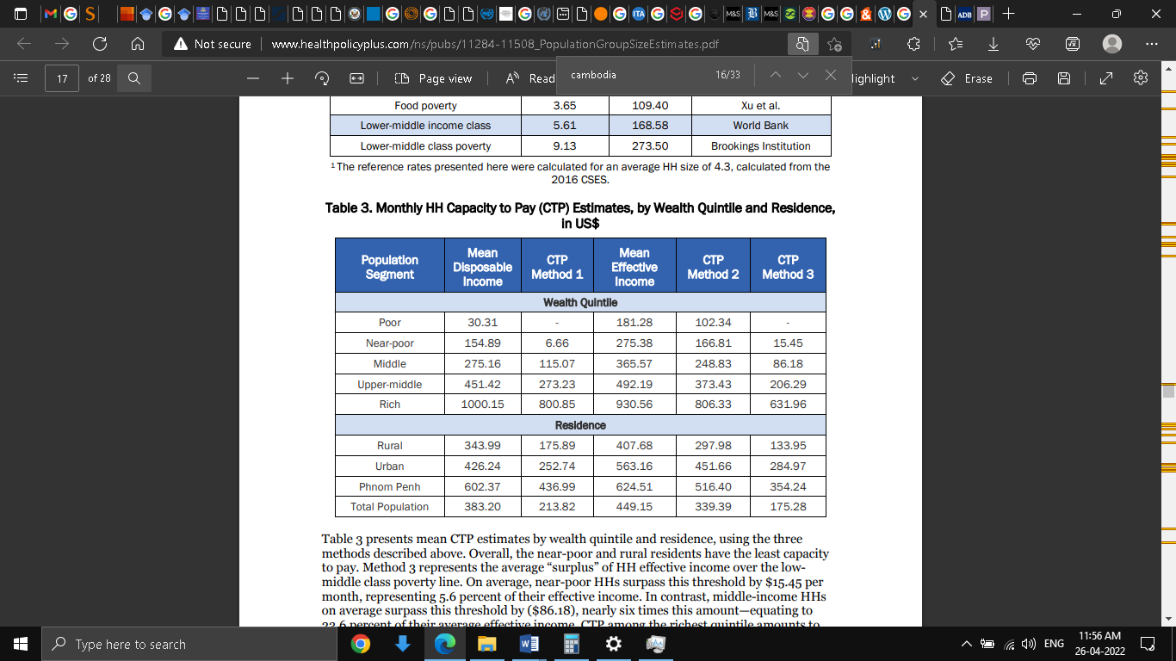

Table A: Monthly House Hold Capacity to Pay

(Source: POPULATION GROUP SIZE ESTIMATES, 2019)

# Reference

Baines, P., Fill, C., Rosengren S. and Antonetti, P. (2019) *Marketing* (5th Ed.) Oxford University Press [e-book]

*Cambodia’s Economy*. Asian Development Bank. (2022). Retrieved 26 April 2022, from https://www.adb.org/news/cambodia-economy-accelerate-2022-and-2023-adb#:~:text=PHNOM%20PENH%2C%20CAMBODIA%20(6%20April,(ADB)%20report%20released%20today.

*Cambodia’s Garment Manufacturing Industry*. ASEAN Business News. (2022). Retrieved 26 April 2022, from https://www.aseanbriefing.com/news/cambodias-garment-manufacturing-industry/.

Cambodiaangkorair.com. (2022). *Living In Cambodia, One Of The World’s Most Emotional Countries|Cambodia Angkor Air - Proudly The National Flag Carrier*. Retrieved 26 April 2022, from https://www.cambodiaangkorair.com/post/251/living-in-cambodia-one-of-the-worlds-most-emotional-countries.

Carolina, Ț. (2019). DIMENSIONS OF NATIONAL CULTURE–CROSS-CULTURAL THEORIES. *Studies in Business & Economics*, *14*(3). https://magazines.ulbsibiu.ro/eccsf/RePEc/blg/journl/14317timbalari.pdf

Derenne, J., & Flynn, L. (2020). The Notion of Advantages to Undertakings. https://orbi.uliege.be/bitstream/2268/261075/1/EStALI%2023.1.2020%20Leo%20Flynn%20%26%20Jacques%20Derenne%20-%20advantage%20to%20undertaking.pdf

*Doing Business in Cambodia*. Practical Law. (2022). Retrieved 26 April 2022, from https://uk.practicallaw.thomsonreuters.com/3-524-4317?transitionType=Default&contextData=(sc.Default)&firstPage=true.

Doole, I., & Lowe, R. (2019). *International marketing strategy: Analysis, development and implementation* (8th ed.): Cengage Learning.

*ENTREPRENEURIAL CAMBODIA*. Openknowledge.worldbank.org. (2018). Retrieved 26 April 2022, from https://openknowledge.worldbank.org/bitstream/handle/10986/30924/128265-REVISED-Nota-Entrepreneruship-web.pdf?sequence=5&isAllowed=y.

Freedom House. (2022). *Freedom in the World*. Retrieved 26 April 2022, from https://freedomhouse.org/country/cambodia/freedom-world/2021.

Greengrowthknowledge.org. (2022). *Environmental Sustainability in Asia: Cambodia*. Retrieved 26 April 2022, from https://www.greengrowthknowledge.org/research/environmental-sustainability-asia-cambodia.

Healthpolicyplus. (2019). *POPULATION GROUP SIZE ESTIMATES*. Retrieved 26 April 2022, from http://www.healthpolicyplus.com/ns/pubs/11284-11508_PopulationGroupSizeEstimates.pdf.

Lorvoralak, P., & Wongsurawat, W. (2019). Entry Strategy and Export Marketing in Emerging Markets: A Small Player Case. *Asian Journal of Management Cases*, 16(1), 76-85. https://journals.sagepub.com/doi/full/10.1177/0972820119827358

Mindtools. (2022). *The Seven Dimensions of Culture: Understanding and Managing Cultural Differences*. Retrieved 26 April 2022, from https://www.mindtools.com/pages/article/seven-dimensions.htm.

Morgan, N. A., Whitler, K. A., Feng, H., & Chari, S. (2019). Research in marketing strategy. *Journal of the Academy of Marketing Science*, *47*(1), 4-29. https://eprints.whiterose.ac.uk/136066/1/JAMS%2520Final%2520Version%2520Unblinded.pdf

Myles, N. O. (2018). ‘The individual’in the individualism/communitarianism debate: In defense of personism. *Legon Journal of the Humanities*, *29*(2), 241-263. https://www.ajol.info/index.php/ljh/article/view/181062

National Institute of Statistics. (2020). *Report of Cambodia Socio-Economic Survey*. Retrieved 26 April 2022, from https://www.nis.gov.kh/nis/CSES/Final%20Report%20of%20Cambodia%20Socio-Economic%20Survey%202019-20_EN.pdf.

Oecd.org. (2022). *Key Issues affecting Youth in Cambodia*. Retrieved 26 April 2022, from https://www.oecd.org/dev/inclusivesocietiesanddevelopment/youth-issues-in-cambodia.htm#:~:text=Cambodia%27s%20youth%20is%20particularly%20exposed,live%20below%20the%20poverty%20line.

*PESTEL Analysis*. Corporate Finance Institute. (2022). Retrieved 26 April 2022, from https://corporatefinanceinstitute.com/resources/knowledge/strategy/pestel-analysis/.

Phat, R., & Vesdapunt, K. (2021). Service Marketing Factors Affecting Consumer Decision Making Behavior of Service Usage for Thai Restaurants in Phnom Penh City, Cambodia. *Executive Journal*, 41(1), 46-58. https://so01.tci-thaijo.org/index.php/executivejournal/article/view/245223/167290

Pirlog, A. (2021). Cross-cultural Analysis of Main Economic Partners of the Republic of Moldova. https://irek.ase.md/xmlui/bitstream/handle/123456789/1870/EEJRS_Is2_V7_pp165-181_PIR.pdf?sequence=1&isAllowed=y

Qi, J. C., & Lee, K. L. (2019). A Review on Western and Chinese Organization Culture: Similarities and Differences. *INTI JOURNAL*, *2019*(65). http://eprints.intimal.edu.my/1364/1/vol.2019_065.pdf

sainsburys.co.uk. (2022). *Sainsbury Annual Report*. Retrieved 26 April 2022, from https://about.sainsburys.co.uk/~/media/Files/S/Sainsburys/documents/reports-and-presentations/annual-reports/sainsburys-ar2021.pdf.

Sangwongwanich, P., & Wongsurawat, W. (2021). Market entry of over-the-counter nutritional supplement–a case study from Thailand. *Emerald Emerging Markets Case Studies*. https://www.emerald.com/insight/content/doi/10.1108/EEMCS-10-2020-0396/full/html

*World Bank in Cambodia*. (2022). Retrieved 26 April 2022, from https://www.worldbank.org/en/country/cambodia/overview#1.

World Economic Forum. (2022). *3 ways Cambodia is using technology for good*. Retrieved 26 April 2022, from https://www.weforum.org/agenda/2021/05/3-ways-cambodia-is-using-tech-for-good-asean-4-0-southeast-asia-technology-fourth-industrial-revolution/.

Zhang, J., & Wang, R. (2019). Research on the marketing strategy of new energy vehicles in SL company. *American Journal of Industrial and Business Management*, 9(2), 306-314. https://www.scirp.org/journal/paperinformation.aspx?paperid=90659