

TY B.Tech ECE AIML
Academic Session: 2025–26

PROJECT BASED LEARNING ACTIVITY
Course: Database Management System
Course Code: [Enter course code]

SMART CINEMA MANAGEMENT, DYNAMIC PRICING AND MOVIE RECOMMENDATION SYSTEM

Submitted by
Satakshi Krishna — Roll No.: [Enter] | PRN: [Enter]
Rutu Vaghaisya — Roll No.: [Enter] | PRN: [Enter]
Division: [Enter] | Batch: [Enter]

Under the guidance of: [Faculty / Guide Name]

Department of Electronics and Electrical Engineering
Dr. Vishwanath Karad MIT World Peace University, Pune

CONTENTS
01. Abstract
02. Keywords
03. Introduction
04. Problem Statement
05. Project Objectives
06. Background & Literature Review
07. Database Requirement Analysis
08. Database Schema Design
09. ER to Relational Mapping
10. System Design & Architecture
11. Implementation
12. Testing & Results
13. Applications
14. Limitations & Future Scope
15. Conclusion
16. Acknowledgment
17. Individual Contribution
18. References
19. Appendix A: Installation & GitHub
20. Appendix B: SQL & UI Evidence
The sections start on separate pages to make the report easy to review. Final page numbers can be updated in Word after inserting project screenshots.

1. ABSTRACT
Smart Cinema Management, Dynamic Pricing and Movie Recommendation System is a database-driven web application developed for cinema booking and basic management. It integrates customer registration and login, movie and theatre management, scheduled shows, seat selection, simulated payments, cancellations, reviews and administrative analytics. The application uses Python Flask for server-side processing and MySQL for persistent relational data, with HTML, CSS, JavaScript and Bootstrap for its interface.
The database consists of 13 primary tables linked through keys and constraints. Transaction handling and a unique show–seat constraint support consistent seat reservations. An occupancy-based MySQL function calculates dynamic ticket prices, while a payment trigger updates booking status. A recommendation module uses TF-IDF and cosine similarity to identify related movies and personalizes suggestions using booking and rating history. An extended nearby-show finder lets users search by city or, with permission, sort theatres with saved coordinates by approximate straight-line distance. It also displays upcoming showtimes, addresses and currently available seat counts. Testing combines browser workflows, SQL verification and a Postman registration request. The result is an educational prototype demonstrating relational modelling, SQL features and integrated web development; payments and refunds are simulated rather than real financial transactions.

2. KEYWORDS
Relational Database; MySQL; Flask; Cinema Ticket Booking; Dynamic Pricing; Content-Based Recommendation; Location-Aware Show Discovery.

3. INTRODUCTION

3.1 Context and Motivation
Cinema booking is a multi-step operation. The system needs to know which movies are showing, where and when a show is scheduled, how many physical seats are present, whether a seat has already been reserved and whether the corresponding payment has been recorded. Without one connected source of data, a booking service can show outdated availability or inconsistent ticket and payment records.
Smart Cinema was designed as a single academic application connecting the customer interface, administrative operations and a MySQL relational database. The project goes beyond static movie listings: it manages state changes across bookings and payments, adds transparent ticket pricing rules, and suggests films based on content similarity.

3.2 Scope
Customers can register, sign in, browse the catalogue, find upcoming shows by theatre or location, inspect seat availability, select seats, make simulated payments, review eligible movies and cancel confirmed bookings. Administrators can manage movie, theatre, screen and show records, inspect bookings and examine analytics. The platform is run locally with Flask, although it can be prepared for deployment in future work.

4. PROBLEM STATEMENT
A reliable cinema platform must coordinate the scheduling of movies across multiple theatres and screens while preserving accurate seat availability. Concurrent customers must not be allowed to reserve the same seat for the same show, and partial booking transactions must not leave incorrect records. A fixed-price approach does not reflect how occupancy changes, while a large catalogue without recommendation support makes discovery difficult. Searching for theatres by name alone may also be inconvenient when customers want to locate suitable nearby showtimes.
The problem addressed is therefore to design a normalized relational database and an integrated Flask interface for booking, payment-state handling, cancellation, show management, occupancy-dependent pricing, relevant movie suggestions and accessible theatre/show discovery. The extension uses an optional user location only for search-time distance ordering, without storing the user’s coordinates in the database.

5. PROJECT OBJECTIVES
- Create a relational database model representing customers, cinema locations, screens, seats, movie schedules and transaction records.
- Establish primary-key, foreign-key and unique constraints to maintain referential integrity and block double reservations.
- Develop customer interfaces for authentication, movie discovery, show selection, booking, payment, cancellation and reviews.
- Calculate ticket prices using current show occupancy, implementing the rules within MySQL.
- Implement a content-based recommendation engine using movie metadata and customer activity.
- Provide admin CRUD functionality, booking statistics and visual analytics.
- Add a nearby-show finder that displays theatre address, future showtime, live seat counts and optional distance-based ordering.
- Test the main workflows and prepare a reproducible, GitHub-safe codebase with installation and migration instructions.

6. BACKGROUND & LITERATURE REVIEW

6.1 Cinema Booking Systems
Online booking systems commonly separate catalogue information from operational records. A movie has descriptive attributes, but its showtime varies by screen and date. A physical seat exists within a screen, yet its reserved status depends on the selected show. Relational modelling and foreign-key constraints are well suited to representing these differences [1], [2].

6.2 Reliability, Transactions and Constraints
Transaction processing is essential whenever a single user action must modify several records. In this project, inserting a booking and its selected seats is treated as one operation. Commit persists all changes; rollback returns the database to the previous consistent state when an error occurs. The unique combination of show_id and seat_id provides a database-level safeguard in addition to application checks [1], [2].

6.3 Pricing and Recommendation Techniques
Occupancy-based pricing applies an explicit percentage increase as reserved seating rises. The method used here is rule-based rather than a prediction trained on demand data. Content-based recommendation compares items from their attributes. TF-IDF converts textual features into numerical vectors, and cosine similarity ranks related movies. This approach is appropriate for an academic project with a comparatively small movie catalogue [3], [4].

6.4 Location-Aware Discovery
A city search can filter theatres using stored city information. When theatre latitude and longitude are available and a customer allows browser location access, the Haversine formula estimates straight-line geographical distance. This is a lightweight approach that requires no external directions service. It should not be interpreted as driving distance or travel time.

7. DATABASE REQUIREMENT ANALYSIS

7.1 Data Requirements
The customer module requires identity, a unique email and hashed password. The catalogue requires movie descriptions and genres. Scheduling requires a link between movies, screens, show dates and start times. Reservations require a booking header and individual seat allocations. Payments and cancellations must refer to the associated booking. Reviews link a customer to the movie being rated.
Table I. Core database entities
Entity | Representative attributes | Use
users | user_id, full_name, email, role | Customer/admin identity
movies | movie_id, title, language, status | Catalogue
theatres | theatre_id, city, address, latitude, longitude | Venue and optional geolocation
screens | screen_id, theatre_id, total_seats | Physical hall
seats | seat_id, screen_id, seat_number | Seat inventory
shows | show_id, movie_id, screen_id, show_date, show_time | Scheduled screening
bookings | booking_id, user_id, show_id, booking_status | Reservation
booking_seats | booking_id, show_id, seat_id, ticket_price | Reserved seat details
payments / cancellations | booking_id, status, amount | Transaction state
reviews | user_id, movie_id, rating | Customer feedback

7.2 Functional Dependencies
Representative functional dependencies are user_id → full_name, email, password_hash, phone and role; theatre_id → theatre_name, city, address, latitude and longitude; screen_id → theatre_id and screen_name; show_id → movie_id, screen_id, show_date, show_time and base_price; booking_id → user_id, show_id, total_amount and status. These dependencies explain why movie, venue and booking data are stored separately.

7.3 Normalization up to 3NF
First Normal Form requires individual values rather than repeated groups: selected seats are stored as separate booking_seats rows, not seat_1, seat_2 and seat_3 columns. Second Normal Form eliminates partial dependencies for composite keys: the movie_genres relation identifies an association by both IDs, without copying the movie title or genre name. Third Normal Form removes avoidable transitive dependencies: theatre name and city remain in theatres, while shows reference a screen which belongs to a theatre. The practical model contains an intentional duplicated show reference in booking_seats so MySQL can enforce UNIQUE(show_id, seat_id); the backend keeps this value aligned with its parent booking.

8. DATABASE SCHEMA DESIGN

8.1 Entity–Relationship Diagram
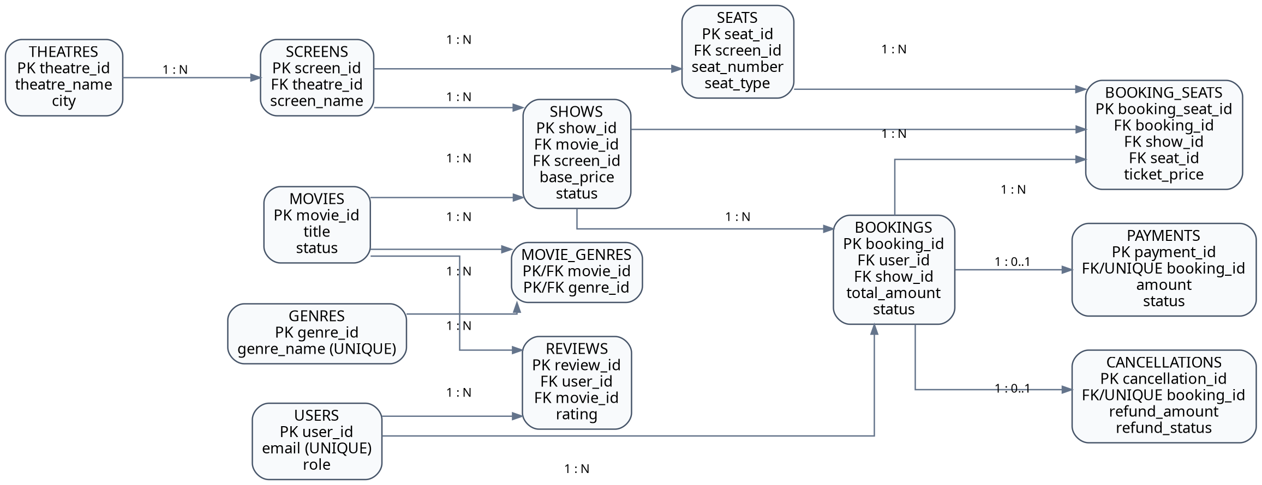
Fig. 1. Original Smart Cinema ER diagram (before adding optional theatre coordinates).
The supplied ER diagram shows the 13 operational tables and their relationships. In the enhanced implementation the existing theatres entity gains two nullable attributes, latitude and longitude; no additional principal table is needed. An updated physical schema is included as database/schema.sql in the project package.

8.2 Relational Schema and Keys
Table II. Tables, primary keys and relationships
Table | Primary key | Main foreign keys
users | user_id | —
movies | movie_id | —
theatres | theatre_id | —
screens | screen_id | theatre_id → theatres
genres | genre_id | —
movie_genres | movie_id + genre_id | movie_id → movies; genre_id → genres
shows | show_id | movie_id → movies; screen_id → screens
seats | seat_id | screen_id → screens
bookings | booking_id | user_id → users; show_id → shows
booking_seats | booking_seat_id | booking_id → bookings; show_id → shows; seat_id → seats
payments | payment_id | booking_id → bookings (unique)
cancellations | cancellation_id | booking_id → bookings (unique)
reviews | review_id | user_id → users; movie_id → movies

8.3 Integrity Rules
Important constraints include users.email UNIQUE, seats(screen_id, seat_number) UNIQUE, movie_genres(movie_id, genre_id) as a composite key, reviews(user_id, movie_id) UNIQUE, and booking_seats(show_id, seat_id) UNIQUE. Nullable theatre coordinates preserve compatibility for existing venues. Payment and cancellation records permit at most one linked record per booking through unique booking identifiers.

9. ER TO RELATIONAL MAPPING
A one-to-many relationship is mapped by placing a foreign key on the many side. Hence screens.theatre_id identifies its parent theatre, seats.screen_id identifies the physical screen, and shows.movie_id and shows.screen_id identify the movie and venue schedule. A booking references one customer and one show; multiple booking_seats rows can reference one booking. One-to-zero-or-one relationships for payment and cancellation use a unique foreign key on booking_id.

9.1 Mapping of Many-to-Many Relationships
The movie-to-genre association is many-to-many. It is represented by movie_genres(movie_id, genre_id) with a combined primary key; a movie can have more than one genre and a genre can describe multiple movies. A booking can contain multiple seats, while a physical seat can participate in separate screenings over time. booking_seats implements the latter allocation relationship with a constraint specific to each show.

9.2 Example Mapping
users(user_id PK, full_name, email UNIQUE, password_hash, role)
shows(show_id PK, movie_id FK, screen_id FK, show_date, show_time)
bookings(booking_id PK, user_id FK, show_id FK, total_amount)
booking_seats(booking_seat_id PK, booking_id FK, show_id FK, seat_id FK)
UNIQUE booking_seats(show_id, seat_id)

10. SYSTEM DESIGN & ARCHITECTURE
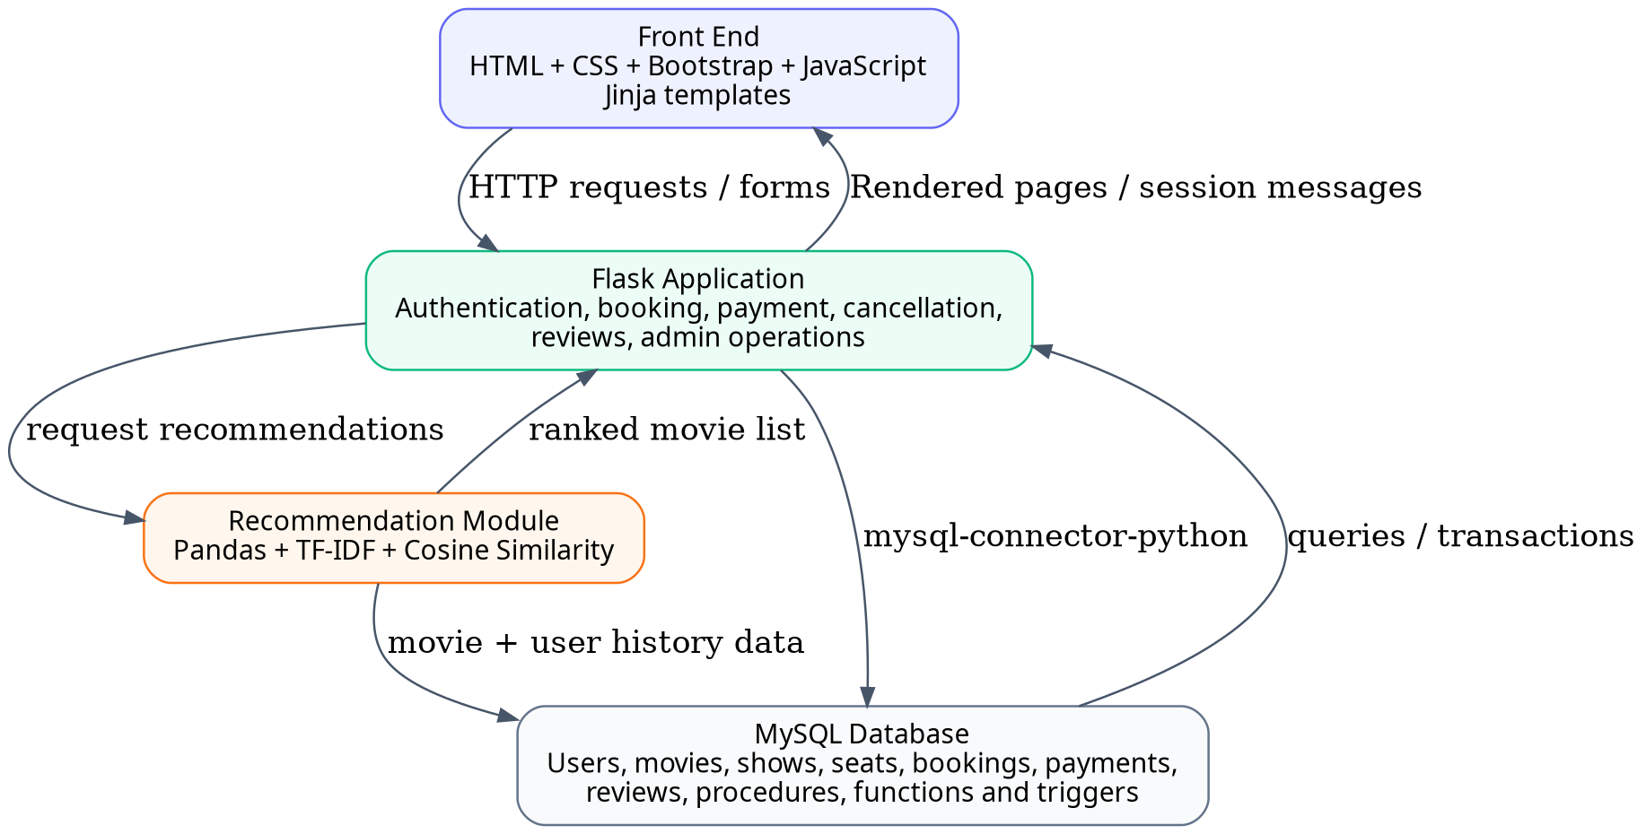
Fig. 2. Smart Cinema application architecture.

10.1 Frontend
The live user interface is built from HTML templates rendered by Jinja, and it uses Bootstrap, CSS and JavaScript for presentation and interaction. Screens cover registration, login, movie browsing, available shows, seat selection, payment, booking history, reviews, recommendations and admin pages. Figma provides the design prototype, but production application data comes from the Flask backend rather than from the Figma file.

10.2 Backend and Request Flow
Flask maps HTTP URLs to Python functions. GET routes display catalogue or status pages, while POST routes process registrations, bookings, payments or administrator updates. The backend connects to MySQL through mysql.connector, executes parameterized SQL statements, obtains results, and returns HTML, redirects or JSON. Werkzeug password hashing protects password storage, while sessions identify signed-in users and distinguish admin access.

10.3 New Nearby-Show Module
The /nearby route accepts an optional city and latitude/longitude query parameters. It joins shows, movies, screens and theatres, limits results to future scheduled screenings, and retrieves physical seat counts and current reserved-seat counts. Seat availability equals total actual seats minus seats reserved for the show. If the user provides valid coordinates and a theatre has coordinates, Haversine distance is calculated and results are ordered with the closest known locations first. Coordinates are not written into a user table.

10.4 Privacy and Security Considerations
The enhanced code reads MySQL credentials and Flask secret key from a local .env file, ignored by Git. Input coordinates are bounded to valid latitude and longitude ranges; the nearest-show query uses parameterized filtering. Location access is requested explicitly by a browser button rather than automatically. The local Flask development server is not intended to be exposed publicly without production configuration and further security controls.

11. IMPLEMENTATION

11.1 Booking and Payment Workflow
After login, the customer selects a movie and future show, opens the seat page and chooses available seats. The server verifies the selected IDs belong to the show’s screen and have not already been reserved. The current ticket price is calculated again on the server before inserting the booking and seat records in a transaction. A booking begins with pending status. A simulated successful payment record triggers a booking-status update to confirmed. Customer cancellation changes status, records simulated refund information and deletes active seat reservations to make them available again.

11.2 SQL Function for Dynamic Pricing
The database function calculate_ticket_price(p_show_id) looks up the show and its base price, counts seat records belonging to the scheduled screen, counts reserved records belonging to the show, then calculates occupancy percentage. The rules are applied in ascending tiers: at most 30% occupancy no increase; above 30% to 60%, 10%; above 60% to 80%, 20%; and above 80%, 30%. Counting actual seats rather than the screen’s declared capacity avoids inconsistency during test setups.
Table III. Dynamic pricing demonstration
Occupancy | Increase | Price for ₹200 base
0–30% | 0% | ₹200
>30–60% | 10% | ₹220
>60–80% | 20% | ₹240
>80% | 30% | ₹260

For the verified sample, four of ten actual seats were booked: occupancy = (4 / 10) × 100 = 40%; price = ₹200 × 1.10 = ₹220. This is rule-based dynamic pricing, not a machine-learning forecasting model.

11.3 Stored Procedure, Trigger and View
The database contains a create_booking stored procedure as a SQL programming demonstration. The Flask booking route uses explicit transaction statements to create the pending reservation and individual seat allocations. The trg_payment_success trigger updates the booking status after insertion of a successful simulated payment. The movie_ratings_view provides reusable average-rating and review-count information. These objects illustrate different SQL programming capabilities.

11.4 Recommendation Engine
The recommendation module obtains movie information and forms a weighted textual representation from attributes such as genres, description, language and age rating. TF-IDF produces numerical vectors for the movie catalogue; cosine similarity ranks related items. The recommend_movies function returns content-based neighbours, while recommend_for_user uses a customer’s confirmed booking and review history to weight candidate recommendations. Previously seen items can be excluded from personalized results. Because the catalogue is relatively small, recommendations should be interpreted as feature similarity rather than evidence of predictive accuracy.

11.5 Nearby Theatre, Timings and Seats Extension
The original schema already contained theatre city/address, show dates/times, screens and seat records. The extension introduces optional latitude/longitude columns in theatres and a /nearby search page. A customer can search by city even without allowing location access, or click Use my location to request browser coordinates and sort theatres with saved coordinates by straight-line distance. Each result displays movie title, theatre, screen, address, date, time, total and available seats and a button linking to the existing seat-selection route. Administrators may enter or edit each theatre’s coordinates. No Google Maps account or external geocoding API is required.

11.6 Admin Dashboard
The admin interface contains pages for movie CRUD operations, theatre and screen management, show scheduling and cancellation, bookings and analytics. SQL aggregate queries calculate metrics such as customer counts, number of bookings, payments and revenue; Chart.js visualizes selected results. Administrative functions validate the logged-in user role before performing write operations.

12. TESTING & RESULTS

12.1 Testing Approach
Testing is divided into input validation, database integrity checks, functional browser tests and targeted request checks. The earlier project demonstrated a successful registration POST test in Postman and a verified 40% occupancy pricing calculation in MySQL Workbench. The new nearby-location extension is included as source code and needs to be run against the actual local MySQL database for final acceptance. No unperformed performance benchmark is presented as a measured result.
Table IV. Functional test matrix
Test case | Input / action | Expected result | Status / evidence
TC01 | New customer JSON POST | 201 Created; hashed user stored | Previously observed Postman 1/1 pass
TC02 | Duplicate email registration | 409 Conflict for JSON | To reconfirm on updated ZIP
TC03 | Seat duplicate attempt | Unique constraint rejects reservation | Constraint included in schema
TC04 | 10 seats, 4 reserved, ₹200 | Calculated price ₹220 | Previously verified in Workbench
TC05 | Successful simulated payment | Booking becomes confirmed | Trigger implemented
TC06 | Cancel confirmed booking | Status/refund record updated; seats released | Backend flow implemented
TC07 | City=existing theatre city | Matching upcoming shows listed | Requires local acceptance test
TC08 | Use my location with coordinates | Closest known-coordinate theatres first | Requires browser permission test
TC09 | Future show with 10 seats, 4 reserved | 6 seats available | Requires local acceptance test
TC10 | Admin enters valid coordinates | Coordinates saved and displayed in nearby results | Requires local acceptance test

12.2 How to Verify Seat Availability
SELECT sh.show_id, t.theatre_name, sh.show_date, sh.show_time,
(SELECT COUNT(*) FROM seats s WHERE s.screen_id = sh.screen_id) AS total_seats,
(SELECT COUNT(*) FROM booking_seats bs WHERE bs.show_id = sh.show_id) AS booked_seats
FROM shows sh
JOIN screens sc ON sc.screen_id = sh.screen_id
JOIN theatres t ON t.theatre_id = sc.theatre_id
WHERE sh.status = 'scheduled';

12.3 User Interface Evidence
Insert actual project screenshots before submission: Fig. 3 Home/Movie Catalogue; Fig. 4 Nearby Shows with city search; Fig. 5 Nearby Shows after location permission and seeded theatre coordinates; Fig. 6 Show Date/Time and Seat Selection; Fig. 7 Booking/Payment Confirmation; Fig. 8 Postman Registration Success; Fig. 9 Admin Analytics. The submitted ZIP contains the relevant templates; screenshots must be captured locally after the database is configured. Do not substitute screenshots from the Figma prototype as evidence of a live backend operation.

13. APPLICATIONS
Smart Cinema can be used as a teaching prototype for multiplex ticketing, theatre screening management and seat inventory control. The same relational model can inspire reservation systems for concerts, seminars and public events where seats, dates, bookings and payment states must remain consistent. The city/location finder illustrates how existing operational data can be combined with optional geographic information for more convenient discovery.
The admin dashboard can support operational insights such as frequently booked films, currently scheduled shows, reservation volumes, simulated revenue and remaining capacity. The system is best understood as a learning implementation rather than a production-scale ticketing platform.

14. LIMITATIONS & FUTURE SCOPE
- Payments and refunds are simulations; no real external payment service is connected.
- Haversine ranks straight-line distances, not road routes, traffic conditions or estimated travel times. Accurate ranking depends on the admin entering correct theatre coordinates.
- The location button depends on user permission and browser support; city search remains the fallback.
- Future shows must be scheduled, and physical seats must already exist, for seat availability to appear.
- Pending bookings currently reserve seats until the application explicitly changes their state; timed expiry should be added for real operations.
- Recommendation quality depends on movie metadata and the amount of genuine booking/review history.
- The application currently runs as a local academic prototype; production deployment requires stronger operational and security controls.
Future enhancements include live payments and actual refunds, scheduled release of abandoned pending reservations, geocoding and route-based distance services, broader recommendation datasets, better accessibility testing, secure deployment and observability. A further database improvement would be to retain a full historical audit of cancelled seat allocations instead of relying only on active reservation rows.

15. CONCLUSION
The Smart Cinema project connects relational database design with a practical web application, demonstrating customer booking, dynamic pricing, payment-state transitions, cancellation, administration and movie recommendation. Thirteen related tables and key-based constraints support data organization, while transactions preserve multi-step operation consistency. The price calculation function and payment trigger show how the database can enforce repeatable business behaviour.
The nearby-show extension uses the existing show, venue and seat model, adding only optional theatre coordinates and a customer-facing search page. This illustrates how a well-designed database can support useful new features without rebuilding the entire system. The resulting academic prototype covers core DBMS concepts and leaves clear opportunities for validation, real-world integrations and deployment.

16. ACKNOWLEDGMENT
We sincerely thank the course faculty and the Department of Electronics and Electrical Engineering at Dr. Vishwanath Karad MIT World Peace University, Pune, for the opportunity to carry out this Project Based Learning activity. We also acknowledge the guidance and feedback received during the database design, implementation and review stages.

17. INDIVIDUAL CONTRIBUTION
Table V. Contribution distribution
Team member | Primary responsibilities
Satakshi Krishna | Relational schema and normalization; keys and constraints; SQL procedure, trigger and pricing function; booking/payment/cancellation backend; database checks and integration.
Rutu Vaghaisya | Figma prototype and frontend templates; movie recommendation module; admin dashboard/analytics; interface testing and report preparation; location-show page design.
Joint | Feature integration, debugging, documentation, manual tests, presentation, GitHub review and final submission.

The contributions above are a working project summary and may be adjusted by the team to reflect their actual work before submission.

18. REFERENCES
[1] R. Elmasri and S. B. Navathe, Fundamentals of Database Systems, 7th ed. Pearson, 2016.
[2] A. Silberschatz, H. F. Korth, and S. Sudarshan, Database System Concepts, 7th ed. McGraw-Hill, 2019.
[3] F. Ricci, L. Rokach, and B. Shapira, Eds., Recommender Systems Handbook, 3rd ed. Springer, 2022.
[4] scikit-learn developers, “Feature extraction from text and cosine similarity,” scikit-learn Documentation. [Online]. Available: https://scikit-learn.org/stable/
[5] Pallets, “Flask documentation.” [Online]. Available: https://flask.palletsprojects.com/
[6] Oracle, “MySQL Reference Manual.” [Online]. Available: https://dev.mysql.com/doc/
[7] Bootstrap contributors, “Bootstrap documentation.” [Online]. Available: https://getbootstrap.com/docs/
[8] GitHub repository: [INSERT FINAL GITHUB REPOSITORY URL].

19. APPENDIX A: SETUP AND GITHUB

A.1 Dependencies
Install Python and MySQL. The project uses Flask, mysql-connector-python, Pandas, scikit-learn and python-dotenv. Dependencies are listed in requirements.txt. Open the project root in VS Code and use the local virtual environment rather than committing it to GitHub.

A.2 Database Preparation
For an existing smart_cinema database, back up data and run database/migrate_nearby.sql once to add nullable latitude and longitude columns to theatres. For a completely new empty database, use database/schema.sql instead; it creates the 13 tables and stored objects without dropping another database. The original project SQL provided for testing begins with DROP DATABASE and includes sample inserts; it must not be run against an existing database with valuable data.

A.3 Run Application
py -m venv venv
venv\Scripts\activate
pip install -r requirements.txt
python app.py
Create .env from .env.example, set DB_PASSWORD and FLASK_SECRET_KEY, then start Flask. Visit http://127.0.0.1:5000/nearby. As an admin, enter correct theatre coordinates (optional); create future showtimes and seat records for the corresponding screen.

A.4 Version Control
git init
git add .
git status
git commit -m "Smart Cinema DBMS project with nearby show finder"
git branch -M main
git remote add origin https://github.com/YOUR_USERNAME/SmartCinema-DBMS.git
git push -u origin main
Check the GitHub repository after pushing. Files such as .env, venv, caches, raw personal data exports and any password-bearing older configuration must not be committed. For detailed steps, see GITHUB_UPLOAD_GUIDE.md included in the project ZIP.

20. APPENDIX B: SQL AND INTERFACE EVIDENCE

B.1 Dynamic Pricing Test
SELECT calculate_ticket_price(1) AS current_ticket_price;
-- Verified example from prior testing: 10 seats, 4 booked,
-- 40% occupancy and a base price of 200 result in 220.

B.2 Nearby Show Records
SELECT t.theatre_name, t.city, t.address, t.latitude, t.longitude,
sh.show_date, sh.show_time, sc.screen_name
FROM theatres t
JOIN screens sc ON sc.theatre_id = t.theatre_id
JOIN shows sh ON sh.screen_id = sc.screen_id
WHERE sh.status = 'scheduled'
ORDER BY sh.show_date, sh.show_time;

B.3 Recommended Final Screenshots
Fig. 3. Home page with movie cards. [INSERT ACTUAL SCREENSHOT]
Fig. 4. Nearby theatre city-search results. [INSERT ACTUAL SCREENSHOT]
Fig. 5. Nearby distance ordering (coordinates added). [INSERT ACTUAL SCREENSHOT]
Fig. 6. Showtime, available seats and seat selection. [INSERT ACTUAL SCREENSHOT]
Fig. 7. Confirmed booking and simulated payment. [INSERT ACTUAL SCREENSHOT]
Fig. 8. Postman registration success (201). [INSERT ACTUAL SCREENSHOT]
Fig. 9. Admin analytics dashboard. [INSERT ACTUAL SCREENSHOT]

