A. Wireframe / Sketch
- Include:
  - Navbar
  - Hero / main featured news
  - News grid or list
  - Sidebar (if you made one)
  - Footer
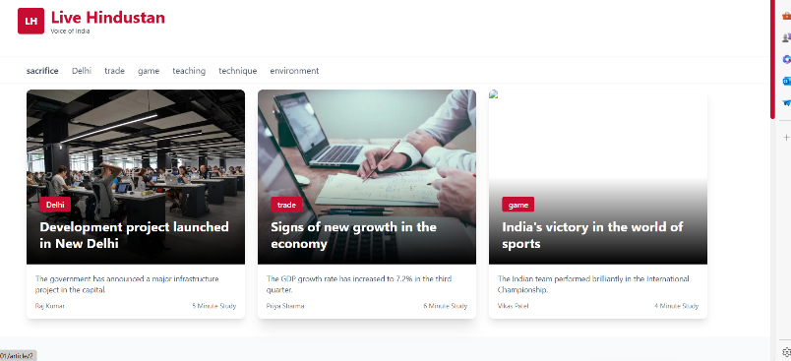
How to include it:
![Wireframe](wireframe.png)
or attach the image file.

B. Layout Decisions
I chose a 3-column grid layout for the main body of the page because it is the industry standard for high-volume news and media portals. This layout maximizes the amount of diverse content visible in the initial viewport, enhancing content discoverability.
- Header: Fixed position for branding and key navigation links.
- Main Content Grid: The main page body uses three columns of equal width:
  - Left Column: Dedicated to a major Category Focus (e.g., "India News").
  - Middle Column: Focused on Latest Updates across all categories, ensuring timeliness.
  - Right Column: Reserved for Trending/Popular stories and potential tertiary elements like quick links or ads.

C. Data-Fetching Strategy
Write:
- getAllArticles()
- getArticleById(id)
- getStaticProps

- it make test easy and isolate UI from external API

2️⃣ Code Explanation
A. Components Created
- Navbar – top navigation bar
- HeroSection – main top story with large image
- NewsCard – card component showing title, image, snippet
- ArticlePage – dynamic route for detailed news
- Footer – bottom section with links
- Layout – wrapper for consistent page structure

B. Data Model
{
id: '1',
title: 'News title',
description: 'short description',
content: `full content ‘,
image: 'https://images.unsplash.com/photo-1504384308090-c894fdcc538d?w=800&q=80',
category: 'state name',
author: 'publushed by name',
publishedAt: new Date().toISOString(),
readTime: 5,
},

C. Challenges Faced
Difficulties:
- Troubleshooting dynamic routes
- Image errors
- API not returning data
- Styling issues
- Responsiveness problems
- Deploying issues
To overcome these issues I used ai for help

D. What You Would Improve With More Time
- Improve mobile UI
- Introduce infinite scroll
- Add animations
- Add better SEO and meta tags
- Connect to a real news API
- Improve accessibility

