Agri-Hackathon

Team name: Agent R.
Team Member and Role: Pratham- Back-end Lead, Prem- Front-end Lead.
Problem Statement: KrishiRakshak.

1. Problem Statement
Farmers encounter considerable difficulties in promptly and accurately identifying crop pests, which is crucial for effective pest management. Conventional identification techniques are often time-consuming and depend heavily on expert knowledge, increasing the risk of crop damage and economic loss. To address these issues, the project proposes an AI-based system capable of analysing leaf images to detect pests efficiently. Additionally, the system aims to provide organic treatment recommendations in regional languages, making pest management accessible to farmers with limited technical expertise. This innovative approach seeks to enhance crop protection, reduce reliance on chemical pesticides, and promote sustainable farming practices by empowering farmers with timely and precise pest identification tools.

2. Rationale Behind Choosing Problem Statement
Agriculture continues to be a vital sector in India, contributing significantly to the country's GDP and employment. Despite its importance, small-scale farmers face challenges such as limited access to advanced pest control technologies. Implementing AI-driven early detection systems can revolutionize pest management by enabling farmers to identify infestations promptly. This approach promotes sustainable agriculture by reducing reliance on chemical pesticides, lowering costs, and minimizing environmental impact. Such innovations can enhance crop yields, improve farmers' livelihoods, and support India's broader economic development goals. The integration of affordable, eco-friendly pest control methods through AI technology represents a crucial step toward modernizing Indian agriculture and ensuring food security for the growing population.

3. Tools Used
• Flask – Backend web framework for creating REST API endpoints.
• Teachable Machine– Used to train a simple pest detection model.
• TensorFlow Lite (or Torch alternative) – For running lightweight AI inference.
• gTTS – Google Text-to-Speech for generating regional voice outputs.
• Python (PIL, Flask-CORS) – For image handling and API integration.
• n8n – Workflow automation for connecting backend responses to frontend and voice output.

4. Modules with Brief Description
• Flask Backend Module: Handles image upload, prediction, and returns JSON response.
• AI Model Integration: Uses Teachable Machine model to classify leaf conditions.
• Knowledge Base Module: Maps detected pest to organic treatments dynamically.
• Voice Integration Module: Converts advice text to voice using gTTS and serves it via Flask.
• Frontend Module: Created by frontend lead (Prem) to upload image and play audio results.

5. Screenshots
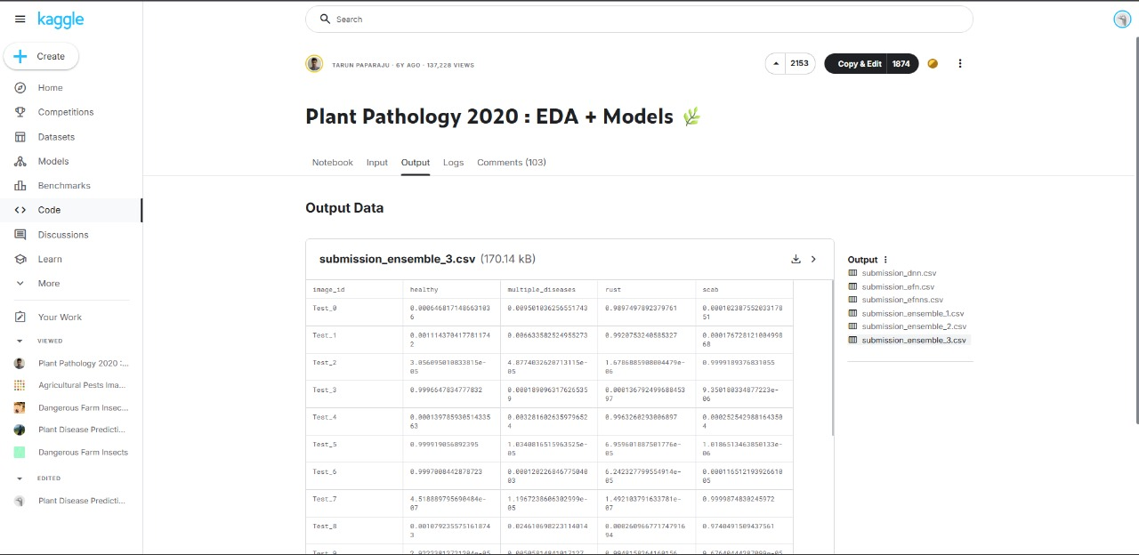
Fig: 5.1 Dataset Used
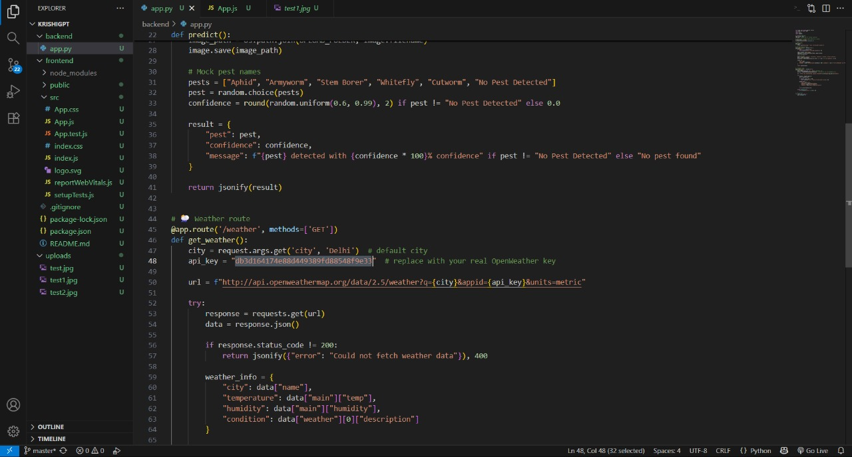
Fig: 5.2 Flask Backend Implementation

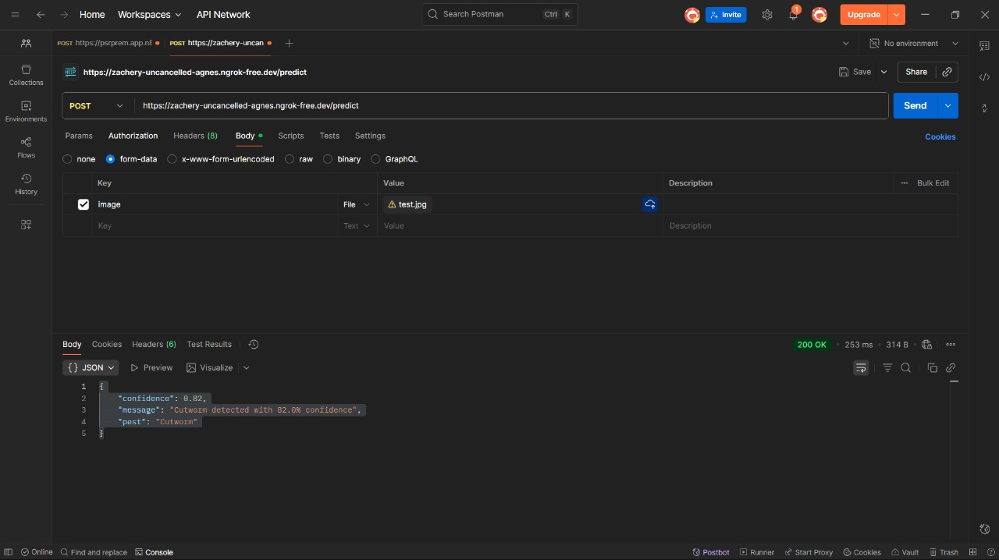
Fig: 5.3 Postman Test Case
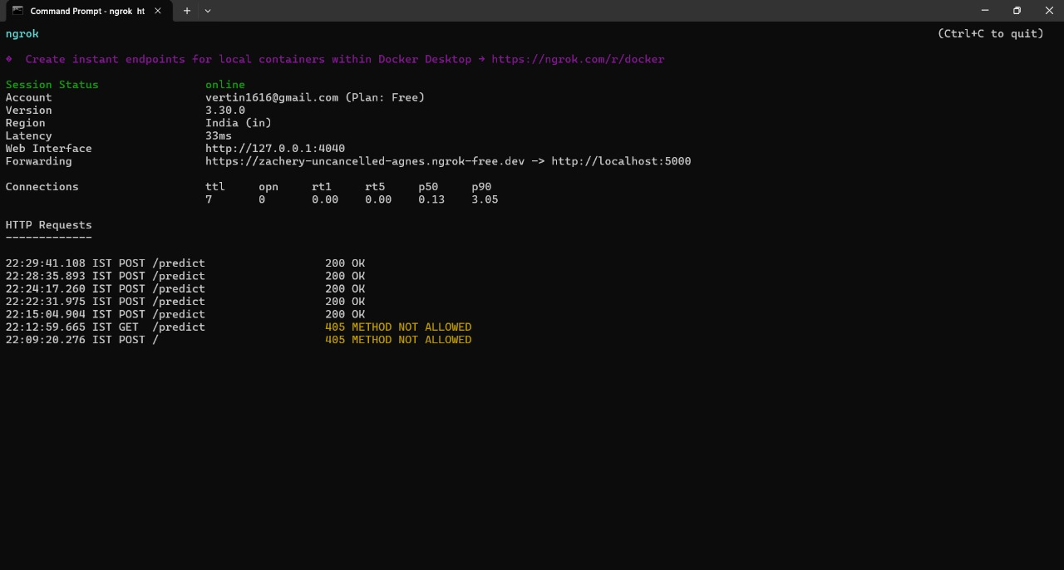
Fig: 5.4 Ngrok Terminal Showing Live Forwarding of The Flask Server

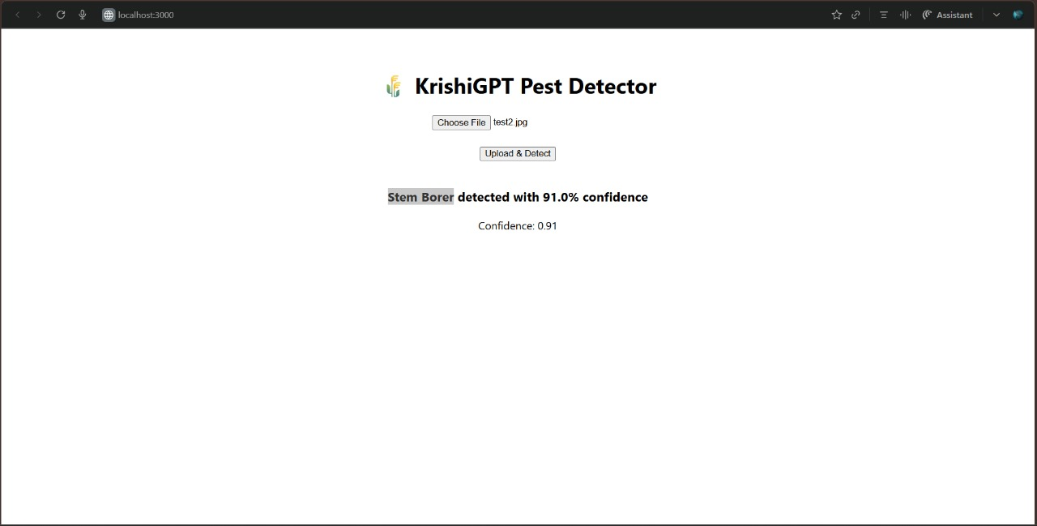
Fig: 5.5 AI Agent Interface

6. Outcome
This system leverages advanced image recognition technology to assist agricultural professionals and farmers in early pest detection, thereby reducing crop damage. The dual-format advice ensures usability across diverse user groups, including those with visual impairments or language preferences. Workflow automation through n8n optimizes operational efficiency, enabling rapid response and data management, which is crucial for effective pest control strategies in modern agriculture.

7. Conclusion
KrishiRakshak demonstrates how AI can be effectively applied to agriculture, combining image recognition, voice assistance, and workflow automation. The system empowers farmers with instant, accessible, and localized crop protection solutions — contributing toward sustainable and smart agriculture.

