System Implementation, Testing and Evaluation

Introduction
This chapter reports how the design of Chapter 4 was implemented as the CAMR memory engine and its evaluation harness, how the implementation was tested, and what the experiments measured. The project follows the AI and machine learning route of the departmental guidelines with one important difference: the language models were never trained or fine-tuned. Every model ran with frozen weights, and what changed between conditions was the external memory and the engine's policy for using it. The chapter therefore reports dataset provenance, the implemented data-to-answer pipeline, the experimental configuration, the tests that verify the requirements of section 4.2, and the measured results for each research objective.
Every number in this chapter was produced by the code in the project repository on real public benchmark data and real models, and each table names the results file it comes from. Where a result is weaker than expected, or a requirement was not met, it is reported as measured. Section 5.2 describes the environment, section 5.3 the datasets, section 5.4 the implementation, section 5.5 testing, section 5.6 the version-control evidence, section 5.7 the declaration of AI-assisted tools, and section 5.8 the results, discussion and limitations.

Implementation Environment
All development and every experiment ran on Linux machines with x86-64 CPUs and no GPU. This is the consumer-laptop class of device that NFR-01 targets: four CPU cores and 16 GB of memory. The system is a local research prototype. It was not deployed for public access.

Hardware and Deployment Environment
Table 5.1: Implementation environment and minimum requirements
Item or layer | Tested specification or version | Purpose and justification | Evidence
Primary machine (A) | Intel(R) Xeon(R) Processor @ 2.10GHz, 4 logical CPUs, 15.7 GB RAM (14.3 GB usable by processes), no GPU, Linux x86-64 | Development, all pilot, growth, ablation, learning and Kimi runs; the stated minimum (NFR-01) | results/pilot/tables/profile.json
Sweep machines (B–E) | Same container class: 4 vCPU Intel Xeon (2.10 GHz; machine C 2.80 GHz), 16 GB RAM | Model-size sweep run in parallel, one model family per machine, then merged | camr merge; FINDINGS F10
Minimum to run the engine | 4 cores, 16 GB RAM. Measured peak: engine process 712 MB, model runtime 1987 MB (qwen2.5:0.5b), store 47.8 MB | A 0.5B model and the engine fit in under 3 GB, leaving headroom on a 16 GB device | camr profile (TC-14)
Large local model | gpt-oss:20b (21B total, 3.6B active, MoE) with memory-mapped weights | Local large-model ceiling; loads in 16 GB only with mmap (first attempt was killed at 13.3 GB) | FINDINGS F6
Cloud ceiling | Moonshot Kimi K3 and Kimi K2.6 via an OpenAI-compatible HTTPS API | Frontier reference model (ceiling condition only; NFR-06) | configs/pilot_kimi.yaml
End-user device (CAMR Personal) | Windows 10/11 (x64, ARM64), macOS (Apple Silicon, Intel), Linux (x64, ARM64); Ollama installed; ≥ 4 GB RAM for a 1.5B model | The application tested by real users; talks only to Ollama on the same machine | CI build and launch test on all six (Table 5.11)
Specialised hardware | None: no GPU, NPU or accelerator was used anywhere | The study targets CPU-only consumer devices; every timing is a CPU timing | Profiles and CI runner labels

Software, Services and Configuration
Table 5.2: Software and services used
Component | Version | Role in the system
Python | 3.11.15 | Implementation language of the engine, harness and CLI
Ollama | 0.35.0 | Local model runtime on the loopback interface (IR-01); Q4/Q8 GGUF weights
SQLite / sqlite-vec | 3.45.1 / 0.1.9 | Single-file store with exact kNN vector search (FR-05, IR-04, NFR-03)
sentence-transformers / PyTorch | 6.1.0 / 2.14.1 (CPU) | BGE-small-en-v1.5 embedder, 384 dimensions (IR-03)
NumPy | 2.4.6 | Scoring, bootstrap confidence intervals, ridge regression and LinUCB
Streamlit | 1.64.0 | Read-only inspection interface (FR-17, IR-06)
Matplotlib / Playwright | 3.11.2 / 1.63.0 | Figures; automated screenshots of the inspector
pytest | 9.1.1 | Unit and integration tests (section 5.5)
Moonshot API | kimi-k3, kimi-k2.6 | Cloud ceiling. The key is read from the MOONSHOT_API_KEY environment variable and never written to configuration, logs or the repository

Configuration is a single YAML file per experiment (NFR-07). It is loaded into typed dataclasses that reject unknown keys, so a misspelt ablation parameter fails loudly instead of silently running the default. Each run records the hash of its full configuration. A completed run with the same label and hash is skipped, which makes every command resumable after an interruption. Containers (Docker) were not part of the solution: the experiments ran directly on the hosts above, and the application ships as a single self-contained executable per platform.

Deployment and Reproducibility
The engine installs as a Python package and is driven by one command-line program, camr (IR-05). The complete pipeline for one configuration is reproduced with a single command (NFR-04):
pip install -e ".[vec,embed,dev,inspect]"
ollama pull qwen2.5:0.5b
python scripts/fetch_data.py # HotpotQA, 2WikiMultiHopQA, GSM8K, PopQA
python scripts/build_popqa_corpus.py # Wikipedia summaries for PopQA
camr reproduce --config configs/pilot.yaml # ingest -> run -> ablate -> analyse -> profile
camr inspect --run-dir results/pilot # read-only web view at localhost:8501

The repository's docs/SETUP.md gives the same steps as an illustrated walkthrough. Figure 5.1 shows the CLI's command surface, and Figure 5.2 the unit-test health check that needs no models or network.
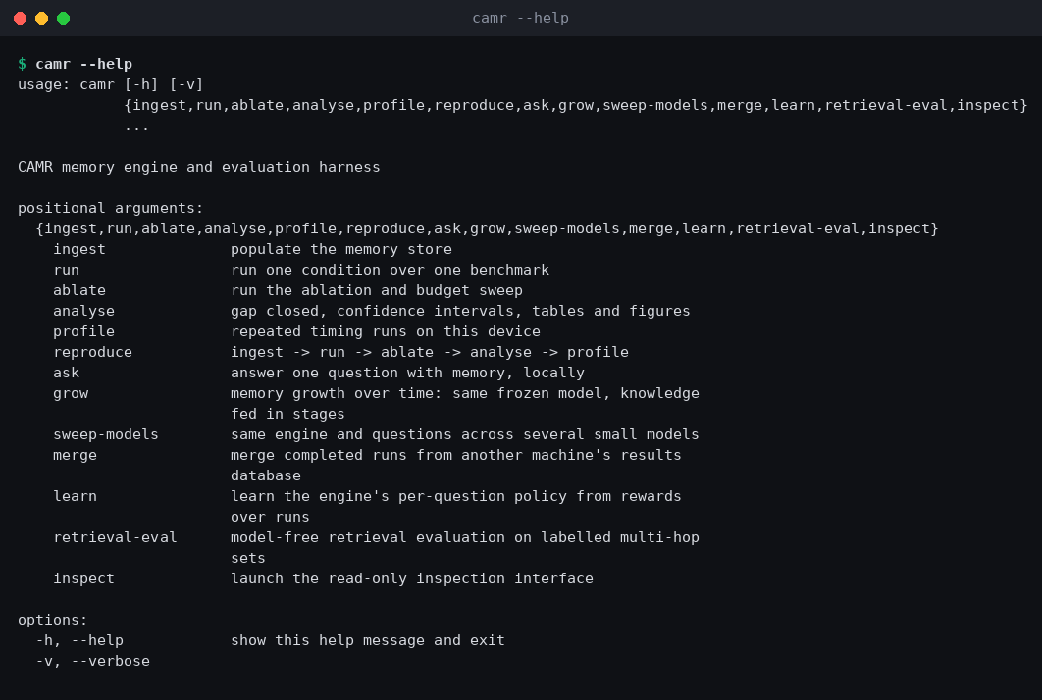
Figure 5.1: The camr command-line interface (captured output)
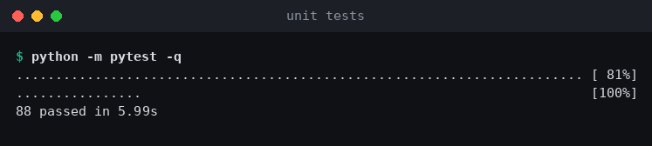
Figure 5.2: Health check: the offline test suite passing (captured output)

Dataset Description
Four public benchmarks were used (DR-01). They were downloaded from their official distributions by scripts/fetch_data.py, and no data was generated synthetically. Table 5.3 summarises them and Table 5.4 shows one real record of each. PopQA ships without documents, so a corpus of real Wikipedia summaries was fetched for the subject entity of each sampled question (design note A4). HotpotQA and 2WikiMultiHopQA supply gold and distractor paragraphs, and those paragraphs, never the question–answer records, populate memory (DR-03).
Table 5.3: Benchmarks used
Benchmark | Source and licence | Size of the file used | Task type | Metric
PopQA | Mallen et al. (2023); templates over Wikidata facts | 14,267 questions; corpus of 357 Wikipedia summaries (CC BY-SA) | Single-hop, long-tail facts | Answer contained (accuracy)
HotpotQA (dev distractor) | Yang et al. (2018); crowd-written over Wikipedia; CC BY-SA | 7,405 questions (5,918 bridge, 1,487 comparison), 10 paragraphs each | Multi-hop | Exact match, F1
2WikiMultiHopQA (dev) | Ho et al. (2020); Wikipedia and Wikidata | 12,576 questions | Multi-hop (retrieval study only) | Supporting-paragraph recall
GSM8K (test; train for exemplars) | Cobbe et al. (2021); human-written; MIT | 1,319 test; 7,473 train solutions | Reasoning control | Final-answer accuracy

Table 5.4: One record from each benchmark (verbatim)
Benchmark | Question | Reference answer | Supporting evidence
PopQA | What is George Rankin's occupation? | politician (also: political leader, political figure) | Wikipedia summary of George Rankin
HotpotQA | Were Scott Derrickson and Ed Wood of the same nationality? | yes | Paragraphs Scott Derrickson and Ed Wood (gold) plus 8 distractors
GSM8K | Janet's ducks lay 16 eggs per day. She eats three for breakfast every morning and bakes muffins for her friends every day with four. She sells the remainder … for $2 per fresh duck egg. How much in dollars does she make every day? | 18 | None (reasoning); solved train problems serve as exemplars

Data Preparation and Partitioning
Each benchmark sample was drawn once from seed 13, sorted by question identifier before sampling so that the draw does not depend on file order, and persisted to samples/<benchmark>.json with the source file's hash (DR-02). Every condition and ablation reused the same questions, so all comparisons are paired. The pilot evaluation sample was 30 PopQA, 30 HotpotQA and 12 GSM8K questions (72 in total), limited by the time the 20B CPU ceiling needed (up to 150 s per GSM8K answer). For the learned policy, a disjoint training split of 144 questions (60 PopQA, 60 HotpotQA, 24 GSM8K) was drawn from the questions not in the evaluation sample. The code asserts that the two splits do not overlap.
Memory was built from documents only. The HotpotQA store also took the paragraphs of 100 further, unsampled questions as extra distractors (design note A5). Before ingestion a holdout guard scanned every document and refused any that contained an evaluation question verbatim (DR-04, TC-21). Text was normalised (Unicode NFKC, whitespace) and paragraphs were stored verbatim with their title prefixed, e.g. The Loudwater Mystery (film): The Loudwater Mystery is a 1921 British silent…. The structured (distilled) write policy is implemented and tested, but it was not used for the reported runs, because distilling every paragraph with the 0.5B model exceeded the pilot's time budget.
Table 5.5 follows one real record from the raw files to what the model finally reads.
Table 5.5: One PopQA record before and after preparation
Stage | Content
Raw question (test.tsv) | id 5939255 · subject The Loudwater Mystery · property director · question Who was the director of The Loudwater Mystery? · answers ["Walter West", "Walter Alabaster West"]
Raw document (corpus) | {"title": "The Loudwater Mystery (film)", "text": "The Loudwater Mystery is a 1921 British silent crime film directed by Walter West and starring Gregory Scott, Pauline Peters and Clive Brook. It was based on the 1920 novel …"}
Stored note (#4863) | The Loudwater Mystery (film): The Loudwater Mystery is a 1921 British silent crime film directed by Walter West … (47 tokens; 384-d BGE vector; provenance: dataset popqa, document id, ingestion time)
Read at question time | Similarity 0.77 → admitted; next candidate 0.62 → outside the 0.15 margin. The prompt's notes section contains this single note (47 tokens instead of a 512-token budget).
Answer and score | 0.5B alone: John Sturges (wrong). 0.5B + CAMR: Walter West: contains = 1, EM = 1

System Implementation
The implementation follows the package structure of Figure 4.6: camr.memory (the engine), camr.models (runners and prompt templates), camr.harness and camr.eval (experiments and analysis), camr.learn (the learned policy), camr.cli and camr.inspect. A test enforces the dependency rules of the package diagram (memory imports nothing from harness, eval, cli or inspect, and nothing imports inspect).

Memory Engine: Write Path
Ingestion implements the sequence of Figure 4.4. A write policy turns a source document into candidate notes (FR-01). The screener rejects empty, degenerate, duplicate, over-length and injection-like candidates and logs the reason (FR-02). An importance score is assigned (FR-04). Then the note, its embedding and its provenance are committed in one SQLite transaction (FR-03, FR-05), so the store never holds a note without its vector or its source. Duplicate detection uses a checksum with a UNIQUE constraint, namespaced by note population, so ablations that change what is stored (write policy, screening) coexist in one file (design note A6). Ingesting 14,567 HotpotQA paragraphs into a 24,475-note store took 622 s on machine A, of which 569 s was embedding.

Memory Engine: Read Path
Recall implements Figure 4.5 and Equations 4.1–4.5. The question is embedded and the k = 20 nearest notes are found by exact kNN in sqlite-vec (FR-06). The notes are ranked by the configured policy, similarity only or composite (FR-07), and packed greedily under the token budget (FR-08). Three capability-adaptive mechanisms were added during implementation, each switchable in configuration and each justified by measurement in section 5.8:
i. Gating. The engine abstains when the best note's similarity is below 0.50, and admits only notes within 0.15 of the best. This keeps irrelevant text away from a small reader.
ii. Entity-bridge expansion. When an admitted note mentions the title of another stored entity, that entity's notes are pulled in. This is a one-step associative hop that needs no graph construction and no model call, and it replaces the optional graph layer of FR-18.
iii. Procedural memory. For reasoning questions, solved GSM8K train problems are retrieved as worked examples instead of factual notes.
Recency uses a logical clock, which advances one step per question instead of wall-clock time, and access state is reset before every run. This makes recall deterministic and independent of machine speed (NFR-05, design note A1).

Model Runners
All runners expose a single generate operation, and none can modify model weights (FR-09). OllamaRunner calls the local runtime with greedy decoding (temperature 0, seed 13) and refuses any host but loopback, unless it is explicitly configured as a ceiling (IR-01, NFR-06). OpenAICompatRunner calls the Moonshot API with a pinned model identifier, a timeout and bounded exponential-backoff retries. When retries are exhausted the query is logged as failed rather than scored (IR-02, IR-07). The Kimi API accepts only temperature 1, so the cloud ceiling is a single stochastic sample per question; this limitation is reported in section 5.8.

Evaluation Harness and Learned Policy
The harness runs four conditions over the fixed sample: floor (small model alone), treatment (small model + CAMR), ceiling (large model alone) and ceiling_rag (large model given the same notes). Each query writes a structured record (FR-13): condition, model and version, configuration hash, retrieved note identifiers and scores, prompt and generated tokens, retrieval, prefill and decode times, and the score. Analysis computes gap closed (Equation 3.1) with paired bootstrap confidence intervals over 2,000 resamples (FR-15). Next to it, it reports the absolute gain, and the residual gap (ceiling_rag − treatment): what model size still buys when both models read the same evidence.
The learned policy (camr learn) chooses, per question, one of five actions: answer with the small model alone, with 128, 512 or 1,024 tokens of memory, or escalate to Kimi K3. Its training configuration is given in Table 5.6. No neural network was trained and no model weights changed. The learned parameters are a ridge-regression weight vector per action (5 × 11 numbers) and a grounding classifier.
Table 5.6: Learned-policy training configuration (from camr/learn/bandit.py and rl_report.json)
Setting | Value
Language-model training | None. All model weights frozen: 0 fine-tuning epochs, no learning rate, no gradient updates
Training / evaluation questions | 144 / 72 (disjoint; 60/60/24 and 30/30/12 PopQA/HotpotQA/GSM8K)
Actions (arms) | local; mem128; mem512 (+ bridging); mem1024 (+ bridging); cloud (Kimi K3)
Logged outcomes | Every action on every question: 720 training and 360 evaluation answers
Context features (11) | Bias; task type (3 one-hot); best-note similarity; margin to second note; number of near-best notes; question length; task type × best-note similarity (3)
Reward | correct − 0.3 × [cloud call] − 0.1 × prompt tokens / 1,000
Offline learner | Ridge regression per action, λ = 1.0, closed-form solution (one pass)
Online learner (LinUCB) | Bandit feedback only; exploration α = 0.5; 5 epochs (passes) over the 144 training questions = 720 episodes, shuffled with seed 13; held-out evaluation every 20 episodes (37 checkpoints)
Grounding cascade | Ridge classifier on answer signals (answer words found in the notes, abstention-like text, length); escalation thresholds swept over 0–1.01
Cloud-cost sweep | 0, 0.05, 0.1, 0.2, 0.3, 0.5, 0.8, 1.2 (Pareto table)

Model Selection and the Validation–Test Protocol
Because no weights were trained, selection meant choosing which frozen model and which engine configuration to recommend, and that choice was made on evidence kept apart from the final test. The baseline was each small model answering alone (the floor condition). The candidates were 19 quantised models from 0.5B to 14.8B parameters across ten families (Table 5.17), each run with the same store, questions and prompt templates (seed 13, greedy decoding, temperature 0). The pilot sample (30/30/12 questions) and the 500-question retrieval study served as the validation evidence: they fixed the read path (similarity ranking, gating at 0.50 with a 0.15 margin, entity bridging) and the budgets (128 tokens for single facts, 512 for multi-hop). The 200-question HotpotQA study (reported in section 5.8) then served as a held-out test: its configuration was written to configs/hotpot200.yaml before it ran and was not changed afterwards. Every run's configuration, hash, model digest and per-question records are saved in its results database and in records/*.jsonl, so each reported number can be regenerated.

Inspection Interface and Integration Workflow
The inspector implements the four wireframes of Figures 4.10–4.13 and opens the results database read-only (mode=ro), so it cannot write (FR-17, IR-06). The screenshots below were captured automatically by Playwright from the real results database. Figure 5.3 is the Run Dashboard of the final pilot. Figure 5.4 follows one question end to end: the 0.5B model alone answered "John Sturges" (wrong), and with CAMR it read one admitted note of 47 tokens and answered "Walter West" (correct). Gating stopped the next candidate (similarity 0.62 vs 0.77) at the budget cutoff.
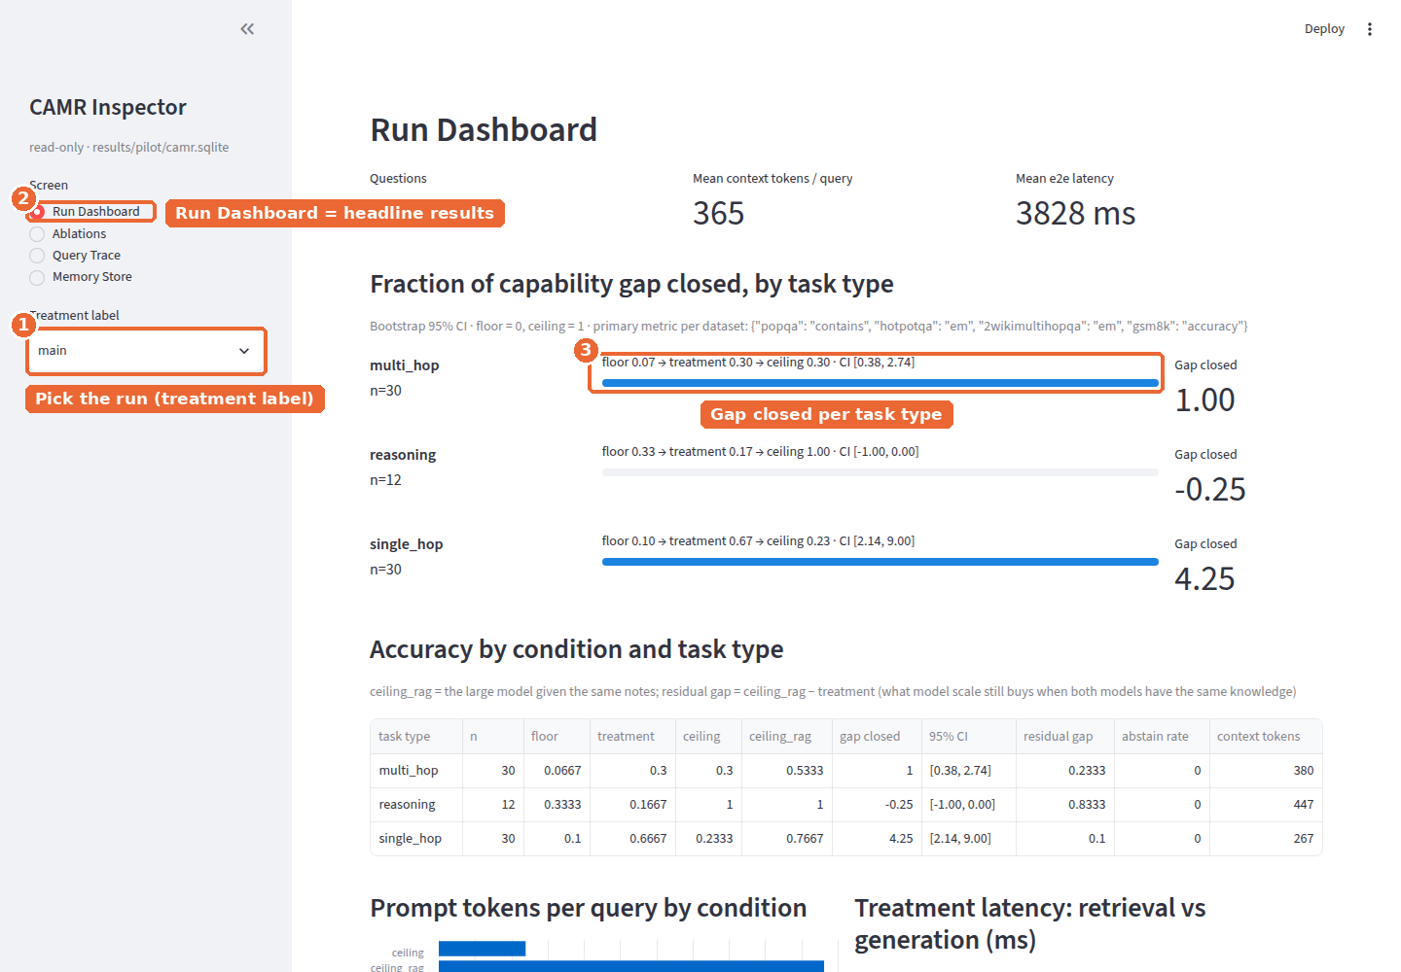
Figure 5.3: Run Dashboard of the final pilot (markers: run selector, screen, gap closed per task type)
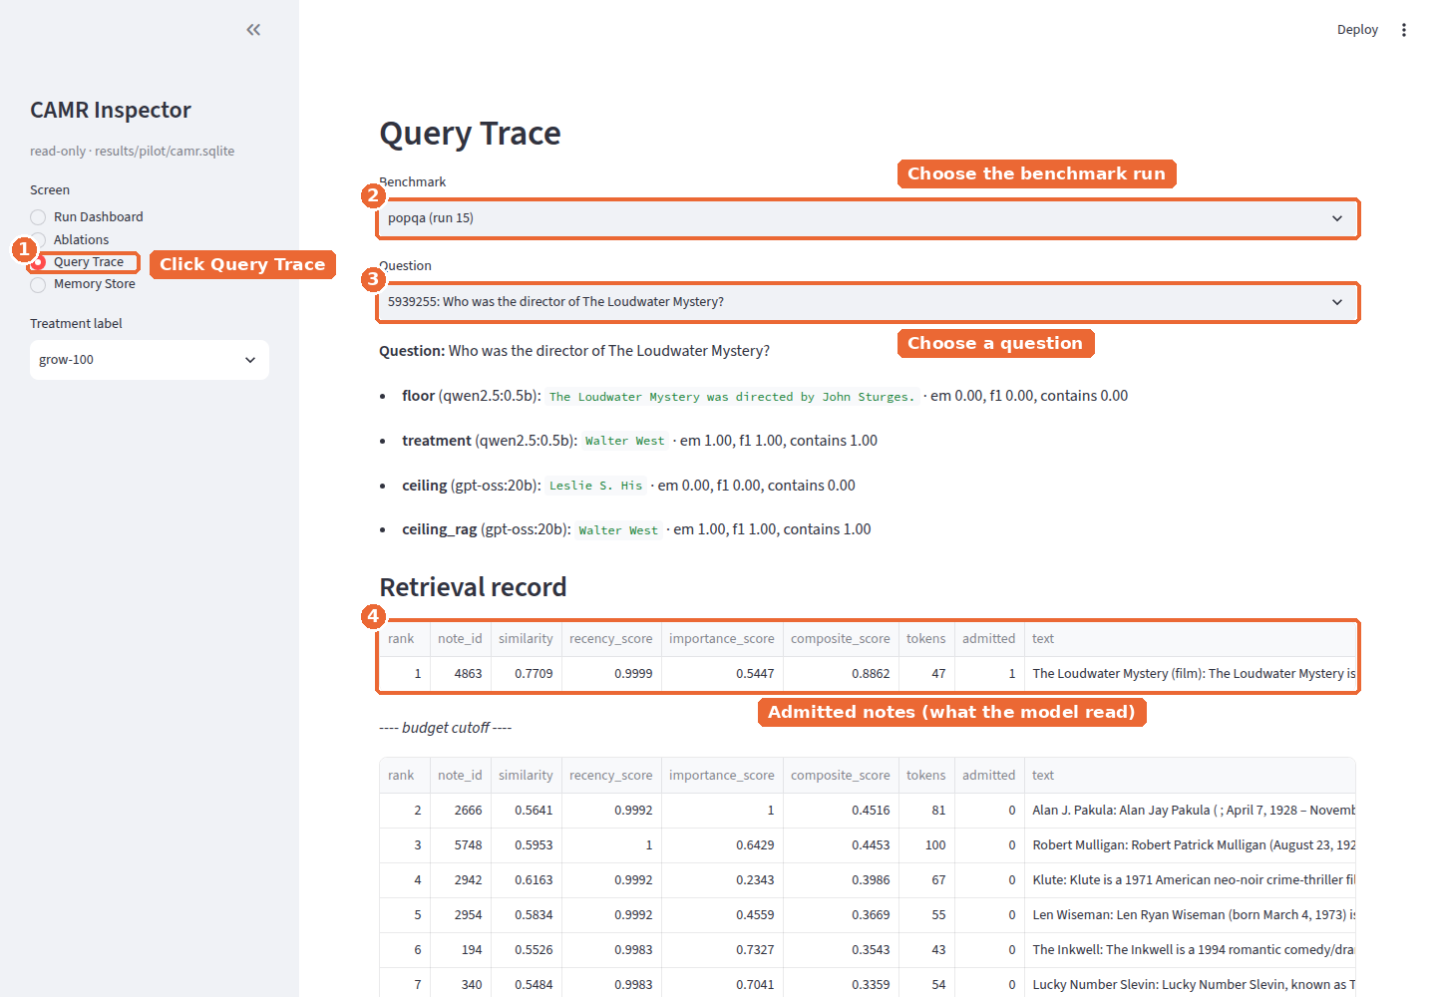
Figure 5.4: Query Trace for one PopQA question at full memory, showing the admitted note and the budget cutoff
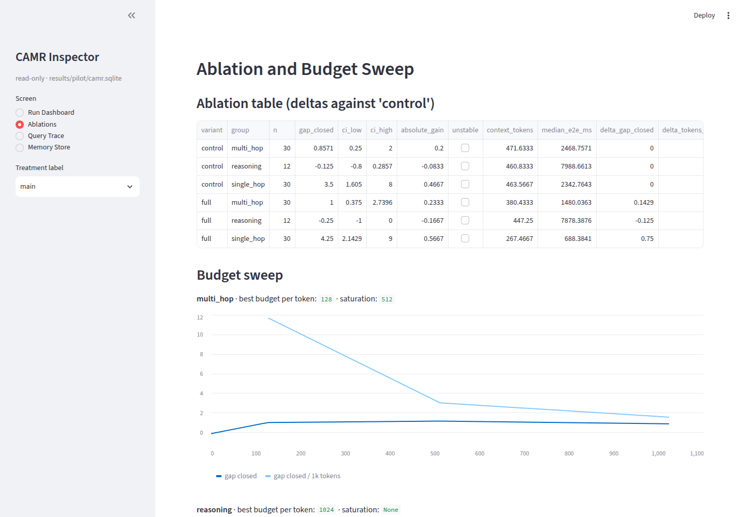
Figure 5.5: Ablations and budget-sweep screen
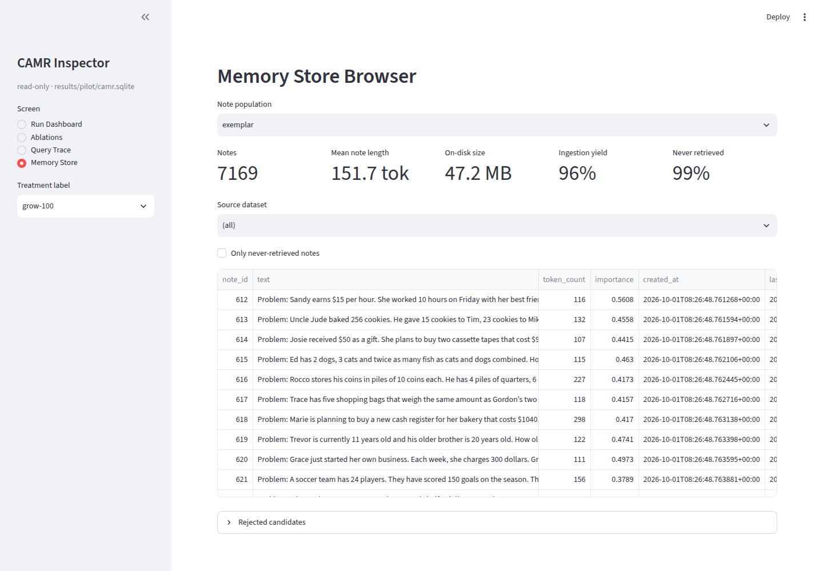
Figure 5.6: Memory Store browser: notes, provenance and retrieval counts
The deployment scenario of section 4.2.1 was exercised with the camr ask command on five personal-style notes (Figure 5.7, Figure 5.8). With an empty store, the 0.5B model invented answers ("next Monday"). With the notes, it answered from them ("Thursday 9 October at 14:30"), showing the note used, 26 context tokens, 27 ms retrieval and 1.7 s generation. For an off-topic question the engine abstained (0 notes admitted) and the model answered wrongly from its weights. This failure mode motivates the escalation policy.
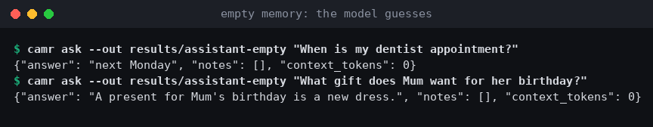
Figure 5.7: Assistant scenario with empty memory: the frozen model guesses
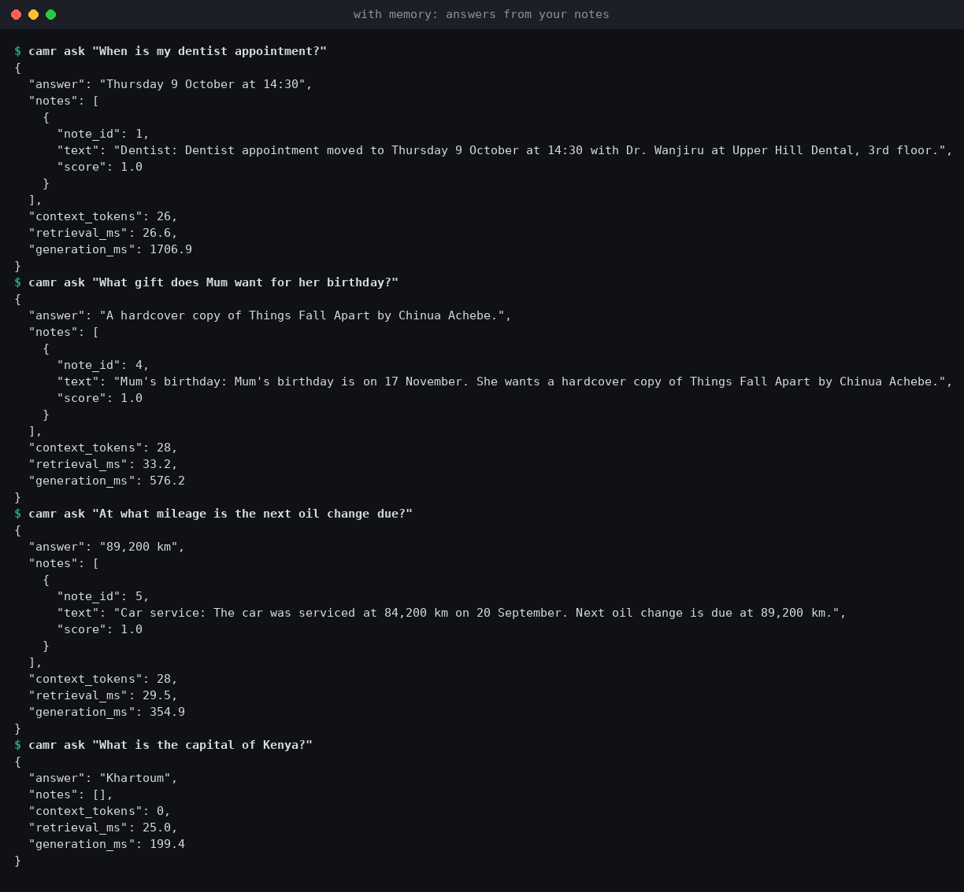
Figure 5.8: Assistant scenario with memory: answers grounded in the user's notes

CAMR Personal: the Engine as an Application
To move from benchmarks to real use, the engine was packaged as CAMR Personal, a desktop application that gives any model the user already has in Ollama a long-term memory. The user teaches it notes and files (.txt, .md, .pdf), dropped anywhere on the window; states facts with remember that …; and approves good answers with a thumbs-up, which stores them as memory. What the user says in chat is also stored, so a fact mentioned weeks earlier is recalled even after it has left the model's context window. Each answer reads only the notes it needs, using the measured best read path (similarity, gating and bridging). A Recalled N memories card appears before the answer streams, and the answer shows how grounded it is in those notes. The model's weights never change: the application adapts to its user through storage, not through compute or a longer context window.
The interface was designed after studying the conventions of ChatGPT (a minimal composer and chat history), Ollama's desktop app (the model picker inside the composer, file drop) and Kimi (sources shown before the answer), with memory made the visible centre: a ring that fills as memory grows, and a panel showing what was read, everything stored, and how memory has grown. It is a standard-library Python server with a single-page front end, bound to 127.0.0.1, refusing foreign hosts and cross-site writes. Embeddings come from a small Ollama model (nomic-embed-text), so the download needs no PyTorch. Its abstain threshold (0.55) was calibrated on HotpotQA with the same rule that places BGE's benchmark threshold (0.50): the 90th percentile of off-topic similarity. Self-contained downloads are built by continuous integration for Windows (x64, ARM64), macOS (Apple Silicon, Intel) and Linux (x64, ARM64). Figure 5.9 and Figure 5.10 show the application running with qwen2.5:1.5b on the demonstration notes.
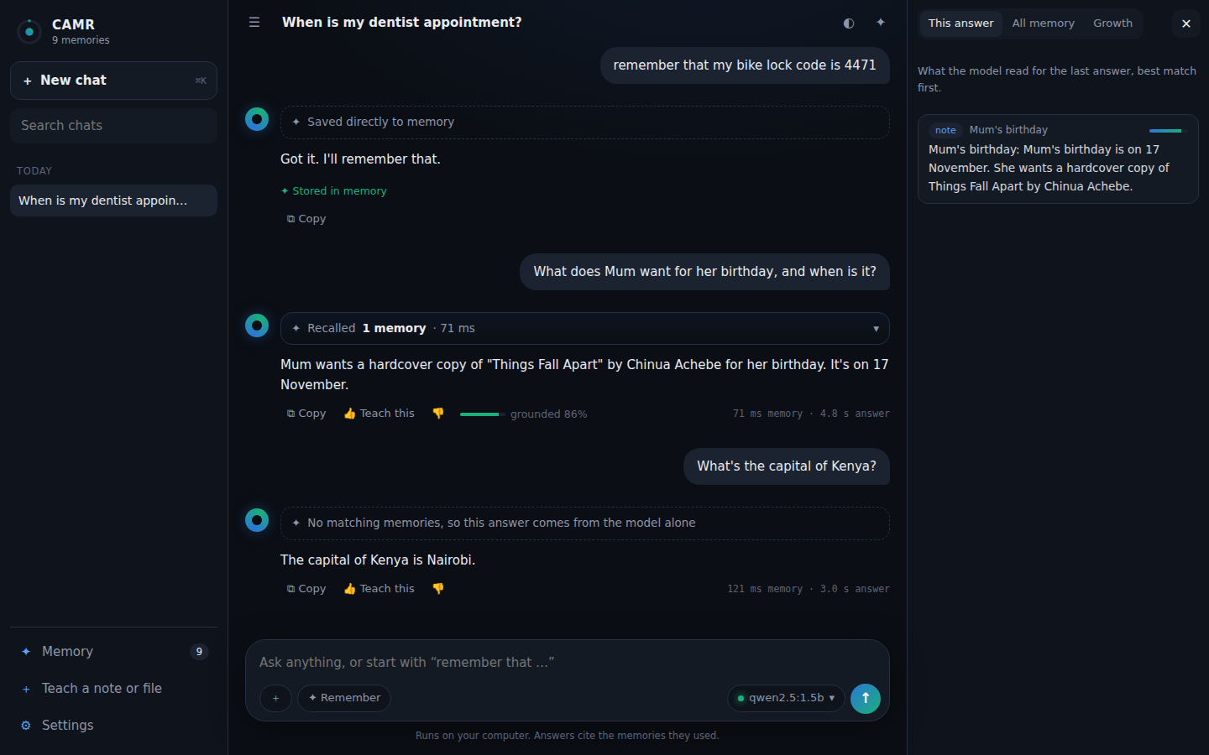
Figure 5.9: CAMR Personal: a remembered fact, an answer with its recalled memory and grounding, and an abstention, with the memory panel open
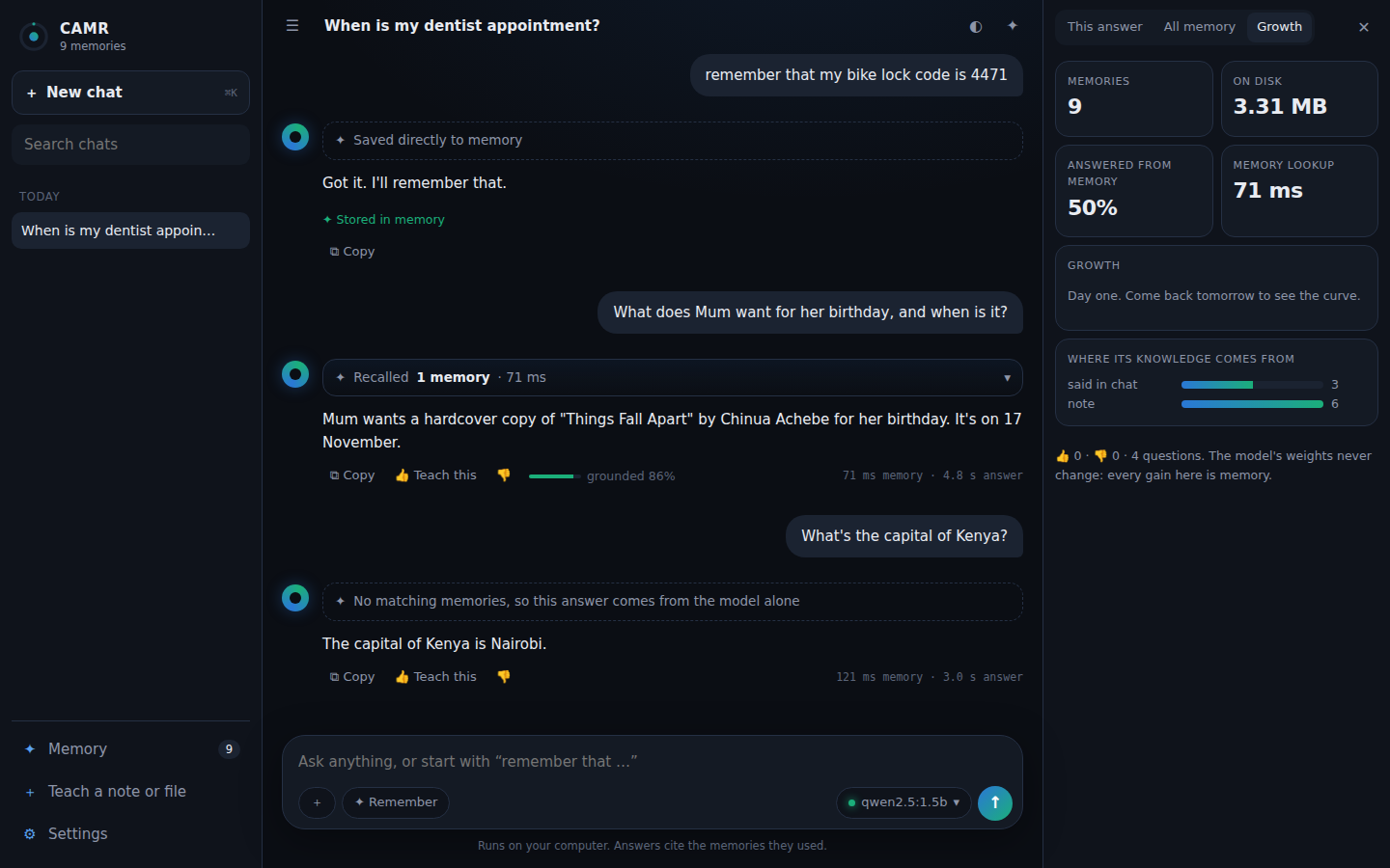
Figure 5.10: CAMR Personal: the growth panel (memories, share of answers drawn from memory, lookup time, sources of knowledge)

Testing and Evaluation

Test Strategy and Acceptance Criteria
Testing combined three levels. Unit and integration tests (white-box, pytest, 102 tests, fully offline) verify each requirement with deterministic test doubles: dry-run models and a hashing embedder. System tests run the real pipeline end to end on real data with real models. Measurements (device profile, latency, memory) verify the non-functional requirements against their thresholds. Each test maps to a test case of Table 4.5. Acceptance criteria were fixed before the runs: a functional test passes when the observed behaviour equals the expected behaviour; NFR-02 passes when retrieval is ≤ 10% of median end-to-end latency; NFR-05 passes when two runs produce byte-identical prompts.

Test Cases, Defects and Retesting
Table 5.7: Test cases and results (unit tests: pytest, 102 passed; measurements: camr profile)
Test ID | Traceability | Scenario and data | Expected result | Actual result and verdict
TC-01 | FR-01 | Verbatim and structured policies on fixture passages | Notes produced; title kept | As expected. Pass
TC-02 | FR-02/03, DR-06 | Empty, duplicate, over-length, injection-like notes | Rejected with logged reason; provenance on all notes | As expected. Pass
TC-03 | FR-04, IR-03 | Commit a note | Timestamp, importance, 384-d embedding stored | As expected. Pass
TC-04 | FR-05, IR-04, NFR-03 | kNN via sqlite-vec vs NumPy fallback | Identical scores; single file | As expected. Pass
TC-05 | FR-06/07 | Similarity-only and composite ranking; Eq. 4.3–4.4 | Order follows the equations | As expected. Pass
TC-06 | FR-08 | Budgets 0–1,024 over random note lengths | Budget never exceeded | As expected. Pass
TC-07 | FR-09, IR-01 | Runner interface; non-loopback host | Only generate; remote host refused | As expected. Pass
TC-08 | FR-10, IR-02, NFR-09 | Cloud runner with failing transport | Bounded retries, then logged failure | As expected. Pass
TC-09 | FR-11, DR-02 | Shuffle the dataset file; redraw | Same sample; persisted with seed and hash | As expected. Pass
TC-10 | FR-12 | EM, F1, contains, GSM8K final number | Matches hand-computed values | As expected. Pass
TC-11, TC-19 | FR-13, NFR-05, NFR-08 | Run the same config twice | Complete records; byte-identical prompts | Unit: pass. System: 30/30 identical prompts. 0.5B answers identical on 20/30 only (D-02)
TC-12 | FR-14, NFR-07 | Ablation plan from config | All variants and budgets planned | As expected. Pass
TC-13 | FR-15 | Gap closed and bootstrap; near-zero denominator | Correct CI; unstable flagged | As expected. Pass
TC-14 | FR-16, NFR-01 | Profile on machine A, 3 × 10 questions | Peak memory recorded; fits 16 GB | Engine 712 MB + runtime 1987 MB. Pass
TC-15 | FR-17, IR-06 | Write through the inspector connection | Write fails at the driver | As expected. Pass
TC-17 | NFR-02 | Retrieval share of median latency, 0.5B | ≤ 10% | 56% in the pilot profile. Fail (D-05; see 5.8)
TC-18 | NFR-04, IR-05 | camr reproduce end to end (dry-run and real) | All tables and figures regenerated | As expected. Pass
TC-20 | NFR-06 | Block sockets; run floor and treatment | No external connection | As expected. Pass
TC-21 | DR-03/04 | Corpus containing an evaluation question | Ingestion refused | As expected. Pass
TC-22 | IR-07 | Local runtime down mid-run | Failures logged; run continues; store intact | As expected. Pass
TC-23 | Deployment (4.2.1) | CAMR Personal: teach, ask, remember, 👍, forget, settings, export; server API, streaming, host/origin checks | Answers cite notes; chat recalled beyond the window; export hides text; foreign hosts refused | 14 tests and a browser test with a real model. Pass

The defects below were found during the real runs. Each was fixed and retested, or is reported as an open limitation. Failed results were kept in the record, not deleted.
Table 5.8: Defects found and retests
ID | Defect | Found by | Correction | Retest
D-01 | The screener rejected the real song title "I Can't Get Next to You" as a model refusal | Retrieval run 1 rejection log | Refusal check applied only to model-generated notes | Regression test added. Pass
D-02 | The 0.5B model's answers differed on 10/30 questions between identical runs (all wrong→wrong) | Repeat runs | Engine confirmed deterministic (prompts identical); floors reported as a range | Open: runtime non-determinism
D-03 | gpt-oss:20b was killed for running out of memory at 13.3 GB | Pilot ceiling run | Memory-mapped weights; one model loaded at a time | Loaded. Pass
D-04 | Changing a configuration field mid-study changed the hash, so resume re-ran finished runs | Pilot resume | Freeze the schema before final runs | Pass
D-05 | Retrieval took 56% of answer time (NFR-02) | TC-17 | Diagnosed as CPU contention; thread partitioning settings added | Engine alone 29 ms; p90 157→50 ms. Still above 10% for 0.5B
D-06 | Composite score (Eq. 4.1) lowered full-support recall by 4.6 points | Retrieval evaluation | Similarity + gating + bridging as the best read path | 2Wiki recall 35.8%→78.4%; HotpotQA equal at 11% fewer tokens
D-07 | When the model server stopped mid-sweep, failed queries were logged (IR-07) but the run was still marked completed, so resume skipped it | Machine B sweep | Resume re-runs any run with failed queries; the failed run is kept | Regression test added. Pass; 19 runs re-run clean
D-08 | gemma2:9b was killed for running out of memory three times at 13.4 GB (runtime prompt cache growing on top of the weights) | Machine B sweep | Runtime prompt cache capped at 1 GiB (affects prefill reuse only) | No further kills. Pass
D-09 | CAMR Personal: the shared store connection failed when the web UI called it from another thread, and the UI's file watcher crashed while crawling the PyTorch modules | App browser test | Store opened for cross-thread use behind a lock; file watcher disabled | App tests and browser test. Pass

Application Testing (CAMR Personal)
The application was tested as a user would meet it, with valid, empty, out-of-scope and unsupported input and with the runtime missing. The live checks used qwen2.5:1.5b and nomic-embed-text through Ollama in a browser driven by Playwright. The automated checks are in tests/test_app*.py and in the continuous-integration smoke test.
Table 5.9: Application test cases and results
Test ID | Scenario | Expected result | Actual result and verdict
TC-24 | Empty message (spaces only) | Rejected; no model call; no chat created | Error event, no chat (test). Pass
TC-25 | Out-of-scope question ("What's the capital of Kenya?") with only personal notes stored | Gating abstains; the answer is labelled as coming from the model alone | 0 memories admitted; labelled; answered "Nairobi". Pass
TC-26 | "remember that my bike lock code is 4471" | Stored without a model call; duplicate reported | Stored; second time "already in memory" (test and browser). Pass
TC-27 | Question answered by a note | Recalled memory shown before the answer; grounded answer | 1 memory, 71 ms; correct answer, grounded 86%, 4.8 s (1.5B, CPU). Pass
TC-28 | Fact said in chat, then asked after it left the context window | Recalled from memory | Recalled as "something you said" (test). Pass
TC-29 | Teach a Markdown file and a PDF | Chunked and stored as memory | Stored (test; PDF via pypdf). Pass
TC-30 | Ollama not running / memory model missing | Setup screen with the missing step and a download button | Setup screen; download with progress; then chat (browser; CI checks the not-running state). Pass
TC-31 | Request with a foreign Host header, or a cross-site POST | Refused (403) | 403 (test). Pass
TC-32 | Path traversal (/../../etc/passwd) | No file outside the app is served | Index page served (test). Pass
TC-33 | Downloadable build on six platforms | Builds, launches, serves the UI and API | All six green in CI (Table 5.11). Pass

These tests show that the application behaves correctly and fails safely. They do not show that people find it useful or easy to use. That requires a user study, which had not been run when this chapter was written (see Limitations, section 5.8).

Evaluation Design
The primary measure is the fraction of the capability gap closed (Equation 3.1) per task type, together with the absolute gain, the residual gap, tokens per question and latency. Two ceilings were used: the local gpt-oss:20b and the cloud Kimi K3. Against a closed-book ceiling that the small model plus memory exceeds, gap closed rises above 1 and stops being a fraction. Kimi K3, the frontier reference, is therefore the anchor for headline statements. With n = 30, one question is 3.3 percentage points, and confidence intervals are reported where they matter.

Version Control and Implementation Evidence
Project repository: https://github.com/Satasdin/CAMR (development branch claude/engine-build-docs-yfw9u0, merged through a pull request into main). The repository contains the README, an illustrated setup walkthrough (docs/SETUP.md), the findings log with every measurement and its source file (docs/FINDINGS.md), the design critique (docs/DESIGN_NOTES.md), dependency files (pyproject.toml), every experiment configuration (configs/), the test suite, and the scripts that regenerate every figure and screenshot in this chapter. Raw results databases and downloaded datasets are excluded by .gitignore, because of their size and licence terms, and are regenerated by the scripts. The Kimi API key was supplied only through an environment variable and does not appear in any commit.
Table 5.10 lists the commit history as recorded by Git. Each commit corresponds to an implemented or measured increment, and the commit messages name the finding they add. The model-size sweep ran on separate machines on result branches, whose databases were merged with camr merge.
Table 5.10: Commit history (git log)
Commit | Date | Author | Change
5fe043f | 29 Sep 2026 09:03 | Satasdin | Build the CAMR memory engine and evaluation harness from the proposal
66fa3de | 29 Sep 2026 09:03 | Satasdin | Initial commit
797ad01 | 01 Oct 2026 06:58 | Satasdin | Make CAMR capability-adaptive and measure the residual gap
9a7e1b3 | 01 Oct 2026 07:38 | Satasdin | Add real-model pilot tooling, retrieval evaluation and screening fix
3700f6a | 01 Oct 2026 07:57 | Satasdin | Add memory-growth experiment, larger comparison models and 2Wiki
6f9d0d0 | 01 Oct 2026 08:16 | Satasdin | Add model-size sweep, cross-machine merge and data fetch script
f9d557e | 01 Oct 2026 08:29 | Satasdin | Add OpenAI-compatible cloud ceiling (Kimi) and second-ceiling analysis
a746641 | 01 Oct 2026 09:08 | Satasdin | Findings log with real pilot results, figures and inspector screenshots
1eec1bd | 01 Oct 2026 09:08 | Satasdin | Add Kimi K2.6 as a second cloud ceiling config
d738a34 | 01 Oct 2026 09:44 | Satasdin | Learn the engine's per-question policy from rewards (contextual bandit)
a30ba07 | 01 Oct 2026 10:30 | Satasdin | Findings: full pilot results (residual gap, ablation, budget sweep, profile), new screenshots, registry metadata
15206ae | 01 Oct 2026 10:40 | Satasdin | Findings F9: small model + CAMR vs Kimi K2.6/K3 with and without memory
06fed37 | 01 Oct 2026 10:51 | Satasdin | Findings F10: model-size sweep (machine E) with figure; sweep figure readability fixes
6e9211c | 01 Oct 2026 11:24 | Satasdin | Findings F11-F12: learned engine policy (contextual bandit) and retrieval-latency diagnosis
e619530 | 01 Oct 2026 11:26 | Satasdin | Grounding cascade: answer locally, escalate ungrounded answers; beats always-Kimi (65.3% vs 63.9%) with 29% cloud
0c90bd3 | 01 Oct 2026 11:27 | Satasdin | Findings F10: add machine C models (gemma3:1b, smollm2, granite3.3:2b, falcon3:3b, phi4-mini)
1bf38e0 | 01 Oct 2026 11:27 | Satasdin | Findings: correct count of models reaching Kimi on PopQA (10 of 11)
ea52fce | 01 Oct 2026 11:38 | Satasdin | Setup walkthrough with annotated screenshots and a personal-notes assistant demo
1ff3ff8 | 01 Oct 2026 11:44 | Satasdin | Chapter 5 builder: proposal Word styles, results read from the results files
bbb65f2 | 01 Oct 2026 11:47 | Satasdin | Findings F10b: machine B (7-14B) merged; fix D-07 resume after runtime failure
945327b | 01 Oct 2026 11:48 | Satasdin | Chapter 5 builder: column widths, per-model answer time, defects D-07/D-08
376eed2 | 01 Oct 2026 11:50 | Satasdin | Chapter 5: AI-use declaration
e42a555 | 01 Oct 2026 12:24 | Satasdin | Findings: machine D merged (19 models) and 2WikiMultiHopQA retrieval
e76a716 | 01 Oct 2026 12:28 | Satasdin | CAMR Personal: a downloadable local assistant whose memory grows with use
e810501 | 01 Oct 2026 12:29 | Satasdin | Chapter 5 builder: 2Wiki retrieval table, 19-model discussion, app section, n=200 study; hotpot200 config and retrieval figures
fd89571 | 01 Oct 2026 12:37 | Satasdin | MIT licence; remove the Discord launch kit
f2d4da1 | 01 Oct 2026 15:37 | Ibrahim Sudheysi Ali | Merge CAMR engine, evaluation harness, findings and CAMR Personal app
08062d3 | 01 Oct 2026 13:34 | Satasdin | Android prototype (parked): Kotlin port of the CAMR engine with a Compose UI
48505a0 | 01 Oct 2026 13:34 | Satasdin | CAMR Personal 0.2: custom chat UI, Ollama embeddings, desktop downloads
2f278c3 | 01 Oct 2026 13:38 | Satasdin | App screenshots (dark/light/mobile), user guide for the downloads, F13 n=200 results, Chapter 5 updates
1775be6 | 01 Oct 2026 16:42 | Ibrahim Sudheysi Ali | Merge CAMR Personal 0.2: new chat UI, desktop downloads, n=200 confirmation
1aa5b23 | 01 Oct 2026 13:43 | Satasdin | Release workflow: publish a release from a manual dispatch; reject empty chat messages

The work followed GitHub flow. Each round of work was developed on one branch and merged through a pull request whose description summarises the change and its test plan: Satasdin/CAMR#2 (engine, harness, findings) and Satasdin/CAMR#3 (CAMR Personal 0.2). Machines B–E pushed their results to their own branches, which were merged into the results database rather than into the code. Feedback from users is collected through a GitHub issue form (.github/ISSUE_TEMPLATE/feedback.yml). The code is released under the MIT licence. Continuous integration (.github/workflows/release-app.yml) runs the application tests and builds and launch-tests the downloadable application on six platforms for every change to the application. Table 5.11 shows the run for the merged version. A published release (v0.2.0) attaches the six downloads.
Table 5.11: Continuous-integration evidence: build and launch test per platform (GitHub Actions run 36870197366)
Target | Runner | Tests | Build | Launch test | Result
Windows x64 | windows-2025 | pass | pass | pass | success
Windows ARM64 | windows-11-arm | pass | pass | pass | success
macOS Apple Silicon | macos-15 | pass | pass | pass | success
macOS Intel | macos-15-intel | pass | pass | pass | success
Linux x64 | ubuntu-24.04 | pass | pass | pass | success
Linux ARM64 | ubuntu-24.04-arm | pass | pass | pass | success

Author Oversight and Use of AI-Assisted Tools
Claude Code, an AI coding assistant provided by Anthropic, was used throughout the implementation and evaluation stages of this project. Under the student's direction it assisted with writing the engine and harness code and its tests, running the benchmark experiments on the cloud machines, producing the figures and screenshots, and drafting this chapter from the logged results. The student defined the research problem, objectives, requirements and design (Chapters 1–4), supplied the cloud model access, and decided which experiments were run, including the comparison with cloud models, the wider model-size sweep, the learned escalation policy and the use of real rather than synthetic benchmark data.
The student reviewed the intermediate results and screenshots as the work progressed and redirected it where it fell short; most importantly, the student required that this chapter report only experiments that had actually been run and benchmarked with real models, and an earlier draft written before the results existed was discarded for that reason. The AI-assisted output was checked through the automated test suite (102 tests), the per-query logs, the read-only inspector, and the findings log, which names the results file behind every reported number, so that each claim can be traced and re-run. The student made the final decisions and takes full responsibility for the submitted work.

Evaluation Results, Discussion and Limitations
The results are organised by research objective. Source files are in results/ and every table is reproduced in docs/FINDINGS.md.

Retrieval Quality (Objective ii)
Before any language model was involved, the read path was evaluated on 500 HotpotQA and 500 2WikiMultiHopQA questions against one store of 38,054 notes built from 23,524 real paragraphs (170 MB). The measure was whether both gold supporting paragraphs reached the context, because a multi-hop question cannot be answered from one of them.
Table 5.12: Full-support recall and tokens supplied, 500 questions each (results/retrieval_eval/tables/retrieval_eval.json)
Read path (512 tokens unless noted) | 2Wiki: both gold | Tokens | HotpotQA: both gold | Tokens
Similarity only (baseline) | 35.8% | 471 | 70.8% | 470
+ recency and importance (Eq. 4.1) | 34.6% | 470 | 65.4% | 467
+ gating | 33.4% | 408 | 64.6% | 384
+ entity bridging, no gating | 75.2% | 472 | 70.0% | 470
Similarity + gating + bridging | 78.4% | 439 | 70.8% | 420
Baseline @ 1,024 tokens | 41.4% | 980 | 79.8% | 978
Similarity + gating + bridging @ 1,024 | 84.0% | 821 | 83.0% | 728

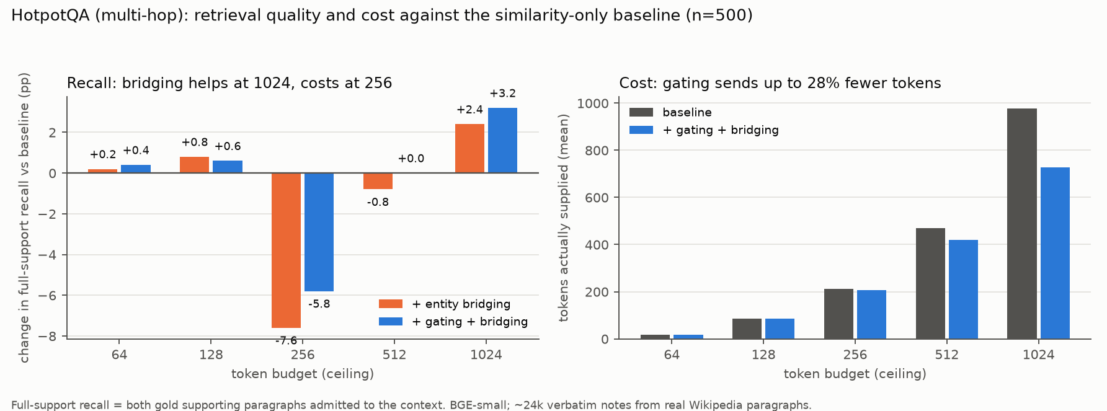
Figure 5.11: HotpotQA: change in full-support recall and tokens supplied relative to the baseline
Entity bridging was the decisive mechanism on 2WikiMultiHopQA: full-support recall rose from 35.8% to 78.4% at the same budget, with 7% fewer tokens. Its questions are compositional (for example, who is the father of the director of film X?). The second paragraph shares almost no words with the question, so similarity search cannot find it, but the first paragraph names it, and that is the hop bridging follows. On HotpotQA the gain depended on the budget: none at 512 tokens, with 11% fewer tokens, and +3.2 points at 1,024 tokens, with 26% fewer tokens. On both benchmarks the composite score of Equation 4.1 lowered recall. On independent questions, recency and importance carry no signal about the current question, which confirms the risk anticipated in section 4.4.7.

Gap Closed and the Residual Gap (Objective iv)
Table 5.13: Accuracy by condition, pilot sample (results/pilot/tables/summary.json, gap_vs_kimi.md)
Task (n) | 0.5B alone | 0.5B + CAMR | gpt-oss-20b | 20B + same notes | Kimi K3 | Kimi K3 + CAMR
Single-hop, PopQA (30) | 10.0% | 66.7% | 23.3% | 76.7% | 66.7% | 83.3%
Multi-hop, HotpotQA (30) | 6.7% | 30.0% | 30.0% | 53.3% | 53.3% | 63.3%
Reasoning, GSM8K (12) | 33.3% | 16.7% | 100% | 100% | 100% | 100%

Against Kimi K3, the engine closed the entire single-hop gap (gap closed 1.00) and half of the multi-hop gap (0.50, 95% CI 0.20–0.90). It closed none of the reasoning gap (−0.25). The 0.5B model with CAMR answered single-hop questions in 1.5 s against Kimi's 7.7 s. The residual gap (20B with the same notes minus 0.5B with them) was 10.0 points on single-hop, 23.3 on multi-hop and 83.3 on reasoning: the more a task needs reading and reasoning, the more model size still buys. This answers research question iii. Memory helps knowledge-bound tasks and does not help reasoning-bound ones. The same notes also lifted the frontier model (Kimi K3 rose from 66.7% to 83.3% on PopQA), so the engine helps beside any model.

Error Analysis: Where Answers Are Lost
Table 5.14 follows each question through the pipeline (from tables/coverage.md): is the gold answer in the store, among the retrieved candidates, in the context actually sent, and was the answer correct? The last column is accuracy given that the answer was in the context.
Table 5.14: Failure decomposition for the 0.5B model with the full engine (pilot)
Benchmark (n) | Answer in store | In candidates | In context | Correct | Correct when in context
PopQA (30) | 93.3% | 93.3% | 90.0% | 66.7% | 74.1%
PopQA, 128-token budget (30) | 93.3% | 93.3% | 86.7% | 76.7% | 84.6%
HotpotQA (30) | 96.7% | 93.3% | 83.3% | 30.0% | 36.0%

Retrieval was rarely the problem. On HotpotQA the answer reached the context for 83% of questions, but the 0.5B model used it correctly only 36% of the time. Of its 21 misses, 16 (76%) had the gold answer in front of it. On PopQA a smaller budget raised correct-when-in-context from 74% to 85%: fewer notes, less distraction. Errors therefore fall into three groups, illustrated in Table 5.16: correct answers read from the note; incomplete answers that pick a related entity from the right evidence; and unsupported answers, where the model ignored or lacked the evidence and fell back on its own (wrong) knowledge.
Table 5.15: Examples of correct, incomplete and unsupported answers (from the query logs)
Type | Question (abridged) | Gold | Answer given
Correct | Who was the screenwriter for The Graduate? | Calder Willingham, Buck Henry | 0.5B + CAMR: Buck Henry (alone: Linda Wachowski)
Correct | McLaren MP4/11 was driven by which Finnish driver? | Mika Häkkinen | 0.5B + CAMR: Mika Häkkinen (gpt-oss-20b alone: Kimi Räikkönen)
Incomplete | City with the Nusretiye Clock Tower and …? | Istanbul, Turkey | Beyoğlu (a district of Istanbul; evidence was in context)
Incomplete | Event where Tyson Gay and Rodney Martin both represented the US? | 4 × 100 m relay | 100 m sprint (evidence in context)
Unsupported | Who was the director of The Loudwater Mystery? (no memory) | Walter West | 0.5B alone: John Sturges (invented)
Unsupported | When is my dentist appointment? (empty memory) | Thursday 9 October 14:30 | next Monday (invented); with the note: correct

Knowledge Growth with Frozen Weights
The knowledge corpus was fed into one store in three stages, and the same frozen 0.5B model answered the same questions after each stage (Figure 5.12). On long-tail facts, accuracy rose from 6.7% to 16.7%, 33.3% and 66.7% as memory grew to 25%, 50% and 100%. That matches Kimi K3 and is roughly three times the 20B model. Median decode speed stayed between 44 and 63 tokens/s at every stage (Figure 5.13). The cost of memory is in prefill (270–460 extra prompt tokens) and a bounded 3–17% per-token decode slowdown, measured across the model sweep, from attending over a longer prompt.
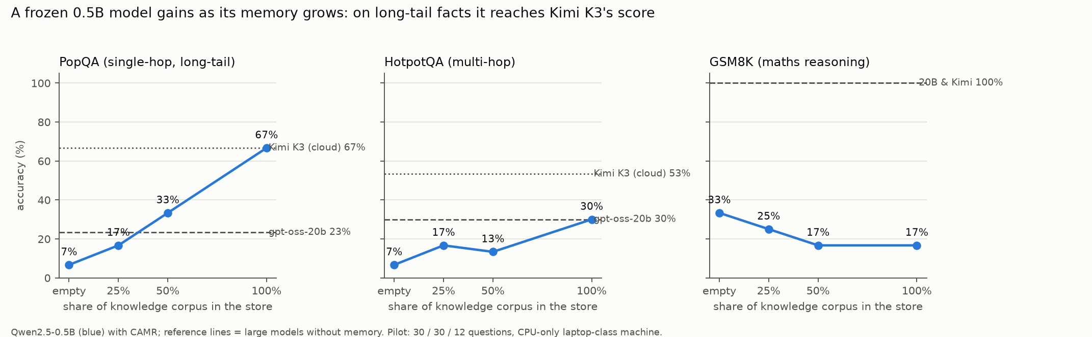
Figure 5.12: Accuracy of the frozen 0.5B model as the memory store grows
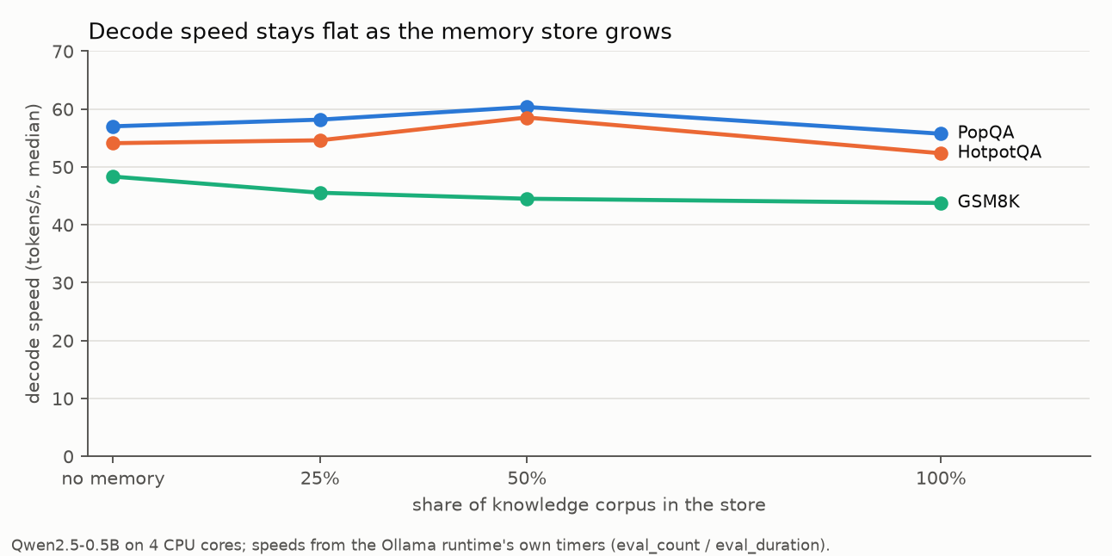
Figure 5.13: Decode speed of the frozen 0.5B model at each store size

Ablation and Token Budget (Objective v)
Table 5.16: Ablation and budget sweep, 0.5B model (ablation.md, budget_sweep.md)
Variant | Single-hop acc. (tokens) | Multi-hop acc. (tokens) | Reasoning acc. | Answer time (single / multi)
Control: similarity only, fixed budget | 56.7% (464) | 26.7% (472) | – | 2,343 / 2,469 ms
Full engine: gating + bridging | 66.7% (267) | 30.0% (380) | – | 688 / 1,480 ms
Budget 0 | 10.0% (0) | 3.3% (0) | 16.7% | –
Budget 128 | 76.7% (82) | 30.0% (86) | 16.7% | –
Budget 512 | 66.7% (267) | 33.3% (380) | 20.8% | –
Budget 1,024 | 66.7% (434) | 26.7% (557) | 16.7% | –

The full engine was more accurate than the control and 1.7–3.4 times faster per answer, because gating sent fewer tokens. For a 0.5B model, the budget that maximised gap closed per token was 128 tokens for single-hop facts. Larger budgets lowered accuracy, because the small model was distracted by extra notes. Multi-hop questions peaked at 512 tokens, and reasoning never benefited. This answers research question iv: the best budget depends on the task type and the model, which motivated the learned policy.

Which Model Sizes Suit the Engine
The same store, questions and ceilings were used with 19 small models from 0.5B to 14.8B parameters (Table 5.17, Figure 5.14). Accuracies are comparable across machines; decode speeds are comparable only within a machine.
Table 5.17: Model-size sweep: alone → with CAMR (results/pilot/tables/model_sweep.json)
Model (parameters, quantisation) | PopQA (%) | HotpotQA (%) | GSM8K (%) | Decode tok/s (PopQA) | s / answer with CAMR (PopQA)
qwen2.5:0.5b (494.03M, Q4_K_M) | 6.7 → 66.7 | 10.0 → 30.0 | 25.0 → 16.7 | 50.3 → 48.9 | 1.4
gemma3:1b (999.89M, Q4_K_M) | 6.7 → 66.7 | 16.7 → 40.0 | 33.3 → 16.7 | 24.9 → 23.9 | 3.5
llama3.2:1b (1.2B, Q8_0) | 10.0 → 63.3 | 16.7 → 40.0 | 58.3 → 33.3 | 36.2 → 33.7 | 1.9
qwen2.5:1.5b (1.5B, Q4_K_M) | 10.0 → 80.0 | 16.7 → 50.0 | 58.3 → 41.7 | 21.4 → 19.9 | 2.1
smollm2:1.7b (1.7B, Q8_0) | 20.0 → 73.3 | 13.3 → 36.7 | 33.3 → 41.7 | 15.2 → 13.8 | 6.4
granite3.3:2b (2.5B, Q4_K_M) | 16.7 → 76.7 | 26.7 → 43.3 | 58.3 → 58.3 | 14.2 → 12.2 | 8.5
qwen2.5:3b (3.1B, Q4_K_M) | 6.7 → 80.0 | 33.3 → 43.3 | 25.0 → 33.3 | 13.3 → 11.0 | 4.2
falcon3:3b (3.2B, Q4_K_M) | 10.0 → 70.0 | 13.3 → 50.0 | 33.3 → 66.7 | 14.2 → 14.5 | 6.6
llama3.2:3b (3.2B, Q4_K_M) | 23.3 → 73.3 | 16.7 → 56.7 | 75.0 → 75.0 | 11.8 → 10.4 | 4.2
phi4-mini:3.8b (3.8B, Q4_K_M) | 13.3 → 80.0 | 10.0 → 40.0 | 83.3 → 91.7 | 12.6 → 10.7 | 9.4
gemma3:4b (4.3B, Q4_K_M) | 20.0 → 73.3 | 20.0 → 53.3 | 75.0 → 50.0 | 9.9 → 9.1 | 5.6
mistral:7b (7.2B, Q4_K_M) | 30.0 → 76.7 | 13.3 → 43.3 | 33.3 → 50.0 | 5.4 → 5.1 | 10.8
olmo2:7b (7.3B, Q4_K_M) | 23.3 → 76.7 | 36.7 → 58.6 | 63.6 → 83.3 | 5.8 → 5.3 | 8.9
qwen2.5:7b (7.6B, Q4_K_M) | 23.3 → 70.0 | 36.7 → 60.0 | 83.3 → 83.3 | 6.1 → 6.0 | 8.3
llama3.1:8b (8.0B, Q4_K_M) | 20.0 → 73.3 | 36.7 → 56.7 | 83.3 → 58.3 | 5.7 → 5.4 | 9.3
granite3.3:8b (8.2B, Q4_K_M) | 16.7 → 80.0 | 33.3 → 50.0 | 58.3 → 72.7 | 5.0 → 4.6 | 13.1
gemma2:9b (9.2B, Q4_0) | 33.3 → 76.7 | 33.3 → 50.0 | 75.0 → 66.7 | 6.7 → 6.5 | 16.5
gemma3:12b (12.2B, Q4_K_M) | 33.3 → 79.3 | 30.0 → 63.0 | 91.7 → 90.0 | 3.9 → 3.7 | 16.2
qwen2.5:14b (14.8B, Q4_K_M) | 13.3 → 73.3 | 46.7 → 63.3 | 66.7 → 91.7 | 3.2 → 3.0 | 17.7
Kimi K3 (cloud), no memory | 66.7 | 53.3 | 100 | – | 7.7

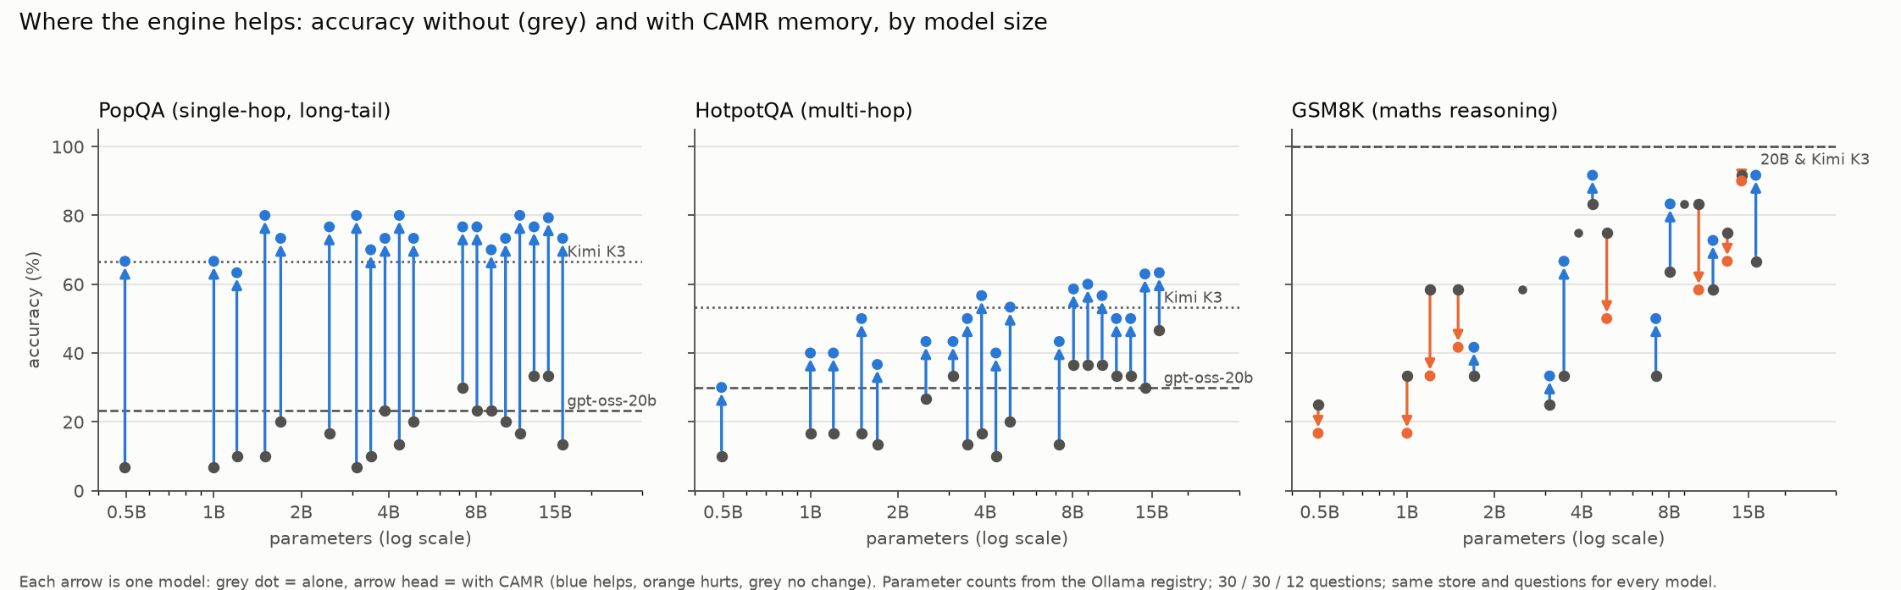
Figure 5.14: Accuracy without and with CAMR by model size, against the Kimi K3 ceiling
All 19 models gained on knowledge tasks: +43 to +73 points on PopQA and +10 to +40 on HotpotQA. With CAMR, 18 of 19 reached or beat Kimi K3 on long-tail facts; only llama3.2:1b (63.3%) fell short. Parametric knowledge barely grew with size: even the 12–15B models alone knew 13–33% of the long-tail facts, while every model from 1.5B upward reached 70–80% with memory. Multi-hop questions depended on the model as a reader. Seven of 19 reached Kimi K3's 53.3%: llama3.2:3b, gemma3:4b and five of the eight 7–15B models, with the best at 63% (qwen2.5:14b, gemma3:12b). Family mattered as much as size, since mistral:7b reached only 43.3%. Speed set the upper bound. On the 4-core CPU, every model of 7B or more with memory answered more slowly than Kimi K3 (8–24 s against 7.7 s on PopQA), so 1.5–4B is the range that suits the engine on this class of device: faster than the cloud model, at or above it on facts, and at it on multi-hop from about 3B. Worked-example memory for maths helped 8 models, was neutral for 4 and hurt 7, depending on family rather than size, so reasoning routing must be learned per model. A few runs on machine D had one to three queries fail with a runtime error; their accuracy is over the answered questions.

Confirmation at Larger Scale: 200 HotpotQA Questions
To test whether the pilot's multi-hop results held beyond 30 questions, the study was repeated on 200 HotpotQA questions with the read path fixed in advance (similarity, gating and bridging, 512 tokens). Nothing was tuned on these questions. Three small models and Kimi K3 were run with and without the same notes. 95% confidence intervals come from 2,000 bootstrap resamples of the questions.
Table 5.18: HotpotQA, n = 200: exact match, alone and with CAMR (results/hotpot200)
Model | Alone | With CAMR | Gain (95% CI) | s / answer with CAMR
qwen2.5:0.5b | 3.5% | 26.5% | +23.0 pts (+17.0 to +29.0) | 2.4
qwen2.5:1.5b | 10.5% | 41.0% | +30.5 pts (+23.0 to +38.0) | 2.8
llama3.2:3b | 19.5% | 54.0% | +34.5 pts (+27.0 to +42.0) | 5.8
Kimi K3 (cloud) | 51.8% | 66.3% | +14.6 pts (+9.0 to +20.6) | 9.5

The larger sample confirmed the pilot. Every small model gained substantially, and every 95% interval excludes zero. With CAMR, llama3.2:3b reached 54.0% exact match against Kimi K3's closed-book 51.8% (n = 199), and answered in 5.8 s against 18.4 s. On multi-hop questions, a 3B model on a laptop CPU with memory therefore matches a frontier cloud model at about a third of the answer time. qwen2.5:1.5b reached 41.0% and qwen2.5:0.5b 26.5%. The ordering by size is the pilot's finding that multi-hop gains depend on how well the model reads the evidence. With the same notes, Kimi K3 rose from 51.8% to 66.3%. The residual gap between the best small model and the frontier model reading the same evidence is the share of multi-hop performance that memory cannot buy. Compared with the pilot (30 questions: 30.0%, 50.0% and 56.7% for the three models with memory), the estimates moved by at most 9 points, within the pilot's uncertainty. Accuracy was identical when the 0.5B run was repeated for clean timings (26.5% both times).

Learning When to Use Memory and When to Escalate
A single fixed configuration cannot be best for every question. The learned policy chose an action per question from pre-answer features and was evaluated on the 72 held-out questions (Table 5.19, Figure 5.15).
Table 5.19: Engine policies on the held-out split (results/learn/tables/rl_policies.md, rl_cascade.md)
Policy | Accuracy | Sent to cloud | Mean s / answer
Always 0.5B alone | 13.9% | 0% | 1.1
Always 0.5B + 128 tokens | 41.7% | 0% | 1.2
Always 0.5B + 512 tokens | 45.8% | 0% | 2.2
Always Kimi K3 | 63.9% | 100% | 12.6
Learned router (ridge, cloud cost 0.3) | 61.1% | 16.7% | 2.2
Learned router (LinUCB, after 5 epochs) | 56.9% | 16.7% | 2.2
Router + grounding cascade | 65.3% | 29.2% | 3.1
Oracle (best action in hindsight) | 79.2% | 23.6% | 2.6

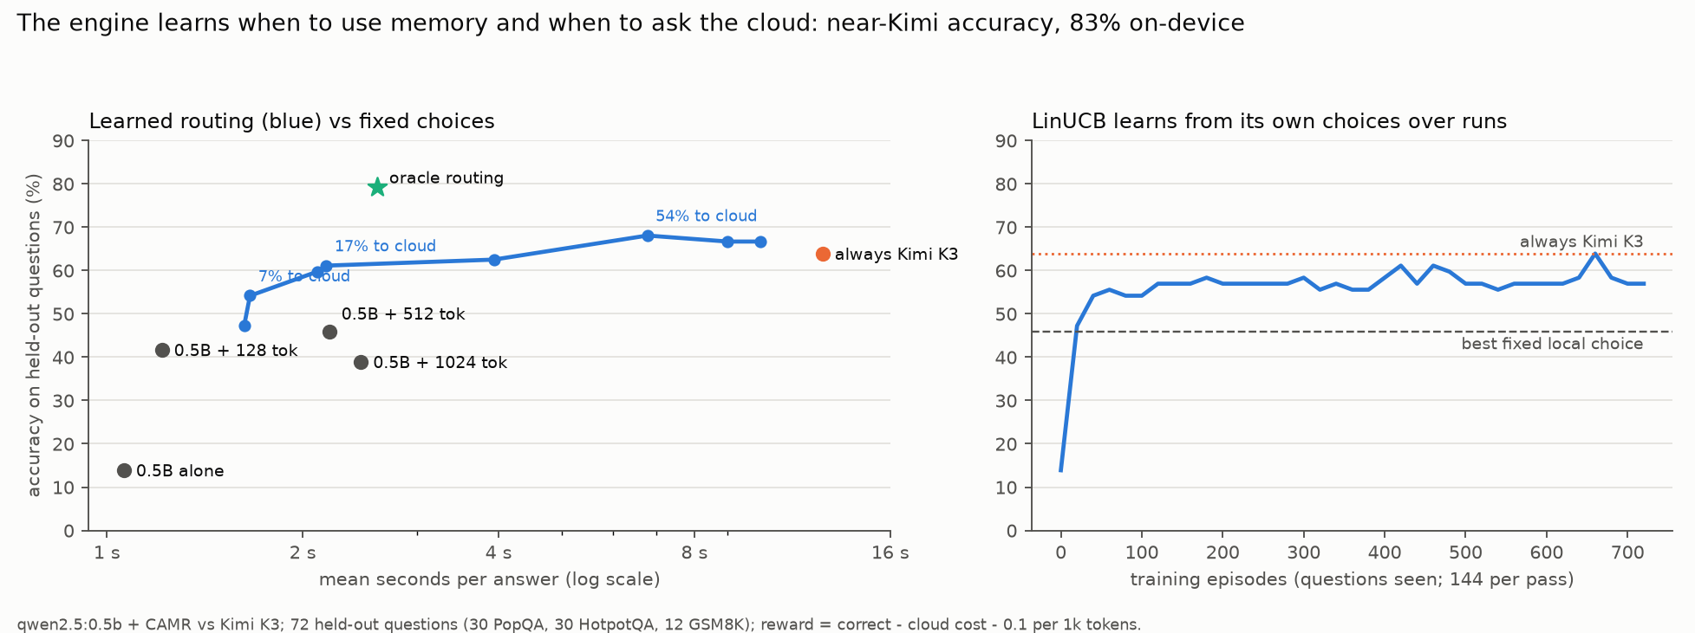
Figure 5.15: Learned routing compared with fixed choices, and the LinUCB learning curve over 5 epochs
The policy learned without supervision to send every reasoning question to the cloud (12 of 12, all correct) and to answer factual questions locally with a small budget. With the grounding cascade, which answers locally first and escalates when the answer's words are not found in its notes, the hybrid reached 65.3% against always-Kimi's 63.9%. 71% of questions never left the device, and mean latency was 4.0 times lower. LinUCB, which sees only the outcome of the action it chose, rose from 13.9% to 54.2% held-out accuracy within the first 40 episodes and then fluctuated between 54% and 64% over the five epochs. The gap to the oracle (79.2%) is mostly on multi-hop questions, where pre-answer features cannot predict whether the small model will read the evidence correctly.

Cost on the Device (Research Question v)
On machine A, median end-to-end latency was 188 ms for the 0.5B model alone and 375 ms with CAMR. The engine added a median of 187 ms and about 536 prompt tokens. Peak memory was 712 MB for the engine and 1987 MB for the model runtime, and the store file was 47.8 MB. NFR-02 was not met: retrieval was 56% of answer time against a 10% target. In isolation the engine's retrieval took 29 ms (embedding 21.5 ms, search 6.2 ms, bridging 1.2 ms, packing 0.4 ms). The rest was contention between the embedder and the model runtime for the same four cores. Partitioning the threads cut the p90 from 157 ms to 50 ms. Because a 0.5B model generates in about 180 ms, the 10% target is reachable only for models whose generation takes 450 ms or more, roughly 1.5B parameters and above on this CPU.
The large local alternative behaved worse on the same device. gpt-oss:20b decoded at about 6.3 tokens/s and needed 19.5–38 s per answer. When a 0.7 GB process ran beside it, it collapsed to 0.4–0.9 tokens/s as its memory-mapped weights were evicted. On a 16 GB device, a small model with external memory is the practical design, not merely the cheaper one.

From Desktop Assistant to Mobile: Progress
The deployment work progressed in three steps. (1) The engine was first exposed as a command (camr ask) over a user's own notes (Figure 5.7 and Figure 5.8). (2) It then became CAMR Personal, a desktop application released for six platforms (Table 5.11). (3) A mobile prototype for Android was then started, following the application case in docs/ANDROID_ASSISTANT.md: the same idea on the device people carry, a phone assistant that grows with its user.
Table 5.20: Android prototype: what exists and what has been verified
Component | Implementation | Status
Memory engine | Kotlin port of the read and write paths: SQLite store with float32 vectors, exact cosine search, gating, entity bridging, greedy token budget, chat as memory, 👍 learning | Compiles; 6 JVM unit tests pass, including token counting identical to the Python engine
Embedder | MediaPipe Text Embedder (Universal Sentence Encoder, 6 MB) bundled in the app | Builds; gating threshold for this embedder not yet calibrated
Language model | On-device MediaPipe/LiteRT model file chosen by the user (e.g. Gemma 3 1B, Qwen2.5 1.5B), or Ollama on the user's computer over Wi-Fi | Builds; not run
Interface | Jetpack Compose, same design language as the desktop app; chat, recall card, memory and settings screens; 'Share to CAMR' from any app | Builds; not run
Package | Release APK, arm64-v8a, 57 MB (Android 8.0+) | Built; not installed on a device

The prototype has not been run on a phone or emulator: the build environment had no virtualisation support. Its accuracy, speed, memory use and battery cost on real handsets are therefore unmeasured, and development was paused to concentrate on the desktop application. Measuring them is set out as future work in Chapter 6.

Limitations
i. Sample size. Pilot samples were 30/30/12 questions per benchmark. One question is 3.3 points, so differences of one or two questions are within noise. Confidence intervals are reported for gap closed. The multi-hop results were confirmed on 200 questions, and the retrieval study used 500 questions per benchmark; the single-hop and reasoning results rest on the pilot sample.
ii. Stochastic cloud ceiling. Kimi accepts only temperature 1, so its scores are single samples. Small-model floors also varied between repeats (20/30 identical answers), so floors are best read as a range.
iii. Oracle-like PopQA corpus. PopQA documents are the subject's own Wikipedia summary, which favours retrieval. HotpotQA, with eight distractors per question and extra distractor paragraphs, is the more realistic test.
iv. Benchmark questions are independent. Recency could not show a benefit. A sessioned benchmark (e.g. LongMemEval) would be needed to evaluate it fairly.
v. Write policy. Only verbatim notes were evaluated end to end. The structured policy is implemented and tested but was not run at scale.
vi. Hardware. All measurements are from CPU cloud containers of laptop class, not from a physical laptop or phone. Decode speeds differ between machines.
vii. No user study yet. The application was tested for correct and safe behaviour, not for usefulness or usability with real users, and the Android prototype has not run on a device.
viii. Policy learning. The learned policy was trained on 144 questions with costs set by the researcher. Its advantage over always-Kimi is 1.4 points, which is within sampling noise; the robust result is equal accuracy at 71% on-device use and lower latency.
Conclusions, recommendations and future work, including feedback from real users of CAMR Personal and a phone version of the assistant, are presented in Chapter 6.

