A Lightweight Memory Engine for Closing the Capability Gap Between Small On-Device and Large Language Models

Ibrahim Sudheys Ali

166344

ICS 4C

Supervisor Name
Tiberius Tabulu

An Informatics and Computer Science Project Proposal Submitted to the School of Computing and Engineering Sciences in Partial Fulfillment of the Requirements for the Award of a Degree in Bachelor of Science in Informatics and Computer Science

School of Computing and Engineering Sciences
Strathmore University
Nairobi, Kenya

June 2026

Declaration and Approval
I declare that this work has not been previously submitted and approved for the award of a degree by this or any other University. To the best of my knowledge and belief, the proposal contains no material previously published or written by another person except where due reference is made in the proposal itself.

Student Name: Ibrahim Sudheysi Ali
Admission Number: 166344

Student Signature: _________________________ Date: ________________________

The proposal of Ibrahim Sudheysi Ali has been reviewed and approved by Tiberius Tabulu, School of Computing and Engineering Sciences, Strathmore University.

Supervisor Signature: _________________________ Date: ________________________

Abstract

Table of Contents
Declaration and Approval ii
Abstract iii
Table of Contents iv
List of Figures vi
List of Tables vii
List of Equations viii
List of Abbreviations ix
Chapter 1: Introduction 1
1.1 Background Information 1
1.2 Problem Statement 2
1.3 Objectives 2
1.3.1 General Objective 2
1.3.2 Specific Objectives 2
1.4 Research Questions 3
1.5 Justification 3
1.6 Scope 4
1.7 Limitations and Delimitations 4
Chapter 2: Literature Review 5
2.1 Introduction 5
2.2 The State of On-Device Language Models and External Memory 5
2.2.1 The rise of on-device models 5
2.2.2 What the capability gap is made of 5
2.2.3 Retrieval as a substitute for scale 6
2.2.4 Compressing what the model reads 6
2.2.5 Evaluation and risks of persistent memory 6
2.3 Related Works 7
2.3.1 MemGPT 7
2.3.2 Generative Agents 8
2.3.3 MemoryBank 9
2.3.4 HippoRAG 9
2.3.5 Mem0 10
2.4 Gaps in Related Works 11
2.5 Conceptual Framework 12
Chapter 3: Methodology 13
3.1 Introduction 13
3.2 Research Paradigm 13
3.2.1 Data acquisition 13
3.2.2 Data preparation 13
3.2.3 Experimental conditions 14
3.2.4 Measurement and validation 14
3.3 Development Approach 14
3.4 System Analysis 15
3.4.1 Functional requirements 15
3.4.2 Non-functional requirements 15
3.5 System Design 15
3.5.1 Architectural overview 16
3.5.2 Experimental design 16
3.5.3 Datasets and task types 17
3.5.4 Evaluation metrics 17
3.5.5 Ablation procedure 18
3.5.6 Threats to validity 18
3.6 Tools and Techniques 18
3.6.1 Python 18
3.6.2 Ollama and local models 19
3.6.3 Hosted inference API 19
3.6.4 Embedding model 19
3.6.5 SQLite with vector search 19
3.6.6 Auxiliary tools 19
3.7 Deliverables 19
3.7.1 The CAMR memory engine 19
3.7.2 The evaluation harness 19
3.7.3 Experimental results 20
3.7.4 System documentation 20
3.8 Ethical Considerations 20
References 21

List of Figures
Figure 2.1: The MemGPT virtual context architecture, adapted from Packer et al. (2023). 8
Figure 2.2: The Smallville environment of Generative Agents (Source: Park et al., 2023, project repository). 8
Figure 2.3: The MemoryBank framework with memory updating and forgetting (Source: Zhong et al., 2024, project repository). 9
Figure 2.4: HippoRAG offline indexing and online retrieval (Source: Gutierrez et al., 2024, project repository). 10
Figure 2.5: The Mem0 memory layer within an agent stack (Source: Mem0 project documentation). 10
Figure 2.6: Conceptual framework of the study. 12

List of Tables
Table 2.1: Comparison of representative memory systems for language models 11
Table 3.1: Experimental conditions 16
Table 3.2: Evaluation datasets and the task type each represents 17

List of Equations
Equation 3.1: Fraction of the capability gap closed. 16

List of Abbreviations
AI - Artificial Intelligence
ANN - Approximate Nearest Neighbour
API - Application Programming Interface
CAMR - Capability-Adaptive Memory Retrieval
CPU - Central Processing Unit
DSR - Design Science Research
EM - Exact Match
GPU - Graphics Processing Unit
JSON - JavaScript Object Notation
KG - Knowledge Graph
LLM - Large Language Model
PPR - Personalized PageRank
QA - Question Answering
RAG - Retrieval-Augmented Generation
RAM - Random Access Memory
SLM - Small Language Model
SQL - Structured Query Language

Chapter 1: Introduction

1.1 Background Information
Language models have become the foundation of modern conversational software, powering assistants that answer questions, summarise documents, and help with everyday tasks. The most capable of these models contain tens or hundreds of billions of parameters and run as cloud services on specialised hardware. Their capability comes at a cost: every query travels over a network, personal data leaves the user's device, the service fails without connectivity, and each request carries a price. Empirical work on scaling has shown that capability grows predictably with model size and training data (Kaplan et al., 2020), which is precisely why the strongest models are also the largest and the least practical to run locally.
A parallel movement has formed around small language models, typically between one and three billion parameters, that run directly on consumer hardware such as laptops and phones. Recent small models such as Qwen2.5 (A. Yang et al., 2024), Llama 3.2 (Grattafiori et al., 2024), Phi-3 (Abdin et al., 2024), and the on-device foundation models that Apple now ships on its consumer chips (Gunter et al., 2024) demonstrate that useful language ability fits comfortably in the memory of an ordinary computer. On-device deployment offers real advantages: answers are generated locally with low latency, private data never leaves the machine, the assistant keeps working offline, and the marginal cost of a query is zero. A recent survey of the field confirms both the rapid progress of small models and their persistent weaknesses relative to their larger counterparts (Lu et al., 2024).
The most consistent of those weaknesses is factual knowledge. A small model simply has not memorised as many facts as a large one. Mallen et al. (2023) showed this directly: language models struggle with less popular, long-tail factual knowledge, retrieval of external text helps significantly in exactly those cases, and making models bigger mainly improves recall of popular facts while barely improving the long tail. This finding suggests a practical opportunity. If much of the gap between small and large models is missing knowledge rather than missing reasoning ability, then supplying the right knowledge at the right time, from outside the model, might recover a meaningful share of the gap without touching the model at all.
This study proposes and evaluates CAMR (Capability-Adaptive Memory Retrieval), a lightweight memory engine that sits beside a frozen small language model on a consumer laptop. The engine records short, structured notes from past interactions, retrieves the most relevant ones when a new question arrives, and packs them into a fixed token budget for the model to read. The model's weights are never changed. The study then measures, separately for different kinds of questions, how much of the gap between a small on-device model and a large cloud model this memory closes, and at what cost in tokens and time.

1.2 Problem Statement
Users who want a private, offline, low-cost assistant must accept a small on-device model, and with it a marked drop in capability, most visibly on questions that require factual knowledge the small model has not memorised. The two standard remedies do not fit the on-device setting. Replacing the small model with a larger one defeats the purpose, because the larger model no longer fits on the device. Fine-tuning the small model on new knowledge requires compute that ordinary users do not have, must be repeated whenever knowledge changes, and risks degrading the model's existing abilities.
Retrieval-augmented approaches offer a third path: leave the model frozen and supply relevant text at question time. The research literature has established the ingredients separately. Retrieval can substitute for model scale on knowledge-heavy tasks (Lewis et al., 2020; Borgeaud et al., 2022; Izacard et al., 2023). Memory systems can accumulate and organise information across long interactions (Packer et al., 2023; Zhong et al., 2024; Gutierrez et al., 2024). Prompts can be compressed so that less text carries the same meaning (Jiang et al., 2023). What no existing work provides is a measured answer to the question that matters for on-device deployment: when these ingredients are combined into a memory engine beside a frozen small model on a real consumer device, what fraction of the small-versus-large capability gap is actually recovered, on which kinds of tasks, and at what cost in tokens and latency? Without that answer, designers of on-device assistants cannot know whether memory engineering is a worthwhile substitute for model scale, or where its limits lie.

1.3 Objectives
This section states the general objective of the study and breaks it down into the specific objectives that will guide the work.

1.3.1 General Objective
The general objective of this study is to design, implement, and experimentally evaluate a lightweight memory engine for a frozen small language model on a consumer laptop, in order to quantify how much of the capability gap between small on-device and large cloud language models such a memory engine can close, by task type, under explicit token and latency accounting.

1.3.2 Specific Objectives
- To investigate existing memory, retrieval, and compression techniques for language models and establish their applicability and limitations in the on-device setting.
- To design a lightweight memory engine for a frozen small language model, comprising a write policy that distils interactions into compact stored notes, a retrieval policy that ranks notes by similarity, recency, and importance, and a token budgeting mechanism that controls how much memory the model reads.
- To implement the designed memory engine on a consumer laptop with no dedicated graphics hardware, using an embedded database as the memory store.
- To evaluate the implemented engine experimentally by measuring the fraction of the capability gap between a small local model and a large cloud model that the engine closes, separately for knowledge-bound and reasoning-bound tasks, together with the token cost and latency of every answer.
- To analyse the contribution of each component of the engine through controlled ablation experiments, so that the value of every design decision is individually measured.

1.4 Research Questions
The study seeks to answer the following research questions:
- What memory, retrieval, and compression techniques exist for language models, and what are their limitations in the on-device setting?
- How much of the capability gap between a small on-device language model and a large cloud language model can a frozen-weights memory engine close?
- Does the memory engine help more on knowledge-bound questions than on reasoning-bound questions?
- What does each component of the memory engine contribute to the gap closed, and what does the engine cost in tokens and latency on a consumer laptop?

1.5 Justification
The study matters for three audiences. For users, especially in settings where connectivity is unreliable or data privacy is a serious concern, a more capable on-device assistant means useful AI that works offline, keeps personal data local, and costs nothing per query. For developers of on-device assistants, the study provides what the literature currently lacks: a measured, component-by-component account of how far memory engineering can substitute for model scale, allowing informed decisions about where to invest effort. For the research community, the study contributes an evaluation method, the gap-closed measure reported per task type with honest token and latency accounting on consumer hardware, that future memory systems can be compared against.
The study is also deliberately scoped to be feasible as a final-year undergraduate project. The language models themselves are reused, not trained, so the original work lies in the design of the engine and the design of the measurement, both of which are achievable on a single consumer laptop with modest API credits for the large reference model.

1.6 Scope
The deployment target is a consumer laptop with no dedicated graphics card and 16 gigabytes of shared memory; this machine is itself the on-device platform on which the engine runs and on which all latency is measured. The small models studied are open-weight models in the one-to-three billion parameter range that run locally on the target machine. The large reference model is accessed through a cloud API and never runs locally; it serves only as the upper anchor against which the gap is measured. Evaluation uses established public question-answering benchmarks in English, covering single-hop factual questions, multi-hop factual questions, and mathematical reasoning questions, so that knowledge-bound and reasoning-bound performance can be separated. The system delivered is the memory engine and its evaluation harness, not an end-user application.

1.7 Limitations and Delimitations
The limitations of the study are the constraints it operates under. Latency measured on one consumer laptop may differ on other hardware, so device results are indicative rather than universal. The large reference model is a commercial service whose exact behaviour can change between versions, which the study mitigates by pinning one model version throughout. Benchmark questions, however well established, are an approximation of real assistant usage, and findings generalise to live deployments only to the degree that the benchmarks represent them.
The delimitations are boundaries the study deliberately draws. The study will not train or fine-tune any language model; all weights remain frozen throughout, since the research question is precisely what memory achieves without touching the model. The study will not port the engine to mobile phones; the laptop target preserves the on-device claim while avoiding mobile toolchain work that adds engineering effort without research value. A graph-based associative retrieval layer in the style of Gutierrez et al. (2024) is treated as an optional extension to be tested only if the core experiments complete ahead of schedule, because its computational weight is poorly suited to the device budget and its contribution can be measured as one further ablation if time allows. Finally, the study is limited to English-language benchmarks and text-only interaction; multilingual and multimodal memory are left to future work.

Chapter 2: Literature Review

2.1 Introduction
This chapter reviews the research that the study builds on. It first surveys the current state of the field: the divide between small and large language models, the evidence on what the capability gap consists of, retrieval as a substitute for scale, the compression of what a model reads, the benchmarks that evaluate memory in long interaction, and the security risks of persistent memory. It then examines specific related systems that implement memory for language models, identifies the gaps those systems leave, and closes with the conceptual framework that guides the study.

2.2 The State of On-Device Language Models and External Memory
This section reviews the current state of the field: the rise of small on-device models, the composition of the capability gap, retrieval as a substitute for model scale, the compression of model inputs, and the evaluation and security of persistent memory.

2.2.1 The rise of on-device models
Scaling studies established that language model capability grows smoothly with parameter count and training data (Kaplan et al., 2020), which drove the field toward ever larger models served from the cloud. A counter-movement followed. Model families such as Qwen2.5 (A. Yang et al., 2024), Llama 3.2 (Grattafiori et al., 2024), Phi-3 (Abdin et al., 2024), and Gemma 2 (Gemma Team, 2024) now publish strong open-weight models at one to three billion parameters, small enough to run in a few gigabytes of memory on an ordinary laptop. Apple has gone further and ships a roughly three billion parameter foundation model directly on its consumer devices, with a larger server model handling requests that exceed the on-device model's ability (Gunter et al., 2024). A survey by Lu et al. (2024) documents both the speed of this progress and the consistent finding that small models remain clearly weaker than large ones, particularly on knowledge-intensive tasks.

2.2.2 What the capability gap is made of
The most important evidence for this study concerns the composition of the gap. Mallen et al. (2023) probed language models of many sizes on factual questions whose subjects ranged from very popular to very obscure, using a dataset they constructed for the purpose, PopQA. Three findings stand out. First, models of every size struggle on long-tail facts, and small models fail on them severely. Second, supplying retrieved text helps substantially on exactly those questions. Third, and most strikingly, scaling the model up mainly improves recall of popular facts and barely improves the long tail at all. In other words, a large part of what users buy with model scale is memorised knowledge, and memorised knowledge is the one ingredient that can also be supplied from outside the model. Reasoning ability, by contrast, appears to be more deeply tied to scale, which is why this study treats knowledge-bound and reasoning-bound tasks separately and predicts different outcomes for each.

2.2.3 Retrieval as a substitute for scale
A line of research spanning several years has demonstrated that letting a model read relevant external text at answer time can substitute for parameters. Retrieval-augmented generation showed that a model paired with a dense retriever over a document store outperforms much larger purely parametric models on knowledge-intensive tasks (Lewis et al., 2020), building on dense passage retrieval techniques that find relevant text by comparing embedding vectors rather than keywords (Karpukhin et al., 2020). Borgeaud et al. (2022) made the substitution explicit: their RETRO model, augmented with retrieval from a trillion-token database, matched the performance of models with twenty-five times more parameters on language modelling benchmarks. Izacard et al. (2023) showed with Atlas that a retrieval-augmented model of eleven billion parameters could outperform a model fifty times its size on knowledge tasks. Together these results establish the premise this study depends on: parameters spent on memorising facts can, to a substantial degree, be replaced by retrieval, and the saving is largest precisely where small models are weakest. What these systems do not address is the on-device setting, where the retrieval corpus, the index, and the model must all fit on a consumer machine and every token read costs measurable time.

2.2.4 Compressing what the model reads
Every token a model reads costs time on a device, so the density of stored memory matters as much as its relevance. Research on prompt compression has shown that the text supplied to a model carries substantial redundancy. Jiang et al. (2023) demonstrated with LLMLingua that prompts can be compressed many times over, by removing low-information tokens, with little loss in the quality of the model's output. A complementary line compresses context into learned representations: Chevalier et al. (2023) taught models to summarise long contexts into compact vectors that stand in for the original text, and Ge et al. (2024) trained an in-context autoencoder that condenses a context window into a short sequence of memory slots. The lesson this study takes is that memory should be stored densely, as short structured notes rather than verbatim transcripts, so that a fixed token budget carries the maximum useful information. Compression has so far been applied to prompts and contexts at inference time, not to the design of a persistent memory store, and never with the question of how compression interacts with capability gap closing on a device.

2.2.5 Evaluation and risks of persistent memory
Benchmarks for conversational memory have matured recently and inform this study's evaluation design. Maharana et al. (2024) introduced LoCoMo, a benchmark of very long multi-session conversations, and found that models, even with long context windows or retrieval, lag far behind human recall of conversation history. Wu et al. (2024) introduced LongMemEval, five hundred questions embedded in long user-assistant histories testing information extraction, multi-session reasoning, temporal reasoning, knowledge updates, and abstention, and found that commercial assistants suffer accuracy drops of around thirty percent when information must be remembered across sustained interaction. They also decompose memory design into indexing, retrieval, and reading stages, a decomposition the proposed engine mirrors in its write path, retrieval policy, and token budgeting. These benchmarks establish that memory in long interaction is an unsolved problem even for large cloud systems; neither, however, measures memory as an instrument for closing the small-versus-large capability gap, which is this study's concern.
A memory store that accepts writes from interaction is also an attack surface, and recent security research documents the risk concretely. Chen et al. (2024) showed with AgentPoison that an agent's long-term memory or retrieval store can be poisoned with a small number of crafted records so that queries containing an optimised trigger retrieve the malicious records and steer the agent's behaviour, with benign queries left untouched. Dong et al. (2025) went further with MINJA, demonstrating that an attacker with ordinary query access, and no privileged write access at all, can inject malicious records into an agent's memory purely through crafted interactions. These findings motivate two design choices in the proposed engine: every stored note carries provenance metadata recording where it came from, and the write path includes a screening step before anything is committed to the store. A full security evaluation is beyond the study's scope, but designing the store so that such an evaluation is possible later costs little and reflects sound practice.

2.3 Related Works
This section examines specific systems that implement memory for language models, from operating-system inspired context management to brain-inspired associative retrieval and production memory layers. Table 2.1 summarises the comparison.

2.3.1 MemGPT
Packer et al. (2023) framed the memory problem in operating-system terms. The model's limited context window is treated as fast main memory, an external store as disk, and the system pages information in and out as the conversation demands, allowing a fixed-context model to sustain interactions far longer than its window. The framing is influential because it makes explicit that what the model reads at each step is a policy decision, not a given, which is exactly the decision this study's token budgeting mechanism controls. MemGPT manages context length, however; it does not target capability gain, and it does not account for token cost or device latency. Figure 2.1 illustrates the two-tier architecture.
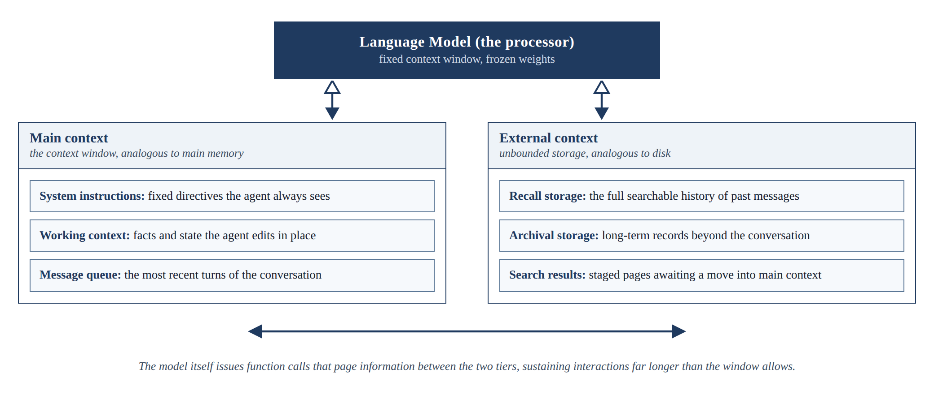
Figure 2.1: The MemGPT virtual context architecture, adapted from Packer et al. (2023).

2.3.2 Generative Agents
Park et al. (2023) gave simulated agents a memory stream of timestamped observations and retrieved from it by combining three scores: relevance to the current situation, recency, and importance. Their generative agents produced believable long-running behaviour in a simulated town, and their three-part retrieval score is adopted directly by this study's retrieval policy. The system was designed for simulation rather than question answering, and its memory records are verbose natural-language entries, which makes it an instructive design source but not an answer to the efficiency questions a device imposes. Figure 2.2 shows the simulated town in which the agents live, work, and remember.
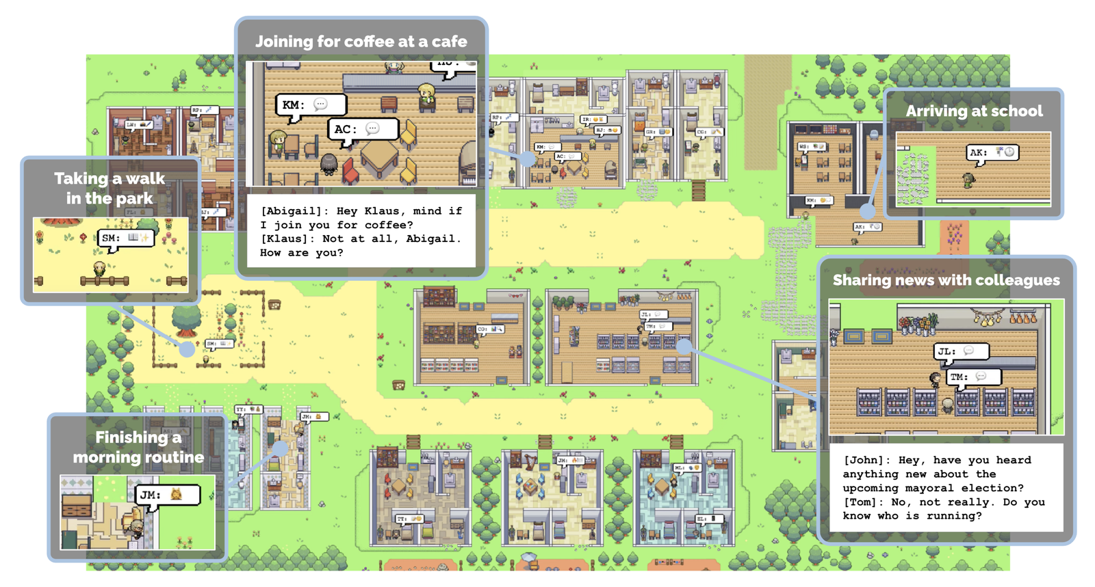
Figure 2.2: The Smallville environment of Generative Agents (Source: Park et al., 2023, project repository).

2.3.3 MemoryBank
Zhong et al. (2024) added a model of forgetting. MemoryBank strengthens or decays stored memories over time in the spirit of the Ebbinghaus forgetting curve, so that what the system retains reflects both how often a memory is used and how old it is. The contribution is a principled answer to what should be kept, complementing the question of what should be retrieved. Like the systems above, MemoryBank is evaluated on the quality of long-term companionship behaviour rather than on capability gain, token cost, or latency. Figure 2.3 reproduces the framework figure from the project's repository, showing the memory bank, the forgetting curve, and retrieval into conversation.
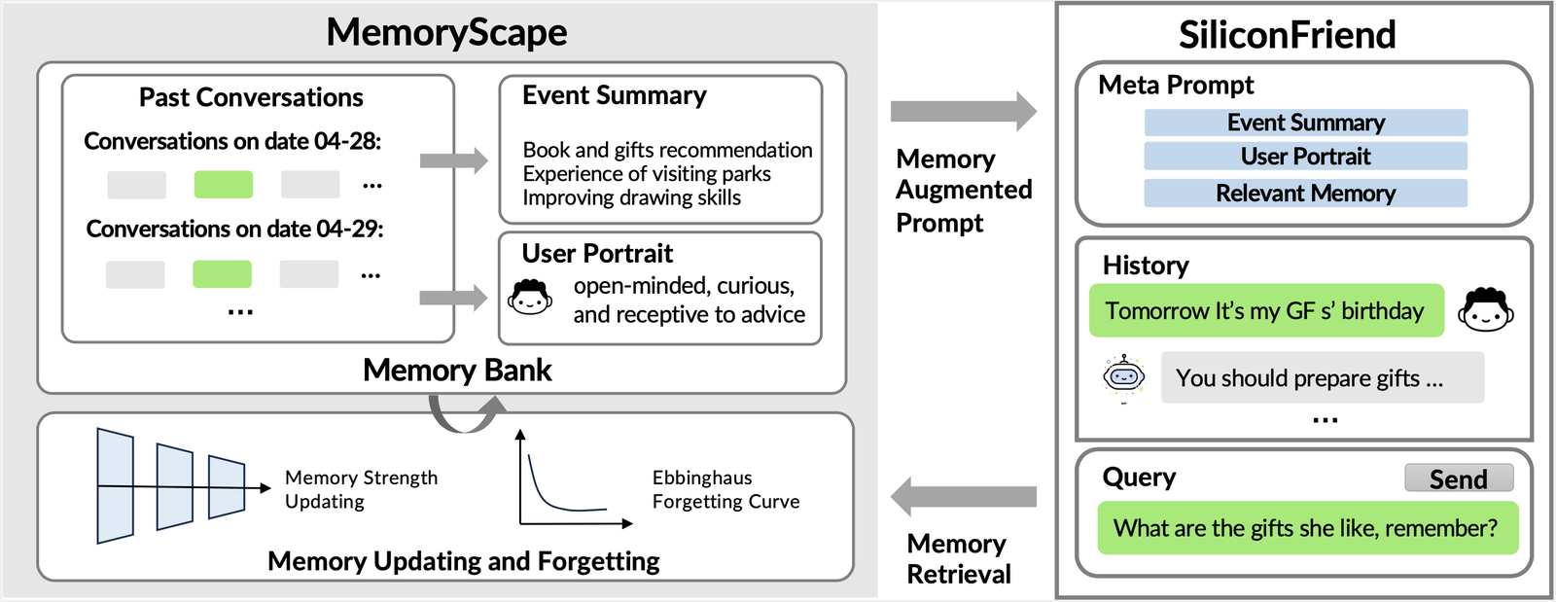
Figure 2.3: The MemoryBank framework with memory updating and forgetting (Source: Zhong et al., 2024, project repository).

2.3.4 HippoRAG
Plain similarity search retrieves passages that resemble the question, but some questions require connecting facts that do not resemble the question at all. Cognitive science offers a model for this in spreading activation, where recalling one concept activates linked concepts (Collins & Loftus, 1975), and in the hippocampal indexing theory, where a compact index links the distributed traces of an experience so that touching one part can reactivate the whole (Teyler & DiScenna, 1986). Gutierrez et al. (2024) operationalised these ideas in HippoRAG: a language model extracts entities from stored passages into a knowledge graph that acts as the index, and at question time the entities in the query seed a Personalized PageRank walk over the graph, spreading relevance to connected passages, including multi-hop neighbours that similarity search misses. Figure 2.4, reproduced from the project's repository, illustrates the pipeline. HippoRAG outperformed strong retrieval baselines on multi-hop question answering by up to twenty percent while being many times cheaper and faster than iterative retrieval methods. Its relevance to this study is twofold: it demonstrates the value of associative structure in memory, and its computational profile, graph construction by a language model and a graph walk per query, illustrates exactly the kind of cost that must be justified against a device budget, which is why this study treats the associative layer as a measured optional extension rather than a core component.
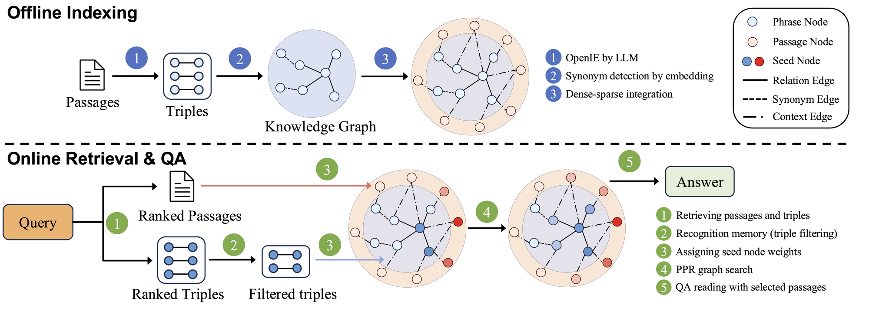
Figure 2.4: HippoRAG offline indexing and online retrieval (Source: Gutierrez et al., 2024, project repository).

2.3.5 Mem0
Production systems have begun packaging these ideas. Mem0 extracts and consolidates salient facts from conversations into a managed store and reports large token savings relative to feeding a model its full history (Chhikara et al., 2025). Its existence is evidence that the engineering direction is commercially credible. As a cloud service, however, it does not answer the on-device question, and like the research systems it does not measure gap closing per task type. Figure 2.5, drawn from the project's documentation, shows where the memory layer sits in an agent stack, reading at question time and writing after each response.
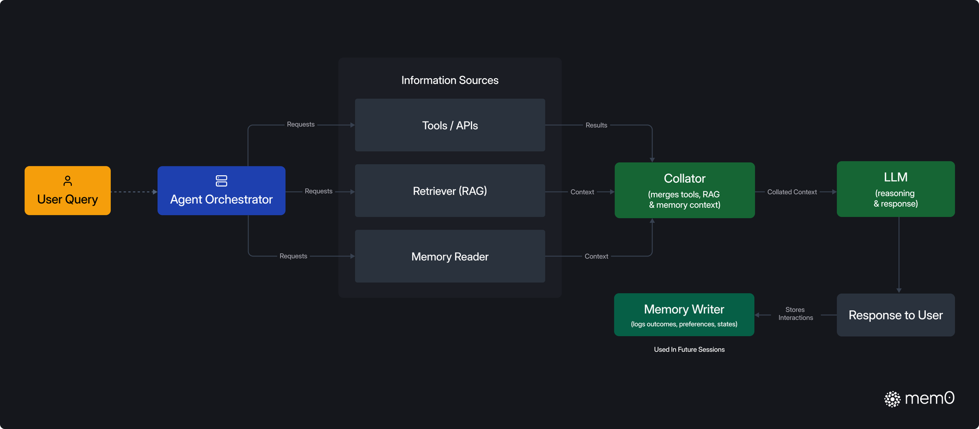
Figure 2.5: The Mem0 memory layer within an agent stack (Source: Mem0 project documentation).
Table 2.1: Comparison of representative memory systems for language models
System | Core idea | Strength | Limitation for the on-device setting
MemGPT (Packer et al., 2023) | Pages context in and out of the window like an operating system | Sustains very long interactions on a fixed window | Manages context length; does not target capability gain or token cost
Generative Agents (Park et al., 2023) | Memory stream scored by relevance, recency, and importance | Simple, effective retrieval scoring | Designed for simulation; verbose natural-language records
MemoryBank (Zhong et al., 2024) | Memory strengthening and decay over time | Principled forgetting | No accounting of token cost or device latency
HippoRAG (Gutierrez et al., 2024) | Knowledge-graph index with Personalized PageRank retrieval | Strong multi-hop recall in a single retrieval step | Graph construction and walk are heavy for a device budget
Mem0 (Chhikara et al., 2025) | Extraction and consolidation of salient facts into a managed store | Production-ready; large token savings reported | Cloud service; gap-closing per task type not measured

2.4 Gaps in Related Works
The reviewed literature establishes each ingredient separately. Retrieval can substitute for model scale on knowledge-heavy tasks (Lewis et al., 2020; Borgeaud et al., 2022; Izacard et al., 2023), and it helps most on exactly the long-tail knowledge where small models fail (Mallen et al., 2023). Memory systems can accumulate, organise, score, and forget information across long interactions (Packer et al., 2023; Park et al., 2023; Zhong et al., 2024; Gutierrez et al., 2024; Chhikara et al., 2025). Text supplied to a model can be heavily compressed with little loss (Jiang et al., 2023; Chevalier et al., 2023; Ge et al., 2024). Benchmarks exist that expose how poorly current systems remember long interactions (Maharana et al., 2024; Wu et al., 2024).
What is missing is the combination and the measurement. No existing work assembles these ingredients into a memory engine beside a frozen small model on a consumer device and then answers the deployment question directly: what fraction of the small-versus-large capability gap does the engine close, separately for knowledge-bound and reasoning-bound tasks, and at what cost in tokens and milliseconds on the device? Existing memory systems are evaluated on recall or task success, not on gap closing; compression is evaluated on prompts, not on persistent stores; and no study reports honest per-component cost accounting on consumer hardware. This intersection, gap closing by task type under explicit token and latency budgets on a device, defines the gap this study addresses.

2.5 Conceptual Framework
Figure 2.6 presents the conceptual framework that structures the study. The independent variable is the configuration of the memory engine: the write policy that turns interactions into stored notes, the retrieval policy that ranks notes by similarity, recency, and importance, and the token budget that limits how much memory the model reads. The process is question answering on the device: the engine recalls relevant notes, assembles them within the budget, and the frozen small model generates an answer from the question plus the assembled memory. The dependent variables are the fraction of the small-versus-large capability gap closed, the accuracy gained per token of memory supplied, and the end-to-end latency on the target device. Task type, knowledge-bound versus reasoning-bound, moderates the relationship: the study predicts substantial gap closing on knowledge-bound questions and little on reasoning-bound questions. The language model itself is held constant throughout, weights frozen, so that every measured gain is attributable to the memory engine alone.
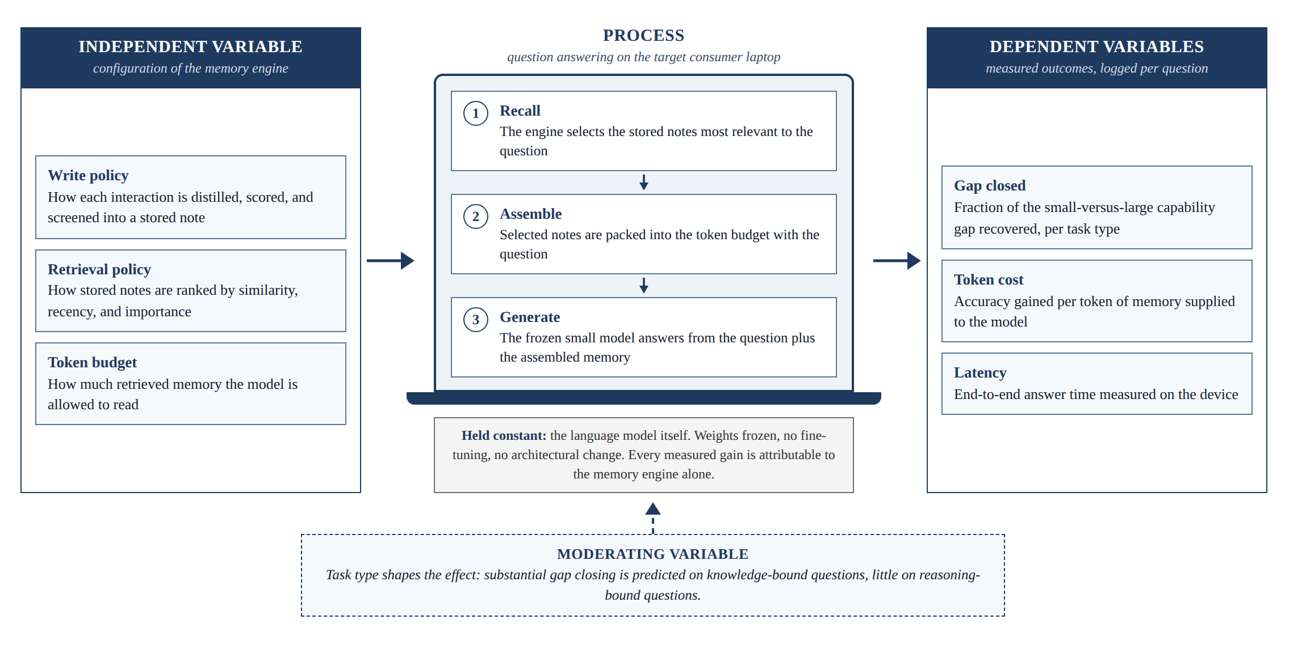
Figure 2.6: Conceptual framework of the study.

Chapter 3: Methodology

3.1 Introduction
This chapter describes how the study will be carried out. It states the research paradigm that will guide the work, the development approach that will be followed, the analysis of what the system must do, the design of both the system and the experiments that will evaluate it, the tools and techniques that will be used, and the deliverables the study will produce. Throughout the chapter, the guiding principle is that the measurement apparatus will be built and validated before the system it measures, so that every subsequent design decision can be evaluated as a controlled experiment.

3.2 Research Paradigm
The study will adopt a pragmatist research philosophy, combining design science research with controlled experimentation. Design science research is appropriate because the study will create and evaluate a novel artefact, the memory engine, and the discipline's guidelines require that such an artefact be evaluated rigorously against explicit measures of utility (Hevner et al., 2004). The study will follow the design science research methodology of Peffers et al. (2007), proceeding through problem identification, definition of solution objectives, design and development, demonstration, evaluation, and communication. The evaluation will take the form of controlled experiments organised as a research pipeline of four stages, described in the subsections that follow.

3.2.1 Data acquisition
Evaluation data will be acquired from four established public benchmarks, chosen so that knowledge-bound and reasoning-bound performance can be separated: PopQA for single-hop long-tail factual questions (Mallen et al., 2023), HotpotQA and 2WikiMultiHopQA for multi-hop factual questions (Z. Yang et al., 2018; Ho et al., 2020), and GSM8K for mathematical reasoning questions (Cobbe et al., 2021). The supporting document collections that accompany the factual benchmarks will also be acquired, since they will populate the memory store. All datasets are released for research use and will be downloaded from their official distributions.

3.2.2 Data preparation
From each benchmark, a fixed random sample of questions will be drawn once, with a fixed random seed, and reused across all conditions and ablations so that every comparison is paired. The memory store will be populated from the supporting document collections only, never from the question-answer pairs themselves, so that the experiment measures the engine's ability to surface relevant knowledge rather than its ability to look up a planted answer. Where a benchmark provides distractor documents, they will be included in the store, so that retrieval must discriminate, not merely fetch. Supporting documents will be processed through the engine's write path into stored notes before any evaluation begins.

3.2.3 Experimental conditions
Three conditions will be run on every evaluation question: a floor condition in which the small local model answers alone, a ceiling condition in which the large cloud reference model answers alone, and a treatment condition in which the small local model answers with the memory engine. The full design of these conditions, including the configurations the treatment will be varied over, is given in section 3.5.2.

3.2.4 Measurement and validation
Every query in every condition will log the model used, the engine configuration, the tokens supplied and generated, the wall-clock latency, and the resulting answer, so that every experiment is reproducible from its logs. Answer quality will be scored with each benchmark's standard metrics, and the central quantity of the study, the fraction of the capability gap closed, will be computed from the three conditions as defined in section 3.5.2. Validity will be protected by the paired design, bootstrap confidence intervals, repeated timing runs, and the threat mitigations described in section 3.5.6.

3.3 Development Approach
The system will be developed incrementally, in small working stages, each of which will be evaluated before the next is begun. An incremental approach suits this study for two reasons. First, the central research instrument, the evaluation harness, must exist before the engine, because every component of the engine will be judged by the harness's measurements; building measurement first removes the largest project risk, which is discovering late that results cannot be produced. Second, the engine itself is designed as a chain of separable components, and adding them one at a time turns development into the ablation study that the fifth specific objective requires.
Development will proceed in four increments. The first increment will build the evaluation harness: the benchmark loaders, the floor and ceiling model runners, the answer scorers, and the logging of tokens and latency for every query, validated by producing a baseline gap measurement with no memory engine at all. The second increment will add the simplest complete treatment: notes stored with embeddings, retrieval by similarity alone, and packing into a token budget, establishing the control condition against which richer policies are compared. The third increment will add the remaining components one at a time, each producing a new measured row: structured compressed notes in place of verbatim text, recency and importance scoring in the retrieval policy, and write-time screening with provenance. The fourth increment will profile the complete engine on the target device, measuring end-to-end latency, memory footprint, and tokens per query under realistic store sizes. If, and only if, these increments complete ahead of schedule, an optional fifth increment will add a graph-based associative retrieval layer as one further ablation.

3.4 System Analysis
This section analyses what the system must do before describing how it will be designed. The analysis will be conducted by studying the requirements that the research questions impose on the system, since in this study the primary stakeholder is the experiment itself: every requirement traces to a measurement the study must be able to make.

3.4.1 Functional requirements
The system will be required to do the following. It will record a short structured note from each completed interaction, capturing the salient content, a timestamp, an importance score, and provenance describing the note's origin. It will screen each candidate note before storage and reject notes that fail validation. It will store notes durably in an embedded database on the device, together with an embedding vector for each note. Given an incoming question, it will retrieve candidate notes and rank them by a combination of semantic similarity to the question, recency, and importance. It will assemble the highest-ranked notes into a context that fits a configurable token budget and supply that context, with the question, to the local language model. It will log, for every answered question, the model used, the configuration of the engine, the number of tokens supplied and generated, the wall-clock latency of retrieval and of generation, and the resulting answer, so that every experiment is reproducible from its logs.

3.4.2 Non-functional requirements
The system will be required to meet the following constraints. It will run entirely on the target consumer laptop, a machine with no dedicated graphics card and sixteen gigabytes of shared memory, with the sole exception of the large reference model, which is accessed through a cloud API and is not part of the engine. Retrieval will be required to add no more than a small fraction of total answer latency, so that the engine's overhead never dominates generation time. The memory store will be a single local file requiring no server process, reflecting the realities of on-device deployment. All stored data will remain on the device, and the engine will function without network connectivity in every configuration except the ceiling measurement. Finally, the entire experimental pipeline will be runnable end to end from a single command, so that results can be regenerated and verified.

3.5 System Design
This section describes the design of the memory engine and, with equal weight, the design of the experiments that will evaluate it. The two are presented together because the engine's components are defined by the measurements that will justify them.

3.5.1 Architectural overview
The engine will consist of three parts arranged around a frozen local language model. The write path will run after each interaction: a summarisation step will distil the interaction into a short structured note containing the salient facts, the note will receive a timestamp and an importance score, a screening step will validate the note and attach provenance, and the note will then be embedded and committed to the store. The store will be a single embedded relational database holding the notes, their embeddings, and their metadata; vector similarity search will be provided by an extension to the database rather than a separate index server, keeping the whole store in one local file. The read path will run when a question arrives: the question will be embedded, candidate notes will be retrieved by vector similarity, each candidate will be scored by a weighted combination of similarity, recency, and importance in the manner of Park et al. (2023), and the top-scoring notes will be packed in rank order into the configured token budget. The assembled context and the question will then be supplied to the frozen model, whose weights and inference machinery remain untouched in every configuration.

3.5.2 Experimental design
The central quantity of the study is the fraction of the capability gap closed, and the experiment will be designed around measuring it cleanly. Three conditions will be run on every evaluation question. The floor condition will be the small local model answering alone, with no memory. The ceiling condition will be the large cloud reference model answering alone. The treatment condition will be the small local model answering with the memory engine. For each task type, the gap closed will be computed as shown in Equation 3.1, where S denotes the accuracy score of a condition on that task type.
Gap closed = (S treatment − S floor) / (S ceiling − S floor)
Equation 3.1: Fraction of the capability gap closed.
A value of zero means the engine added nothing and a value of one means the small model with memory matched the large model. Alongside accuracy, every query in every condition will log the tokens supplied to the model, the tokens generated, and the wall-clock latency, so that accuracy per token and accuracy per second can be reported, not just accuracy. Table 3.1 summarises the conditions.
Table 3.1: Experimental conditions
Condition | Model | Memory engine | Purpose
Floor | Small local model (one to three billion parameters) | None | Lower anchor of the gap
Ceiling | Large cloud reference model via API | None | Upper anchor of the gap
Treatment | Same small local model as the floor | CAMR engine, configuration varied per experiment | Measures the gap closed by each configuration
One design guard will be enforced throughout: the evaluation questions will be held out of the corpus from which the memory store is built, as described in section 3.2.2, so that the experiment measures the engine's ability to surface relevant knowledge rather than its ability to look up a planted answer.

3.5.3 Datasets and task types
The benchmarks introduced in section 3.2.1 will be assigned to task types as follows. PopQA will provide single-hop factual questions about long-tail entities, the case where small models fail most severely and where the gap is therefore widest and most visible (Mallen et al., 2023). HotpotQA and 2WikiMultiHopQA will provide multi-hop factual questions whose answers require combining facts from more than one stored passage (Z. Yang et al., 2018; Ho et al., 2020). GSM8K will provide grade-school mathematical reasoning questions as the control task type, where the required ability is reasoning rather than recall and where memory is predicted to help little (Cobbe et al., 2021). A null result on the reasoning control will be treated as a positive finding, since it would demonstrate that the engine does what it claims, supplies knowledge, and not what it does not claim. Table 3.2 summarises the datasets.
Table 3.2: Evaluation datasets and the task type each represents
Dataset | Task type | Why it is included
PopQA (Mallen et al., 2023) | Knowledge-bound, single hop | Long-tail facts where small models fail severely; the widest, most visible gap
HotpotQA (Z. Yang et al., 2018) | Knowledge-bound, multi-hop | Answers require combining facts across stored passages
2WikiMultiHopQA (Ho et al., 2020) | Knowledge-bound, multi-hop | Structured multi-hop questions with clean supporting evidence
GSM8K (Cobbe et al., 2021) | Reasoning-bound (control) | Memory is predicted to help little; tests the limits of the mechanism

3.5.4 Evaluation metrics
Answer quality will be scored with the standard metrics of each benchmark: exact match and token-level F1 for the question-answering datasets, and final-answer accuracy for the mathematical reasoning dataset. From these, the gap closed will be computed per task type using Equation 3.1. Efficiency will be reported as tokens supplied per query, tokens generated per query, retrieval latency, generation latency, and end-to-end latency, all measured on the target device, together with the peak memory footprint of the engine and the on-disk size of the store. Where two configurations achieve similar accuracy, the one that does so with fewer tokens and lower latency will be judged superior, since on a device every token costs time.

3.5.5 Ablation procedure
Each component of the engine will be evaluated by adding it to the control condition and measuring the change, holding everything else fixed. The control will be the simplest complete treatment: verbatim notes, similarity-only retrieval, and a fixed token budget. The ablations will then measure, one at a time, the effect of structured compressed notes in place of verbatim text, the effect of adding recency and importance to the retrieval score, the effect of varying the token budget across a range of values, and, if the optional increment is reached, the effect of an associative graph layer over the same store. Each ablation will be reported as a row stating the change in gap closed, the change in tokens per query, and the change in latency, so that the value of every design decision is individually visible and the final engine is justified component by component rather than as a whole.

3.5.6 Threats to validity
The study will guard against the following threats. Answer leakage, where the store contains the answers themselves, will be prevented by the holdout guard described in sections 3.2.2 and 3.5.2. Prompt sensitivity, where results depend on incidental wording, will be reduced by using one fixed prompt template per condition across all datasets and reporting it verbatim in the final document. Sampling error will be addressed by drawing benchmark samples large enough for the observed differences, with paired comparisons across conditions and confidence intervals computed by bootstrap resampling. Latency noise on a consumer machine will be reduced by repeating timed runs, reporting medians, and running all timing on the same machine under the same conditions. Ceiling instability, where the cloud reference model changes between runs, will be handled by pinning a specific model version and recording it in every log. Finally, scorer error in exact-match grading will be checked by manually auditing a random sample of scored answers.

3.6 Tools and Techniques
This section describes the tools that will be used to build the engine and the harness, and the role each will play.

3.6.1 Python
The engine and harness will be implemented in Python, the standard language of the research ecosystem the study draws on, with the scientific Python stack used for experiment configuration, analysis, and the generation of all figures and tables from logged results.

3.6.2 Ollama and local models
Local models will be served through Ollama, which manages quantised one-to-three billion parameter models on consumer hardware. The small models used will be drawn from the Qwen2.5, Llama 3.2, and Phi-3 families (A. Yang et al., 2024; Grattafiori et al., 2024; Abdin et al., 2024).

3.6.3 Hosted inference API
The large reference model will be accessed through a hosted inference API and pinned to a single version for the duration of the study, so that the ceiling anchor remains stable across all experiments.

3.6.4 Embedding model
Note embeddings will be produced by a compact open-source sentence embedding model from the BGE family, chosen because it runs quickly on a laptop processor with no dedicated graphics hardware (Xiao et al., 2024).

3.6.5 SQLite with vector search
The memory store will be SQLite with a vector search extension, keeping the entire store, notes, embeddings, and metadata, in one serverless local file, which reflects the realities of on-device deployment and requires no running database server.

3.6.6 Auxiliary tools
Version control will use Git. All experiment results will be written as structured records so that every figure and table in the final document can be regenerated from the logs. The target machine for all development and all device measurements will be a consumer laptop with sixteen gigabytes of shared memory and no dedicated graphics card.

3.7 Deliverables
The study will produce the following deliverables, each described in its own subsection.

3.7.1 The CAMR memory engine
A documented, installable software package implementing the write path, the store, and the read path described in section 3.5.1, runnable entirely on the target consumer laptop.

3.7.2 The evaluation harness
The benchmark loaders, condition runners, scorers, and logging needed to reproduce every experiment in the study from a single command.

3.7.3 Experimental results
The measured gap closed per task type, the full ablation table quantifying each component's contribution, and the device cost profile of tokens, latency, and memory footprint, together with the complete regenerable logs that support them.

3.7.4 System documentation
The final project document reporting the design, the experiments, and the findings, including the verbatim prompt templates, configuration files, and instructions sufficient for an independent reader to reproduce the results.

3.8 Ethical Considerations
The study will involve no human participants and no personal data. All evaluation data will come from established public benchmarks released for research use, and all language models used will be either open-weight models run locally or commercial models accessed through their providers' terms of service. The memory store in all experiments will contain only benchmark text, never user data. The study will report results honestly, including null and negative results, which in this design carry evidential value of their own; in particular, a finding that memory fails to help on reasoning-bound tasks will be reported as a finding, not suppressed. API usage for the ceiling condition will be metered and kept within a modest budget, and the energy footprint of the work is naturally limited by the decision to run everything except the ceiling on a single consumer laptop.

References
Abdin, M., Aneja, J., Awadalla, H., Awadallah, A., Awan, A. A., Bach, N., Bahree, A., Bakhtiari, A., Bao, J., Behl, H., et al. (2024). Phi-3 technical report: A highly capable language model locally on your phone. arXiv preprint arXiv:2404.14219.
Borgeaud, S., Mensch, A., Hoffmann, J., Cai, T., Rutherford, E., Millican, K., van den Driessche, G., Lespiau, J.-B., Damoc, B., Clark, A., et al. (2022). Improving language models by retrieving from trillions of tokens. Proceedings of the 39th International Conference on Machine Learning, PMLR 162, 2206-2240.
Chen, Z., Xiang, Z., Xiao, C., Song, D., & Li, B. (2024). AgentPoison: Red-teaming LLM agents via poisoning memory or knowledge bases. Advances in Neural Information Processing Systems 37.
Chevalier, A., Wettig, A., Ajith, A., & Chen, D. (2023). Adapting language models to compress contexts. Proceedings of the 2023 Conference on Empirical Methods in Natural Language Processing, 3829-3846.
Chhikara, P., Khant, D., Aryan, S., Singh, T., & Yadav, D. (2025). Mem0: Building production-ready AI agents with scalable long-term memory. arXiv preprint arXiv:2504.19413.
Cobbe, K., Kosaraju, V., Bavarian, M., Chen, M., Jun, H., Kaiser, L., Plappert, M., Tworek, J., Hilton, J., Nakano, R., Hesse, C., & Schulman, J. (2021). Training verifiers to solve math word problems. arXiv preprint arXiv:2110.14168.
Collins, A. M., & Loftus, E. F. (1975). A spreading-activation theory of semantic processing. Psychological Review, 82(6), 407-428.
Dong, S., et al. (2025). A practical memory injection attack against LLM agents. arXiv preprint arXiv:2503.03704.
Ge, T., Hu, J., Wang, L., Wang, X., Chen, S.-Q., & Wei, F. (2024). In-context autoencoder for context compression in a large language model. Proceedings of the Twelfth International Conference on Learning Representations.
Gemma Team. (2024). Gemma 2: Improving open language models at a practical size. arXiv preprint arXiv:2408.00118.
Grattafiori, A., et al. (2024). The Llama 3 herd of models. arXiv preprint arXiv:2407.21783.
Gunter, T., et al. (2024). Apple Intelligence foundation language models. arXiv preprint arXiv:2407.21075.
Gutierrez, B. J., Shu, Y., Gu, Y., Yasunaga, M., & Su, Y. (2024). HippoRAG: Neurobiologically inspired long-term memory for large language models. Advances in Neural Information Processing Systems 37.
Hevner, A. R., March, S. T., Park, J., & Ram, S. (2004). Design science in information systems research. MIS Quarterly, 28(1), 75-105.
Ho, X., Nguyen, A.-K. D., Sugawara, S., & Aizawa, A. (2020). Constructing a multi-hop QA dataset for comprehensive evaluation of reasoning steps. Proceedings of the 28th International Conference on Computational Linguistics, 6609-6625.
Izacard, G., Lewis, P., Lomeli, M., Hosseini, L., Petroni, F., Schick, T., Dwivedi-Yu, J., Joulin, A., Riedel, S., & Grave, E. (2023). Atlas: Few-shot learning with retrieval augmented language models. Journal of Machine Learning Research, 24(251), 1-43.
Jiang, H., Wu, Q., Lin, C.-Y., Yang, Y., & Qiu, L. (2023). LLMLingua: Compressing prompts for accelerated inference of large language models. Proceedings of the 2023 Conference on Empirical Methods in Natural Language Processing, 13358-13376.
Kaplan, J., McCandlish, S., Henighan, T., Brown, T. B., Chess, B., Child, R., Gray, S., Radford, A., Wu, J., & Amodei, D. (2020). Scaling laws for neural language models. arXiv preprint arXiv:2001.08361.
Karpukhin, V., Oguz, B., Min, S., Lewis, P., Wu, L., Edunov, S., Chen, D., & Yih, W.-t. (2020). Dense passage retrieval for open-domain question answering. Proceedings of the 2020 Conference on Empirical Methods in Natural Language Processing, 6769-6781.
Lewis, P., Perez, E., Piktus, A., Petroni, F., Karpukhin, V., Goyal, N., Kuttler, H., Lewis, M., Yih, W.-t., Rocktaschel, T., Riedel, S., & Kiela, D. (2020). Retrieval-augmented generation for knowledge-intensive NLP tasks. Advances in Neural Information Processing Systems 33, 9459-9474.
Lu, Z., Li, X., Cai, D., Yi, R., Liu, F., Zhang, X., Lane, N. D., & Xu, M. (2024). Small language models: Survey, measurements, and insights. arXiv preprint arXiv:2409.15790.
Maharana, A., Lee, D.-H., Tulyakov, S., Bansal, M., Barbieri, F., & Fang, Y. (2024). Evaluating very long-term conversational memory of LLM agents. Proceedings of the 62nd Annual Meeting of the Association for Computational Linguistics, 13851-13870.
Mallen, A., Asai, A., Zhong, V., Das, R., Khashabi, D., & Hajishirzi, H. (2023). When not to trust language models: Investigating effectiveness of parametric and non-parametric memories. Proceedings of the 61st Annual Meeting of the Association for Computational Linguistics, 9802-9822.
Packer, C., Wooders, S., Lin, K., Fang, V., Patil, S. G., Stoica, I., & Gonzalez, J. E. (2023). MemGPT: Towards LLMs as operating systems. arXiv preprint arXiv:2310.08560.
Park, J. S., O'Brien, J., Cai, C. J., Morris, M. R., Liang, P., & Bernstein, M. S. (2023). Generative agents: Interactive simulacra of human behavior. Proceedings of the 36th Annual ACM Symposium on User Interface Software and Technology, 1-22.
Peffers, K., Tuunanen, T., Rothenberger, M. A., & Chatterjee, S. (2007). A design science research methodology for information systems research. Journal of Management Information Systems, 24(3), 45-77.
Teyler, T. J., & DiScenna, P. (1986). The hippocampal memory indexing theory. Behavioral Neuroscience, 100(2), 147-154.
Wu, D., Wang, H., Yu, W., Zhang, Y., Chang, K.-W., & Yu, D. (2024). LongMemEval: Benchmarking chat assistants on long-term interactive memory. arXiv preprint arXiv:2410.10813.
Xiao, S., Liu, Z., Zhang, P., & Muennighoff, N. (2024). C-Pack: Packed resources for general Chinese embeddings. Proceedings of the 47th International ACM SIGIR Conference on Research and Development in Information Retrieval, 641-649.
Yang, A., et al. (2024). Qwen2.5 technical report. arXiv preprint arXiv:2412.15115.
Yang, Z., Qi, P., Zhang, S., Bengio, Y., Cohen, W. W., Salakhutdinov, R., & Manning, C. D. (2018). HotpotQA: A dataset for diverse, explainable multi-hop question answering. Proceedings of the 2018 Conference on Empirical Methods in Natural Language Processing, 2369-2380.
Zhong, W., Guo, L., Gao, Q., Ye, H., & Wang, Y. (2024). MemoryBank: Enhancing large language models with long-term memory. Proceedings of the AAAI Conference on Artificial Intelligence, 38(17), 19724-19731.

