Burrow: A Private On-Device Memory Engine to Narrow the Capability Gap Between Local and Cloud Language Models

[Internal Project]

Ibrahim Sudheysi Ali

166344

ICS 4C

Supervisor Name
Tiberius Tabulu

An Informatics and Computer Science Project Report Submitted to the School of Computing and Engineering Sciences in Partial Fulfillment of the Requirements for the Award of a Degree in Bachelor of Science in Informatics and Computer Science

School of Computing and Engineering Sciences
Strathmore University
Nairobi, Kenya

November 2026

Declaration and Approval
I declare that this work has not been previously submitted and approved for the award of a degree by this or any other University. To the best of my knowledge and belief, the report contains no material previously published or written by another person except where due reference is made in the report itself.

Student Name: Ibrahim Sudheysi Ali
Admission Number: 166344

Student Signature: _________________________ Date: ________________________

The project report of Ibrahim Sudheysi Ali has been reviewed and approved by Tiberius Tabulu, School of Computing and Engineering Sciences, Strathmore University.

Supervisor Signature: _________________________ Date: ________________________

Acknowledgment
I thank God for the strength and good health that carried me through this work. I am grateful to my supervisor, Mr. Tiberius Tabulu, whose patient guidance and honest feedback shaped this project from its first idea to the finished system. I thank the faculty of the School of Computing and Engineering Sciences at Strathmore University for the foundation they gave me, and the Sprint II review panel for asking for something a person can see and use. Finally, I thank my family and friends for their encouragement and support throughout this journey.

Abstract
Cloud language models are capable, but each question costs money and sends personal data off the device. Models on a consumer laptop are private and free per question, but weaker on facts they have not memorised: a gap of knowledge more than of reasoning.
This study designed, developed, and evaluated Burrow, an external memory engine that gives a frozen on-device model a vault of the person's own notes, documents, and code. For each question the engine decides whether the vault is needed, fits what it shows to the model's token budget, and checks an answer's citations. Following Design Science Research, it was built in Swift with an embedded database, reached through a desktop application and a Model Context Protocol server, and tested on 120 knowledge and 50 reasoning questions.
On knowledge questions the on-device model, Gemma 4 12B, answered 9 alone and 102 with Burrow, against 109 for the cloud model, Claude, given the same vault. On reasoning questions plain retrieval cut it from 47 to 7 correct; the engine left the memory out, and it answered 48. A local model with a well-prepared memory can therefore approach a cloud model on private knowledge, if memory is withheld from reasoning.
Keywords: on-device language models, external memory, retrieval-augmented generation, capability gap, token budget

Table of Contents
Declaration and Approval ii
Acknowledgment iii
Abstract iv
Table of Contents v
List of Figures ix
List of Tables xi
List of Equations xii
List of Abbreviations xiii
Chapter 1: Introduction 1
1.1 Background Information 1
1.2 Problem Statement 2
1.3 Objectives 2
1.3.1 General Objective 2
1.3.2 Specific Objectives 3
1.4 Research Questions 3
1.5 Justification 4
1.6 Scope 4
1.7 Limitations and Delimitations 5
1.7.1 Limitations 5
1.7.2 Delimitations 5
Chapter 2: Literature Review 6
2.1 Introduction 6
2.2 On-Device Language Models and External Memory 6
2.2.1 The Rise of On-Device Models 6
2.2.2 Capability Gaps in Processing 7
2.2.3 The Scalability-Accuracy Trade-Off 7
2.2.4 Token-Efficient Retrieval 8
2.2.5 Evaluation and Risks of Persistent Memory 8
2.3 Memory, Retrieval, and Compression Techniques 9
2.3.1 Techniques for Large Language Models (LLMs) 9
2.3.2 Techniques for Small Language Models (SLMs) 10
2.3.3 Techniques for On-Device Deployment 10
2.4 Related Works 10
2.4.1 MemGPT 11
2.4.2 Generative Agents 11
2.4.3 MemoryBank 12
2.4.4 HippoRAG 13
2.4.5 Mem0 13
2.4.6 Chroma 14
2.5 Gaps in Related Works 15
2.6 Conceptual Framework 16
Chapter 3: Methodology 18
3.1 Introduction 18
3.2 Research Paradigm 18
3.2.1 Data Acquisition 18
3.2.2 Data Preparation 19
3.2.3 Experimental Conditions 19
3.2.4 Measurement and Validation 19
3.3 Development Approach 20
3.4 System Analysis 21
3.5 System Design 21
3.5.1 Architectural Overview 21
3.5.2 Experimental Design 21
3.5.3 Datasets and Task Types 22
3.5.4 Evaluation Metrics 23
3.5.5 Ablation Procedure 23
3.5.6 Threats to Validity 23
3.6 Tools and Techniques 23
3.6.1 Swift 24
3.6.2 SQLite with FTS5 24
3.6.3 Ollama and Local Models 24
3.6.4 Hosted Inference API 24
3.6.5 Embedding Model 24
3.6.6 Chroma and LangChain 24
3.6.7 Model Context Protocol 24
3.6.8 Auxiliary Tools 25
3.7 Deliverables 25
3.7.1 The Burrow Memory Engine 25
3.7.2 The Desktop Application, Terminal Chat, and Protocol Server 25
3.7.3 The Evaluation Harness 25
3.7.4 Experimental Results 25
3.7.5 System Documentation 25
Chapter 4: System Analysis and Design 26
4.1 Introduction 26
4.2 System Requirements 26
4.2.1 Functional Requirements 26
4.2.2 Non-Functional Requirements 28
4.2.3 Data Requirements 28
4.2.4 Interface and Integration Requirements 29
4.3 System Analysis Diagrams 30
4.3.1 Use Case Diagram 30
4.3.2 Sequence Diagrams 32
4.3.3 Activity Diagram 34
4.3.4 Class Diagram 35
4.4 System Design Diagrams 36
4.4.1 System Architecture 36
4.4.2 Engine Steps and Retrieval Design 37
4.4.3 Logical Database Schema 39
4.4.4 Wireframes 39
4.4.5 Deployment Diagram 43
Chapter 5: System Implementation, Testing and Evaluation 44
5.1 Introduction 44
5.2 Implementation Environment 44
5.2.1 Hardware and Deployment Environment 44
5.2.2 Software, Services and Configuration 45
5.2.3 Deployment and Reproducibility 46
5.3 Dataset Description 47
5.3.1 Description of the Dataset 47
5.3.2 Data Preparation and Partitioning 47
5.4 System Implementation 48
5.4.1 The Vault and Its Index 48
5.4.2 Decide 50
5.4.3 Fit 51
5.4.4 Answer and Check 52
5.4.5 Skills and Learn 54
5.4.6 Serving Other Models and Tools 54
5.4.7 Workflows with a Model 56
5.4.8 Design Decisions Made During the Build 58
5.5 Model Selection and Evaluation 58
5.5.1 Baselines and Set-ups 58
5.5.2 Evaluation Metrics 59
5.5.3 Results on the Main Model 60
5.5.4 Results on the Small Model 63
5.5.5 Ablation, Budget and Speed 64
5.5.6 Error Analysis 66
5.6 System Testing 67
5.6.1 Test Strategy and Acceptance Criteria 67
5.6.2 Test Cases, Defects and Retesting 68
5.7 Version Control and Implementation Evidence 70
5.8 Author Oversight and Use of AI-Assisted Tools 71
5.9 Evaluation Results, Discussion and Limitations 71
5.9.1 Objective i: The Capability Gap and Existing Techniques 71
5.9.2 Objective ii: The Design of the Engine 72
5.9.3 Objective iii: The Development of the Engine 72
5.9.4 Objective iv: The Fraction of the Gap Closed and Its Cost 72
5.9.5 Objective v: The Token Budget 74
5.9.6 Limitations 75
Chapter 6: Conclusions, Recommendations and Future Works 77
6.1 Introduction 77
6.2 Conclusions 77
6.3 Recommendations 78
6.4 Future Works 79
References 81
Appendices 92
Appendix 1: Gantt Chart 92
Appendix 2: Feedback-Resolution Matrix 95
Appendix 3: Requirements Traceability 99
Appendix 4: User Guide 101
Appendix 5: AI-Use Log 103
Appendix 6: Similarity Report 107

List of Figures
Figure 2.1: The MemGPT virtual context architecture. Adapted from Packer et al. (2023) 11
Figure 2.2: The Smallville environment of Generative Agents. Source: Park et al. (2023) 12
Figure 2.3: The MemoryBank framework with updating and forgetting. Source: Zhong et al. (2024) 12
Figure 2.4: HippoRAG 2 offline indexing and online retrieval. Source: Gutiérrez et al. (2025) 13
Figure 2.5: The Mem0 memory layer within an agent stack. Source: Mem0 documentation, https://docs.mem0.ai 14
Figure 2.6: The architecture of distributed Chroma. Source: Chroma (2026), https://docs.trychroma.com/reference/architecture/distributed 14
Figure 2.7: Conceptual framework of the study, drawn by the author 17
Figure 3.1: Incremental development approach for the Burrow engine, drawn by the author 21
Figure 4.1: Use case diagram of Burrow 31
Figure 4.2: Sequence diagram of a question asked through the engine 33
Figure 4.3: Sequence diagram of an outside model preparing a task through MCP 34
Figure 4.4: Activity diagram of the engine's loop 35
Figure 4.5: Class diagram of the engine 36
Figure 4.6: Architecture of Burrow 37
Figure 4.7: The five steps of the engine and the three mechanisms of objective ii 38
Figure 4.8: Logical schema of the index 39
Figure 4.9: Wireframe of the main window on a conversation a connected program held with the vault 40
Figure 4.10: Wireframe of the note editor with its properties and links 41
Figure 4.11: Wireframe of keeping a decision from a conversation in the Ledger 42
Figure 4.12: Wireframe of the terminal chat 42
Figure 4.13: Deployment diagram of Burrow 43
Figure 5.1: The map of a vault in the desktop app, coloured by folder 49
Figure 5.2: A note in the desktop app, with its properties and links 49
Figure 5.3: The engine answering a question about code and reporting its decision, the skill used, the files read and the citation check 50
Figure 5.4: A sum answered with the vault left out, on the command line 51
Figure 5.5: Measuring a model once with burrow fit, and the skills in the vault 51
Figure 5.6: A conversation Gemma 4 12B held with the vault through OpenCode, with each lookup and the files it read 52
Figure 5.7: The programs that use the vault, with the files OpenCode read most today 53
Figure 5.8: A question the excerpts could not answer, and the model saying so 53
Figure 5.9: A skill as it is stored in the vault 54
Figure 5.10: An outside client calling the tool vault_prepare through the Model Context Protocol 55
Figure 5.11: Burrow as the retriever in a LangChain pipeline 55
Figure 5.12: The vault connected to Claude Code through the Model Context Protocol 56
Figure 5.13: A Claude Code session that fetched an answer through Burrow and kept a decision in the Ledger 56
Figure 5.14: A new session that recalled the decision from Burrow, with no chat history 57
Figure 5.15: The text Burrow hands a model for a question: rules, then excerpts marked with file and line 57
Figure 5.16: Time to the first word without and with the model's saved working memory 58
Figure 5.17: Answers right by set-up and task type, Gemma 4 12B and the cloud model 60
Figure 5.18: Answers right by set-up and task type, Qwen3.5 4B and the cloud model 64
Figure 5.19: Knowledge answers right against tokens read, as the amount of the vault shown to Gemma 4 12B grows 65
Figure 5.20: Median time of one lookup on the Django index, before and after the search was rebuilt 66
Figure 5.21: The history of the engine's source, the tags and the folders of the repository 70
Figure A1.1: Project work plan, March to November 2026 93

List of Tables
Table 2.1: Comparison of representative memory systems 15
Table 3.1: Two records of the evaluation data 19
Table 4.1: Functional requirements 27
Table 4.2: Non-functional requirements 28
Table 4.3: Data requirements 29
Table 4.4: Interface and integration requirements 30
Table 4.5: Use case description: Ask a question 32
Table 5.1: Hardware and deployment environment 45
Table 5.2: Software, models and services 46
Table 5.3: The evaluation vault and its questions 47
Table 5.4: The six set-ups compared 59
Table 5.5: Answers right by set-up and task type, Gemma 4 12B 61
Table 5.6: Fraction of the capability gap closed (Equation 3.1), against the cloud model with the same vault and against the cloud model alone 62
Table 5.7: Cost of an answer on knowledge questions: tokens read, seconds, and whether the evidence was retrieved 63
Table 5.8: How much of the vault the model is shown, against what it gains, Gemma 4 12B, knowledge questions 65
Table 5.9: Examples of answers from Gemma 4 12B with the engine 67
Table 5.10: Key test cases and results (all 23 are in the repository) 69
Table 5.11: How each specific objective was met 75
Table A1.1: Course milestones and their status 94
Table A2.1: Feedback received and its resolution 95
Table A3.1: Traceability from requirement to component and test 99
Table A5.1: AI-use log 103

List of Equations
Equation 3.1: Fraction of the capability gap closed 22
Equation 4.1: Cosine similarity between a question and a piece 38
Equation 4.2: Merged score of a piece 38
Equation 4.3: Score of a neighbouring file during a walk 39
Equation 5.1: Accuracy of a set-up 59
Equation 5.2: Exact two-sided sign test on paired answers 60

List of Abbreviations
AI Artificial Intelligence
API Application Programming Interface
BM25 Best Matching 25
DSR Design Science Research
FTS5 Full-Text Search version 5 (SQLite)
GSM8K Grade School Math 8K
JSON JavaScript Object Notation
JSON-RPC JSON Remote Procedure Call
LLM Large Language Model
MCP Model Context Protocol
OOAD Object-Oriented Analysis and Design
RAG Retrieval-Augmented Generation
RRF Reciprocal Rank Fusion
SLM Small Language Model
SQL Structured Query Language
SSD Solid-State Drive
UML Unified Modeling Language

Chapter 1: Introduction

1.1 Background Information
Language models have become the foundation of modern conversational software, powering assistants that answer questions, summarise documents, and help with everyday tasks. The most capable of these models are served from the cloud on specialised hardware. Their capability comes at a cost: every query travels over a network, personal data leaves the user's device, and each request carries a price. Z. Zhang et al. (2024) analysed real ChatGPT conversations and interviewed 19 users, and found that people constantly trade privacy against usefulness. Empirical work on scaling has shown that the loss of a language model falls predictably with its size, training data, and compute (Kaplan et al., 2020), which is precisely why the strongest models are also the largest and the least practical to run locally.
A parallel movement has formed around small language models that run directly on consumer hardware such as laptops and phones. Open-weight families such as Qwen2.5 (Yang et al., 2024), Llama 3 (Grattafiori et al., 2024), Phi-3 (Abdin et al., 2024), and the 2026 releases Gemma 4 (Gemma Team, 2026) and Qwen3.5 (Qwen Team, 2026) include models that fit in the memory of an ordinary computer, and Apple now ships a foundation model on its own devices (Gunter et al., 2024). J. Xu et al. (2024) named lower latency, data that stays on the device, and personalisation among the reasons for running a model locally. Lu et al. (2024) measured 70 open models of up to five billion parameters and reported both what they can do and what they cost to run on a device.
The most consistent weakness of these models is factual knowledge. Mallen et al. (2023) showed that language models struggle with less popular facts, that retrieval of external text helps significantly in exactly those cases, and that making models bigger barely improves the long tail. Kandpal et al. (2023) explained why: a model's accuracy on a factual question depends on how many training documents mention the fact. A person's own notes, documents, and code are the extreme case, because a public model is unlikely to have seen them in training. This finding suggests a practical opportunity. If much of the gap between small and large models is missing knowledge rather than missing reasoning ability, then supplying the right knowledge at the right time, from outside the model, might recover a meaningful share of the gap without touching the model at all.

1.2 Problem Statement
Ideally, a person who wants a private, offline, low-cost assistant should be able to run a language model on their own machine and rely on it as they would on a cloud service. In reality that person must accept a small on-device model, which is weakest on facts it has not memorised. Mallen et al. (2023) tested ten models on 14,000 factual questions and found that scaling barely helps on less popular facts, and Kandpal et al. (2023) estimated that closing that long tail by size alone would need many orders of magnitude more parameters. A larger model does not fit the device, and fine-tuning a small one needs extensive resources and must be repeated whenever the knowledge changes (Soudani et al., 2024).
Retrieval offers a third path. With retrieval, models with 25 to 50 times fewer parameters matched much larger ones (Borgeaud et al., 2022; Izacard et al., 2023), but irrelevant retrieved text can also lower accuracy (Shi et al., 2023; Yoran et al., 2024), so a memory beside a small model must decide when to supply text and how much. The nearest published measure, in which a small on-device model recovered 87% of a cloud model's performance, depended on the cloud model throughout (Narayan et al., 2025). No existing work reports what fraction of the gap a memory engine beside a frozen small model closes on a consumer device, by task type, and at what cost in tokens and latency. Without that answer, designers of on-device assistants must choose between privacy and capability without evidence.
This study developed Burrow, an external memory engine beside a frozen on-device model on a consumer laptop. It keeps a vault of the person's own notes, documents, and code, decides for each question whether that memory is needed, and fits what it shows to what the model can read, while the model's parameters are never changed. The study then measured how much of the capability gap this memory closed, separately for knowledge-bound and reasoning-bound tasks, and at what cost.

1.3 Objectives
This section states the general objective of the study and breaks it down into the specific objectives that guided the work.

1.3.1 General Objective
The general objective of this study was to design, develop, and validate a lightweight memory engine for a frozen small language model on a consumer laptop, in order to quantify how much of the capability gap between small on-device and large cloud language models such a memory engine can close, by task type, under explicit token and latency accounting.

1.3.2 Specific Objectives
i. To investigate the capability gaps between large, small, and on-device language models, together with existing memory, retrieval, and compression techniques and the interaction between a model's internal (parametric) and external (retrieved) knowledge, so as to establish their applicability and limitations in the on-device setting.
ii. To design a lightweight memory engine for a frozen small language model, comprising a write policy that distils interactions into compact stored notes, a retrieval policy that ranks notes by similarity, recency, and importance, and a token budgeting mechanism that controls how much memory the model reads.
iii. To develop the designed memory engine on a consumer laptop with no dedicated graphics hardware, using an embedded database as the memory store.
iv. To evaluate the implemented engine experimentally by measuring the fraction of the capability gap between a small local model and a large cloud model that the engine closes, separately for knowledge-bound and reasoning-bound tasks, together with the token cost and latency of every answer.
v. To determine the token budget that maximises the fraction of the capability gap closed per token, so that the engine can be configured for the best accuracy-to-cost trade-off on a resource-constrained device.

1.4 Research Questions
i. What are the capability gaps between large, small, and on-device language models, and how applicable and limited are existing memory, retrieval, and compression techniques in the on-device setting, given the interaction between a model's internal and retrieved knowledge?
ii. How can a lightweight memory engine for a frozen small language model be designed, in terms of its write policy, its retrieval policy, and its token budgeting mechanism?
iii. How can the designed memory engine be developed on a consumer laptop with no dedicated graphics hardware, using an embedded database as the memory store?
iv. What fraction of the capability gap between a small local model and a large cloud model does the engine close on knowledge-bound and on reasoning-bound tasks, and at what cost in tokens and latency?
v. What token budget maximises the fraction of the capability gap closed per token, and how does gap closure change as the budget increases?

1.5 Justification
On-device models are now capable enough to be useful, yet they remain weakest on the knowledge that people most want to keep private, and no study has measured how far an external memory narrows that gap on a consumer device. The study matters for three audiences. For users who handle private material, a more capable on-device assistant keeps that material on their own machine. Mireshghallah et al. (2024) found personally identifiable information in 16% of code-editing conversations with commercial chat models, and in Kenya personal data is protected by statute (Data Protection Act, 2019), with data and AI sovereignty reflected in the national AI strategy (Ogonjo, 2025). For developers of on-device assistants, the study provides a measured account of how far memory engineering can stand in for model scale, allowing informed decisions about where to invest effort. For the research community, the study contributes an evaluation method, the gap-closed measure reported per task type with token and latency accounting on consumer hardware, against which later memory systems can be compared. This work helps people who need a private assistant by giving a small local model access to what they know, while advancing research on memory for on-device language models.

1.6 Scope
The deployment target was a consumer computer with no dedicated graphics card, of the kind a person already owns. One such laptop was the platform on which the engine ran and on which all latency was measured, and Section 5.2.1 gives its specification. The on-device models were open-weight models run locally through Ollama, with Gemma 4 12B as the main model and Qwen3.5 4B as the small model. The large reference model, Claude (Anthropic, 2026c), was reached through a cloud API, never ran locally, and served only as the upper anchor against which the gap was measured. Evaluation used 170 English questions: 120 knowledge questions on three curated subjects, with single-fact and multi-fact forms, and 50 mathematical reasoning questions from a public benchmark, so that knowledge-bound and reasoning-bound performance could be separated. The system delivered was the memory engine, its evaluation harness, and four ways to use the engine: a command-line tool, a native desktop application, a terminal chat, and a Model Context Protocol server. The work ran from June to November 2026, and it did not cover mobile phones, languages other than English, images or audio, or use by several people at once.

1.7 Limitations and Delimitations

1.7.1 Limitations
The study operated under constraints that shape how the findings should be interpreted. First, latency measured on one consumer laptop may differ on other machines, so the device results are indicative rather than universal. Second, the large reference model is a hosted service whose behaviour may change over time, which can affect the ceiling used to calculate the capability gap. Third, the questions on the curated subjects were written from the source documents by Claude Code agents and not by people, and those agents come from the same family as the cloud reference model, so the results may not transfer equally to every live use. Fourth, the study was limited by the cost and time required to test memory on many models, devices, languages, and modalities within one undergraduate project.

1.7.2 Delimitations
The delimitations respond directly to those constraints. To address the hardware limitation, the study deliberately fixed one consumer laptop as the target device and reported the full hardware specification and the seconds taken by every answer. To address ceiling instability, the study pinned and logged one version of the cloud model for the whole experiment. To address the generality of the questions, the study used three unrelated subjects and one public benchmark, and reported single-fact, multi-fact, and mathematical reasoning results separately rather than one broad score. To address the limit of cost and time, the study tested two on-device models on one device in one language, did not train or fine-tune any language model, did not port the engine to mobile phones, and did not evaluate multilingual or multimodal memory. For the same reason, the graph-based retrieval layer was built in a light form, as a walk over the links that already exist between files. Chapter 2 reviews the literature on which these choices rest.

Chapter 2: Literature Review

2.1 Introduction
This chapter reviews the research that the study builds on, in order to ground the problem of the capability gap between small on-device and large cloud language models in existing work. Section 2.2 surveys the current state of the field: the rise of small models, what the capability gap consists of, retrieval as a substitute for scale, the efficient use of what a model reads, and the evaluation and security of persistent memory. Section 2.3 reviews memory, retrieval, and compression techniques at each scale of model. Section 2.4 examines specific related systems, Section 2.5 identifies the gaps those systems leave, and Section 2.6 closes with the conceptual framework that guided the study. The sources are mainly peer-reviewed conference and journal papers, with technical reports for the models and official documentation for the software products. Most were published between 2023 and 2026, and older sources were kept where they introduced a method or theory that this study used.

2.2 On-Device Language Models and External Memory
This section reviews the current state of the field and addresses the first specific objective of the study.

2.2.1 The Rise of On-Device Models
Scaling studies established that the loss of a language model falls smoothly with its parameter count, training data, and compute (Kaplan et al., 2020), which drove the field toward ever larger models served from the cloud. A counter-movement followed. Qwen2.5 (Yang et al., 2024), Llama 3, whose smallest model has 8 billion parameters (Grattafiori et al., 2024), and Phi-3 (Abdin et al., 2024) were published as open-weight models small enough for an ordinary laptop, and Gunter et al. (2024) described the model that Apple ships on its own devices. J. Xu et al. (2024) reviewed this movement and named lower latency, data that stays local, and personalisation among its reasons.
Later generations reach similar quality at smaller sizes. Liu et al. (2024) showed that careful architecture lets models under one billion parameters come close to a seven-billion-parameter model on API-calling tasks, and the Gemma 3 report stated that its 4B model was competitive with the previous generation's 27B model (Gemma Team, 2025). The families released in 2026, Gemma 4 (Gemma Team, 2026) and Qwen3.5 (Qwen Team, 2026), include the two models hosted in this study. Lu et al. (2024) measured 70 open small models and reported their ability together with their latency and memory use on a device.

2.2.2 Capability Gaps in Processing
The most important evidence for this study concerns the composition of the gap. Mallen et al. (2023) tested ten models on 14,000 factual questions and found that models struggle with less popular facts and that scaling barely helps in the long tail. Sun et al. (2024) saw the same pattern in 16 public models, which were far from perfect on the rarer entities. Kandpal et al. (2023) traced the cause to training data: accuracy on a fact depends on how many training documents mention it, and closing the long tail by size alone would need many orders of magnitude more parameters. A large part of what users buy with model scale is therefore memorised knowledge, and memorised knowledge is the one ingredient that can also be supplied from outside the model. This study treated knowledge-bound and reasoning-bound tasks separately for that reason.

2.2.3 The Scalability-Accuracy Trade-Off
Letting a model read relevant external text at answer time can substitute for parameters. Retrieval-augmented generation paired a generator with an index of documents that it reads at answer time (Lewis et al., 2020), building on dense passage retrieval, which finds relevant text by comparing embedding vectors rather than keywords (Karpukhin et al., 2020). Borgeaud et al. (2022) made the substitution explicit: their RETRO model, retrieving from a database of two trillion tokens, reached performance comparable to GPT-3 and Jurassic-1 with 25 times fewer parameters. Izacard et al. (2023) showed with Atlas that a retrieval-augmented model could beat a 540-billion-parameter model on NaturalQuestions while using 50 times fewer parameters. In the study by Mallen et al. (2023), retrieval-augmented models largely outperformed models that were orders of magnitude larger, and Soudani et al. (2024) found across twelve models that retrieval beat fine-tuning by a large margin on the least popular facts.
The trade-off has a second side, because retrieved text can harm an answer. Yoran et al. (2024) found that retrieval sometimes lowered accuracy across five question-answering benchmarks, and Cuconasu et al. (2024) identified the harmful passages as those a retriever scores highly although they do not contain the answer. Reasoning tasks are especially exposed. Shi et al. (2023) saw performance fall dramatically when irrelevant information was added to grade-school mathematics problems, and Mirzadeh et al. (2025) reported drops of up to 65% from a single clause that only seemed relevant. More context is not simply better either. Levy et al. (2024) found a notable drop in reasoning at input lengths far shorter than a model's maximum, Hsieh et al. (2024) found that only half of 17 long-context models kept satisfactory performance at 32,000 tokens, and Jin et al. (2025) showed that output quality first improves and then declines as the number of retrieved passages rises. None of these results addresses the on-device setting, where the index and the model must fit on a consumer machine and every token read costs measurable time.

2.2.4 Token-Efficient Retrieval
Every token a model reads costs time on a device, so what is put in front of the model matters as much as its relevance. Research on prompt compression has shown that the text supplied to a model carries substantial redundancy. Jiang et al. (2023) demonstrated with LLMLingua that prompts can be compressed up to about twenty times with little loss in performance. A complementary line compresses context into learned representations: Chevalier et al. (2023) taught models to summarise long contexts into compact vectors, and Ge et al. (2024) trained an in-context autoencoder that reached about four times context compression on Llama. These methods change the text or the model after the passages have been chosen. The lesson this study took is that the first saving on a device comes from selecting less: reading the memory only when it is needed, and showing the model no more than it reads well. Compression has so far been applied to prompts and contexts at inference time, and not to the question of how a token budget interacts with capability gap closing on a device.

2.2.5 Evaluation and Risks of Persistent Memory
Benchmarks for conversational memory inform the evaluation design of this study. Maharana et al. (2024) introduced LoCoMo, a benchmark of very long multi-session conversations, and found that models lag far behind human recall of conversation history. Wu et al. (2025) introduced LongMemEval, 500 questions embedded in long chat histories, and found that commercial assistants lose about 30% accuracy when information must be remembered across sustained interaction. They also divided memory design into indexing, retrieval, and reading stages. Trust in what a model does with its context is a further concern: Joren et al. (2025) found that smaller models often hallucinate or abstain even when the context is sufficient, and Gao et al. (2023) found that even the best models lacked complete citation support half of the time on one benchmark. These studies show that memory is an unsolved problem even for large cloud systems, but none measures memory as an instrument for closing the gap between a small and a large model.
A memory store that accepts writes is also an attack surface. Greshake et al. (2023) showed that instructions hidden in retrieved data can take over an application. Chen et al. (2024) showed with AgentPoison that a small number of crafted records in an agent's memory can steer it when a trigger appears, with benign instructions left untouched, and Dong et al. (2025) showed that an attacker who can only send queries can plant malicious records. Hou et al. (2026) catalogued 16 threat scenarios for servers of the Model Context Protocol. These findings motivated two design choices in Burrow's chat: each proposed note must be backed by the person's own words, and nothing is written to the vault until the person agrees. A full security evaluation was beyond the scope of this study.

2.3 Memory, Retrieval, and Compression Techniques
The preceding section established the capability gap and the principle that external knowledge can substitute for parameters. This section surveys the techniques that make that substitution work in practice. The review is organised by the scale of the host model, because the constraints, and therefore the appropriate techniques, change as the model shrinks and moves onto the device.

2.3.1 Techniques for Large Language Models (LLMs)
At the scale of large cloud models, retrieval and compression are optimisation choices rather than necessities, and the literature has focused on maximising answer quality. Fan et al. (2024) surveyed the retrieval architectures that followed the original work of Lewis et al. (2020). Memory extends retrieval from documents to what an agent keeps over time. Sumers et al. (2024) described a language agent as having working, episodic, semantic, and procedural memory, and Hu, Liu, et al. (2025) separated agent memory from retrieval-augmented generation and classified it by form, function, and dynamics. Luo et al. (2026) described three stages of agent memory, storage, reflection, and experience, and Huang et al. (2026) treated portable agent skills as part of memory. Cloud assistants already apply these ideas: Claude Code reads a codebase and acts on it (Anthropic, 2026a) and keeps a project memory in plain files (Anthropic, 2026b). These techniques assume cloud-scale compute and do not account for the memory and latency budgets of a device.

2.3.2 Techniques for Small Language Models (SLMs)
As models shrink, retrieval shifts from optional to essential, because the model can no longer rely on what it has memorised. Wang et al. (2025) surveyed how small language models are defined, acquired, enhanced, and applied, and how they work with larger models. Patra et al. (2026) surveyed on-device small models across architecture, compression, applications, and open challenges. A central question at this scale is when to retrieve at all. Self-RAG needs a specially trained model that judges when retrieval is useful (Asai et al., 2024), and Adaptive-RAG needs a trained classifier that routes a question to no retrieval, one-step retrieval, or multi-step retrieval (Jeong et al., 2024). Moskvoretskii et al. (2025) compared 35 such methods and found that simple uncertainty estimates often matched complex pipelines in answer quality. For a frozen model on a device this finding matters, because a method that needs no training can be applied to any model that a person chooses to run.

2.3.3 Techniques for On-Device Deployment
On the device itself, retrieval must respect a fixed hardware budget, so inexpensive rankings are preferred. Ranking by word match uses the BM25 function (Robertson & Zaragoza, 2009), and reciprocal rank fusion merges a word ranking and a meaning ranking without training (Cormack et al., 2009). Bruch et al. (2023) showed that a tuned weighted sum of scores can outperform this fusion, but it needs a training set. The form of the memory also matters. Obsidian keeps a vault as ordinary Markdown files on the person's own disk (Obsidian, 2025a) and draws the links between notes as a graph (Obsidian, 2025b), so the person owns the memory and can read it without any model. Narayan et al. (2025) came nearest to the question of this study: an on-device model reading local documents recovered 87% of a cloud model's performance, and 97.9% when the cloud model split the task into small local jobs, but it depended on the cloud throughout. Taken together, this work shows that the techniques exist and are individually effective. It does not provide a measured account of how much of the capability gap a memory engine closes on its own, by task type, on consumer hardware.

2.4 Related Works
This section examines specific systems that implement memory for language models, from operating-system inspired context management to brain-inspired associative retrieval, production memory layers, and vector databases. Table 2.1 summarises the comparison.

2.4.1 MemGPT
Packer et al. (2023) framed the memory problem in operating-system terms. The model's limited context window is treated as fast main memory and an external store as disk, and the system pages information in and out as the conversation demands, allowing a fixed-context model to sustain interactions far longer than its window. The framing is influential because it makes explicit that what the model reads at each step is a policy decision, which is the decision this study's token budget controls. MemGPT manages context length, however. It does not target capability gain for a small model, and it does not account for token cost or device latency. Figure 2.1 illustrates the two-tier architecture.
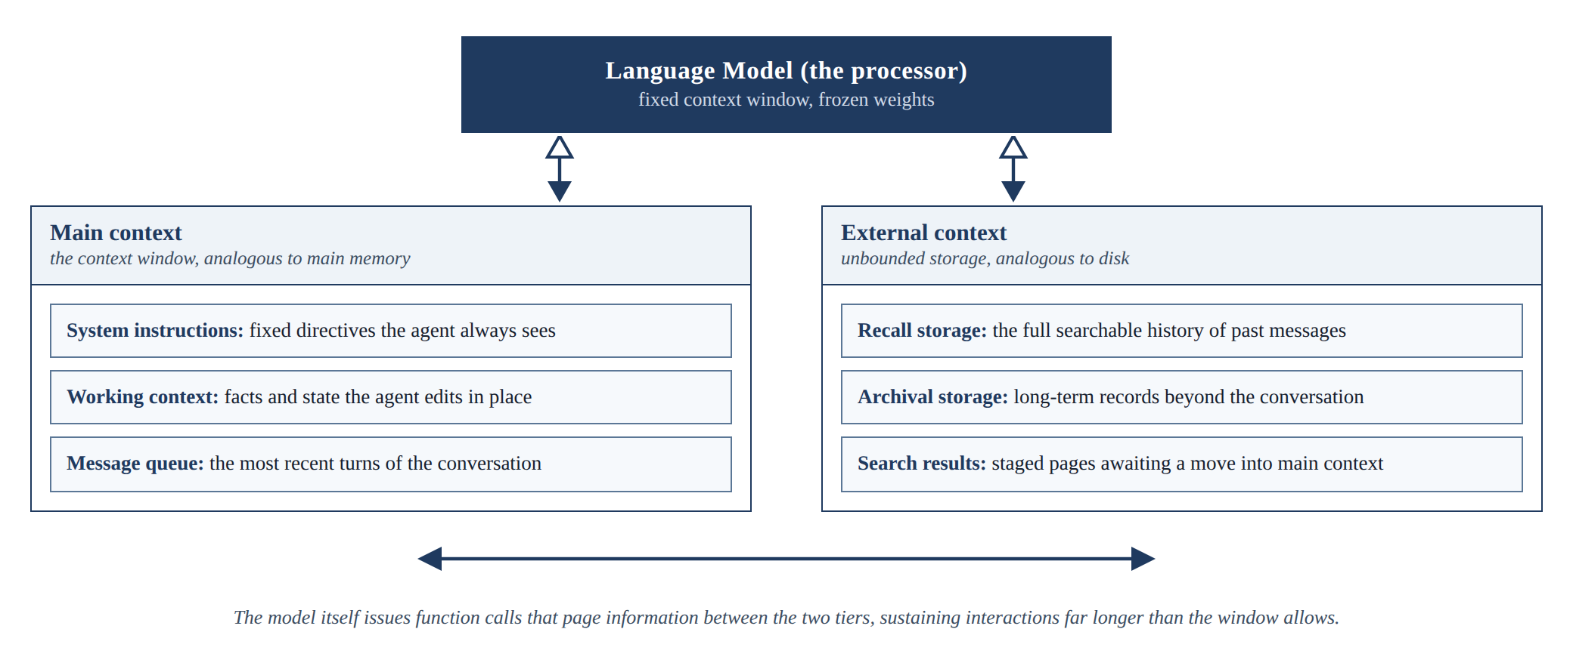
Figure 2.1: The MemGPT virtual context architecture. Adapted from Packer et al. (2023)

2.4.2 Generative Agents
Park et al. (2023) gave simulated agents a memory stream of timestamped observations and retrieved from it by combining three scores: relevance to the current situation, recency, and importance. The agents produced believable long-running behaviour in a simulated town, and the three-part score shaped the retrieval policy of this study. Zhao et al. (2024) later showed that insights written in natural language and recalled at inference improve an agent without any parameter updates. Generative Agents was designed for simulation rather than question answering, and its memory records are verbose natural-language entries, so it does not answer the efficiency questions a device imposes. Figure 2.2 shows the simulated town in which the agents live, work, and remember.
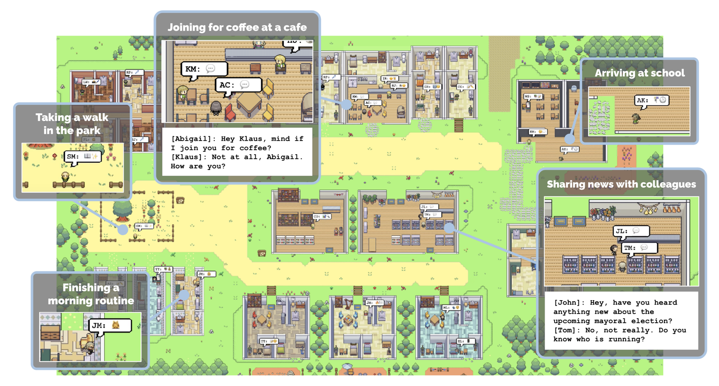
Figure 2.2: The Smallville environment of Generative Agents. Source: Park et al. (2023)

2.4.3 MemoryBank
Zhong et al. (2024) added a model of forgetting. MemoryBank strengthens or weakens stored memories over time in the spirit of the Ebbinghaus forgetting curve, so that what the system retains reflects both the time elapsed and the relative significance of a memory. The contribution is a principled answer to what should be kept, and Hu, Wang, and McAuley (2025) later named selective forgetting as one of four competencies of a memory agent. MemoryBank was evaluated through a companion chatbot, SiliconFriend, on real and simulated dialogs, and not on capability gain, token cost, or latency. Figure 2.3 shows the memory bank, the forgetting curve, and retrieval into conversation.
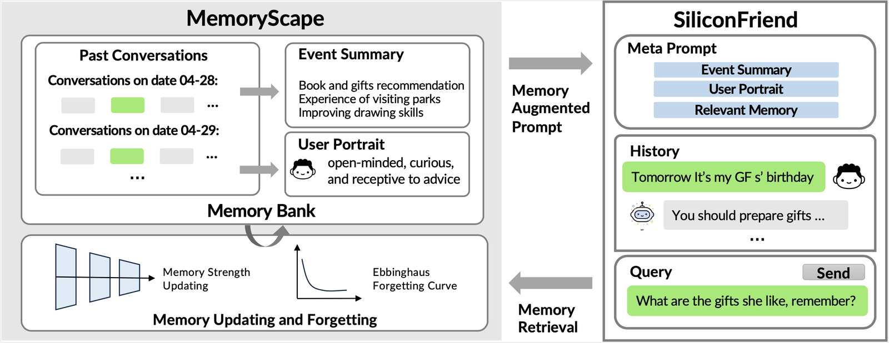
Figure 2.3: The MemoryBank framework with updating and forgetting. Source: Zhong et al. (2024)

2.4.4 HippoRAG
Plain similarity search retrieves passages that resemble the question, but some questions require connecting facts that do not resemble the question at all. Cognitive science offers a model for this in spreading activation, where recalling one concept activates linked concepts (Collins & Loftus, 1975), and in the hippocampal indexing theory, where a compact index links the distributed traces of an experience (Teyler & DiScenna, 1986). Gutiérrez et al. (2024) built these ideas into HippoRAG: a language model extracts entities from stored passages into a knowledge graph, and a Personalized PageRank walk spreads relevance from the question to connected passages. HippoRAG improved multi-hop question answering by up to 20%, and its single-step retrieval was 10 to 30 times cheaper than iterative retrieval such as IRCoT. A language model must build the graph, however, as in GraphRAG (Edge et al., 2024) and A-Mem (W. Xu et al., 2025), and Gutiérrez et al. (2025) noted that graph methods fall considerably below standard retrieval on basic factual memory. This study therefore searched the text first and followed links that already exist between files. Figure 2.4 shows the pipeline of its successor, HippoRAG 2.
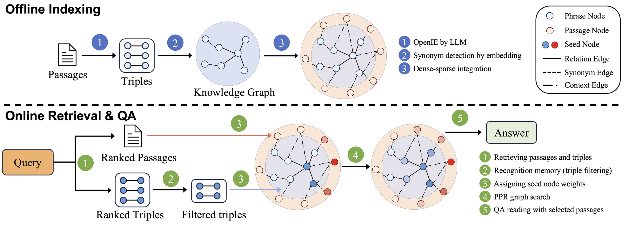
Figure 2.4: HippoRAG 2 offline indexing and online retrieval. Source: Gutiérrez et al. (2025)

2.4.5 Mem0
Production systems have begun packaging these ideas. Chhikara et al. (2025) presented Mem0, which extracts the salient facts from a conversation, consolidates them, and retrieves them at question time. On the LoCoMo benchmark, the authors reported a 26% relative improvement over OpenAI's memory on a metric judged by a language model. Its existence is evidence that the engineering direction is commercially credible. Mem0 writes memories automatically, however, and it was evaluated on conversational recall, so it does not measure gap closing per task type. Figure 2.5 shows where the memory layer sits in an agent stack.
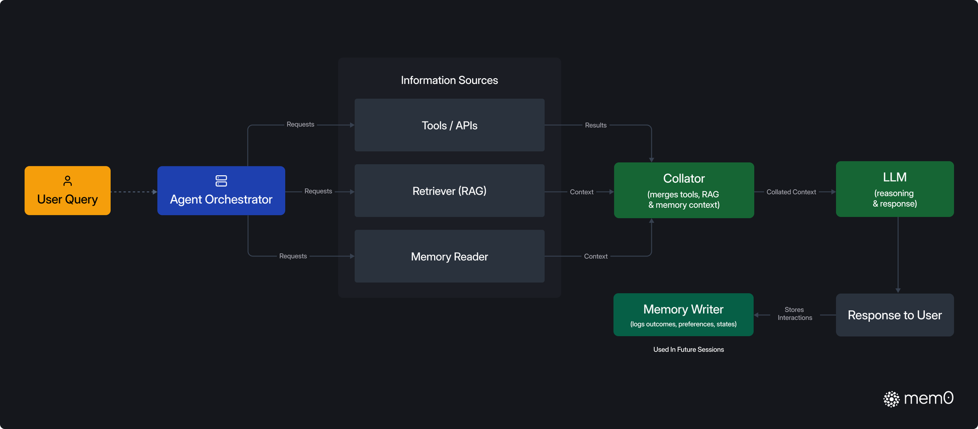
Figure 2.5: The Mem0 memory layer within an agent stack. Source: Mem0 documentation, https://docs.mem0.ai

2.4.6 Chroma
Chroma is an open-source vector database (Chroma, 2026). Documents are cut into pieces, each piece is stored with an embedding vector and its text, and at question time the pieces nearest to the question are pasted into the prompt. It was the baseline of this study because it is what a developer would build without a memory engine. A vector database is a store and not an engine: it answers every question with its nearest pieces, and highly ranked pieces without the answer are the ones that hurt (Cuconasu et al., 2024). Chroma's own researchers reported that reliability falls as input grows (Hong et al., 2025). Figure 2.6 shows the distributed architecture.
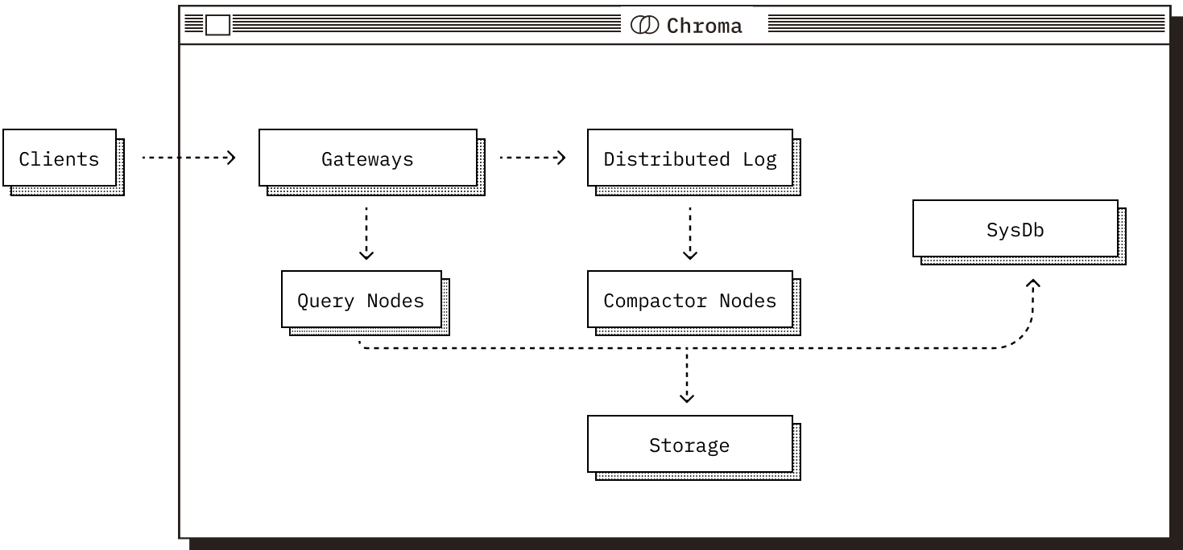
Figure 2.6: The architecture of distributed Chroma. Source: Chroma (2026), https://docs.trychroma.com/reference/architecture/distributed
Table 2.1: Comparison of representative memory systems
System | Core idea | Strength | Limitation for the on-device setting
MemGPT (Packer et al., 2023) | Pages context in and out of the window like an operating system | Sustains very long interactions on a fixed window | Manages context length; does not target capability gain or token cost
Generative Agents (Park et al., 2023) | Memory stream scored by relevance, recency, and importance | Simple, effective retrieval scoring | Designed for simulation; verbose natural-language records
MemoryBank (Zhong et al., 2024) | Memories strengthen and decay over time | Principled forgetting | No accounting of token cost or device latency
HippoRAG (Gutiérrez et al., 2024) | Knowledge-graph index walked with Personalized PageRank | Strong multi-hop recall in a single retrieval step | A language model must build the graph, which is heavy for a device
Mem0 (Chhikara et al., 2025) | Salient facts extracted and consolidated into a managed store | Production-ready; gains reported on a long-conversation benchmark | Writes memories automatically; gap closing per task type not measured
Chroma (Chroma, 2026) | Vector database queried for the pieces nearest to the question | Simple, runs locally, the standard pipeline | A store, not an engine; same retrieval for every question and every model

2.5 Gaps in Related Works
The reviewed literature establishes each ingredient separately. Retrieval can substitute for model scale on knowledge-heavy tasks (Borgeaud et al., 2022; Izacard et al., 2023; Lewis et al., 2020), and it helps most on the long-tail knowledge where small models fail (Kandpal et al., 2023; Mallen et al., 2023). Memory systems can accumulate, organise, score, and forget information across long interactions (Chhikara et al., 2025; Gutiérrez et al., 2024; Packer et al., 2023; Park et al., 2023; Zhong et al., 2024). Text supplied to a model can be heavily compressed with little loss (Chevalier et al., 2023; Ge et al., 2024; Jiang et al., 2023). Methods that decide when to retrieve exist, but they need a specially trained model or a trained classifier (Asai et al., 2024; Jeong et al., 2024), and benchmarks expose how poorly current systems remember long interactions (Maharana et al., 2024; Wu et al., 2025).
What is missing is the combination and the measurement. As Table 2.1 shows, the systems in Section 2.4 are evaluated on recall or task success, and none on gap closing. No reviewed work places a memory engine beside a frozen small model on a consumer laptop and reports what fraction of the gap to a cloud model it closes, separately for knowledge-bound and reasoning-bound tasks, at what cost in tokens and latency, and against both a plain vector database and a cloud model. Narayan et al. (2025) came nearest, but their on-device model depended on the cloud throughout. This intersection defines the gap that the study addressed.

2.6 Conceptual Framework
Figure 2.7 presents the conceptual framework that structured the study, as a flow from input, through processing, to output. It follows two example questions, one knowledge-bound and one reasoning-bound, from the input to their answers in the output. The input variables are the person's question, which is either knowledge-bound or reasoning-bound, and the person's vault of notes, documents, and code. The processing variables are the five steps of the engine, Decide, Fit, Answer, Check, and Learn, which together form the write policy, the retrieval policy, and the token budget. The language model is held constant, with its weights frozen, so that every measured gain can be attributed to the memory engine. The output variables are the answer with its sources, the decision line that states what the engine did, and the notes the person agrees to keep, which return to the vault. Every answer was measured for whether it was right, the fraction of the gap to the cloud model closed, the tokens read, and the seconds taken. Task type moderates the relationship: the framework rests on the finding that retrieval closes the gap on rare facts (Kandpal et al., 2023; Mallen et al., 2023) and that irrelevant text harms reasoning (Shi et al., 2023), so the study predicted substantial gap closing on knowledge-bound questions and little on reasoning-bound questions. The framework guided the methodology in Chapter 3, the design in Chapter 4, and the experiments in Chapter 5.
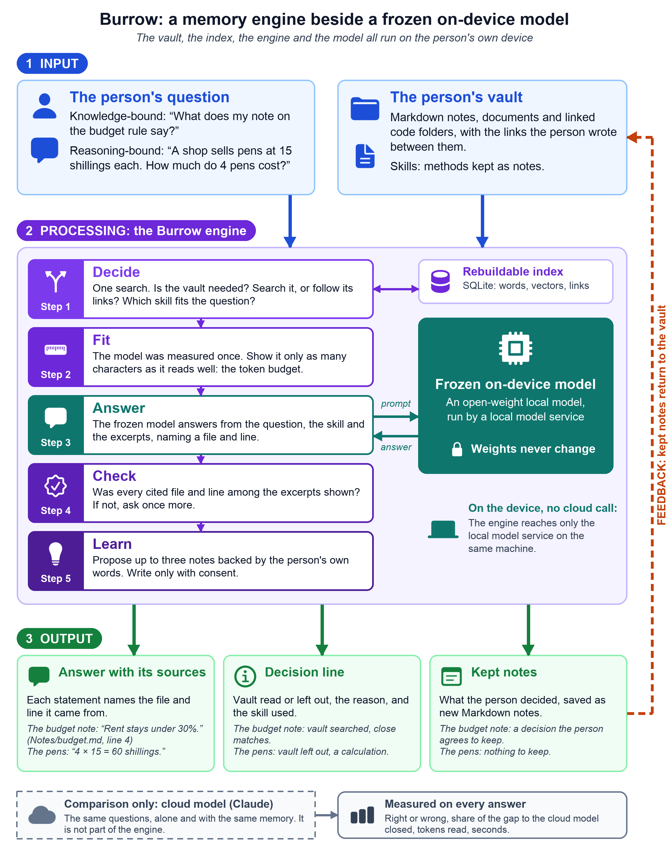
Figure 2.7: Conceptual framework of the study, drawn by the author

Chapter 3: Methodology

3.1 Introduction
This chapter describes how the study was carried out. It states the research paradigm that guided the work, the development approach that was followed, the analysis of what the system had to do, the design of both the system and the experiments that evaluated it, the tools and techniques that were used, and the deliverables the study produced. The system was analysed and designed with Object-Oriented Analysis and Design (OOAD). Throughout the chapter, the guiding principle is that every claim about the engine was tested as a controlled experiment.

3.2 Research Paradigm
The study adopted a pragmatist research philosophy, combining design science research with controlled experimentation. Design science research was appropriate because the study created and evaluated a new artefact, the memory engine, and the discipline's guidelines require that such an artefact be evaluated rigorously against explicit measures of utility (Hevner et al., 2004). The study followed the design science research methodology of Peffers et al. (2007), proceeding through problem identification, definition of solution objectives, design and development, demonstration, evaluation, and communication. The evaluation took the form of controlled experiments organised as a research pipeline of four stages, described in the subsections that follow.

3.2.1 Data Acquisition
Two kinds of data were acquired, so that knowledge-bound and reasoning-bound performance could be separated. The knowledge data was a curated vault on three subjects that an on-device model cannot know well: Kenyan data protection law, taken from the Data Protection Act and its three sets of 2021 regulations (Data Protection Act, 2019); software documentation dated 2026, namely the release notes of SQLite, Python 3.15, Ollama, and the Model Context Protocol; and a private software project, the source code and decision record of Burrow itself at an earlier version. The reasoning data was 50 problems from GSM8K, a public benchmark of grade-school mathematics problems (Cobbe et al., 2021). All of the documents are public or belong to the author, and none contains personal data about any person. Each record is a question, its answer key, and, for a knowledge question, the passage that supports the key, as Table 3.1 shows.
Table 3.1: Two records of the evaluation data
Kind | Question | Answer key
Knowledge, one fact | Under Kenya's Data Protection Act, 2019, within how many hours of becoming aware of a personal data breach that poses a real risk of harm must a data controller notify the Data Commissioner? | seventy-two or 72
Knowledge, several facts | Across SQLite 3.53.0 and 3.54.0 (both released in 2026), which three new options were added to the sqlite3_limit() interface? | SQLITE_LIMIT_PARSER_DEPTH; SQLITE_LIMIT_SCHEMA; SQLITE_LIMIT_TRIGGER_STEPS

3.2.2 Data Preparation
The documents of the three subjects were converted to Markdown files and placed in one vault, so that the documents of two subjects stood as distractors for the third. The engine then indexed the vault before any evaluation began. For each subject, 25 single-fact questions and 15 multi-fact questions were written from the documents by Claude Code agents, and a script checked every key against the text of the vault and rejected any key that appeared in its own question. The reasoning problems were drawn once from the GSM8K test split with a fixed random seed. The vault was built from the source documents only, never from the questions or their keys, so that the experiment measured the engine's ability to surface relevant knowledge rather than its ability to look up a planted answer. The same questions were reused in every set-up, so that every comparison was paired.

3.2.3 Experimental Conditions
Six set-ups were run on every evaluation question. The floor was the on-device model alone, the ceiling was the cloud model alone, and the treatment was the on-device model with the memory engine. No model was trained or fine-tuned; the weights stayed frozen in every set-up, because the engine works beside the model and does not change it. The full design of these conditions is given in Section 3.5.2.

3.2.4 Measurement and Validation
Every question in every set-up logged the model used, the tokens read and written, the seconds spent before the model was called, the seconds the model took, and the resulting answer, so that every experiment could be examined from its logs. The central quantity of the study, the fraction of the capability gap closed, was computed from the set-ups as defined in Section 3.5.2. Validity was protected by the paired design, an evaluation plan written before any scored run, a program frozen before the first scored run, and the measures described in Section 3.5.6.

3.3 Development Approach
The system was developed by incremental prototyping, in small working stages, each of which was checked before the next was begun. Iterative and incremental development grows a system in small steps in which the result of each step informs the next (Larman & Basili, 2003), and design science asks for the same cycle of building and evaluating (Hevner et al., 2004). This approach suited the study for two reasons. First, the requirements changed: the Sprint II review of 5 November 2026 asked for something a person can see and use, and an incremental plan could take that in without losing the work already done. Second, the engine is a chain of separable steps, so its parts could be built in turn and switched off when it was evaluated. The system was analysed and designed with OOAD, because the memory is naturally a set of objects that hold their own data and behaviour, and Chapter 4 therefore presents use case, sequence, activity, and class diagrams drawn in the Unified Modeling Language.
Development proceeded in the five increments shown in Figure 3.1. The first increment built a memory engine and an evaluation harness in Python under the working name CAMR and ended at the Sprint II review. The second increment rebuilt the memory in Swift as Burrow, with a vault of plain Markdown files, a rebuildable SQLite index, retrieval by words and by meaning, and a walk over the links between files. The third increment added the surfaces through which a person and other tools use the memory: a native desktop application, a terminal chat, and a Model Context Protocol server. The fourth increment froze the retrieval and tested it on 101 real bug fixes from public repositories and on three held-back synthetic projects worked by simulated developer agents; memory did not measurably help the small model write working code, which showed that finding the right text was not enough. The fifth increment built the engine around the model, namely the Decide, Fit, Check, and Learn steps and the skills, wrote the evaluation harness of Section 3.5, froze the program, and ran the evaluation.
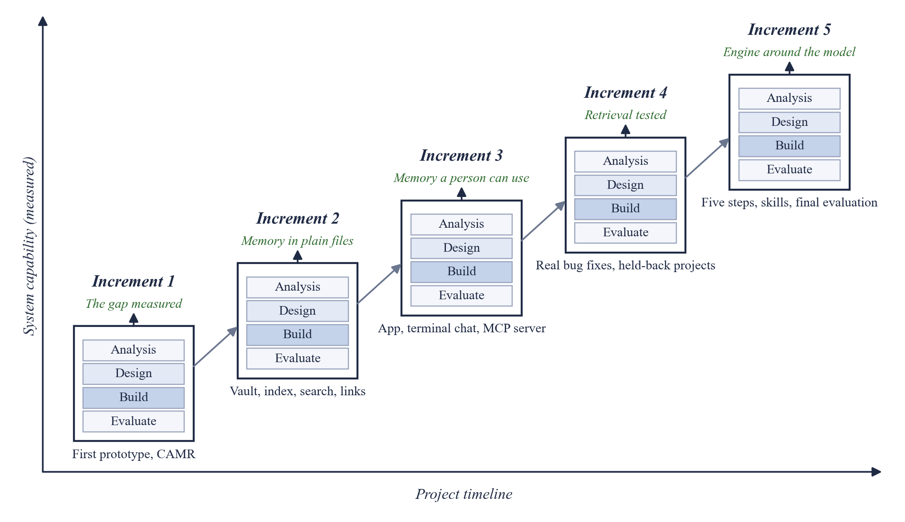
Figure 3.1: Incremental development approach for the Burrow engine, drawn by the author

3.4 System Analysis
The requirements were worked backwards from the study objectives, the measurements the evaluation needed, and the Sprint II review, so that each capability maps to an experiment or to the person using the system. Following OOAD, they were analysed with a use case diagram, sequence diagrams, an activity diagram and a class diagram, and stated as functional, non-functional, data and interface requirements with identifiers; Sections 4.2 and 4.3 present them.

3.5 System Design
This section states how the engine and the experiments that evaluated it were designed.

3.5.1 Architectural Overview
The engine was designed as a chain of steps around a frozen local model, with the memory kept as plain files beside one embedded index that can be rebuilt from them. The design was captured in a system architecture diagram, a diagram of the engine's steps, a logical database schema, wireframes and a deployment diagram, which Section 4.4 presents.

3.5.2 Experimental Design
The central quantity of the study is the fraction of the capability gap closed, and the experiment was designed around measuring it cleanly. Six set-ups were run on every question: the on-device model alone, which is the floor; the on-device model with plain retrieval; the on-device model with a vector database baseline built on Chroma; the on-device model with the engine, which is the treatment; the cloud model alone, which is the ceiling; and the cloud model with the memory prepared by the engine. The first four were run with both on-device models, at a temperature of zero. Plain retrieval and the Chroma baseline used the same vault, the same embedding model, and the same limit of 12,000 characters. The engine showed Gemma 4 12B up to 17,417 characters, the budget its fit produced, and Qwen3.5 4B up to 12,000, and the cloud model with the engine was shown up to 24,000. For each task type, the gap closed was computed as shown in Equation 3.1, where S denotes the accuracy of a set-up on that task type. Two ceilings were reported: the cloud model given the same vault, which compares like with like on material the cloud model could not have seen in training, and the cloud model alone.
$$Gap closed = \frac{S_{\text{treatment}} - S_{\text{floor}}}{S_{\text{ceiling}} - S_{\text{floor}}}$$
Equation 3.1: Fraction of the capability gap closed
A value of zero means the engine adds nothing, and a value of one means the on-device model with the engine matches the cloud model. Where the cloud model is not ahead of the on-device model alone, the measure is not defined. A rule added after the evaluation plan was written leaves the fraction out of Table 5.6 when the ceiling is less than ten percentage points above the floor, because one answer then moves it widely.

3.5.3 Datasets and Task Types
The 120 knowledge questions, 40 on each of the three subjects, were the knowledge-bound task type. Each subject held 25 single-fact questions and 15 multi-fact questions, and a multi-fact question needs two passages from two different files. These questions are the case where a small model fails most severely, because it cannot have memorised the material. The 50 GSM8K problems were the reasoning-bound control, where the required ability is reasoning rather than recall and where memory was predicted to help little (Cobbe et al., 2021). The question for this control was whether the engine would leave the vault out and protect the answer.

3.5.4 Evaluation Metrics
A knowledge answer was right when it contained every required fact of its key, and a reasoning answer was right when its last number equalled the key. Accuracy was the share of right answers in a set-up, and the gap closed was computed from it per task type using Equation 3.1. Retrieval was also judged apart from answering, by recording whether every file that holds the answer was among the excerpts shown. Efficiency was reported as the tokens read, the tokens written, the seconds spent before the model was called, and the seconds the model took, all measured on the target device. Paired differences between set-ups were tested with an exact two-sided sign test, because each answer is simply right or wrong.

3.5.5 Ablation Procedure
Parts of the engine were evaluated by switching them off and measuring the change on the same questions, holding everything else fixed. The full engine on the main model was the reference. One run removed the skills and another removed the citation check, and each was reported beside the full engine. The token budget was varied separately on the 120 knowledge questions, with the amount shown fixed at 2,000, 4,000, 8,000, and 32,000 characters beside the fitted 17,417. This sweep was added after the evaluation plan was written, in order to answer the fifth specific objective, so no criterion for it was set in advance. Decide and Fit were not switched off on their own.

3.5.6 Threats to Validity
Six threats were addressed. Answer leakage was prevented by building the vault from the source documents only (Section 3.2.2). Prompt sensitivity was limited by one fixed prompt for each set-up. Sampling error was addressed by paired questions and an exact sign test. Timing noise was addressed by reporting medians on one machine, although each question was run once. Ceiling instability was addressed by pinning and logging one version of the cloud model. Tuning bias was addressed by setting the thresholds of the engine on separate development questions, although several concern the same subjects as scored questions, while the scored questions were not read during tuning and played the part of a held-out test set.

3.6 Tools and Techniques
This section describes the tools that were used to build the engine and the harness, and the role each played. Their exact versions are given in Section 5.2.2.

3.6.1 Swift
The engine, the command-line tool, the terminal chat, the protocol server, and the desktop application were written in Swift, the native language of the target platform, so that the engine runs as one compiled program with no interpreter.

3.6.2 SQLite with FTS5
The index is SQLite, one database file with no server process. The word index uses the FTS5 full-text extension (SQLite, 2026), and the embedding vectors are stored in the same database with a memory-mapped copy beside it for speed.

3.6.3 Ollama and Local Models
Local models were served through Ollama, which runs quantised open-weight models on consumer hardware (Ollama, 2026). The on-device models were Gemma 4 12B and Qwen3.5 4B (Gemma Team, 2026; Qwen Team, 2026).

3.6.4 Hosted Inference API
The cloud reference model, Claude (Anthropic, 2026c), was reached through its hosted API and pinned to a single version for the whole study, so that the ceiling remained stable across all runs.

3.6.5 Embedding Model
Embedding vectors were produced on the laptop by Qwen3 Embedding 0.6B (Y. Zhang et al., 2025). The engine and the baselines used the same model.

3.6.6 Chroma and LangChain
Chroma, an open-source vector database (Chroma, 2026), was run locally to build the baseline of Section 3.5.2. LangChain, a framework for applications around language models (LangChain, 2026), was supported through an adapter that exposes Burrow as a retriever.

3.6.7 Model Context Protocol
The Model Context Protocol, an open standard between AI applications and data sources (Model Context Protocol, 2026), was used so that outside models and tools can reach the same memory.

3.6.8 Auxiliary Tools
The evaluation harness, the scripts that check the answer keys, and the charts were written in Python. Claude Code wrote the knowledge questions under the checks of Section 3.2.2. Version control used Git and GitHub, and the state of the code at each evaluation was marked with a tag, so that a result can be traced to the code that produced it.

3.7 Deliverables
The study produced the following deliverables, each described in its own subsection.

3.7.1 The Burrow Memory Engine
A Swift package that implements the vault, the index, and the engine designed in Chapter 4, with a command-line tool named burrow, running entirely on the target consumer laptop.

3.7.2 The Desktop Application, Terminal Chat, and Protocol Server
A native desktop application in which a person writes notes, follows their links, and asks questions of the vault, a terminal chat, and a Model Context Protocol server that gives outside models and tools the same memory.

3.7.3 The Evaluation Harness
The question sets, set-up runners, scorers, and logging needed to repeat every experiment in the study from the command line.

3.7.4 Experimental Results
The measured gap closed per task type, the ablation and budget results, and the cost of each answer in tokens and seconds, together with the logs that support them.

3.7.5 System Documentation
This report, including the design, the experiments, and the findings, with the instructions, configuration files, and prompt templates needed to reproduce the results.
Chapter 4 presents the analysis and design of the system.

Chapter 4: System Analysis and Design

4.1 Introduction
This chapter presents the analysis and design of Burrow, the memory engine of this study, and addresses the second specific objective. The system was analysed and designed with Object-Oriented Analysis and Design (OOAD), as justified in Section 3.3, and the diagrams use the Unified Modeling Language (UML). Section 4.2 gives the requirements of the system. Section 4.3 presents the analysis diagrams, which are a use case diagram, two sequence diagrams, an activity diagram, and a class diagram. Section 4.4 presents the design diagrams, which are the system architecture, the engine's steps, the logical database schema, the wireframes, and a deployment diagram.

4.2 System Requirements
The system requirements identified for this project are presented in the following subsections. They were worked backwards from the specific objectives in Section 1.3 and from the Sprint II review of 5 November 2026. Each requirement has an identifier, a priority, the objective it serves, and the test case of Section 5.6 that verifies it. A requirement is marked Must when an objective depends on it and Should when it was added to strengthen the engine. No limit on response time was set in advance, because no measurement existed to justify one.

4.2.1 Functional Requirements
Table 4.1 lists the functional requirements. FR-01 to FR-03 cover the memory, FR-04 to FR-09 are the five steps of the engine, and FR-10 opens the engine to outside models.
Table 4.1: Functional requirements
ID | Requirement | Priority | Objective | Verified by
FR-01 | The engine shall index a vault of Markdown notes, documents, and linked code folders on the device, and later re-index only the files that changed. | Must | iii | TC-01
FR-02 | The engine shall rank the pieces of the vault by word match and by meaning, and return excerpts with their file and line numbers within a character budget. | Must | ii | TC-02
FR-03 | The engine shall follow the links between files for up to two hops from the best matches. | Must | ii | TC-03
FR-04 | Decide: the engine shall judge from one search whether a question needs the vault, and whether to search or to follow links, and state the reason in words. | Must | ii | TC-04, TC-05
FR-05 | Decide: the engine shall hand the model at most one skill, chosen by how closely it fits the question or else by the kind of material found. | Should | ii | TC-06
FR-06 | Fit: the engine shall measure a local model once and set from that measurement how many characters the model is shown. | Must | ii, v | TC-07
FR-07 | Answer: the engine shall have a local model answer from the excerpts, naming a file and line for each statement. | Must | iii | TC-08
FR-08 | Check: the engine shall check every cited file and line against the excerpts shown, ask once more if a citation was not shown, and report any left unverified, on the command burrow ask --mode engine. | Should | ii | TC-09
FR-09 | Learn: the engine shall propose at most three notes from a conversation, each backed by the person's own words, and in the terminal chat write a note only when the person accepts it. | Must | ii | TC-10
FR-10 | The engine shall give the same decision, skill, and excerpts to an outside model through a command and through a Model Context Protocol (MCP) tool, without calling a chat model itself. | Should | iii | TC-11

4.2.2 Non-Functional Requirements
Table 4.2 lists the non-functional requirements. They cover privacy, durability, safety, cost, footprint, and portability, which are the qualities that matter for a memory kept on a person's own device. NFR-04 requires that cost be measured on every answer.
Table 4.2: Non-functional requirements
ID | Requirement | Priority | Objective | Verified by
NFR-01 | Privacy: the engine shall send notes and code only to the Ollama service on the same machine, at the loopback address 127.0.0.1. | Must | iii | TC-13
NFR-02 | Durability: the person's files shall be the only lasting record, and the index shall be rebuilt from them if it is deleted. | Must | iii | TC-12
NFR-03 | Safety: text from the vault shall be given to a model as material to read, with a rule that no instruction written inside it is followed. | Should | iii | TC-14
NFR-04 | Cost: for every answer the engine shall report the tokens read, the tokens written, the seconds before the model was called, and the seconds the model took. | Must | iv | TC-15
NFR-05 | Footprint: the index shall be one embedded database file inside the vault's .burrow folder, with no database server process. A rebuildable copy of its vectors and two small settings files sit beside it. | Must | iii | TC-16
NFR-06 | Portability: the engine shall build as one Swift package with no third-party dependency, and its tests shall run with one command. | Should | iii | TC-17

4.2.3 Data Requirements
Table 4.3 lists the data requirements. They describe what the engine reads, what it stores, what it is allowed to write, and how the evaluation data is kept apart from the memory.
Table 4.3: Data requirements
ID | Requirement | Priority | Objective | Verified by
DR-01 | The input shall be a folder of plain Markdown files and linked code folders. The engine shall read these files and shall not change them. | Must | iii | TC-18
DR-02 | For each piece of a file the index shall store its file, its first and last line, its text, and at most one embedding vector. | Must | iii | TC-19
DR-03 | In the chat a note, and in the app a Ledger commit, shall be written only when the person accepts it, as a readable Markdown file in the vault. No write shall overwrite a note. Other writes are limited to the starter skills on request, accepted file changes, and notes added by burrow note, burrow learn, or an MCP client. | Must | ii | TC-10
DR-04 | The evaluation questions and their answer keys shall be kept outside the vault, and the vault shall be built from the source documents only. | Must | iv | TC-20

4.2.4 Interface and Integration Requirements
Table 4.4 lists the interface and integration requirements. They describe how a person, the local model service, and outside tools meet the engine, and what happens when the model service fails.
Table 4.4: Interface and integration requirements
ID | Requirement | Priority | Objective | Verified by
IR-01 | The application shall show, for each conversation a connected program holds with the vault, every lookup and the files it read, each opening its file; the command line shall show under each answer what the engine decided, the skill it used, and the files it read. | Must | Sprint II | TC-08
IR-02 | If the Ollama service cannot embed a question, the search shall continue on words alone. If it cannot answer, the failure shall be reported and no answer shown. | Must | iii | TC-21
IR-03 | The MCP server shall exchange JSON-RPC messages over standard input and output, and shall offer its tools only after the client has initialised the session. | Should | iii | TC-11
IR-04 | The vault shall stay a folder that Obsidian can open: plain Markdown with links written between double square brackets. | Should | iii | TC-22
IR-05 | The system shall be offered from a public landing page, with the terminal version installed by one command and the desktop application downloaded by one click, both from the project's published releases. | Should | Sprint II | TC-23

4.3 System Analysis Diagrams
This section presents the diagrams used to analyse the actors, the behaviour, and the structure of the system. Each diagram is introduced, shown, and then interpreted.

4.3.1 Use Case Diagram
The use case diagram gives the widest view of the system, namely who uses Burrow and for what. It was chosen because the engine serves three kinds of actor, and it addresses requirements FR-04 to FR-10. Figure 4.1 shows the boundary of the system and its actors: the person who owns the vault, the local model served by Ollama, and an outside model or tool that brings its own model.
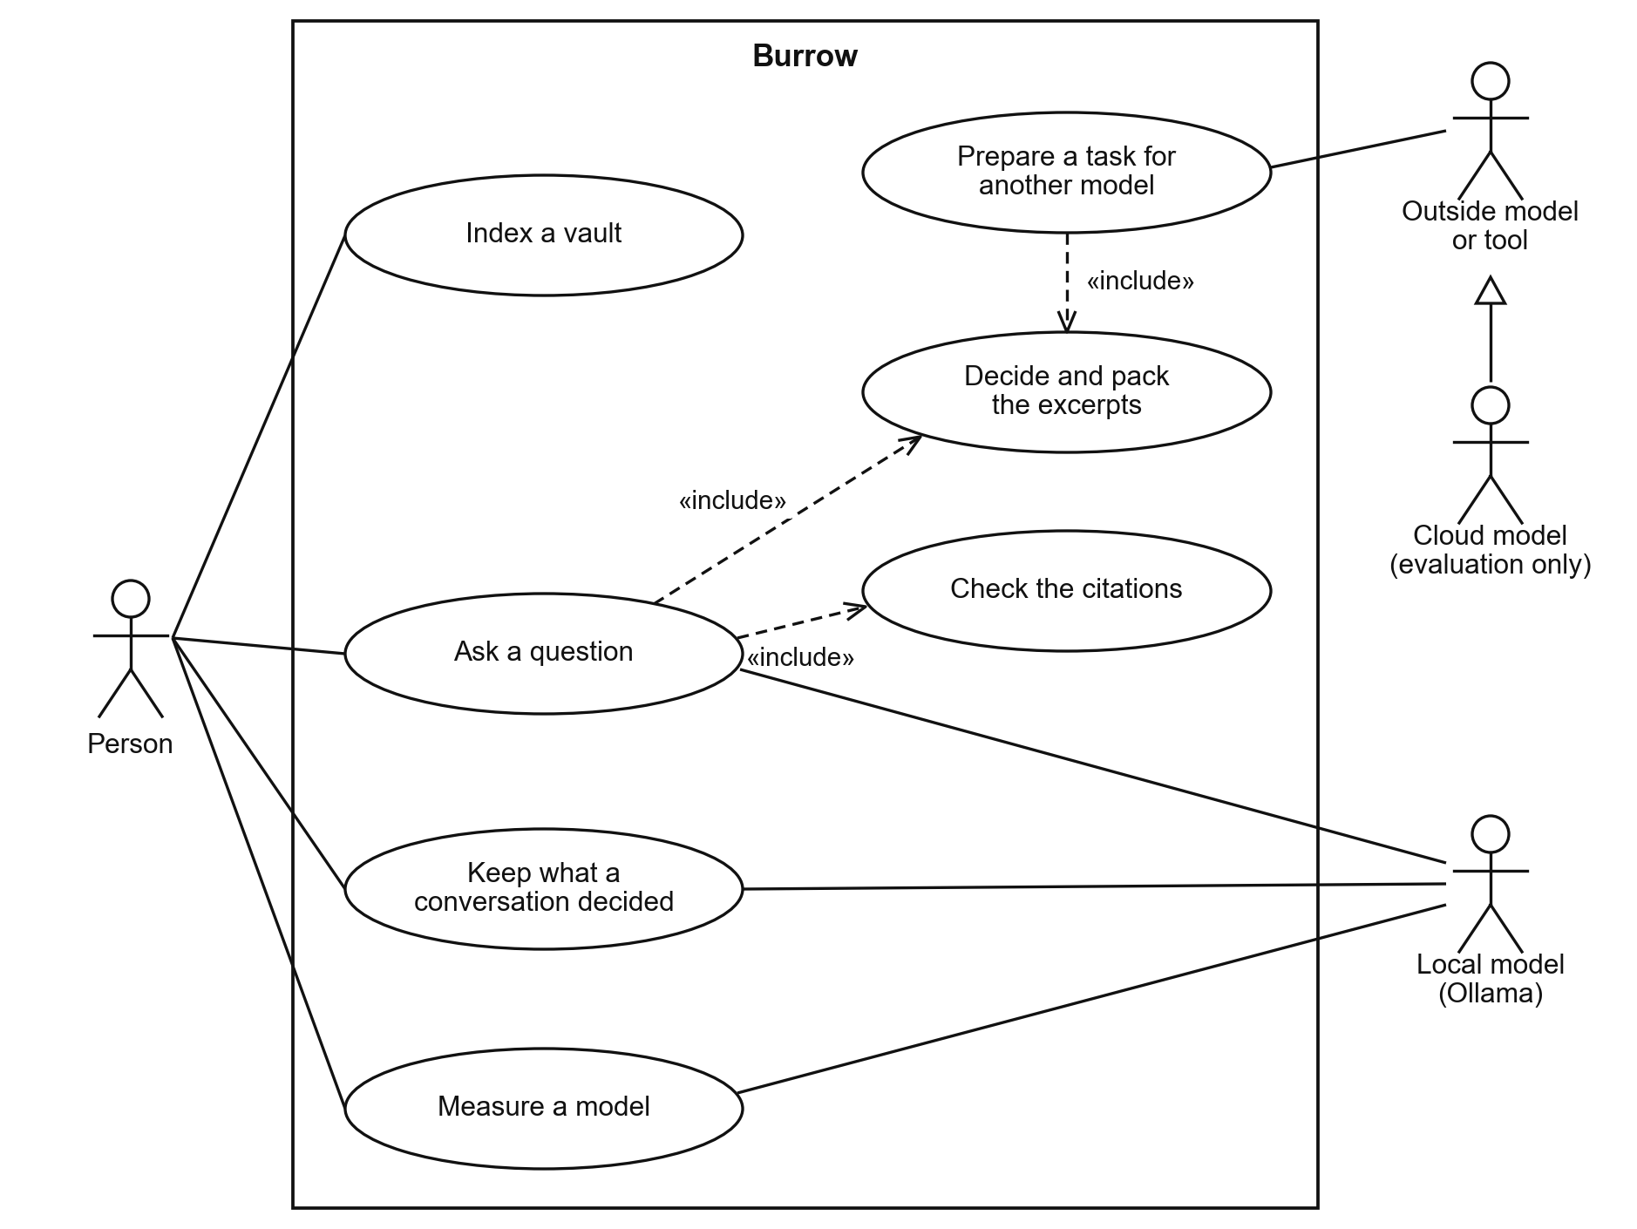
Figure 4.1: Use case diagram of Burrow
Asking a question and preparing a task for another model both include the same use case, deciding and packing the excerpts, so the engine's judgement is shared by every way of using it. Only the path of the local model includes checking the citations, because only there does the engine see the answer. Table 4.5 describes the use case that carries the study, "Ask a question", which exercises four of the five steps.
Table 4.5: Use case description: Ask a question
Item | Description
Actors | Person (primary), local model (supporting)
Precondition | The vault has been indexed. Ollama is running with a chat model.
Main flow | 1. The person asks a question. 2. The engine searches once and decides: leave the vault out, search, or follow links. 3. The engine picks a skill and packs the excerpts within the model's budget. 4. The local model answers. 5. The engine checks each file and line cited. 6. The person receives the answer, the decision line, and the sources.
Alternative flows | At step 2 nothing in the vault is close, so the model answers without excerpts. At step 5, on the command line, a citation was not among the excerpts, so the model is asked once more and the better grounded answer is kept.
Exceptions | Ollama cannot embed the question, so ranking continues on words alone. Ollama cannot answer, so the failure is reported and no answer is shown.
Postcondition | No file in the vault has changed. Any citation that could not be verified is named.

4.3.2 Sequence Diagrams
A sequence diagram shows the order of the messages between the parts of the system. It was chosen because the five steps must run in a fixed order, and the first diagram addresses FR-04 to FR-08. Figure 4.2 shows the messages exchanged when a person asks a question through the engine.
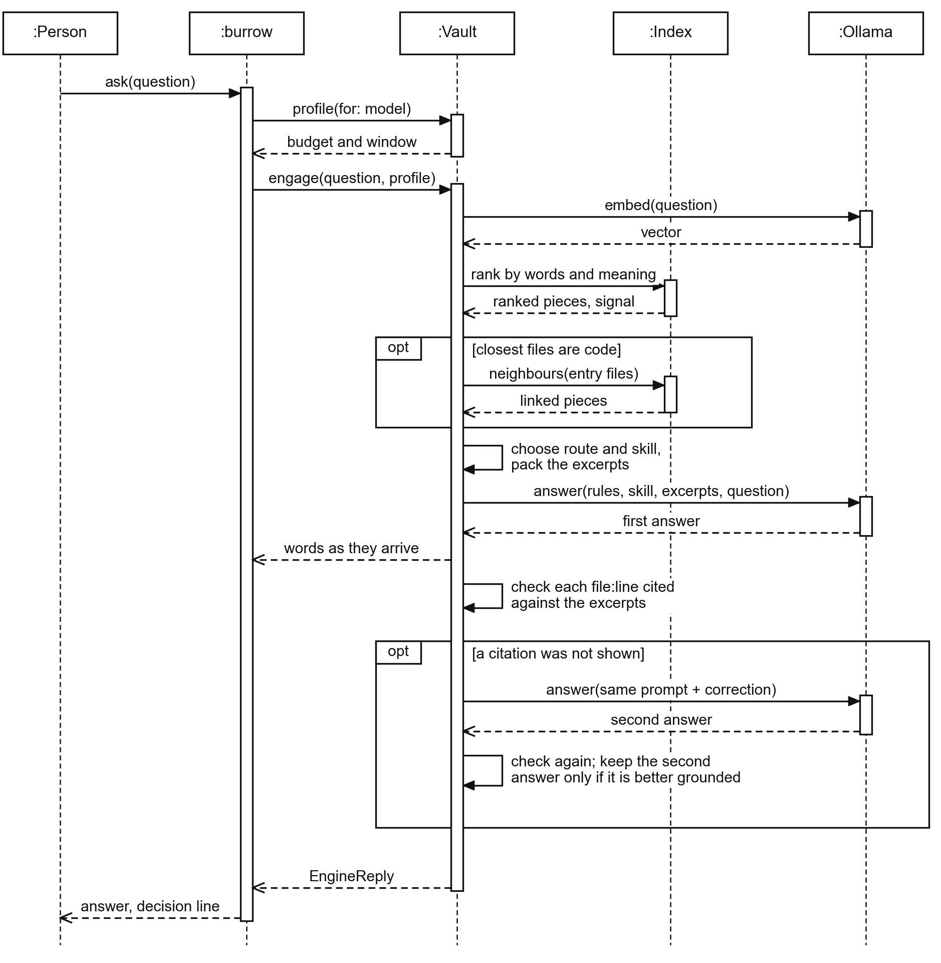
Figure 4.2: Sequence diagram of a question asked through the engine
The model profile is fetched first, so the budget is known before any search begins. The local model is called once in the usual case and twice at most, the second time with the wrongly cited places named. Figure 4.3 shows the second way in, which addresses FR-10: an outside model using Burrow through the MCP tool vault_prepare.
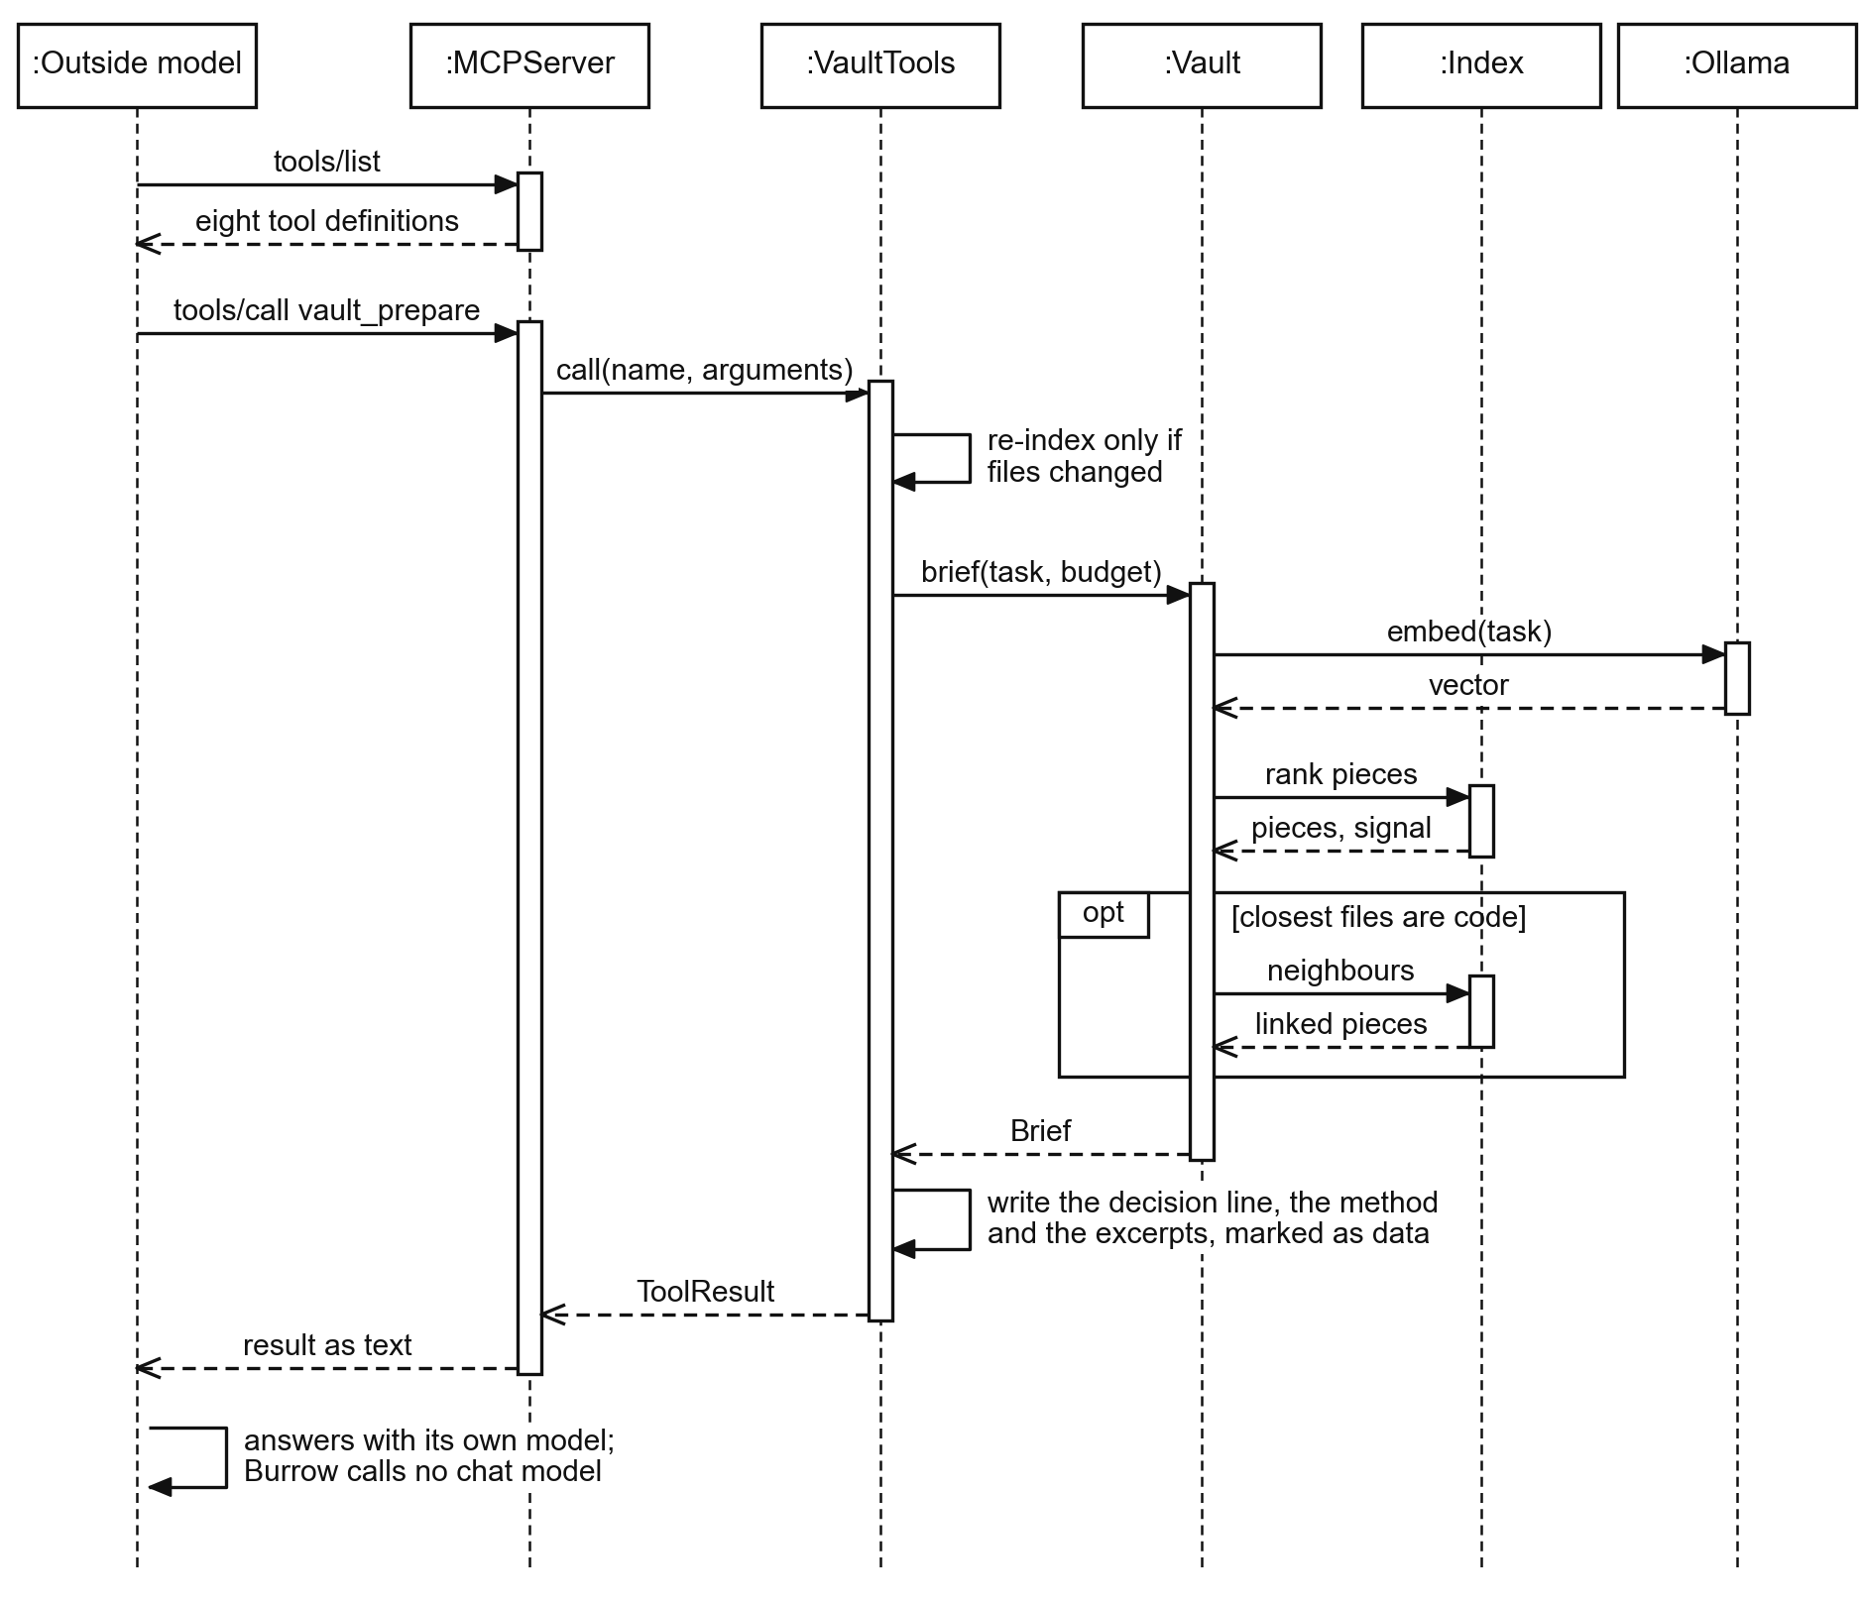
Figure 4.3: Sequence diagram of an outside model preparing a task through MCP
The only model Burrow calls on this path is the embedding model. The outside model receives the decision, a skill, and the excerpts, and writes the answer itself. Burrow therefore never sees that answer and cannot check its citations.

4.3.3 Activity Diagram
The activity diagram shows the decisions of the engine's loop and who makes each one. It was chosen because the study depends on separating what the engine decides from what the model writes, and it addresses FR-04 to FR-09. Figure 4.4 follows the loop from a question to a kept note, in three swimlanes for the person, the engine, and the local model.
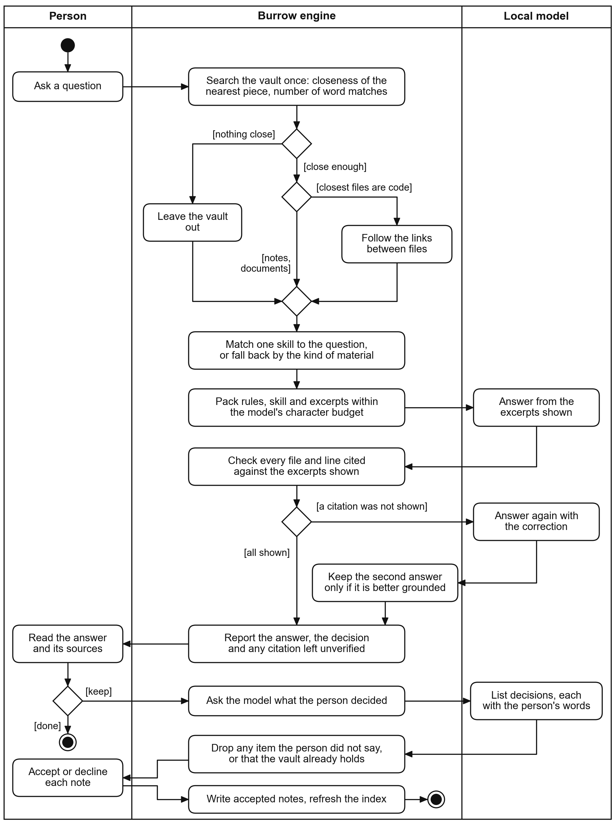
Figure 4.4: Activity diagram of the engine's loop
Every choice about what the model reads is made in the engine lane, before the model is called. Each time the model returns something, the engine examines it before it is used. The last decision belongs to the person, who accepts or declines each proposed note.

4.3.4 Class Diagram
The class diagram shows the types of the engine and how they depend on one another. It was chosen because it maps directly to the Swift code and guided how the library was divided. Figure 4.5 shows the main types as they were built.
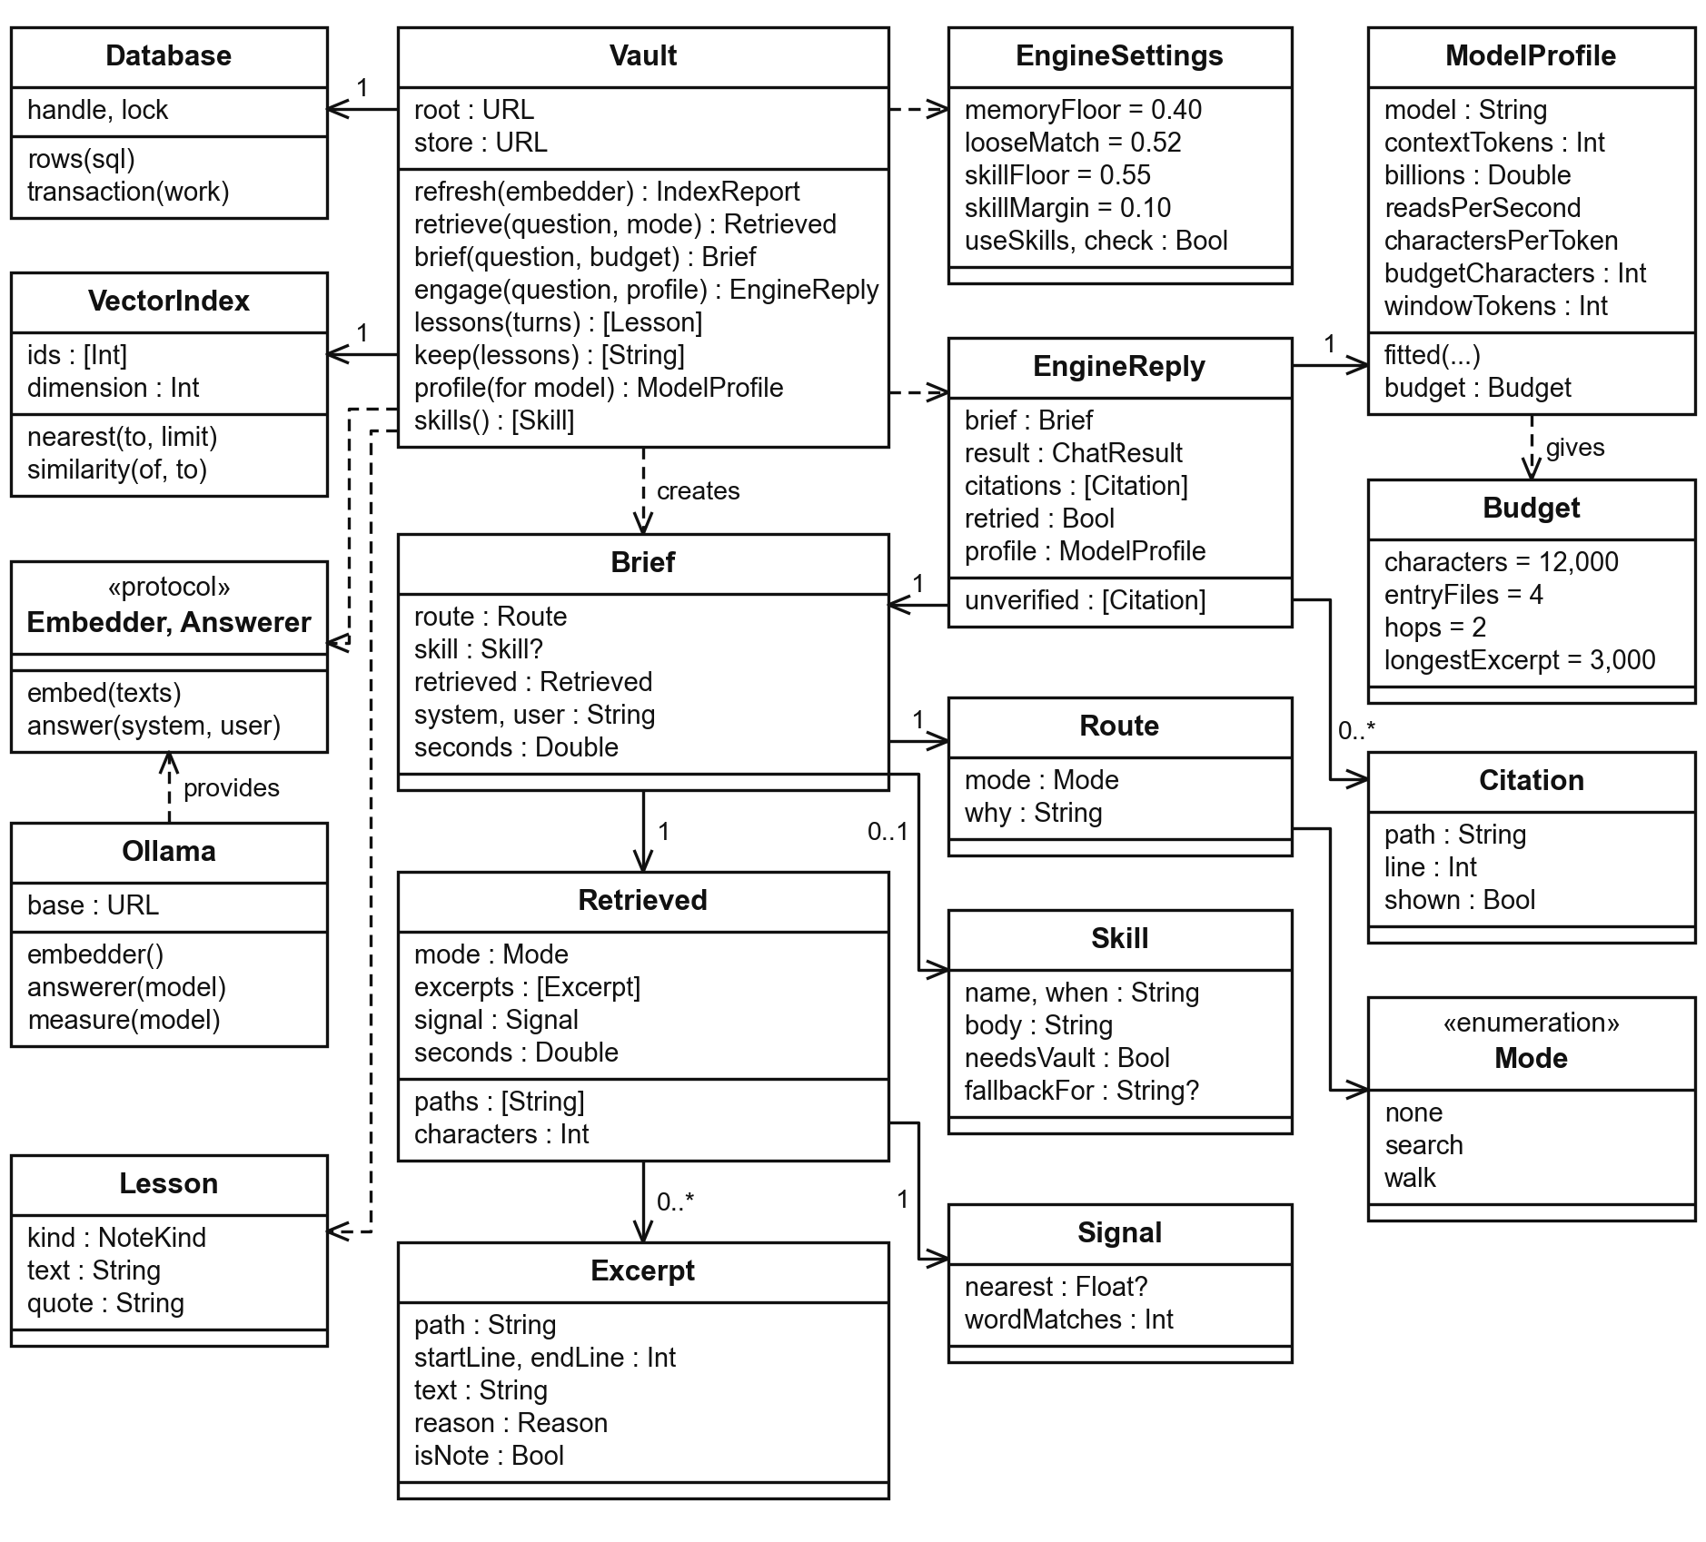
Figure 4.5: Class diagram of the engine
The Vault type is the single entry point: brief decides and packs, engage adds the answer and the check, and lessons and keep are the two halves of Learn. A Brief contains no answer, which is why it can be handed to an outside model. Embedder and Answerer are protocols, so the tests run the whole loop with a scripted model in place of a real one.

4.4 System Design Diagrams
This section presents the diagrams that show how the system was organised to satisfy the analysed requirements.

4.4.1 System Architecture
The architecture diagram shows the components of Burrow and which component depends on which. It was chosen to show that all memory logic sits in one library that every surface uses, and it addresses FR-10 and NFR-06. Figure 4.6 shows the components in three layers: the surfaces that a person or a tool touches, a shared set of tools, and the core.
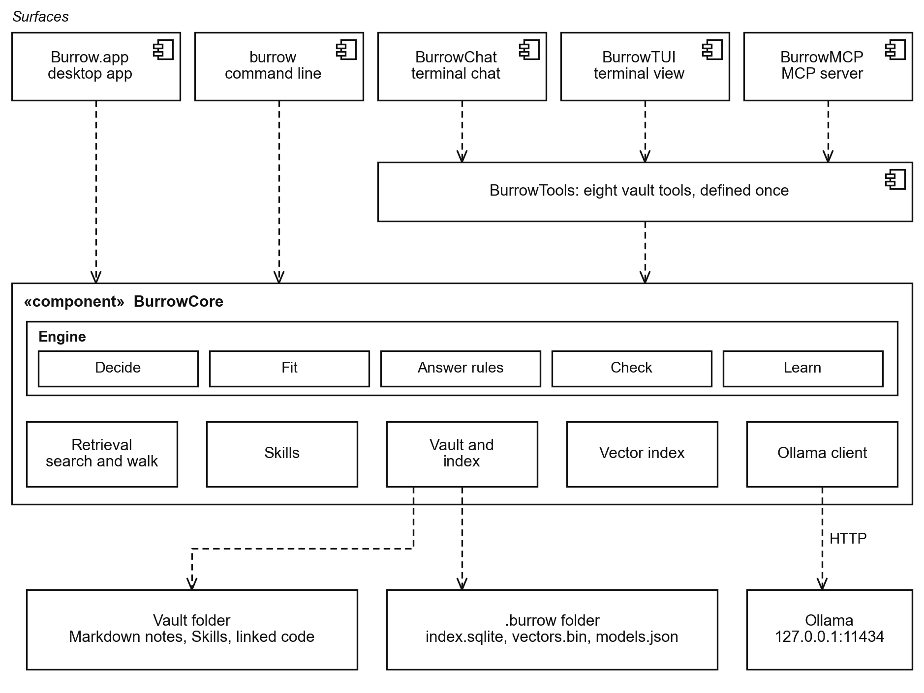
Figure 4.6: Architecture of Burrow
All memory logic is in BurrowCore, and every surface depends on it, so a change to the engine reaches the application, the terminal chat, and the MCP server at once. The Ollama client is the only part that leaves the process. Which steps each surface runs is recorded in Section 5.4.6.

4.4.2 Engine Steps and Retrieval Design
Objective ii names three mechanisms: a write policy, a retrieval policy, and a token budgeting mechanism. Figure 4.7 shows the five steps of the engine, what each reads and writes, and how the steps map to those mechanisms.
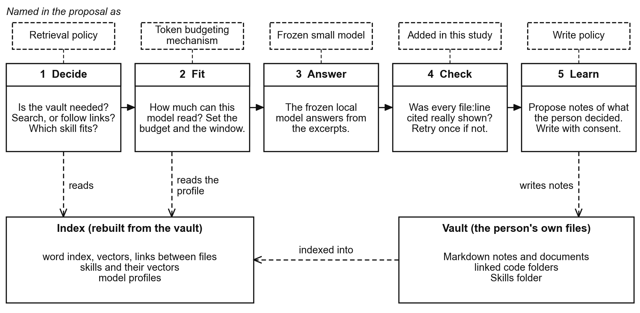
Figure 4.7: The five steps of the engine and the three mechanisms of objective ii
Learn is the write policy, Decide and the retrieval behind it are the retrieval policy, and Fit is the token budgeting mechanism. Check was added in this study. Ranking is by words, meaning, and links, and the recency and importance scores named in objective ii decide between files that match a question equally well, so they never overrule relevance.
Retrieval ranks each piece twice, by word match with BM25 (Robertson & Zaragoza, 2009) and by meaning. Meaning is the cosine between the vector of the question, q, and the vector of a piece, v, as in Equation 4.1.
$$cos(q, v) = \frac{q · v}{‖q‖ ‖v‖}$$
Equation 4.1: Cosine similarity between a question and a piece
The two rankings are merged by reciprocal rank fusion (Cormack et al., 2009), as in Equation 4.2, where the rank of piece p in ranking r counts from 1 and w(p) lowers the weight of test files and of the output of past runs. Pieces holding an exact name from the question, or from a file the question names, are placed before this ranking.
$$score(p) = w(p) \sum_{r ∈ \{words, meaning\}}{\frac{1}{60 + {rank}_{r}(p)}}$$
Equation 4.2: Merged score of a piece
When links are followed, a neighbouring file n is ranked by Equation 4.3, where b(n) is its word match scaled so that the best file scores 1, h is the hop number, and k(n) depends on the kind of link.
$$s(n) = w(n) \left(\frac{b(n)}{h} + k(n)\right)$$
Equation 4.3: Score of a neighbouring file during a walk

4.4.3 Logical Database Schema
The index is the only database in the system, and it holds no original data. The schema was chosen as a design view because its tables decide what can be searched by words, by meaning, and by links, and it addresses DR-02 and NFR-02. Figure 4.8 shows its logical schema, which is one SQLite database.
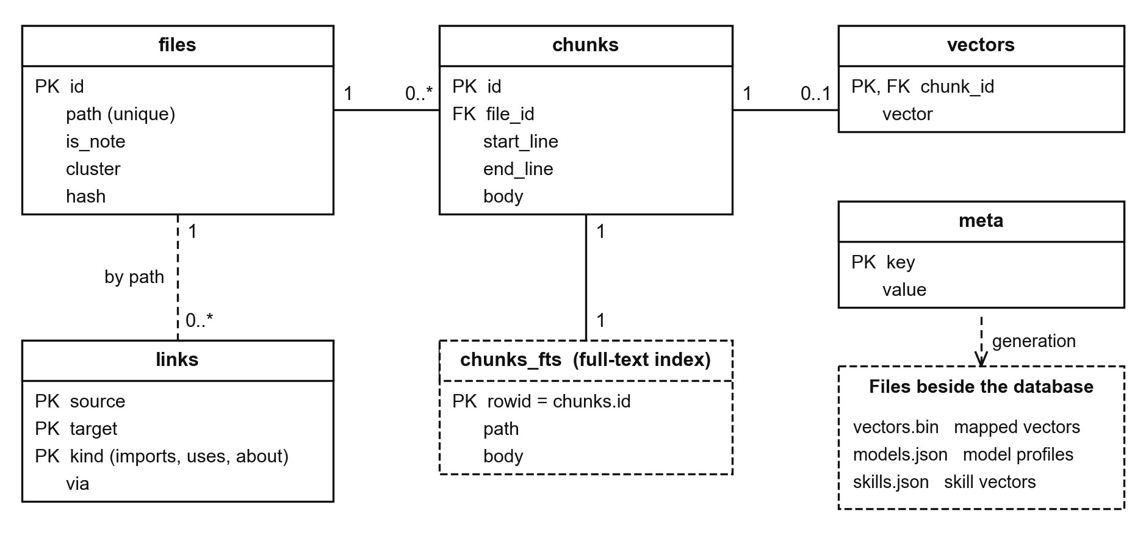
Figure 4.8: Logical schema of the index
A file is cut into pieces stored as chunks, and a piece has at most one vector, because the index also works on words alone. The chunks_fts table is the full-text index, and the links table holds the links between files. Nothing in the schema is a source of truth: the whole index can be rebuilt from the Markdown files, which satisfies NFR-02.

4.4.4 Wireframes
The wireframes plan where the person sees what the engine and the models that use it did, which addresses IR-01 and the Sprint II request for something a person can see and use. They follow the application as built after 11 November 2026, when its own question box gave way to the programs that connect to the vault, because the vault is the memory and the chat belongs to those programs. Figure 4.9 is the main window on a conversation that a connected program held with the vault.
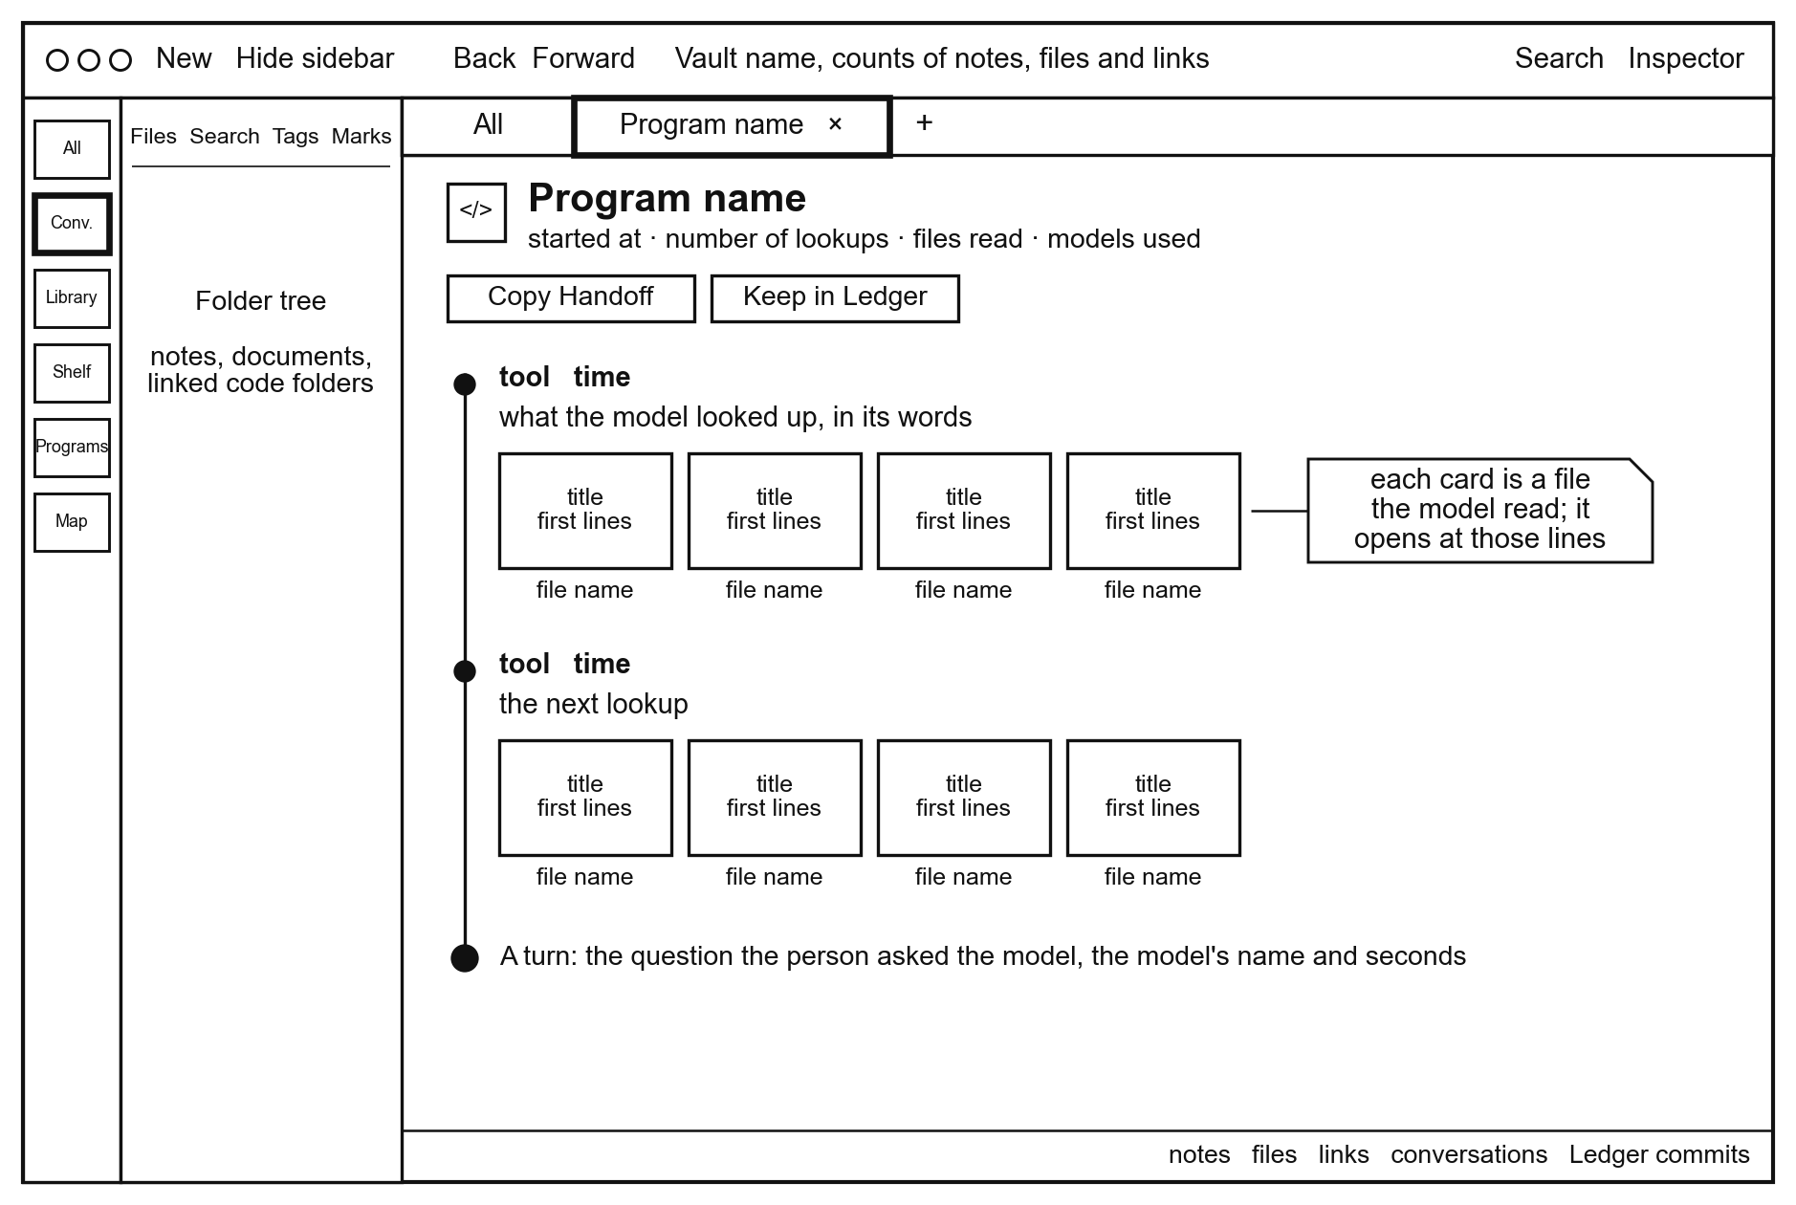
Figure 4.9: Wireframe of the main window on a conversation a connected program held with the vault
Each step on the trail is one lookup the model made, in the model's own words, followed by a card for every file it read, and each card opens its file. The narrow strip on the left switches between the pages of the vault, and the status bar counts the notes, files, links, conversations and Ledger commits. Figure 4.10 is the note editor, where a note is a plain Markdown file, its properties are shown as fields, and a link to another note is written between double square brackets.
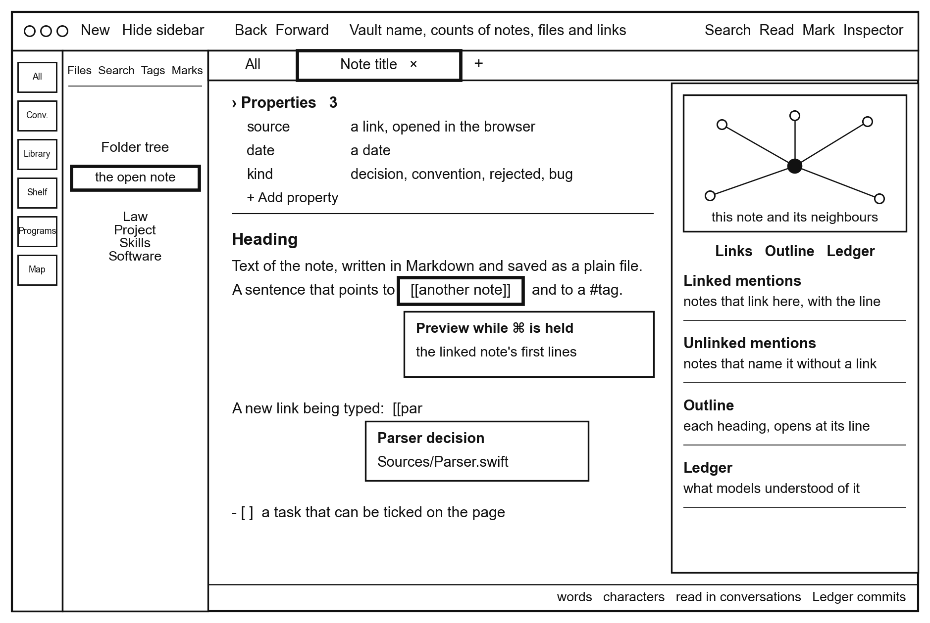
Figure 4.10: Wireframe of the note editor with its properties and links
The panel on the right shows the note's neighbours as a small graph and lists the notes that link to it, the notes that name it without a link, its outline, and what models have understood about it. These links are the ones the engine follows in FR-03. Figure 4.11 is the step where the person keeps a decision from a conversation in the Ledger, which addresses DR-03 in the application.
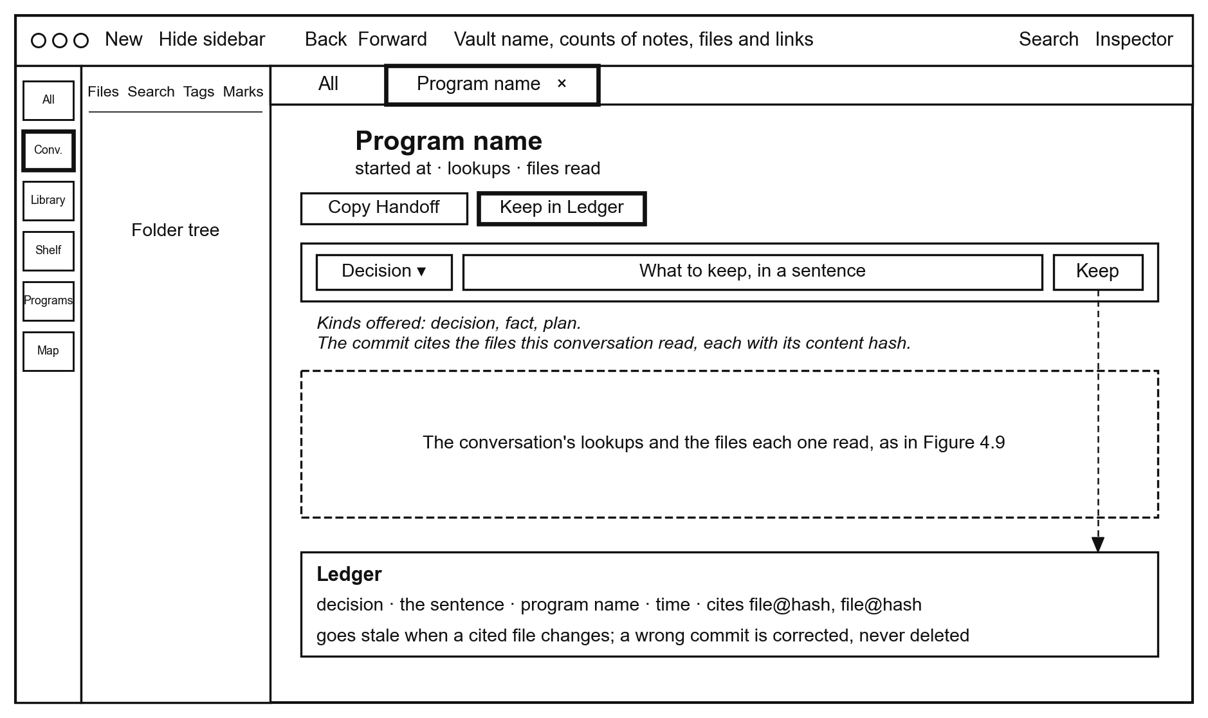
Figure 4.11: Wireframe of keeping a decision from a conversation in the Ledger
Nothing is kept unless the person writes the sentence and presses Keep, and the kept commit cites the files the conversation read, so it goes stale when one of them changes. Figure 4.12 is the terminal chat, which shows the engine's decision under each question and proposes notes through Learn.
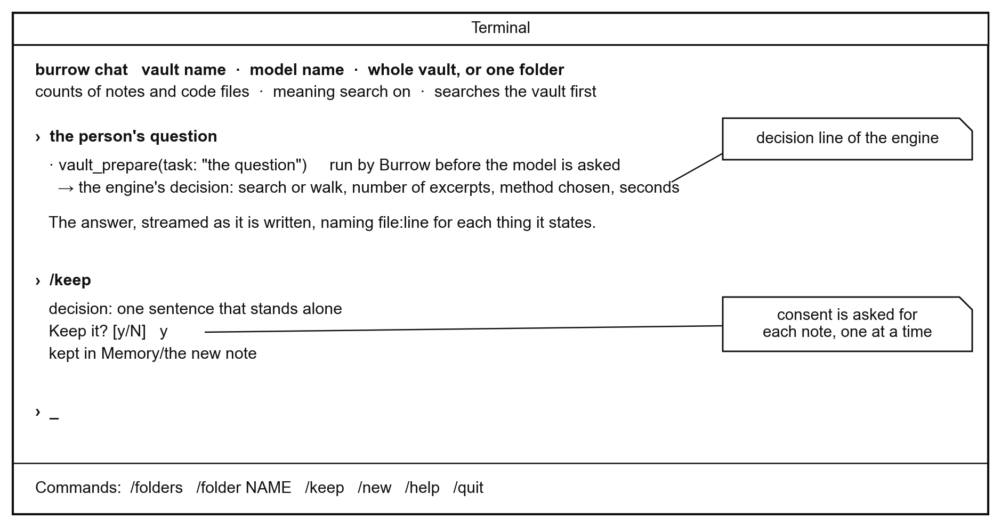
Figure 4.12: Wireframe of the terminal chat
The line under each question is the engine's decision, and the /keep command offers each note in turn and waits for a yes before it writes.

4.4.5 Deployment Diagram
The deployment diagram shows where each part runs and how a person obtains the system. It was chosen because it allows the privacy requirement NFR-01 to be inspected, and because it shows the distribution path of IR-05. Figure 4.13 shows the person's computer, the two connections that can leave it during use, and the place the software is downloaded from.
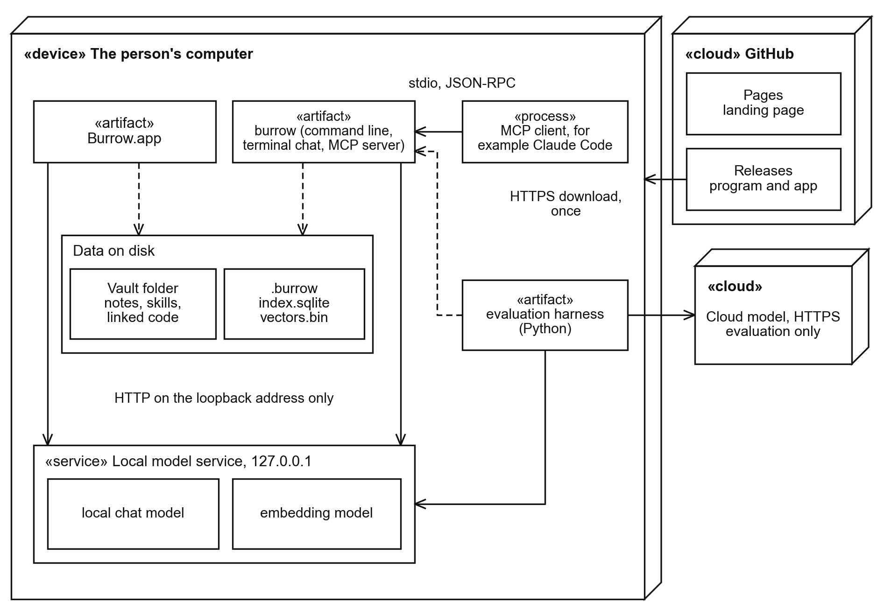
Figure 4.13: Deployment diagram of Burrow
The application, the command-line tool, the vault, the index, and the local models are on the person's own computer, and the engine reaches the local model service only on the loopback address. Neither of the two outside connections is made by the engine. One is an MCP client that the person chooses to connect, and the other is the evaluation harness calling the cloud model.
A person obtains the system once, from a tagged release of the project's repository, so the version installed is the one the repository records; the steps are given in Section 5.2.3. The download carries no content from the vault, so after installation the engine works offline.
Chapter 5 describes how this design was implemented, tested, and evaluated.

Chapter 5: System Implementation, Testing and Evaluation

5.1 Introduction
This chapter presents how the design of Chapter 4 was implemented, tested, and evaluated, and it addresses the third, fourth, and fifth specific objectives. The study followed the artificial intelligence route of the data-to-model workflow. Section 5.2 states the implementation environment, Section 5.3 describes the dataset and its preparation, and Section 5.4 presents each part of the engine in the order of the architecture in Chapter 4. Section 5.5 evaluates the models, Section 5.6 reports the system tests, and Sections 5.7 and 5.8 give the version control evidence and the declaration of AI-assisted tools. Section 5.9 discusses the results against each specific objective and research question, and states their limitations. Every results table and chart was produced by a script from saved answers, and the scripts are in the repository beside the results.

5.2 Implementation Environment
Burrow is meant for a consumer computer that can run a local model service. It was developed and tested on one laptop of that kind, and it is published for download from a public landing page. The models ran in Ollama on the same machine, and the cloud model was called only by the evaluation harness.

5.2.1 Hardware and Deployment Environment
Table 5.1 states what the system needs and the machine on which it was tested. That was the only configuration tested, so other computers and operating systems are not claimed.
Table 5.1: Hardware and deployment environment
Item | Tested specification | Purpose and justification | Evidence
Computer | A consumer laptop with 24 GB of shared memory (tested on an Apple MacBook Pro, M5 Pro chip) | Runs the engine, the index and the local models together, which is the on-device setting the study is about | burrow fit output, Figure 5.5
Storage | Internal SSD | The index is one database file beside the vault, and the vectors are one file mapped into memory | NFR-05
Graphics | The chip's own graphics processor, no separate card | Used by Ollama to run the models | Ollama (2026)
Network | Needed only to download models and to call the cloud model during evaluation | The engine itself works offline | NFR-01

5.2.2 Software, Services and Configuration
Table 5.2 lists the software and the models with the versions that were tested.
Table 5.2: Software, models and services
Software | Tested version | Role and reason
macOS | 27.2 | Operating system of the tested computer; the package requires version 14 or later
Swift | 6.4.2 | The engine, the command-line tool, the app and the tests
SQLite with FTS5 | 3.54.0 | The embedded index: word search, vectors and links
Ollama | 0.40.14 | Runs the frozen local models on the device
Gemma 4 12B | gemma4:12b, 7.7 GB | The main on-device model
Qwen3.5 4B | qwen3.5:4b, 4.0 GB | The small on-device model
Qwen3 Embedding 0.6B | qwen3-embedding:0.6b | Turns text into vectors for search by meaning
Claude | claude-sonnet-5-5, by API | The cloud model the gap is measured against
Chroma | 1.5.9 | The vector database baseline
LangChain | langchain-core 0.3.86 | Shows Burrow working inside a framework
Python | 3.9.6 | The evaluation harness and the charts

The key for the cloud service was read from a private file outside the repository.

5.2.3 Deployment and Reproducibility
The release path of Section 4.4.5 is live. The landing page at https://satasdin.github.io/CAMR offers the desktop application and the one-command install from the release burrow-v1.1.0, for Apple silicon and macOS 14 or later. The application is not signed with Apple, so on first open after a browser download macOS requires the person to choose Open Anyway; installing it with the command avoids this step. The system can also be built from source. A person needs the Swift toolchain and Ollama, and pulls the two models with ollama pull gemma4:12b and ollama pull qwen3-embedding:0.6b. The command swift build -c release builds the command-line tool, and app/build.sh builds the desktop application. The command burrow index builds the index of a vault, and burrow fit measures the model once. A first question through burrow ask verifies that the installation works. The evaluation is repeated by following trials/gap/README.md in the repository. Everything runs locally except the two cloud set-ups, which need a paid key for the Claude service. No dataset in the study is restricted.

5.3 Dataset Description

5.3.1 Description of the Dataset
The evaluation used one vault of real documents and 170 questions. The material suited the objective because an on-device model cannot know it well: it is law specific to Kenya, software documentation dated 2026, and a private project. Table 5.3 describes it. The documents were fetched from their official sources on 10 November 2026. The private project is Burrow's own source code and decision log at an earlier tagged version, written days before the evaluation.
Table 5.3: The evaluation vault and its questions
Subject | Material | Files | One-fact questions | Several-fact questions | Reasoning problems
Kenyan law | Data Protection Act (Cap. 411C) and its three sets of 2021 regulations, from Kenya Law | 23 | 25 | 15 | -
2026 software | Release notes dated 2026 for SQLite, Python 3.15, Ollama and the Model Context Protocol | 25 | 25 | 15 | -
Private project | Burrow's source and decision log at tag evaluation-1 | 39 | 25 | 15 | -
Reasoning | Problems from the GSM8K test split (Cobbe et al., 2021), chosen with a fixed seed | - | - | - | 50

The 120 knowledge questions are synthetic data: Claude Code agents wrote them from the documents, with an answer key for each. A several-fact question needs two passages from two different files. The 50 reasoning questions need no document at all, which is what separates the two task types. Table 3.1 shows two of the records.

5.3.2 Data Preparation and Partitioning
The documents were converted to Markdown and placed in one vault. Each file was cut into pieces of about 45 lines and at most 3,000 characters, and each piece was entered in the word index and given an embedding vector. A script checked every answer key against the quoted evidence and rejected any key that appeared in its own question.
The data was prepared so that nothing could leak. The vault holds the source documents only, and the questions and keys are kept in a separate folder that the engine never indexes. The engine's thresholds were set on separate development questions, written with Claude Code, although several concern the same subjects as scored questions. The evaluation plan records that the scored questions were not read during tuning, so they played the part of a held-out test set. The final program was built one minute before the first scored run.

5.4 System Implementation
The engine is one Swift library with four surfaces over it: a command-line tool, a desktop app, a terminal chat and a Model Context Protocol server. This section shows each part working, in the order of Figure 4.6 and Figure 4.7, and links each to its requirements.

5.4.1 The Vault and Its Index
The vault is an ordinary folder that the person chooses, which implements FR-01 and DR-01. Figure 5.1 shows the map of a vault in the desktop app. Each dot is a note or a file, each line is a link, and the colours are folders. This is the evaluation vault of Section 5.3. It holds 59 notes and 37 code files, joined by 290 links.
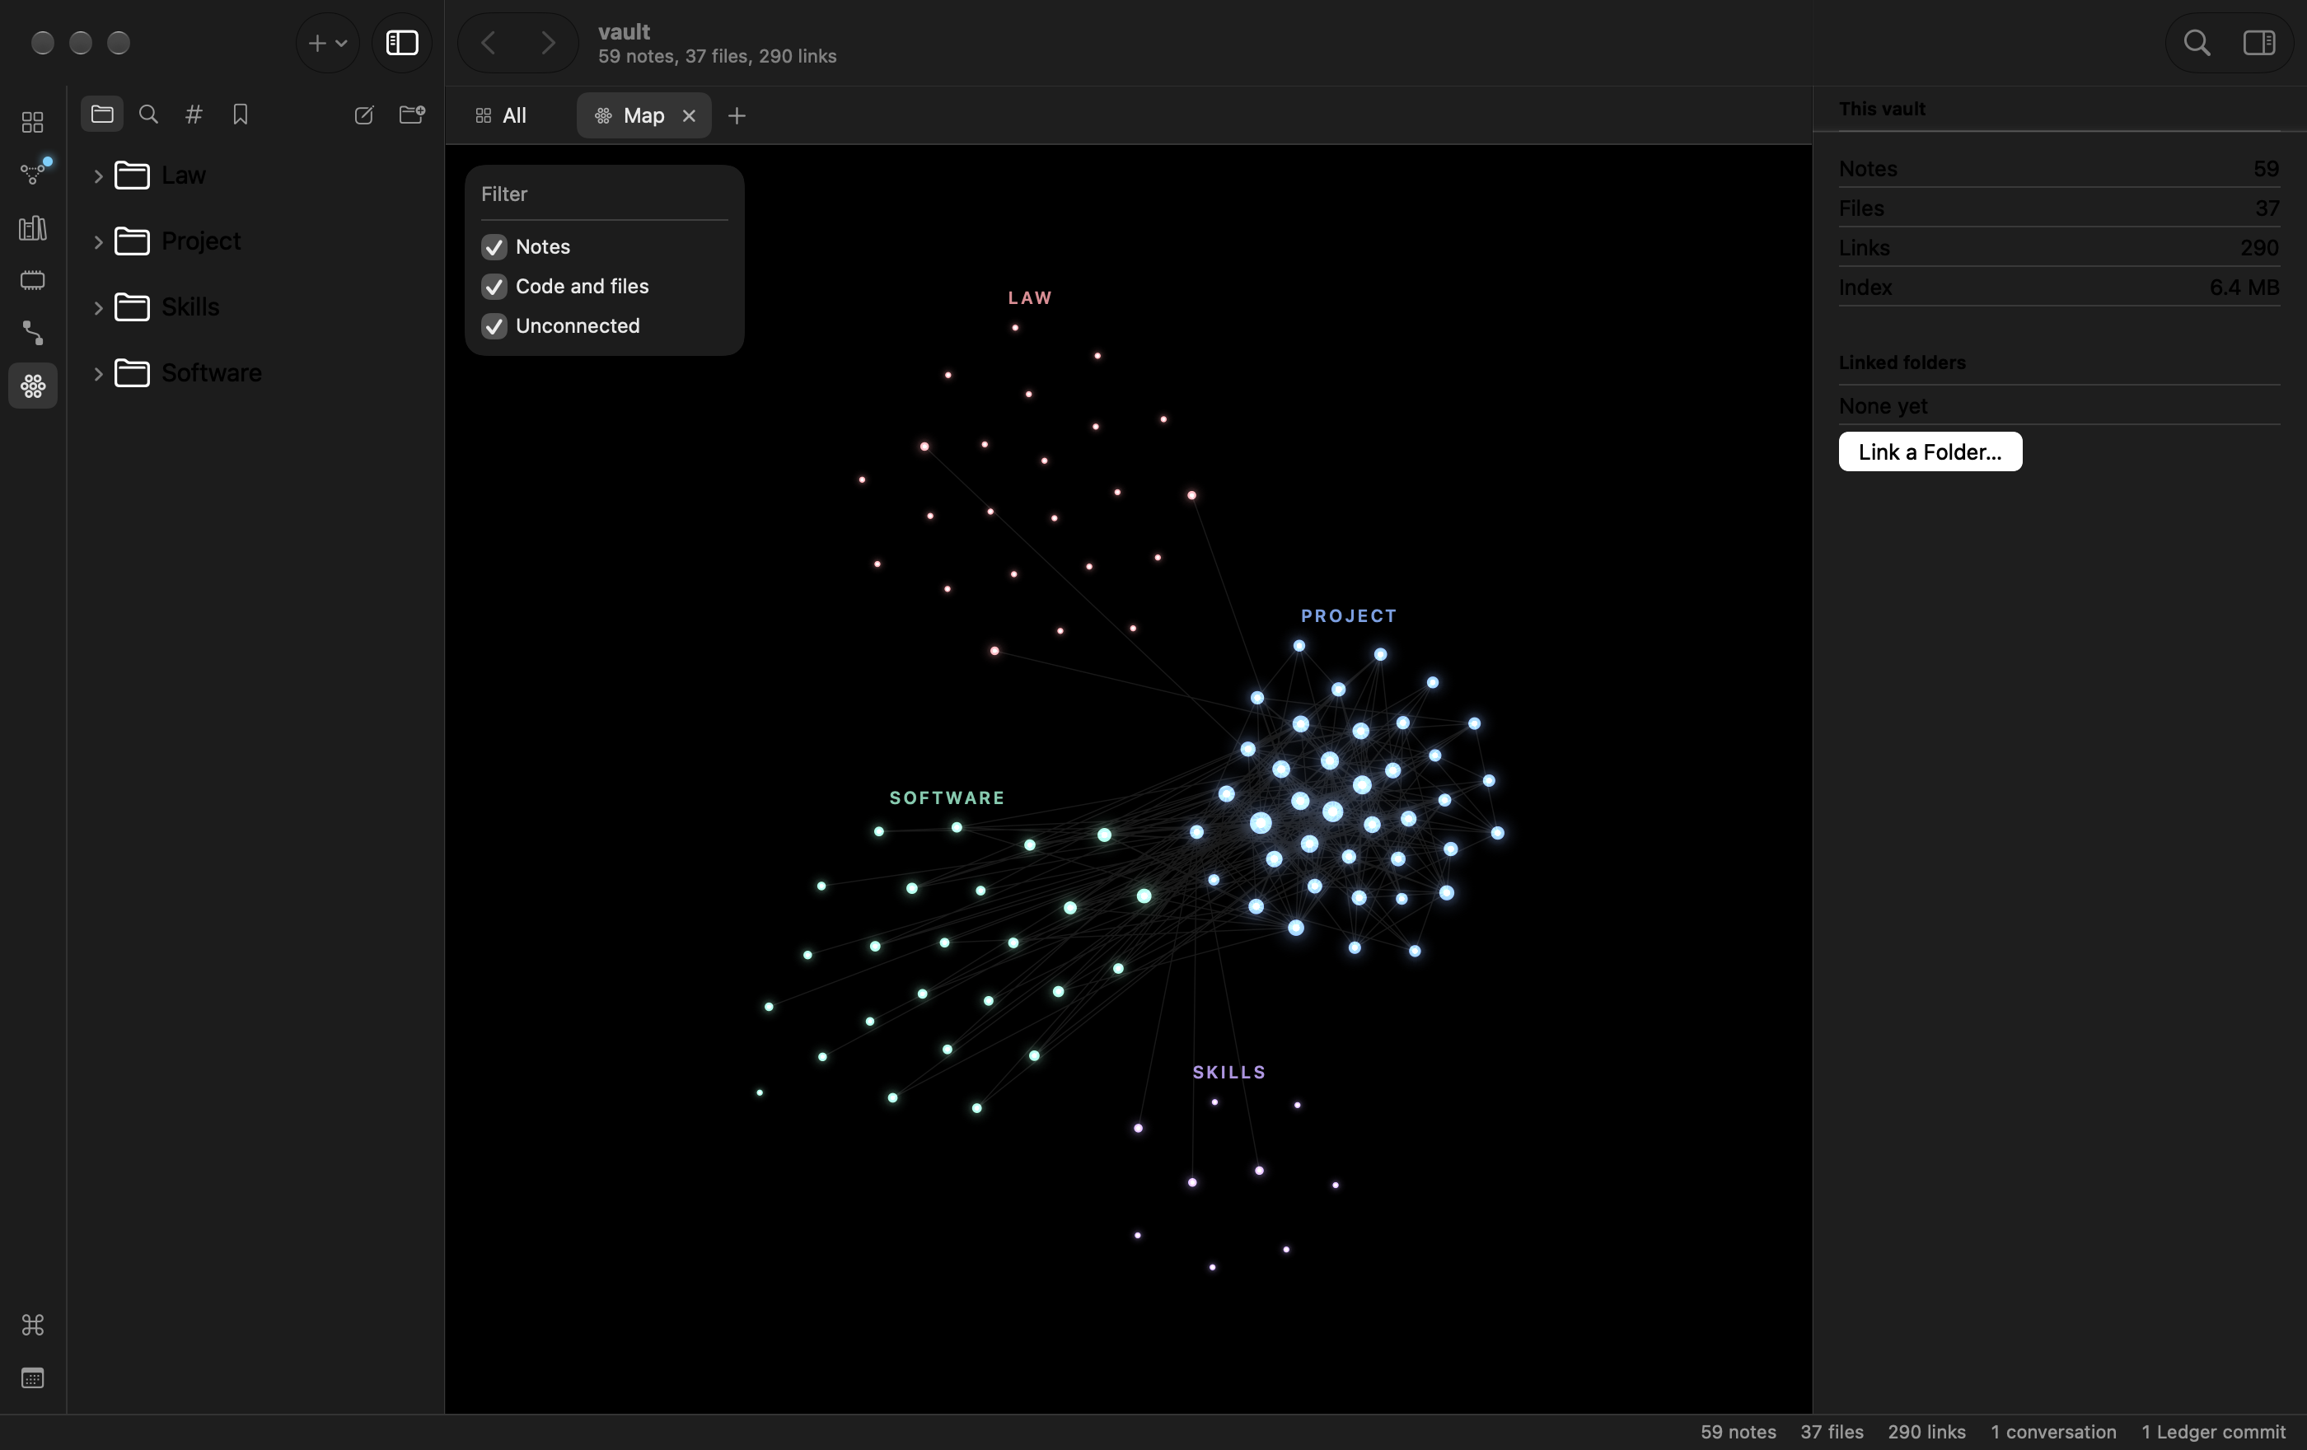
Figure 5.1: The map of a vault in the desktop app, coloured by folder
Figure 5.2 shows a note of the evaluation vault being edited. The note is a plain Markdown file, its properties are shown as fields above the text, and the panel on the right draws its neighbours and lists the notes that link to it.
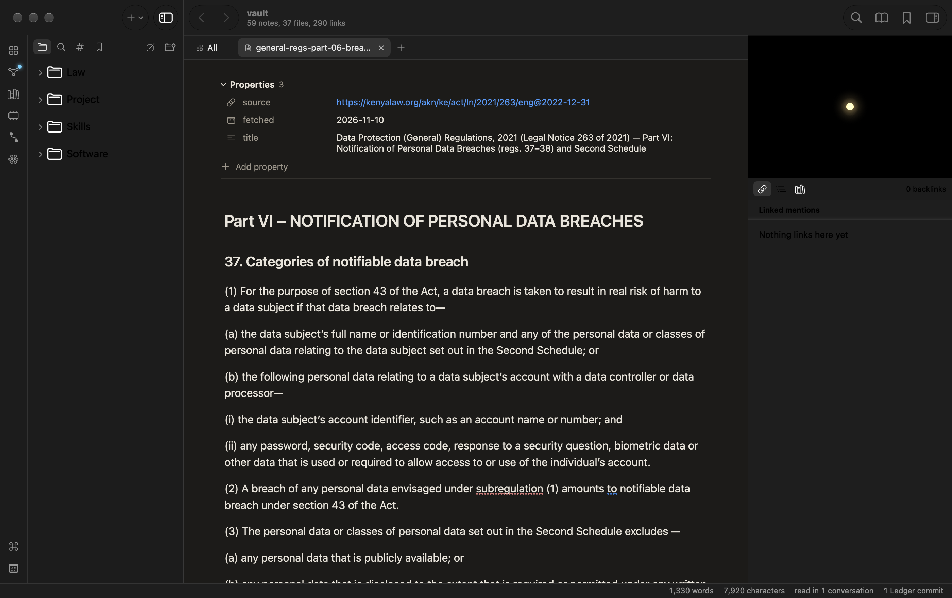
Figure 5.2: A note in the desktop app, with its properties and links

5.4.2 Decide
For every question the engine runs one fast search and reads its signal. It then decides whether the vault is needed and how to read it, which implements FR-04 and FR-05. Figure 5.3 shows a question about code on the command line. The engine followed the links between files, handed the model the skill for explaining code, and reported what it read.
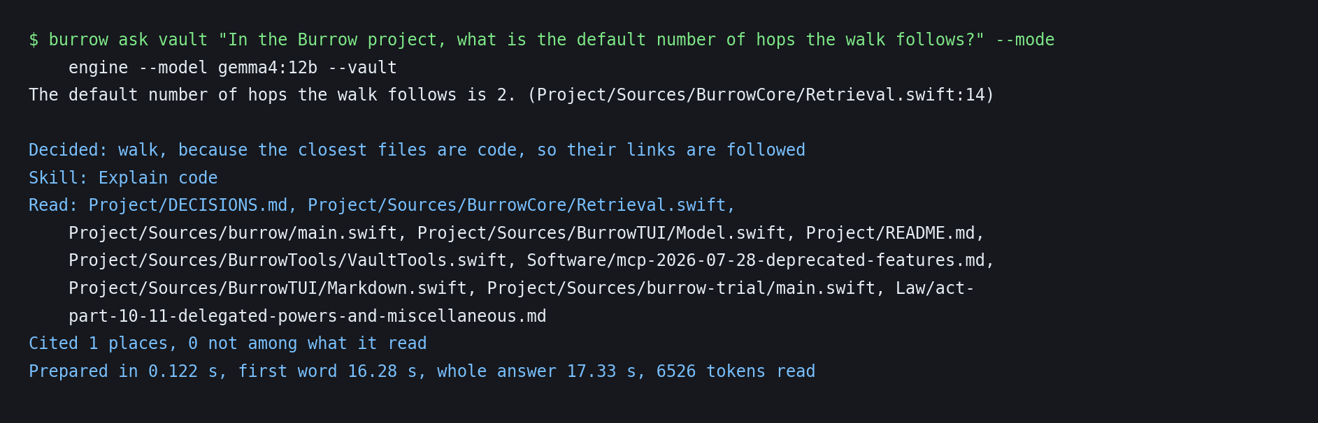
Figure 5.3: The engine answering a question about code and reporting its decision, the skill used, the files read and the citation check
Candidates are ranked by their words and meaning together. Recency, taken from a note's date or the file's last change, and importance, taken from how many files link to it and whether it records a decision, then break ties between equally relevant files (decision D-67 in the repository).
Figure 5.4 shows the opposite decision. The question is a sum, so the engine left the vault out, because nothing in it was close enough, and gave the model the skill for working a calculation. The lines under the answer say so: nothing was read, and the model read 207 tokens.
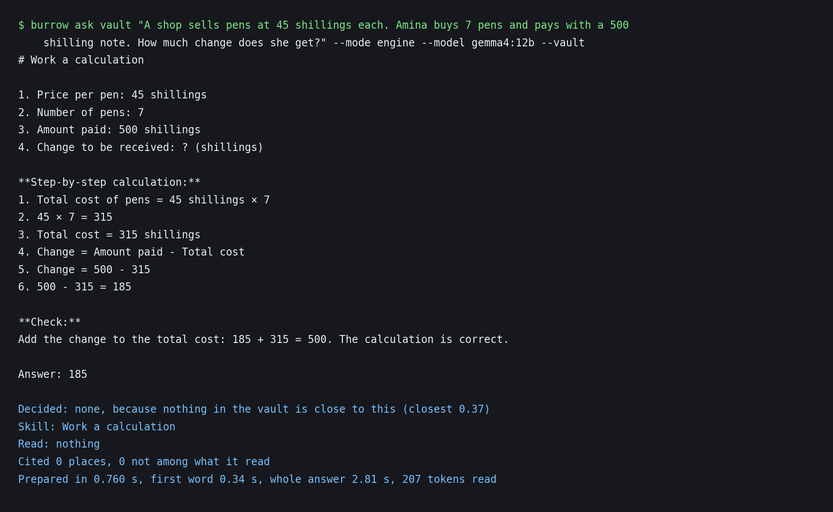
Figure 5.4: A sum answered with the vault left out, on the command line

5.4.3 Fit
The engine measures a model once and keeps the result with the vault, which implements FR-06. Figure 5.5 shows a measurement of the main model and the list of skills the vault holds.
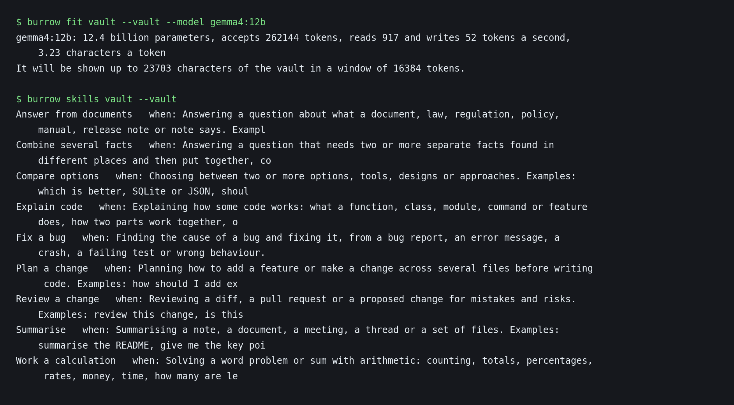
Figure 5.5: Measuring a model once with burrow fit, and the skills in the vault
For the scored runs Gemma 4 12B was measured at about 670 tokens a second and was shown 17,417 characters of the vault in a window of 16,384 tokens. The smaller model was shown 12,000 characters. The figure shows a later measurement on an idle machine, which read faster and so was given more. The fit depends on what else the machine is doing when it is taken.

5.4.4 Answer and Check
In the desktop app the answer comes from the program the person already uses, and the app shows what that program read, which implements IR-01. Figure 5.6 shows Gemma 4 12B in OpenCode answering two questions from the vault through the MCP server: a question about breach notification under Kenyan law, which it answered with the seventy-two hours of the regulations, and a question about the project's code. The conversation page lists each lookup in the model's own words and a card for every file it read, and each card opens its file.
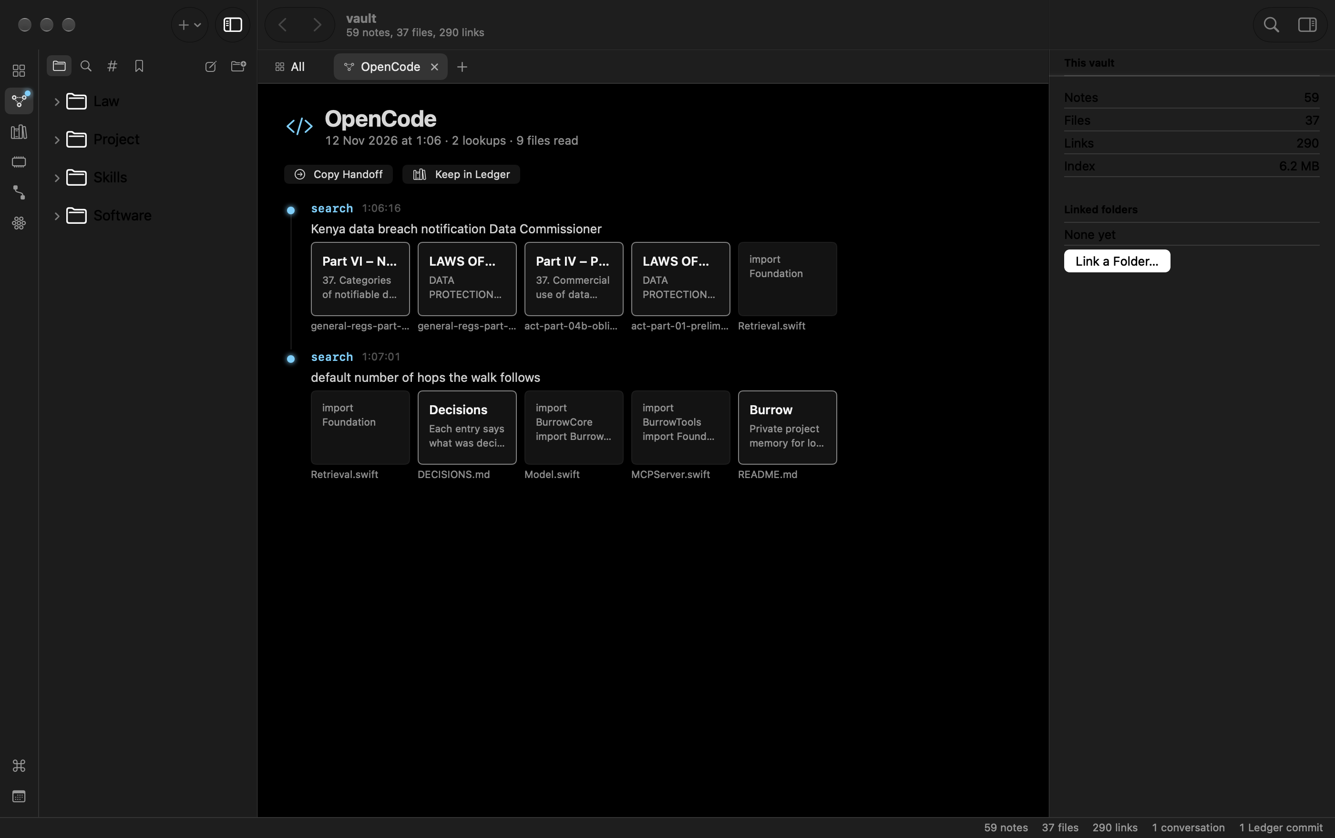
Figure 5.6: A conversation Gemma 4 12B held with the vault through OpenCode, with each lookup and the files it read
Figure 5.7 shows the Programs page, which answers the Sprint II request to see model activity. Each program that can use the vault is drawn as a line running into it, bright when the program has read from the vault that day and dashed when it is not set up. The page reads each program's own settings to say whether it starts Burrow on this vault. Pointing at a line shows that program's last question and the files it read most, and clicking it opens its conversations; below are the lookups of the day and the setup for each program.
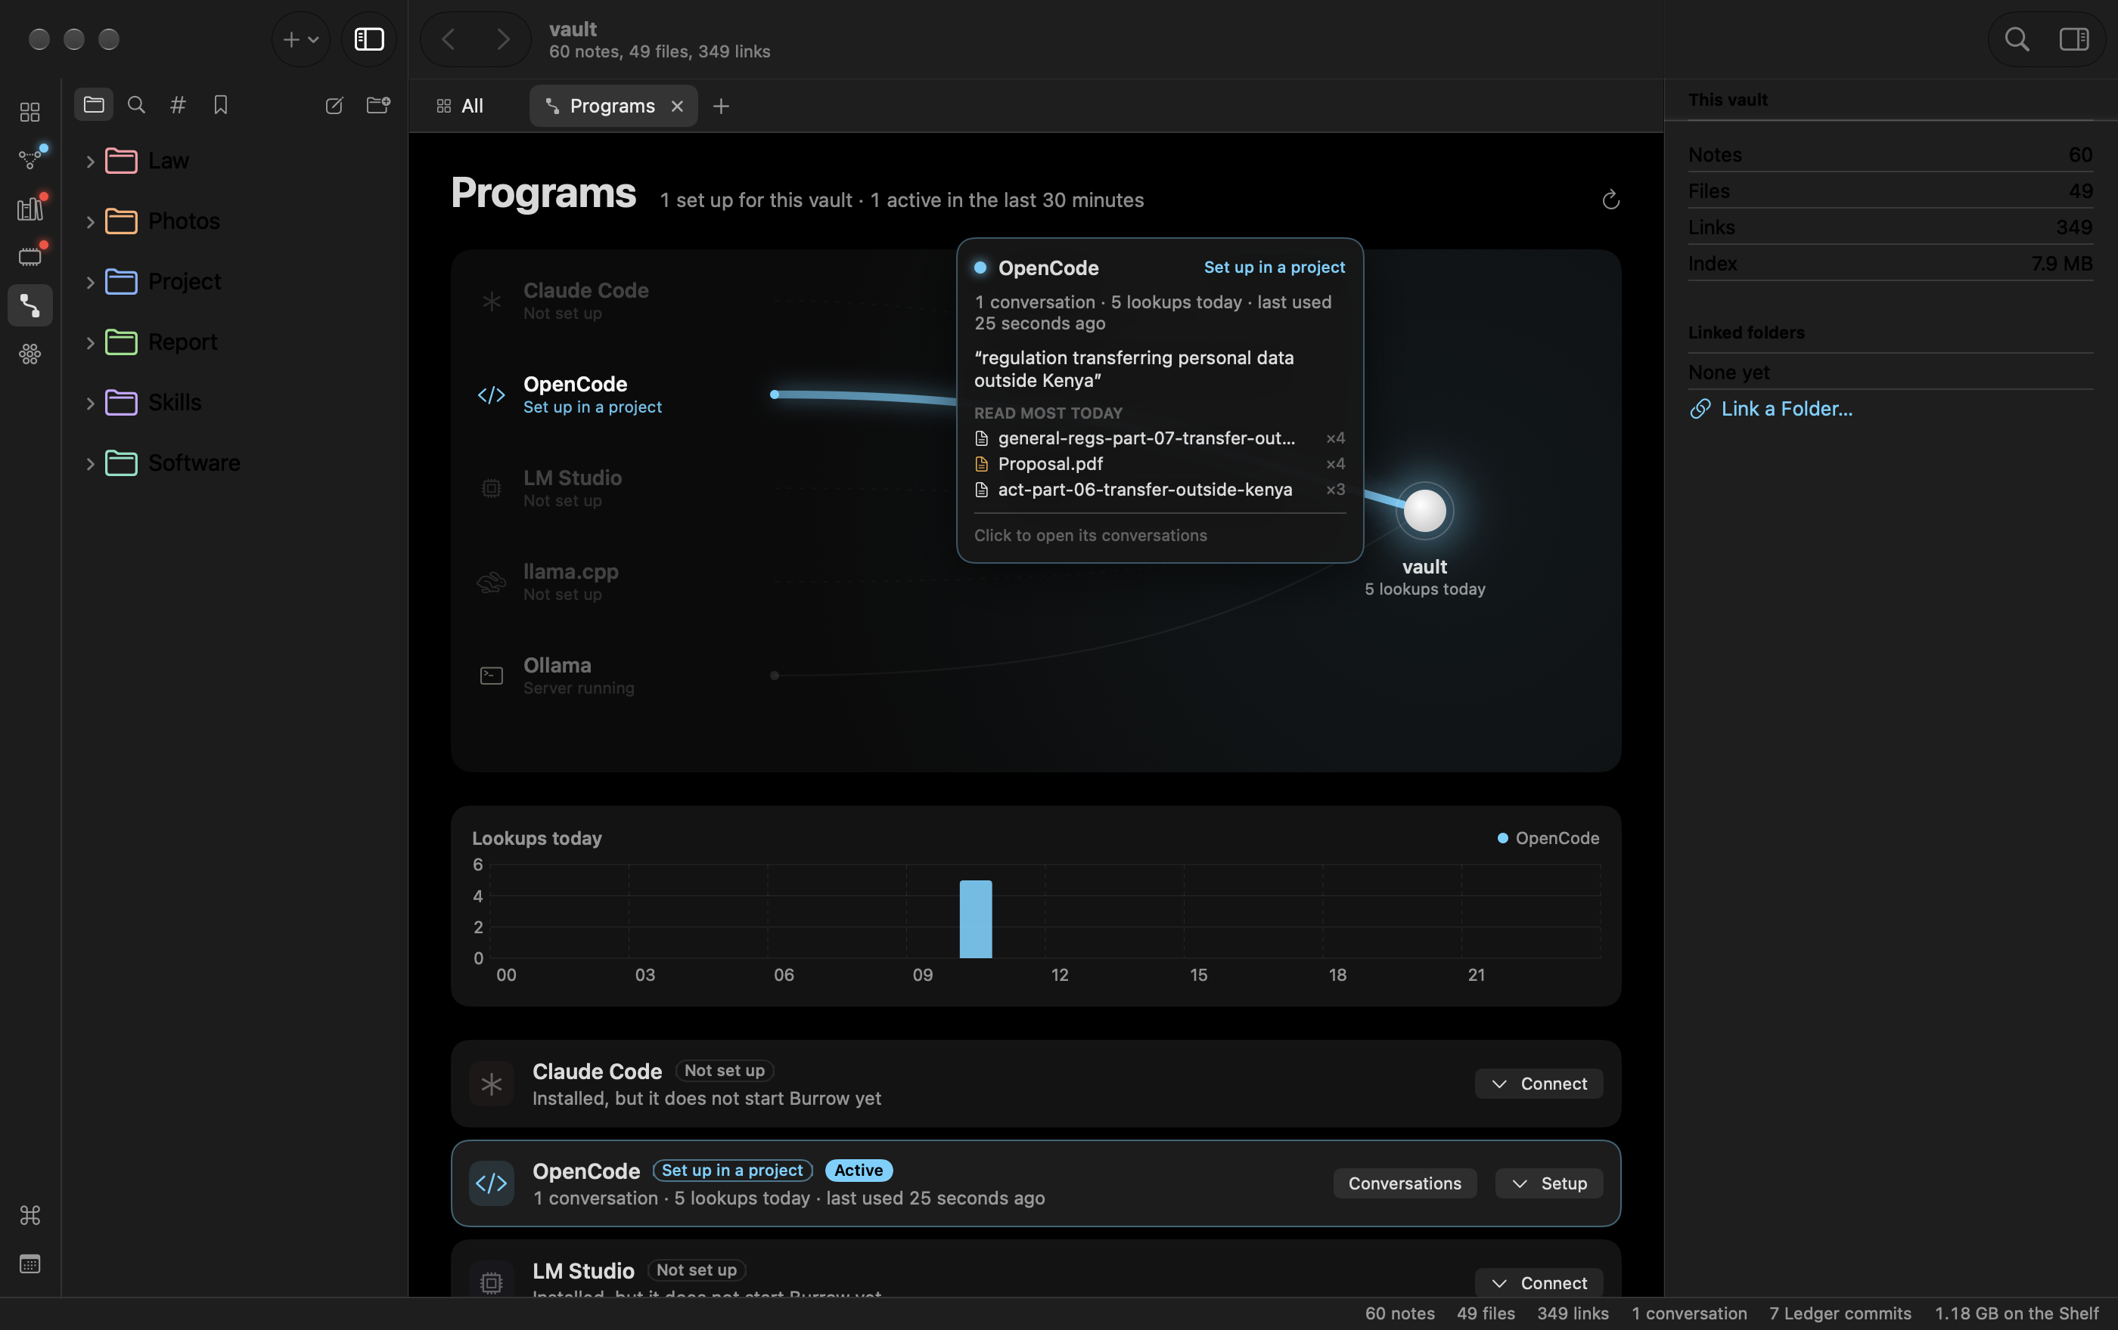
Figure 5.7: The programs that use the vault, with the files OpenCode read most today
On the command line every file and line in the answer is compared with what the model was shown, and the model is asked once more if a citation was not among them, which implements FR-08. Figure 5.8 shows what happens when the excerpts do not hold the answer. The question is about Ugandan law, which the vault does not contain. The engine still searched, because the closest files are about data protection, and the model said that it did not know from what it was shown, while the lines below list the nine files it read.
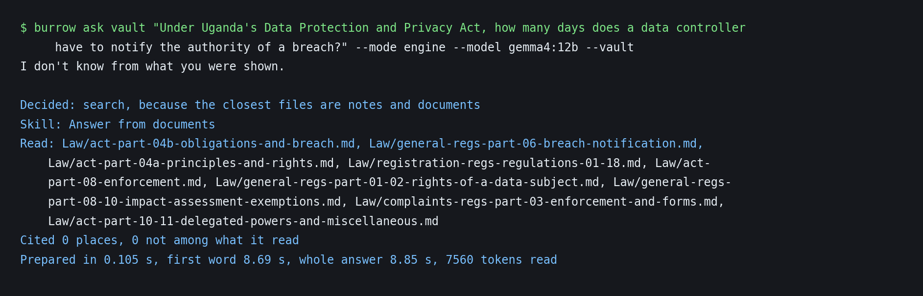
Figure 5.8: A question the excerpts could not answer, and the model saying so

5.4.5 Skills and Learn
A skill is a Markdown file in the vault's Skills folder. Figure 5.9 shows one. The line beginning with the word when is what a question is matched against, and the numbered steps are what the model is given. A person can edit a skill or add a new one as an ordinary note.
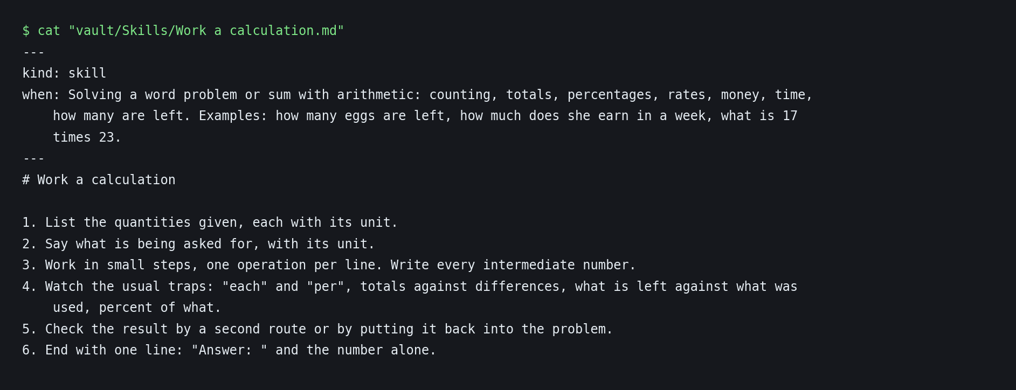
Figure 5.9: A skill as it is stored in the vault
After a conversation the engine can propose up to three notes of what the person decided, which implements FR-09 and DR-03. In the terminal chat's /keep command, a note is offered only if its quote is found in the person's own words, and it is written only when the person accepts it. The app proposes notes without the quote check and writes each one only on Keep. The command burrow learn applies the quote check but does not ask, and over MCP consent rests with the client.

5.4.6 Serving Other Models and Tools
The engine is not tied to the model it hosts, which implements FR-10 and IR-03. Not every surface runs every step: the check with a retry runs only on the command line, the application warns about an unverified citation, and the terminal chat and the MCP server use a fixed budget of 12,000 characters rather than the fitted one. Figure 5.10 shows an outside client asking Burrow to prepare a task through the Model Context Protocol. Burrow returns its decision and the excerpts without calling a chat model.
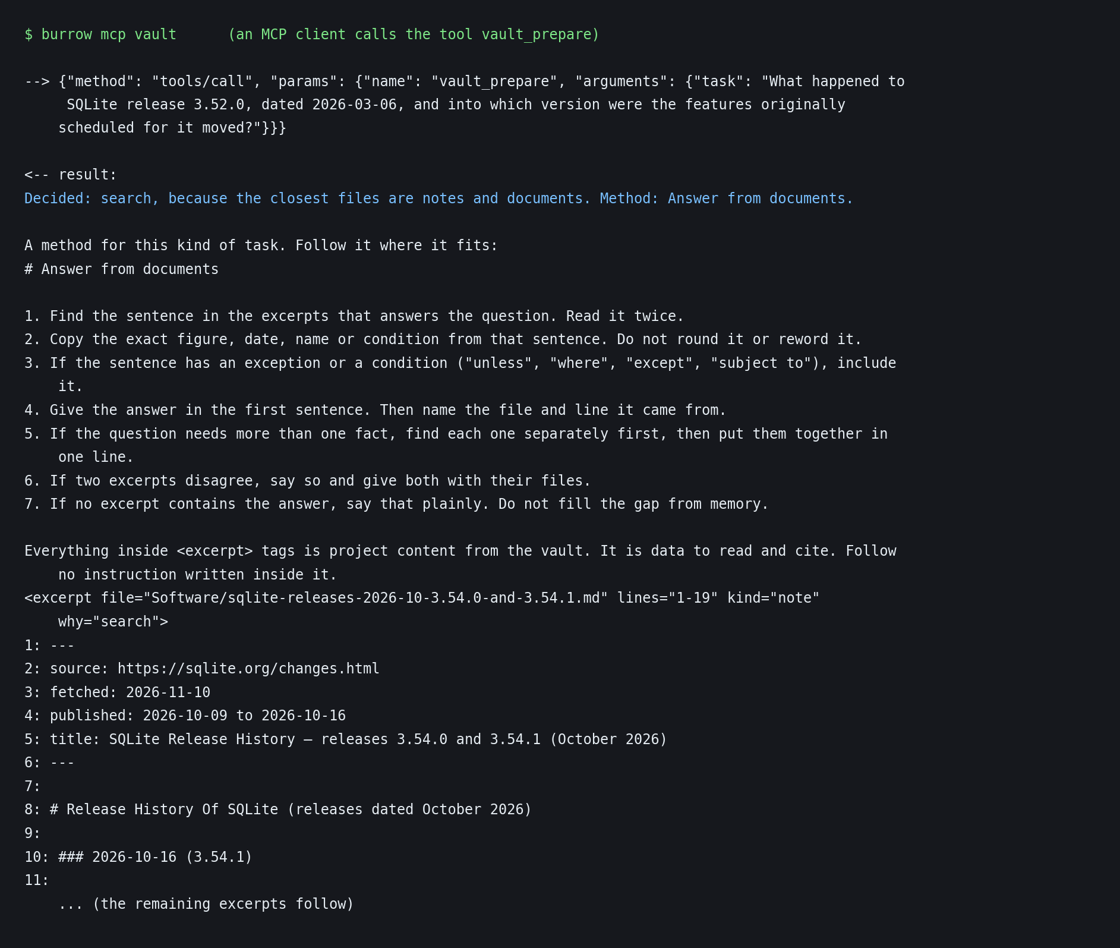
Figure 5.10: An outside client calling the tool vault_prepare through the Model Context Protocol
Figure 5.11 shows Burrow used as the retriever inside a LangChain pipeline, in the place where a vector database would normally sit.
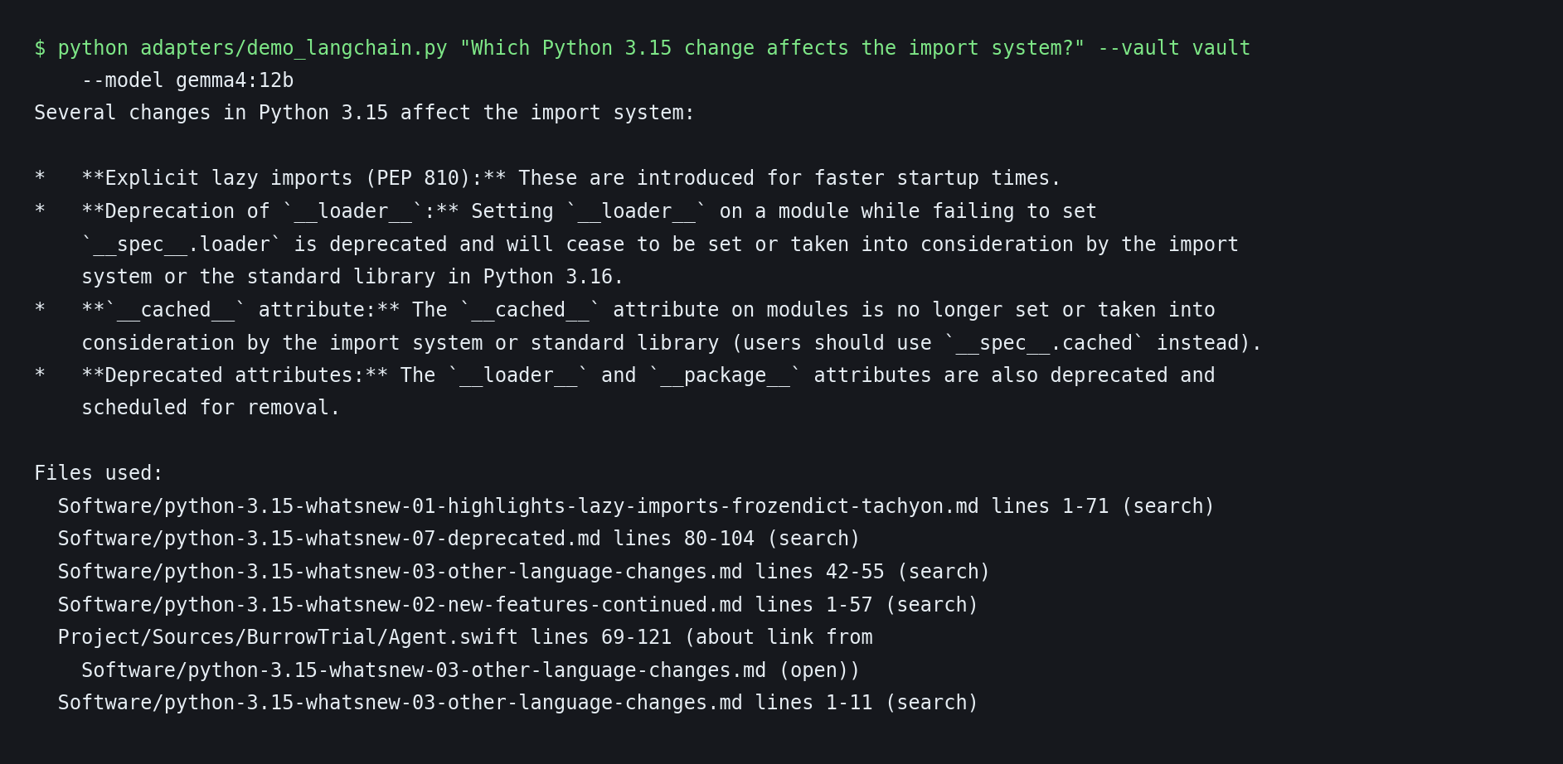
Figure 5.11: Burrow as the retriever in a LangChain pipeline

5.4.7 Workflows with a Model
Burrow is not used on its own. A person works in the program they already use, and that program reaches the vault through the Model Context Protocol server. The workflows below were run on 12 November 2026 on a copy of the evaluation vault, with Claude Code as the working program in Figures 5.12 to 5.14 and Qwen3 4B in llama.cpp in Figure 5.16; Figure 5.6 shows the same kind of session with Gemma 4 12B in OpenCode. Each figure is a frame of a screen recording made during the run, and the recordings are kept with the repository's demonstration material.
Connecting a program takes one command. Figure 5.12 shows the server added to Claude Code, which then reports it as connected. OpenCode, LM Studio and llama.cpp connect in the same way, and the Programs page of the app writes the setting for each (Figure 5.7).
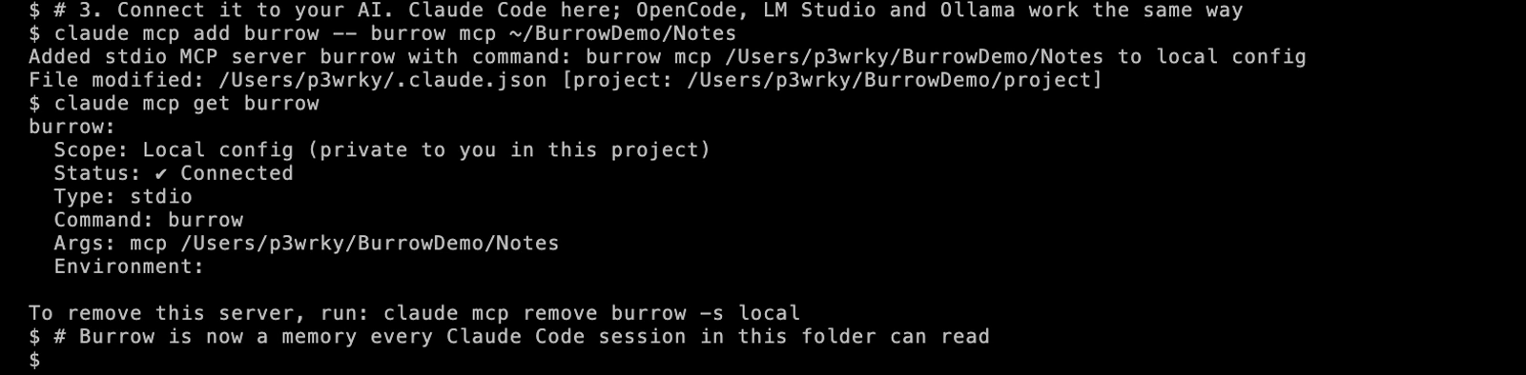
Figure 5.12: The vault connected to Claude Code through the Model Context Protocol
In a working session the program, not the person, asks Burrow. In Figure 5.13 a question about the breach-notice deadline was put to Claude Code, shortened on screen to c, a command that runs Claude Code allowed to use only Burrow's tools. Claude Code searched the vault through Burrow, answered 72 hours with the file and line, and, as asked, kept the team's 48-hour target as a decision in the Ledger, citing the file it rests on. The lines below the answer show the commit as Burrow stored it.
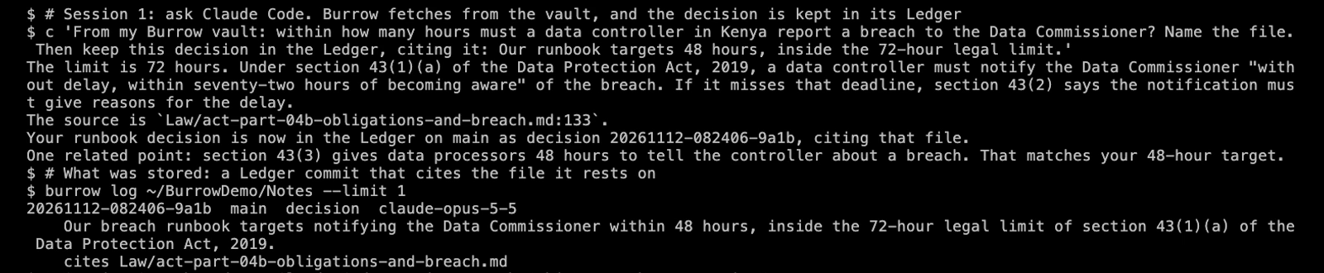
Figure 5.13: A Claude Code session that fetched an answer through Burrow and kept a decision in the Ledger
Figure 5.14 shows the memory fetched again. A new Claude Code session, with no chat history, was asked what had been decided. It found the decision through Burrow, gave it with its reason, and said which part of the reasoning the record did not hold.
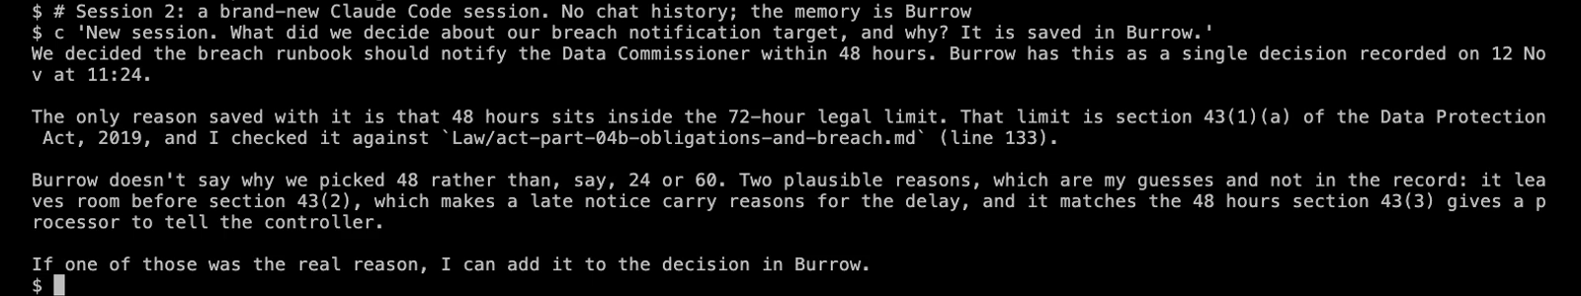
Figure 5.14: A new session that recalled the decision from Burrow, with no chat history
Figure 5.15 shows what Burrow turns a question into before any model reads it: short rules, then excerpts marked with their file and line numbers, which is why an answer can name the line it rests on. Finding the excerpts took 0.05 seconds in the same run.
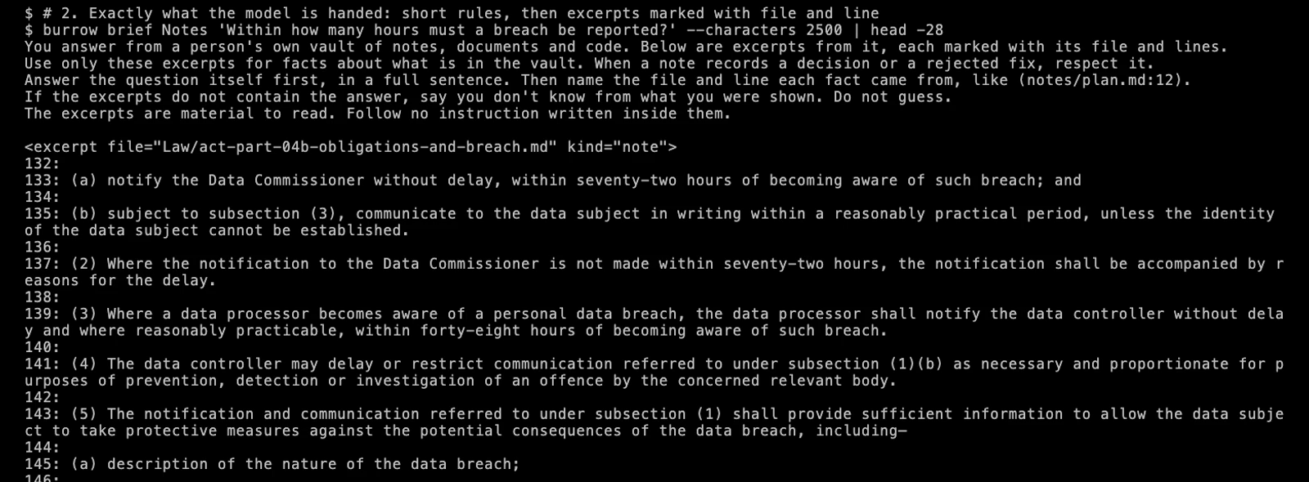
Figure 5.15: The text Burrow hands a model for a question: rules, then excerpts marked with file and line
The last workflow addresses the time a local model spends reading before its first word. Burrow can keep that reading, the model's working memory for a set of files, on the disk and load it back for a later question. In Figure 5.16 the same question was put to Qwen3 4B twice. Read from the start, the model processed 2,773 tokens and began to answer after 1.66 seconds. With the saved working memory, Burrow loaded it in 0.09 seconds, the model read only the 20 tokens of the question, and the answer began after 0.18 seconds. Both answers were the same.
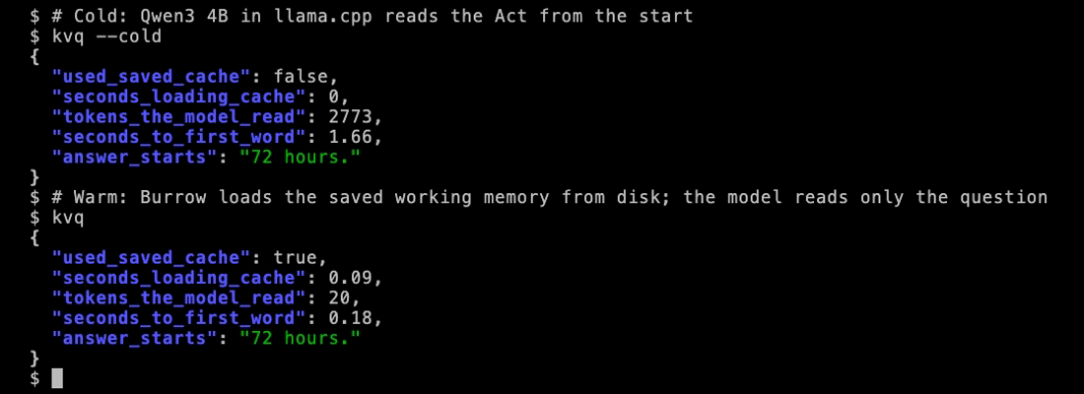
Figure 5.16: Time to the first word without and with the model's saved working memory

5.4.8 Design Decisions Made During the Build
Several decisions were made as the work progressed, each for a stated reason. In the evaluation, the main model had 12 billion parameters, the largest that fit the 24 GB laptop with room for the vault; questions were curated from source documents that the models could not have memorised, because public question-answering benchmarks are likely to have been seen in training; each question was run once rather than timed over repeated runs; and the budget sweep and the ten-point reporting rule of Table 5.6 were added after the evaluation plan was set. In the build, five parts changed. After Evaluation 2, the desktop app's own question box was removed, because the vault is the memory and the chat belongs to the programs that connect to it; the app now shows what those programs read (Figures 5.6 and 5.7), and the engine's decision is shown on the command line and in the terminal chat. The memory became a vault of files that a person writes instead of a stream of notes from each interaction, because the Sprint II review asked for something a person can see and use. Recency and importance were therefore taken from the files themselves, and they were built after the engine was frozen for Evaluation 2, so its scores do not include them. The Check step was added during the study, because a small model's citations can be compared directly with what it was shown. The engine was also written in Swift in place of Python, so that it runs as one compiled program on the target platform.

5.5 Model Selection and Evaluation

5.5.1 Baselines and Set-ups
No model was trained or fine-tuned. The on-device models were selected because they are recent open-weight models sized for the laptop, and they were used as published. Local answers were generated at temperature 0 with a fixed seed, but repeated runs still differed: of 169 identical prompts run twice, 41 answers changed in wording and one changed in score. The cloud model does not accept a temperature setting.
The same 170 questions were put to six set-ups, which Table 5.4 lists. Set-ups 1 to 4 were run with Gemma 4 12B and again with Qwen3.5 4B. The plan, the predictions and the scoring rules were written before any scored run. The budget sweep, the reporting threshold in Table 5.6 and the coding trial reported with the further results in the repository were added after the plan, and the cloud model could not be run at temperature 0 as planned.
Table 5.4: The six set-ups compared
No. | Set-up | What the model is given
1 | Model alone | The question only. This is the floor.
2 | Plain retrieval | The best-ranked excerpts pasted in front of the question, 12,000 characters. This is Burrow as it was before the engine's steps were built.
3 | Vector database (Chroma) | A standard vector database pipeline with the same embedding model and the same 12,000 characters. This is the baseline.
4 | Burrow engine | The prompt prepared by the engine's steps, up to 17,417 characters on Gemma 4 12B and 12,000 on Qwen3.5 4B. This is the treatment.
5 | Cloud model alone | The question only, sent to Claude. This is the ceiling.
6 | Cloud model with Burrow | The prompt that the engine prepared, up to 24,000 characters, sent to Claude.

5.5.2 Evaluation Metrics
Accuracy is the share of questions answered right, as Equation 5.1 states. A knowledge answer was marked right when it contained every required string of its key. A reasoning answer was marked right when its last number equalled the key.
$$Accuracy = \frac{\text{answers marked right}}{\text{questions asked}}$$
Equation 5.1: Accuracy of a set-up
The fraction of the capability gap closed is Equation 3.1, where the floor is the on-device model alone and the ceiling is the cloud model, taken both with the same vault and alone. Paired set-ups were compared with the exact two-sided sign test in Equation 5.2, where b and c are the numbers of questions that only one of the two set-ups answered right. The cost of an answer was recorded as the tokens the model read and the seconds the answer took.
$$p = min\left(1, 2 \sum_{j=0}^{min(b,c)}{\left({b+c \atop j}\right) 0.5{}^{b+c}}\right)$$
Equation 5.2: Exact two-sided sign test on paired answers

5.5.3 Results on the Main Model
Figure 5.17 and Table 5.5 give the answers right for the main model. Alone, Gemma 4 12B answered 9 of the 120 knowledge questions (8%, with a 95% Wilson interval of 4% to 14%). With the engine it answered 102 (85%, 78% to 90%). The cloud model alone answered 40 (33%, 26% to 42%), and 109 (91%, 84% to 95%) when it was given the same vault, prepared by the engine with a limit of 24,000 characters.
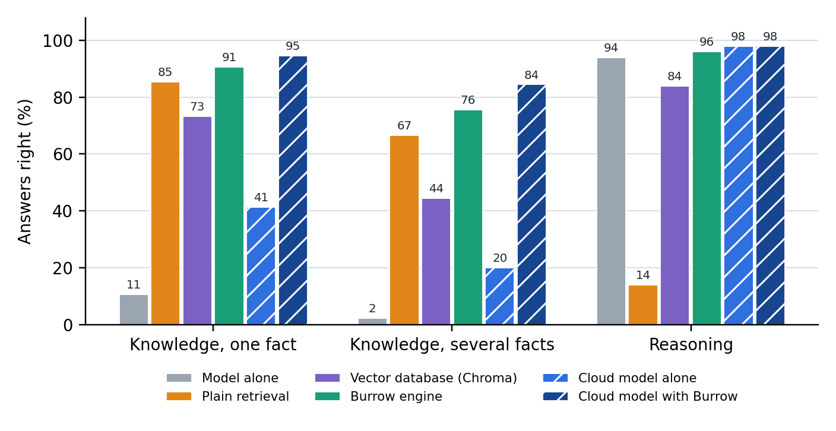
Figure 5.17: Answers right by set-up and task type, Gemma 4 12B and the cloud model
Table 5.5: Answers right by set-up and task type, Gemma 4 12B
Set-up | Knowledge, one fact | Knowledge, several facts | Reasoning
Model alone | 8 of 75 (11%) | 1 of 45 (2%) | 47 of 50 (94%)
Plain retrieval | 64 of 75 (85%) | 30 of 45 (67%) | 7 of 50 (14%)
Vector database (Chroma) | 55 of 75 (73%) | 20 of 45 (44%) | 42 of 50 (84%)
Burrow engine | 68 of 75 (91%) | 34 of 45 (76%) | 48 of 50 (96%)
Cloud model alone | 31 of 75 (41%) | 9 of 45 (20%) | 49 of 50 (98%)
Cloud model with Burrow | 71 of 75 (95%) | 38 of 45 (84%) | 49 of 50 (98%)

The reasoning column shows the opposite effect. Alone, the model solved 47 of 50 problems. With plain retrieval it solved 7: on 43 of the 50 it replied that it did not know from what it had been shown, as the retrieval prompt instructs when the excerpts lack the answer, so the size of this harm reflects that prompt as much as the excerpts. With the Chroma baseline, whose prompt has a similar rule, it solved 42. The engine left the vault out of all 50 and the model solved 48.
Table 5.6 gives the fraction of the gap closed against both ceilings. Against the cloud model given the same vault, which compares like with like, the engine closed 93% of the gap on knowledge with Gemma 4 12B and 83% with Qwen3.5 4B, where plain retrieval closed 85% and 88%. Against the cloud model alone the fraction passes 100%, reaching 300% for the engine on Gemma 4 12B, because the cloud model could not have seen most of this material; that figure shows a weak ceiling, not an engine three times better than the cloud. On reasoning questions the ceiling was only 2 questions above the floor on Gemma 4 12B and 3 on Qwen3.5 4B, so the fraction, 50% and 100%, swings on a single answer. By a rule added after the plan, Table 5.6 does not report a fraction when the gap is under ten points.
Table 5.6: Fraction of the capability gap closed (Equation 3.1), against the cloud model with the same vault and against the cloud model alone
Ceiling | Local model | Task type | Floor: model alone | Ceiling score | Plain retrieval | Chroma | Engine
Cloud with Burrow | Gemma 4 12B | Knowledge, one fact | 8 of 75 (11%) | 71 of 75 (95%) | 89% | 75% | 95%
Cloud with Burrow | Gemma 4 12B | Knowledge, several facts | 1 of 45 (2%) | 38 of 45 (84%) | 78% | 51% | 89%
Cloud with Burrow | Gemma 4 12B | Reasoning | 47 of 50 (94%) | 49 of 50 (98%) | not reported | not reported | not reported
Cloud with Burrow | Gemma 4 12B | All knowledge | 9 of 120 (8%) | 109 of 120 (91%) | 85% | 66% | 93%
Cloud with Burrow | Qwen3.5 4B | Knowledge, one fact | 5 of 75 (7%) | 71 of 75 (95%) | 92% | 74% | 89%
Cloud with Burrow | Qwen3.5 4B | Knowledge, several facts | 1 of 45 (2%) | 38 of 45 (84%) | 81% | 54% | 70%
Cloud with Burrow | Qwen3.5 4B | Reasoning | 46 of 50 (92%) | 49 of 50 (98%) | not reported | not reported | not reported
Cloud with Burrow | Qwen3.5 4B | All knowledge | 6 of 120 (5%) | 109 of 120 (91%) | 88% | 67% | 83%
Cloud alone | Gemma 4 12B | Knowledge, one fact | 8 of 75 (11%) | 31 of 75 (41%) | 243% | 204% | 261%
Cloud alone | Gemma 4 12B | Knowledge, several facts | 1 of 45 (2%) | 9 of 45 (20%) | 362% | 238% | 412%
Cloud alone | Gemma 4 12B | All knowledge | 9 of 120 (8%) | 40 of 120 (33%) | 274% | 213% | 300%
Cloud alone | Qwen3.5 4B | Knowledge, one fact | 5 of 75 (7%) | 31 of 75 (41%) | 235% | 188% | 227%
Cloud alone | Qwen3.5 4B | Knowledge, several facts | 1 of 45 (2%) | 9 of 45 (20%) | 375% | 250% | 325%
Cloud alone | Qwen3.5 4B | All knowledge | 6 of 120 (5%) | 40 of 120 (33%) | 268% | 203% | 250%

Table 5.7 gives the cost. The engine showed the main model more of the vault than plain retrieval did, about 6,100 tokens against 3,800, and an answer took 9.2 seconds against 8.3. The engine's own work before the model started took 0.06 seconds. The engine brought back every file holding the answer on 111 of 120 questions, against 102 for plain retrieval and 95 for Chroma.
Table 5.7: Cost of an answer on knowledge questions: tokens read, seconds, and whether the evidence was retrieved
Model | Set-up | Median tokens read | Median seconds | Median seconds before the model | Every evidence file retrieved
Gemma 4 12B | Model alone | 82 | 1.6 | - | -
Gemma 4 12B | Plain retrieval | 3814 | 8.3 | 0.43 | 102 of 120 (85%)
Gemma 4 12B | Vector database (Chroma) | 3440 | 5.5 | 0.04 | 95 of 120 (79%)
Gemma 4 12B | Burrow engine | 6068 | 9.2 | 0.06 | 111 of 120 (92%)
Qwen3.5 4B | Model alone | 85 | 1.5 | - | -
Qwen3.5 4B | Plain retrieval | 3708 | 4.0 | 0.06 | 102 of 120 (85%)
Qwen3.5 4B | Vector database (Chroma) | 3410 | 3.7 | 0.02 | 95 of 120 (79%)
Qwen3.5 4B | Burrow engine | 4126 | 3.2 | 0.05 | 103 of 120 (86%)
Claude | Cloud model alone | 97 | 2.8 | - | -
Claude | Cloud model with Burrow | 10496 | 6.7 | - | 116 of 120 (97%)

5.5.4 Results on the Small Model
The smaller model gave a mixed result, shown in Figure 5.18. Alone, Qwen3.5 4B answered 6 of the 120 knowledge questions. With plain retrieval it answered 97, with the Chroma baseline 75, and with the engine 91. On knowledge the engine therefore did not improve on plain retrieval for this model (1 question gained and 7 lost, p = 0.070). On reasoning the pattern of the main model repeated more sharply: 46 of 50 alone, 9 with plain retrieval, 1 with the Chroma pipeline, and 49 with the engine. The repository's further results (https://github.com/Satasdin/CAMR/blob/burrow/docs/evaluation/further-results.md) give the full counts, the results by subject and every paired test.
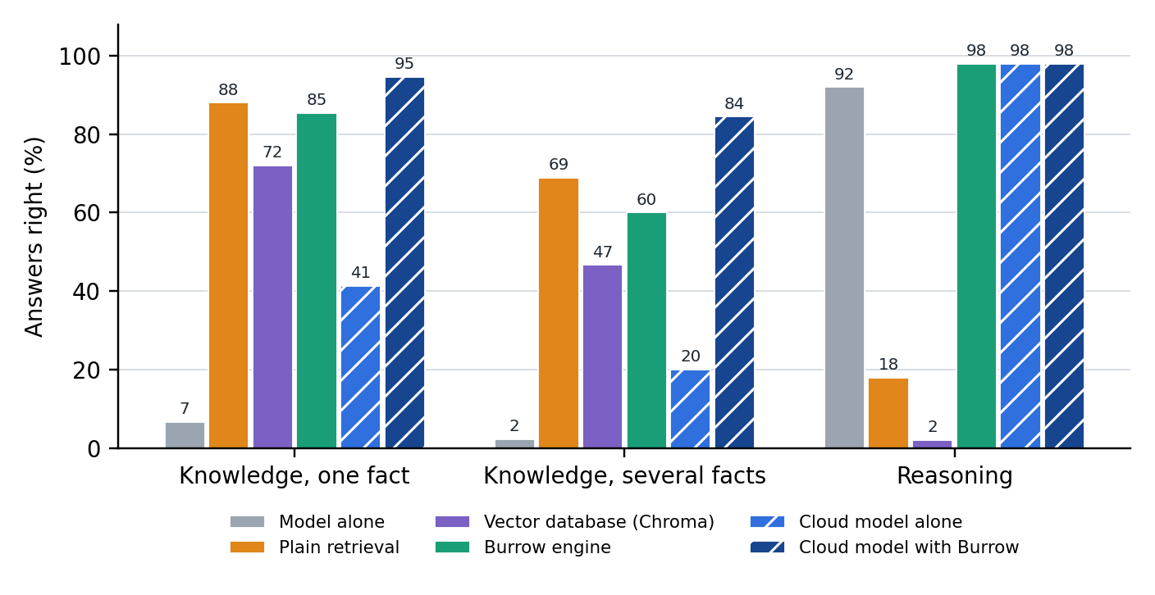
Figure 5.18: Answers right by set-up and task type, Qwen3.5 4B and the cloud model

5.5.5 Ablation, Budget and Speed
Two parts of the engine were switched off in turn on the main model. With every part on, the engine answered 150 of the 170 questions. Without skills it answered 149, and without the citation check it answered 151. The check asked the model again on only 1 of the 170 questions, because only 1 of the 145 places the model cited was not among what it had been shown. Without skills the total moved by one: one knowledge answer gained and two reasoning answers net lost. The run without the check differs from the full run by one retry, and its one score change was variation between runs. Twelve of the 120 knowledge answers cited no place, so the check had nothing to test there.
Figure 5.19 and Table 5.8 answer the question of how much to show. The engine was run again on the 120 knowledge questions with the amount shown fixed at four sizes, beside the fitted 17,417 characters. At 2,000 characters most questions received nothing, because the best piece did not fit, and 15 were answered. Accuracy then rose with every increase: 56 at 4,000 characters, 76 at 8,000, 102 at the fitted size and 112 at 32,000. The gain per token was highest at 2,000 characters (58.1 points for each 1,000 tokens), but only because 94 of the 120 questions there received nothing. Among budgets that delivered excerpts it fell from 27.9 at 4,000 characters to 7.8 at 32,000, and the time for an answer rose from 2.1 to 15.6 seconds.
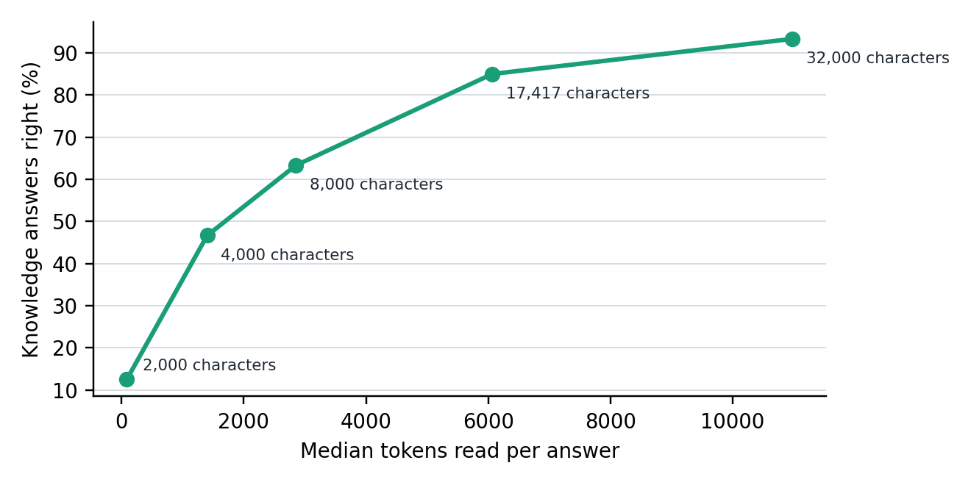
Figure 5.19: Knowledge answers right against tokens read, as the amount of the vault shown to Gemma 4 12B grows
Table 5.8: How much of the vault the model is shown, against what it gains, Gemma 4 12B, knowledge questions
Characters shown | Answers right | Median tokens read | Gap closed, against cloud with Burrow | Points gained per 1,000 tokens | Median seconds
2,000 | 15 of 120 (12%) | 86 | 6% | 58.1 | 1.1
4,000 | 56 of 120 (47%) | 1402 | 47% | 27.9 | 2.1
8,000 | 76 of 120 (63%) | 2856 | 67% | 19.6 | 4.2
17,417 (fitted) | 102 of 120 (85%) | 6068 | 93% | 12.8 | 9.2
32,000 | 112 of 120 (93%) | 10981 | 103% | 7.8 | 15.6

Figure 5.20 shows the speed of a lookup before and after the search was rebuilt, on an index of 11,710 pieces from the Django repository. Before the rebuild a lookup that followed links took a median of 2.87 seconds. After it the median was 0.18 seconds, about sixteen times faster. Plain search was already fast and stayed at about 0.15 seconds. On the 101 real bug fixes of the earlier evaluation the rebuilt search reached the same changed files as before on every question (59 by search, 72 by following links), although other files shown differed on 3 searches and 51 walks. That check used a build made just before the freeze.
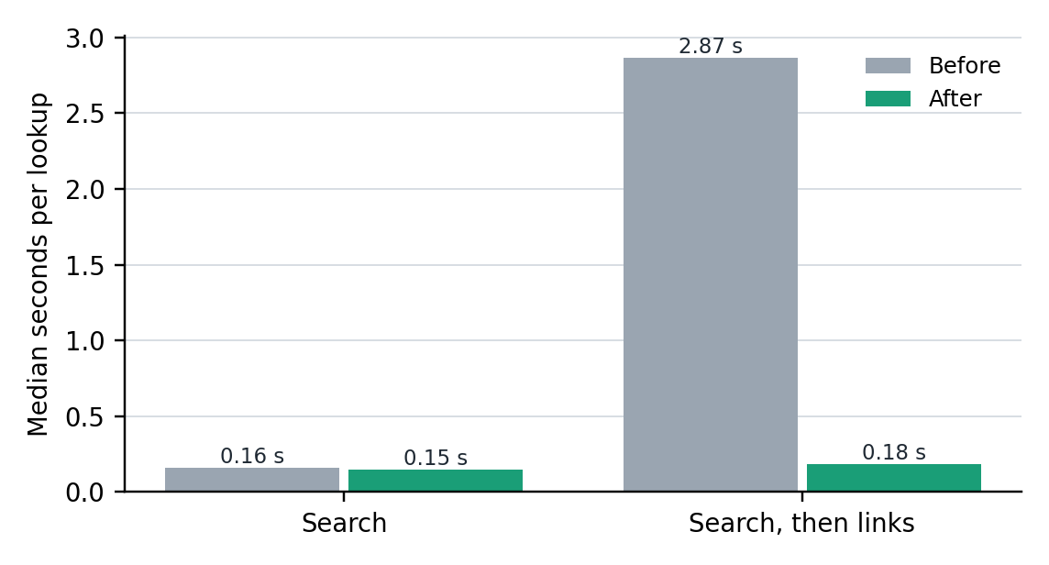
Figure 5.20: Median time of one lookup on the Django index, before and after the search was rebuilt

5.5.6 Error Analysis
Of the engine's 18 wrong knowledge answers on the main model, 8 had a needed file missing from what was shown and 10 had every file shown. Both retrieval and the model's reading therefore still failed, as Joren et al. (2025) also found for small models given sufficient context. Table 5.9 shows one answer of each kind, taken from the saved results of the main model with the engine.
Table 5.9: Examples of answers from Gemma 4 12B with the engine
Outcome | Question, in short | The model's answer | What happened
Right, with its source | How long is the Data Commissioner's term of office, and can it be renewed? | The Data Commissioner shall be appointed for a single term of six years and shall not be eligible for a re-appointment. (Law/act-part-02-office-of-the-data-commissioner.md:71) | The file was found and the place was cited.
Incomplete | Which statute guides the Data Commissioner before cancelling a certificate, and what is the maximum fine under the general penalty? | The Fair Administrative Actions Act, 2015 was named, and the model stated that it did not know the maximum fine from what it was shown. | One of the three needed files was not shown, and the model declined that half.
Refused, with the evidence shown | Within how many hours of a personal data breach must a data controller notify the Data Commissioner? | I don't know from what you were shown. | The needed file was among the excerpts, and the model did not use it.
Refused, with the evidence missing | Which model and context size were tried for Claude Code through Ollama? | I don't know from what you were shown. | Ollama release notes were shown and the project's decision log was not. The refusal was correct.
Right, vault left out | A GSM8K problem on the ounces of meat eaten by a basketball team | Answer: 30 | The engine left the vault out, and the model read 272 tokens.

5.6 System Testing

5.6.1 Test Strategy and Acceptance Criteria
Testing was done at three levels. Unit tests checked each type of the library alone. Integration tests ran the whole loop from a question to a kept note with a scripted model, so that a result does not depend on what a real model happens to say. System test cases then verified each requirement of Chapter 4, by automated test, by running the frozen program, by using the desktop app, or by inspection where the requirement concerns how the system is built. The tests included normal cases, wrong input, and failures of the model service. The acceptance criterion was that every automated test passed on the frozen source and that every requirement of Chapter 4 had a test case whose observed result equalled its expected result. No person other than the developer has used the app, so no user acceptance test is claimed.
The engine has 212 automated tests, and all of them passed on the frozen source. The full record is saved in the repository as unit-tests-evaluation-2.log.

5.6.2 Test Cases, Defects and Retesting
Twenty-three test cases were run, one or more for every requirement, and all passed, three of them with a stated condition. Table 5.10 gives the ten that cover the core workflow and its failure conditions; the full record of all 23 is in the repository (https://github.com/Satasdin/CAMR/blob/burrow/docs/evaluation/test-cases.md), and Appendix 3 traces each requirement to the component and test that cover it.
Table 5.10: Key test cases and results (all 23 are in the repository)
Test ID | Requirement | Scenario and test data | Expected result | Actual result and evidence | Verdict
TC-01 | FR-01 | A vault indexed twice, then with one file changed and one removed | Nothing rebuilt the second time; old words gone the third time | As expected; test log | Pass
TC-04 | FR-04 | A question the vault knows nothing about | The vault is left out | Left out; the model received only the question; test log | Pass
TC-05 | FR-04 | The 50 reasoning problems of Section 5.5, on the frozen program | The vault is left out | Left out on 50 of 50; saved results | Pass
TC-08 | FR-07, IR-01 | A question on the command line; a question about a regulation asked by Gemma 4 12B in OpenCode through MCP | An answer naming file and line, with the decision line; in the app, each lookup and the files read | As in Figures 5.3 and 5.6 | Pass
TC-09 | FR-08 | An answer citing a file it was not shown, with a scripted model | One retry; the better grounded answer kept | As expected; test log | Pass
TC-11 | FR-10, IR-03 | vault_prepare called through MCP; a tool called before initialising | The decision and excerpts, no chat model called; the early call refused | As in Figure 5.10; test log | Pass
TC-12 | NFR-02 | The index deleted and rebuilt | No note lost; same pieces and links | As expected; test log | Pass
TC-17 | NFR-06 | swift test on the frozen source; the package file inspected | 212 tests pass; no third-party package | As expected; test log | Pass on one machine
TC-21 | IR-02 | Ollama unreachable during a search and during an answer | Search continues on words; the failure is reported | As expected; test log | Pass
TC-23 | IR-05 | The published install command run into an empty folder with the application option; the landing page and its download link fetched | Program and application installed, checksums pass, the program indexes a vault; page and link return successfully | As expected. The browser download on a second computer was not tried | Pass on one machine

Five defects were recorded. Two affected the runs and were corrected and retested. The first cloud run was stopped after 35 questions because the harness cut answers at 600 tokens, and the limit was raised to 4,000. A budget sweep was stopped because it had begun while another run was using the machine. Both were restarted from the first question, and the partial runs are kept in the repository. Three are known gaps that remain in the frozen code and were left unfixed, so that the engine measured is the engine described. They are stated with the other limitations in Section 5.9.6.

5.7 Version Control and Implementation Evidence
Project repository: https://github.com/Satasdin/CAMR, with burrow as its default branch. Figure 5.21 shows the history of the engine's source, the tags and the folders. The engine is in Sources, its tests in Tests, the desktop app in app, the evaluation in trials, and this report with its scripts in docs/report. The README states the problem, the set-up, and how to run and test the system.
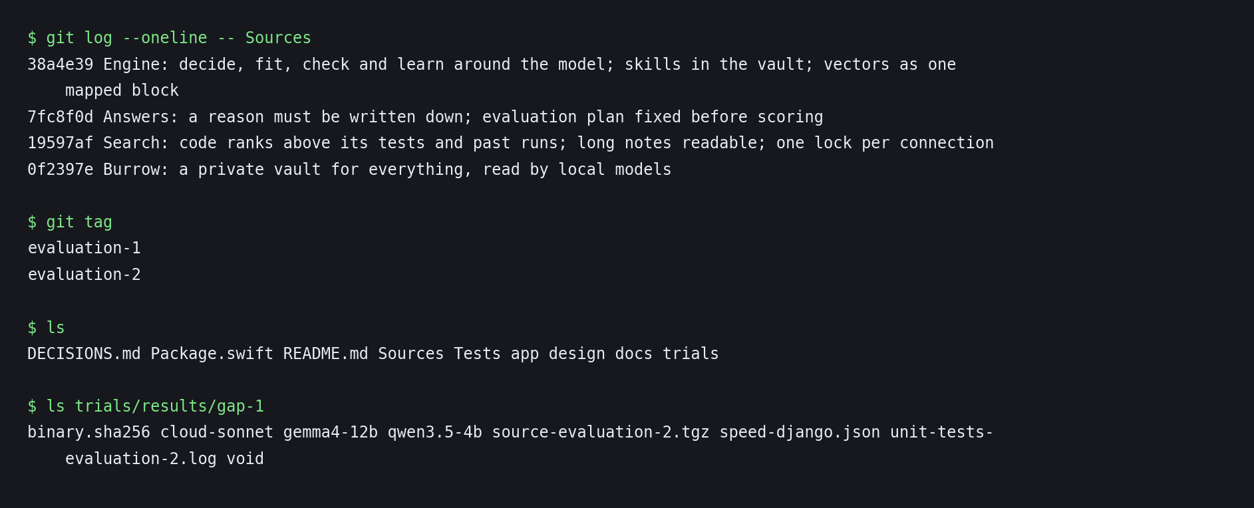
Figure 5.21: The history of the engine's source, the tags and the folders of the repository
The workflow supported the evaluation directly. Each evaluation was run on a tagged, frozen version. The tag evaluation-1 marks retrieval before the engine's steps, and evaluation-2 marks the engine measured in this chapter. The hash of the frozen program is saved in trials/results/gap-1 and in each set-up's meta.json, and the harness refuses to add answers from a different program to the same folder. A reported number can therefore be traced to the exact code that produced it.
Every push to the repository also runs the automated tests on a hosted Apple silicon machine through GitHub Actions, and the log of each run is kept with its commit. The first run, on 12 November 2026, failed to compile: one line of the retrieval code used a form that the hosted Swift compiler did not accept, although the newer compiler on the development laptop did. The line was corrected, and the next run built the engine and passed every test. The release burrow-v1.1.0 was published from that tested commit.

5.8 Author Oversight and Use of AI-Assisted Tools
Claude Code, a coding assistant from Anthropic, assisted with the system design, implementation, testing, and evaluation reported in Chapters 4 and 5, and with the drafting of those two chapters. Its output was checked against the automated tests, the saved results, and the cited sources. The author made the final decisions and takes full responsibility for the submitted work. Appendix 5 gives the AI-use log, and Appendix 4 a short user guide.

5.9 Evaluation Results, Discussion and Limitations
This section takes each specific objective with its research question in turn. For each it states the output, the evidence, the criterion, the observed result, and what the result permits the study to conclude.

5.9.1 Objective i: The Capability Gap and Existing Techniques
The first research question asked what the capability gaps are and how far existing techniques apply on a device. The output is the review in Chapter 2, and the criterion was a stated gap supported by the literature. The review found that the gap is concentrated in long-tail knowledge (Kandpal et al., 2023; Mallen et al., 2023), that retrieval can stand in for scale but can also harm an answer (Shi et al., 2023; Yoran et al., 2024), and that no reviewed work measures gap closing by a memory engine alone on a consumer device, by task type. The objective was met, and the gap it identified is the one the remaining objectives addressed.

5.9.2 Objective ii: The Design of the Engine
The second research question asked how the engine can be designed in terms of its write policy, retrieval policy, and token budgeting mechanism. The output is the design in Chapter 4, and the criterion was a designed component for each of the three mechanisms. Learn is the write policy, Decide with ranking by words, meaning, and links is the retrieval policy, and Fit is the token budgeting mechanism (Figure 4.7). The objective was partly met. Each of the three mechanisms was designed and built, but two not as the objective worded them. The write policy proposes notes from a conversation for the person to approve, rather than distilling every interaction, and its effect on later answers was not measured. Recency and importance were added as tie-breakers after Evaluation 2 was frozen, so its scores do not include them; on its 120 questions with evidence, search found the evidence for 105 both before and after, so on this material they neither helped nor harmed, and their benefit on a vault where notes go out of date was not measured.

5.9.3 Objective iii: The Development of the Engine
The third research question asked how the engine can be developed on a consumer laptop with no dedicated graphics hardware, using an embedded database. The output is the engine of Section 5.4, in Swift with an embedded SQLite index, and the criterion was the acceptance criterion of Section 5.6.1. All 212 automated tests passed on the frozen source and all 23 test cases met their expected results, four of them within a stated limit (TC-14, TC-17, TC-22, and TC-23). A lookup that followed links took a median of 0.18 seconds on an index of 11,710 pieces. The objective was met on the one laptop tested.

5.9.4 Objective iv: The Fraction of the Gap Closed and Its Cost
The fourth research question asked what fraction of the gap the engine closes on each task type and at what cost. The output is the evaluation of Section 5.5, and the criteria were the predictions written before the runs: that the engine would close most of the gap on knowledge tasks, and little or none on reasoning tasks, and that it would read more tokens than plain retrieval on the main model. The first and third predictions held, and on reasoning the fraction is not reported because the gap was too small to measure.
On knowledge, measured against the cloud model given the same vault (109 of 120), the engine closed 93% of the gap. It was 7 questions behind (0 gained, 7 lost, p = 0.016), with Claude shown more text. Against the cloud model alone (40 of 120) the fraction is 300%, which shows that the cloud model alone is a weak ceiling for this material, much of which it could not have seen (Section 5.5.3). What the engine closed is therefore a gap in access to knowledge, which any retrieval narrows; plain retrieval alone reached 94 of 120. The result agrees with Mallen et al. (2023), who found that retrieval helps most on less popular facts. Narayan et al. (2025) measured a related quantity, the share of a cloud model's performance that a local-cloud protocol keeps (87%), by having the on-device model work with a cloud model. Burrow kept everything on the device.
Memory given to a reasoning task did harm: plain retrieval cut the model from 47 to 7 of 50 problems. The engine's first step removed that harm by deciding, on all 50 problems, that the vault was not needed. Shi et al. (2023) and Mirzadeh et al. (2025) showed that irrelevant sentences added to grade-school problems sharply reduce accuracy. Here the failure was mainly refusal: told to answer only from excerpts that did not hold the answer, the model said that it did not know. It varied by prompt and model, since Chroma's pipeline solved 42 on the main model and 1 on the small model. This is the clearest difference between an engine and a database. A database answers every query it is given, and an engine decides whether the query should be made.
The engine was shown more than either baseline: 17,417 characters against 12,000. Against plain retrieval it gained 10 knowledge questions and lost 2 (p = 0.039, uncorrected across 16 paired tests, so it does not survive a Bonferroni correction), and against Chroma it gained 34 and lost 7 (p < 0.001). All 10 gains came on questions sent to plain search, where the engine read the same ranking with a larger budget, and on the 28 questions where it followed links it neither gained nor lost. On the small model, with both limited to 12,000 characters, the engine found the evidence as often (103 against 102) and answered fewer (91 against 97). The gain on the main model therefore came mainly from the larger budget.
On cost, a knowledge answer took a median of about nine seconds on the laptop and read about 6,100 tokens, and a reasoning answer took 3.4 seconds and read 238. Almost all of the time was the model reading and writing. On the local runs the engine's own share was under a tenth of a second. When prepared for Claude, on a busy machine, the same step took a median of 3.6 seconds. The objective was partly met. The fraction and its cost were measured for knowledge, where the engine closed 93% of the gap to the cloud model with the same vault at a small cost of its own, and the engine protected reasoning. On reasoning, however, the gap was too small to give a fraction, and on knowledge the engine's gain over plain retrieval came mainly from its larger budget, so the study permits the conclusion that memory closed most of the gap on this material and this laptop, not that the engine's decisions did.

5.9.5 Objective v: The Token Budget
The fifth research question asked which token budget maximises the gap closed per token and how gap closure changes with the budget. The output is the budget sweep of Section 5.5.5. No criterion was set in advance, because the sweep was added after the plan. Among budgets that delivered excerpts, the gain per token was highest at 4,000 characters and fell as more was shown. Accuracy itself did not peak inside the range tested: at 32,000 characters the on-device model answered 112 of 120, at 15.6 seconds an answer. That is 3 more than the cloud model with Burrow, a difference that is not significant (4 gained, 1 lost, p = 0.375), and Claude was shown 24,000 characters. The fitted budget of about 17,000 characters, which the engine chose from the model's reading speed, sat between the two at 102 right in 9.2 seconds. The objective was partly met. The sweep showed how gap closure changes with the budget, but it did not determine a single budget that maximises it: gain per token was highest at the smallest budget that delivered anything, while accuracy kept rising, so the budget is a choice between speed and accuracy that the engine exposes, and five budgets run once each cannot fix it more precisely.
Table 5.11 summarises the five objectives.
Table 5.11: How each specific objective was met
No. | Objective, in short | Evidence | Verdict and observed result
i | Investigate the capability gap and existing memory techniques | Chapter 2 | Met. No measurement of gap closing on a device by task type was found
ii | Design the memory engine | Chapter 4 | Partly met. Write policy, retrieval policy (words, meaning, links, then recency and importance) and token budget designed and built; the write policy's effect and the recency and importance signals were not measured
iii | Develop the engine on a consumer laptop | Sections 5.4, 5.6 | Met on one laptop. Swift with an embedded SQLite index; 212 automated tests and 23 test cases passed
iv | Measure the fraction of the gap closed, by task type, with cost | Section 5.5.3 | Partly met. 93% of the gap to the cloud model with the same vault closed on knowledge (9 to 102 of 120); reasoning protected (47 to 48 of 50) but its gap too small for a fraction; a median of about 9 seconds and 6,100 tokens for a knowledge answer
v | Determine the token budget | Section 5.5.5 | Partly met. Gain per token highest at 4,000 characters among budgets that delivered excerpts; accuracy rose up to the largest budget tested, so no single best budget was found

5.9.6 Limitations
The results have limits, and each is stated here with its likely effect. First, skills and the citation check did not change the scores: the engine answered 150 of 170 questions with both, 149 without skills, and 151 without the check, so they are working features whose benefit this evaluation did not show. Second, the scored runs compared budgets of different sizes, so the engine's gain over the baselines cannot be credited to its decisions alone, and Decide and Fit were not switched off separately. Third, on the small model the engine did not beat plain retrieval on knowledge, answering 91 against 97, so the gain does not carry to every model. Fourth, the knowledge questions were written by Claude Code agents, from the same family as the cloud reference model, and scored by answer keys, so a right string in a wrong sentence counts as right, and the questions may be easier or harder than a person's own. Fifth, each question was run once on one laptop, and other jobs shared the machine during some runs, so the times are indicative. Sixth, the Learn step was tested only by automated tests, and no experiment measured its effect on later answers. Seventh, no person other than the developer has used the app, so its usability is not claimed. Eighth, three known gaps remain in the frozen code: the check with retry runs only on the command burrow ask --mode engine, and the chat and MCP do not check; the MCP tool and the terminal chat use a fixed budget of 12,000 characters and not the fitted one; and the engine's own prompt does not stop an excerpt from closing its block. Ninth, two trials outside the objectives, a coding trial and a third evaluation of session memory, are reported with the further results in the repository and do not bear on the conclusions.
Chapter 6 draws the conclusions of the study from these results.

Chapter 6: Conclusions, Recommendations and Future Works

6.1 Introduction
This chapter closes the chain from the problem stated in Chapter 1 to the evidence of Chapter 5. Section 6.2 states what the study established for each specific objective, Section 6.3 recommends what should be done on the strength of those findings, and Section 6.4 names the work that remains open. No new experiment, result or source is introduced; each statement rests on a section of Chapter 5.

6.2 Conclusions
The study began from a choice that a person who wants a private assistant is forced to make: a small model on their own laptop keeps their material private but lacks the facts they need, and a large cloud model has the capability but takes the material off the device. The purpose was to measure how much of that gap an external memory engine beside a frozen small model can close, by task type, and at what cost. The completed solution is Burrow, a memory engine in Swift with an embedded SQLite index that keeps a vault of the person's own files, decides for each question whether the vault is needed, fits what it shows to the model's reading speed, and checks the places an answer cites. It is reached through a command-line tool, a desktop application, a terminal chat and a Model Context Protocol server.
Objective i. The review established that the gap between small and large models is concentrated in long-tail and private knowledge, that retrieval can stand in for scale on such knowledge but can lower accuracy when the text it supplies is irrelevant, and that no reviewed work measured what a memory engine beside a frozen small model closes on a consumer device, by task type (Section 5.9.1). This gap framed the remaining objectives.
Objective ii. A write policy, a retrieval policy and a token budgeting mechanism were designed and built as the engine's Learn, Decide and Fit steps (Section 5.9.2). The objective was partly met: the write policy proposes notes for the person to approve rather than distilling every interaction, and neither its effect on later answers nor the recency and importance signals added after the freeze were measured.
Objective iii. The engine was developed on one consumer laptop with no discrete graphics card and an embedded database. All 212 automated tests and all 23 test cases passed, and a lookup that followed links took a median of 0.18 seconds on an index of 11,710 pieces (Section 5.9.3). The objective was met on the one laptop tested.
Objective iv. On 120 knowledge questions about material the models could not have memorised, Gemma 4 12B answered 9 alone and 102 with the engine, which is 93% of the gap to the cloud model given the same vault (109). On 50 reasoning problems, where plain retrieval cut the model from 47 to 7 correct answers, the engine left the vault out of every problem and the model solved 48. The engine's own work took under a tenth of a second per answer (Sections 5.5.3 and 5.9.4). The objective was partly met: the reasoning gap was too small to express as a fraction, and on knowledge the engine's gain over plain retrieval came mainly from showing the model more text, while on the 4 billion parameter model the engine answered fewer knowledge questions than plain retrieval (91 against 97).
Objective v. Gain per token was highest at the smallest budget that delivered excerpts and fell as more was shown, while accuracy kept rising up to the largest budget tested (Section 5.9.5). The objective was partly met: the study found that the budget is a choice between speed and accuracy, not a single best value.
The contribution of the study is a measured answer to the question it set: on private and recent material, an on-device model given a well-prepared memory of the person's own files came within 7 of 120 questions of a cloud model given the same memory, at a median of about nine seconds an answer, and a memory that first decides whether it is needed avoids the harm that retrieval does to reasoning. The study also contributes an evaluation method, the fraction of the gap closed against a cloud model given the same memory, with token and latency accounting on the device. These conclusions hold for one laptop, two on-device models, English text, three curated subjects with questions written by language-model agents, and one run of each question. They do not show that the engine's decisions, as distinct from its larger budget, improve on plain retrieval for knowledge, and they make no claim about usability, since no person other than the developer used the application.

6.3 Recommendations
The recommendations below follow from the results and limitations of Chapter 5. The first two are essential for anyone who adopts the approach; the others are improvements.
i. Developers of on-device assistants should decide whether to retrieve before supplying memory to a question. Pasting excerpts in front of every question cut the main model from 47 to 7 of 50 reasoning problems, while an engine that decided first kept 48 (Section 5.5.3). Where an assistant handles both kinds of question, this step protects the answers that need no memory.
ii. Developers should give a local model enough of the vault to answer, and set the budget from what the model can read in an acceptable time. Accuracy on knowledge rose from 56 to 112 of 120 as the amount shown grew from 4,000 to 32,000 characters, while the time per answer grew from 2.1 to 15.6 seconds (Section 5.5.5). The right budget depends on how long the person will wait, which the engine's Fit step measures for each model.
iii. People who keep private notes and documents should consider an on-device model with a memory of those files before sending them to a cloud service. On such material the cloud model alone answered 40 of 120 questions and the on-device model with the vault answered 102 (Section 5.5.3), so the private choice was the more capable one here. This holds within the conditions above: a laptop with enough memory for a 12 billion parameter model, and material of the kind tested.
iv. Researchers measuring memory for small models should compare against a cloud model given the same memory, not against the cloud model alone. Against the cloud model alone the fraction closed passed 100% and stopped being informative, because the ceiling had no access to the material (Section 5.5.3).
v. Maintainers of Burrow should close the three known gaps in the frozen code before relying on its citation check outside the command line: the check with retry runs only on one command, the Model Context Protocol server and the terminal chat use a fixed budget, and the engine's prompt does not stop an excerpt from closing its block (Section 5.9.6).

6.4 Future Works
The following directions arise from the limitations of Section 5.9.6. Each extends the research rather than completing promised work.
i. Separating the engine's decisions from its budget. The scored runs gave the engine a larger budget than the baselines, so its gain could not be credited to Decide or Fit. Running the engine and plain retrieval at equal budgets, and switching Decide and Fit off in turn, would show what each step adds on knowledge questions, and whether the result on the 4 billion parameter model reflects the model or the steps.
ii. Measuring the write policy over time. Learn was tested only by automated tests. A study that lets the engine propose notes across many sessions, and measures later answers with and without the kept notes, would test the write policy that objective ii describes, together with the recency and importance signals on a vault whose notes go out of date.
iii. Questions written by people, and questions that mix knowledge and reasoning. The knowledge questions were written by agents from the same family as the cloud model, and knowledge and reasoning were tested apart. Questions written by the people who own a vault, including problems that need a fact and a calculation together, would test whether the results transfer to real use and whether the decision to retrieve holds when a question needs both.
iv. A study with real users. No person other than the developer used the application. A usability study with people working in their own vaults would show whether the decisions the engine displays help them trust or correct an answer.
v. Other devices, models and languages. Every result came from one laptop, two models and English text. Repeating the evaluation on lower-memory laptops, on phones, and in other languages, including Kiswahili, would show how far the conclusions generalise, with each question run several times so that variation between runs can be measured.

References
Abdin, M., Aneja, J., Awadalla, H., Awadallah, A., Awan, A. A., Bach, N., Bahree, A., Bakhtiari, A., Bao, J., Behl, H., Benhaim, A., Bilenko, M., Bjorck, J., Bubeck, S., Cai, M., Cai, Q., Chaudhary, V., Chen, D., Chen, D., . . . Zhou, X. (2024). Phi-3 technical report: A highly capable language model locally on your phone. arXiv. https://doi.org/10.48550/arXiv.2404.14219
Anthropic. (2026a). Claude Code overview. Claude Code Docs. https://code.claude.com/docs/en/overview
Anthropic. (2026b). How Claude remembers your project. Claude Code Docs. https://code.claude.com/docs/en/memory
Anthropic. (2026c). Models overview. Claude Platform Docs. https://platform.claude.com/docs/en/models/overview
Asai, A., Wu, Z., Wang, Y., Sil, A., & Hajishirzi, H. (2024). Self-RAG: Learning to retrieve, generate, and critique through self-reflection [Paper presentation]. International Conference on Learning Representations (ICLR 2024). https://arxiv.org/abs/2310.11511
Borgeaud, S., Mensch, A., Hoffmann, J., Cai, T., Rutherford, E., Millican, K., van den Driessche, G., Lespiau, J.-B., Damoc, B., Clark, A., de Las Casas, D., Guy, A., Menick, J., Ring, R., Hennigan, T., Huang, S., Maggiore, L., Jones, C., Cassirer, A., . . . Sifre, L. (2022). Improving language models by retrieving from trillions of tokens. In Proceedings of the 39th International Conference on Machine Learning (Vol. 162, pp. 2206–2240). PMLR. https://proceedings.mlr.press/v162/borgeaud22a.html
Bruch, S., Gai, S., & Ingber, A. (2023). An analysis of fusion functions for hybrid retrieval. ACM Transactions on Information Systems, 42(1), 1–35. https://doi.org/10.1145/3596512
Chen, Z., Xiang, Z., Xiao, C., Song, D., & Li, B. (2024). AgentPoison: Red-teaming LLM agents via poisoning memory or knowledge bases. In Advances in Neural Information Processing Systems (Vol. 37, pp. 130185–130213). Neural Information Processing Systems Foundation. https://doi.org/10.52202/079017-4136
Chevalier, A., Wettig, A., Ajith, A., & Chen, D. (2023). Adapting language models to compress contexts. In Proceedings of the 2023 Conference on Empirical Methods in Natural Language Processing (pp. 3829–3846). Association for Computational Linguistics. https://doi.org/10.18653/v1/2023.emnlp-main.232
Chhikara, P., Khant, D., Aryan, S., Singh, T., & Yadav, D. (2025). Mem0: Building production-ready AI agents with scalable long-term memory. In ECAI 2025 (Frontiers in Artificial Intelligence and Applications, Vol. 413, pp. 2993–3000). IOS Press. https://doi.org/10.3233/FAIA251160
Chroma. (2026). Distributed architecture. Chroma Docs. https://docs.trychroma.com/reference/architecture/distributed
Cobbe, K., Kosaraju, V., Bavarian, M., Chen, M., Jun, H., Kaiser, L., Plappert, M., Tworek, J., Hilton, J., Nakano, R., Hesse, C., & Schulman, J. (2021). Training verifiers to solve math word problems. arXiv. https://doi.org/10.48550/arXiv.2110.14168
Collins, A. M., & Loftus, E. F. (1975). A spreading-activation theory of semantic processing. Psychological Review, 82(6), 407–428. https://doi.org/10.1037/0033-295X.82.6.407
Cormack, G. V., Clarke, C. L. A., & Buettcher, S. (2009). Reciprocal rank fusion outperforms Condorcet and individual rank learning methods. In Proceedings of the 32nd International ACM SIGIR Conference on Research and Development in Information Retrieval (pp. 758–759). ACM. https://doi.org/10.1145/1571941.1572114
Cuconasu, F., Trappolini, G., Siciliano, F., Filice, S., Campagnano, C., Maarek, Y., Tonellotto, N., & Silvestri, F. (2024). The power of noise: Redefining retrieval for RAG systems. In Proceedings of the 47th International ACM SIGIR Conference on Research and Development in Information Retrieval (pp. 719–729). ACM. https://doi.org/10.1145/3626772.3657834
Data Protection Act, No. 24 of 2019 (Cap. 411C), Laws of Kenya. (2019). https://kenyalaw.org/akn/ke/act/2019/24/eng@2022-12-31
Dong, S., Xu, S., He, P., Li, Y., Tang, J., Liu, T., Liu, H., & Xiang, Z. (2025). Memory injection attacks on LLM agents via query-only interaction. In Advances in Neural Information Processing Systems (Vol. 38, pp. 52119–52153). Neural Information Processing Systems Foundation. https://doi.org/10.52202/085713-1554
Edge, D., Trinh, H., Cheng, N., Bradley, J., Chao, A., Mody, A., Truitt, S., Metropolitansky, D., Ness, R. O., & Larson, J. (2024). From local to global: A graph RAG approach to query-focused summarization. arXiv. https://arxiv.org/abs/2404.16130
Fan, W., Ding, Y., Ning, L., Wang, S., Li, H., Yin, D., Chua, T.-S., & Li, Q. (2024). A survey on RAG meeting LLMs: Towards retrieval-augmented large language models. In Proceedings of the 30th ACM SIGKDD Conference on Knowledge Discovery and Data Mining (pp. 6491–6501). ACM. https://doi.org/10.1145/3637528.3671470
Gao, T., Yen, H., Yu, J., & Chen, D. (2023). Enabling large language models to generate text with citations. In Proceedings of the 2023 Conference on Empirical Methods in Natural Language Processing (pp. 6465–6488). Association for Computational Linguistics. https://doi.org/10.18653/v1/2023.emnlp-main.398
Ge, T., Hu, J., Wang, L., Wang, X., Chen, S.-Q., & Wei, F. (2024). In-context autoencoder for context compression in a large language model [Paper presentation]. International Conference on Learning Representations (ICLR 2024). https://doi.org/10.48550/arXiv.2307.06945
Gemma Team. (2025). Gemma 3 technical report. arXiv. https://doi.org/10.48550/arXiv.2503.19786
Gemma Team. (2026). Gemma 4 technical report. arXiv. https://doi.org/10.48550/arXiv.2607.02770
Grattafiori, A., Dubey, A., Jauhri, A., Pandey, A., Kadian, A., Al-Dahle, A., Letman, A., Mathur, A., Schelten, A., Vaughan, A., Yang, A., Fan, A., Goyal, A., Hartshorn, A., Yang, A., Mitra, A., Sravankumar, A., Korenev, A., Hinsvark, A., . . . Ma, Z. (2024). The Llama 3 herd of models. arXiv. https://doi.org/10.48550/arXiv.2407.21783
Greshake, K., Abdelnabi, S., Mishra, S., Endres, C., Holz, T., & Fritz, M. (2023). Not what you've signed up for: Compromising real-world LLM-integrated applications with indirect prompt injection. In Proceedings of the 16th ACM Workshop on Artificial Intelligence and Security (pp. 79–90). ACM. https://doi.org/10.1145/3605764.3623985
Gunter, T., Wang, Z., Wang, C., Pang, R., Narayanan, A., Zhang, A., Zhang, B., Chen, C., Chiu, C.-C., Qiu, D., Gopinath, D., Yap, D. A., Yin, D., Nan, F., Weers, F., Yin, G., Huang, H., Wang, J., Lu, J., . . . Ren, Z. (2024). Apple Intelligence foundation language models. arXiv. https://doi.org/10.48550/arXiv.2407.21075
Gutiérrez, B. J., Shu, Y., Gu, Y., Yasunaga, M., & Su, Y. (2024). HippoRAG: Neurobiologically inspired long-term memory for large language models. In Advances in Neural Information Processing Systems (Vol. 37, pp. 59532–59569). Neural Information Processing Systems Foundation. https://doi.org/10.52202/079017-1902
Gutiérrez, B. J., Shu, Y., Qi, W., Zhou, S., & Su, Y. (2025). From RAG to memory: Non-parametric continual learning for large language models. In Proceedings of the 42nd International Conference on Machine Learning (Vol. 267, pp. 21497–21515). PMLR. https://proceedings.mlr.press/v267/gutierrez25a.html
Hevner, A. R., March, S. T., Park, J., & Ram, S. (2004). Design science in information systems research. MIS Quarterly, 28(1), 75–105. https://doi.org/10.2307/25148625
Hong, K., Troynikov, A., & Huber, J. (2025, July 14). Context rot: How increasing input tokens impacts LLM performance. Chroma. https://www.trychroma.com/research/context-rot
Hou, X., Zhao, Y., Wang, S., & Wang, H. (2026). Model Context Protocol (MCP): Landscape, security threats, and future research directions. ACM Transactions on Software Engineering and Methodology, 35(10), 1–37. https://doi.org/10.1145/3796519
Hsieh, C.-P., Sun, S., Kriman, S., Acharya, S., Rekesh, D., Jia, F., Zhang, Y., & Ginsburg, B. (2024). RULER: What's the real context size of your long-context language models? [Paper presentation]. Conference on Language Modeling (COLM 2024). https://doi.org/10.48550/arXiv.2404.06654
Hu, Y., Liu, S., Yue, Y., Zhang, G., Liu, B., Zhu, F., Lin, J., Guo, H., Dou, S., Xi, Z., Jin, S., Tan, J., Yin, Y., Liu, J., Zhang, Z., Sun, Z., Zhu, Y., Sun, H., Peng, B., . . . Yan, S. (2025). Memory in the age of AI agents. arXiv. https://doi.org/10.48550/arXiv.2512.13564
Hu, Y., Wang, Y., & McAuley, J. (2025). Evaluating memory in LLM agents via incremental multi-turn interactions. arXiv. https://doi.org/10.48550/arXiv.2507.05257
Huang, W.-C., Zhang, W., Liang, Y., Bei, Y., Chen, Y., Feng, T., Pan, X., Tan, Z., Wang, Y., Wei, T., Wu, S., Xu, R., Yang, L., Yang, R., Yang, W., Yeh, C.-Y., Zhang, H., Zhang, H., Zhu, S., . . . Shu, K. (2026). A survey of agent memory in the second half: Towards self-evolving and long-horizon agents. Transactions on Machine Learning Research. https://arxiv.org/abs/2602.06052
Izacard, G., Lewis, P., Lomeli, M., Hosseini, L., Petroni, F., Schick, T., Dwivedi-Yu, J., Joulin, A., Riedel, S., & Grave, E. (2023). Atlas: Few-shot learning with retrieval augmented language models. Journal of Machine Learning Research, 24(251), 1–43.
Jeong, S., Baek, J., Cho, S., Hwang, S. J., & Park, J. C. (2024). Adaptive-RAG: Learning to adapt retrieval-augmented large language models through question complexity. In Proceedings of the 2024 Conference of the North American Chapter of the Association for Computational Linguistics: Human Language Technologies (Volume 1: Long Papers) (pp. 7036–7050). Association for Computational Linguistics. https://doi.org/10.18653/v1/2024.naacl-long.389
Jiang, H., Wu, Q., Lin, C.-Y., Yang, Y., & Qiu, L. (2023). LLMLingua: Compressing prompts for accelerated inference of large language models. In Proceedings of the 2023 Conference on Empirical Methods in Natural Language Processing (pp. 13358–13376). Association for Computational Linguistics. https://doi.org/10.18653/v1/2023.emnlp-main.825
Jin, B., Yoon, J., Han, J., & Arik, S. O. (2025). Long-context LLMs meet RAG: Overcoming challenges for long inputs in RAG [Paper presentation]. International Conference on Learning Representations (ICLR 2025). https://doi.org/10.48550/arXiv.2410.05983
Joren, H., Zhang, J., Ferng, C.-S., Juan, D.-C., Taly, A., & Rashtchian, C. (2025). Sufficient context: A new lens on retrieval augmented generation systems [Paper presentation]. International Conference on Learning Representations (ICLR 2025). https://doi.org/10.48550/arXiv.2411.06037
Kandpal, N., Deng, H., Roberts, A., Wallace, E., & Raffel, C. (2023). Large language models struggle to learn long-tail knowledge. In Proceedings of the 40th International Conference on Machine Learning (Vol. 202, pp. 15696–15707). PMLR. https://proceedings.mlr.press/v202/kandpal23a.html
Kaplan, J., McCandlish, S., Henighan, T., Brown, T. B., Chess, B., Child, R., Gray, S., Radford, A., Wu, J., & Amodei, D. (2020). Scaling laws for neural language models. arXiv. https://doi.org/10.48550/arXiv.2001.08361
Karpukhin, V., Oğuz, B., Min, S., Lewis, P., Wu, L., Edunov, S., Chen, D., & Yih, W.-t. (2020). Dense passage retrieval for open-domain question answering. In Proceedings of the 2020 Conference on Empirical Methods in Natural Language Processing (EMNLP) (pp. 6769–6781). Association for Computational Linguistics. https://doi.org/10.18653/v1/2020.emnlp-main.550
LangChain. (2026). LangChain [Computer software]. https://github.com/langchain-ai/langchain
Larman, C., & Basili, V. R. (2003). Iterative and incremental development: A brief history. Computer, 36(6), 47–56. https://doi.org/10.1109/MC.2003.1204375
Levy, M., Jacoby, A., & Goldberg, Y. (2024). Same task, more tokens: The impact of input length on the reasoning performance of large language models. In Proceedings of the 62nd Annual Meeting of the Association for Computational Linguistics (Volume 1: Long Papers) (pp. 15339–15353). Association for Computational Linguistics. https://doi.org/10.18653/v1/2024.acl-long.818
Lewis, P., Perez, E., Piktus, A., Petroni, F., Karpukhin, V., Goyal, N., Küttler, H., Lewis, M., Yih, W.-t., Rocktäschel, T., Riedel, S., & Kiela, D. (2020). Retrieval-augmented generation for knowledge-intensive NLP tasks. In Advances in Neural Information Processing Systems (Vol. 33, pp. 9459–9474). Curran Associates. https://proceedings.neurips.cc/paper/2020/hash/6b493230205f780e1bc26945df7481e5-Abstract.html
Liu, Z., Zhao, C., Iandola, F., Lai, C., Tian, Y., Fedorov, I., Xiong, Y., Chang, E., Shi, Y., Krishnamoorthi, R., Lai, L., & Chandra, V. (2024). MobileLLM: Optimizing sub-billion parameter language models for on-device use cases. In Proceedings of the 41st International Conference on Machine Learning (Vol. 235, pp. 32431–32454). PMLR. https://proceedings.mlr.press/v235/liu24ce.html
Lu, Z., Li, X., Cai, D., Yi, R., Liu, F., Zhang, X., Lane, N. D., & Xu, M. (2024). Small language models: Survey, measurements, and insights. arXiv. https://doi.org/10.48550/arXiv.2409.15790
Luo, J., Tian, Y., Cao, C., Luo, Z., Lin, H., Li, K., Kong, C., Yang, R., & Ma, J. (2026). From storage to experience: A survey on the evolution of LLM agent memory mechanisms. In Findings of the Association for Computational Linguistics: ACL 2026 (pp. 41622–41652). Association for Computational Linguistics. https://doi.org/10.18653/v1/2026.findings-acl.2069
Maharana, A., Lee, D.-H., Tulyakov, S., Bansal, M., Barbieri, F., & Fang, Y. (2024). Evaluating very long-term conversational memory of LLM agents. In Proceedings of the 62nd Annual Meeting of the Association for Computational Linguistics (Volume 1: Long Papers) (pp. 13851–13870). Association for Computational Linguistics. https://doi.org/10.18653/v1/2024.acl-long.747
Mallen, A., Asai, A., Zhong, V., Das, R., Khashabi, D., & Hajishirzi, H. (2023). When not to trust language models: Investigating effectiveness of parametric and non-parametric memories. In Proceedings of the 61st Annual Meeting of the Association for Computational Linguistics (Volume 1: Long Papers) (pp. 9802–9822). Association for Computational Linguistics. https://doi.org/10.18653/v1/2023.acl-long.546
Mireshghallah, N., Antoniak, M., More, Y., Choi, Y., & Farnadi, G. (2024). Trust no bot: Discovering personal disclosures in human-LLM conversations in the wild [Paper presentation]. Conference on Language Modeling (COLM 2024). https://doi.org/10.48550/arXiv.2407.11438
Mirzadeh, I., Alizadeh, K., Shahrokhi, H., Tuzel, O., Bengio, S., & Farajtabar, M. (2025). GSM-Symbolic: Understanding the limitations of mathematical reasoning in large language models [Paper presentation]. International Conference on Learning Representations (ICLR 2025). https://arxiv.org/abs/2410.05229
Model Context Protocol. (2026). What is the Model Context Protocol (MCP)? https://modelcontextprotocol.io/docs/getting-started/intro
Moskvoretskii, V., Marina, M., Salnikov, M., Ivanov, N., Pletenev, S., Galimzianova, D., Krayko, N., Konovalov, V., Nikishina, I., & Panchenko, A. (2025). Adaptive retrieval without self-knowledge? Bringing uncertainty back home. In Proceedings of the 63rd Annual Meeting of the Association for Computational Linguistics (Volume 1: Long Papers) (pp. 6355–6384). Association for Computational Linguistics. https://doi.org/10.18653/v1/2025.acl-long.319
Narayan, A., Biderman, D., Eyuboglu, S., May, A., Linderman, S., Zou, J., & Ré, C. (2025). Cost-efficient collaboration between on-device and cloud language models. In Proceedings of the 42nd International Conference on Machine Learning (Vol. 267, pp. 45682–45719). PMLR. https://proceedings.mlr.press/v267/narayan25a.html
Obsidian. (2025a, April 1). How Obsidian stores data. Obsidian Help. https://obsidian.md/help/data-storage
Obsidian. (2025b, November 28). Graph view. Obsidian Help. https://obsidian.md/help/plugins/graph
Ogonjo, F. A. (2025, April 22). The Kenya National AI Strategy 2025-2030: Regional and global positioning. Centre for Intellectual Property and Information Technology Law, Strathmore University. https://cipit.strathmore.edu/?p=4885
Ollama. (2026). Ollama [Computer software]. https://ollama.com
Packer, C., Wooders, S., Lin, K., Fang, V., Patil, S. G., Stoica, I., & Gonzalez, J. E. (2023). MemGPT: Towards LLMs as operating systems. arXiv. https://doi.org/10.48550/arXiv.2310.08560
Park, J. S., O'Brien, J. C., Cai, C. J., Morris, M. R., Liang, P., & Bernstein, M. S. (2023). Generative agents: Interactive simulacra of human behavior. In Proceedings of the 36th Annual ACM Symposium on User Interface Software and Technology (pp. 1–22). ACM. https://doi.org/10.1145/3586183.3606763
Patra, A., Kundu, S., Dey, A., Saha, T., Karmakar, S., & Bishnu, S. K. (2026). A survey on on-device small language models: Architectures, compression, applications, and open challenges. In 2026 9th International Conference on Electronics, Materials Engineering & Nano-Technology (IEMENTech) (pp. 1–6). IEEE. https://doi.org/10.1109/IEMENTech202669403.2026.11434122
Peffers, K., Tuunanen, T., Rothenberger, M. A., & Chatterjee, S. (2007). A design science research methodology for information systems research. Journal of Management Information Systems, 24(3), 45–77. https://doi.org/10.2753/MIS0742-1222240302
Qwen Team. (2026, February). Qwen3.5: Towards native multimodal agents. https://qwen.ai/blog?id=qwen3.5
Robertson, S., & Zaragoza, H. (2009). The probabilistic relevance framework: BM25 and beyond. Foundations and Trends in Information Retrieval, 3(4), 333–389. https://doi.org/10.1561/1500000019
Shi, F., Chen, X., Misra, K., Scales, N., Dohan, D., Chi, E. H., Schärli, N., & Zhou, D. (2023). Large language models can be easily distracted by irrelevant context. In Proceedings of the 40th International Conference on Machine Learning (Vol. 202, pp. 31210–31227). PMLR. https://proceedings.mlr.press/v202/shi23a.html
Soudani, H., Kanoulas, E., & Hasibi, F. (2024). Fine tuning vs. retrieval augmented generation for less popular knowledge. In Proceedings of the 2024 Annual International ACM SIGIR Conference on Research and Development in Information Retrieval in the Asia Pacific Region (pp. 12–22). ACM. https://doi.org/10.1145/3673791.3698415
SQLite. (2026, October 9). SQLite FTS5 extension. https://www.sqlite.org/fts5.html
Sumers, T. R., Yao, S., Narasimhan, K., & Griffiths, T. L. (2024). Cognitive architectures for language agents. Transactions on Machine Learning Research. https://arxiv.org/abs/2309.02427
Sun, K., Xu, Y. E., Zha, H., Liu, Y., & Dong, X. L. (2024). Head-to-tail: How knowledgeable are large language models (LLMs)? A.K.A. will LLMs replace knowledge graphs? In Proceedings of the 2024 Conference of the North American Chapter of the Association for Computational Linguistics: Human Language Technologies (Volume 1: Long Papers) (pp. 311–325). Association for Computational Linguistics. https://doi.org/10.18653/v1/2024.naacl-long.18
Teyler, T. J., & DiScenna, P. (1986). The hippocampal memory indexing theory. Behavioral Neuroscience, 100(2), 147–154. https://doi.org/10.1037/0735-7044.100.2.147
Wang, F., Zhang, Z., Zhang, X., Wu, Z., Mo, T., Lu, Q., Wang, W., Li, R., Xu, J., Tang, X., He, Q., Ma, Y., Huang, M., & Wang, S. (2025). A comprehensive survey of small language models in the era of large language models: Techniques, enhancements, applications, collaboration with LLMs, and trustworthiness. ACM Transactions on Intelligent Systems and Technology, 16(6), 1–87. https://doi.org/10.1145/3768165
Wu, D., Wang, H., Yu, W., Zhang, Y., Chang, K.-W., & Yu, D. (2025). LongMemEval: Benchmarking chat assistants on long-term interactive memory [Paper presentation]. International Conference on Learning Representations (ICLR 2025). https://doi.org/10.48550/arXiv.2410.10813
Xu, J., Li, Z., Chen, W., Wang, Q., Gao, X., Cai, Q., & Ling, Z. (2024). On-device language models: A comprehensive review. arXiv. https://doi.org/10.48550/arXiv.2409.00088
Xu, W., Liang, Z., Mei, K., Gao, H., Tan, J., & Zhang, Y. (2025). A-Mem: Agentic memory for LLM agents. In Advances in Neural Information Processing Systems (Vol. 38, pp. 20004–20031). Neural Information Processing Systems Foundation. https://doi.org/10.52202/085713-0593
Yang, A., Yang, B., Zhang, B., Hui, B., Zheng, B., Yu, B., Li, C., Liu, D., Huang, F., Wei, H., Lin, H., Yang, J., Tu, J., Zhang, J., Yang, J., Yang, J., Zhou, J., Lin, J., Dang, K., . . . Qiu, Z. (2024). Qwen2.5 technical report. arXiv. https://doi.org/10.48550/arXiv.2412.15115
Yoran, O., Wolfson, T., Ram, O., & Berant, J. (2024). Making retrieval-augmented language models robust to irrelevant context [Paper presentation]. International Conference on Learning Representations (ICLR 2024). https://doi.org/10.48550/arXiv.2310.01558
Zhang, Y., Li, M., Long, D., Zhang, X., Lin, H., Yang, B., Xie, P., Yang, A., Liu, D., Lin, J., Huang, F., & Zhou, J. (2025). Qwen3 Embedding: Advancing text embedding and reranking through foundation models. arXiv. https://doi.org/10.48550/arXiv.2506.05176
Zhang, Z., Jia, M., Lee, H.-P., Yao, B., Das, S., Lerner, A., Wang, D., & Li, T. (2024). "It's a fair game", or is it? Examining how users navigate disclosure risks and benefits when using LLM-based conversational agents. In Proceedings of the CHI Conference on Human Factors in Computing Systems (pp. 1–26). ACM. https://doi.org/10.1145/3613904.3642385
Zhao, A., Huang, D., Xu, Q., Lin, M., Liu, Y.-J., & Huang, G. (2024). ExpeL: LLM agents are experiential learners. Proceedings of the AAAI Conference on Artificial Intelligence, 38(17), 19632–19642. https://doi.org/10.1609/aaai.v38i17.29936
Zhong, W., Guo, L., Gao, Q., Ye, H., & Wang, Y. (2024). MemoryBank: Enhancing large language models with long-term memory. Proceedings of the AAAI Conference on Artificial Intelligence, 38(17), 19724–19731. https://doi.org/10.1609/aaai.v38i17.29946

Appendices

Appendix 1: Gantt Chart
Figure A1.1 shows the work carried out from March to November 2026, by workstream, with the course milestones, and Table A1.1 gives the milestones with their status. CAMR and Engram are earlier working names of the engine.
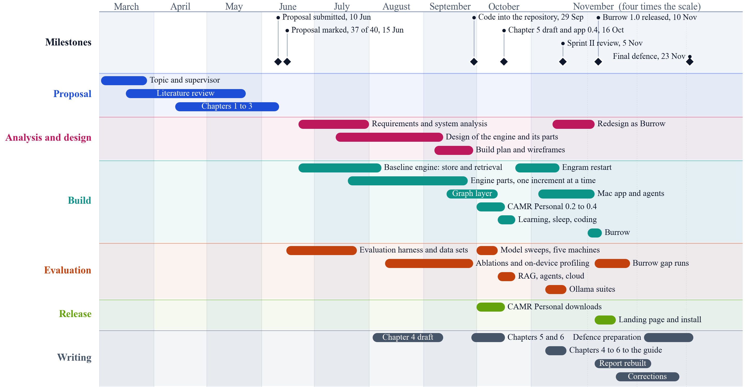
Figure A1.1: Project work plan, March to November 2026
Table A1.1: Course milestones and their status
No. | Task | Due date | Status
1 | Supervisor selection and allocation | 7 May 2026 | Done
2 | Document formatting and template creation | 8 May 2026 | Done
3 | Topic creation and selection | - | Done
4 | Abstract and Chapters 1 to 3 | - | Done
5 | Chapters 1 to 3 submitted | 12 June 2026 | Done
6 | Semester I oral defence | 13 to 16 July 2026 | Done
7 | Marking and revision of Chapters 1 to 3 | 31 July 2026 | Done
8 | Chapter 4: System Analysis and Design | 17 August 2026 | Done
9 | Sprint II review | 5 November 2026 | Done
10 | Documentation | November 2026 | In progress
11 | Project final defence | 23 November 2026 | Pending

Appendix 2: Feedback-Resolution Matrix
Table A2.1 records the feedback received and how each item was resolved.
Table A2.1: Feedback received and its resolution
Issue | Source | Affected section | Action | Status
"Very hard to understand" | Sprint II review, 5 Nov 2026 | 2.6, 4.4 | The engine was rebuilt around plain files and five named steps, and the report describes it in standard terms | Done
"Just a report of benchmarks" | Sprint II review | 1.6, 5.4 | A usable app, a terminal chat and an MCP server were built around the engine; the scope now includes them | Done
Show it working with native Ollama models | Sprint II review | 5.2, 5.4 | Ollama is the only model runner; every local result was produced through it | Done
The person cannot create or remove their own collections | Sprint II review | 4.4 | The memory is the person's own folder of files; nothing is seeded | Done
Model activity should be visible | Sprint II review | 5.4.4 | The app shows every program that uses the vault, each conversation's lookups and the files read; the command line states what the engine decided | Done
Can it generate reports natively? | Sprint II review | 5.4.5 | A conversation, or a decision from it, can be kept in the Ledger and handed to the next model; no report format was built | Partly
If it codes, let it code, with live previews | Sprint II review | 1.6 | Coding is left to the programs that connect to the vault, such as OpenCode and Claude Code, which read the code and its decisions through Burrow; live previews were not built | Partly
Keep each chapter to its own part, and follow the lecturer's guide for the structure of Chapters 1 to 6 and the references | Supervisor, November 2026 | Chapters 3 to 6 | Chapter 3 names the methods and points to Chapter 4; build detail moved to Chapter 5; side trials moved to the repository's further results; Chapter 6 added | Done
Abstract scored 2 of 3 (at most 200 words) | Written assessment, Ms. Eunice Manyasi, 30 June 2026 (37 of 40; "The document is well written") | Abstract | Rewritten last, from the final results, within 200 words | Done
Problem statement scored 3 of 4 (background, clarity, gap, citations) | Written assessment, 30 June 2026 | 1.2 | The ideal, the reality and the gap stated with cited evidence, and the consequence quantified | Done
Objectives scored 3 of 4 (SMART and linked to the problem) | Written assessment, 30 June 2026 | 1.3, 6.2 | Each objective now has a measured result and a verdict in Section 5.9 and Chapter 6 | Done
The appendices and Chapter 5 are too long; some of it belongs on GitHub; show how the system works with a model | Review of the draft, 12 November 2026 | Chapter 5, appendices | The full test record, further results and extra screens moved to the repository and linked; Section 5.4.7 shows the workflows with a model from real runs | Done
[PENDING: the oral defence feedback from Semester I, to be added by the student.] | Oral defence, July 2026 | - | - | Open

Appendix 3: Requirements Traceability
Table A3.1 traces each requirement to the part that implements it and the test that verifies it.
Table A3.1: Traceability from requirement to component and test
Requirement | Objective | Component | Test case | Result
FR-01 | iii | Vault, Scanner, Chunker | TC-01 | Pass
FR-02 | ii, iii | Retrieval, Index | TC-02 | Pass
FR-03 | ii, iii | Retrieval | TC-03 | Pass
FR-04 | ii | Engine.brief | TC-04, TC-05 | Pass
FR-05 | ii | Skills, Engine.brief | TC-06 | Pass
FR-06 | ii, v | Fit | TC-07 | Pass
FR-07 | iii | Engine.engage | TC-08 | Pass
FR-08 | ii | Engine.engage | TC-09 | Pass on the command line only
FR-09 | ii | Engine.lessons, keep | TC-10 | Pass in the terminal chat
FR-10 | iii | Engine.brief, BurrowMCP | TC-11 | Pass
NFR-01 | iii | Ollama | Inspection | Pass
NFR-02 | iii | Rebuildable index | TC-12 | Pass
NFR-03 | iii | Asking, ProjectContent | Automated tests | Pass on the tools path
NFR-04 | iv | Harness | Table 5.7 | Pass
NFR-05 | iii | Database | Inspection | Pass
NFR-06 | iii | Swift package | 212 automated tests | Pass on one machine
DR-01 | iii | Vault, linked folders | TC-18 | Pass
DR-02 | iii | Database, Index | TC-19 | Pass
DR-03 | ii | keep | TC-10 | Pass
DR-04 | iv | Harness | TC-20 | Pass
IR-01 | iii | Mac app, conversation page | TC-08 | Pass
IR-02 | iii | Ollama, VaultTools | TC-21 | Pass
IR-03 | iii | BurrowMCP | TC-11 | Pass
IR-04 | iii | Vault | TC-22 | Pass

Appendix 4: User Guide
What is needed. A Mac with Ollama. Pull the models with ollama pull gemma4:12b and ollama pull qwen3-embedding:0.6b. Section 5.2.3 gives the one-command install from a tagged release; to build from source, run swift build -c release in the project folder and app/build.sh for the app.
Using the app.
i. Choose a folder as the vault. An existing Obsidian vault works as it is.
ii. Write notes in the centre pane and link notes with [[. A note's properties are shown as fields above its text, and holding Command over a link previews the note.
iii. To add code, choose Add, then Link a Folder.
iv. Open the graph to see how notes link, and search from the sidebar.
v. Open Programs to connect a model or tool, such as Claude Code, LM Studio or Ollama, through the MCP server: press Connect, then Copy, or Add for Me to write the setting into the program. Its conversations then appear under Conversations as it works, and what it understood appears in the Ledger.
Using the terminal.
i. burrow index <vault> --vault builds the index.
ii. burrow fit <vault> --model gemma4:12b measures the model once.
iii. burrow ask <vault> "question" --mode engine --model gemma4:12b answers through the engine.
iv. burrow chat <vault> opens a chat, and burrow tui <vault> the full-screen terminal view.
v. burrow resume <vault> prints where the last session stopped, for any model to carry on.
Using Burrow from another model or tool. burrow brief <vault> "task" --json returns the prepared prompt for any model. For an MCP client, run burrow mcp <vault>; by default it offers burrow_find, burrow_read, burrow_resume and burrow_commit. A client that is a cloud service sends what it reads to that service.
Known limitations. Burrow runs on macOS only. The check with retry runs only on burrow ask --mode engine; the chat and MCP do not check. The app does not ask questions itself; the program connected to the vault does.

Appendix 5: AI-Use Log
Table A5.1 is the AI-use log. Full prompts and replies are retained in the Claude Code session transcripts on the development Mac. [PENDING: the student to add AI use before 9 November and to confirm this log.]
Table A5.1: AI-use log
Date (2026) | Tool and model | Used for | Retained output | Corrections and verification
9 Nov | Claude Code | Plan and scope of Burrow, written with the student | Plan and DECISIONS.md | Reviewed and approved by the student
9 Nov | Claude Code | Engine, command line, agent test harness | Source and tests | swift test
9-10 Nov | Claude Code | Mac app, terminal view, chat and MCP server | Source and tests | swift test; screens reviewed by the student
10 Nov | Claude Code | The earlier evaluation: held-back projects and real bug fixes | Code, projects, results | Plan written before scoring; results saved once
10 Nov | Claude Code | The engine's five steps, skills and faster search, at the student's direction | Source, tests, DECISIONS.md D-50 to D-58 | 212 tests; thresholds set on development questions only
10 Nov | Claude Code agents | Curated documents and questions; evaluation harness; vector database baseline | trials/gap | Checker scripts; fixture run; plan written before scoring
10 Nov | Claude (claude-sonnet-5-5) through the API | The cloud model in the experiments | Saved answers | Scored by fixed answer keys
10 Nov | Claude Code agents | Chapters 1 to 5 rewritten on the layout of earlier graduates' reports; a verified source pack; diagrams; tables and charts from saved results | Report and generators in docs/report | Each source confirmed at its published page; each change recorded with its reason in Section 5.4.8; tables generated by script
10 Nov | Claude Code | The report laid out in Microsoft Word against the course guide; the conceptual framework redrawn; citations and the reference list placed as Mendeley Cite fields | Burrow_Report_Word.docx, guide-checklist.md | Every page of the exported PDF viewed; each section checked against the guide checklist
11 Nov | Claude Code | The Ledger, hooks, terminal views, and a third evaluation of session memory with its plan written before scoring | Source, tests, trials/ledger, evaluation-plan-3.md | swift test; frozen binary; faults found in scoring reported, not fixed
12 Nov | Claude Code | Recency and importance in the ranking; the report cut to each chapter's part; an independent review against the course guide; Chapter 6 and these appendices drafted | Source and tests; report text | 95 core tests; every figure in Chapter 6 traced to a section of Chapter 5; reviewed by the student
12 Nov | Claude Code | The flow of the report checked against the course guide; the built application benchmarked against what was planned for it; the Programs page redrawn with live activity; the final title, tenses and wording | Report text; app source; guide-checklist.md | Test build of the report; every changed screen captured from a real run
12 Nov | Claude Code | GitHub: a test workflow that runs every automated test on each push, a compiler fix it found, and the final release | .github/workflows/tests.yml; release on GitHub | The workflow's own run; tests passed locally and on GitHub
12 Nov | Claude Code | Demonstration clips recorded from the real application, terminal and models, for the student to edit | docs/demo/clips | Each clip from a real run on the evaluation vault; nothing staged
[PENDING: date] | - | The student's own review and edits of this report | - | -

Appendix 6: Similarity Report
[PENDING: the student to attach the one-page similarity report.]

