DEMO PROJECT

Digital Transformation of

“Three Lines of Defense Model”

(Business Case: User’s IT Network Access Controls)

Functional Specification Document

Sateesh Babu

Dec 30,2021

Version 1.0

**Disclaimer:** Any data or opinions presented in this project presentation are solely those of the author and do not necessarily represent those of his organization or any other organizations. It’s a hypothetical problem. Solution is designed by the author to exhibit his skills and experience.

# Document Purpose

## Project Information

|  |  |
| --- | --- |
| Project ID | xyz2021 |
| Project Manager | Sateesh |
| Project Sponsor | xyz IT team |
| Business Lead | Sateesh |

## Revision History

|  |  |  |  |  |
| --- | --- | --- | --- | --- |
| Revision | Date | Status | Contribution By | Summary of Changes |
| 1 | 2021/12/30 | Draft | Sateesh |  |
| 2 | 2021/12/30 | Final | Sateesh |  |
|  |  |  |  |  |

## Document Approval List

|  |  |  |  |  |
| --- | --- | --- | --- | --- |
| Revision | Date | Status | Reviewed By | Summary of Changes |
| 1 | 2021/12/30 | Approved | Sateesh |  |

## Document Distribution List

|  |  |  |  |  |
| --- | --- | --- | --- | --- |
| Revision | Date | Status | Reviewed By | Summary of Changes |
| 1 | 2021/12/30 | Final | Sateesh |  |

Contents

1 Document Purpose 1

1.1 Project Information 1

1.2 Revision History 1

1.3 Document Approval List 1

1.4 Document Distribution List 1

2 Introduction 4

2.1 Executive Summary 4

2.2 Three lines of Defense Model and Project stakeholders 4

2.2.1 Primary Stakeholders 4

2.2.2 Secondary Stakeholders 5

2.3 Business Needs 6

3 Project and Scope 6

3.1 Project Objective 6

3.2 Project Scope 6

3.3 Project Out-Of-Scope 6

3.4 Project Dependencies 6

3.5 Project Assumptions 7

3.6 Project Constraints 7

3.7 Project Risks 7

4 Requirements 7

4.1 Business Requirements 7

4.1.1 User Stories 8

4.2 Data Requirements 8

4.2.1 Source systems 9

4.2.2 Data Profiling Analysis 9

4.2.3 Data transformations / enrichments 10

4.2.4 Reporting Attributes 11

4.2.5 ER Diagram 11

4.2.6 Reporting Model 12

4.2.7 Source-to-Target Mapping (Data Lineage) 14

4.3 Operational Dashboard Prototype 14

4.4 Non-Functional Requirements 15

5 Appendices 16

5.1 List of Acronyms 16

5.2 Glossary of Terms 16

5.3 Related Documents 16

# Introduction

## Executive Summary

Digital transformation is the integration of digital technology into all areas of a business, fundamentally changing how you operate and deliver value to customers. It's also a cultural change that requires organizations to continually challenge the status quo, experiment, and get comfortable with failure.

In the post COVID era, as most of workforce started connecting to the IT network remotely and IT Infrastructure managed by cloud service vendors, our enterprise has implemented “Three lines of Defense Model” control measures in reviewing user network access on timely manner.

Digitalizing these control measures will bring the following benefits:

1. It will improve efficiency, transparency, and coordination among the stakeholders of “Three lines of Defense Model”
2. It will break the data silos and saves cost as well as processing time.
3. It will help in quicker problem identification (including unauthorized access) and enables a secured environment.
4. Finally, it provides better experience and motivation to the workforce while connecting to the IT network remotely.

## Three lines of Defense Model and Project stakeholders

The three lines of defense framework is a fundamental pillar of corporate governance structures and enterprise risk management. Its objective is to provide a right information at right time to the governing body and the senior management for their risk-based decisions. Also, provides assurance to regulators and external auditors.

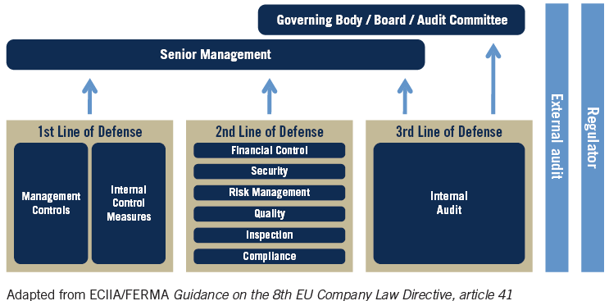

### Primary Stakeholders

Business stakeholders in the “Three lines of defense model” play a distinct role within the three lines of defense. But they use the same organizational data for different perspectives/or reporting. Inaccurate reporting will lead to wrong management decisions and conflicting assurance opinions.

|  |  |  |  |  |
| --- | --- | --- | --- | --- |
| **Line of Defense** | **Responsibility/Description in** | **Business Stakeholders/Users** | **Primary Contact Email id** | **RACI Chart** |
| 1st Line: IT Operational Management | Responsibility to own and manage risks associated with day-to-day operational activities of the “IT network access and security”. Other accountabilities assumed by the first line include design, operation, and implementation of controls. | IT Security and networking team | [abc@xyz.com](mailto:abc@xyz.com) | Accountable,  Consulted,  Informed |
| 2nd Line: Risk Control and Compliance | Specialize in the oversight of risk management and compliance. It does this by providing compliance and oversight in the form of frameworks, policies, tools, and techniques to support risk and compliance management. | Risk & Compliance committee; Cybersecurity team | [qwer@xyz.com](mailto:qwer@xyz.com) | Accountable,  Informed |
| 3rd Line: Risk Assurance | Ensure whether the first- and second-line functions are operating effectively. It is charged with the duty of reporting to the board and audit committee, in addition to providing assurance to regulators and external auditors that the control culture across the organization is effective in its design and operation. | Assurance team/auditors | [yoyoyyoy@xyz.com](mailto:yoyoyyoy@xyz.com) | Accountable,  Informed |

Note: IT Security and networking team are the project sponsor and act as a point of contact for all network systems processes.

### Secondary Stakeholders

Data Owners/Stewards/Custodians, Domain Experts, Project team and Enterprise Data Governance are the secondarystakeholders, who play an important role in the delivering the project.

|  |  |  |  |
| --- | --- | --- | --- |
| **Description/Context** | **Secondary Stakeholders** | **Primary Contact Email id** | **RACI** |
| HR datasets | HR reporting team | [hrrep@xyz.com](mailto:hrrep@xyz.com) | Responsible,  Consulted |
| Active Directory (network) datasets | Vendor (Cloud Service Provider) | vendor@vendy.com | Responsible,  Consulted |
| Work order/ RFI approvals | Procurement team | [proc@xyz.com](mailto:proc@xyz.com) | Informed |
| Solution & Data architecture review | Enterprise Architect team | [ea@xyz.com](mailto:ea@xyz.com) | Consulted |
| Project delivery team | Third party IT vendor | [vend@ibxy.com](mailto:vend@ibxy.com) | Responsible |
| Enterprise Data Governance | Data Governance Committee | [edg@xyz.com](mailto:edg@xyz.com) | Informed |

## Business Needs

Summarized the business needs as below:

* Need access to accurate and organized data analysis of “Users’ IT network access”. This gives the ability to spot risk trends/alerts and make effective decisions in monitoring organization’s IT resources.
* Centralized integrated data platform (digital asset) should have capabilities to collect, store, process, analyze, and visualize high volumes of a wide variety of data, drive value in many ways by considering standard enterprise data taxonomies, data integrity checks and data security measures.
* The integrated data and analytical platform should be flexible, scalable, cost economical and the freedom to design and deploy standard as well as custom controls that fit business context at any given time.

# Project and Scope

## Project Objective

Project objective is to digitalize the “User’s IT Network Access Controls” by leveraging the enterprise data lake and analytics. Thereby, it would help key stakeholders of “Three Lines of Defense Model” to set risk control mechanism with strong corporate governance for better decision making and assurance reporting in monitoring “User Network Access” of xyz enterprise.

## Project Scope

* All users in vendor’s active directory who are tagged to xyz departments and xyz groups. Both active and inactive users.
* Digitalize the “User’s IT Network Access Controls” by leveraging the enterprise data lake and analytics
* Train stakeholders of “Three Lines of Defense Model” on the analytics outcomes and exceptions handling.
* Design operational visual dashboard in Power BI.
* Reviewing IT network access of rehired FTEs (employee) is part of the scope

## Project Out-Of-Scope

* Entities/users/user groups within the active directory of cloud service provider (vendor), which don’t belong to XYZ, are not in scope.
* Does not cover security at the database, operating system, network, client stations level, etc.
* Active directory’s segregation of duties is not in scope. Unable to identify conflict responsibilities.
* The source datasets don’t cover processing of Manager’s requests to the vendor.
* Current IT infrastructure as well as business processes do not support real-time analytics. To achieve that all IT system should be well integrated on real-time basis and should provide their real-time/near-time feeds to enterprise data lake.
* AD's daily EOD snapshot doesn't have historical versions and their metadata changes, like who approved, who created etc. Hence, the analytical reports don’t include any of these metadata attributes.

## Project Dependencies

* Availability of key stakeholders to participate in necessary business processes and technical reviews.
* Establishing the data ingestion connection or SFTP connection to vendor system after adhering to their security checks as well as internal security checks.

## Project Assumptions

* Ensure all necessary and appropriate stakeholders are available to participate in necessary business processes and technical reviews.
* Assume that the work email in active directory could be possible match with HR Email id of each FTEs
* Unmatched emails or users with no emails in active directory are treated as contractor or mismatch
* Within the unmatched email list, if the user’s email id has suffix as xyz.com than they will be considered as “FTEs mismatch”
* All datasets are available on every day between 10pm to 12pm after completion of the dependent jobs in the respective source systems.
* Vendor and xyz’s security teams will implement a clean revoke in scenarios like - Termination, Transfers or any other events that are linked to role change.
* Assume that data owners/stewards/custodians will provide complete and validated daily datasets in tandem to the business processes.
* Project virtual servers or environments are configured as expected.
* The project scope will not change once the stakeholders sign off on the BRD.
* The system of the project is compatible, functions properly and stable for the project to take place smoothly.
* Project will be completed in expected timelines and within the budget allocated.

## Project Constraints

* As AD don’t have metadata information on the version history in its dataset, it’s not feasible to provide version changes of each user account.
* No primary key for AD user/ group assignments, there will be some challenges in maintaining the delta extractions.
* Vendor’s Active Directory does not delineate between xyz FTEs and contractors.
* HR datasets don’t have information on the contractors. HR system is only for the FTEs
* Data quality issues (like email mismatches, user id mismatches, no standard master data etc) in the vendor AD, might be a constraint in designing and maintaining the dashboard visuals.

## Project Risks

* No control over staff priorities in unexpected events like COVID-19 pandemic.
* Vendor’s statement of work (SOW) might be delayed in getting approved by procurement team due to post COVID-19 changes in the business processes.

# Requirements

## Business Requirements

The following are the business requirements of the business stakeholders to digitalize three lines of defense checks:

|  |  |  |  |
| --- | --- | --- | --- |
| **#BR** | **Business Requirement** | **Description** | **Business Stakeholder/Owner** |
| 1 | Daily Operational Review of network access of XYZ’s users. | To provide operational visual dashboard so that IT security team can review the user’s network access and can make decisions in controlling user’s network access in their day-to-day activities. And also, should able to manage the master date, especially for attributes – department and groups | IT Security operations team  (1st line of defense) |
| 2 | Monthly validation of active Network access of XYZ’s users by their managers | To generate excel files at end of each month for each manager in XYZ so that they can review and validate their reportee’s network access. | Risk & Compliance team  (2nd line of defense) |
| 4 | Adhoc review of active Network access of XYZ’s terminated users. | To generate excel file with list of terminated users having network access to XYZ entities/groups, for assurance/audit team on adhoc basis. | Assurance team  (3rd line of defense) |

### User Stories

|  |  |  |
| --- | --- | --- |
| **#US** | **User Story** | **#BR mapping** |
| #US1 | As IT security team lead, I need a POWER BI visual dashboard on details of active directory (AD)'s users who have access to XYZ groups along with their HR details (like - his/her work email, position, department, manager's email etc) for daily operational review. Would be helpful if this dashboard gets updated daily at end of the day (EOD). | #BR 1 |
| #US2 | As IT security team lead, I want an adhoc excel report with all master data changes (new, amend and deleted) in active directory (AD), especially for the attributes – department names, groups, user ids. This report will be helpful in defining the daily operational review controls. | #BR 1 |
| #US3 | As risk and compliance team lead, I need a excel report for each manager with the details of their reportees and their active network access assignments in active directory. Would be helpful if these excel reports are available for managers’ validation at end of each month. | #BR 2 |
| #US4 | As Assurance and audit team lead, I need a excel report with list of terminated/departed users having network access to XYZ entities/groups, for validation checks on adhoc basis. | #BR 3 |

## 

## Flow charts

BR#2

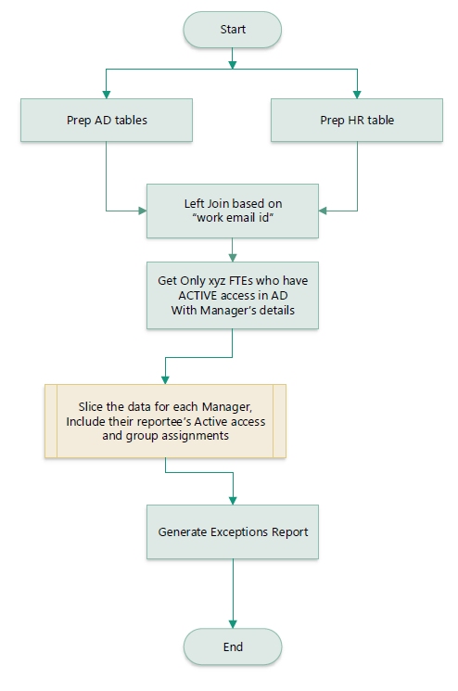

BR#3A

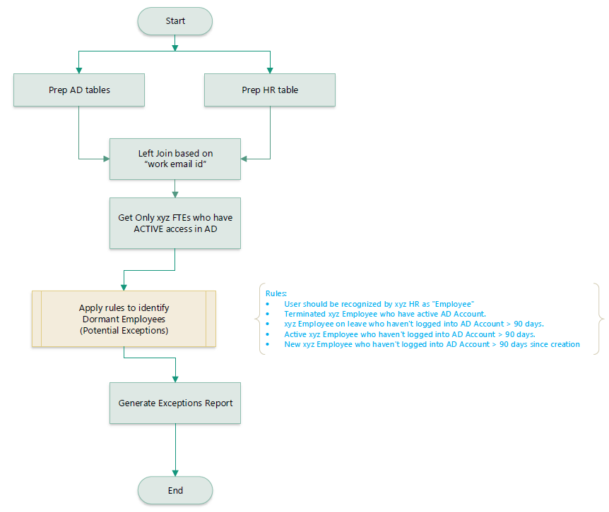

BR#3B

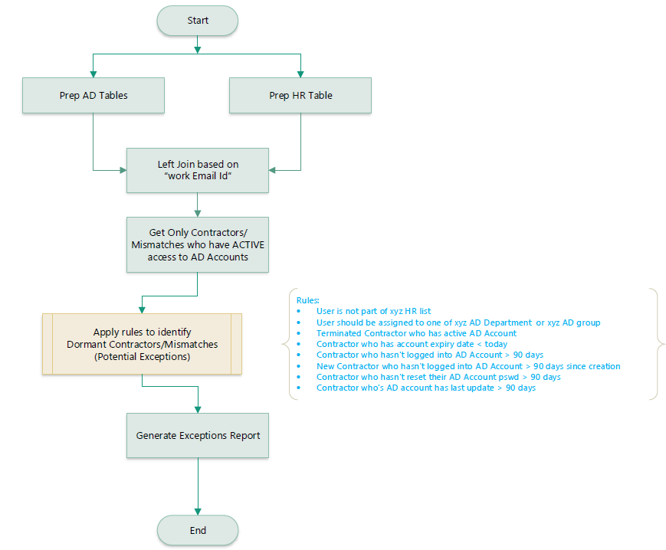

## Data Requirements

The following are the data requirements of this project:

### Source systems

|  |  |  |
| --- | --- | --- |
| **#DR** | **Data Requirement** | **Description** |
| 1 | Need daily ingestion from the sources – active directory and HR. | To create a daily ingestion pipeline in the enterprise data lake for each of the source system – Active directory and HR. |

### Data Profiling Analysis

The source datasets are analyzed based on dimensions –Number of datasets, Completeness, Uniqueness, Timeliness (point of time), Validity, Accuracy, Consistency, Relationship etc

|  |  |  |  |
| --- | --- | --- | --- |
| **Dimension** | **Active Directory Dataset** | **HR Dataset** | **Comment** |
| # of Datasets | 1 Excel file:   1. IT_AD_XYZ_Users_yyyymmdd.xlsx | 2 Excel files:   1. HR_Status_Active_yyyymmdd.xlsx 2. HR_Status_Departure_yyyymmdd.xlsx |  |
| Point of time | It’s an EOD dataset which is generated and shared between 10pm-12am | It’s an EOD dataset which is generated and shared between 10pm-12am | Both datasets are generated on the same point of time at EOD after all important data changes. |
| Completeness | User and their group assignments are provided as a full data snapshot on every day.  But, metadata attributes – who created, who approved, version history – are missing.  Master data attributes (Department, work id) have some missing values. | FTEs and their key details are provided as a full data snapshot on every day.  But, metadata attributes – who created, who approved, version history – are missing. | Extracts’ record counts are matching with the source systems |
| Uniqueness | There is no primary key defined. But, “SamAccountName” is a unique attribute which can used to define the incremental changes (records addition and deletions) in the dataset. | There is no primary key defined. But, “Employee Number” is a unique attribute which can used to define the incremental changes (records addition and deletions) in the dataset. |  |
| Validity and Accuracy | Some users work email ids are not matching with their corresponding HR work email ids. | Rehired employees are not defined or flagged in the HR dataset. | Both datasets are validated by the data owners/stewards. |
| Consistency | Did a consistency check on the last 5 days snapshots. There is no change in the data structures.  User’s Group data value should be parsed to a table format. | Did a consistency check on the last 5 days snapshots. There is no change in the data structures of both HR datasets.  Noticed duplicate records when merging the two excels (active and departed).  Also, the data structures of the both excel files are not matching. We need to merge, normalize the data structures, de-duplicate the records and identify rehired employees. | This duplication issue won’t exist if established direct data ingestion connection between source systems and enterprise data lake. |
| Relationship | EmailAddress is used as join key | Work_email is used as join key | HR data is used as reference data to enrich the AD user info. |

### Data transformations / enrichments

|  |  |  |
| --- | --- | --- |
| **#DR** | **Data Requirement** | **Description** |
| 2 | Normalize the data structures | Merge the datasets of each, if received multiple files. Choose the latest updated record in case of duplication records. |
| 3 | Enrich AD data with corresponding HR details of xyz employee. | Use work email to join the datasets. If matched, then mark as record as “HR_Matched”, else it should mark as “MisMatch”. |
| 4 | Rehire flag of the XYZ employees | If XYZ employee’s Start Date is greater than their Termination date, then flag them as “rehired employee”. |
| 5 | Parse AD user assignments into a separate table | Parse the values in the “Group” column into each row for each user. |
| 6 | Add prefixes to the attributes | Add the following prefix to the source and derived attributes,   1. “AD_” in case of Active Directory dataset 2. “HR_” in case of HR dataset 3. “z” in case of derived/calculated attributed |
| 7 | Transform AD status of each user | If AD_Enabled = “True”, then transform as “Active” user. Else, transform as “Inactive” user. |
| 8 | Flag the terminated users with active network access. | If the XYZ employee’s HR Status is “Departed” and his/her AD status is “Active”, then flag as “AuditCheck”. |
| 9 | Aging in days | Calculate the days difference between run date and AD source attributes - 'AD_LastLogonDate', 'AD_Passwordset', 'AD_WhenChanged', 'AD_WhenCreated'. |
| 10 | Reporting Date | Is the date when both the source system datasets are ingested into the enterprise data lake. |

### Reporting Attributes

|  |  |  |
| --- | --- | --- |
| **#DR** | **Data Requirement** | **Description** |
| 8 | User Group Assignments table | ['AD_SamAccountName','AD_DisplayName', 'AD_Group', 'AD_xyz_Grp_Tags', 'AD_Privileged_Access',"zMatched","Reporting_Date"] |
| 9 | User Dimension table | ['AD_SamAccountName','AD_DisplayName','AD_AccountExpiry', 'AD_Company', 'AD_CreateTimeStamp', 'AD_Department', 'AD_Description', 'AD_EmailAddress',  'AD_Enabled', 'AD_Firstname', 'AD_LastLogonDate', 'AD_Lastname', 'AD_Passwordset', 'AD_xyz_Dept_Tags', 'AD_WhenChanged', 'AD_WhenCreated', 'HR_Department_Name', 'HR_Division', 'HR_Employee_No', 'HR_First_Name', 'HR_Last_Name', 'HR_Manage_Email', 'HR_Record_Type',  'HR_Status', 'HR_Termination_Date', 'HR_Work_Email', 'zAD_User_Status', 'zTerminated_User_ActiveAD', 'zDays_SinceLastLogonDate', 'zDays_SincePswdReset', 'zDays_SinceWhenChanged', 'zDays_SinceWhenCreated',"zMatched","Reporting_Date"] |

### ER Diagram

Inmon approach is followed in designing the normalized data structures in the refined layer of the data lake. This layer serves as the single source of truth for the enterprise. As the business requirements change or source data changes, it is easy to update the data warehouse as one thing is in only one place. The following is the entity -relationship diagram of the refined tables.

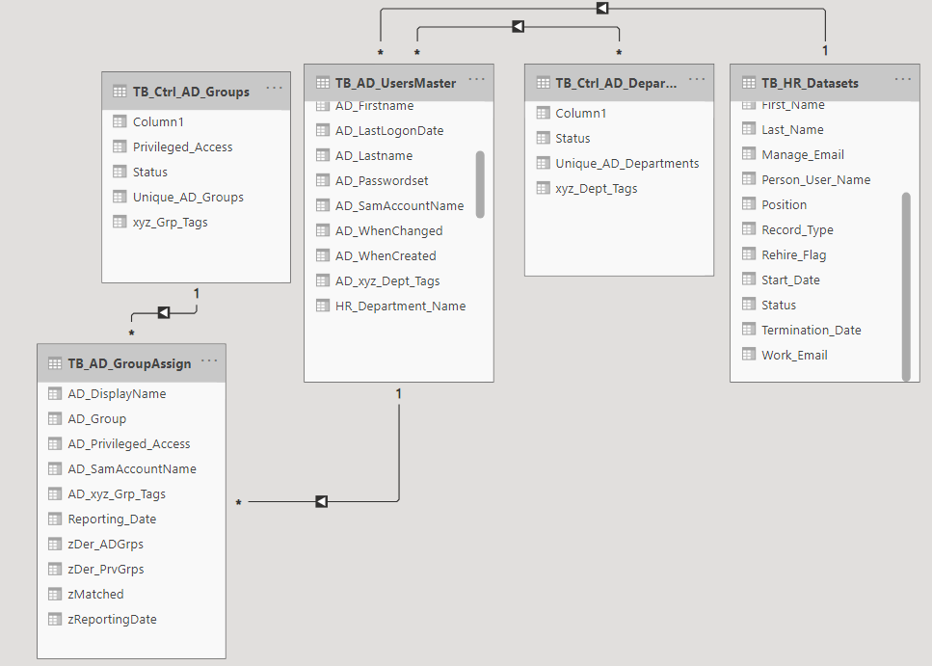

### Reporting Model

The below star schema is a denormalized data structure is used for better performance of the Power BI dashboard. Dimensional tables – Enriched AD Users Master and Date Dummy table, are linked to the AD user assignments fact table. Table “zMeasures” is placeholder for all the calculated measures that were used in designing the visual dashboard.

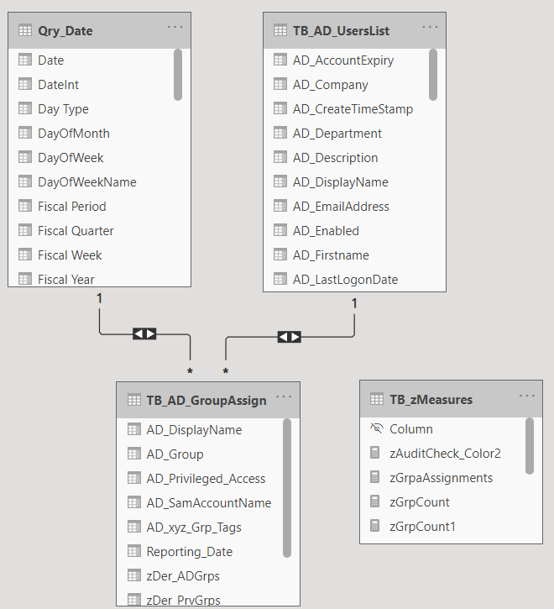

Relationships and Cardinalities are stated as below:

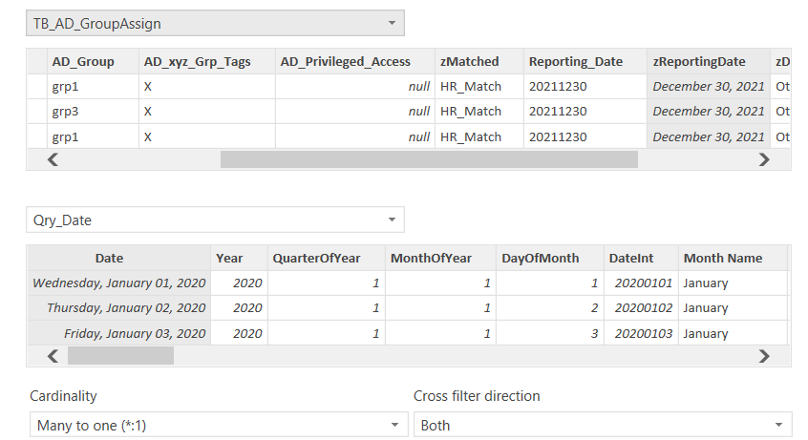

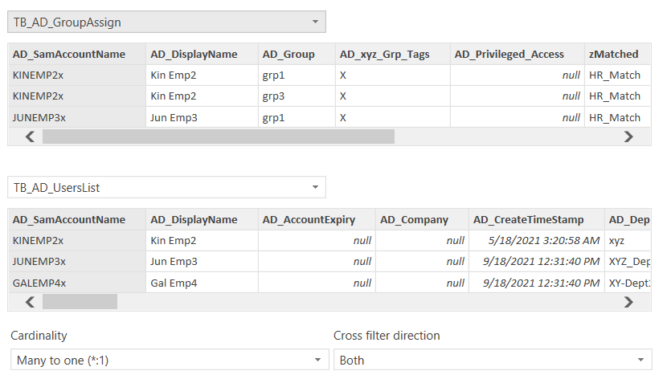

### Source-to-Target Mapping (Data Lineage)

Source-to-Target Mapping (Data mapping) is where a map of the source data and how it is transformed and derived to reach its target destination in analytical reports. This Data lineage process gives visibility while greatly simplifying the ability to trace errors back to the root cause in a data analytics process.

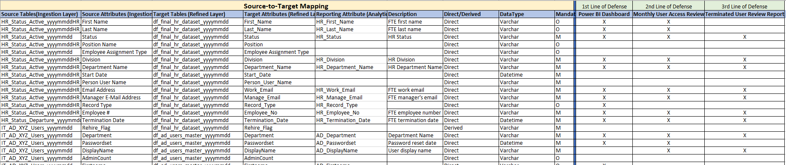



## Operational Dashboard Prototype

The below operational dashboard prototype is designed in Power BI

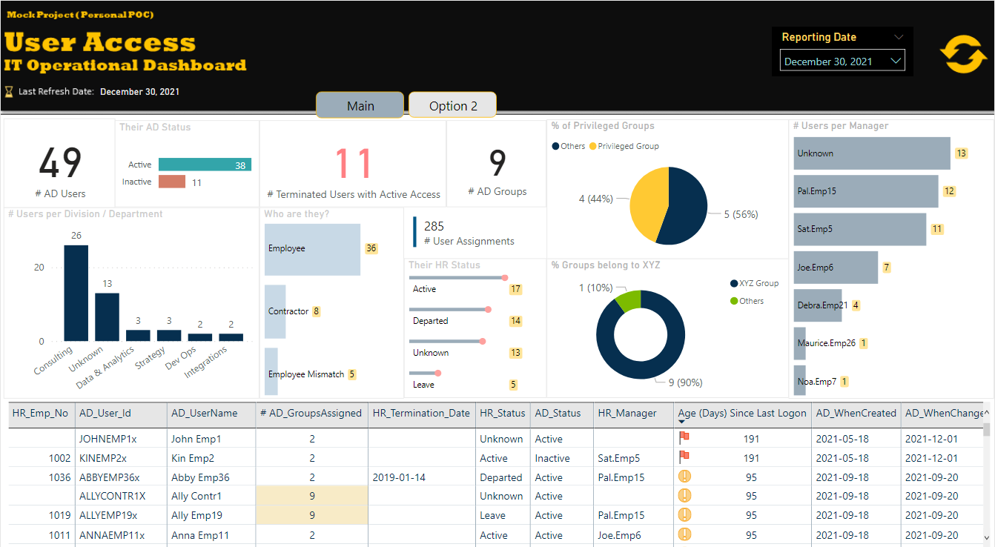

## Non-Functional Requirements

The following are the non-functional requirements of this project:

|  |  |  |
| --- | --- | --- |
| **#NFR** | **NF Requirement** | **Description** |
| 1 | Frequency | Schedule the data pipelines in sequence at EOD between 10pm to 12am. Please ensure that all dependencies jobs in source systems are completed. |
| 2 | Performance | While processing the data pipelines or access the visual dashboard, ensure there is no performance issues occurred. |
| 3 | Scalability | Optimal resources are available at given time and should able to accommodate change requests/or upgradations in the near future. |
| 4 | Security and SLA | All standard security and compliance measures are implemented while running the data pipelines and accessing the visual dashboard.  Also, ensure RTO (Recovery Time Objective) and RPO (Recovery Point Objective) measures are implemented as per the SLA agreement. |

# Appendices

## List of Acronyms

|  |  |
| --- | --- |
| Acronyms | Meaning |
| ETL | Extract Transform and Load |
| DW | Data warehouse |
| DB | Database |
| API | Application Programming Interface |
| AD | Active Directory |

## Glossary of Terms

**Data wrangling (ELT)**, sometimes referred to as data munging, is the process of transforming and mapping

data from one "raw" data form into another format with the intent of making it more appropriate and

valuable for a variety of downstream purposes such as analytics. A data wrangler is a person who performs

these transformation operations.

**Extract-Transform-Load (ETL)** is different from data wrangling. Here, we extract source data and apply the

required transformations and then, load the refined data to target system.

## Related Documents

|  |
| --- |
| Link(s) |
| **Three lines of Defense Model**: <https://na.theiia.org/standards-guidance/Public%20Documents/PP%20The%20Three%20Lines%20of%20Defense%20in%20Effective%20Risk%20Management%20and%20Control.pdf> |
| **Three lines of Defense Model to Cloud Operations Segment:** <https://guidehouse.com/insights/financial-services/2021/public-sector/garp-three-lines-of-defense> |
| **Digital Transformation:** https://www.i-scoop.eu/digital-transformation/ |
| **COVID-19 impact on business strategy** :https://www.ibm.com/thought-leadership/institute-business-value/report/covid-19-future-business |