System which requires information from other system is called?

Client or Source.

Domain Name Service is an Internet service that translates domain name into IP address?

True.

HTML is a compiled language?

No, it is a Interpreted language.

Identify the instruction from below:

<!DOCTYPE html>

<html>

<head>

<body>

<!DOCTYPE html>

Who invented HTML?

Tim Berners Lee

HTML stands for?

Hyper Text Markup Language

Structure of the we site can be created by using?

HTML

Container + Content is called as?

Element.

Open tag + closing tag is called as?

Container.

Internet is mandatory to execute HTML file?

No, not mandatory

Only use internet for the online things which are not in local system.

HTML file must be saved with the extension?

.html or .htm

Identify the output for below snippet:

<body>

<p style=”color : green orange; ”>Hello Everyone</p>

</body>

Hello Every One will be displayed in default color.

Identify the error for below snippet:

<body>

<h1 color = “ red ”>My favourite color </h1>

</body>

As color is a css property, style attribute shoud be used.

What is the output for below snippet:

<body>

<h1>Hello Everyone</H1>

</body>

Hello Everyone will be displayed with out any error & in black color.

Identify the order of heading code that displays the following:

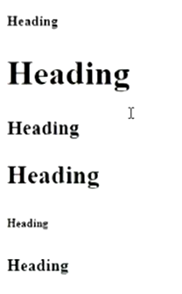

H5, h1, h3, h2, h6, h4.

Which aligns the paragraph horizontally to the right side of the browser window?

<p align=”right”>

Multiple poperties in a style attribute can be used by separating the properties with?

Semicolon.

Identify the invalid type of CSS among the following?

Outline

Inline

External

Internal

Outline

The style attribute is used for?

Inline css

The HTML style attribute has the syntax:

<tagname style=”property:value;”>

The element which displays a horizontal rule on the web page?

<hr>