DOER
DOER is an acronym expands to Decentralized Distributed Disk of Offline Open Educational Resources. We call it simply DOER instead of the longer abbrev "DDDOOER".

DOER is packaged as a cluster of servers that can be installed on any PC by copying the DOER distribution image of a 1 TB hard disk.

When we boot from this specially crafted hard disk, the PC boots with several servers that include:
- NROER (Natioinal Repository of Open Educational Resources)
- Wikipedia in English and Indian languages.
- Activity Based Collaborative Distributed Online Courses
- Online Course Maker and Course Delivery Platform
- Khan Academy Lite (KALite)
- PHET Simulations
- LOGO, Snap, Edgy (Block based computing platforms)
- Sugar Learning Environment
- Open Street Map
- Free and Open Source Software for Education
- etc.
All the above can be accessed from the PC when it is connected in a LAN of a school or a college. All of them will work without connecting to Internet.

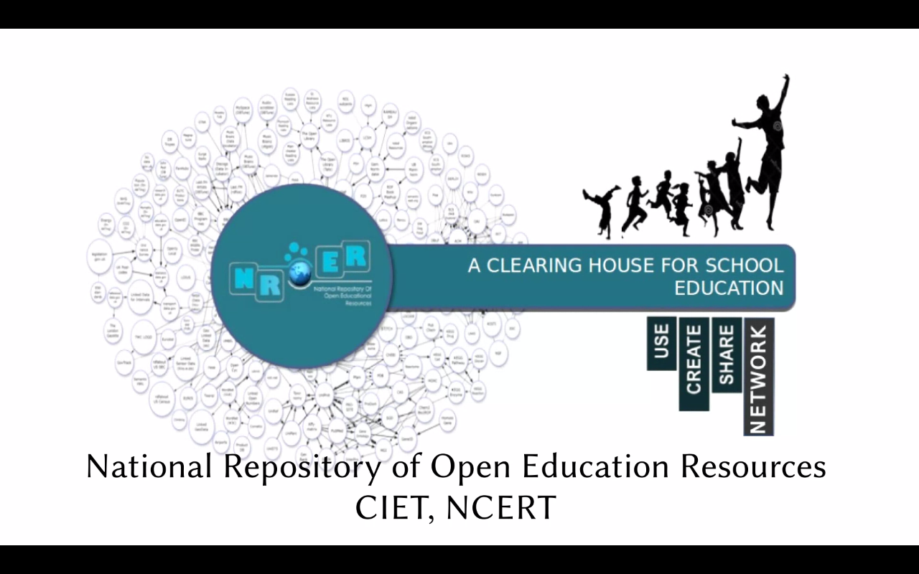
NROER (National Repository of Open Educational Resources)

This is an offline snapshot of the http://nroer.gov.in/ which includes more than 8000 resources on all subjects.

It is an initiative of MHRD, Govt of India and CIET NCERT. It brings together digital resources across all stages of school education and teacher education.

More and more resources and features are being added to this platform every month.

Online courses are also served from this platform.

The platform is an instance of GNOWSYS Studio developed, hosted and maintained by the gnowledge lab of Homi Bhabha Centre for Science Education, TIFR.

Online Courses (ABCDE)

Activity based collaborative distributed online courses can be created and published using this server.

The server is integrated with a digital repository to create and manage content (CMS) and a learning management system (LMS). LMS is designed as an interactive system, not merely as a delivery system. Learners could contribute in creating content, participate in peer to peer assessment, rating, discussions, conversations and write blogs.

- Activities are composed using digital resources like video, audio or images, assessments and embeddable web based interactives.
- Lessons are composed as a sequence of activities.
- Units are composed as a sequence of lessons
- Modules are composed of a set of units.
Detailed user analytics are available at every unit level.


Wikipedia

An offline searchable of Wikipedia.org for selected languages. The offline version is developed and maintained by Kiwix project (http://www.kiwix.org/).

The current version has English and Hindi. More languages will be updated in future releases.


Open Street Map

An offline version of open Street Map (https://osm.org). This is customized to include detailed maps of Asia. This also includes an editor to practice map creation in an offline server.

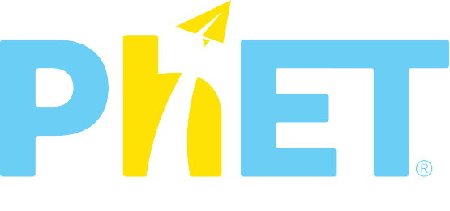
PhET Simulations

PhET provides fun, free, interactive, research-based science and mathematics simulations.

The simulations are developed by Colarado University (https://phet.colorado.edu/en/about).


KALite (Khan Academy Resources)

An offline version of Khan Academy

KA Lite is open-source software that mimics the online experience of Khan Academy for offline situations. Running KA Lite as a local server, you can watch Khan Academy videos, do Khan exercises, and track student progress -- all without needing an Internet connection!

KA Lite offers instructional videos from Khan Academy on math, science, history, economics and matches the common core standards.
Free and Open Source Software
Several downloadable softwares are provided for installing on their computers. The downloads include only free and open source software.

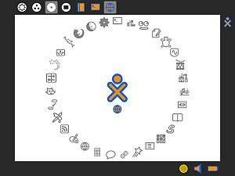
Sugar Learning Environment

Sugar is both a desktop and a collection of Activities. Activities, as the name implies, are Apps that involve active engagement from the learner. Activities automatically save results to a journal, where reflections are recorded. Activity instances can be shared between learners; many support real-time collaboration.

Turtle Graphics (Logo programming)

Turtle Blocks is an activity with a Logo inspired graphical "turtle" that draws colorful art based on snap-together visual programming elements. Its "low floor: provides an easy entry point for beginners. It also has "high celing" programming features which will challenge the more adventurous.

This is an HTML5 version developed using JavaScript that runs directly in a browser.

Snap! and Edgy (block based programming environments)
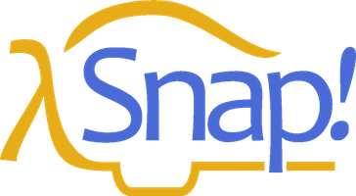
Snap! is a visual, drag-and-drop programming language. It is an extended re-implementation of Scratch (a project of the Lifelong Kindergarten Group at the MIT Media Lab) that allows you to Build Your Own Blocks. It also features first class lists, first class procedures, and continuations. These added capabilities make it suitable for a serious introduction to computer science for high school or college students.
In the example below, a Snap! user can create new control structures, such as a for loop (which isn’t built into the language), by writing a script as shown at the left. Once the for block is created, it can be used even to make nested loops, as shown in the center. A sprite carries out that script at the right.
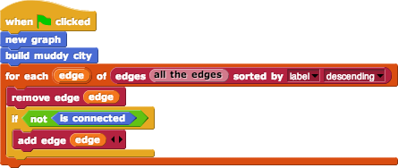
Edgy is based on Snap to do graphs and networks.

