**Current Network**



Proposed AMS Azure Configuration

The proposed AMS Azure design will separate servers from IES. Only the internet connection will be shared with IES . All other services will be segmented. This will include a VPN connection from the Main office to the Azure hosted virtual appliance Cisco ASAv. Protected behind the Cisco firewall will be the virtual machines providing various services.

##### Infrastructure Configuration

The client portal will run on Azure Web App services, and two windows VM web servers (prod & dev) will run on a DMZ network segment, behind a Cisco ASA virtual firewall. A second secured network segment will contain the SQL Server elastic services, Active Directory Domain Controller Windows VM and windows File server VM. Remote users will utilize Cisco AnyConnect VPN to connect to Azure Cisco ASA virtual firewall to access Azure network. OMS Log Analytics will run as a cloud service as the Audit Logging service, and users will continue to access email directly from O365. The log analytics service will log the main office WatchGuard firewall syslog, the Azure Cisco ASAv virtual appliance/firewall syslog, Active directory domain controller and file service event logs. Alerting can be configured to notify staff in the event of specific events occurring, which may require action.

The main office WatchGuard firewall will have a VPN tunnel to the Azure Cisco ASAv virtual firewall appliance. The Azure Cisco ASAv, will allow AMS to fulfill HIPAA compliance, and enable access and event logging. The AMS-Log01 server will be repurposed and remain at the main office running the Blue Iris security camera software, and function as a secondary domain controller for on premise use. The Qlik Sense application will remain on the AMS-LOG-01 server on premise, and be addressed in a future project.

Azure Active Directory will be used in the future for partner and vendor access. This service does not exist today.

##### Proposed Network Diagram

AMS Network Layout - Logical

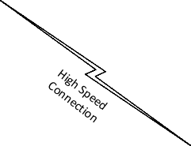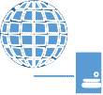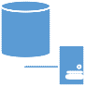

LAN

Remote User

AnyConnect VPN used At Login

AMS-Log01

Blue Iris/

Domain Controller

WatchGuard

Internet

Client Portal

Web App Services

PredictDX PredictDX

Web App Services Web App Services

PROD DEV

Office 365

DMZ vNet

Microsoft

Azure

Cisco ASAv

Virtual Appliance

LAN vNet

SQL Elastic Services

OMS

Log Analytics

Azure

Active Directory

(Used for Partners/

Domain Controller File Server

vendors today)

### AMS Summary of Azure Costs

|  |  |  |  |  |  |
| --- | --- | --- | --- | --- | --- |
| Service type | Custom name | Region | Description | Estimated Cost | One Time Cost |
| App Service | Client Portal App Service | Central US | 1 instance(s) x 744 Hours, Size: S2, Standard tier, 1 SNI connection(s), 1 IP connection(s) | $148.80 |  |
| Virtual Machines | Cisco ASAv Firewall | Central US | 1: D2: 2 cores, 7 GB RAM, 100 GB  disk | $114.58 |  |
| Web App Service Plan | PredictDX Prod Web App | Central US | S3: 4 Cores, 7 GB RAM, 50 GB disk | $297.60 |  |
| Bandwidth |  | Central US | Zone 1: North America, Europe, 250 GB | $21.32 |  |
| IP Addresses |  | Central US | Classic type, 5 Instance-Level IP Address(es) x 744  Hours, 5 Load Balanced IP Address(es) x  744 Hours, 5 Reserved IP Address(es) x  744 Hours, 5 IP Address remap(s) | $26.78 |  |
| Network Watcher |  | East US | Free | $0.00 |  |
| Virtual Machines | Windows File Server | Central US | 1: D2: 2 cores, 7 GB RAM, 100 GB  disk | $208.32 |  |
| Virtual Machines | Windows Domain Controller | Central US | 1: D1: 1 cores, 3.5 GB RAM, 50 GB  disk | $104.16 |  |
| Log Analytics |  | East US | Standalone tier, 10 GB(s) | $23.00 |  |
| Azure Monitor |  | East US | Free until November 1, 2017 | $0.00 |  |
| Web App Service Plan | PredictDX DEV Web App | Central US | S2: 2 Cores, .35 GB RAM, 50 GB disk | $74.40 |  |
| SQL Database |  | Central US | Elastic Database, Standard tier, 100 eDTUs level, 100 GB storage per pool, 200 DBs per pool | $224.75 |  |
| Cisco ASAv Appliance |  |  | One Time Purchase |  | $2,400.00 |
| Support |  |  | Support | $300.00 |  |
|  |  |  | Monthly Total | $1,543.71 | $2,400.00 |
|  |  |  | Annual Total | $18,524.46 |  |

AMS Implementation Tasks

|  |  |  |
| --- | --- | --- |
| **AMS Task List** | **Time** | **GGK** |
| Setup Azure Subscription, Resource Groups, User Access | 8 | Not GGK |
| Install Cisco ASAv Firewall | 4 | Not GGK |
| Setup 2 Virtual Networks, configure routing through Cisco ASA | 4 | Not GGK |
| Configure Cisco ASAv, VPN | 4 | Not GGK |
| Configure Cisco AnyConnect | 4 | Not GGK |
| Install Windows Domain Controller VM, DC-PROMO to DC | 4 | Not GGK |
| Configure AMS Domain Active Directory for multi-site configuration | 4 | Not GGK |
| Configure A/D Connect to sync with Azure Active Directory | 2/3 | GGK |
| Configure Office 365 to use Azure Active Directory Authentication | 2 | Not GGK |
| Install File Server services and configure DFS | 2/3 | GGK |
| Configure File server shares, permissions, A/D groups, login script | 4/5 | GGK |
| Transfer file server data to Azure File Server | 8 | GGK |
| Configure Web App for PredictDX Prod Environment – Jay to complete  ay to complete |  | Jay 66666 |
| Configure Web App for PredictDX Dev Environment - Jay to complete |  | Jay |
| Configure SQL Elastic services - Jay to complete |  | Jay |
| Migrate databases to SQL Elastic Services - Jay to complete |  | Jay |
| Configure PredictDX Prod Web App - Jay to complete |  | Jay |
| Configure PredictDX Dev Web App - Jay to complete |  | Jay |
| Test PredictDX Prod/Dev Web App - Jay to complete |  | Jay |
| Test Client Portal App Web App - Jay to complete |  | Jay |
| Configure Web App for client Application portal | 8 | GGK |
| Configure External App access via IP Addresses | 2 | GGK |
| Install Log Analytics services to 3 Web Apps & Cisco ASAv Firewall | 4 | Not GGK |
| Configure OMS Log Analytics services to collect data, Create dashboard view | 8 | GGK |
| Create detailed Network Diagram with IP Address/Hostnames | 4 | GGK |
| Create detailed summary of implementation installation | 8 | GGK |
| Assist in configuring Cisco AnyConnect users | 8 | Not GGK |
| Troubleshooting issues/Buffer | 8/24 | GGK |
| Total Hours | 100/75 |  |

Proposed IES Azure Configuration

The proposed IES Azure design will separate servers from AMS. Only the internet connection will be shared with AMS. All other services will be segmented.

##### Infrastructure Configuration

A network segment will contain a DMZ network providing web services for external access to clients. A second network segment will contain segmented network containing SQL service, IES domain controller windows VM and file server windows VM. Active Directory will provide security for domain joined machines. Remote users will VPN into PPTP VPN services running on domain controller and map network drives to windows file server VM. Users will continue to access email directly from O365.

##### Proposed Network Diagram

IES Network Layout - Logical

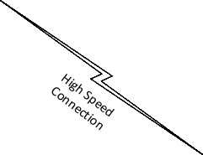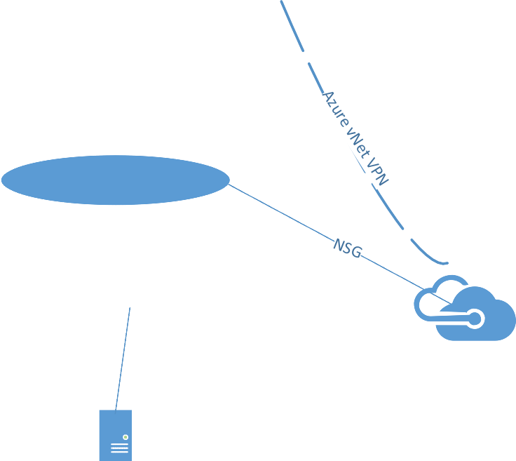

LAN

Remote Users

PPTP VPN connection for

domain access & file access

WatchGuard

Shared Internet with AMS

Internet

Client Apps

Web App Services

DMZ vNet

Office 365

LAN vNet

SQL Services

Microsoft

Azure

Domain Controller

PPTP VPN Server

& File Server

### IES Summary of Azure Costs

|  |  |  |  |  |
| --- | --- | --- | --- | --- |
| Service type | Custom name | Region | Description | Estimated Cost |
| Azure Monitor |  | East US | Free until November 1, 2017 | $0.00 |
| Virtual Machine | Windows Domain Controller/File Server | Central US | 1: D2 v2: 2 cores, 7 GB RAM, 100 GB disk | $208.32 |
| VPN Gateway |  | Central US | Basic VPN tier, 744 Gateway hour(s), 200 GB, Inter-VNET Outbound VPN | $33.78 |
| Bandwidth |  | Central US | Zone 1: North America, Europe, 50 GB | $43.07 |
| IP Addresses |  | Central US | Classic type, 2 Instance-Level IP Addresses, 744 Hours, 2 Load Balanced IP Address(es) x 744 Hours, 2 Reserved IP Address(es) x 744 Hours, 2 IP Address | $8.93 |
| App Service |  | Central US | 1 instance(s) x 744 Hours, Size: S2, Standard tier | $148.80 |
| SQL Database |  | Central US | Single Database, Standard tier, S2 level, 50 DTUs, 250 GB storage per DB | $75.02 |
| Support |  |  | Support | $300.00 |
|  |  |  | Monthly Total | $817.92 |
|  |  |  | Annual Total | $9,815.00 |

IES Implementation Tasks

|  |  |  |
| --- | --- | --- |
| **IES Task List** | **Time** | **GGK** |
| Setup Azure Subscription, Resource Groups, User Access | 8 | NOT GGK |
| Setup 2 Virtual Networks, configure routing through vNet | 4/5 | GGK |
| Configure vNet Gateway | 4 | GGK |
| Install Windows Domain Controller VM | 2 | NOT GGK |
| Configure Active Directory for single site configuration | 3 | GGK |
| A/D create users, groups, login scripts | 4 | GGK |
| Add IES machines to new domain (10 workstations, 15 minutes each) | 2.5 | GGK |
| Reconfigure IES pc profiles. Setup email, copy over profile info from old profile to new (10 workstations, 30 minutes each) | 5 | GGK |
| Configure VPN on IES pc's (10 workstations, 15 minutes each) | 2.5 | GGK |
| Install windows server RRAS - PPTP service for VPN access | 1 | NOT GGK |
| Configure A/D Connect to Azure Active Directory | 2 | GGK |
| Configure Azure Active Directory to O365 email | 2 | NOT GGK |
| Install File Server Services on Domain Controller, configure DFS | 2 | NOT GGK |
| Configure File server shares, permissions | 2/4 | GGK  based on number of users |
| Transfer data to Azure File Server | 8 | GGK |
| Configure SQL services | 2 | GGK |
| Migrate databases to SQL Services | 4 | GGK |
| Configure Web App for client Application portal | 2 | GGK |
| Test Web App for Client Portal App Services | 2 | GGK |
| Configure External App access via IP Addresses | 2 | GGK |
| Configure Network Security group for DMZ | 2 | GGK |
| Configure network security group for Internal Network | 2 | GGK |
| Create detailed Network Diagram with IP Address/Hostnames | 4 | GGK |
| Create detailed summary of implementation installation | 4 | GGK |
| Assist in configuring Windows PPTP client access | 4 | NOT GGK |
| Troubleshooting issues/ Buffer | 8/24 | GGK |
| Total Hours | 88/88 |  |
|  |  |  |