**Payout Verification Form**

Note:-

Fields marked with (**\***) are mandatory remarks to be updated.

|  |  |  |  |
| --- | --- | --- | --- |
| **Policy Number*-:** **15671049** | | **KRN-:**  **761561** | |
| **Application Number-:** **LL38616530** | | **Confirmation on Request Given *-:YES** | | |
| **Customer Name*-:** **CHANDA DEVI** | | **Father Name-*NA** | |
| **Allocation Date*-:NOVEMBER 30 ,2021** | | **Nominee Name-*NA** | |
| **Date and Time of Field Visit*-:DECEMBER 3,2021 AND 10:40 PM** | | **Nominee DOB-*NA** | |
|  | |  | |
| **Existing Address Details\*** | W/O SUBHASH CHANDRA BOSE BABU CHAKLA MAHADIPUR MAHDIPUR KHAGARIA | **New Address(if any)\*** | NA | |
| **State** | BIHAR | **State** | NA | |
| **Pin Code** | 851212 | **Pin Code** | NA | |
| **Landmark** | NEAR BHAGWATI STHAN | **Landmark** | NA | |
| **Landline No & Extension Number** | NA | **Landline No & Extension Number** | NA | |
| **E-mail ID 1** | NA | **E-mail ID 1** | NA | |
| **E-mail ID 2** | NA | **E-mail ID 2** | NA | |
| **Mobile Number\*** | 9798087965 | **Phone Number 1** | NA | |

**In case, subscriber is not available, specify details of Third Party confirmation including spouse/children/relation/neighbor\***

|  |  |
| --- | --- |
| **Details obtained from family representatives:\*** | |
| **Customer Representative Name (if any)** | NA |
| **Relationship with LA** | NA |
| **Contact number of the representative\*** | NA |
| **Representative Comments:** | |

|  |  |
| --- | --- |
| **Details obtained during vicinity check:\*** | |
| **Name of the person met** | NA |
| **Address of the person met** | NA |
| **Contact number of the person met\*** | NA |

**Residence Status**

|  |  |  |  |
| --- | --- | --- | --- |
| **Type of House** | DOUBLE STORIED | **Traceability** | EASY TO TRACE |
| **Location** | VILLAGE AREA | **Ownership\*** | HUSBAND’s OWNED |

**Contact ability**

|  |  |
| --- | --- |
| **Customer Contacted At Address** | YES |
| **Customer Contacted Over Phone** | YES |

**Final Remarks*-:**

|  |
| --- |
| WE VISITED AT THE ADDRESS.FOUND ADDRESS IS CORRECT.AT THE ADDRESS WE MET LA AND TOLD HER ABOUT THE VERIFICATION PROCESS.AFTER THAT LA SHOWED US ALL THE REQUIRED DOCUMENTS. |

**Photographs*-:**

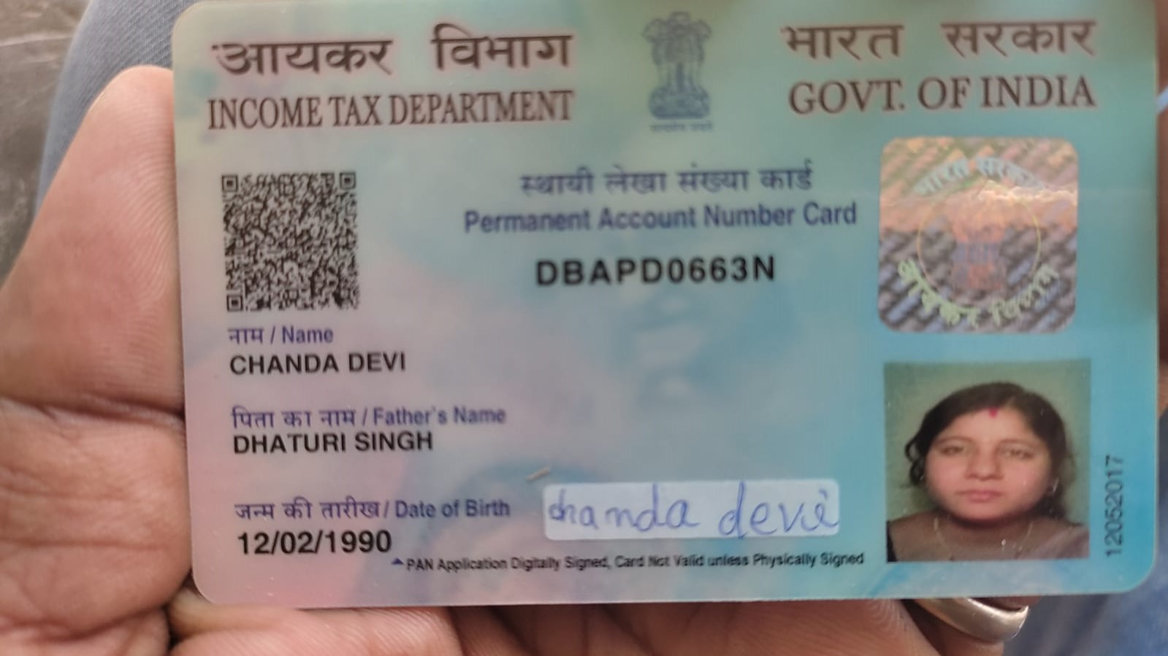

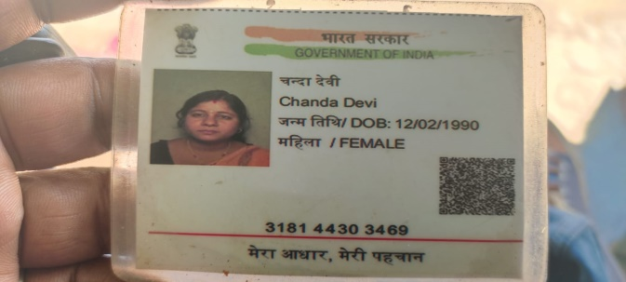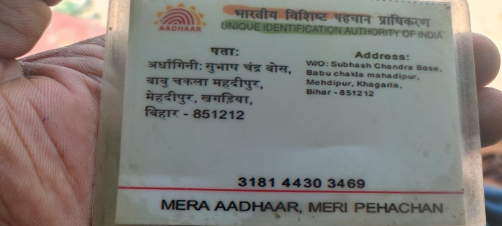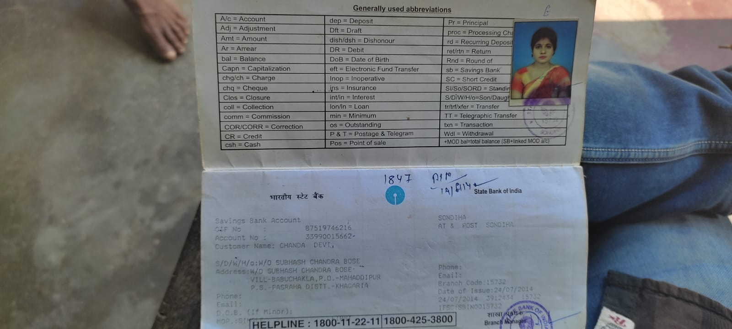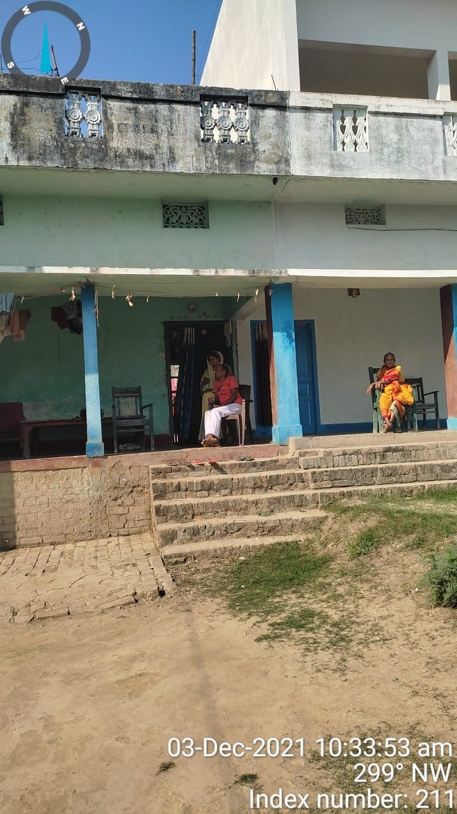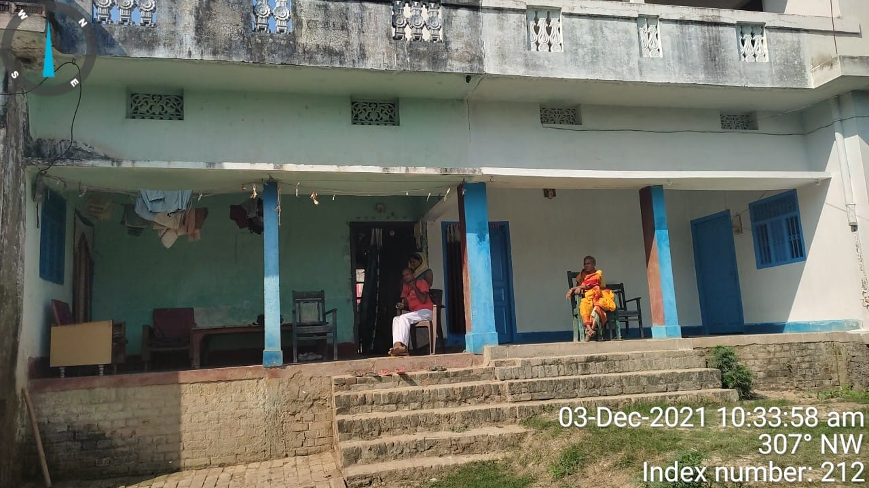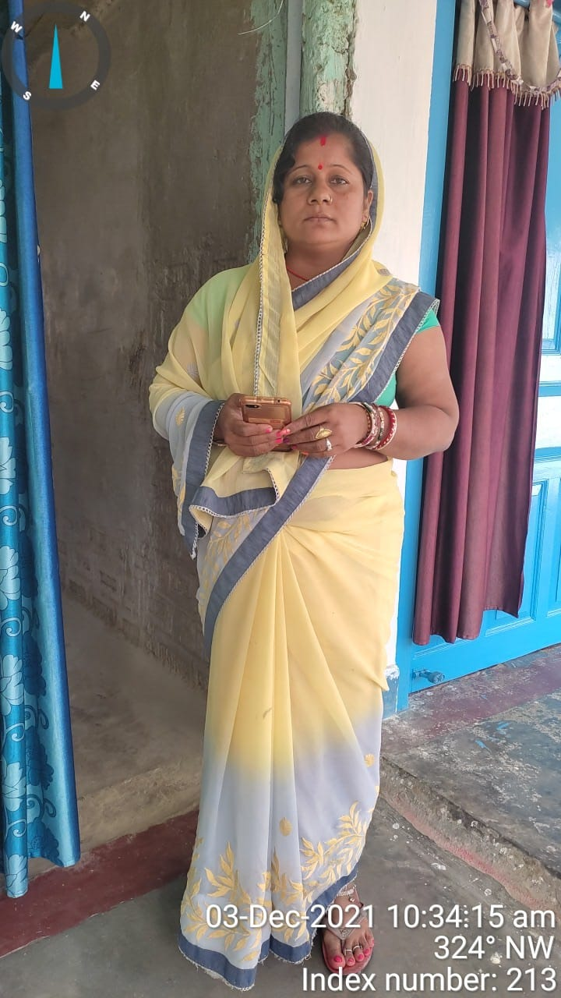

**RCU SEAL AND SIGNATURE**

