**DAC_Phase5**

|  |  |
| --- | --- |
| Date | 01 November 2023 |
| Team ID | Proj_216193_Team_5 |
| Project Name | Product Sales Analysis |

**1. Objective:**

The objective of product sales analysis documentation is to provide a comprehensive and structured report that enables business to gain valuable insights into their sales performance.

**2. Design Thinking Process:**

* Performance evaluation allows business assess the market products.
* Identifying sales trends overtime and impact of marketing.
* Pricing strategy is determining the effectiveness of products.
* Customer insights provides customer performance and behavior.
* Budget and forecasting is crucial for future sales.
* Decision supports related to the product.

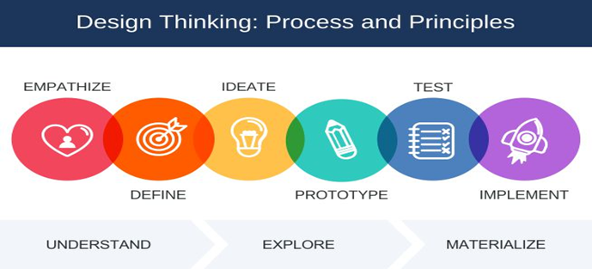

Link : <https://www.google.com/url?sa=i&url=https%3A%2F%2Fwww.linkedin.com%2Fpulse%2Fdesign-thinking-b2b-sales-mahendra-nimkar&psig=AOvVaw27WvzdBS5CGeb_eNgYmIX6&ust=1699162571380000&source=images&cd=vfe&opi=89978449&ved=0CBIQjRxqFwoTCLD9lfTPqYIDFQAAAAAdAAAAABAE>

**3. Development Phases:**

**Phase 1** - Data Collection:

* Collect the data from the identified sources.
* This may involve exporting data from databases, spreadsheets, or using APIs to access data from online platform.

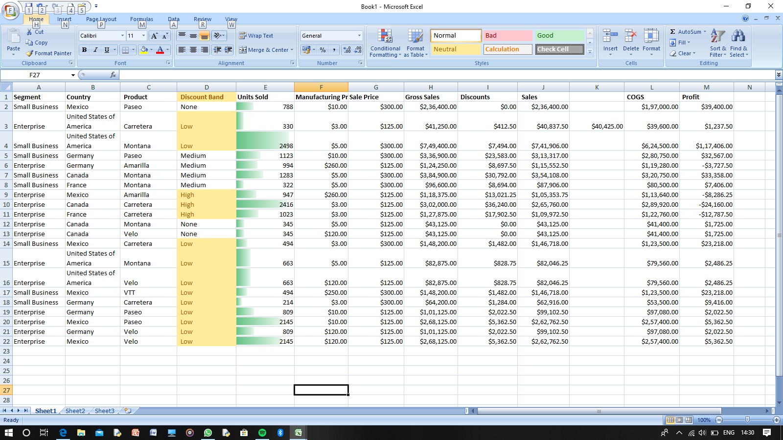

**Phase 2** - Data Analysis:

* Depending on your objectives, choose appropriate analysis technology.
* Common technique include, descriptive statistics, inferential statistics, data visualization, regression analysis, clustering.

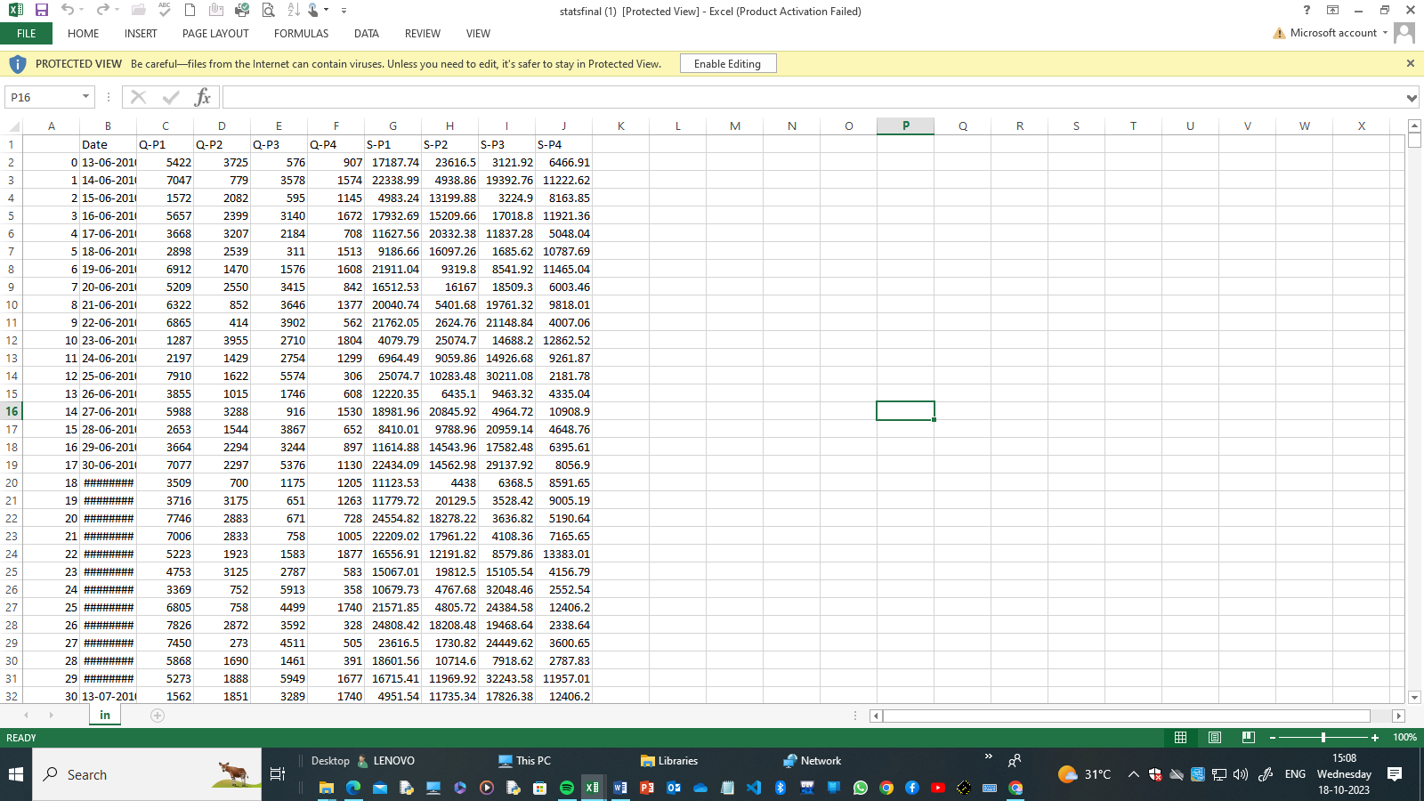

**Phase 3** - Data Visualization using IBM Cognos:

* Utilize IBM Cognos for creating visualizations.
* Present the data using charts, graphs, and maps.

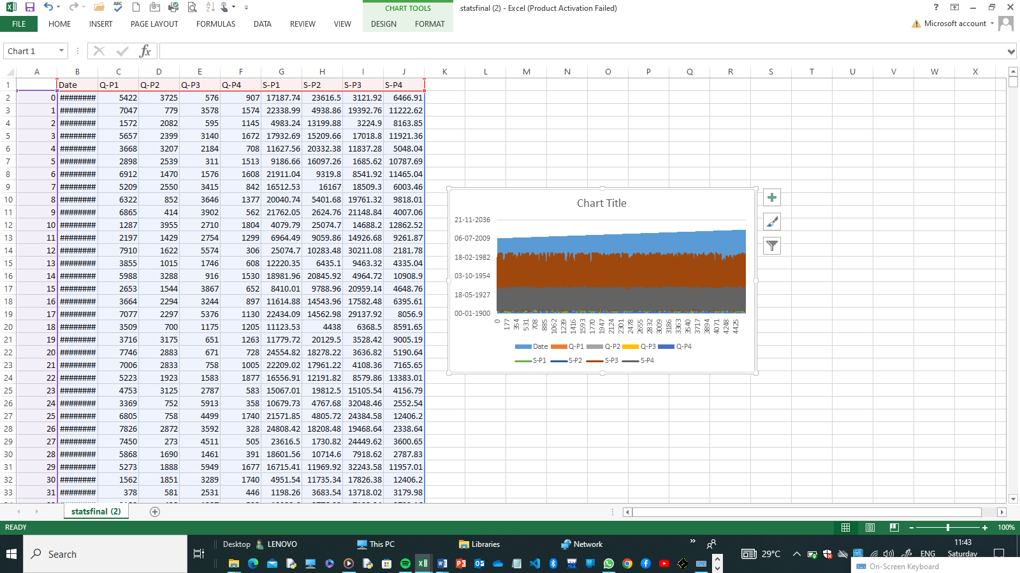

**Phase 4** - Insights and Interpretation:

* Analyse the visualizations and draw insights from the data.
* Compare various aspects of **product sales analysis** and their impacts.

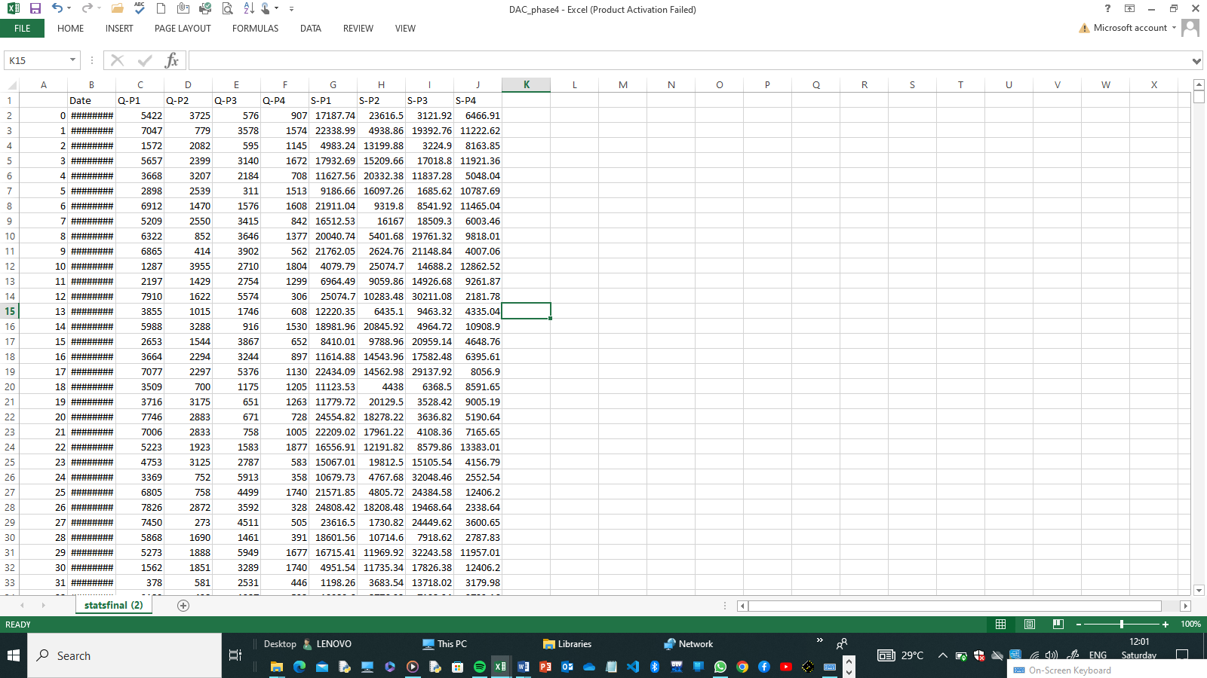

**Phase 5** - Conclusion and Communication:

* Summarize your key findings and insights based on the data analysis.
* Communicate results to stakeholders and the public.

**4. Analysis Objectives:**

The choice of the analysis objective depends on the specific problem you're trying to solve and the type of data you have available. It's essential to clearly define your objectives at the outset of a data analysis project to guide the entire process and ensure that you're answering relevant questions and generating actionable insights.

**5. Data Collection Process:**

The data collection process should be well-planned and executed with care to ensure that the data gathered is accurate, reliable, and suitable for its intended use, whether it's for analysis, decision-making, or research.

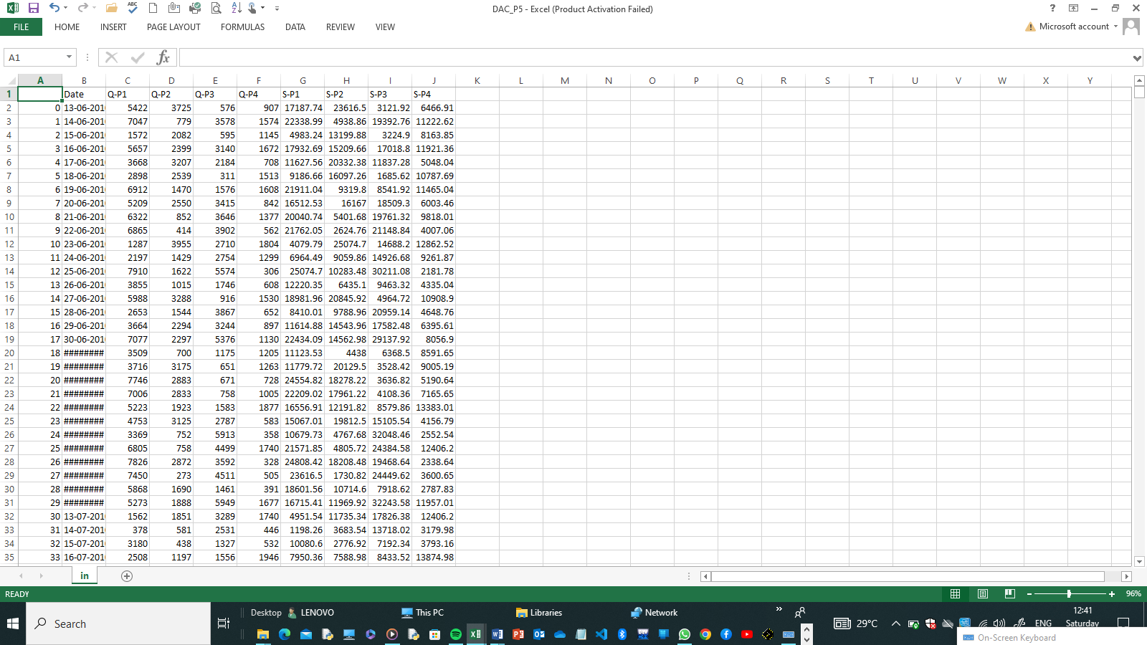

**6. Data Visualization using IBM Cognos:**

* Utilize IBM Congo’s for creating interactive dashboards and reports.
* Generate various visualizations like line charts, bar graphs, heat maps, and maps.
* Highlight key metrics and trends in the data.

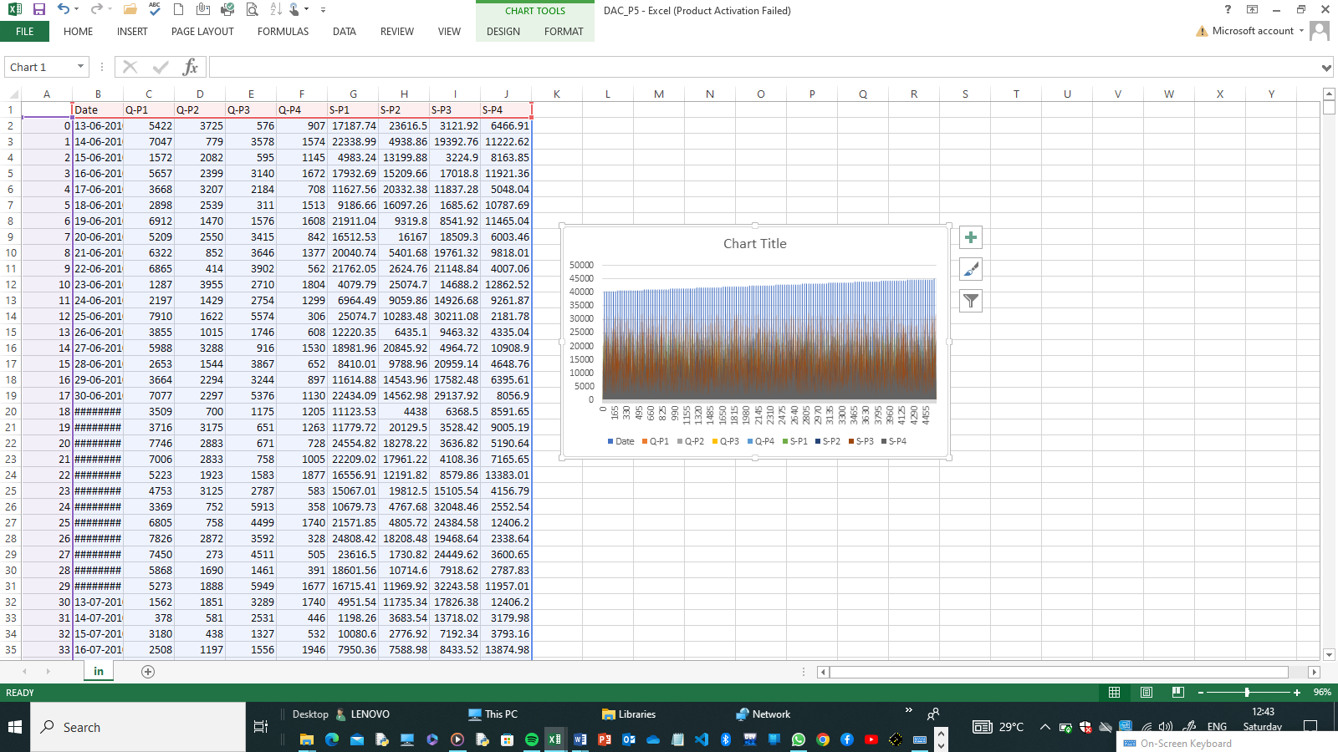

**9.Conclusion:**

This outline should serve as a guide to structure your project and communicate the objectives, process, and insights effectively. You can expand on each section with more details as needed.