

## NLC INDIA LIMITED – NEYVELI

(“NAVRATNA” A GOVERNMENT OF INDIA ENTERPRISE) NEYVELI,TAMILNADU

**INTERNSHIP REPORT ON**

**IPMS WEB DEVELOPMENT SUBMITTED BY**

**Balaji. V - 412422104024**

**Sathasivam R S - 412422104152**

**B.E-COMPUTER SCIENCE AND ENGINEERING**



**Sri Sai Ram Institute of Technology**

**Sai Leo Nagar, West Tambaram, Chennai, Tamil Nadu,600044**

**UNDER THE GUIDANCE OF**

**SHRI. RONIJ PANDEY**

**DEE/CS, MINE-I**

**NLC INDIA LIMITED**



**NLC INDIA LIMITED**

(“NAVRATNA” – A GOVERNMENT OF INDIA ENTERPRISE) NEYVELI – 607801, TAMIL NADU

# BONAFIDE CERTIFICATE

This is to certify that the internship training titled “**WEB DEVELOPMENT” is** the original work **of Balaji V (412422104024) , Sathasivam R S (412422104152)** students of **B.E (CSE)** **Sri Sai Ram Institute of Technology,** carried out during the period from **07/01/2025 to 18/01/2025** at the **Administrative Office, Mine-I, NLCIL, NEYVELI.**

Their performance, conduct and attendance during the period were found to be

## SIGNATURE OF THE GUIDE

Permitted to submit the internship report to college / university authority.

**DATE: DEPUTY GENERAL MANAGER PLACE: NEYVELI LEARNING AND DEVELOPMENT CENTRE** **NLC INDIA LIMITED, NEYVELI**

# DECLARATION

I hereby affirm that the Internship Report titled **“WEB DEVELOPMENT”**, carried out at the **Administrative Office, Mine-I, NLC India Limited**, and submitted **to Sri Sai Ram Institute of Technology** as part of the partial requirement for the award of the degree **B.E. (CSE)**, is a record of my own original work completed under the guidance of **SHRI RONIJ PANDEY, DEE/CS,** MINE-1, NLC India Limited, Neyveli.

This report is intended solely for reference purposes, and no part of it will be reproduced or published in any form without prior written consent from the officials of NLCIL, Neyveli.

**SIGNATURE OF THE STUDENTS**

**Balaji V**

**Sathasivam R S**

**DATE:18/01/25**

**PLACE: NEYVELI**

# ACKNOWLEDGEMENT

The internship opportunity we had with NLCIL was an incredible experience for both learning and professional growth. We feel truly fortunate to have been part of it and deeply appreciate the chance to connect with so many inspiring individuals and experts who guided me throughout this journey.

We also express our sincere thanks to **Shri A.K.R. SARAVANA BHAVAN, GENERAL MANAGER/ L&DC** & **Shri K. PRABHAKARAN, DEPUTY GENERAL MANAGER, Learning and Development Centre** for providing the opportunity to carry out the internship training in NLC India Limited.

We are deeply grateful to **SHRI. ARULSELVI B, DY.GENERAL MANAGE COMPUTER SERVICES/MINE-1**, for sharing valuable insights, offering essential advice, and providing guidance while facilitating all the arrangements to ensure a smooth experience.

We would also like to express my heartfelt thanks to **SHRI. RONIJ PANDEY, DEE/CS, MINE-I, NLCIL**, for his guidance and support in completing my internship training.

This moment serves as a significant milestone in my career development, and we sincerely acknowledge their contributions. I extend my gratitude to my friends and everyone who consistently supported me in successfully completing this internship.

# ABSTRACT

**PURPOSE:** Internship Training on **“WEB DEVELOPMENT”**

**VENUE:** Administrative Office, Mine-I, Neyveli Township

The project titled **"IP Management App"** aims to create an interactive and visually appealing web-based dashboard with a vintage and funky design for managing IP addresses efficiently. The dashboard is designed to streamline the **"IP Address Management System"**, focusing on the development of a robust platform for efficient creation, updating, deletion, and viewing of IP addresses. The system incorporates user-friendly features, including animated background shapes, and ensures all data is stored securely in a JSON file.

The **goal of the project** is to enhance the process of managing IP addresses within an organization, ensuring better resource allocation, reducing conflicts, and fostering smooth communication between users and administrators.

The IP Management App is designed to efficiently handle and organize IP addresses while ensuring seamless tracking of their usage. Key features include classifying IP addresses as free or reserved, associating them with devices such as laptops, cameras, PCs, servers, and routers/modems, and integrating robust validation mechanisms to prevent invalid entries using regex at both frontend and backend levels. Developed with React for the frontend, JavaScript/Node.js for backend validation, and a JSON file for lightweight data storage, the app offers a adaptable one.

# TABLE OF CONTENTS

|  |  |  |
| --- | --- | --- |
| **SI.NO** | **CONTENTS** | **PAGE NO** |
| **1** | INTRODUCTION:   * 1. Profile of NLCIL   2. History of NLCIL   3. Vision/Mission of NLCIL | 7  10  11 |
| **2** | CONTENT OF THE STUDY   * 1. Introduction   2. Key Objectives   3. System Requirements   4. Technology | 13  14  15  17 |
| **3** | DEVELOPMENT PROCESS:   * 1. Login   2. Dashboard      1. Create      2. View      3. Update      4. Delete | 18  18  18  19  19  19 |
| **4** | SCREENSHOTS | 20 |
| **5** | CONCLUSION | 26 |
| **6** | REFERENCES | 27 |
| **7** | FEEDBACK | 27 |

**1.INTRODUCTION**

## PROFILE OF NLCIL

For over six decades, NLC India Limited (NLCIL) has been at the forefront of India's energy sector, leading the way in lignite mining and playing a major role in the generation of thermal and renewable energy. Since its incorporation on 14th November 1956, NLCIL has consistently contributed to India’s energy security, becoming one of the most significant Public Sector Enterprises (PSEs) in the country. As a Navratna Government of India Enterprise under the administrative control of the Ministry of Coal, NLCIL is recognized for its continuous efforts to expand and modernize its operations, thus contributing to both national development and energy sustainability. NLCIL operates across several states in India, including Tamil Nadu, Rajasthan, Uttar Pradesh, Odisha, Jharkhand, Gujarat, and the Andaman & Nicobar Islands, ensuring that its operations are spread across the country, fulfilling diverse regional energy needs. With a vision to provide sustainable energy, the company has grown into a leader in the sector, setting benchmarks in energy production, particularly in lignite and coal mining, as well as thermal power generation. NLCIL is known for its mining operations, specifically its lignite mines. It operates three opencast lignite mines in Neyveli (Tamil Nadu) with a total installed capacity of 28 Million Tonnes Per Annum (MTPA). The mines are central to the company’s operations, providing the raw material needed for its power plants. In addition to the Neyveli mines, NLCIL also operates an opencast lignite mine at Barsingsar, Rajasthan, which has an installed capacity of 2.10 MTPA, and an open-cast coal mine at Talabira, Odisha, with a capacity of 20 MTPA. These mining operations form the backbone of NLCIL’s energy generation capabilities. NLCIL has expanded its mining footprint with the Talabira-II & III coal mine in Odisha, with a combined coal production capacity of 20 MTPA. This mine commenced production on 26th April 2020, and achieved Commercial Operations Date (COD) on 1st April 2021. The coal mined here is utilized for both NTPL (NLC Tamil Nadu Power Limited) in Thoothukudi and NTPC’s Thermal Power Stations. 8 In the thermal power sector, NLCIL operates a total of four lignitebased pit- head thermal power stations at Neyveli, with a combined capacity of 3,390 MW. These power stations are crucial for the country's energy demand and are strategically located near lignite mines for easy supply of raw materials. The company has also established a 250 MW lignite-based thermal power station at Barsingsar, Rajasthan. Further, through its joint venture with TANGEDCO, NLCIL operates a 1,000 MW coal- based thermal power station at Thoothukudi, Tamil Nadu under the subsidiary NLC Tamil Nadu Power Limited (NTPL). The joint venture between NLCIL and TANGEDCO has an equity participation ratio of 89:11. In alignment with the growing demand for sustainable energy, NLCIL has made significant strides in the renewable energy sector. The company is currently operating 1,380 MW of solar power plants located in various districts of Tamil Nadu and the Andaman & Nicobar Islands, as well as a 51 MW wind power plant in Tirunelveli, Tamil Nadu. In fact, NLCIL was the first Central Public Sector Enterprise (CPSE) to achieve a 1 GW capacity in solar power generation, a landmark achievement that solidifies its position as a leader in clean energy. The company has also become a member of the International Solar Alliance (ISA), contributing to global efforts to combat climate change. NLCIL aims to expand its renewable energy capacity to 6,031 MW by 2030, with plans for further solar and wind power projects in various regions across India. NLCIL has ambitious plans for the future, with a target to achieve a total power generation capacity of 17,171 MW by 2030. The company is actively pursuing expansion projects, including a 3x660 MW coal- based thermal power station at Ghatampur, Uttar Pradesh, in a joint venture with Uttar Pradesh Rajya Vidyut Utpadan Nigam Limited (UPRVUNL). Additionally, the Talabira-II & III coal mines (20 MTPA) in Odisha and the Pachwara South Coal Block (9 MTPA) in Jharkhand are part of NLCIL’s expansion strategy. The Talabira mines began operations in 2020, with an anticipated commissioning of the Pachwara South Coal Block by 2024-2025. 9 The company is also moving forward with the development of a 3,200 MW coal-based pit-head thermal power station at Talabira, Odisha, with land acquisition currently in progress. In addition to its core activities, NLCIL has made significant moves to strengthen its position in the energy sector by forming several joint ventures and subsidiaries. One notable development is the incorporation of Coal Lignite Urja Vikas Private Limited (CLUVPL) on 10th November 2020 with Coal India Limited, which is focused on coal and lignite-based power generation projects. On 14th June 2023, NLCIL formed a wholly owned subsidiary called NLC India Renewables Limited (NRE), aimed at managing its renewable energy assets. Another subsidiary, NLC India Green Energy Limited (NIGEL), was incorporated on 13th October 2023 to oversee the company’s future renewable energy projects. NLCIL’s contributions extend beyond energy generation. For more than six decades, the company has been actively involved in societal development by supporting various socio- economic initiatives in education, health, infrastructure, and rural development. As a responsible corporate entity, NLCIL has contributed significantly to India’s growth by providing sustainable energy solutions, creating employment opportunities, and improving the quality of life for people in the regions where it operates.

## HISTORY OF NLCIL

The discovery of lignite in Neyveli occurred by accident in 1934 when a 'brown substance' was found flowing with water from an artesian well on the 620-acre farm of Rao Bahadur M. Jambulingam Mudaliar. This surprising find led him to promptly notify the British colonial administration. In response, the British Raj dispatched a team of geologists to investigate the unusual substance. After further analysis, the material was identified as lignite, a valuable resource for energy production. Recognizing the potential of this discovery, Rao Bahadur M. Jambulingam Mudaliar took a significant step by 10 generously offering a substantial portion of his land for exploration purposes. His selfless contribution did not end there. He donated the entire 620 acres of land to the Madras Government, enabling the state to explore the rich lignite deposits beneath the surface. This pioneering act laid the foundation for the establishment of what would become one of India’s leading mining and power generation sites. The discovery marked the beginning of Neyveli’s transformation into a hub for lignite mining, which would later play a critical role in India's energy sector. The establishment of NLC India Limited (NLCIL) in Neyveli in the 1950s, followed by the opening of large-scale lignite mines, can be directly traced back to this fortuitous discovery. Over the years, the lignite reserves in Neyveli have contributed significantly to the country’s power generation, and the area has become a vital energy resource centre. Rao Bahadur M. Jambulingam Mudaliar’s vision and generosity not only advanced the understanding of India’s natural resources but also played a pivotal role in shaping the nation’s energy infrastructure. His contributions continue to be remembered as the catalyst that ignited Neyveli’s legacy in lignite mining and thermal power generation.

## VISION/MISSION OF NLCIL VISION:

To establish ourselves as a premier mining and power corporation, recognized for our leadership in the energy sector, committed to social responsibility, and dedicated to accelerating the nation's progress through sustainable practices and innovation. We aim to provide reliable, affordable, and clean energy while creating value for all stakeholders and contributing to the socio-economic development of India.

## MISSION:

* Enhance Capabilities in Power and Mining: We are committed to continually improving and expanding our expertise in the fields of power generation and mining. Our focus is on increasing operational efficiency, leveraging advanced technologies, and ensuring financial stability to foster growth and profitability.
* Promote Sustainable Development: As a socially responsible organization, we strive to integrate environmental sustainability into every aspect of our operations. We are dedicated to minimizing the ecological impact of our activities, while contributing to national goals such as clean energy transition and climate change mitigation.
* Foster Social Responsibility and Community Development: We aim to improve the quality of life for communities around our operations through initiatives in education, healthcare, infrastructure 11 development, and other areas of social welfare. By being sensitive to the needs of society, we seek to be a catalyst for positive change.
* Excellence in Operations: We will continuously strive for excellence in all our processes, from mining to power generation, ensuring high standards of safety, quality, and efficiency. By adopting best practices and fostering a culture of innovation, we aim to stay ahead of industry trends and meet the growing energy demands of the nation.
* Environmental Stewardship: We recognize the importance of protecting the environment and aim to set industry standards for sustainability. We are committed to adopting green technologies, reducing carbon emissions, and restoring natural habitats, ensuring that our growth aligns with the long-term health of the planet. Through these core objectives, we aim to build a company that is not only a leader in the energy sector but also a responsible corporate citizen that contributes to the betterment of society and the environment.

# 2.1 INTRODUCTION

**INTRODUCTION OF IPMS**

**OVERVIEW**

This project focuses on developing a web application with key functionalities like user authentication (login page), Dashboard page redirecting to create, view, update, delete pages, creation and approval workflows. The backend integrates with a database to ensure secure data storage and retrieval of IP addresses. The application is designed to enhance operational efficiency and user experience.

# PURPOSE

The purpose of this IP Management System (IPMS) is to provide an efficient and user-friendly platform for managing IP addresses within a network. It allows network administrators to easily create, update, delete, and view IP address records through an intuitive web interface. The sole purpose of this project aims for:

* + **Centralized IP Address Management:** Allows efficient handling of IP addresses within a network.
  + **CRUD Operations**: Provides functionality to Create, Read, Update, and Delete IP address records.
  + **Nodejs Database Integration:** Stores IP addresses securely in a Nodejs database for easy retrieval and management.
  + **User Authentication:** Ensures that only authorized personnel can access and modify IP address records.
  + **Real-Time Overview:** Offers a dashboard for administrators to view and track the status of IP addresses.

**2.2 KEY OBJECTIVES**

The IP Management System aims to achieve the following objectives:

* **Secure User Authentication**: Develop a reliable login system to prevent unauthorized access.
* **Efficient IP Management**: Centralize and streamline the creation, updating, deletion, and viewing of IP address records.
* **Simplified Operations**: Deliver an intuitive interface using HTML and CSS to ensure seamless user interaction.
* **Data Integrity and Security**: Use a robust MySQL database to ensure accurate and secure data storage.
* **Scalability and Maintainability**: Design the system to accommodate future expansions with minimal modifications.
* **Backend Automation**: Implement Python scripts to automate backend tasks like database queries.
* **Error Handling and Validation**: Validate IP address inputs and handle errors gracefully.
* **User-Friendly Experience**: Provide a responsive, visually appealing interface.
* **Real-Time Data Access**: Enable instant updates and retrieval of IP address information for better decision-making.

# 2.3 SYSTEM REQUIREMENTS

**Hardware Requirements**:

* **Processor**:

Minimum: Dual-core processor (e.g., Intel i3); Recommended: Quad-core processor (e.g., Intel i5 or higher).

* **RAM**:

Minimum: 4 GB; Recommended: 8 GB or higher for enhanced performance.

* **Storage**:

Minimum: 20 GB; Recommended: 50 GB for scalability.

* **Display**:

HD resolution (1366 x 768) or higher.

* **Network**:

Stable internet connection for database connectivity and remote deployment.

* **Peripherals**:

Keyboard and mouse for development.

**Software Requirements**:

* **Operating System**:

Windows 10/11, macOS, or Linux (e.g., Ubuntu 20.04+).

* **Web Browser**:

Chrome, Firefox, Edge, or any modern browser.

* **Programming Tools**:
* **Frontend**:

React.js for building the user interface and ensuring responsiveness. Code editors like **Visual Studio Code**, **Sublime Text**, or **Atom** were used for development.

* **Backend**:

**Node.js** for server-side JavaScript execution with **Express.js** for managing routes and APIs.

* **Database**:

**Json** installed and configured to manage IP address data and user credentials.

# 2.4 TECHNOLOGIES

* **Frontend Development:**
  + **React.js**: A JavaScript library for building the user interface with reusable components, ensuring a dynamic and responsive user experience.
  + **CSS**: Used to style the application for responsiveness and visual appeal.
  + **React Router**: For implementing seamless navigation between different pages (e.g., Login, Dashboard, CRUD pages).
* **Backend Development:**
  + **Node.js**: A runtime environment for executing server-side JavaScript, used to handle API requests, business logic, and communication with the database.
  + **Express.js**: A web application framework for building RESTful APIs, managing routes, and handling middleware.
    - **Development Tools and Environment:**
* **VS Code**: A code editor used for writing and managing the application code.

## 3.DEVELOPMENT PROCESS

### Login

The login module is the entry point for the IP Management System. It allows authenticated users to securely access the system. Users enter their credentials, which are validated against the database. Security measures, such as password encryption, are implemented to prevent unauthorized access. Error messages are displayed for incorrect credentials or missing input fields.

### Dashboard

### The dashboard serves as the central interface for managing IP addresses within the system. It provides an overview of key functionalities, including the addition, editing, viewing, and deletion of IP addresses. Important metrics, such as unused IP addresses and recent changes, are displayed to enhance user experience and operational efficiency. The design is both simple and responsive, ensuring smooth transitions between different tasks, such as device selection, IP validation, and data management. The interface incorporates a vintage and funky design with animated background shapes, ensuring both functionality and an engaging user experience.

### Create

This module enables users to add new IP address entries into the system. A form is provided to input details such as IP address, type, and description. Input validation is implemented to ensure correct data format. Upon successful submission, the data is stored in the Json database. Error messages or success notifications are displayed based on the outcome.

### View

The view module allows users to see a list of all stored IP addresses. Data is fetched dynamically from the database and displayed in a tabular format. Search and filter options are provided for better accessibility. Pagination is implemented to handle large datasets efficiently. Users can click on specific rows for detailed information.

### Edit

The edit module enables modifications to existing IP address records. Users can select an entry, which populates the form with current data for editing. Input validation ensures data integrity during updates. Changes are saved to the database, and success messages are displayed upon completion. A cancel option allows users to revert changes if needed.

### Delete

This module allows users to remove IP address records from the system. A delete button is provided for each entry, with a confirmation dialog to prevent accidental deletions. Upon confirmation, the selected entry is permanently removed from the database. A notification confirms the successful deletion. If the operation fails, an error message is displayed.

# 4.SCREENSHOTS

# 4.1 FOLDER & FILES

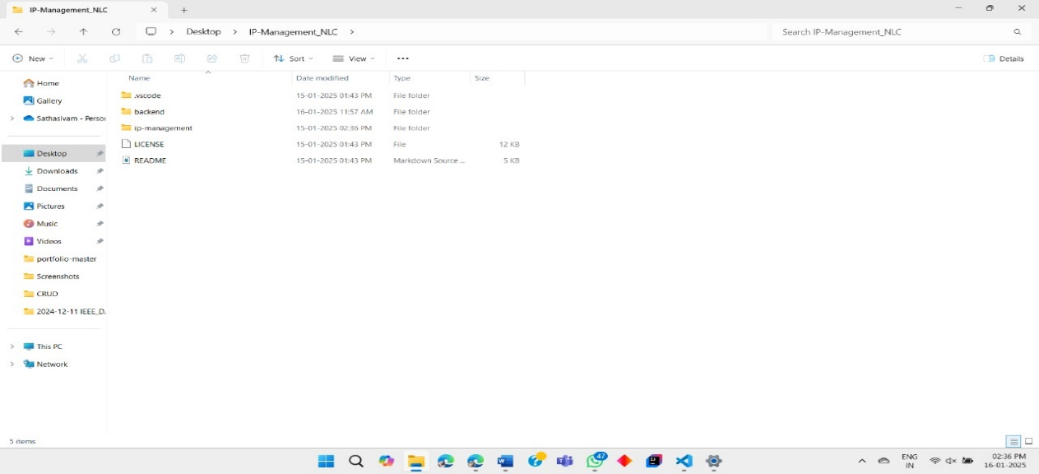

Create a folder named **ip_management_system** in the following directory **C:\Users\Desktop\IP-Management_NL** and create the files for the project.

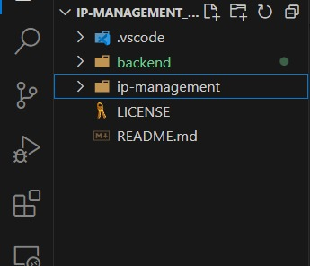

Open **Visual Studio Code** and open the project folder from the directory.

## 4.2 LOGIN PAGE

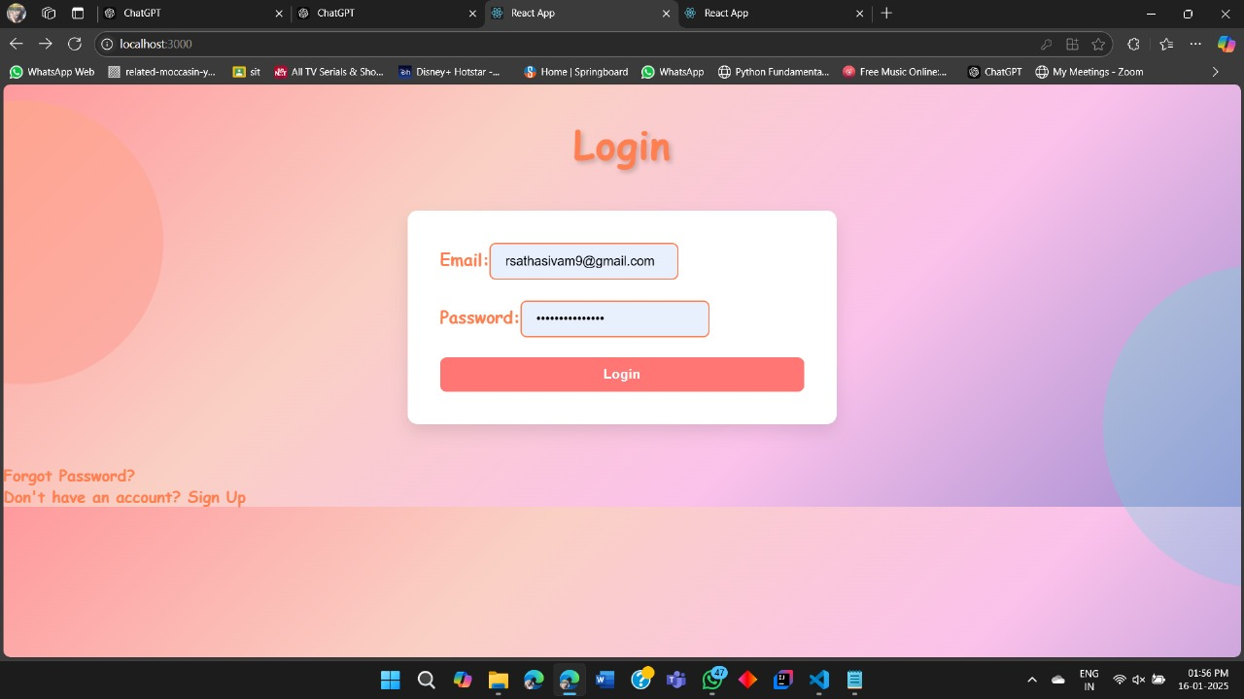

The **login page** requires **Username** and **Password** for authentication. The default username and password is stored in the database to avoid unnecessary data breaches in the web page.

## 4.3 DASHBOARD PAGE

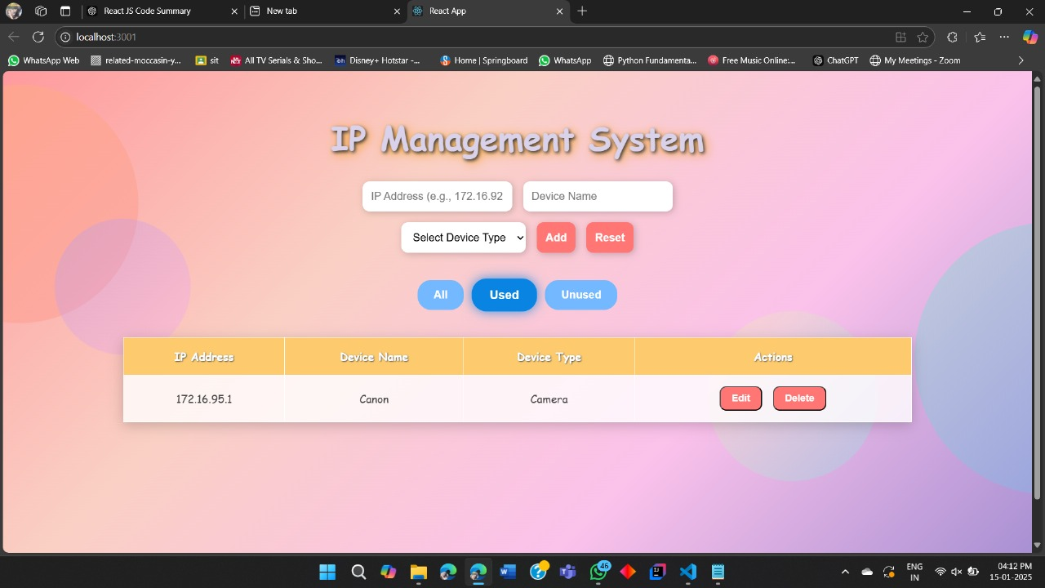

The **Dashboard page** navigates to the create, update, delete and viewpage to the information of IP addresses stored in the databases.

## 4.4 CREATE PAGE

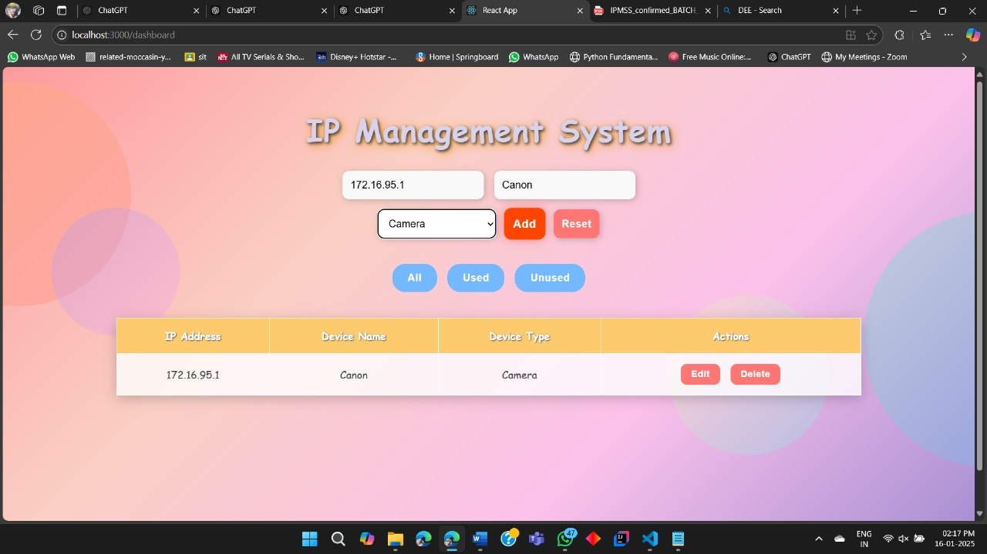

The **Create Page** has the above fields and stores the information the user provides to the database.

## EDIT PAGE

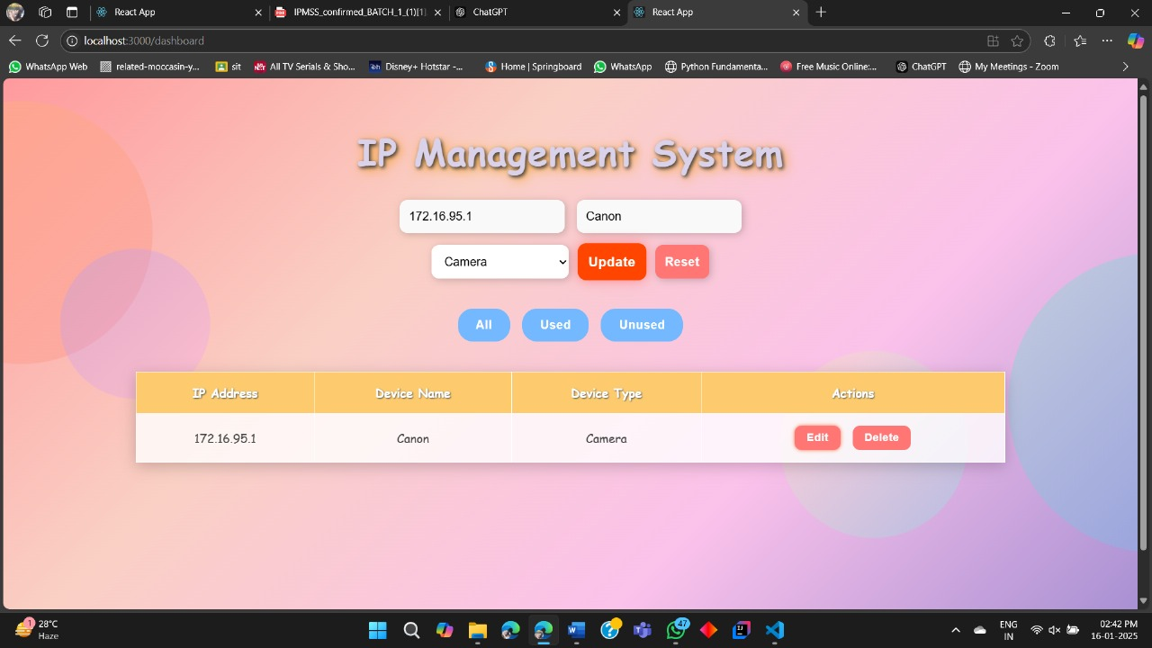

The **Edit Page** gets the ip address and the new asset name and updates them in the database.

## DELETE PAGE

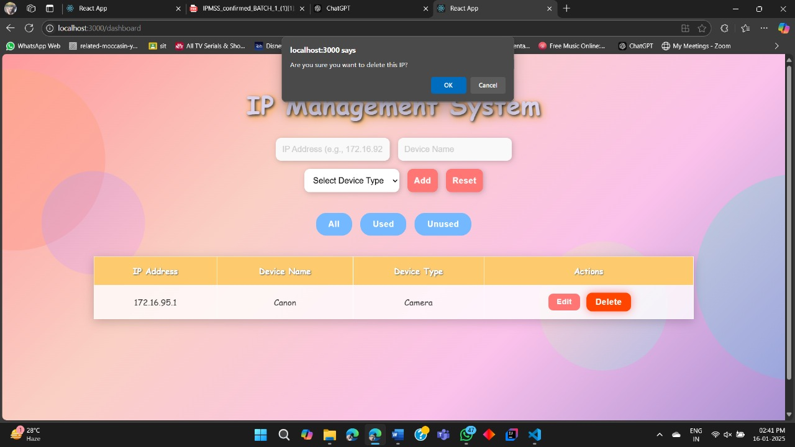

The **Delete Page** gets the IP address from the user and deletes it from the database.

## C:\Users\balaj\Downloads\WhatsApp Image 2025-01-15 at 4.12.31 PM.jpeg VIEW PAGE

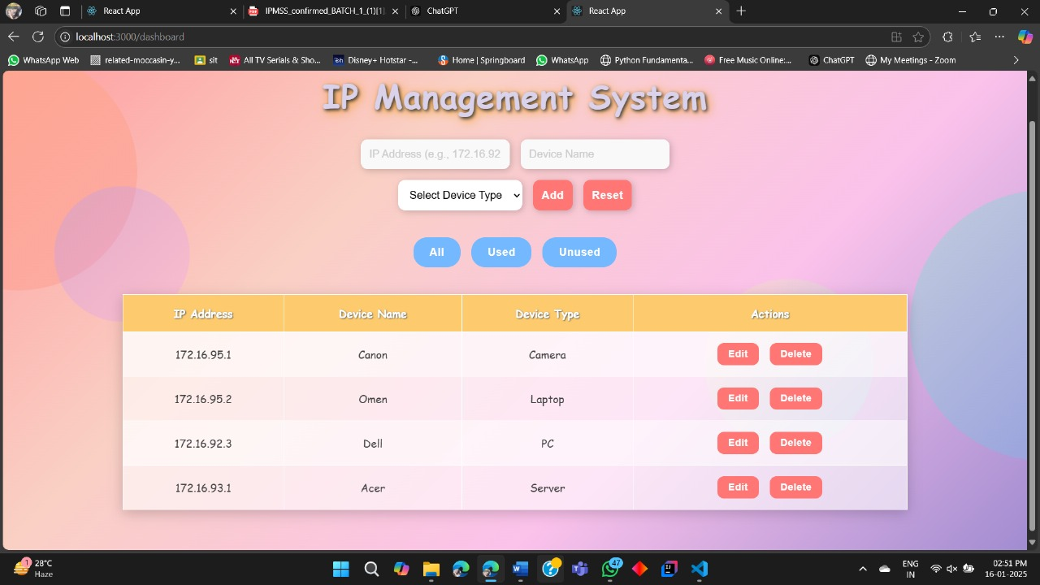The **View Page** contains around **1016 IP Addresses.** In that all the Free and Reserved IP addresses are listed in this page.

# 5.CONCLUSION

In conclusion, the **IP Address Management System (IPAMS)** is a vital tool for efficiently managing and organizing IP addresses within a network. It offers a centralized and user-friendly platform, enabling network administrators to perform **CRUD operations** on IP addresses, thereby minimizing conflicts and ensuring optimal utilization of resources.

By leveraging **Json** for secure and scalable storage, the system ensures that IP address data is easily accessible, consistent, and well-organized. The incorporation of **user authentication** via **JWT** adds an essential layer of security, restricting access to authorized personnel only. The intuitive and responsive **React.js dashboard interface** simplifies the monitoring and management of IP address statuses in real time.

This project not only streamlines the management process but also enhances the efficiency of network operations by reducing manual errors and improving organization. Its **scalability** makes it suitable for both small and large networks, offering flexibility as the network infrastructure evolves. Additionally, the use of **Node.js** and **Express.js** for the backend, combined with a local development environment , ensures reliable testing, deployment, and future modifications.

The IP Address Management System improves network management with efficient IP allocation, enhanced security, and smooth operations, using React.js, Node.js, Express.js, and JSON for reliable solutions.

## 6.REFERENCES

**Title:** Dynamic IP Address Management for Scalable Corporate Networks

**Authors:** S. R. Gupta, A. Kumar

**Title:** IPv6 Address Management in Large-Scale Enterprise Networks

**Authors:** R. Verma, M. Bansal

**Title:** Cloud-Based IP Address Management and Allocation in Distributed Corporate Environments

**Authors:** V. S. Mehta, N. S. Prasad

**Title:** Automated IP Address Allocation for Smart Devices in Corporate Networks

Authors: A. S. Choudhary, P. R. Patel

**Title:** Optimizing IP Address Management in Large Networks Using Artificial Intelligence

**Authors:** K. L. Rathi, P. Sharma

## 7.FEEDBACK

The internship provided valuable exposure to various libraries and software, along with insightful interactions with employees and mentors. We sincerely thank my guides for their support and guidance throughout the training sessions.