1)

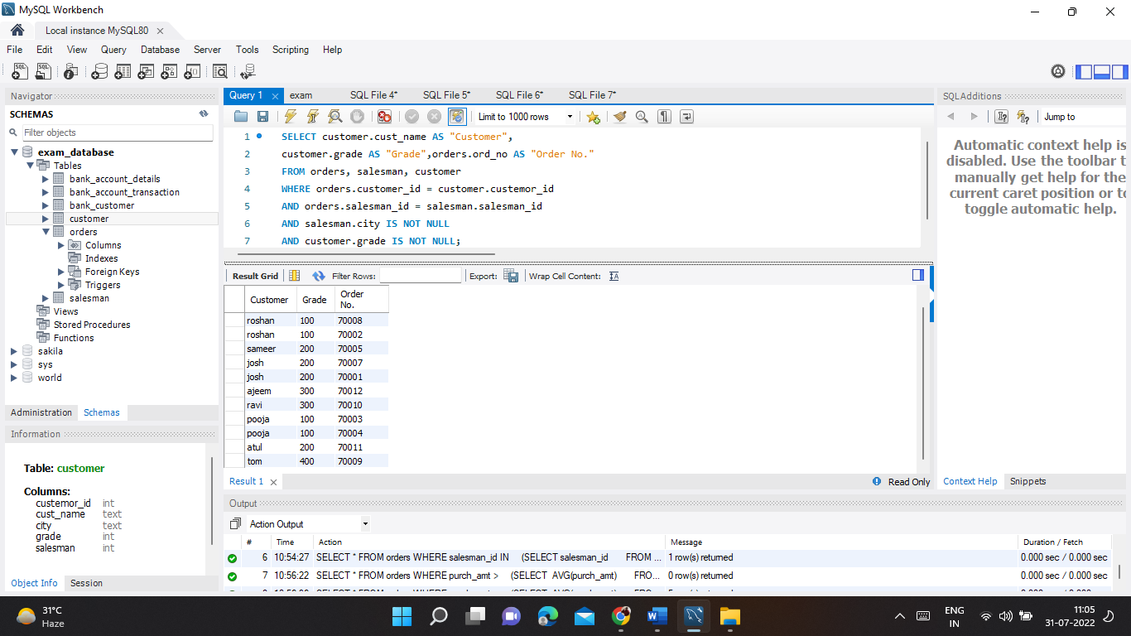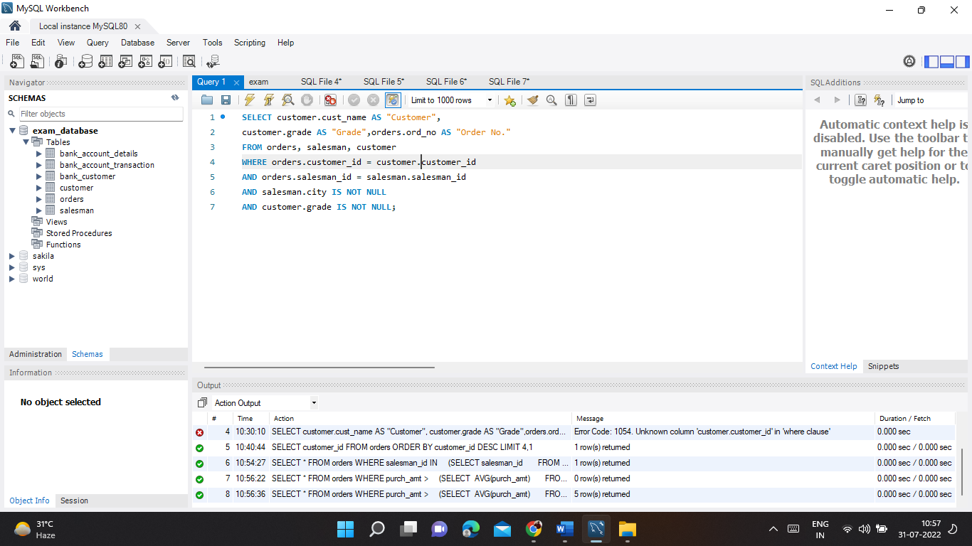

2)

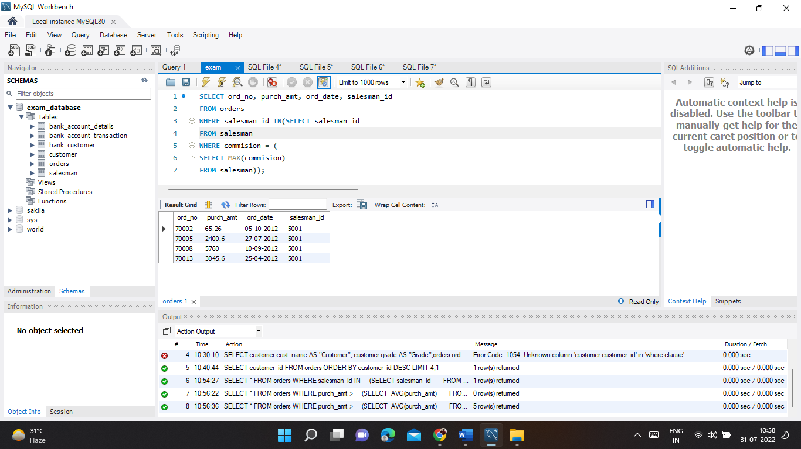

3)

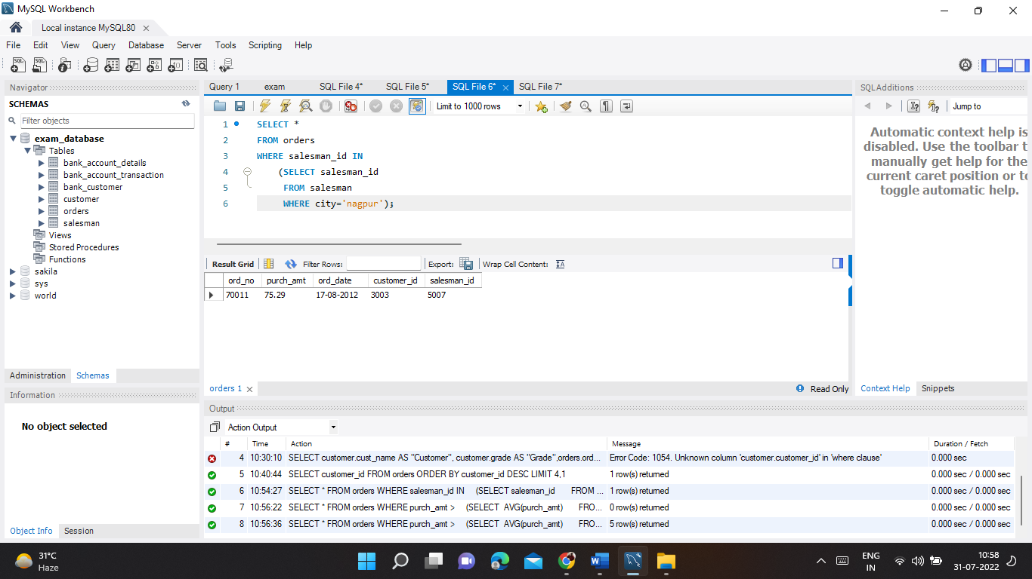

4)

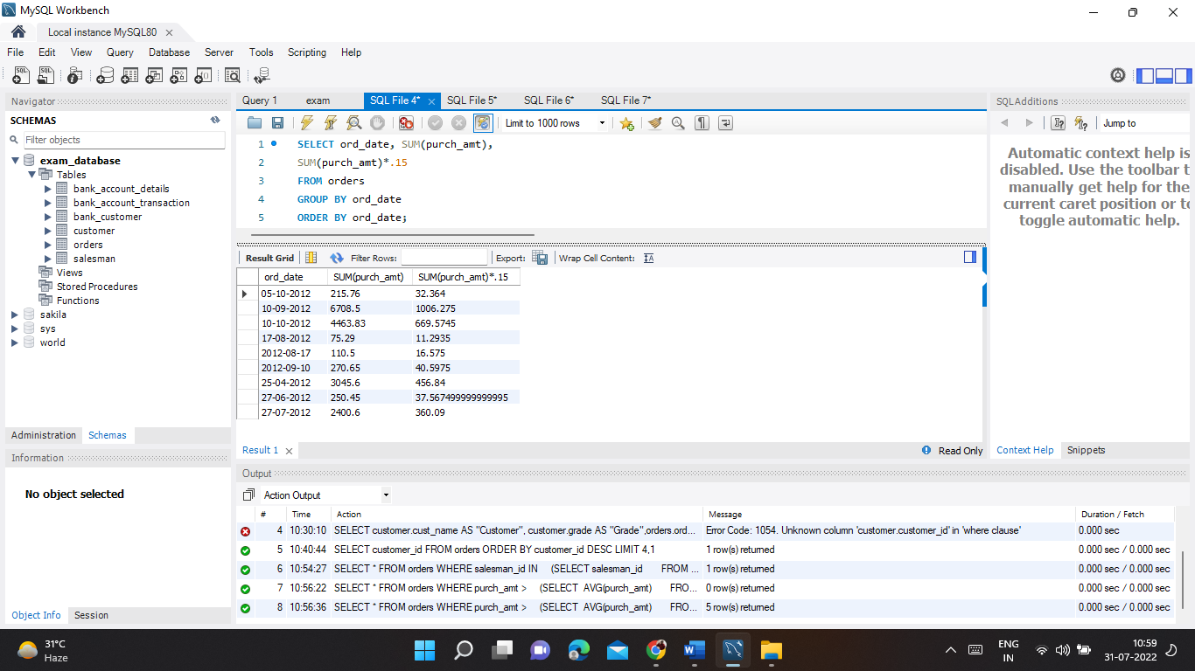

5)

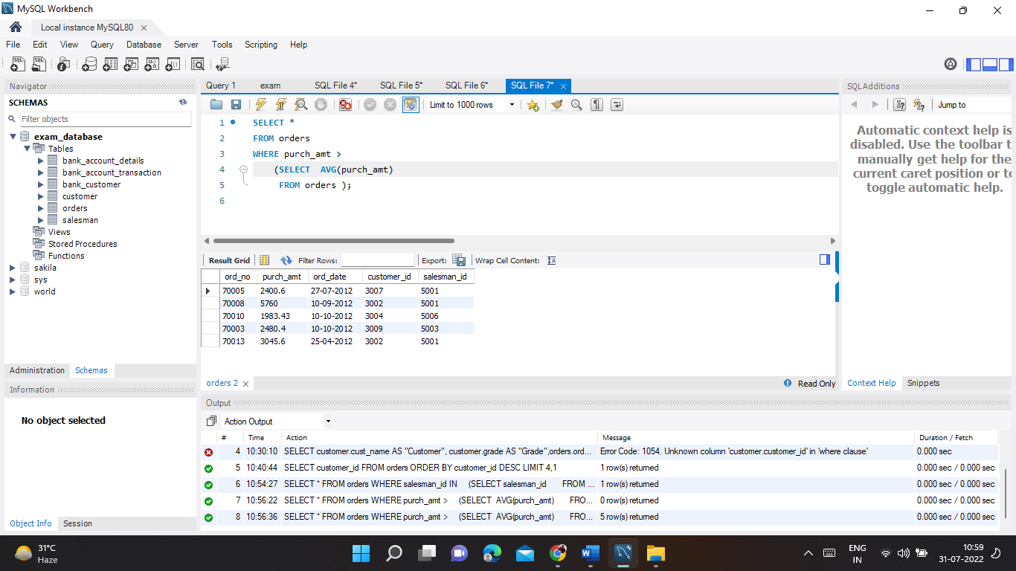

6)

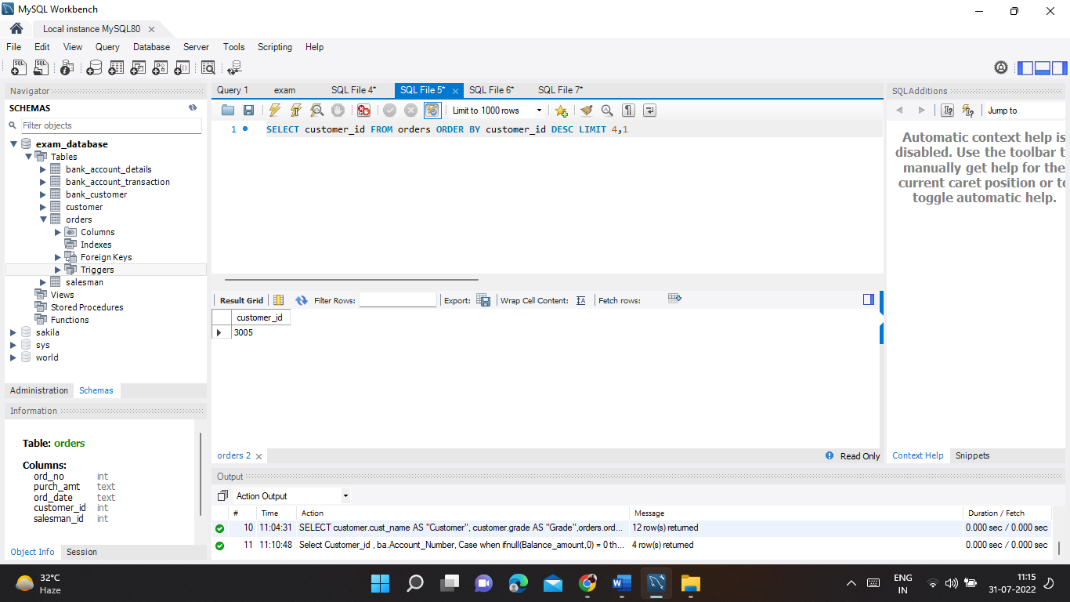

7) **entity** – entity can be real-world object. it is a collection of related attributes or properties.example: employee, department, etc. **Strong Entity** –An entity that has a primary key is called as Strong entity. Rectangle represents strong entity.  **Weak Entity** –Weak entity doesn’t have sufficient attributes to form a primary key of its own.  Double rectangle represents weak entity.

The entity-relationship (ER) model is used to design relational databases by removing all existing redundancy in the data. The basic object of the ER model is an entity—that is, a real-world object. Each entity has several attributes, which are properties of the entity and therefore describe it