2.Write a program which will find all such numbers which are divisible by 7 but are not a multiple of 5, between 2000 and 3200 (both included). The numbers obtained should be printed in a comma-separated sequence on a single line.
f=2000
l=3200
m=[]
for i in range(f,l+1):
if i%7==0 and i%5!=0:
m.append(i)
print(m)

Output:
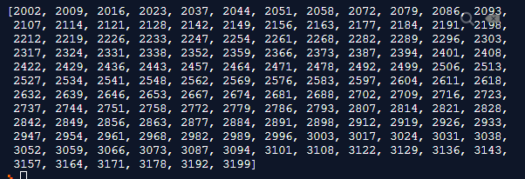

3.Write a Python program to accept the user's first and last name and then getting them printed in the reverse order with a space between first name and last name.
first= (input("Enter the first name: "))
last= (input("Enter the last name: "))

print("The reverse name is:",last,"",first)

Output

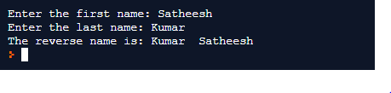

4. Write a Python program to find the volume of a sphere with diameter 12 cm
from math import pi
diameter=12
radius=diameter/2
volume= (4/3* pi*(radius*3))
print("The Volume of the Sphere is: ",round(volume,3),”cm*3”)

Output:

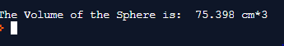
The Volume of the Sphere is: 75.398 cm*3

Task-2:

1.Write a program which accepts a sequence of comma-separated numbers from console and generate a list.

num=(input("Enter the sequence of number: "))

list=num.split(",")
print(list)

Output:

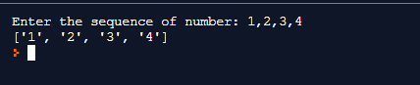
2.Create the below pattern using nested for loop in Python.

for i in range(0,5):
for i in range(i+1):
print("*", end="")
print()

for i in range(5,0,-1):
for j in range(i-1):
print("*",end="")
print()

Output:

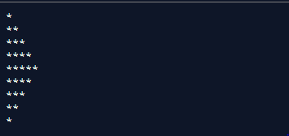

3. Write a Python program to reverse a word after accepting the input from the user.

name=input("Enter the String: ")

print(name[::-1])

Output

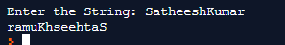

4.

name= '''WE, THE PEOPLE OF INDIA,
having solemnly resolved to constitute India into a SOVEREIGN,
SOCIALIST, SECULAR, DEMOCRATIC REPUBLIC
and to secure to all its citizens'''

print(name)

Output :

