**INTRODUCTION**

* The Gold Price Prediction Project is a data-driven initiative leveraging machine learning techniques to forecast the future prices of gold (GLD). Gold, a crucial commodity with a dynamic market influenced by various factors, presents an intriguing challenge for predictive modelling. In this project, historical data encompassing features such as **stock market indices (SPX)**, **oil prices (USO)**, **silver prices (SLV)**, and **currency exchange rates (EUR/USD)** are employed to develop a robust predictive model.
* The primary objective of this project is to develop a reliable and accurate gold price prediction model. By utilizing a dataset containing features such as stock market indices (e.g., SPX), exchange rates (e.g., EUR/USD), and commodity prices (e.g., USO and SLV), the Random Forest Regressor algorithm is trained to understand the intricate relationships between these variables and the price of gold. The model's performance is evaluated based on metrics like **Mean Absolute Error (MAE)**, providing insights into its predictive capabilities.

**DESCRIPTION**

1. **Data Collection and Preprocessing**

* This project utilizes a comprehensive dataset containing historical data on gold prices along with other relevant features. These features include stock market indices such as SPX, exchange rates like EUR/USD, and commodity prices including USO and SLV. The dataset is explored, cleaned, and pre-processed to ensure that it meets the requirements for training a machine learning model.
* The corelation among all features of the dataset is:

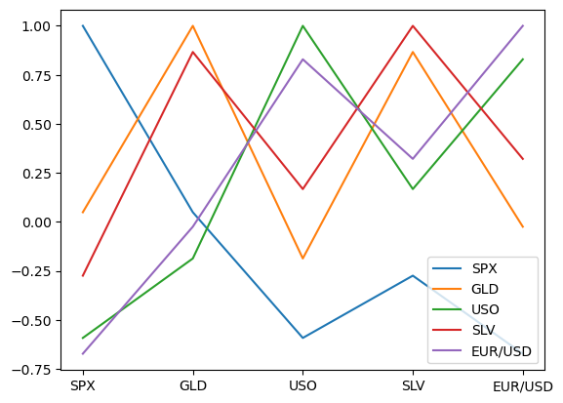

1. **Machine Learning Model**

* The core of the project involves the implementation of the Random Forest Regressor, a versatile algorithm known for its ability to handle complex relationships and deliver accurate predictions. The model is trained on a subset of the dataset, with features such as stock market indices and commodity prices serving as inputs, and the gold price as the target variable. The training process involves optimizing the model's parameters to achieve the best performance.

1. **Evaluation Metrics**

* The performance of the gold price prediction model is assessed using metrics such as Mean Absolute Error (MAE). MAE quantifies the average absolute differences between the predicted and actual gold prices, providing a measure of the model's accuracy. Additionally, visualizations are employed to compare actual and predicted values, offering a comprehensive understanding of the model's predictive capabilities.

**RESULTS**

* The accuracy of the Gold price prediction is calculated by the Mean Absolute Error (MAE), which is 1.299 in this case.
* Below is the graph which shows the actual and predicted results of the Gold price data.

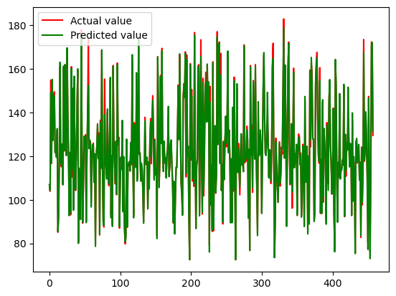

**CONCLUSION**

* The Gold Price Prediction project successfully developed a machine learning model capable of forecasting gold prices based on historical and economic indicators. The project's results, as indicated by the MAE and visualizations, demonstrate the model's accuracy and potential value in informing investment decisions. Ongoing efforts to refine and expand the model will contribute to its adaptability in capturing the complexities of the ever-changing financial landscape.

**REFERENCES**

* Dataset: <https://www.kaggle.com>
* https://www.youtube.com/@Siddhardhan