Revision History

|  |  |  |  |
| --- | --- | --- | --- |
| Version | Date | Author | Description |
| 1.0 | 25.01.2019 | Sathesh.gunasekaran | First Draft |

Table of Contents

Revision History 1

Table of Contents 1

1 PURPOSE 2

2 DEFINITION 2

3 SET UP AND INSTALLATION 2

3.1 JAVA SET UP AND INSTALLATION 2

3.1.1 JDK Download 2

3.1.2 Environment variable setup 3

3.2 TOOL SET UP 5

3.2.1 Tool Download and its Content 5

3.2.2 Run Batch File Set Up 5

3.2.3 Configuration File Set Up 6

3.2.4 Output Email HTML Template Set up (If Needed) 7

3.2.5 JSON File Username and Password Set Up 8

3.2.6 Email from Local Set Up 9

4 HOW TO USE THE TOOL 10

4.1 INPUT TEXT FILE PREPARATION 10

4.2 RUN THE BATCH FILE MANUALLY 11

4.3 TRIGGERING THE TOOL FROM TASK SCHEDULER 11

5 TROUBLESHOOTING 16

5.1 EXCEPTIONS 16

5.2 LOGS 17

# PURPOSE

This document describes how to set up, configure and use the tool.

# DEFINITION

The TAC Automation tool is used to monitor, re-run and report the failed/error jobs/tasks present in the Server by checking them at regular intervals.

# SET UP AND INSTALLATION

## JAVA SET UP AND INSTALLATION

Make sure whether the environment is having Java installed. To verify, type “**java –version**” and press **Enter** key in command prompt.

Note: Any Java -version is fine.

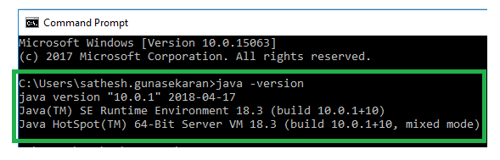

Figure: Verifying whether Java is Installed

If it is not installed, please follow the below mentioned steps for installing it.

### JDK Download

1. Visit “[**Oracle official website**](http://www.oracle.com/technetwork/java/javase/downloads/index.html)**”**, Accept License Agreement and Download Java JDK for your version (32 or 64 bit) of Windows.

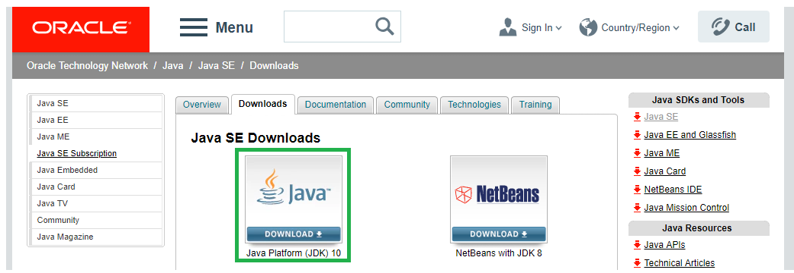

Figure: Java Installation Website

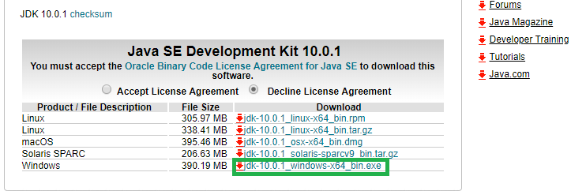

Figure: Download the jdk file

1. Once the download is complete, run the exe for installing “**JDK”** and Click “**Next”**.

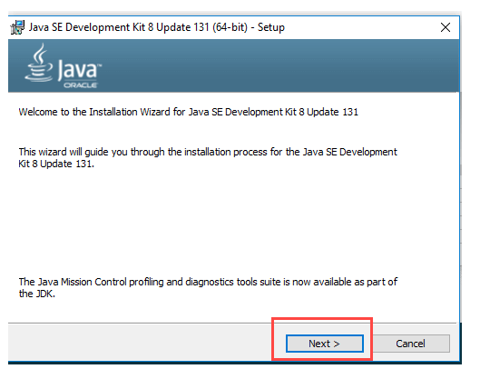

Figure: Steps while installing java

1. Once installation is complete, Click “**Close**” button.

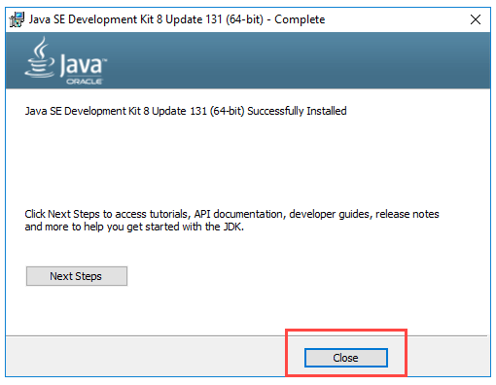

Figure: Steps while installing jdk

### Environment variable setup

1. Go to “**Control Panel**” 🡪 “**Advanced System Settings**” 🡪 “**Environmental Variables**”.

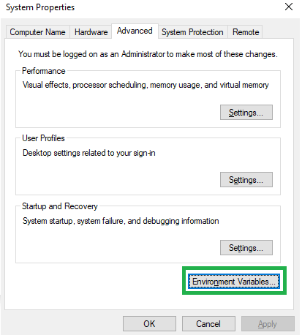

Figure: Set Environment Variable Set up

1. Add the “**JAVA_HOME”** variable with the respective value containing its location.

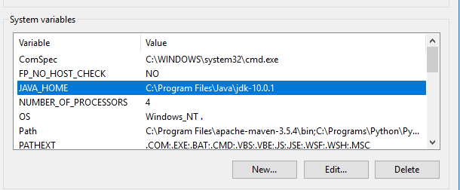

Figure: Adding JAVA_HOME as system variable

1. Add Java Binpath in “**Path”** variable.

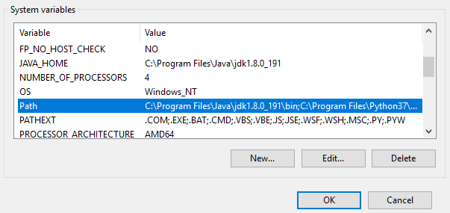

Figure: Editing the System Path Variable

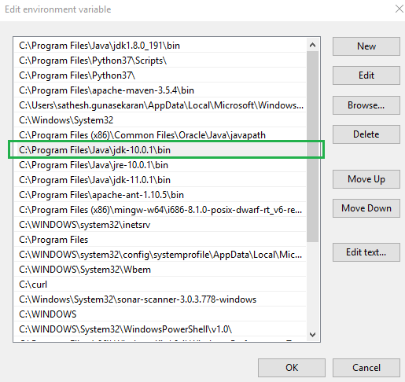

Figure: Editing the System Path Variable

1. To verify, run “**java –version**” in the command prompt

This step ends the Java installation in our Environment.



Figure 9: Verifying the Java version.

## TOOL SET UP

### Tool Download and its Content

1. The downloaded tool will contain the below Zip file as shown below.



Figure: Downloaded Zip File

1. When we extract the “**TAC.zip**” file, we will find the tool structure as below.

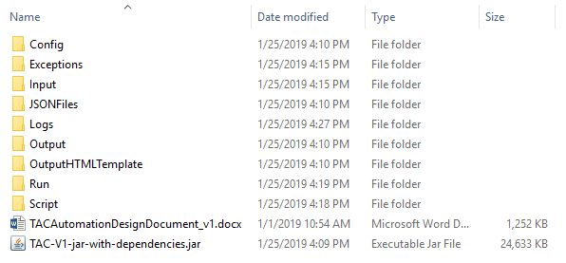

Figure: Tool Structure

### Run Batch File Set Up

1. Please Open the “**Run**” folder present in the extracted “**TAC**” zip file.

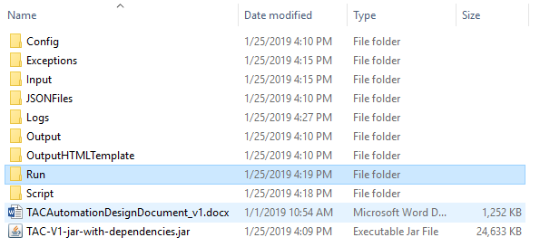

Figure: Run Folder

1. Edit the Batch file named “**Run.bat**”

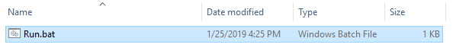

Figure: Run.bat file under Run Folder

1. The following content will be displayed as shown in the figure below.



Figure: Run.Bat file Content

1. Edit the Batch file with correct paths as per your system.

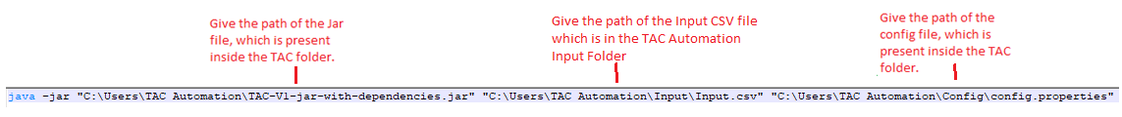

Figure: Edit Run.bat file

### Configuration File Set Up

1. Please Open the “**Config**” folder, to find the “**config.properties**” file and Edit it.

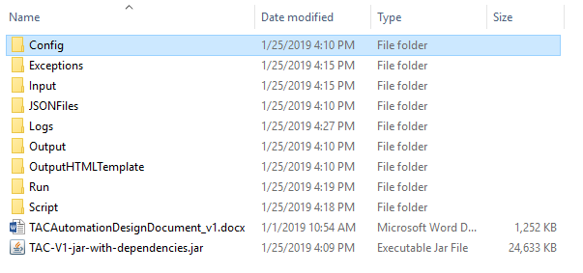

Figure: Config Folder

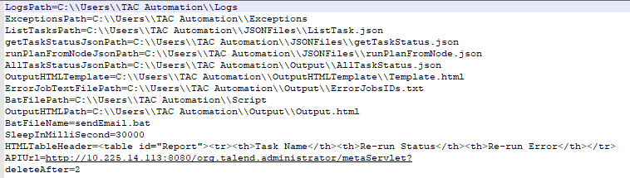

Figure: Config.properties File

1. Please make sure the following Paths like LogsPath, ExpectionsPath, JobTextFilePath, GetTaskIDJsonPath, GetStatusJsonPath, GetRunTaskJsonPath, OutputHTMLTemplate, OutputHTMLPath are as per your system, if it is not so update them.
2. Please have a look at the below attached config file for further details.

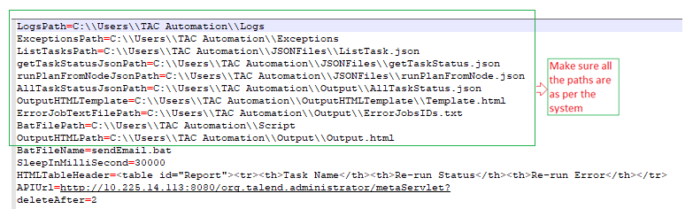

Figure: Editing Config.properties File

### Output Email HTML Template Set up (If Needed)

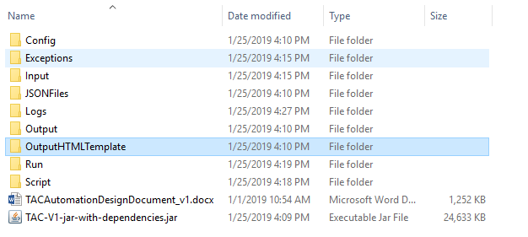

Figure: Email HTML Template Folder

1. Please Open the “OutputHTMLTemplate” folder and Edit the “Template.html” file.
2. Edit this HTML file if needed to do any change in the Email Content as shown in the below figure.

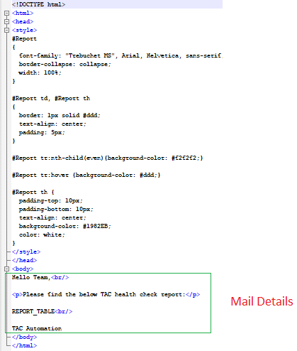

Figure: Email Template

### JSON File Username and Password Set Up

1. **Open** the **JSONFiles** Folder from the Tool Folder Structure.

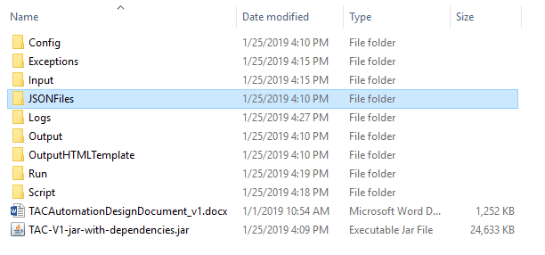

Figure: JSON File Folder

1. There will be three JSON files, which should be edited one by one.

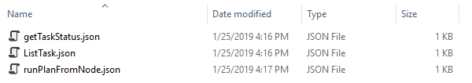

Figure: JSON Files

1. Get Task Status
   * Provide **authPass** and **authUser** values in the JSON file.

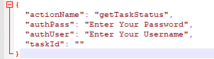

Figure: GetTaskStatus JSON File

1. List Task
   * Provide **authPass** and **authUser** values in the JSON file.

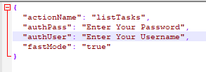

Figure: ListTask JSON File

1. Run Plan from Node
   * Provide **authPass** and **authUser** values in the JSON file.

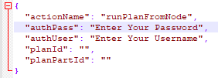

Figure: RunPlanFromNode JSON File

### Email from Local Set Up

1. **Open** the **Script** folder from the Tool Structure

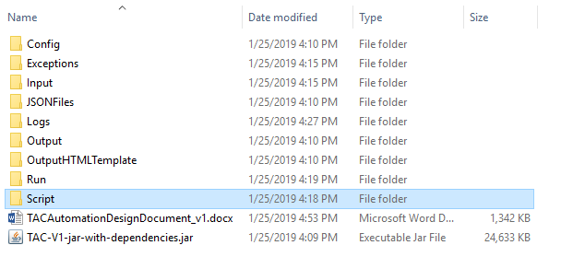

Figure: Script Folder

1. **Edit** the “**sendEmail.bat**” file.

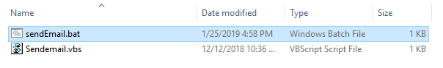

Figure: Send Email Bat File

1. **Provide** the **Script Folder Path**, **To** Address, **Cc** Address, **OutputHTMLPath** and **Subject** of the Email properly.

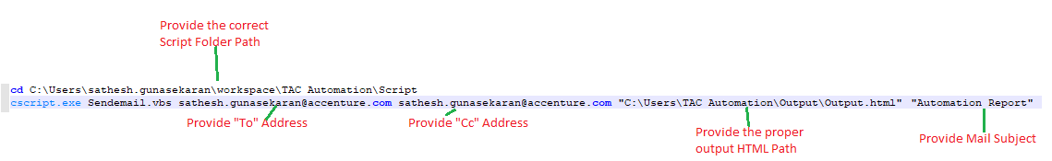

Figure: Editing Send Email Bat File

1. **Save** and **Close** the file.

# HOW TO USE THE TOOL

Usage of the Tool involves two major process.

1. Input Text File Preparation
2. Run the Batch File Manually
3. Triggering the Tool from Task Scheduler

## INPUT TEXT FILE PREPARATION

1. Please mentioned name of all the job/task which needs to be monitored using the tool.
2. Make sure that there are no spelling mistakes while entering the name of the task/job.
3. Please Open the “**Input**” folder

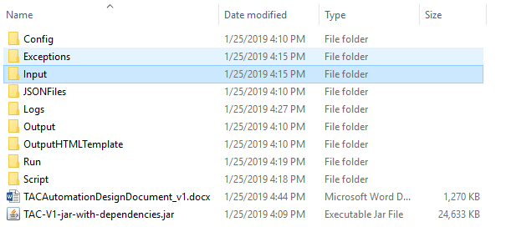

Figure: Input File Folder

1. Edit the “**Input.csv**” file

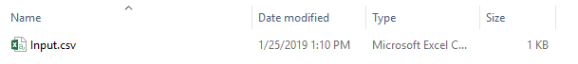

Figure: Input CSV File

1. Add the Jobs/Tasks to be monitored as shown in the figure below.

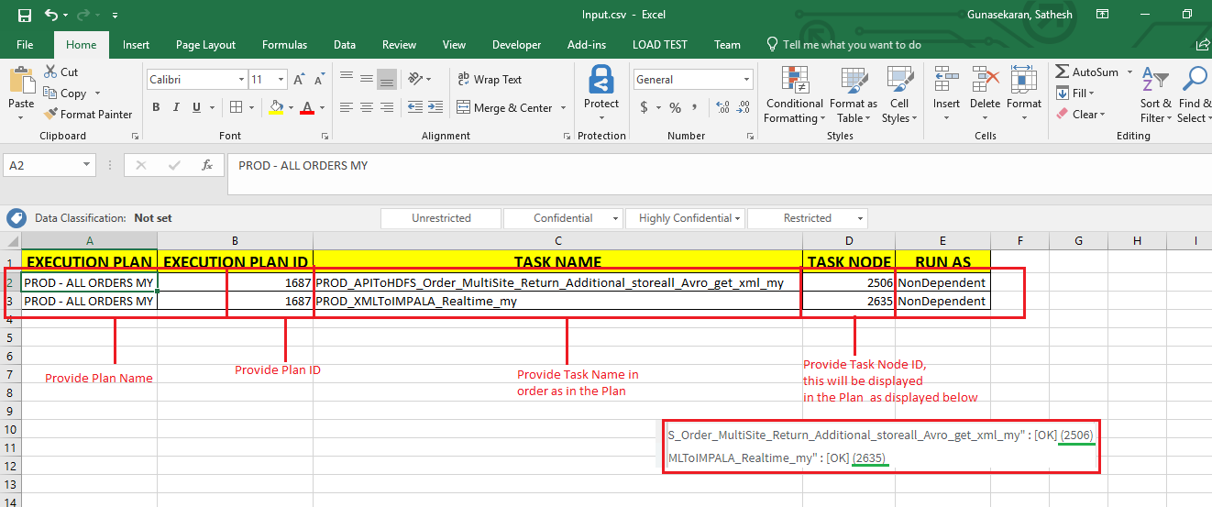

Figure: Adding Jobs in Input CSV File

## RUN THE BATCH FILE MANUALLY

1. To run the tool, Open “**Run**” folder.

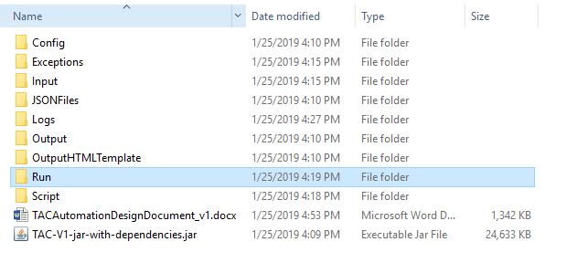

Figure: Run Folder

1. Double Click the “**Run.bat**” file to run the tool manually.

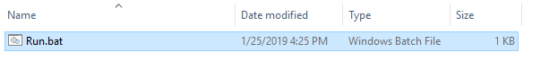

Figure: Run Batch File

## TRIGGERING THE TOOL FROM TASK SCHEDULER

1. Go to Start 🡪 Task Scheduler as shown in the figure below.

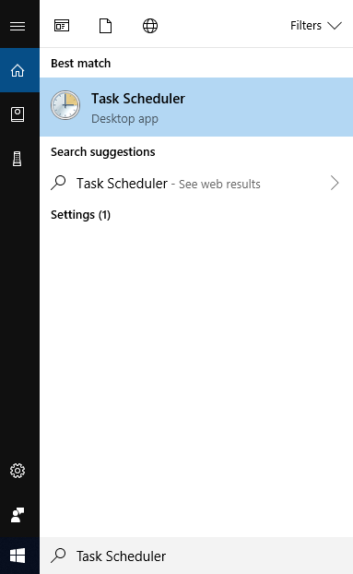

Figure: Open Task Scheduler

1. Click “**Create Task**” button in the Right pane as shown in the figure below.

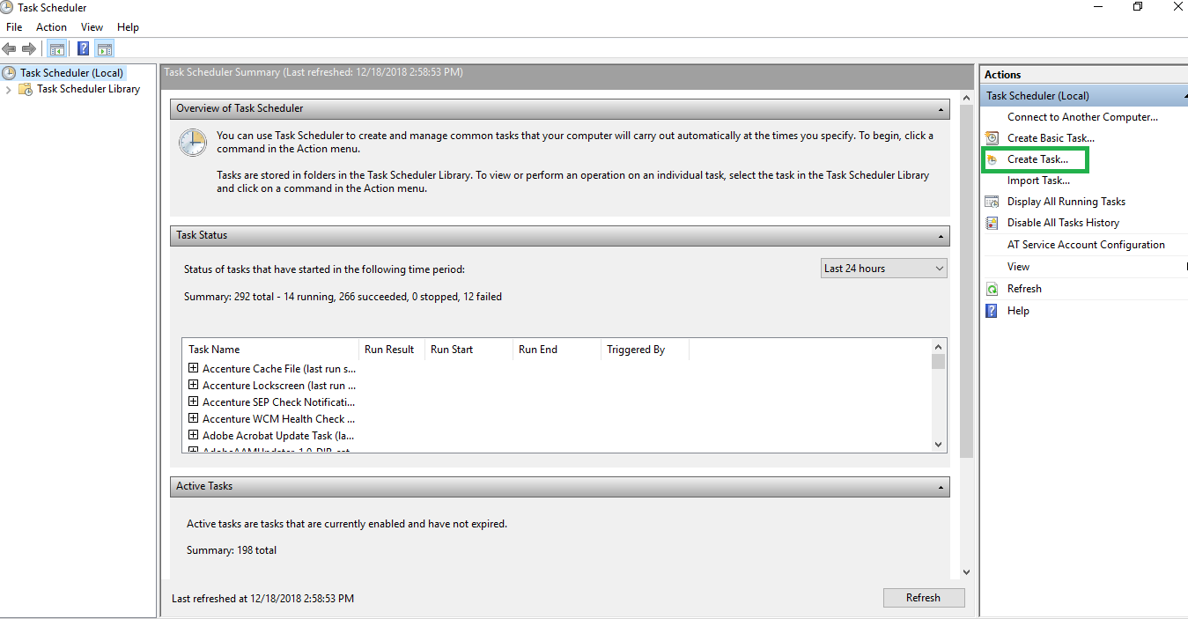

Figure: Create Task

1. Under “**General**” tab provide the “**Name**” and “**Description**” of the Task as shown in the figure below.

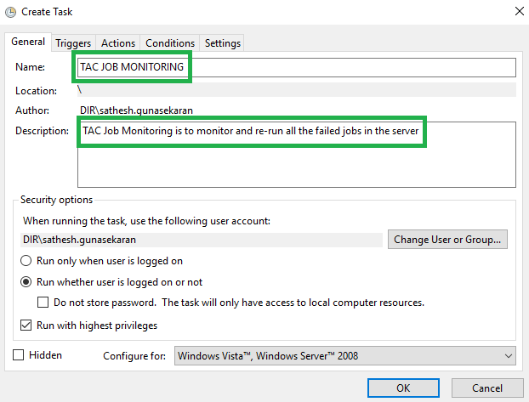

Figure: General Tab of Task Scheduler

1. Switch to the “**Triggers**” tab and Click the “**New**” button as shown in the figure.

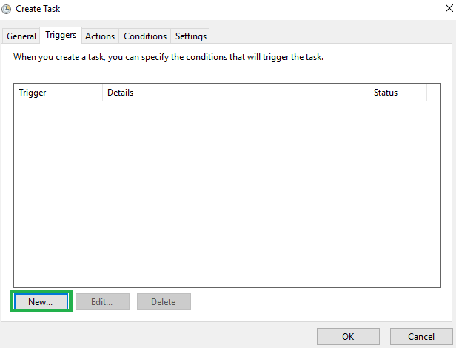

Figure: Triggers Tab of Task Scheduler

1. In the “**Edit Trigger**” dialog box, provide the respective values as shown in the figure.

**Note**: Here the task is made to run thrice a day i.e., Run once in 8 hours for a day.

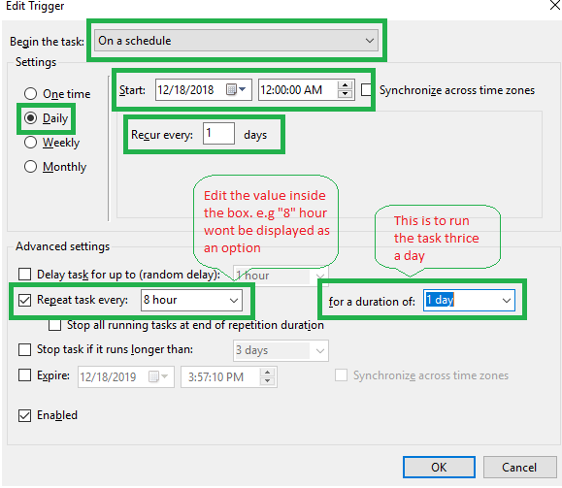

Figure: Edit Trigger Dialog Box of Task Scheduler

1. Switch to the “**Actions**” tab and Click the “**New**” button as shown in the figure below.

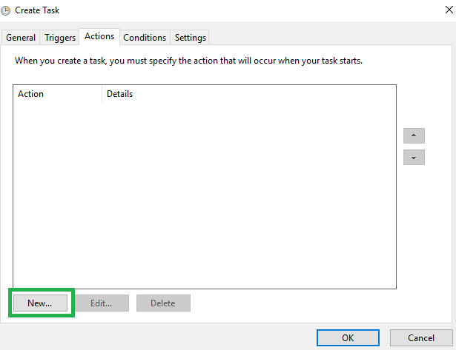

Figure: Actions Tab of Task Scheduler

1. In the “**New Action**” dialog box, provide the values as shown in the figure below. Don’t forget to browse the and select the “**Run.bat**” file from the “**TAC**” folder.

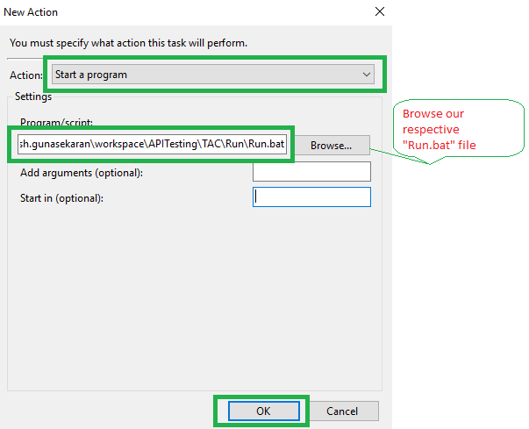

Figure: New Action Dialog Box of Task Scheduler

1. Switch to the “**Conditions**” tab and Click “**Ok**” as shown in the figure below.

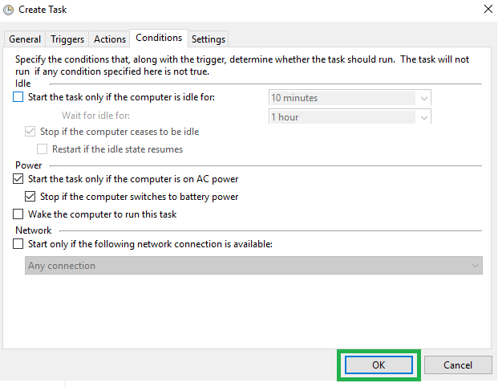

Figure: Conditions Tab of Task Scheduler

1. Switch to the “**Settings**” tab and Click “**Ok**” as shown in the figure below.

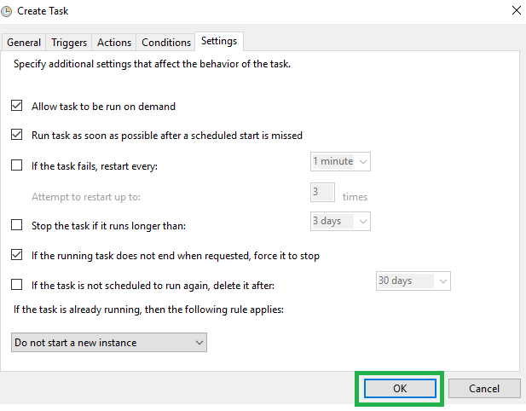

Figure: Settings Tab of Task Scheduler

1. Click the “**Task Scheduler Library**”, there you find the task which we have created as shown in the figure below.

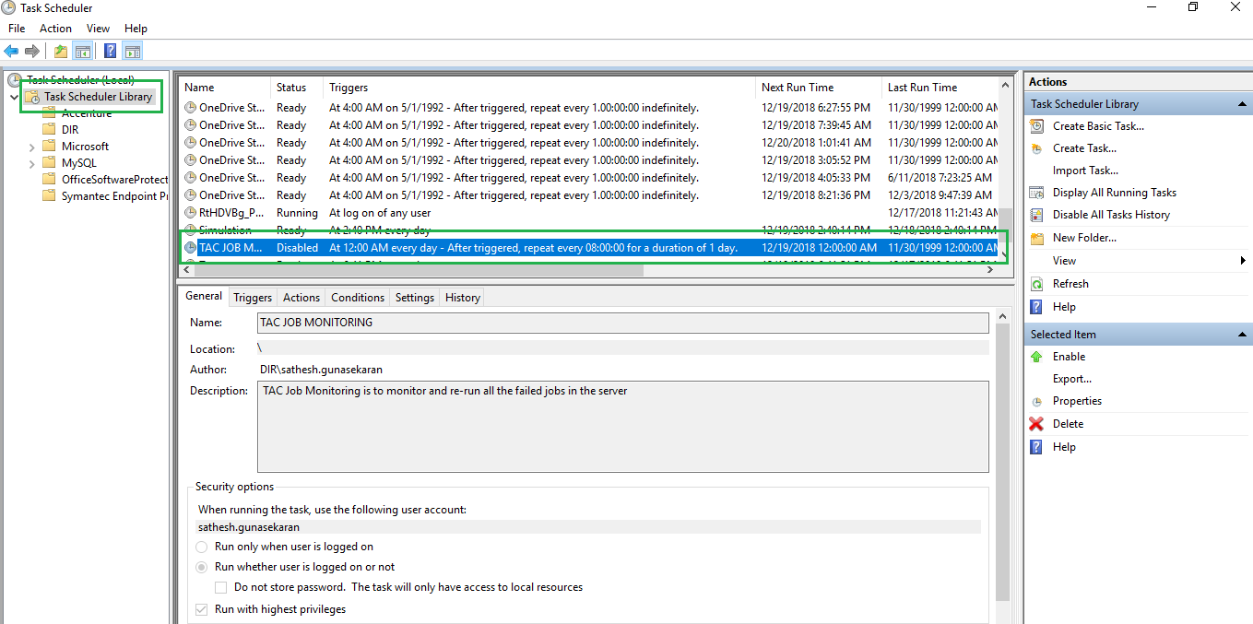

Figure: Task Scheduler Library View

# TROUBLESHOOTING

## EXCEPTIONS

1. For any exceptions while running the tool can be checked from the Exceptions Folder.

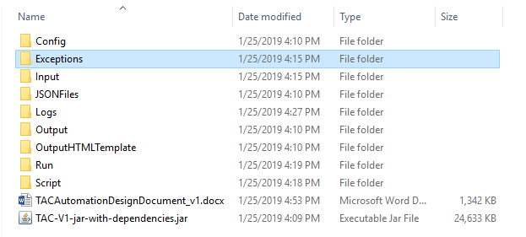

Figure: Exceptions Folder

1. Open the “**Exceptions**” folder where you will find the “**Exceptions.txt**” file as shown in the figure below after a successful run.

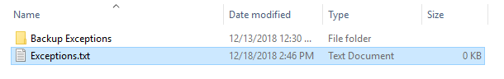

Figure: Exceptions File

## LOGS

1. The flow of the code is written in a log file for each run, this can also be used for troubleshooting.

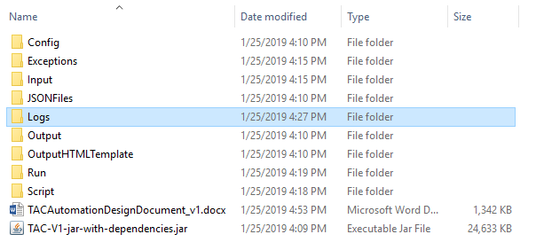

Figure: Logs Folder

1. Open “**Logs**” folder and Open the “**Logs.txt**” file as shown in the figure below.

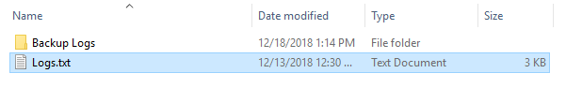

Figure: Logs File