

**EBS**

•

Introduction to Amazon EBS

•

EBS Size and Capacity

•

EBS Benefits

•

Use Case

•

Volume Types

•

EBS Features

•

Pricing

•

Instance Store

-

backed Instances

•

EBS

-

backed Instances

**Amazon EBS**

•

Amazon Elastic Block Store (Amazon EBS) provides

**persistent storage volumes**

for Amazon

EC2 instances.

•

Each Amazon EBS volume is automatically

**replicated**

within its Availability Zone to protect you

from component failure, offering

**high availability**

and

**durability**

.

•

With Amazon EBS, you can scale your usage

**up or down**

within minutes

**–**

all while paying a low price

for only what you provision

Size and capacity

* We can create Amazon EBS volumes that can store up to **16 TB**, and process up to 20,000 input/output operations per second (IOPS).

We can also create Amazon EBS General Purpose solid state drive (**SSD**) volumes that can store up to **16** **TB**, and process up to 10,000 IOPS. These volumes are designed for **five 9s** of availability and up to **320 mb** per second of throughput when attached to EBS optimized instances.

* These performance improvements make it even easier to run applications requiring **high performance** or high amounts of **storage**, such as large transactional databases, big data analytics, and log processing systems.

* Larger and faster volumes are available now in all commercial AWS regions and in AWS **GovCloud**

(

US).

EBS Benefits

**Reliable, secure storage**

•

Each Amazon EBS volume is automatically replicated within its Availability Zone to protect you

from component failure.

•

Amazon EBS encryption provides security between EC2 instances and EBS volumes.

**Consistent and low**

**-**

**latency performance**

•

Amazon EBS

General Purpose (SSD) volumes and Amazon EBS Provisioned IOPS (SSD) volumes

deliver low

-

latency through SSD technology and consistent I/O performance.

**Backup and restore,**

•

Backup your data by taking point

-

in

-

time snapshots of your Amazon EBS volumes.

•

Restore business by implementing EBS snapshots into EC2 instances.

**Quickly scale up, easily scale down**

•

Increase or decrease the storage and performance within minutes.

**Geographic flexibility**

•

Amazon EBS provides the ability to copy snapshots across

**AWS regions**

, enabling geographical

expansion, data center migration, and disaster recovery.

Use cases

# Relational databases

• Amazon EBS supports millions of gaming customers or billions of e-commerce transaction databases

such as Oracle, Microsoft SQL Server, MySQL and PostgreSQL.

# Enterprise applications

Amazon EBS provides an environment for mission-critical applications such as SAP and Microsoft SharePoint.

# File workloads

* Amazon EBS can store files and applications securely and supports distributed file sharing.

Ex: NASA/JPL uses GlusterFS on Amazon EBS

EBS Volume Types

Amazon EBS allows you

**to create storage volumes and attach them to Amazon EC2 instances.**

Amazon EBS volumes are placed in a specific Availability Zone and automatically

**replicated**

to

protect from the failure of a single component.

•

Amazon EBS provides

**three**

volume

**types**

based on performance and cost

**General**

**Purpose**

**(**

**SSD),**

**Provisioned**

**IOPS**

**(**

**SSD),**

**Magnetic.**

All EBS volume types offer the same durable snapshot capabilities and are designed for

**99.999**

% availability

**Amazon EBS General Purpose (SSD) Volumes**

•

General Purpose (SSD) volumes are the def

ault EBS volume type for Amazon EC2 instances.

•

General Purpose (SSD) volumes are backed by Solid

-

State Drives (SSDs) and are suitable for

**small to**

**medium**

**-**

**sized databases**

,

**development and test environments**

.

* General Purpose (SSD) volumes offer consistent baseline performance of 3 IOPS/GB to a maximum of 10,000 IOPS, and provide up to 160 MBps of throughput per volume.

# Amazon EBS Provisioned IOPS (SSD) Volumes

Provisioned IOPS (SSD) volumes are backed by **Solid-State Drives** (SSDs) and suitable for applications with I/O-intensive workloads.

• Provisioned IOPS (SSD) volumes offer consistent baseline performance of up to 30 IOPS/GB to a maximum of 20,000 IOPS, and provide up to 320 MBps of throughput per volume.

# Amazon EBS Magnetic Volumes

* Magnetic volumes provide the lowest cost per GB of all EBS volume types.

•

Magnetic volumes are backed by magnetic drives an

d are ideal for infrequent data access and for

low storage cost.

•

Magnetic volumes provide approximately 100 IOPS on average, with an ability to burst to

hundreds of IOPS.

EBS Features

**Amazon EBS Snapshots**

•

You can back up the data on your EBS volumes to

**Amazon S3**

by taking point

-

in

-

time snapshots.

•

Snapshots are

**incremental backups**

, which means that only the blocks on the device that have

changed after your most recent snapshot are saved.

•

If you are dealing with snapshots of sensitive data, you should consider

**encrypting**

your data

manually before taking the snapshot. Snapshots of encrypted volumes are automatically

encrypted.

•

When you create an EBS volume, you can create it based on an

existing

**snapshot**

.

•

If you access a piece of data that hasn't been loaded yet, the

**volume immediately downloads**

**the**

**requested data**

from Amazon S3, and then continues loading the rest of the volume's

data in the

background.

•

S

napshots are constrained to the region in which they are created.

EBS Features

**Key features of Amazon EBS Snapshots:**

* **Immediate access to Amazon EBS volume data** - After a volume is created from a snapshot, there is noneed to wait for all of the data to transfer from Amazon S3 to your Amazon EBS volume. We can start accessing the volume.

* **Resizing Amazon EBS volumes** - When you create a new Amazon EBS volume based on a snapshot,

youmay specify a larger size for the new volume.

* **Sharing Amazon EBS Snapshots** - **A azo EBS S apshots’ share**-ability makes it easy for you to share

data with your co-workers or others in the AWS community.

# • Copying Amazon EBS Snapshots across AWS regions - A azo EBS’s a ility to opy s apshots a ross

AWS regions makes it easier to leverage multiple AWS regions for geographical expansion, data center migration and disaster recovery. You can copy any snapshot accessible to you: snapshots you created; snapshots shared with you; and snapshots from the AWS Marketplace, VM Import/Export, and AWS Storage Gateway.

# Pricing

**Amazon EBS**

**-**

**Optimized Instances**

•

EBS

-

optimized instances enable EC2 instances to fully use the IOPS provisioned on an EBS volume.

It allows

**dedicated**

throughput between Amazon EC2 and Amazon EBS.

**Amazon EBS Availability and Durability**

•

Amazon EBS volumes are designed to be highly available and reliable at no additional charge.

•

Amazon EBS volume data is replicated across multiple servers in an Availability Zone to prevent the

loss of data from the failure of any single component

**Amazon EBS Encryption and AWS Identity and Access Management**

•

Amazon EBS encryption offers encryption of EBS data volumes and snapshots.

•

EBS encryption enables data security by encrypting your data volumes and snapshots using

Amazon

-

managed keys or keys you create and manage using the

[AWS Key Management Servic](https://aws.amazon.com/kms/)

[e](https://aws.amazon.com/kms/)

(

KMS).

•

Access to Amazon EBS volumes is integrated with AWS Identity and Access Management (IAM).

IAM enables access control to your Amazon EBS volumes

EBS Pricing

**Region:US East (N. Virginia)**

**Amazon EBS General Purpose (SSD) volumes**

$0.10 per GB

-

month of provisioned storage

**Amazon EBS Provisioned IOPS (SSD) volumes**

$0.125 per GB-month of provisioned storage $0.065 per provisioned IOPS-month

# Amazon EBS Magnetic volumes

$0.05 per GB-month of provisioned storage

$0.05 per 1 million I/O requests

# Amazon EBS Snapshots to Amazon S3

$0.095 per GB-month of data stored

EBS Features

•

**Instance Store**

**-**

**backed Instances**

•

Instances that use instance stores for the root device automatically have instance store volumes

available, with one serving as the root device volume. When an instance is launched, the image that is

used to boot the instance is copied to the root volume (

typicallysda1). Any data on the instance store

volumes persists as long as the instance is running, but this data is deleted when the instance is

terminated

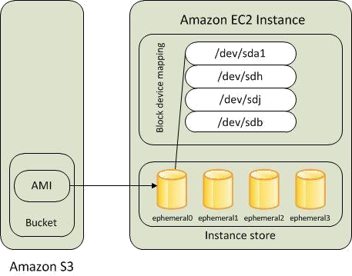

•

**Amazon EBS**

**-**

**backed Instances**

•

Instances that use Amazon EBS for the root device automatically have an A

mazon EBS volume attached.

When you launch an Amazon EBS

-

backed instance, we create an Amazon EBS volume for each Amazon

EBS snapshot referenced by the AMI you use. You can optionally use other Amazon EBS volumes or

instance store volumes

A fresh billing hour is started for the instance when you start it again. E.g., if you start a new instance and then stop/start it 3 times within the first 60 minutes, **you’ll get charged for 4 hours instead** **of 1**.

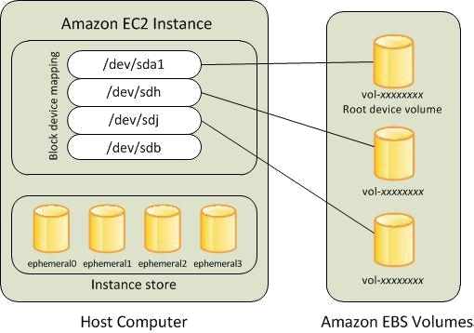

**Things that change when you stop/start include:**

•

**New internal IP address**

, though could randomly be the same. [VPC instances keep same internal

IP

addresses through stop/start.]

•

**New external IP address**

though could randomly be the same

).

(

**•**

**If a Elasti IP address**

**as asso iated ith the i sta e efore it**

**as stopped, the you’ll eed to re**

-

associate it after the start. [VPC instances keep Elastic IP addresses associated through stop/start.]

**•**

Any contents on t

**he i**

**sta e’s for er ephe eral storage ere**

**iped a d you are gi e fresh ephe eral**

storage (often mounted as /mnt).

•

You can leave an instance stopped for as long as you like and not get charged for run time (though you do

get charged at a much lower rate for the EBS volume storage). See the next point.

•

• There is a small chance that EC2 will not have available slots of the correct instance type to run your  **i sta e he you a t to start it agai . I’ e had this happe a d te porarily s it hed to a differe t,** available instance type to get it running again.