1. **Abstract**

This project is about creating a modern wedding planner web application named DreamDay, which helps couples, and wedding planners organize wedding events more easily using one platform. The system is developed using the ASP.NET MVC framework, written in C#, and uses SQL Server as the backend database. The platform supports multiple user roles such as Couples, Wedding Planners, and Administrators. Each user type has its own features and interface.

Couples can register, plan their wedding, manage checklists, create guest lists, book vendors, track budgets, and set wedding day timelines. Wedding planners can manage multiple weddings, communicate with couples, assign vendors, and monitor the progress. The admin panel allows administrators to manage users, vendors, and generate reports to monitor the system.

The goal of this project is to build a complete and easy-to-use solution for wedding planning with all the main tools in one place. By using object-oriented programming, the system is designed to be modular, scalable, and secure. It also uses a user-friendly interface to make the planning process smoother for every user.

Keywords: wedding planner, ASP.NET MVC, budget tracking, guest list, user roles, SQL Server, vendor management, event planning.

1. **Introduction**

DreamDay is a modern wedding planning platform designed to help couples and wedding planners organize and manage wedding events using an easy-to-use web-based system. Traditional wedding planning involves lots of manual work, paper lists, phone calls, and time-consuming coordination. This system aims to solve those problems by moving everything online and giving users the tools they need to plan weddings more effectively.

The platform allows couples to register and plan their weddings by managing checklists, creating guest lists, tracking their budget, booking vendors like photographers or florists, and setting timelines for their big day. Wedding planners can also use the system to manage multiple weddings at once, communicate with clients, assign vendors, and monitor the planning process. Administrators have full control of the platform, including managing user accounts, vendor data, and viewing system reports.

This online solution removes many limitations of traditional planning, such as time restrictions and location boundaries. Since it is web-based, users can access the system anytime and from anywhere. It also helps reduce the overhead of managing wedding-related tasks manually and improves the user experience by providing everything in one place.

The system is developed using ASP.NET MVC and C#, with a backend supported by SQL Server. It uses Role-Based Access Control (RBAC) to manage access securely and follows Object-Oriented Programming principles like encapsulation and inheritance, which help in keeping the system flexible, easy to maintain, and ready for future upgrades.

The main aim of this project is to support the digital transformation of the wedding planning process, increase the satisfaction of couples and planners, and make wedding management smarter and simpler.

* 1. Overview

DreamDay is an upcoming digital wedding planning solution aimed at helping couples and planners organize weddings in a smart and efficient way. In recent years, the demand for digital tools in event planning has increased, especially with people looking for easy, centralized systems to handle all aspects of their big day. DreamDay focuses on solving this need by providing a complete online platform that supports everything from booking vendors to managing guest lists.

This system is useful for different types of users including engaged couples, professional wedding planners, and system administrators. Each user has a specific set of features based on their role in the system. Couples can plan their wedding in a step-by-step way, planners can manage multiple weddings at once, and admins can maintain the overall platform.

The goal of the DreamDay system is to make the wedding planning process easier, save time, and improve communication between couples and planners. With the help of web technology, the platform can be used from anywhere at any time, offering flexibility and convenience. The project also supports the use of modern development techniques to make the system scalable, user-friendly, and ready for future upgrades.

DreamDay is not just a planning tool — it’s a smart system to guide users through one of the most important days of their lives with less stress and more organization.

* 1. Project Scope

The DreamDay project is focused on developing a complete web-based wedding planning system. The system will be used by couples to plan their weddings and by wedding planners to manage multiple wedding events. There will also be an admin panel to control and monitor the system.

The main features for couples include registration, creating wedding checklists, managing guest lists, booking vendors, setting a timeline for the event, and tracking the wedding budget. Wedding planners will be able to handle several weddings at the same time, communicate with clients, assign vendors, and check progress. Admins will be responsible for managing users, updating vendor data, and generating reports.

The system will be developed using ASP.NET MVC with C#, and it will include a SQL Server database to store all records. It will also use role-based access control to make sure each user only sees and manages what is relevant to their role.

This project will only focus on building a web application that works on both computers and mobile web browsers. A separate mobile app is not included in the scope at this stage. The main goal is to provide a responsive and user-friendly system that works well on all devices without needing to install anything.

DreamDay is designed to give users all the tools they need to plan weddings online in one place, reducing stress and saving time during the process.

* 1. Objectives

The main objective of this project is to design and develop a full web-based application for DreamDay, which helps couples and planners organize wedding events more easily and efficiently. The system will improve the planning process by offering important tools like vendor booking, checklist tracking, guest list management, and budget control — all in one place.

For couples, the goal is to give a smooth and user-friendly experience where they can register, plan their wedding, and follow their progress step by step. For wedding planners, the system helps manage multiple weddings at the same time, communicate with clients, and handle vendor assignments. From the admin side, the application will support system-wide management of users, vendors, and reports.

Another important objective is to build the system using ASP.NET MVC and C#, with a secure and flexible backend. It should be mobile-friendly, so users can access it from any device at any time. The system will use Role-Based Access Control to make sure each user sees only the features related to their role.

This project is not just about creating a website — it's about offering a smart, all-in-one solution for wedding planning that meets the modern needs of users and stays up to date with current technology trends.

1. System Requirement Specification

This section explains all the main requirements needed to develop and run the DreamDay wedding planner system. It includes the functional requirements, which describe what features and tasks the system should perform for each type of user. It also includes the non-functional requirements, such as performance, usability, and security expectations. Additionally, this section outlines the hardware and software requirements for running the system smoothly, including what devices and technologies are needed. These specifications provide a clear guideline for both the development and successful operation of the project.

* 1. Functional Requirements
* The system must allow couples and wedding planners to register by providing their name, email, and password.
* The system must allow all users to securely log in and access their personalized dashboards based on their roles.
* The system must provide role-based access control to ensure that couples, planners, and admins can only access relevant features.
* The system must allow couples to create and manage their wedding checklist, including adding, editing, and deleting tasks.
* The system must allow couples to browse and search the vendor catalog by service type (e.g., florist, photographer, venue).
* The system must allow couples to view detailed vendor profiles including services offered, price range, and reviews.
* The system must allow couples to book vendors and view all vendors assigned to their wedding.
* The system must allow couples to add and manage a guest list, including RSVP status, meal preferences, and seating arrangements.
* The system must allow couples to manage their budget, including setting amounts for categories and tracking expenses.
* The system must allow couples to create and update a timeline for wedding day events like ceremonies, meals, and speeches.
* The system must allow wedding planners to view and manage all weddings assigned to them.
* The system must allow wedding planners to assign vendors, update wedding checklists, and communicate with couples.
* The system must allow administrators to manage users, including viewing, updating, and deleting user accounts.
* The system must allow administrators to manage vendors, including adding, updating, and removing vendor profiles.
* The system must allow administrators to generate system-level reports on users, vendors, and overall activity.
* The system must display confirmation messages or alerts for successful actions like saving data or submitting forms.
* The system must perform proper data validation, ensuring fields like email, phone number, and required inputs are correctly entered.
  1. Non-Functional Requirements

The non-functional requirements define how the DreamDay system should behave in terms of performance, security, and usability. These requirements help to ensure a smooth and reliable experience for all users including couples, planners, and administrators.

* Performance: The system should be able to support at least 100 active users at the same time without slowing down or crashing.
* Scalability: The system should be built in a way that it can grow easily to support more weddings, users, and vendor records in the future.
* Security: All user data, such as login passwords and personal details, must be encrypted and securely stored. Role-based access control should be applied to protect sensitive actions.
* Usability: The user interface should be simple, clean, and easy to use for both couples and planners. Users should be able to complete tasks without confusion.
* Accessibility: The system should be mobile-friendly and work properly in all modern browsers like Chrome, Firefox, Edge, and Safari.
* Reliability: The system should have 99.9% uptime, minimizing downtime so users can always access their wedding plans when needed.
  1. Software and Hardware Requirements

This section describes the recommended software and hardware needed for both **development** and **deployment** of the DreamDay wedding planner web application.

**💻 Hardware Requirements**

**🔧 Development Environment**

| **Component** | **Requirement** |
| --- | --- |
| Processor | Intel Core i5 or higher |
| RAM | Minimum 8 GB |
| Storage | 256 GB SSD or 1 TB HDD |

**🖥️ Server Environment**

| **Component** | **Requirement** |
| --- | --- |
| Processor | Intel Xeon or equivalent |
| RAM | 16 GB or higher |
| Storage | 500 GB SSD |

**🧰 Software Requirements**

**🛠️ Development Tools**

| **Item** | **Requirement** |
| --- | --- |
| IDE | Visual Studio 2017 or higher |
| Framework | ASP.NET MVC |
| Programming Language | C# |
| Database | Microsoft SQL Server |
| Web Server | Internet Information Services (IIS) |
| Operating System (Development) | Windows 10 / Windows 11 |
| Operating System (Deployment) | Windows Server 2019 |
| Supported Browsers | Google Chrome, Mozilla Firefox, Microsoft Edge |
| 1. **System Analysis and Design** |  |

* 1. System Architecture

(Diagram)

The DreamDay wedding planner system follows the ASP.NET MVC architecture, which divides the application into three main parts: Model, View, and Controller. This separation helps keep the code organized, easier to manage, and supports better development practices. Users interact with the system through a web browser, and their actions are handled by the controller.

The Controller receives user requests and interacts with the Model, which contains the business logic and handles data operations using Entity Framework. The View is responsible for displaying the user interface, showing data from the controller in a user-friendly format. The application also uses a SQL Server database to store all important information like users, weddings, vendors, and guests.

A separate Service Layer is included between the controller and the model to handle key features like vendor booking, budget tracking, and guest management. This makes the system more flexible, easier to maintain, and ready for future updates. The architecture supports good performance, security, and scalability for handling wedding planning tasks online.

* 1. Use Case
  2. ER
  3. Class

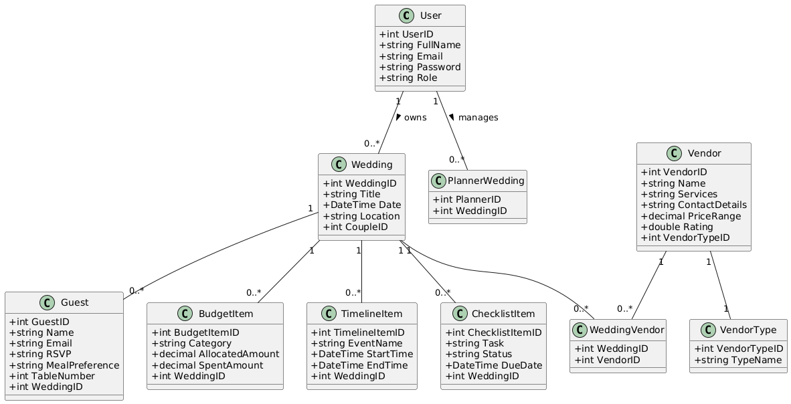

* 1. Sequence

