**Cloud-Based Crypto Exchange Service Deployment Report**

**Introduction**

This paper discusses the design, implementation, and deployment of a cloud-based crypto exchange service using modern DevOps practices such as Kubernetes, Docker, and CI/CD pipelines. The crypto exchange service will be containerized to ensure scalability, high availability, and fault tolerance. Key features such as Blue-Green deployment ensure the service can be updated without experiencing any downtime-very critical for high-demand and high-traffic financial services. The project addresses the technical challenges of deploying a crypto exchange while safeguarding the security and continuous availability of the crypto exchange.

Due to the high demand for cryptocurrency services, there is a perceived need for more security, scalability, and robust infrastructure. A project of this nature would target addressing such issues through the development of a cloud-based architecture that is appropriate for constant traffic and high-volume transactions, while keeping up to date with security and privacy regulations. This report outlines specific design architectures, different deployment strategies, automation of CI/CD pipelines, and security challenges during the implementation process.

**Objectives**

Key highlights of the project objectives listed below:

Cloud deployment of the Scalable Crypto Exchange Application: Using container orchestration, cloud services in putting a fault-tolerant application in place.

Deployment via Blue-Green Strategy: To have at least disruption/downtime during updating of the application.

Total automation of CI/CD pipeline: Completely automated CI/CD for totally smooth updates.

Ensure Security and Compliance: Remove security vulnerabilities of cloud-based financial systems by applying appropriate access control, data encryption, and compliance with respective regulations.

Objectives meet the demand of the industry in high availability, performance, and security on a continuous basis, especially in the context of a financial service such as the crypto exchange.

**Solution Architecture**

It is made up of several components, each of which plays an important role in the whole deployment process. Its main components are Dockerized applications, Kubernetes clusters for managing the containers, and the continuous deployment process that makes the application update automatically without any faults.

1. Dockerized Node.js Application

It is built using Node.js, one of the most appropriate technologies for building scalable network applications due to its asynchronous event-driven architecture. In that respect, the Docker container provides a consistent environment in which to develop, test, and deploy the application's source code.

Dockerfile: A Dockerfile is a configuration file that contains the steps used in containerizing a Node.js Application. These are as follows:

Base Image: The base image for Node.js is normally an Alpine or slim version, which helps in keeping the overall size of the general image small.

Dependency Installation: The Node.js dependencies are listed in the package.json. These are installed at the time of building the image. The package-lock.json file ensures that the exact versions of the dependencies installed are used.

Application Code: The Node.js application code is copied into the container image during a build.

Application containerization makes it easier to maintain consistency across different stages of environments: development, testing, and production. This would avoid the "it works on my machine" issue, which says the application should behave exactly the same, irrespective of where it is deployed.

2. Docker Compose for Local Development

docker-compose.yml: The project will contain a docker-compose.yml file that will be able to define multi-container setups for local development. For instance, a developer can bring up the whole stack-for example, application, database, and Redis-with one command. Docker Compose is particularly useful for testing services that will be run locally before deploying in Kubernetes.

Kubernetes Deployment

It works on top of Kubernetes to manage the deployment, scaling, and availability of application containers. It automates the orchestration of containerized applications, hence, always running, scaling up, or scaling down to meet the demands of traffic.

1. Kubernetes Deployments

Kubernetes deployments manage the desired state of pods, which are the smallest unit in Kubernetes. Each pod can contain one or more containers. Kubernetes will guarantee that the number of running pods will always be equal to the replica count.

deployment.yaml: This is the normal deployment descriptor of the application including which container image to make use of, resource limits-for example, CPU and memory, and how many replicas to create. Kubernetes automatically manages these replicas; if one pod fails, another is spawned so that the desired state is maintained.

Deployment-blue.yaml / Deployment-green.yaml: These files support Blue-Green deployment. This approach ensures there is no downtime when new updates are deployed. The Blue-Green deployment keeps running two environments parallel: the "blue" environment that handles the live traffic, and the "green" environment where the new version will be tested.

2. Kubernetes Services

service.yaml: It describes a method for exposing pods to the outside world or other services in a cluster. It can also do some load balancing among the pods. It performs service discovery and ensures that the right pods receive the traffic and further balances this out among those pods.

Load Balancing: This will be handled by Kubernetes itself, in case there are several replicas running for a Pod. It would ensure the distribution of the traffic among them.

Exposure to External: The Service can be exposed to external by utilizing Kubernetes resources, either LoadBalancer or Ingress to forward the external traffic so as to reach the application.

Deployment Strategy: Blue-Green Deployment

The project will follow a Blue-Green deployment strategy to avoid any kind of downtime during the deployment. That means, it has used two production environments: Blue, being the currently active version, and Green, for the new version. In the Green environment, the changes are applied, updated, and tested, while pointing the traffic to the Blue environment. Once testing is already completed, gradual switching will be implemented in the Green environment. If some errors pop up in this regard, then deploying it back to Blue will be quite easy.

Steps for Blue-Green Deployment:

Initial Blue Deployment: The application is first deployed to the Blue environment, which hosts live traffic.

Deploying to Green: Once a new update is prepared, it is deployed to the Green environment. No live traffic is routed to Green in this step.

Testing in Green: Automated tests-smoke tests, performance tests-are executed on the Green environment to ensure that the update will operate as expected.

Traffic Switch: Once the tests are all okay, live traffic is routed from Blue to Green. Rollback Capability: In case of any failure in Green, switching back to Blue is very easy, thereby ensuring least disturbance for users. This deployment strategy is best suited for high-availability applications where losses due to downtown may lead to financial losses and dissatisfaction among customers.

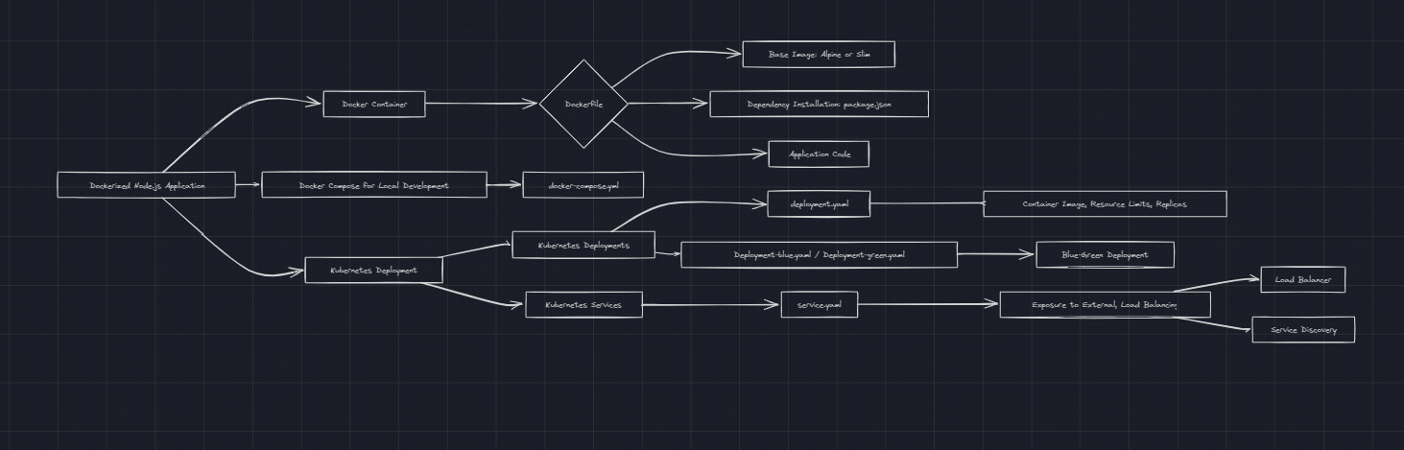

**Automation of CI/CD Pipelines**

Continuous Integration and Continuous Deployment are key to keeping up with the fast development and deployment cycles of modern applications. This project will implement a continuous integration/continuous deployment pipeline, which automates everything from committing the code to deploying to production.

1. CI Process Continuous Integration

GitHub Integration: Source code is in GitHub, and the repository is integrated with the pipeline. It automatically triggers the pipeline on every new commit and pull request made.

Automated Builds: The application gets automatically built through Docker, wherein unit tests are run during this stage to catch bugs early.

2. Continuous Deployment Process

Once the application passes the build and test phases, the CD will deploy the Docker image to the Kubernetes cluster.

Kubernetes Deployment: These deployment files - Deployment.yaml, Deployment-blue.yaml, and Deployment-green.yaml define how the application is deployed to the cluster. Kubernetes guarantees that the new version is deployed without affecting the running application.

Continuous Blue-Green Deployment: The pipeline automates Blue-Green deployment wherein the new version is first tested into a production-like environment before switching the live traffic to it. Automation reduces the risk of human error while hastening up the development cycle by enabling more frequent updates without sacrificing reliability.

**Security Considerations**

Consider the nature of the financial transactions on this crypto exchange; security would be of utmost importance. The following are some measures put into place to secure the application and infrastructure running it.

1. Role-Based Access Control

Kubernetes' Role-Based Access Control at the cluster level is engaged to ensure that only trusted users and services can reach out to certain resources.

2. Secrets Management

Sensitive information, such as database credentials, API keys, and encryption keys, is stored at the base level as Kubernetes Secrets. Secrets are encrypted and can be mounted into containers as environment variables or as files. This is done so that sensitive data is never hard-coded into the application or stored in plain text.

3. Data Encryption

In-Transit: Data in transit, i.e., the data exchanged between services and clients, is encrypted by TLS/SSL. This prevents the man-in-the-middle attack, where data can be intercepted during transmission.

At Rest: Data at rest, for example, in databases or object storage, is encrypted through native cloud encryption services with AWS KMS (Key Management Service).

4. Ingress and HTTPS Management

An Ingress controller manages the access of Kubernetes services from outside, making sure the connections are secure via HTTPS. This ensures all of the external traffic is encrypted, and it has extra features like SSL termination and URL routing.

5. Vulnerability Scanning

Automated security scans are used in this project to defend the application from vulnerabilities. It finds out if there is a chance that the application uses Docker images and dependencies that are known to be vulnerable. The issues are resolved before the deployment of the application.

Ethical and Legal Considerations

The project covers various ethical and legal issues that come with the management of financial transactions in a crypto exchange.

Data Privacy: Compliance with such regulations as GDPR is paramount in handling users' data. The project implements security in data privacy through encryption, anonymization, and control of access.

Legal Compliance: Legal framework regulating money laundering and financial regulation around crypto exchanges is very complex. The project ensures that the application complies with relevant laws and regulations.

**Conclusion**

The following exercise will demonstrate the realization of a containerized crypto exchange service in a cloud environment with Kubernetes and Docker. It uses Continuous Integration and Continuous Deployment to facilitate smooth deployments of new updates without suffering from downtime. This practice will ensure continuity guaranteed through the Blue-Green deployment strategy. Strong security shall be provided for sensitive financial data and system integrity through encryption, RBAC, and secrets management.

It is designed for the cryptocurrency industry, where high availability, security, and scalability are of utmost importance. Automating the whole development lifecycle reduces the chance of human error, thus allowing faster and more reliable deployments.