**PREDICTING HOUSE PRICE USING MACHINE LEARNING**

**REG NO: 950621104087**

**NAME: SATHISH KUMAR M**



**PHASE 2: INNOVATION**

|  |  |
| --- | --- |
| Date | 11 October 2023 |
| Team ID | Proj_212169_Team_4 |
| Project Name | HOUSE PRICE PREDICITON  USING MACHINE LEARNING |

**INTRODUCTION:**

* The real estate market is one of the most dynamic and lucrative sectors, with house prices constantly fluctuating based on various factors such as location, size, amenities, andeconomic conditions. Accurately predicting house prices is crucial for both buyers and sellers, as it can help make informed decisions regarding buying, selling, or investing in properties.
* Traditional linear regression models are often employed for house price prediction. However, they may not capture complex relationships between predictors and the target variable, leading to suboptimal predictions.

**CONTENT FOR PROJECT PHASE 2:**

* Consider exploring advanced regression techniques like Gradient Boosting or XGBOOST forimproved Prediction accuracy.

**DATA SOURCE**

A good data source for house price prediction using machine learning should be Accurate, Complete, Covering the geographic area of interest, Accessible.

Dataset Link: (https://[www.kaggle.com/datasets/vedavyasv/usa-housing HYPERLINK "http://www.kaggle.com/datasets/vedavyasv/usa-housing)")](http://www.kaggle.com/datasets/vedavyasv/usa-housing))

**DATA COLLECTION AND PREPROCESSING:**

* **Importing the dataset**: Obtain a comprehensive dataset containing relevant featuressuch as square footage, number of bedrooms, location, amenities, etc.
* **Data preprocessing:** Clean the data by handling missing values, outliers, andcategorical variables. Standardize or normalize numerical features.

**EXPLORATORY DATA ANALYSIS (EDA):**

* Visualize and analyze the dataset to gain insights into the relationships between variables.
* Identify correlations and patterns that can inform feature selection and engineering.
* Present various data visualizations to gain insights into the dataset.
* Explore correlations between features and the target variable (house prices).
* Discuss any significant findings from the EDA phase that inform feature selection.

**ADVANCED REGRESSION TECHNIQUES:**

* **RIDGE REGRESSION :** Introduce L2 regularization to mitigate multicollinearity and over fitting.
* **LASSO REGRESSION:** Employ L1 regularization to perform feature selection and simplify the model.
* **ELASTIC NET REGRESSION:** Combine both L1 and L2 regularization to benefit from their respective advantages.
* **RANDOM FORSET REGRESSION:** Implement an ensemble technique to handle non-linearity and capture complex relationships in the data.
* **GRADIENT BOOSTING REGRESSOR (e.g., XGBOOST):** Utilize gradient boosting algorithms for improved accuracy.

**DEPLOYMENT AND PREDICTION:**

* Deploy the chosen regression model to predict house prices.
* Develop a user-friendly interface for users to input property features and receive price predictions.

**PROGRAM:**

**HOUSE PRICE PREDICTION**

Importing Dependencies import pandas as pd import numpy as np import seaborn as sns

import matplotlib.pyplot as plt

from sklearn.model_selection import train_test_split from sklearn.preprocessing import StandardScaler

from sklearn.metrics import r2_score, mean_absolute_error,mean_squared_error

from sklearn.linear_model import LinearRegression from sklearn.linear_model import Lasso

from sklearn.ensemble import RandomForestRegressor from sklearn.svm import SVR

import xgboost as xg

%matplotlib inline import warnings

warnings.filterwarnings("ignore")

**LOADING DATASET**

dataset = pd.read_csv('E:/USA_Housing.csv')

**MODEL1:LINEAR REGRESSION**

**In [1]:**

model_lr=LinearRegression()

**In [2]:**

model_lr.fit(X_train_scal, Y_train)

**Out[2]:**

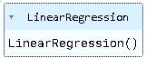

**PREDICTING PRICES**

**In [3]:**

Prediction1 = model_lr.predict(X_test_scal)

**EVALUATION OF PREDICTING DATA:**

**In [4]:**

plt.figure(figsize=(12,6))

plt.plot(np.arange(len(Y_test)), Y_test, label='Actual Trend')

plt.plot(np.arange(len(Y_test)), Prediction1, label='Predicted Trend')

plt.xlabel('Data')

plt.ylabel('Trend')

plt.legend()

plt.title('Actual vs Predicted')

**Out[4]:**

**Text(0.5, 1.0, 'Actual vs Predicted')**

**In [5]:**

sns.histplot((Y_test-Prediction1), bins=50)

**Out[5]:**

**<Axes: xlabel='Price', ylabel='Count'>**

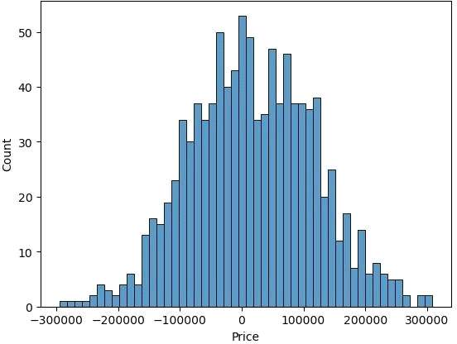

**In [6]:**

print(r2_score(Y_test, Prediction1))

print(mean_absolute_error(Y_test, Prediction1))

print(mean_squared_error(Y_test, Prediction1))

**Out[6]:**

**0.9182928179392918**

**82295.49779231755**

**10469084772.975954**

**MODEL2: SUPPORT VECTOR REGRESSOR:**

**In [7]:**

model_svr = SVR()

**In [8]:**

model_svr.fit(X_train_scal, Y_train)

**Out[8]:**

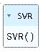

**In [9]:**

Prediction2 = model_svr.predict(X_test_scal)

**EVALUATION OF PREDICTING DATA**

**In [10]:**

plt.figure(figsize=(12,6))

plt.plot(np.arange(len(Y_test)), Y_test, label='Actual Trend')

plt.plot(np.arange(len(Y_test)), Prediction2, label='Predicted Trend')

plt.xlabel('Data')

plt.ylabel('Trend')

plt.legend()

plt.title('Actual vs Predicted')

**Out[10]:**

**Text(0.5, 1.0, 'Actual vs Predicted')**

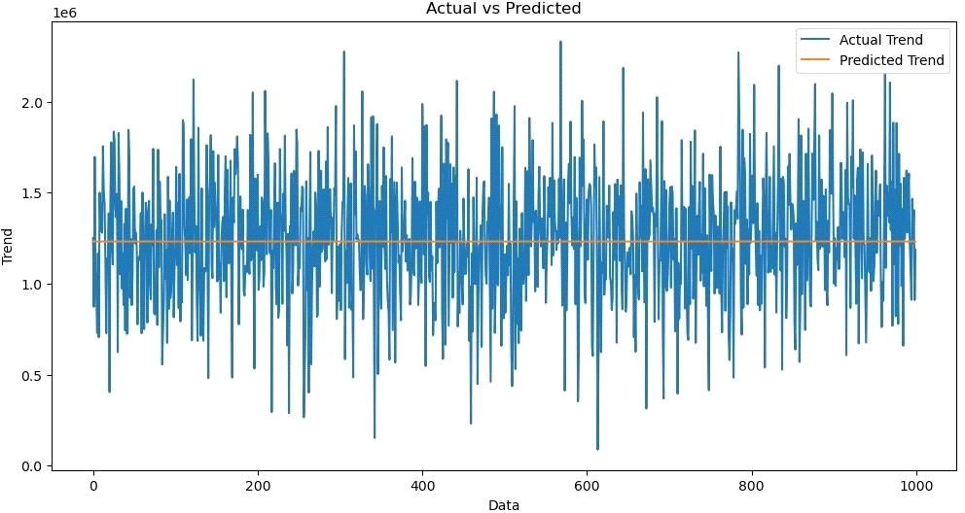

**In [11]:**

sns.histplot((Y_test-Prediction2), bins=50)

**Out[12]:**

**<Axes: xlabel='Price', ylabel='Count'>**

**In [12]:**

print(r2_score(Y_test, Prediction2))

print(mean_absolute_error(Y_test, Prediction2))

print(mean_squared_error(Y_test, Prediction2))

**-0.0006222175925689744**

**286137.81086908665**

**128209033251.4034**

**MODEL3:**

**In [13]:**

model_lar = Lasso(alpha=1)

**In [14]:**

model_lar.fit(X_train_scal,Y_train)

**Out[14]:**

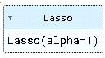

**PREDICTING PRICES:**

**In [15]:**

Prediction3 = model_lar.predict(X_test_scal)

**EVALUATION OF PREDICTING DATA**

**In [16]:**

plt.figure(figsize=(12,6))

plt.plot(np.arange(len(Y_test)), Y_test, label='Actual Trend')

plt.plot(np.arange(len(Y_test)), Prediction3, label='Predicted Trend')

plt.xlabel('Data')

plt.ylabel('Trend')

plt.legend()

plt.title('Actual vs Predicted')

**Out[16]:**

**Text(0.5, 1.0, 'Actual vs Predicted')**

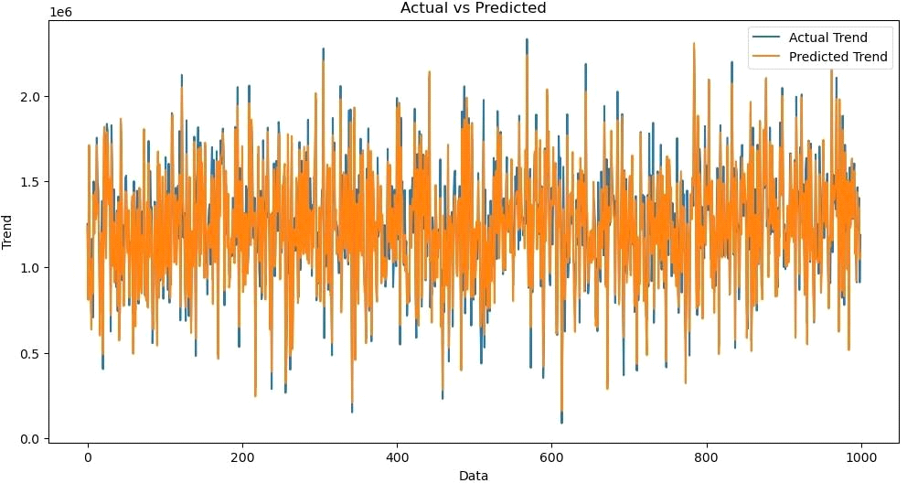

**In [17]:**

sns.histplot((Y_test-Prediction3), bins=50)

**Out[17]:**

**<Axes: xlabel='Price', ylabel='Count'>**



**In [18]:**

print(r2_score(Y_test, Prediction2))

print(mean_absolute_error(Y_test, Prediction2))

print(mean_squared_error(Y_test, Prediction2))

**-0.0006222175925689744**

**286137.81086908665**

**128209033251.4034**

**MODEL4: RANDOM FOREST REGRESSOR**

**In [19]:**

model_rf = RandomForestRegressor(n_estimators=50)

**In [20]:**

model_rf.fit(X_train_scal, Y_train)

**Out[20]:**

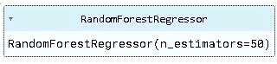

**In [21]:**

Prediction4 = model_rf.predict(X_test_scal)

**In [22]:**

plt.figure(figsize=(12,6))

plt.plot(np.arange(len(Y_test)), Y_test, label='Actual Trend')

plt.plot(np.arange(len(Y_test)), Prediction4, label='Predicted Trend')

plt.xlabel('Data')

plt.ylabel('Trend')

plt.legend()

plt.title('Actual vs Predicted')

**Out[22]:**

**Text(0.5, 1.0, 'Actual vs Predicted')**

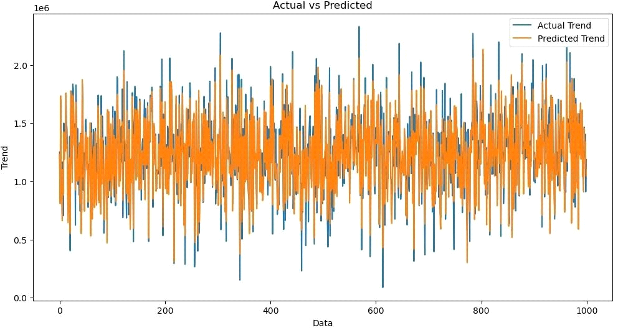

**In [23]:**

sns.histplot((Y_test-Prediction4), bins=50)

**Out[23]:**

**<Axes: xlabel='Price', ylabel='Count'>**

**In [24]:**

print(r2_score(Y_test, Prediction2))

print(mean_absolute_error(Y_test, Prediction2))

print(mean_squared_error(Y_test, Prediction2))

**Out [24] :**

**-0.0006222175925689744**

**286137.81086908665**

**128209033251.4034**

**MODEL5**

**In [25]:**

model_xg = xg.XGBRegressor()

**In [26]:**

model_xg.fit(X_train_scal, Y_train)

**Out[26]**:

XGBRegressor(base_score=None, booster=None, callbacks=None, colsample_bylevel=None, colsample_bynode=None, colsample_bytree=None, early_stopping_rounds=None, enable_categorical=False, eval_metric=None, feature_types=None,

gamma=None, gpu_id=None, grow_policy=None, importance_type=None,

interaction_constraints=None, learning_rate=None, max_bin=None, max_cat_threshold=None, max_cat_to_onehot=None, max_delta_step=None, max_depth=None, max_leaves=None, min_child_weight=None, missing=nan, monotone_constraints=None, n_estimators=100, n_jobs=None, num_parallel_tree=None, predictor=None, random_state=None, ...)

**In [27]:**

Prediction5 = model_xg.predict(X_test_scal)

**In [28]:**

plt.figure(figsize=(12,6))

plt.plot(np.arange(len(Y_test)), Y_test, label='Actual Trend')

plt.plot(np.arange(len(Y_test)), Prediction5, label='Predicted Trend')

plt.xlabel('Data')

plt.ylabel('Trend')

plt.legend()

plt.title('Actual vs Predicted')

**Out[28]:**

**Text(0.5, 1.0, 'Actual vs Predicted')**

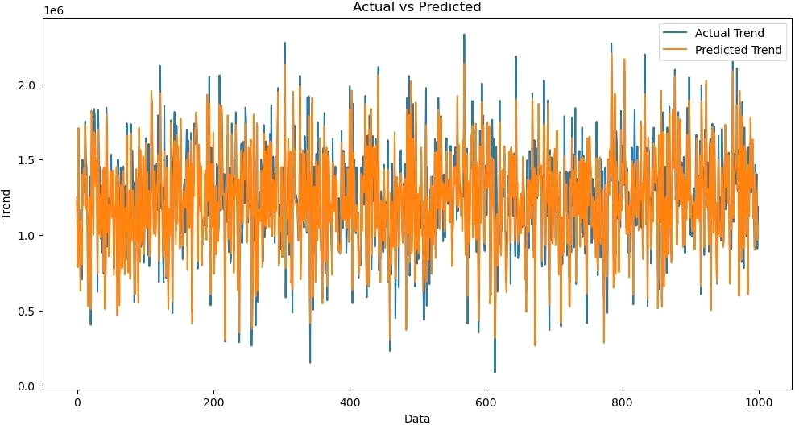

**In [29]:**

sns.histplot((Y_test-Prediction4), bins=50)

**Out[29]:**

**<Axes: xlabel='Price', ylabel='Count'>**

**In [30]:**

print(r2_score(Y_test, Prediction2))

print(mean_absolute_error(Y_test, Prediction2))

print(mean_squared_error(Y_test, Prediction2))

**Out [30] :**

**-0.0006222175925689744**

**286137.81086908665**

**128209033251.4034**

**CONCLUSION**

* In the Phase 2 conclusion, we will summarize the key findings and insights from the advanced regression techniques. We will reiterate the impact of these techniques on improving the accuracy and robustness of house price predictions.
* Future Work: We will discuss potential avenues for future work, such as incorporating additional data sources (e.g., real-time economic indicators), exploring deep learning models for prediction, or expanding the project into a web application with more features and interactivity.