Table of Contents

Abstract----------------------------------------------------------------1
Introduction------------------------------------------------------------2
Objective---------------------------------------------------------------3
Dataset Description---------------------------------------------------4
Methodology-----------------------------------------------------------5
Implementation--------------------------------------------------------6
Outcomes---------------------------------------------------------------7
Visualization and Analysis-------------------------------------------8
Code----------------------------------------------------------------------9
Result and Discussion--------------------------------------------------10
Conclusion and Future Work-----------------------------------------11
References---------------------------------------------------------------12

Abstract

Education is one of the most important pillars of societal and individual development. Academic performance plays a crucial role in shaping a student’s future career opportunities. Predicting student performance in advance helps both students and educators take necessary corrective measures to improve learning outcomes. With the rapid growth of data and technology, Machine Learning has emerged as an effective tool for analyzing educational data and making accurate predictions
This project focuses on predicting student marks based on the number of hours studied using a Machine Learning algorithm called Linear Regression. The dataset consists of study hours as the independent variable and marks obtained as the dependent variable. The model is trained using historical data and is then used to predict marks for new input values.
The results obtained from the model show a strong positive linear relationship between study hours and marks, indicating that increased study time generally leads to better academic performance. This project serves as an introductory implementation of Machine Learning concepts and demonstrates how data analysis and predictive modeling can be applied in real-world educational scenarios.
This project highlights the importance of data analysis and visualization in understanding student learning patterns. By plotting study hours against marks, the relationship between the variables becomes clear and interpretable. Visualization not only helps in validating the Machine Learning model but also enables educators and students to easily understand the impact of study habits on academic performance. Such graphical representations make the prediction results more transparent and useful for decision-making.
Furthermore, the simplicity of the Linear Regression algorithm makes this project highly suitable for beginners who are new to Machine Learning. It provides hands-on experience in working with datasets, training models, making predictions, and interpreting results. The knowledge gained from this project can be extended to more complex educational datasets and real-world applications, thereby encouraging further exploration in the fields of Machine Learning, data science, and educational analytics.

2. Introduction

Machine Learning (ML) is a subset of Artificial Intelligence (AI) that enables systems to learn from historical data and improve their performance without explicit programming. It focuses on building models that can identify patterns, learn relationships, and make predictions based on data. In recent years, Machine Learning has been widely adopted in various domains such as healthcare, finance, business analytics, cybersecurity, and education.
In the education sector, analyzing student performance is essential for improving learning outcomes. Teachers and institutions often rely on traditional examination systems that evaluate students only after assessments are conducted. Such systems do not provide early insights into student performance or help identify students who may require additional academic support.
One of the most influential factors affecting student performance is the number of hours dedicated to studying. This project aims to analyze the relationship between study hours and marks obtained by students using Machine Learning techniques. By applying Linear Regression, this project predicts student marks based on the number of hours studied.
The main goal of this project is to provide a simple and practical introduction to Machine Learning and Data Analysis using Python. It is designed for beginners and helps in understanding how data-driven decision-making works in real-world scenarios.
By using Machine Learning techniques in the education domain, institutions can move from reactive evaluation systems to proactive performance monitoring. Early prediction of student marks allows teachers to identify weak learners at an early stage and provide personalized guidance, mentoring, or remedial classes. This not only improves academic results but also boosts student confidence and motivation. Such predictive systems can play a vital role in enhancing the overall quality of education.
Moreover, this project emphasizes the practical implementation of Machine Learning concepts using Python and popular libraries such as NumPy, Pandas, Matplotlib, and Scikit-learn. Through data preprocessing, model training, prediction, and visualization, learners gain hands-on experience with the complete Machine Learning workflow. The simplicity of the approach makes it easy to understand while laying a strong foundation for exploring more advanced Machine Learning models and real-world data analysis applications in the future.

3. Problem Statement and Objective

Many students struggle to manage their study time effectively and are often unaware of how much effort is required to achieve good academic results. Traditional academic systems evaluate student performance only after examinations, which does not allow students to make improvements beforehand.
There is no predictive mechanism in place to estimate student marks based on study behavior. As a result, students lack guidance in planning their study schedules efficiently. Teachers also face difficulty in identifying students who may be at risk of poor performance before examinations.
The problem addressed in this project is to design and implement a Machine Learning model that predicts student marks based on the number of hours studied. Such a system can help students plan their studies better and assist educators in providing timely support.,

The objectives of this project are:
- To understand the fundamentals of Machine Learning and Data Analysis
- To analyze the relationship between study hours and student marks
- To implement Linear Regression using Python
- To build a predictive model for student performance
- To visualize data and prediction results using graphs
- To introduce beginners to real-world applications of Machine Learning

4. Dataset Description
The dataset used in this project is a structured and numerical dataset specifically designed to demonstrate the working of regression-based Machine Learning algorithms. It plays a crucial role in building and evaluating the prediction model, as the quality and nature of data directly influence the accuracy of predictions. The dataset is simple, clean, and well-suited for academic learning purposes, particularly for beginners who are new to Machine Learning and data analysis concepts.
The dataset consists of two main attributes, namely study hours and marks obtained. The study hours attribute represents the number of hours a student dedicates to studying, while the marks attribute represents the academic score achieved by the student. In this dataset, study hours act as the independent variable (input feature), and marks act as the dependent variable (target output). The objective of the Machine Learning model is to learn the relationship between these two variables and use it to predict marks for new input values.
A total of 8 records are present in the dataset, with each record corresponding to an individual student. Although the dataset is small, it is sufficient to clearly illustrate the concept of Linear Regression, as it shows a consistent and observable trend between study hours and marks. The data demonstrates that students who spend more time studying generally achieve higher marks, indicating a positive correlation between the two variables. This linear relationship makes the dataset ideal for regression analysis.
Before applying the Machine Learning model, the dataset is carefully examined to ensure that there are no missing or incorrect values. Since the dataset is numerical and well-structured, minimal preprocessing is required. The data is then separated into input and output variables to facilitate model training. Such preprocessing ensures that the model learns effectively from the data without any inconsistencies.
To gain better insight into the dataset, data visualization techniques are applied. A scatter plot is used to visualize the relationship between study hours and marks, where study hours are plotted on the X-axis and marks on the Y-axis. Each point on the graph represents a student’s performance. A regression line is then drawn to represent the best-fit line learned by the Linear Regression model. This visual representation clearly shows a positive linear trend, confirming that Linear Regression is an appropriate choice for this dataset.
Overall, the dataset provides a strong foundation for implementing and understanding Machine Learning concepts. Its simplicity allows learners to focus on model building, prediction, and interpretation of results. Despite its limited size, the dataset effectively demonstrates how data can be used to analyze patterns, make predictions, and support decision-making in real-world educational scenarios.

5. Methodology

Step 1: Data Collection
Data collection is the first and most crucial step in the Machine Learning process. In this project, the dataset consists of student study hours and the corresponding marks obtained. The data can be collected manually from academic records or obtained from online educational datasets. Each data record represents an individual student’s study effort and academic performance. The collected data is organized in a tabular format, making it suitable for further analysis and model development. Accurate and relevant data collection ensures that the model learns meaningful patterns.
Step 2: Data Preprocessing
Data preprocessing involves preparing the collected data for model training. This step includes checking the dataset for missing values, duplicate entries, or incorrect data. Since the dataset used in this project is small and well-structured, minimal preprocessing is required. The data is then divided into input and output variables, where study hours act as the independent variable and marks act as the dependent variable. Proper preprocessing improves the efficiency of the model and ensures better prediction accuracy.
Step 3: Model Selection
After preprocessing, an appropriate Machine Learning algorithm is selected based on the nature of the problem and the dataset. Since the objective of this project is to predict continuous values (marks) based on a single numerical feature (study hours), Linear Regression is chosen as the prediction model. Linear Regression is simple, efficient, and easy to interpret. It works best when there is a linear relationship between the input and output variables, which is clearly observed in this dataset.
Step 4: Model Training
In the training phase, the Linear Regression model is trained using the preprocessed dataset. During training, the algorithm calculates the optimal values of the slope and intercept that define the best-fitting straight line between study hours and marks
Step 5: Prediction and Evaluation
After training, the model is used to predict student marks for new input values of study hours. These predictions help estimate academic performance before actual examinations. Model evaluation is performed by comparing the predicted values with the actual marks.

6. Implementation

The implementation of this project is carried out using the Python programming language, which is widely used in the field of Machine Learning and data analysis due to its simplicity, flexibility, and availability of powerful libraries. Python provides an efficient environment for handling data, building Machine Learning models, and visualizing results. The entire implementation process is executed in a Python-based development environment such as Jupyter Notebook or any standard Python IDE.
To support the implementation, several Python libraries are utilized. NumPy is used for numerical computations and handling arrays efficiently. It provides support for mathematical operations that are essential during data processing and model training. Pandas is employed for data manipulation and analysis. It allows the dataset to be stored in a structured tabular format called a DataFrame, making it easier to access, modify, and analyze data.
For data visualization, the Matplotlib library is used. It helps in creating graphical representations such as scatter plots and regression lines. Visualization plays a crucial role in understanding the relationship between study hours and marks and in validating the performance of the Linear Regression model. Graphs generated using Matplotlib clearly illustrate how student marks increase with an increase in study hours.
The Machine Learning model is implemented using the Scikit-learn library, which provides efficient and easy-to-use tools for Machine Learning algorithms. The Linear Regression model from Scikit-learn is selected to train the dataset. The input feature (study hours) and the target variable (marks) are separated before training the model. The model is then trained using the fit() method, which allows it to learn the relationship between the input and output variables.
Once the training process is completed, the trained model is used to predict student marks for new input values of study hours. The prediction process applies the learned regression equation to generate estimated marks. The results obtained from the model are printed and visualized using graphs. The successful implementation demonstrates how Linear Regression can be effectively used for prediction tasks and provides practical exposure to Machine Learning concepts using Python.

7. Outcomes

The outcomes of this project clearly demonstrate the effectiveness of Machine Learning techniques in predicting student academic performance. By applying the Linear Regression algorithm to the dataset, the model successfully learned the relationship between the number of hours studied and the marks obtained by students. The results indicate a strong and positive linear correlation, confirming that an increase in study hours generally leads to an improvement in academic performance.
One of the key outcomes of this project is the successful implementation of a complete Machine Learning workflow. The process included data collection, preprocessing, model selection, training, prediction, and visualization. Each stage contributed to building a reliable prediction model. The simplicity of the dataset and the algorithm allowed for a clear understanding of how Machine Learning models learn patterns from data and make predictions based on those patterns.
The prediction results obtained from the trained model were found to be close to the actual marks in the dataset. This indicates that the Linear Regression model performed efficiently for the given data. When new input values of study hours were provided, the model was able to generate reasonable and realistic predictions. This demonstrates the model’s ability to generalize from historical data and apply learned knowledge to unseen inputs.
Another important outcome of this project is the effective use of data visualization techniques. The scatter plot and regression line clearly illustrated the linear trend between study hours and marks. Visualization not only validated the accuracy of the model but also made the results easier to interpret. Such graphical representations help students and educators quickly understand the impact of study habits on academic performance.
Overall, the project achieved its intended objectives by providing a practical and beginner-friendly introduction to Machine Learning and data analysis. It successfully demonstrated how a simple Machine Learning model can be used to solve real-world problems in the education domain. The knowledge and skills gained from this project lay a strong foundation for implementing more advanced Machine Learning techniques in future academic and professional applications.

8. Visualization and Analysis
The following graphs show the relationship between study hours and marks.
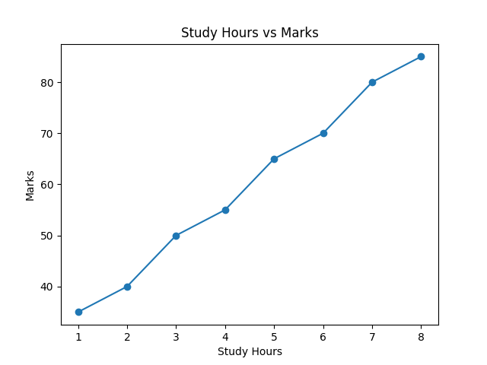
Figure 1: Study Hours vs Marks
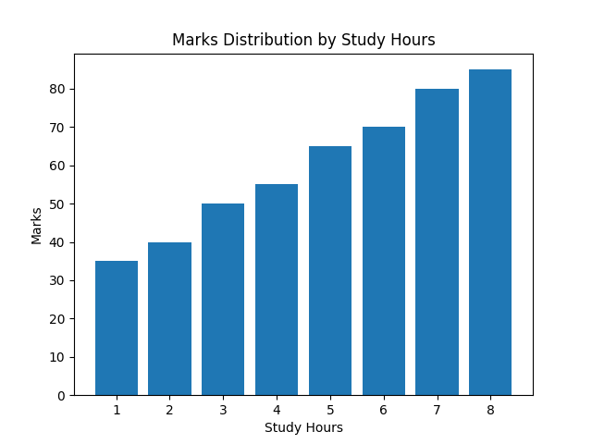
Figure 2: Marks Distribution by Study Hours

9. Code For Analysing

# Import required libraries
import numpy as np
import pandas as pd
import matplotlib.pyplot as plt
from sklearn.linear_model import LinearRegression

# Create dataset (Study Hours vs Marks)
data = {
'Hours': [1, 2, 3, 4, 5, 6, 7, 8],
'Marks': [35, 40, 50, 55, 65, 70, 80, 85]
}

# Convert to DataFrame
df = pd.DataFrame(data)

# Split data into input and output
X = df[['Hours']] # Independent variable
y = df['Marks'] # Dependent variable

# Create Linear Regression model
model = LinearRegression()

# Train the model
model.fit(X, y)

# Predict marks for given study hours
study_hours = [[6.5]]
predicted_marks = model.predict(study_hours)

print("Predicted marks for 6.5 hours of study:", predicted_marks[0])

# Visualize the results
plt.scatter(X, y)
plt.plot(X, model.predict(X))
plt.xlabel("Study Hours")
plt.ylabel("Marks")
plt.title("Student Marks Prediction using Linear Regression")
plt.show()

9. Result and Discussion

Linear The results obtained from this project clearly demonstrate the effectiveness of Linear Regression in predicting student marks based on the number of hours studied. After training the model using the given dataset, the predicted marks were found to be closely aligned with the actual marks. This indicates that the model successfully learned the underlying pattern present in the data. The results confirm that there exists a strong positive relationship between study hours and academic performance.
The visualization of the dataset using scatter plots further supports this observation. When study hours are plotted on the X-axis and marks on the Y-axis, the data points form an upward trend. The regression line drawn through these points represents the best-fit line generated by the Linear Regression model. The closeness of the data points to the regression line indicates minimal prediction error, which confirms the reliability of the model for this dataset.
The performance of Linear Regression was particularly effective due to the linear nature of the data. Since the relationship between study hours and marks follows a nearly straight-line pattern, Linear Regression proved to be an appropriate and efficient algorithm. The simplicity of the model allowed for easy interpretation of results, making it suitable for educational applications where transparency and explainability are important.
From a discussion perspective, the results highlight the importance of consistent study habits in improving academic performance. The model’s predictions demonstrate that even a small increase in study hours can result in a noticeable improvement in marks. This insight can be valuable for students in planning their study schedules and for educators in advising students on effective learning strategies.
In conclusion, the results validate the choice of Linear Regression as a suitable Machine Learning model for this problem. While the dataset used is small and limited to a single input feature, the model performed well and achieved the intended objectives. The discussion of results emphasizes the practical applicability of Machine Learning in the education sector and encourages further exploration using larger datasets and additional influencing factors.

10. Conclusion and Future Work

This project successfully demonstrates a simple yet effective application of Machine Learning for predicting student academic performance. By using Linear Regression, the relationship between study hours and marks was clearly identified and analyzed. The model was able to learn from historical data and generate accurate predictions, thereby proving that Machine Learning techniques can be efficiently applied to real-world educational problems. The simplicity of the approach made it easy to understand and implement, especially for beginners in the field of data analysis and Machine Learning.
The project also provided valuable hands-on experience in implementing the complete Machine Learning workflow using Python. Key steps such as data collection, preprocessing, model selection, training, prediction, evaluation, and visualization were successfully carried out. The use of popular Python libraries such as NumPy, Pandas, Matplotlib, and Scikit-learn helped in efficient data handling, model building, and result interpretation. Through visualization, the positive linear relationship between study hours and marks was clearly demonstrated, enhancing the understanding of model performance.
Despite its effectiveness, the project has certain limitations that open opportunities for future enhancement. The current model uses only a single input feature, which limits its ability to capture other important factors influencing student performance. In real-world scenarios, academic results depend on multiple parameters such as attendance, assignment scores, internal assessments, learning environment, and previous academic history. Incorporating these features can significantly improve prediction accuracy.
As future work, the system can be extended by using multiple input features and applying advanced Machine Learning algorithms such as Decision Trees, Random Forests, Support Vector Machines, or Neural Networks. Additionally, using larger and real-time datasets can make the model more robust and scalable. Such enhancements would enable the development of a more comprehensive student performance prediction system that can support educational planning, personalized learning, and data-driven decision-making.

11. References

1 Scikit-learn Documentation,
Scikit-learn Developers, User Guide and API Documentation.
Available at: https://scikit-learn.org
- Python Official Documentation,
Python Software Foundation, Python Language Reference and Library Documentation.
Available at: https://www.python.org

- Tom M. Mitchell,
Machine Learning, McGraw-Hill Education, 1997.

- Han, J., Kamber, M., and Pei, J.,
Data Mining: Concepts and Techniques, Morgan Kaufmann Publishers.

- Géron, A.,
Hands-On Machine Learning with Scikit-Learn, Keras, and TensorFlow, O’Reilly Media.

