HEALTHCARE DATA ANALYTICS SYSTEM
23CS1ME - Mini-Capstone Project

Submitted by
SATHISH B - 2312099

In partial fulfilment for the award of the degree
of
BACHELOR OF ENGINEERING
in
COMPUTER SCIENCE AND ENGINEERING

NATIONAL ENGINEERING COLLEGE
(An Autonomous Institution affiliated to Anna University, Chennai)
K.R. Nagar, Kovilpatti - 628503

APRIL - 2026

BONAFIDE CERTIFICATE
This is to certify that the project entitled "Healthcare Data Analytics System" is the bona fide work of Sathish B (2312099), Department of Computer Science and Engineering, National Engineering College, Kovilpatti, carried out under the guidance of the project coordinator during the Mini-Capstone Project course.

Project Coordinator | Head of the Department
Ms. P. Priyadharshini  Assistant Professor / CSE | Department of CSE  National Engineering College

Submitted to the Mini-Capstone Project Viva-Voce Examination held at National Engineering College, Kovilpatti.

ACKNOWLEDGEMENT
I express my sincere gratitude to the management, principal, faculty members, and the Department of Computer Science and Engineering of National Engineering College for providing the opportunity and the resources required to complete this mini-capstone project successfully.
I would like to thank Ms. P. Priyadharshini, Assistant Professor / CSE and project coordinator, for her valuable guidance, encouragement, and timely suggestions throughout the development of this project.
I also thank my friends and family members for their continuous support, motivation, and encouragement during the preparation of the project, presentation, and report.

ABSTRACT
Healthcare organizations generate large amounts of patient data that contain important relationships among age, gender, symptoms, and diseases. When such information is not analyzed properly, it becomes difficult to identify patterns, support diagnosis, and provide quick decision assistance. This project proposes a Healthcare Data Analytics System that combines data preprocessing, machine learning, and a simple web-based interface to analyze healthcare records and predict likely diseases from patient symptoms.
The transformed dataset used in this project contains 989 valid patient records. The system cleans raw healthcare data, standardizes fields, derives age groups, and uses symptom text together with demographic details as input features. A Multinomial Naive Bayes classifier is trained on these features to identify the most probable diseases. Experimental evaluation achieved an accuracy of 99.49%, showing that the model is effective for this dataset and suitable for quick clinical support scenarios.
The developed solution includes a Flask-based interface for entering patient information and displaying the top three predicted diseases as high, medium, and low risk categories. In addition, a dashboard-style view supports basic analytics and visualization over the transformed dataset. Overall, the system demonstrates how healthcare data analytics can improve understanding of symptom-disease relationships and support informed decision-making.
The report has been prepared to clearly document each stage of the project, including data collection, preprocessing, feature engineering, model development, web integration, dashboard analytics, observed results, and possible future enhancements. The explanation has been expanded so that the project can be understood easily during review, viva, and final submission.

TABLE OF CONTENTS
Section | Title
ABSTRACT
CHAPTER 1 | INTRODUCTION
1.1 | Healthcare Data Analytics and Machine Learning
1.2 | Disease Prediction and Decision Support System
CHAPTER 2 | LITERATURE SURVEY
CHAPTER 3 | DESIGN THINKING
CHAPTER 4 | PROPOSED METHODOLOGY
4.1 | Existing Work
4.2 | Proposed Work
4.3 | System Design
4.4 | System Architecture
4.5 | Modules
4.6 | System Requirements
CHAPTER 5 | IMPLEMENTATION AND RESULT
5.1 | Implementation
5.2 | Results
CHAPTER 6 | CONCLUSION AND FUTURE SCOPE
APPENDIX I | SAMPLE INPUT / OUTPUT
APPENDIX II | SOFTWARE SNAPSHOTS
OUTCOME
REFERENCES

CHAPTER 1
INTRODUCTION
Healthcare data analytics is an important area where patient records are transformed into actionable information for doctors, administrators, and healthcare stakeholders. Symptoms reported by patients often have hidden patterns that can indicate one or more diseases, but manually identifying these patterns from large datasets is difficult. This project focuses on building an analytics-driven healthcare system that organizes symptom data and produces reliable disease predictions from user input.
The proposed system uses a structured dataset containing patient age, gender, symptoms, symptom count, and disease labels. The dataset is cleaned, duplicates are removed, invalid ages are filtered, and age groups are derived. The processed data is then used to train a machine learning model. The resulting application accepts patient details through a web form and returns ranked predictions that can support preliminary assessment.
Along with disease prediction, the project also includes a browser-based healthcare dashboard created in index.html. This dashboard summarizes the transformed dataset through cards and charts such as total records, top disease, average age, disease distribution, age-group distribution, gender distribution, disease versus age group, disease versus gender, and top-five diseases. This addition makes the project stronger because it supports both predictive analytics and descriptive analytics in a single workflow.
In the implemented dashboard, the summary cards are visually differentiated using the original color styling of the page: blue is used to highlight the total record count, red emphasizes the top disease, and green indicates the average age. The report keeps this explanation as part of the documentation, while leaving the actual dashboard code unchanged.
The current transformed dataset shows that Stroke is the most frequent disease class, and the top three categories are Stroke (152), Diabetes (150), Heart Disease (148). These observations show that the dataset is diverse enough to demonstrate analytics, visualization, and supervised learning in a healthcare context.

1.1 Healthcare Data Analytics and Machine Learning
Healthcare data analytics involves collecting, processing, and interpreting clinical or patient-related data to identify patterns that improve healthcare delivery. Machine learning extends this process by enabling systems to learn from historical examples and make predictions for new patient inputs. In this project, symptom text and demographic attributes are converted into feature vectors so that a Naive Bayes model can classify diseases.
- Data-driven disease pattern identification from historical records.
- Fast prediction suitable for lightweight web applications.
- Integration of symptoms, age, gender, and age group in one model.
- Usable output in the form of ranked disease risk categories.

1.2 Disease Prediction and Decision Support System
A disease prediction and decision support system assists users by narrowing down likely diseases from the symptoms entered by the patient or clinician. In this work, the web application acts as the front-end interaction layer, while the preprocessing and machine learning logic are handled in the backend. The system is not intended to replace doctors; instead, it provides an analytics-based aid that improves awareness and speeds up preliminary assessment.
The importance of the system lies in its ability to reduce manual effort in examining healthcare records. Rather than scanning symptoms one by one, the user can provide a compact input and immediately obtain ranked disease predictions. At the same time, the dashboard reveals larger trends in the dataset, which makes the overall project useful both for prediction and for educational understanding of healthcare data behavior.

CHAPTER 2
LITERATURE SURVEY
Existing healthcare analytics systems usually focus on one of two directions: medical data dashboards for trend analysis or machine learning models for disease prediction. Dashboard-based systems summarize trends such as disease count, gender distribution, and age-group spread, but they may not provide predictive capability. Conversely, prediction-oriented systems often classify diseases from symptoms but lack interactive analytics for understanding the dataset behind the model.
Traditional symptom checkers rely on manually created rules or keyword matching, which may not scale well when datasets grow and disease classes increase. Supervised learning methods such as Decision Tree, Random Forest, Support Vector Machine, and Naive Bayes have been widely applied in disease prediction problems. For text-based symptom input and lightweight deployment, Naive Bayes remains a strong baseline because of its low computational cost and reliable performance.
The present project combines both analytics and prediction. It provides cleaned data for visualization and a trained model for real-time prediction. This makes the system more useful than a static dashboard or a standalone prediction model alone.
Compared with simple academic prototypes, the current project contains two distinct user-facing components. The first is the disease prediction interface rendered through Flask templates, and the second is the independent analytics dashboard page that reads the transformed CSV file directly and creates multiple charts through Chart.js. This dual-structure design improves both usability and report value.
From the review of related approaches, it can be observed that projects become more effective when data quality, model simplicity, and result presentation are balanced carefully. This project follows that idea by combining a clean dataset, a lightweight classifier, and a clear interface instead of using a complex pipeline that would be harder to explain in an academic setting.

CHAPTER 3
DESIGN THINKING

3.1 Empathy Map
The key users of the proposed system are students, healthcare learners, patients seeking early insights, and healthcare staff who need quick access to symptom-based information. Their main need is a system that is simple, fast, and understandable. Users prefer entering a few symptom details and receiving meaningful output without technical complexity.
- Says: I want to know the most likely disease from the symptoms entered.
- Thinks: The system should be quick and should not be difficult to use.
- Sees: Large amounts of healthcare information but limited easy-to-use analysis tools.
- Hears: Machine learning can support diagnosis, but results should be interpretable.
- Pain: Manual symptom analysis is slow and error-prone.
- Gain: Quick preliminary prediction with supporting analytics and visualization.
This design-thinking view helps align the system with user expectations. The form page addresses the need for a simple prediction workflow, while the analytics dashboard satisfies the user need for transparency and broader insight into the data. As a result, the project is not only technically functional but also user-oriented.

CHAPTER 4
PROPOSED METHODOLOGY

4.1 Existing Work
Many existing systems either stop with basic descriptive analysis or provide symptom-based prediction without showing how the underlying data is organized. Some approaches also depend on hard-coded rules, which are difficult to maintain and expand. Such systems may not capture the probability distribution of multiple diseases or present insights such as age-group and gender trends.
Another limitation of earlier work is that raw healthcare data often contains duplicate records, inconsistent text formatting, missing values, or weak feature representations. If such issues are not handled properly, even a good model may produce unreliable predictions. Therefore, the preprocessing stage becomes a major factor in the success of healthcare analytics systems.

4.2 Proposed Work
The proposed Healthcare Data Analytics System addresses these gaps through a full pipeline that begins with data cleaning and ends with visual analytics and prediction. The system validates data, computes derived age-group features, converts symptom text into vectors, trains a Naive Bayes model, and integrates the trained model with a Flask-based web application.
- Dataset cleaning and validation using Python and Pandas.
- Feature engineering through combined text input fields.
- Disease prediction using Multinomial Naive Bayes.
- Web interface for patient input and top-three disease output.
- Analytics dashboard for disease, age-group, and gender insights.
The complete workflow of the project begins with loading the raw CSV file and ends with presenting analytics and prediction results to the user. This structured sequence ensures that every stage contributes meaningfully to the final output and that each processing step can be explained clearly in the project review.

4.3 System Design

4.3.1 Use Case Description
The primary actor is the end user. The user enters patient details such as name, age, gender, and symptoms. The backend validates the values, derives the age group, sends the input to the trained model, and returns the top three disease predictions. The analytics mode reads the transformed dataset and displays charts for further understanding of the data.

4.4 System Architecture
The system architecture consists of four major layers: data layer, preprocessing layer, machine learning layer, and presentation layer. The data layer stores the healthcare CSV dataset. The preprocessing layer removes invalid rows, fills missing values, and derives age groups. The machine learning layer vectorizes symptom-based input and trains the Naive Bayes classifier. The presentation layer includes the Flask application and HTML templates used for form-based prediction and dashboard visualization.
The architecture is intentionally modular so that each part of the system can be modified independently. For example, the model can be upgraded later without redesigning the web form, and new dashboard views can be added without changing the preprocessing logic. This separation improves maintainability and makes future extension easier.
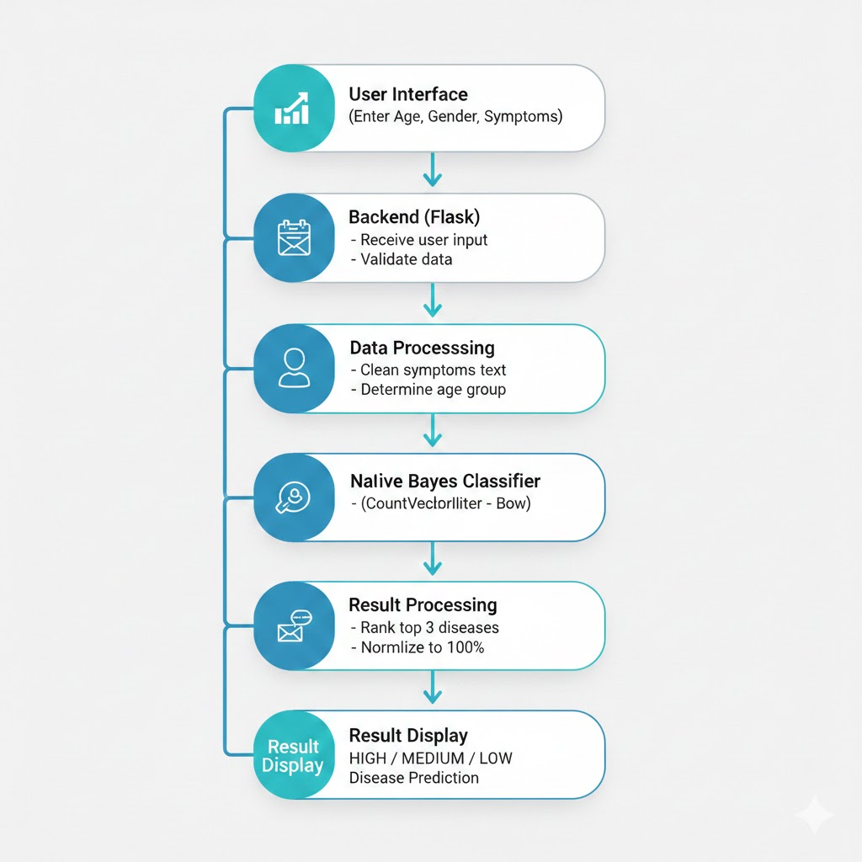
Fig. 4.1 Project workflow diagram

4.5 Modules
1. Data Preprocessing Module
Loads the raw healthcare dataset, removes duplicate rows, validates age values, checks symptom counts, fills missing values, and derives the age group column.
2. Feature Engineering Module
Combines age, gender, age group, and symptom text into a single machine-learning input string suitable for vectorization.
3. Prediction Module
Uses CountVectorizer and Multinomial Naive Bayes to classify diseases and generate probability-based rankings.
4. Web Application Module
Implements the Flask application that accepts user input and returns the top three diseases in high, medium, and low risk order.
5. Analytics and Visualization Module
Displays dataset insights such as disease distribution, age-group distribution, gender split, disease versus age group, disease versus gender, top-five disease comparison, and summary cards.
Together, these modules form a complete end-to-end application. The preprocessing and feature modules prepare the data, the prediction module produces class probabilities, and the interface modules present both individual and dataset-level results in a way that is easy to understand.

4.6 System Requirements
Component | Details
IDE | Visual Studio Code
Language | Python
Framework | Flask
Libraries | Pandas, NumPy, scikit-learn
Front-end | HTML, JavaScript, Tailwind CSS
Dataset | Healthcare_data.csv / Healthcare_Transformed.csv

CHAPTER 5
IMPLEMENTATION AND RESULT

5.1 Implementation
The implementation begins with the script in data.py, where the raw dataset is loaded and cleaned. Duplicate records are removed, invalid age values are filtered, symptom counts are validated, and missing values are handled. A derived age group is then assigned to every record, and the transformed output is saved as Healthcare_Transformed.csv.
The model.py file uses the transformed dataset to create a combined text feature from age, gender, age group, and symptoms. CountVectorizer converts this input into numeric vectors, and a Multinomial Naive Bayes model is trained for disease classification. The system then computes probabilities for each disease and normalizes the top three results into High, Medium, and Low risk categories.
The Flask application in app.py connects the trained model to a user-friendly HTML form. On submission, the app validates the user input, derives the age group, performs prediction, and renders the result back to the browser. A second interface supports dashboard-style analytics using the transformed CSV file.
The updated dashboard in index.html reads Healthcare_Transformed.csv in the browser, parses the rows, and generates six chart-based visual components. It also calculates summary metrics such as total records, most frequent disease, and average age. This dashboard broadens the scope of the project from only prediction to complete healthcare data exploration.
From the transformed data, the patient age spans from 6 to 80 years, with an average of 44.54. Such values show that the dataset covers multiple age segments, which is useful for meaningful age-group analysis in the dashboard as well as in the trained prediction model.

5.1.1 Training Phase
- Load the transformed healthcare dataset.
- Remove commas from symptoms and combine all useful fields into one input string.
- Vectorize text using CountVectorizer.
- Split the dataset into training and testing subsets.
- Train the Multinomial Naive Bayes classifier.
- Evaluate the model and store the trained pipeline for prediction logic.
During training, the project uses a bag-of-words style text representation. This is appropriate because the symptom field contains descriptive text values. By combining symptoms with age, gender, and age group into a single input string, the model receives both demographic and symptom-level information in a compact form.

5.1.2 Prediction Phase
- Accept name, age, gender, and symptoms from the form.
- Calculate the corresponding age group.
- Transform the new input using the trained vectorizer.
- Predict disease probabilities using the Naive Bayes model.
- Display the top three diseases as HIGH, MEDIUM, and LOW risk levels.
The final prediction output is designed to be simple and readable. Instead of returning only one label, the system reports three ranked disease options. This is useful because symptom overlap is common in healthcare datasets, and ranking provides a more informative result than a single hard decision.

5.1.3 Dashboard Implementation
- Load the transformed CSV file asynchronously using JavaScript fetch.
- Parse each row and extract age, gender, disease, and age group fields.
- Compute total record count, average age, and the top occurring disease.
- Prepare aggregated objects for disease count, age-group count, and gender count.
- Render bar, pie, doughnut, and comparative charts using Chart.js.
- Display the dashboard as a visual analytics layer for the healthcare dataset.
The dashboard has been kept separate from the Flask template so that it can act as an independent visualization page during demonstration. It highlights how the same transformed dataset can be used not only for prediction but also for exploratory analysis. This strengthens the academic value of the project by showing multiple uses of one dataset.

5.2 Results
After preprocessing, the final dataset contains 989 records with an average patient age of 44.54. Female records are slightly higher than male records, and the adult category represents the largest age group. The machine learning model achieved an accuracy of 99.49% on the test split, showing that the selected feature construction and classifier are well suited to this dataset.
The disease distribution indicates that Stroke is the dominant class. The system successfully returns ranked predictions and also supports dataset-level interpretation through dashboard charts for disease, age group, and gender analysis.
The result analysis shows that the project performs well not only in model accuracy but also in output clarity. Users can review disease predictions from the form interface and can also inspect broad healthcare trends through dashboard visuals. This combination makes the project presentation richer and easier to explain in front of reviewers.
The current dashboard implementation in index.html contains summary cards and six analytical charts. These visualizations help the user understand the composition of the dataset beyond individual predictions. Since the final dashboard screenshots may be updated manually later, dedicated placeholder spaces are provided below for direct paste-in of screenshots during final report submission.
In the current design, the dashboard cards use blue, red, and green highlights for key summary indicators, and the charts use multiple distinct colors to make categories easy to differentiate visually. This color behavior is documented here for report completeness, while the report text itself remains formatted in black for a clean print style.

5.2.1 Disease Prediction Output Placeholder
Fig. 5.1 Disease prediction module output placeholder
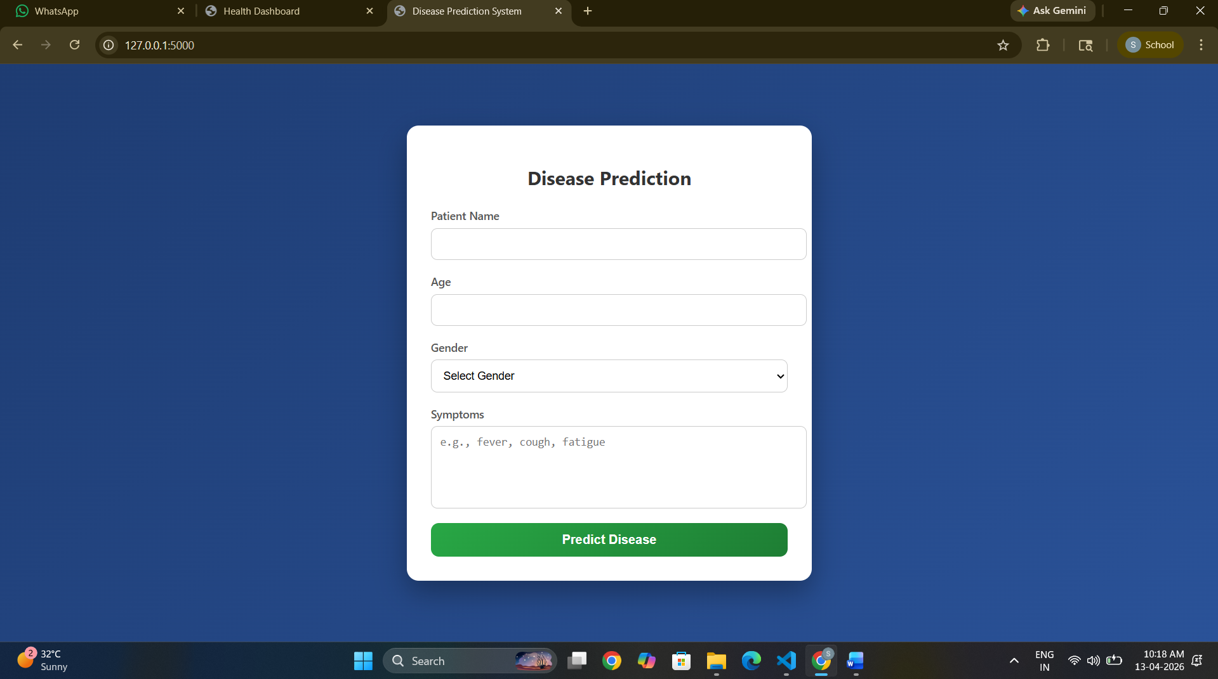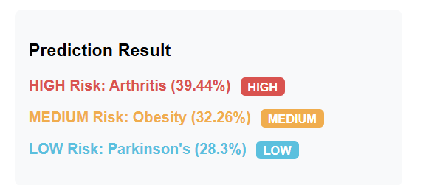

5.2.2 Main Dashboard Placeholder
Fig. 5.2 Main dashboard placeholder
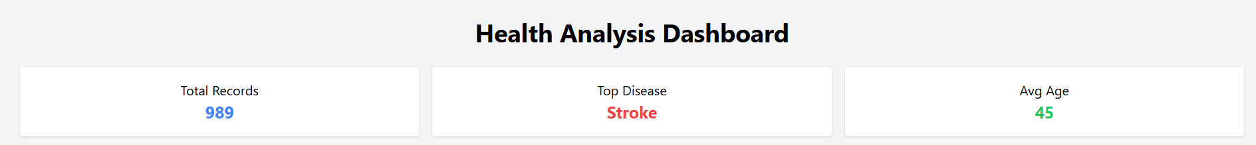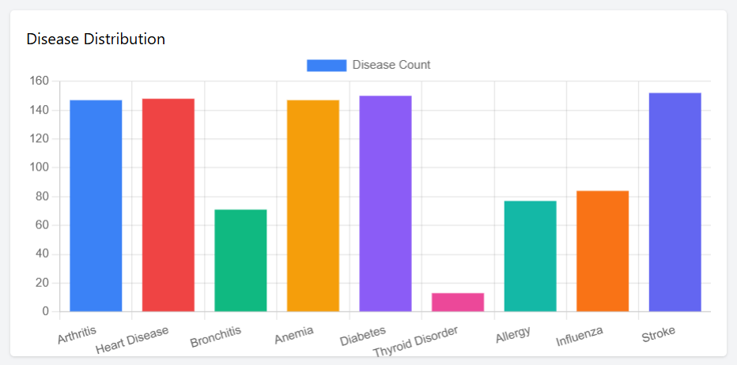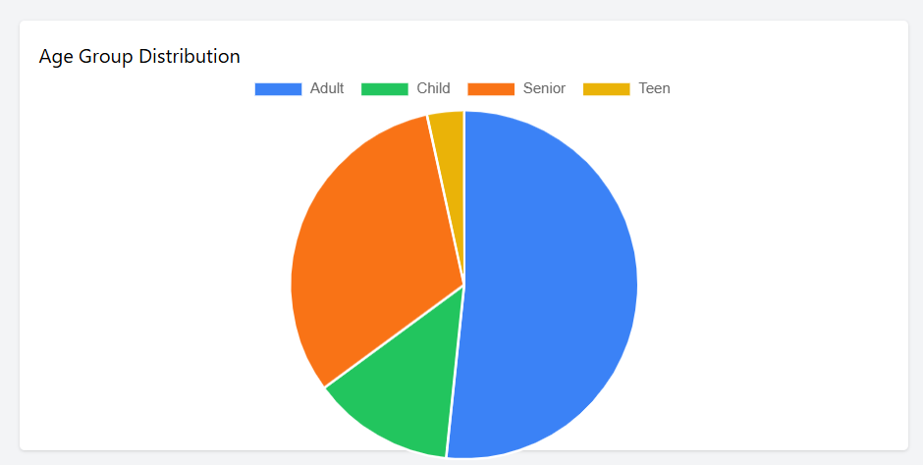

5.2.3 Dashboard Charts Placeholder
Fig. 5.3 Dashboard charts placeholder
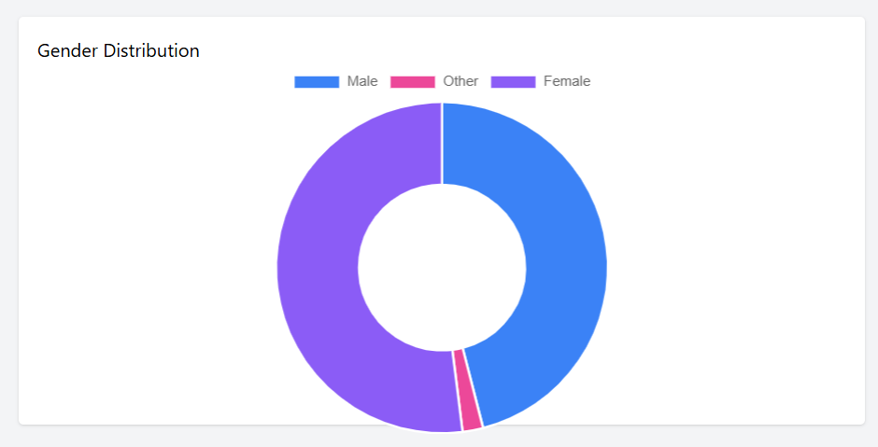
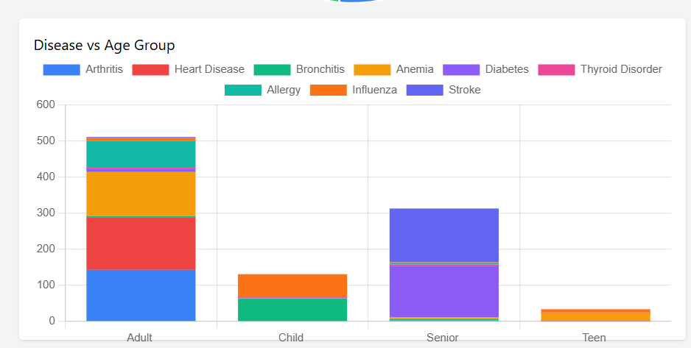

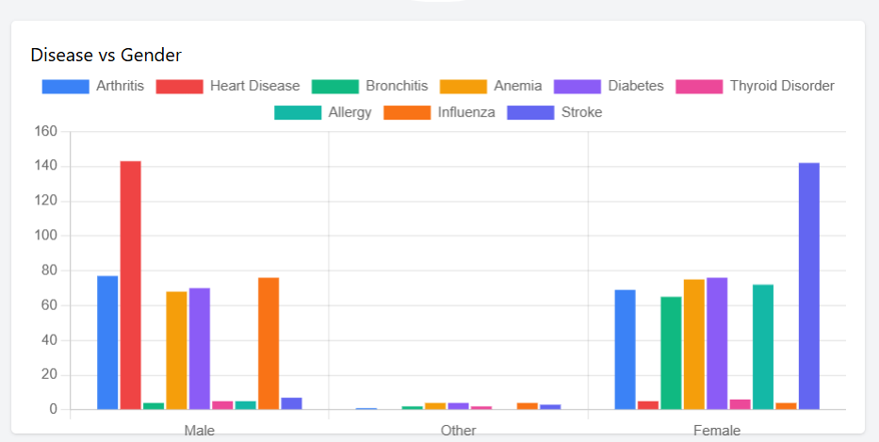

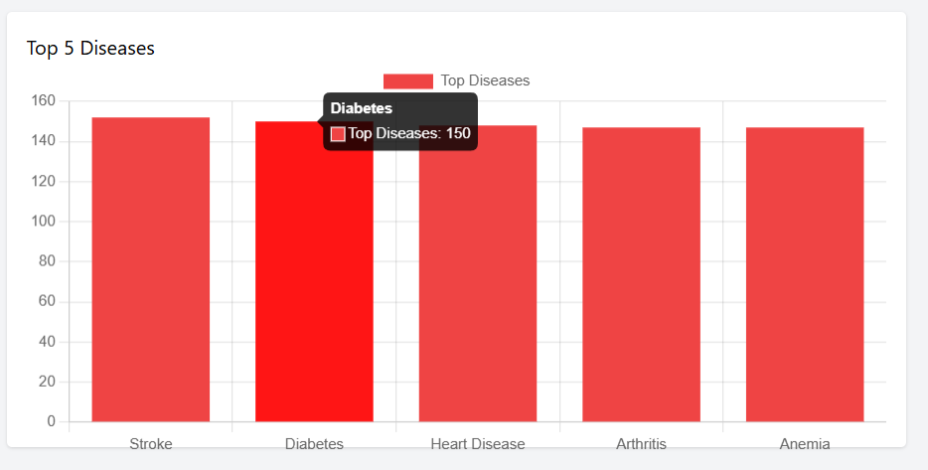
CHAPTER 6
CONCLUSION AND FUTURE SCOPE

6.1 Conclusion
This project successfully demonstrates a Healthcare Data Analytics System that integrates data preprocessing, machine learning, and web-based interaction. By transforming patient symptom records into structured features and training a Naive Bayes classifier, the system is able to provide fast and accurate disease predictions. The analytics dashboard further improves understanding of the dataset by visualizing disease frequency and demographic distribution.
The project is practical for academic demonstration because it covers the complete pipeline from dataset cleaning to application deployment. It shows how analytics and prediction can work together to support healthcare-related decision assistance.
The final report now presents the project in a clearer and more complete manner, making it easier for readers to understand the motivation, workflow, implementation, and significance of the work without needing to inspect the source code first.

6.2 Future Scope
- Improve prediction quality using larger and more diverse clinical datasets.
- Compare Naive Bayes with Random Forest, SVM, or deep learning approaches.
- Add patient history, lab values, and severity indicators as extra features.
- Deploy the solution with authentication and persistent patient record management.
- Build a more advanced dashboard with downloadable reports and trend analysis.

APPENDIX I
SAMPLE INPUT / OUTPUT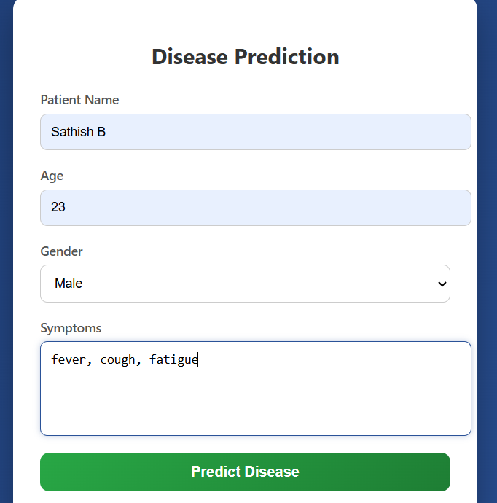
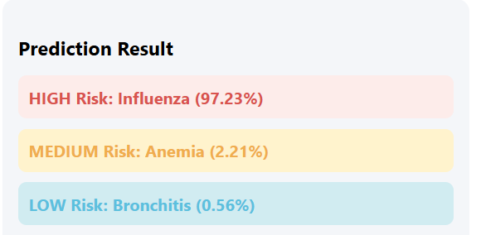

OUTCOME
The project produced a cleaned healthcare dataset, a trained symptom-based disease prediction model, a Flask web application for patient interaction, and an analytics dashboard for dataset interpretation. The final system is suitable for mini-capstone demonstration and documentation. The report also now reserves dedicated spaces for the latest dashboard screenshots so the final submission can be customized easily.

REFERENCES
Ian H. Witten, Eibe Frank, Mark A. Hall, and Christopher J. Pal, Data Mining: Practical Machine Learning Tools and Techniques.
Tom M. Mitchell, Machine Learning.
Pandas Documentation for data preprocessing and CSV handling.
scikit-learn Documentation for CountVectorizer and Multinomial Naive Bayes.
Flask Documentation for web application development.
Project source files: data.py, model.py, app.py, index.html, and Healthcare_Transformed.csv.

